Eastside Christian Church
July Newsletter

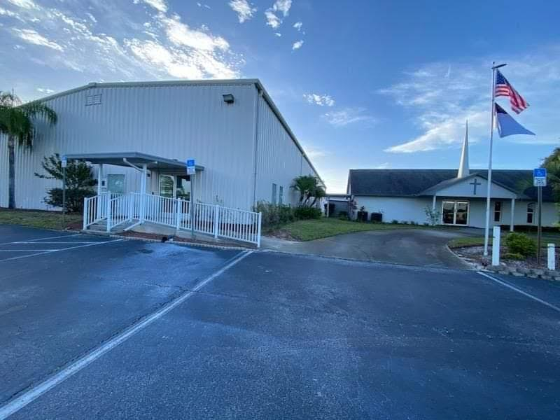

July Events
Wednesday Night Bible Study starts back on the 15th at 6 PM
Independence Day 4th
Leadership meeting: Elders & Deacons at 8 AM on the 9th
Leadership Board: 9 AM on the 9th
Ladies' Ministry meeting on the 16th at 9 AM
Lunch Bunch on the 30th at 11:30, place TBA



Independence Day 4th
^{Manna Ministries}
Our church is helping Manna Ministries to provide food, encouragement, and hope to families and individuals in our community facing food insecurity. Through this outreach, groceries and essential supplies are shared with those in need, serving as a reminder that they are valued and not forgotten.
We warmly encourage you to prayerfully consider contributing non-perishable food items. Every donation, big or small, has a meaningful impact. Together, we can reflect Christ’s love by offering both physical nourishment and heartfelt compassion.
🫧 Manna Ministries Donation Drive – July Theme 🫧
"Jesus, You Are the Bubbles to My Bath"
In July, we will collect personal care items for Manna Ministries. These everyday essentials can make a big difference in the lives of those in need.
Items needed include: soap and body wash, shampoo and conditioner, toothpaste and toothbrushes, mouthwash, lotion, deodorant, shaving cream and razors, and other personal hygiene products.
Thank you for your generosity and for being the hands and feet of Jesus as we serve our community!
“The King will reply, ‘Truly I tell you, whatever you did for one of the least of these brothers and sisters of mine, you did for me’ Matthew 25:40❤️
Devotional

Refreshing Our Souls
"He leads me beside quiet waters, He refreshes my soul." — Psalm 23:2-3
July is often a month filled with vacations, family gatherings, and time spent outdoors. We look forward to slowing down, enjoying warm days, and taking a break from our normal routines. While physical rest is important, God reminds us that our souls need refreshing as well.
Life has a way of draining us. Responsibilities, worries, disappointments, and even daily routines can leave us spiritually weary. The good news is that Jesus invites us to come to Him for renewal. He is not merely interested in helping us survive; He desires to refresh and restore us.
Just as a cool drink of water is welcome on a hot summer day, God's presence brings refreshment to our hearts. Through prayer, time in His Word, worship, and fellowship with other believers, we find the strength and peace that only He can provide.
Perhaps this month you will find yourself traveling, spending time with family, or enjoying a slower pace. Make room for God in those moments. Take a walk and thank Him for His creation. Spend a few extra minutes in prayer. Read a Psalm while enjoying your morning coffee. Allow Him to refresh your spirit.
When we intentionally draw near to Christ, we discover that true rest is not found in a vacation destination but in a relationship with our Savior.
As we enjoy the blessings of summer, may we also experience the refreshing presence of God, who faithfully restores our souls day after day.

Ladies Ministry


Bloom Where God Has Planted You
"Let us not become weary in doing good, for at the proper time we will reap a harvest if we do not give up." Galatians 6:9
July is a beautiful reminder of growth. Gardens are blooming, crops are maturing, and God's creation is on full display. Yet, behind every beautiful flower and fruitful plant is a season of planting, watering, and patient waiting.
As women of faith, we often find ourselves in seasons that require patience. We pray for loved ones, serve our families, minister to others, and faithfully carry out responsibilities that may go unnoticed. Sometimes we wonder if our efforts matter or if the seeds we've planted will ever bear fruit.
God reminds us in Galatians 6:9 not to grow weary in doing good. Every act of kindness, every prayer offered, every meal prepared, every encouraging word spoken, and every sacrifice made in love is seen by Him. While we may not always witness immediate results, God is working beneath the surface, nurturing the seeds we have sown.
Blooming where God has planted us doesn't mean life is always easy. Flowers endure storms, heat, and drought before they reach full beauty. In the same way, God uses every season of our lives—both joyful and difficult—to shape us into women who reflect His grace and love.
This month, take time to thank God for the place He has planted you. Whether you are serving in your home, workplace, church, or community, know that He has a purpose for you. Continue to trust Him, remain faithful, and allow His love to bloom through your life.


As we enter the month of July, I am filled with gratitude for all that God has done at Eastside
Christian Church. This month marks two years since Mary and I came to Eastside, and what
an incredible journey! Looking back, we can clearly see God’s hand at work in our church.
Over these past two years, we have accomplished many things together. Eastside now has a
presence on the web, allowing us to reach people beyond our church walls and share the message
of Christ with our community and beyond.
More importantly, God has continued to add to our church family. We have welcomed new
members, celebrated baptisms, and watched lives be changed through the power of the Gospel.
Every baptism is a reminder that God is still moving and calling people to Himself.
We are also excited about our current church-wide study of The Story. This journey through
Scripture will take us through the entire Bible by November. It has been a blessing to see our
church growing deeper in God’s Word together.
As we continue forward, let us remain focused on the mission God has given Eastside Christian
Church: Love • Grow • Serve
Love God and people.
Grow as disciples who reflect Christ.
Serve our community with compassion and truth.
Thank you for your faithfulness, prayers, and support. The best days of Eastside are not behind us; they are ahead of us. Let us continue working together to fulfill God’s purpose for our church.
In Christ,
Bobby
Here are our numbers if you need to contact us for anything.
Office- 863-465-7065
The office is open Tuesday, Wednesday, and Thursday
Bobby- 863-840-1022 Cell Email: eastsidechristianchurchpastor@gmail.com
Mary- 863-235-1205 Cell Email: eastsidechristianchurchoffice@gmail.com
Please leave a message if there is no answer.

