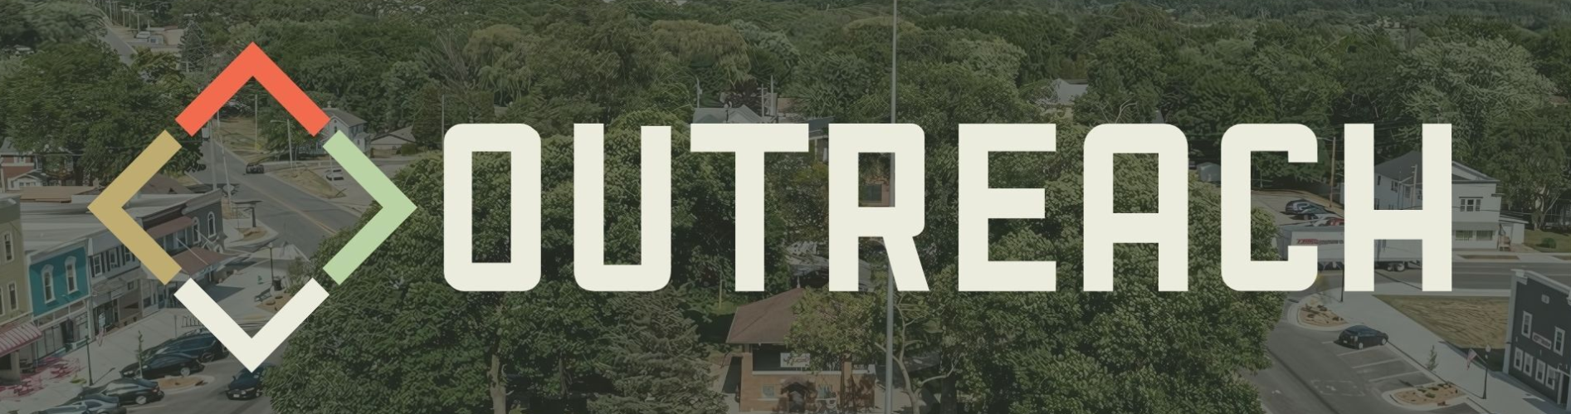

The Reach Church C.A.R.E. (Community Assistance & Relief Effort) Team is a group of volunteers dedicated to helping our community that we’ve been called to serve in their time of need.
Whether it’s clearing storm debris, helping with yard work, or stepping in during times of crisis, we believe the church should be the first to serve.

Emergency/Crisis Response
Disaster relief (floods, fires, storms)
Emergency supply coordination
Support for families in sudden crisis (funeral help, job loss, etc.)
Food & Essentials Outreach
Monthly food pantry or pop-up grocery distribution
“Blessing Bags” (snacks, hygiene items, socks) for people experiencing homelessness
Home Repair & Yard Work
Minor home repairs for elderly, single parents, or disabled residents
Yard cleanups, lawn care, debris removal
Seasonal help (leaf raking, snow shoveling)
Community Care Visits
Nursing home visits
Hospital encouragement visits
Check-ins with shut-ins or isolated individuals


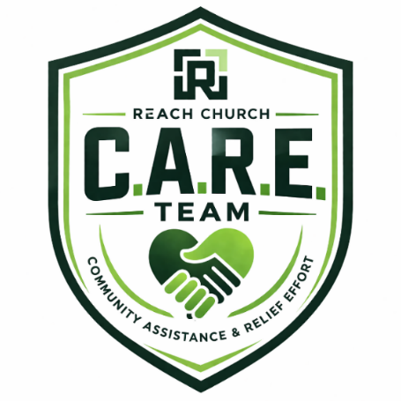
If you or someone you know are in need of assistance with any of these things, or something not listed, or if you would like to donate or volunteer, scan the QR Code below or leave a message for The C.A.R.E. Team at 262-766-7729.

