Our Meeting Times
Sunday’s
Small Groups - 9:50 am
Morning Worship - 11:00 am
Children’s Church - 11: 20 (K4-5th)
Youth Group – Sunday - 6:00 pm (6-12th)
Evening Worship – 6:00 pm
Wednesday’s
Adult Bible Study - 7:00 pm
Awana Youth Ministry Ages 3 - High School
6:45 – 8:15 (during the school calendar)

Saturday Mornings (Bi-Weekly)
The Man Church (Men) & The Hive (Ladies) - 9:00 am
Last Friday of the Month
Legacy Builders (60+) – 5:00 pm
Thank You for choosing One Accord today! We are so glad that you are here. God cares for you and so we do too
!
Please fill out and drop your connection card (found in the back of the pews) into the offering plate.
Get easily connected through our Sunday School Life Groups.
We would love to have you join us.
Scan the QR code to connect. (We are working on the webpage)

QR Codes for Apple, Android, & Website
Apple Android Website

Romans 15:6 "That with one accord ye may with one mouth glorify the God and Father of our Lord Jesus Christ."
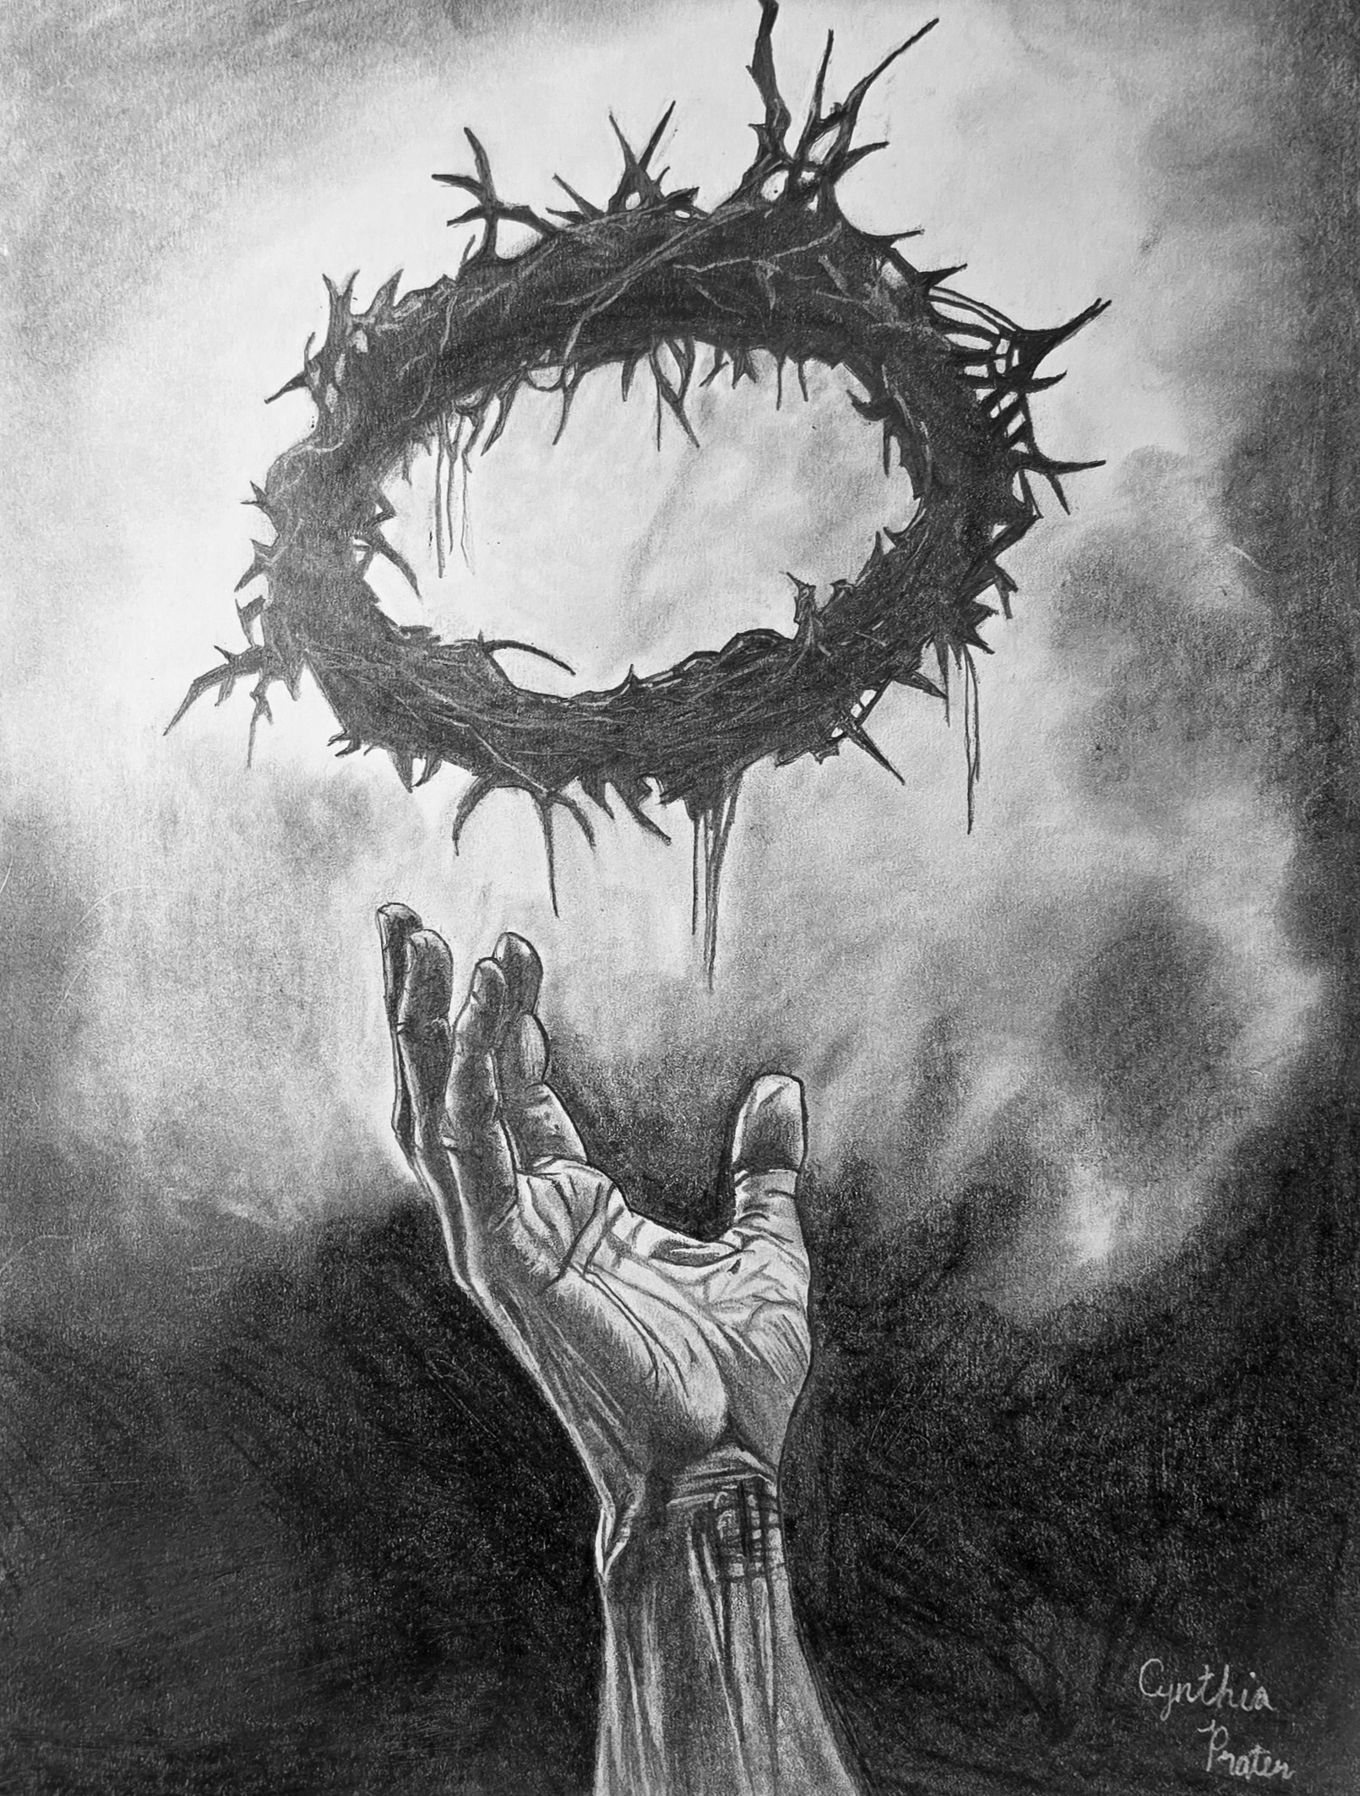
One Accord Community Church
343 Sweetland Drive - Red Bank, TN 37415
(423) 875-8377

Founding Pastor, Ray Williams (423) 488-9993
Email: rwilliams196413@gmail.com

Youth Pastor: David Carter (423) 260-6677
Email: Davidcarter_93@hotmail.com

Chairman of the Deacons – Jerry Elkins
Churchwide Missions: Tina Williams 423-645-5296
Children’s Church Director: Alisa Nepp
Awana Director: Debbie Cordell (423) 647-3082

July 12, 2026
The Lord’s Day


Today’s Message
(A.M. Service)
By Pastor Ray Williams.

“When Jesus Meets the Doubting”
Scripture: Mark 16:9-20

Please stand if able, giving reverence to God’s Word.
Mark 16:9 Now when He rose early on the first day of the week, He appeared first to Mary Magdalene, out of whom He had cast seven demons. ^{(NKJ)}
Jeremiah 29:13 And you will seek Me and find Me, when you search for Me with all your heart. ^{(NKJ)}

*Come back tonight as we continue in
Ecclesiastes Chapter 3:16-22

“When Injustice Seems to Prevail”
- Pastor Ray Williams


FROM SMALL GROUPS THIS MORNING
Honor-Believers’ Highest Calling is to Honor God in Every Aspect of Their Lives (See Matthew 22: 15-40)

KEY DOCTRINE: The Christian and the Social Order
(See Romans 13:1-2; 1 Timothy 2:1-2)

Announcements & Upcoming Opportunities

MARK YOUR CALENDARS:

VBS is HERE! July 12-15, 6:30-8:30 pm (Workers be here at 5:30)

Man Church & The Hive, Saturday, July 25th @ 9:00 a.m.

Legacy Builders: Friday, July 31st @ 5:00 Pizza & Movie

Movie planned: “I Can Only Imagine 2”

**Anyone interested in table games-

meet at 6:00 pm Friday nights in the Fellowship Hall

(we bring refreshments to share).

Nursery Schedule:

7/12 Alisa/Tina W.

7/19 Savannah & Tina C.

7/26 Loretta / Felicia

We are still collecting food items for families for summer in partnership with Northside Neighborhood House (NNH).

Items urgently needed: Canned Chicken & Tuna (or pouches), Ramen, Breakfast Bars, Mac & Cheese, cereals, + Personal items.

Please designate on your offering envelope or check
for which of these you are giving. There are envelopes in the pews. You can also give online on our website.
https://www.oneaccordcommunitychurch.org/give

VBS Giving: (to help offset some of the costs) https://oneaccordcommunitychurchorg.myanswers.com/emerald-crossing/

Thank you for giving to the Lord!

