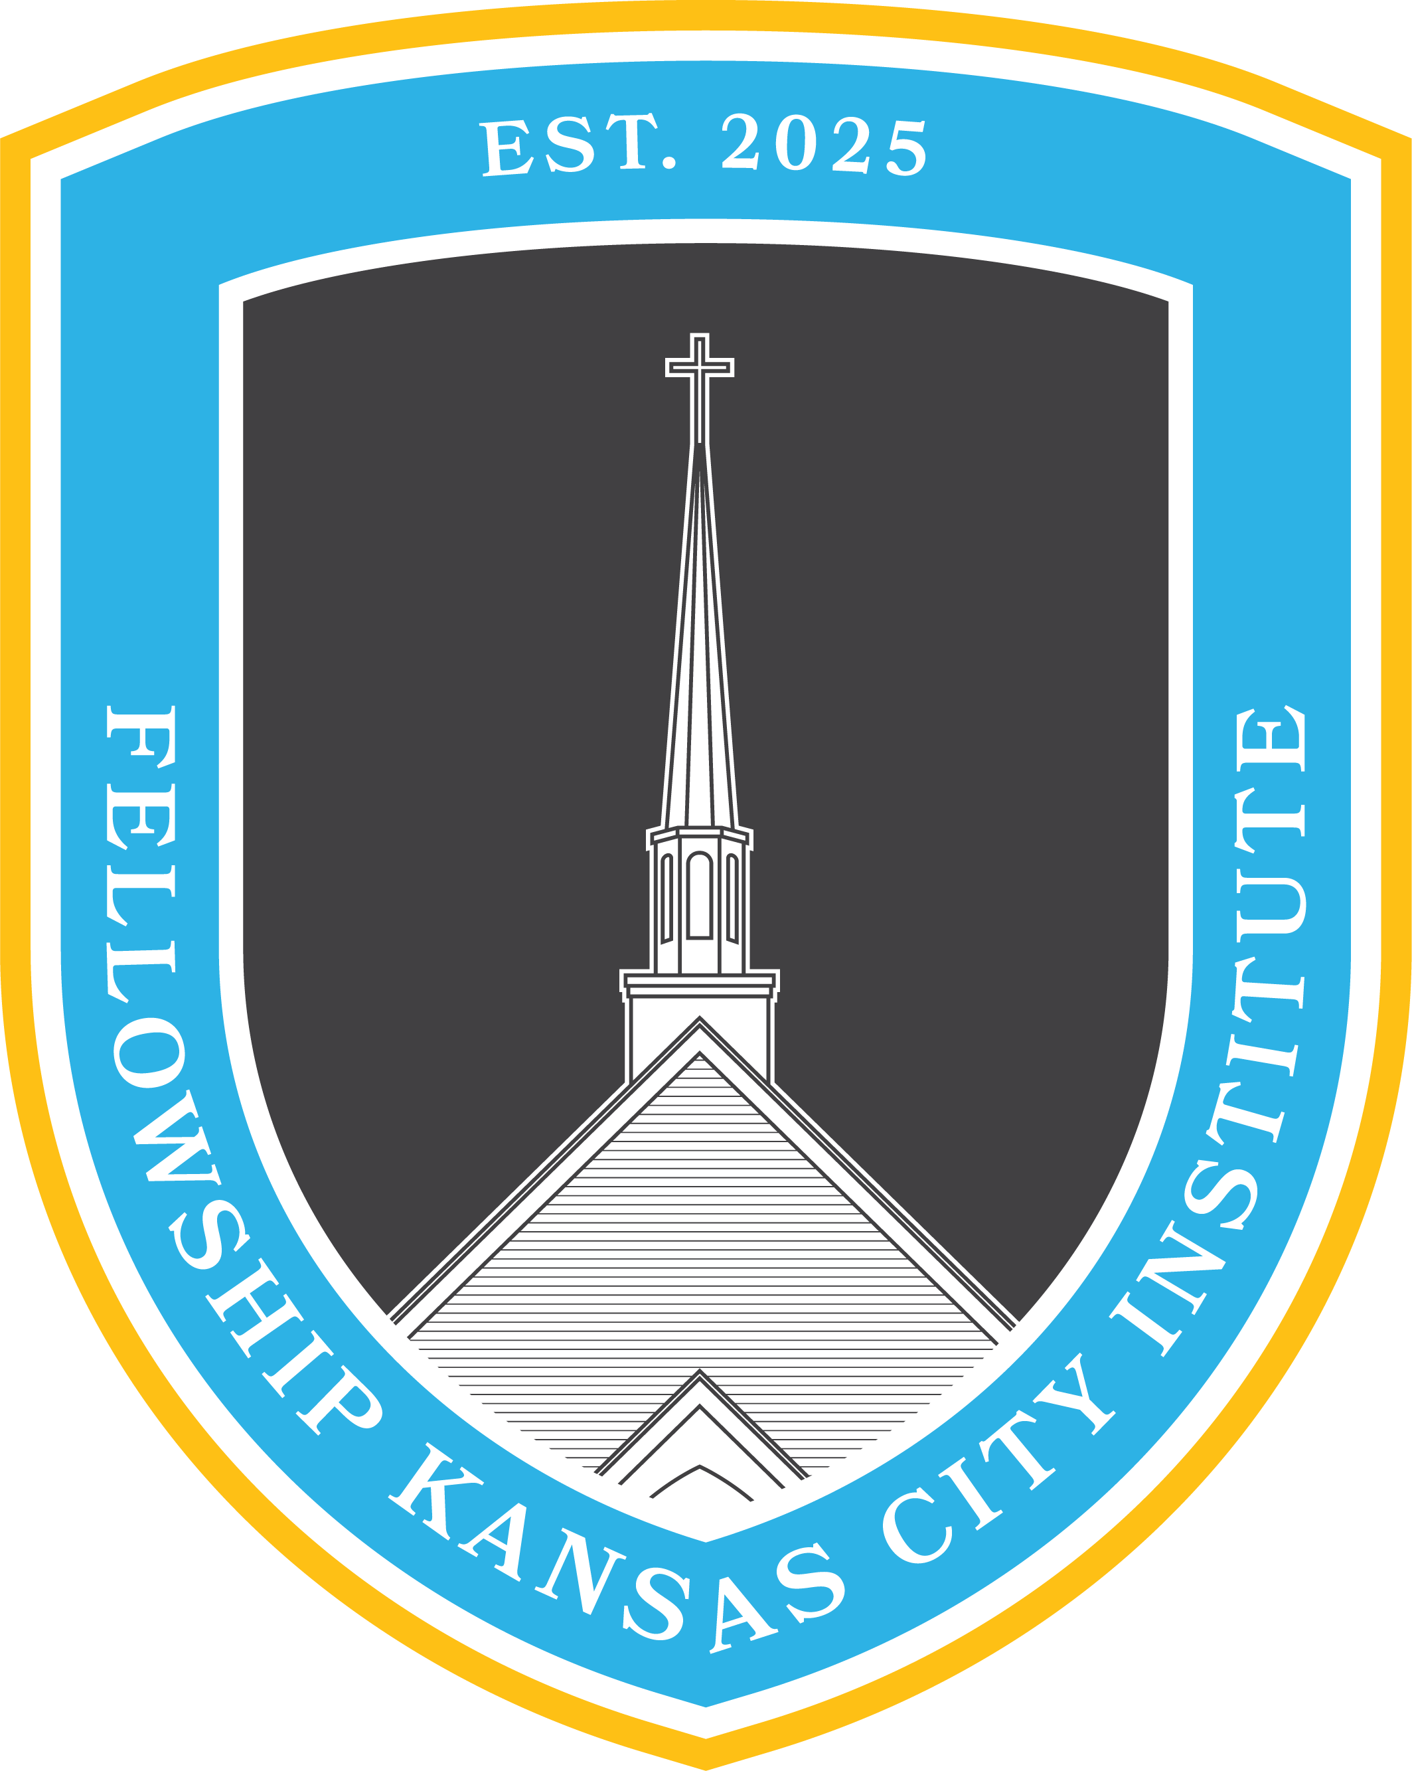
Pneumatology
6:00 pm–7:30 pm / Sundays
Fall 2026

I. Course Description
This FKCI course is a formal study of the orthodox doctrine of the Holy Spirit. The course will prioritize biblical exegesis of relevant passages to conduct a systematic theology of the Holy Spirit. Attention will be given to historical confessions on the doctrine and modern approaches to it.

II. Course Objectives
Church members who complete this course will be able to:
- Articulate an orthodox position on the doctrine of the Holy Spirit.
- Understand the function of the Holy Spirit in the life of a believer and church.
- Apply the course material to themselves to fulfill the biblical command to live a life in the Spirit and to be filled by the Spirit.

III. Suggested Reading (Order: Beginner, Intermediate, Advanced)
- Sproul, R. C. The Mystery of the Holy Spirit. Fearn, Scotland: Christian Focus Publications, 2009.
- Ferguson, Sinclair B. The Holy Spirit. Contours of Christian Theology. Downers Grove, IL: InterVarsity Press, 1996.
- Owen, John. The Holy Spirit. Abridged and made easy to read by R. J. K. Law. Puritan Paperbacks. Edinburgh: Banner of Truth Trust, 1998.

IV. Requirements for Certification
- Attendance
  - Church members must attend at least 2/3 classes of the course.
- Scripture Reading
  - Church members must meditate on the assigned Scripture readings for the course, prior to the respective class.
- Lesson Assignment
  - Church members must commit to teaching a component of this course to a family member, friend, or colleague not in attendance in the course. The lesson should highlight a portion of the course material, explaining the Gospel through the lesson.

V. Course Organization

Week | Topic | Scripture Reading  (Required) | Suggested Reading  (Optional)
1 | The Doctrine of the Holy Spirit  Systematic & Historical Theology | - John 14-16  - Acts 5:1-11 | - Sproul Chs. 1-4  - Ferguson Ch. 1  - Owen Chs. 1-3
2 | The Story of the Holy Spirit  Biblical Theology | - Genesis 1:1-2:3  - Ezekiel 36:22-32  - John 1:1-34 | - Sproul Chs. 5-6  - Ferguson Chs. 2-6  - Owen Chs. 4-8
3 | Life in the Holy Spirit  Orthopraxy and Practical Ministry | - Romans 8  - Galatians 5:13-26  - 1 Corinthians 12-14 | - Sproul Chs. 7-10  - Ferguson Chs. 7-11  - Owen Chs. 9-26

VI. General Information

- This course is not intended to replace the gathering of the church on Sunday morning or your personal devotion time in God’s Word and prayer.
- For questions about the course or course content please contact Pastor Tyler and/or Pastor Landon: Tyler@fellowshipkc.com / Lsmith@fellowshipkc.com

