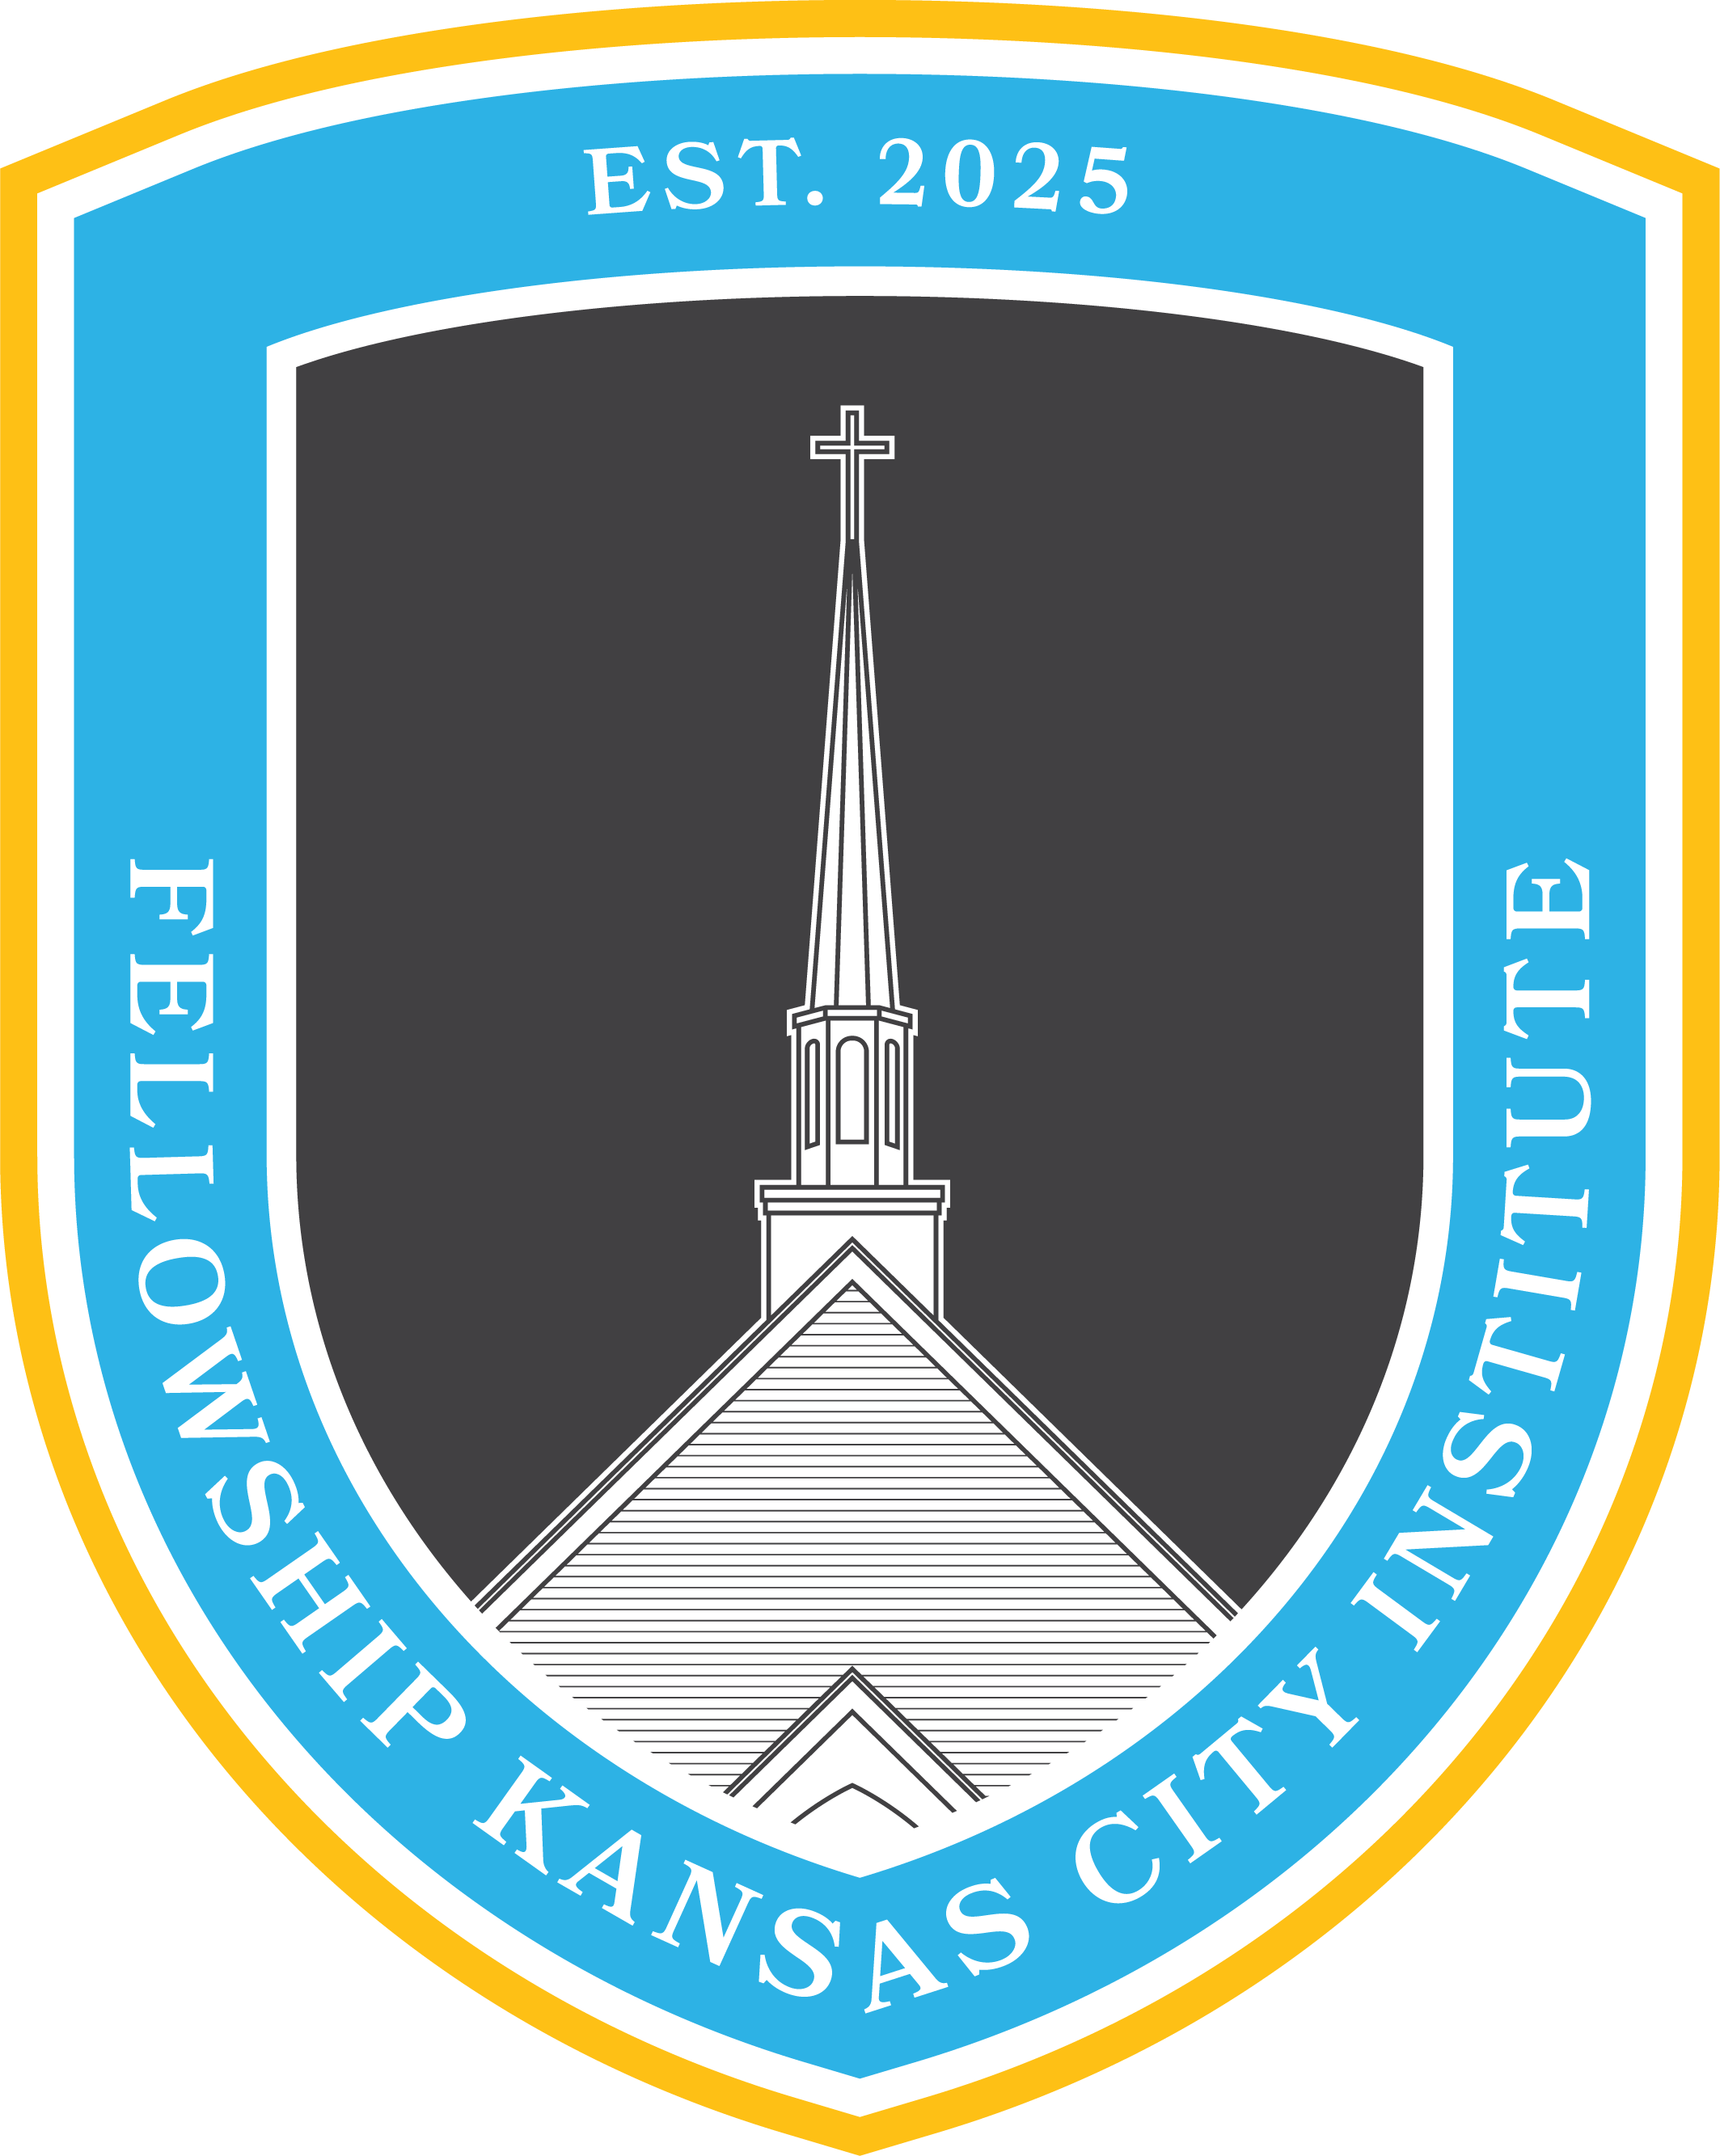
The Book of the Law
6:00 pm–7:30 pm / Sundays
Spring 2026

I. Course Description
This FKCI course is a formal study of the first five books of the Bible, treating them as a single, foundational unit. This course will focus on understanding the narrative and structure of the Pentateuch, giving special attention to the covenant laws given to Israel. Upon examining the foundational work of the Pentateuch, the course will investigate how Jesus fulfilled the various aspects of the law and how the New Covenant Church relates to the Old Covenant law.

II. Course Objectives
Church members who complete this course will be able to:
- Articulate the narrative and structure of the Pentateuch.
- Understand the redemptive-historical function of Israel’s law.
- Apply the first five books of the Bible to themselves, their households, their church, and their civil responsibilities.

III. Suggested Reading (Order: Beginner, Intermediate, Advanced)
- Vaillancourt, Ian J. The Dawning of Redemption: The Story of the Pentateuch and the Hope of the Gospel. Wheaton, IL: Crossway, 2022.
- Alexander, T. Desmond. From Paradise to the Promised Land: An Introduction to the Pentateuch. Grand Rapids, MI: Baker Academic / Paternoster Press, 2002.
- Averbeck, Richard E. The Old Testament Law for the Life of the Church: Reading the Torah in the Light of Christ. Downers Grove, IL: IVP Academic, 2022.

IV. Requirements for Certification
- Attendance
  - Church members must attend at least 2/3 classes of the course.
- Scripture Reading
  - Church members must meditate on the assigned Scripture readings for the course, prior to the respective class.
- Lesson Assignment
  - Church members must commit to teaching a component of this course to a family member, friend, or colleague not in attendance in the course. The lesson should highlight a portion of the course material, explaining the Gospel through the lesson.
V. Course Organization

Week | Topic | Scripture Reading  (Required) | Suggested Reading  (Optional)
1 | Overview:  Discovering the setting, story, and structure of the Book of the Law. | - Psalm 105  - Nehemiah 9 | - Vaillancourt: Intro, Ch 1-3  - Alexander: 1-6  - Averbeck: Part 1
2 | Ordinances:  Examining the legal texts their historical, literary, and redemptive, contexts. | - Exodus 19  - Leviticus 19  - 1 Peter 2:1-12 | - Vaillancourt: Ch 4-6  - Alexander: 7-12  - Averbeck: Part 2
3 | Outworking:  Tracing the fulfillment of the Law in Christ and discerning its ongoing significance for New Covenant Christians | - Matthew 5:17-20  - Romans 8:1-4  - Psalm 95  - Hebrews 3 | - Vaillancourt: Ch 7-9  - Alexander 13-18  - Averbeck: Part 3

VI. General Information

- This course is not intended to replace the gathering of the church on Sunday morning or your personal devotion time in God’s Word and prayer.
- For questions about the course or course content please contact Pastor Tyler and/or Pastor Landon: Tyler@fellowshipkc.com / Lsmith@fellowshipkc.com

