INTRODUCTION

Welcome to LakeRidge Methodist Church Children’s Day Out Program. Your child is a special person to us. Our goal is to provide a healthy, happy, Christian atmosphere for the children and parents and bring a Christian perspective to a quality nurturing and learning
environment.

LakeRidge Children’s Day Out Program is a non-profit Christian outreach service of LakeRidge Methodist Church.

We hope your family will find many opportunities for growth at LakeRidge Methodist and are pleased you have chosen our Children’s Day Out Program. If you have questions or need more information, please call us at 806-698-5709.

Opportunities at LakeRidge Children’s Day Out

Children’s Day Out is an activity-oriented program for children ages three months to two years. The program offers full days and half days. Weekly themes, Bible stories, art/creative activities, supervised free play, and music are part of the developmentally appropriate setting that encourages young children to explore God’s world.

Children’s Day Out Hours

The Children’s Day Out program is available from 9:00 am -2:45 pm or half day from 9:00 am -12:00 pm. Each child and all belongings must be picked up by 12:00/2:45 pm. If you have more than one child, please begin the pick-up process in time to pick up the last child by 12:00/2:45 pm. If your child has not been picked up by these times, the teachers are instructed to bring him/her to the CDO office and late fees will be assessed.

Children’s Day Out Fees

Payment for the entire month will be due by the 7th of each month.
A $25.00 late fee will be assessed for payments received after the 7th. Due to our strict monthly budget, we may not allow children to remain in school unless tuition is paid. A $25 return check fee will be charged if monthly check is returned. THERE ARE NO REFUNDS FOR MISSED DAYS because teachers must be paid and supplies must be purchased
to accommodate a certain number of children.

Children’s Day Out Hours

Tuesdays & Thursdays: 9:00-2:45
Tuesdays & Thursdays: 9:00-12:00

Tuition has been divided into 9 equal payments. Students must be paid in full by May 7th.

Financial Policies
a. THE REGISTRATION FEE IS NON-REFUNDABLE.
b. Refunds are not given for part of a month missed.
c. Tuition is due on the 7th of each month and is due as long as a place is reserved for your child.
d. The school office must be notified at least two weeks in advance if the child is withdrawing from the program for any reason. Parents are responsible for an additional two weeks of tuition if they fail to give the full two weeks advance notice.
e. We accept ACH draft, checks and cash. Make checks payable to LakeRidge Methodist, noting your child's name in the lower corner. A child may not attend school if there is any unpaid tuition from previous months.
f. A $25 late fee will be assessed for tuition received after the 7th of the month. A fee to cover bank costs will be assessed for any checks returned due to insufficient funds. Repeated insufficient funds will result in payments through a cash only basis.
g. September tuition for kindergarten only must be pre-paid by May 7th and is non-refundable.
h. In order to enroll for the next school year in any LittleRidge program there may be no past-due balances.
i. All family accounts with LakeRidge LittleRidge must be current at the end of the school year in order to continue holding a spot for a child previously enrolled for the next school session.
j. A child may not attend school if there is any unpaid tuition from previous months.
k. Full tuition must be paid by May 7th in order for a child to attend the remainder of the month and year.

Late Pick-Up Fees

You will be charged a $10.00 per MINUTE late pick-up fee if you do not pick up your child before 2:45.
1st time - $10 fee per minute per child starting at 2:46
2nd time - $10 fee per minute per child + letter sent home to be signed
3rd time - $10 fee per minute per child + meeting w/ the school Director & LakeRidge Executive Pastor
4th time - $10 fee per minute per child + meeting with board
Possible expulsion from the program.

Being late to pick up your child makes it difficult for the employees of CDO to pick up their own children and it is also very upsetting to the child who has been left to wait on mom or dad.

We ask for your help and promptness in this matter so that we will not have to utilize this late fee policy.

DROP-OFF AND RELEASE OF CHILDREN

For the security of your children, we are using the Shelby Next check-in system. Parents may download the Shelby Next App on their phone and can check in children once they are in the LakeRidge Methodist parking lot. Parents will use the same Shelby Next process to check out their child at the end of the day. If anyone other than adults authorized through the Shelby Next system will be picking up your child, the Director will need to be notified by the parents. The Director will also record the individual’s driver’s license and car tag number.

If you arrive at a time the doors are locked, please enter through the Main Church Office doors. The teachers have been instructed not to leave their rooms at any time to open any doors.

Parking Lot Safety

Please remember that safety is our number one concern. Please drive slowly and with caution so that everyone is safe in the LakeRidge Methodist parking lot. Help us police the parking lot to ensure safe arrivals and departures from school.

Parent Communication

Parent communication is very important to us. It is our responsibility to provide parents with information about their child’s day. It is the parent’s responsibility to know what is happening each day with their child. We feel strongly about working together as a team.

We will be sending out monthly calendars that will convey the unit of study/focus each week, as well as special activities.

Daily reports will be given out at the end of each day. These cards give parents more specific information about the child’s lunch, rest time, favorite activities, and diaper changes.

Health and Safety

Your child’s health is very important to us.

All health records and a signed Physician’s Statement must be received by LittleRidge prior to admission. Records can be faxed to 806-698-5729.

Communicable diseases spread quickly in classrooms. Please check with your physician before returning your child to school after recovering from a communicable illness. MEDICATION CANNOT BE GIVEN AT SCHOOL.

LittleRidge does not keep an unassigned epinephrine auto-injector.

You must keep your child home if one or more of the following exists:
- The illness prevents the child from participating comfortably in child-care center activities including outdoor play;
- The illness results in a greater need for care than caregivers can provide without compromising the health, safety, and supervision of the other children in care;
- The child has one of the following:
  - An oral temperature above 101 degrees that is accompanied by behavior changes or other signs or symptoms of illness;
  - A tympanic (ear) temperature above 100 degrees that is accompanied by behavior changes or other signs or symptoms of illness.
  - An axillary (armpit) temperature above 100 degrees that is accompanied by behavior changes or other signs or symptoms of illness;
- Symptoms and signs of possible severe illness such as lethargy, abnormal breathing, uncontrolled diarrhea, two or more vomiting episodes in 24 hours, rash with fever, mouth sores with drooling, behavior changes, or other signs that the child may be severely ill;
- A health-care professional has diagnosed the child with a communicable disease, and the child does not have medical documentation to indicate that the child is no longer contagious.
No specific vaccinations for employees are required by LakeRidge Methodist; however, all employees are encouraged to follow the recommendations of their primary care physician regarding immunizations for teachers of young children.

A health check is a visual or physical assessment of a child to identify potential concerns about a child’s health, including signs or symptoms of illness and injury. Health checks may be conducted if necessary.

QUICK REFERENCE—STAY HOME CHART
I need to stay home if…
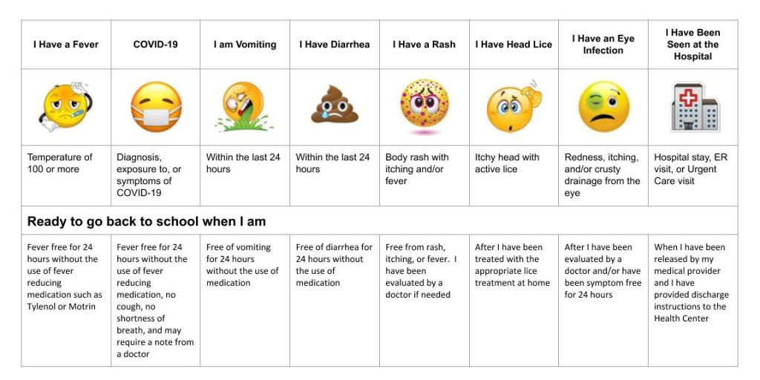

Medical Emergencies

In case of accidental injury, we will make an immediate attempt to contact a parent. If we cannot reach a parent, we will refer to the emergency contact information that you have provided. If necessary, we will call an ambulance and have your child taken to your designated hospital in the company of a staff member. The physician, ambulance attendant, paramedic, director or teacher will be in charge and make all decisions about the care of the child until relieved by a parent. Parents will be responsible for any resultant expenses. We will maintain a parent signed consent form agreeing to the provision. It is to your child’s benefit that you keep the forms up to date with correct phone numbers and other pertinent information.

Lunch
Children must bring their own lunch consisting of finger foods and a drink. Send the lunch in a lunch box or sack. Please send foods children can handle themselves without a lot of assistance. Do not send food that needs warmed. This causes your child to wait for their lunch while the other children are eating. Please do not send colored (red, blue, or purple) juice in your child’s lunch, as it will stain the carpet if spilled. Please send any utensils your child will need for lunch and label all of your child’s belongings to avoid lost items. Milk will not be available for purchase. Please remember to cut grapes and weenies into bite size pieces.

Rest Time
Each child in the full day program has a nap or quiet time during the day. Babies nap according to their own schedules. Children one year of age to three year olds, rest after lunch. (Please see Child’s Belongings section for items your child will need.)

Music
Our program offers a music class for the babies through two year olds. We enjoy presenting a Christmas and Spring music program so you can see the accomplishments of your child.

Parent Volunteers

There are occasions in which parent help is needed in order to enhance the quality of our program, to ensure the safety of each child, and to keep our costs to a minimum. We can never have too many adults to help supervise children. There are various times during the year when parents are needed for special occasions such as picture day, special events, and teacher appreciation luncheons. Please see the director if you are interested in any volunteer work.

Birthday Celebrations

If you want to bring a special snack for your child’s class in honor of his/her birthday, please notify the teacher in advance. However, we must ask that you not bring cupcakes. We recommend sugar cookies, as these are easier for little guys to handle. Too much stimulation (clowns, balloons, noise makers, etc.) makes for very active children. Please ask your child’s teacher for appropriate birthday suggestions. Please do not hand out birthday invitations unless everyone in the class is invited.

Holiday Schedule

Holiday schedules will follow Lubbock ISD. Please check the
preschool calendar for tentative dates to remember.

Inclement Weather Policy

If LISD delays school, Children’s Day Out and Preschool will start at 10:00 am. If LISD cancels school, Children’s Day Out and Preschool will be canceled as well. Should turbulent weather occur during school hours, the children will be taken to the basement. During this time, our priority will be to move the children to safety as soon as possible. Every precaution will be taken to insure the safety of your child.

Biting

For the safety of all children enrolled in our Children’s Day Out program, we have a biting policy. If a child bites any other child 3 times, then he/she will be asked to take a two week leave. After the two week period, the child is welcome to come back to the program. If the child continues to bite, then a meeting will be set up with the parents to evaluate the child’s position within the program. Each child’s safety and well-being is of utmost important to the staff here at LakeRidge Methodist Children’s Day Out. We appreciate your understanding and cooperation with this matter.

Discipline

Children need to have their physical needs met before any learning can take place. As they develop, their need for social interaction is increased. Many times children will use inappropriate actions to get the attention of another individual. When this happens, correct
behavior will be demonstrated and the child’s attention will be diverted to another activity. If the child continues to misbehave and verbal warnings do not bring positive results, the teacher will remove the child from the situation or activity and place him or her in a “thinking chair.” In the “thinking chair,” the teacher will place the child in a chair in a remote part of the room and discuss the unacceptable behavior. This will give the child time to evaluate the situation and re-direct his/her behavior. If after repeated “thinking chairs,” the child’s behavior is still deemed unacceptable, the teacher will ask the director for assistance, who will then discuss the behavior with the parents. If any child endangers the physical well-being of another child, he or she will be dismissed from the program without a refund. Caregivers teach respect for others by showing respect for each child. This is demonstrated to the children by listening when they talk, showing sincere concern for their feelings, and by not allowing others to hurt them. All children will be encouraged and praised when appropriate behavior is demonstrated.

Dismissal/Suspension

Intervention in the early years can be crucial. We make every attempt to work with parents and children to resolve issues. When that does not work, dismissal is our last resort.

LakeRidge LittleRidge reserves the right to dismiss any child at any time, with or without cause.

Parents will be refunded any unused tuition within 30 days of the dismissal. A check will be mailed to the address indicated in the child’s file. Any past due balances must be paid within 30 days of dismissal. An invoice detailing the past due balances will be forwarded to the address indicated in the child’s file within one week of the dismissal.

The LakeRidge LittleRidge Director or designee will assist the parent in gathering the child’s belongings at the time of dismissal and parents are required to leave the LakeRidge Methodist property in a calm and respectful manner, immediately.

A dismissed child and his/her parents are required to call and request an appointment with the LakeRidge LittleRidge Director if they wish to return to the property following a dismissal. Appointments are made at the discretion of the LakeRidge LittleRidge Director and are not a right of the dismissed child or parent.

Accommodations

Decisions pertaining to accommodations for children with special needs will be made on a case by case basis upon evaluation. Any adaptive equipment and additional staffing must be supplied by the parent and comply with licensing requirements.

Child’s Belongings

Infants: All of the following must be brought each day and labeled with your child’s name: a day’s supply of diapers, a lightweight blanket, a bib for lunch, a change of clothes in case of an accident, and any other important items your child needs like a pacifier or cuddly animal.

Toddlers and Two Year Olds: All of the following must be brought each day and labeled with your child’s name: a day’s supply of diapers (if needed), a bib for lunch (if needed), a change of clothes in case of an accident, a mat or sleeping bag, and a lightweight blanket and any other important items your child needs like a pacifier or cuddly animal.

Toys from Home

Except for toys that are needed for young children to ease the transition from home to school and special show-n-tell days or special event days, we ask that you not allow your child to enter the building with toys. If an item is brought, we cannot be responsible for seeing that it is not broken or lost. If you have a toy, book, or music which you feel might enrich the children’s activities especially during a special unit, please make arrangements with your child’s teacher to share it with the class.

Contact Information

Laurie McKee
Director of Preschool & Kindergarten

Ph. 806-698-5710 Fax 806-698-5729

Bus. Hours M-F 9:00-12:00 lmckee@lakeridgeumc.org

Address: 4701 82nd St, Lubbock, TX 79424

• If you have any questions about our policies and procedures, feel free to contact me at any time.

