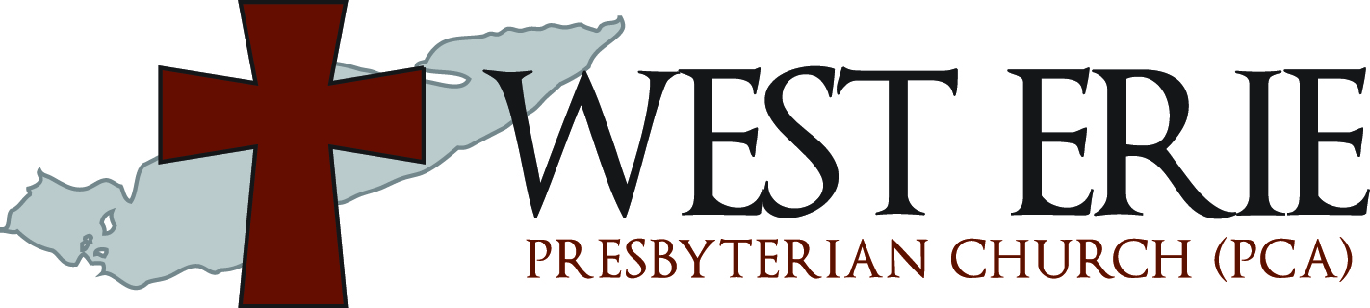

Then the LORD said in His heart, "I will never again curse the ground for man's sake…”
--Genesis 8:21b

Worship Leaders:
Pastor Marc Miller, R.E. Matt Fair

The Lord’s Worship Service
Sunday, November 7, 2021
Order of Worship

Announcements

Preparation for Worship

Call to Worship*

Psalm 18:1-3
Leader: I will love You, O LORD, my strength.
All: The LORD is my rock and my fortress and my deliverer; My God, my strength, in whom I will trust; My shield and the horn of my salvation, my stronghold.
Leader: I will call upon the LORD, who is worthy to be praised; So shall I be saved from my enemies.

Gloria Patri*

GLORIA PATRI (MEINKE) Irreg. Charles Meineke, 1844
“Glory be to the Father, and to the Son, and to the Holy Ghost;
as it was in the beginning, is now, and ever shall be
world without end. Amen, amen.”

Prayer of Invocation*

Hymn of Praise* “O Worship the King”

TUNE: LYONS 10.10.11.11 Based on Psalm 104. Robert Grant, 1833.

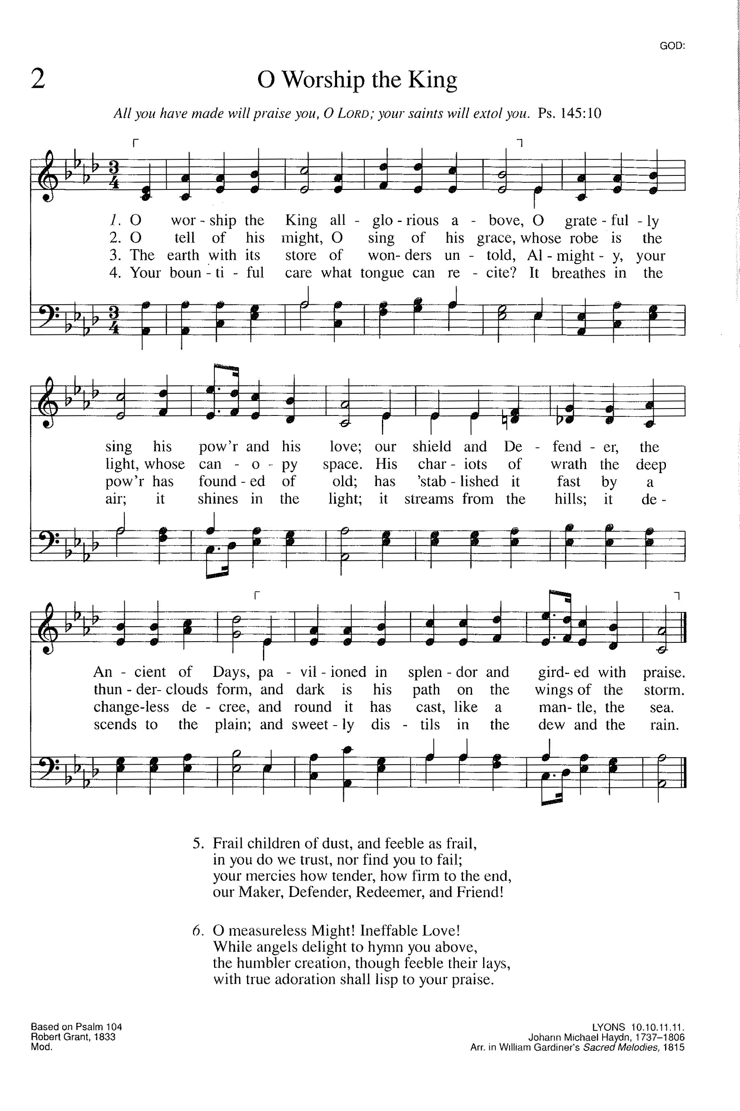

Confession of Faith*
Apostle’s Creed

All: I believe in God the Father Almighty, Maker of heaven and earth.

I believe in Jesus Christ, His only Son, our Lord, who was conceived by the Holy Spirit, and born of the virgin Mary. He suffered under Pontius Pilate, was crucified, died, and was buried. He descended into hell. The third day He rose again from the dead. He ascended into heaven and is seated at the right hand of God the Father Almighty. From there He will come to judge the living and the dead.

I believe in the Holy Spirit, the holy catholic church, the communion of saints, the forgiveness of sins, the resurrection of the body, and the life everlasting. Amen.

Confession of Sin

Psalm 25:4-7, 11
All: “Show me Your ways, O LORD; Teach me Your paths. Lead me in Your truth and teach me, For You are the God of my salvation; On You I wait all the day. Remember, O LORD, Your tender mercies and Your lovingkindnesses, For they are from of old. Do not remember the sins of my youth, nor my transgressions; According to Your mercy remember me, For Your goodness' sake, O LORD. For Your name's sake, O LORD, pardon my iniquity, for it is great .” Hear now our silent confessions in Jesus’ name.

Scriptural Assurance of Pardon

Romans 6:23
Leader: Hear the good news! “For the wages of sin is death, but the gift of God is eternal life in Christ Jesus our Lord.”

Worship through Giving

Psalm 1

TUNE: ARLINGTON CM “This is the Day the Lord Has Made”
O greatly bless-ed is the man Who walketh not astray
In counsel of ungodly men, Nor stands in sinners’ way,

Nor sitteth in the scorner’s chair, But placeth his delight
Upon GOD’S law, and meditates On His law day and night.

He shall be like a tree that grows Set by the water side,
Which in its season yields its fruit, And green its leaves abide;

And all he does shall prosper well. The wicked are not so,
But are like chaff which by the wind Is driven to and fro.

In judgment, therefore, shall not stand Such as ungodly are,
Nor in th’assembly of the just Shall wicked men appear.

Because the way of godly men Is to Jehovah known,
Whereas the way of wicked men Shall quite be overthrown

Pastoral Prayer
All: “Our Father who art in heaven, hallowed be thy name. Thy kingdom come, thy will be done, on earth as it is in heaven. Give us this day our daily bread. And forgive us our debts, as we forgive our debtors. And lead us not into temptation, but deliver us from evil. For thine is the kingdom, and the power, and the glory, forever. Amen.”

Responsive Psalm Reading

Psalm 43:1-5
Leader: Vindicate me, O God, And plead my cause against an ungodly nation; Oh, deliver me from the deceitful and unjust man!
All: For You are the God of my strength; Why do You cast me off? Why do I go mourning because of the oppression of the enemy?
Leader: Oh, send out Your light and Your truth! Let them lead me; Let them bring me to Your holy hill And to Your tabernacle.
All: Then I will go to the altar of God, To God my exceeding joy; And on the harp I will praise You, O God, my God.
Leader: Why are you cast down, O my soul? And why are you disquieted within me? Hope in God; For I shall yet praise Him, The help of my countenance and my God.

Gospel Reading

Luke 2:25-52
And behold, there was a man in Jerusalem whose name was Simeon, and this man was just and devout, waiting for the Consolation of Israel, and the Holy Spirit was upon him. ²⁶And it had been revealed to him by the Holy Spirit that he would not see death before he had seen the Lord's Christ. ²⁷So he came by the Spirit into the temple. And when the parents brought in the Child Jesus, to do for Him according to the custom of the law, ²⁸he took Him up in his arms and blessed God and said: ²⁹"Lord, now You are letting Your servant depart in peace, According to Your word; ³⁰For my eyes have seen Your salvation ³¹Which You have prepared before the face of all peoples, ³²A light to bring revelation to the Gentiles, And the glory of Your people Israel." ³³And Joseph and His mother marveled at those things which were spoken of Him. ³⁴Then Simeon blessed them, and said to Mary His mother, "Behold, this Child is destined for the fall and rising of many in Israel, and for a sign which will be spoken against ³⁵"(yes, a sword will pierce through your own soul also), that the thoughts of many hearts may be revealed." ³⁶Now there was one, Anna, a prophetess, the daughter of Phanuel, of the tribe of Asher. She was of a great age, and had lived with a husband seven years from her virginity; ³⁷and this woman was a widow of about eighty-four years, who did not depart from the temple, but served God with fastings and prayers night and day. ³⁸And coming in that instant she gave thanks to the Lord, and spoke of Him to all those who looked for redemption in Jerusalem. ³⁹So when they had performed all things according to the law of the Lord, they returned to Galilee, to their own city, Nazareth. ⁴⁰And the Child grew and became strong in spirit, filled with wisdom; and the grace of God was upon Him. ⁴¹His parents went to Jerusalem every year at the Feast of the Passover. ⁴²And when He was twelve years old, they went up to Jerusalem according to the custom of the feast. ⁴³When they had finished the days, as they returned, the Boy Jesus lingered behind in Jerusalem. And Joseph and His mother did not know it; ⁴⁴but supposing Him to have been in the company, they went a day's journey, and sought Him among their relatives and acquaintances. ⁴⁵So when they did not find Him, they returned to Jerusalem, seeking Him. ⁴⁶Now so it was that after three days they found Him in the temple, sitting in the midst of the teachers, both listening to them and asking them questions. ⁴⁷And all who heard Him were astonished at His understanding and answers. ⁴⁸So when they saw Him, they were amazed; and His mother said to Him, "Son, why have You done this to us? Look, Your father and I have sought You anxiously." ⁴⁹And He said to them, "Why did you seek Me? Did you not know that I must be about My Father's business?" ⁵⁰But they did not understand the statement which He spoke to them. ⁵¹Then He went down with them and came to Nazareth, and was subject to them, but His mother kept all these things in her heart. ⁵²And Jesus increased in wisdom and stature, and in favor with God and men.

New Testament Reading

Hebrews 7:1-28
For this Melchizedek, king of Salem, priest of the Most High God, who met Abraham returning from the slaughter of the kings and blessed him, ²to whom also Abraham gave a tenth part of all, first being translated "king of righteousness," and then also king of Salem, meaning "king of peace," ³without father, without mother, without genealogy, having neither beginning of days nor end of life, but made like the Son of God, remains a priest continually. ⁴Now consider how great this man was, to whom even the patriarch Abraham gave a tenth of the spoils. ⁵And indeed those who are of the sons of Levi, who receive the priesthood, have a commandment to receive tithes from the people according to the law, that is, from their brethren, though they have come from the loins of Abraham; ⁶but he whose genealogy is not derived from them received tithes from Abraham and blessed him who had the promises. ⁷Now beyond all contradiction the lesser is blessed by the better. ⁸Here mortal men receive tithes, but there he receives them, of whom it is witnessed that he lives. ⁹ =Even Levi, who receives tithes, paid tithes through Abraham, so to speak, ¹⁰for he was still in the loins of his father when Melchizedek met him. ¹¹Therefore, if perfection were through the Levitical priesthood (for under it the people received the law), what further need was there that another priest should rise according to the order of Melchizedek, and not be called according to the order of Aaron? ¹²For the priesthood being changed, of necessity there is also a change of the law. ¹³For He of whom these things are spoken belongs to another tribe, from which no man has officiated at the altar. ¹⁴For it is evident that our Lord arose from Judah, of which tribe Moses spoke nothing concerning priesthood. ¹⁵And it is yet far more evident if, in the likeness of Melchizedek, there arises another priest ¹⁶who has come, not according to the law of a fleshly commandment, but according to the power of an endless life. ¹⁷For He testifies: "You are a priest forever According to the order of Melchizedek." ¹⁸For on the one hand there is an annulling of the former commandment because of its weakness and unprofitableness, ¹⁹for the law made nothing perfect; on the other hand, there is the bringing in of a better hope, through which we draw near to God. ²⁰And inasmuch as He was not made priest without an oath ²¹(for they have become priests without an oath, but He with an oath by Him who said to Him: "The LORD has sworn And will not relent, 'You are a priest forever According to the order of Melchizedek' "), ²²by so much more Jesus has become a surety of a better covenant. ²³Also there were many priests, because they were prevented by death from continuing. ²⁴But He, because He continues forever, has an unchangeable priesthood. ²⁵Therefore He is also able to save to the uttermost those who come to God through Him, since He always lives to make intercession for them. ²⁶For such a High Priest was fitting for us, who is holy, harmless, undefiled, separate from sinners, and has become higher than the heavens; ²⁷who does not need daily, as those high priests, to offer up sacrifices, first for His own sins and then for the people's, for this He did once for all when He offered up Himself. ²⁸For the law appoints as high priests men who have weakness, but the word of the oath, which came after the law, appoints the Son who has been perfected forever.

Psalm of Preparation* “Psalm 126”

TUNE: OLIVET 664.66.64 “My Faith Looks up to Thee”
When Zion’s exile band The LORD brought back, we were As those who dream.
For then our mouth was filled With laughter and delight;
Our tongue then overflowed With shouts of joy.

Among the nations all They said, “The LORD has done Great things for them!”
The LORD has done for us Great things, and we are glad.
Restore our fortunes, LORD, Like desert streams.

For those who sow in tears Shall reap at harvest time With shouts of joy.
The one who weeping goes, Bearing his precious seed,
Shall singing come again, Bearing his sheaves

SERMON

Genesis 8:20-22 “God’s Promise” Pastor Marc Miller
- Then Noah built an altar to the LORD, and took of every clean animal and of every clean bird, and offered burnt offerings on the altar.
- And the LORD smelled a soothing aroma. Then the LORD said in His heart, "I will never again curse the ground for man's sake, although the imagination of man's heart is evil from his youth; nor will I again destroy every living thing as I have done.
- "While the earth remains, Seedtime and harvest, Cold and heat, Winter and summer, And day and night Shall not cease."

Sermon Notes

- Point 1

- Point 2

- Point 3

The Sacrament of the Lord’s Supper

Hymn of Preparation “Behold the Lamb”

Keith Getty, Kristyn Getty, Stuart Townend © 2007 Thankyou Music (Admin. by EMI Christian Music Publishing)

Behold the Lamb who bears our sins away slain for us and we remember
The promise made that all who come in faith Find forgiveness at the cross
So we share in this Bread of Life And we drink of His sacrifice
As a sign of our bonds of peace Around the table of the King

The body of our Saviour Jesus Christ Torn for you eat and remember
The wounds that heal the death that brings us life Paid the price to make us one
So we share in this Bread of Life And we drink of His sacrifice
As a sign of our bonds of love Around the table of the King

The blood that cleanses every stain of sin shed for you drink and remember
He drained death's cup that all may enter in to receive the life of God
So we share in this Bread of Life And we drink of His sacrifice
As a sign of our bonds of grace Around the table of the King

And so with thankfulness and faith we rise to respond and to remember
Our call to follow in the steps of Christ As His body here on earth
As we share in His suffering we proclaim Christ will come again
And we'll join in the feast of heaven Around the table of the King

Words of Institution and Invitation

Prayer of Preparation

Passing of the Bread and the Cup

**The wafers are nut and gluten free.

Prayer of Thanksgiving

Hymn of Response* “I Know Whom I Have Believed”

TUNE: EL NATHAN C.M. ref. Daniel W. Whittle, 1883

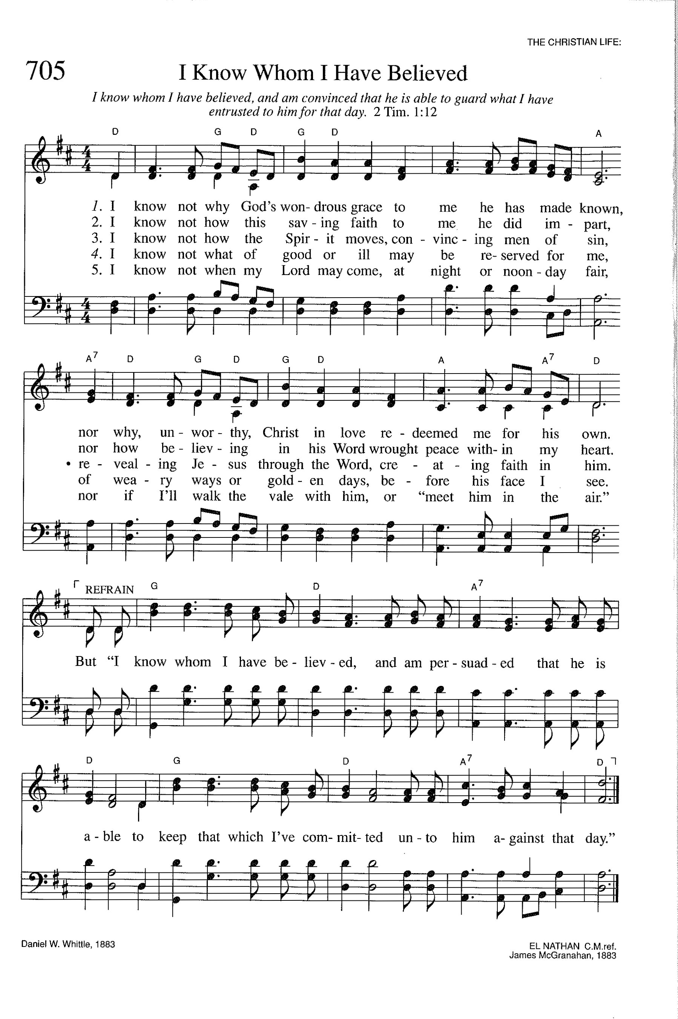

Benediction*
* --Please stand if able
CCLI # 174248
Prayer Requests
- This week’s WEPCA Missionaries: The Garrett Family
- Pray for country’s leaders
- Pray for our covenant children
- Pray for our Elders and Deacons.
Announcements
- We will be having a prayer meeting over Zoom on Wednesday evenings starting at 8:30 p.m. All are encouraged to attend. If you need more information, please see Pastor Miller.
- The next men’s Bible study will be on Saturday, December 4, at 8 a.m. We will be working through the book of Philippians using Sinclair Ferguson’s “Let’s Study Philippians” book. Please read chapter 7 and 8.
- Sunday School starts at 10 a.m. We offer 3 elementary aged classes and an adult class. The adults are studying the Westminster Shorter Catechism.
- The next women’s book study will be on Monday, November 15, at 7:30 p.m. The book study is titled “In All Things” by Mellissa Kruger. It is a study on the book of Philippians. For more information, please see Mary Moser.
- Please mark your calendars for a Fall clean up event at the church. It will be held on Saturday, November 13, starting at 9 am. All are welcome and encouraged to help!
- We will be having our annual congregational meeting after church today.
- We will be welcoming Dr. Jay Neikirk to our pulpit next week.

Who Should take Communion?
The question of who is eligible to receive communion is one of vital importance. In order to draw our minds towards examining ourselves in accordance with the Apostle Paul’s exhortation to the church in Corinth, the Session of West Erie Presbyterian Church in America encourages all in attendance today to consider the following questions:

- Do you believe that Jesus Christ, the Son of God, died for your sins and rose again bodily from the dead?
- Do you trust in the Lord Jesus Christ alone for your salvation?
- Have you been baptized?
- Are you a communicate member in good standing of a Bible-believing, gospel proclaiming church?
- Are you pursuing a life of obedience by forsaking sin and striving, by grace and help of the Holy Spirit, to glorify God with your entire life?

If you can answer “Yes” to each of these questions, then the Session of West Erie Presbyterian Church in America welcomes and invites you to partake of the Lord’s Supper with us today.
If however, you cannot answer “Yes” to each of these questions – or if you are not sure – then we request that you refrain from partaking at this time. We encourage you to take this time to consider your own personal need for Christ, His abundant provision for the salvation of sinners, as well of the biblical requirement to join a local body of believers in humble submission to Christ’s provision of elders and overseers. After the service, please come speak with a member of the Session to discuss the steps necessary to enable you to openly enjoy Communion with Christ and his people through the sacrament of the Lord’s Supper.

WELCOME!
If you are visiting our church today we welcome you to our worship service and Christian community. There are a few things that we would like you to know about West Erie Presbyterian Church.

- We are Historically Reformed.
  - This means that we believe in the inspired and inerrant Word of God.
  - This means we believe in the absolute sovereignty of God.
  - This means we hold to a covenantal framework of Scripture.
  - This means that we believe that salvation is a free gift of God.
- We are Community Oriented.
  - We seek to share the only hope that this world has: that is the Gospel of Jesus Christ.
  - We seek to be a church that is salt and light to the community around us and fulfill the Great Commission.
- We are Confessional.
  - As a Christian church, ancient statements such as the Apostles’ Creed and the Nicene Creed help us to confess certain basic and essential truths of the Christian faith.
  - As a Presbyterian church, our confessional or doctrinal standards consist of the Westminster Confession of Faith and the Westminster Larger and Shorter Catechisms (copies of these documents are available from the church).
  - All of these statements are under the authority of Scripture.

We thank you for visiting today! If you have any questions regarding our style of worship please feel free to ask the pastor or one of our elders. We would be happy to talk with you. Also, we would ask you to stay after and enjoy the fellowship of our Christian community. West Erie Presbyterian Church is a congregation of the Presbyterian Church in America (www.pcanet.org).

Phone: (814) 504-6513
Address: 621 West 2nd Street Erie PA, 16507
E-mail: westeriepca@gmail.com
Website: www.wepca.org
Download our App on all the major carriers

