Communion Checklist
(Revised 1/9/2024, S. McNabb)

Note: This checklist covers our normal communion supplies and procedures. Additionally, at the end, “emergency supplies and procedures” are covered in case we don’t have the little pre-packaged sacraments:

Coordination:

- A week before Communion (Communion is usually the first Sunday of every month) Communion Deacons should physically confirm all the necessary supplies are available.
  - Our normal pre-packaged sacraments:
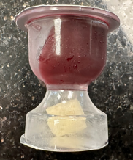

  - Clean altar cloths
  - Cloth napkins
  - Paper towels
  - Small plates for serving the musicians, A/V booth, and Sheepdawgs/Constable.

Emergency supplies in case we don’t have the normal issue.
  - Grape juice - Welche's 100% grape juice.
  - Bread - Matzos (Unsalted Matzos available at Kroger's. Allot 1 box per communion)
  - Disposable Cups - (Order from Amazon. There are 1000 cups per box. That's a 3-1/2 month supply)
  - Plastic wrap to cover the exposed crackers and juice
- Coordinate with the other assigned deacon on a time to prepare. Preparation is not recommended for Sunday morning. Don’t rush yourselves…the church is depending on you.

Preparation:

- Wash your hands and utensils.
- Most of the supplies for communion are located in the upper cupboards next to the refrigerator. And/Or, in the freezer.

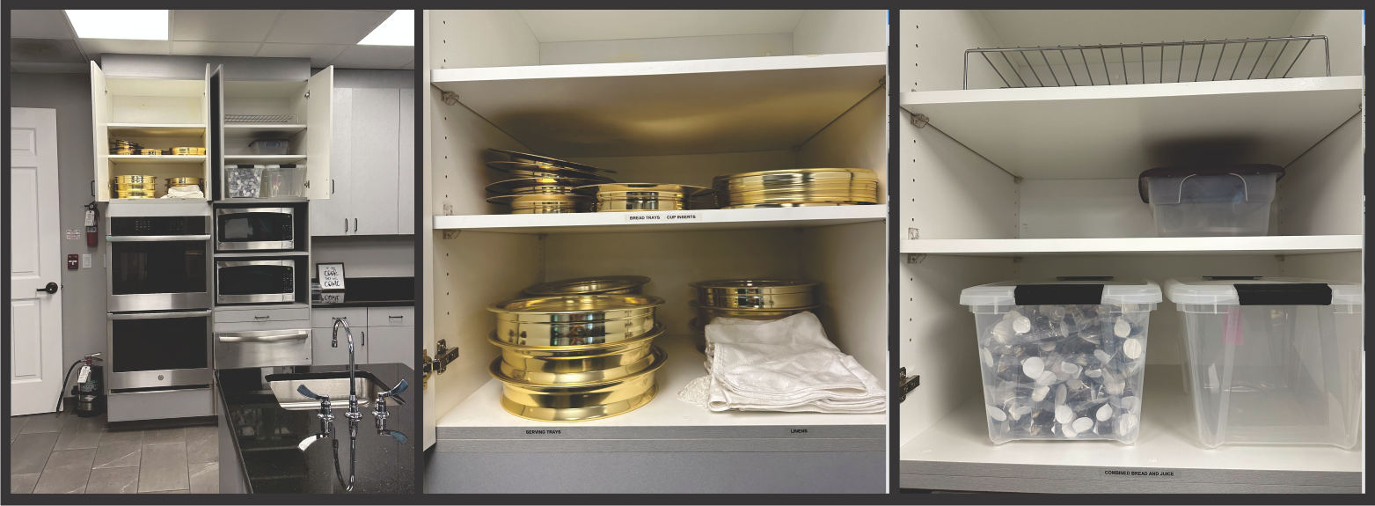

- Fill SIX (6) trays with the pre-packaged sacraments. Each tray holds about 60 servings. That will serve about 360 people. As of today (5/3/2023), for a normal Sunday communion, that should be more than enough. You must adjust accordingly on special occasions and also consider future growth in the church. You might think that is too many, however, it is always better to build too many than to turn up short. Turning up short is unforgivable.

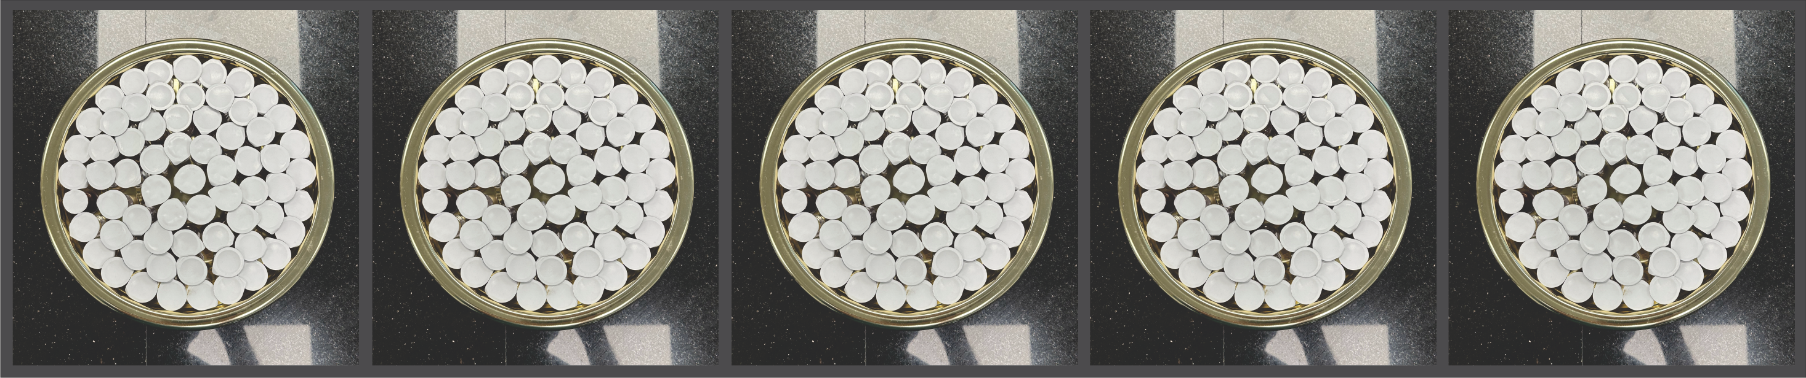

- Put the trays into the refrigerator. Also, inspect the tops of the sacraments to assure none of them are blemished - just don’t look clean and fresh.

Prepare Table in Worship Center

- Turn the table in front of the pulpit around so the words face the congregation.

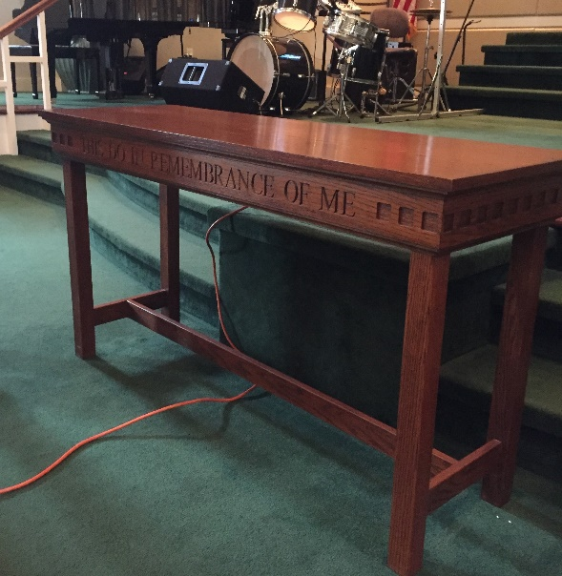

- Place the table runner on the table. Place four cloth napkins on the table.

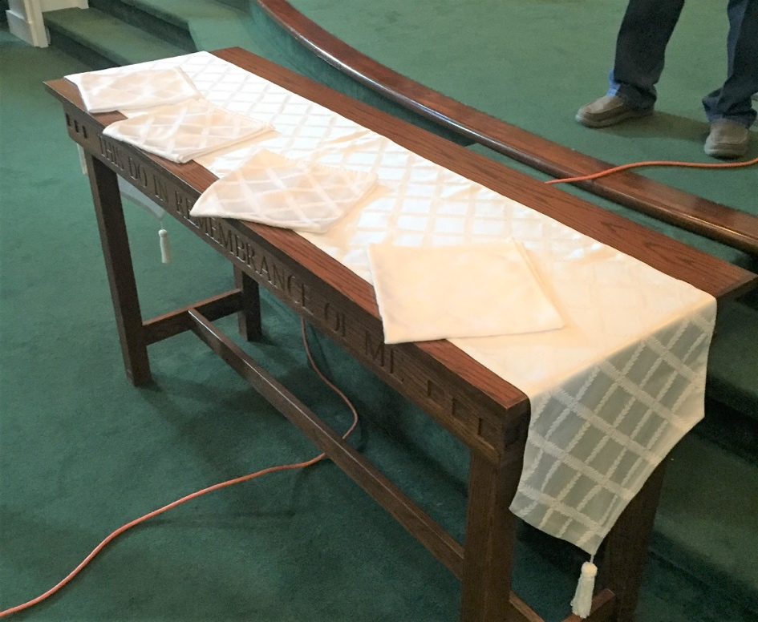

Sunday Morning:
Deacon help: Contact four deacons to serve for each service. Make sure they know the drill. Read this to them if you need to. A deacon in charge of the communion that Sunday should be ready to act as a back up – not part of the deacons serving.

  - Know when communion will take place. Be prepared. Cue up at the back of the center aisle and get into the described formation in b.
  - Deacons come forward when cued by Pastor. Be prepared to come up together from the back of the center aisle in a “box” of deacons with the outside aisles (1 & 4) deacons in front, closest to their respective aisles followed by inside aisle (2 & 3) deacons, thusly: altar
Pastor
1 4
2 3
  - Aisle 1 & 4 deacons will be handed a tray by the Pastor and leave the altar together. Aisle 2 & 3 deacons will step forward to receive the trays and then do an about face. All deacons start passing the treys together.
  - When finished, wait in the back of the sanctuary, then reverse track and come down the aisles together arriving at the Pastor at the same time.
  - Give the trays to the Pastor and wait for him to serve you the sacraments.
  - Return to your seats at the same time.

Before 9am Service
- Place four trays in two stacks in center of table and cover with napkins.
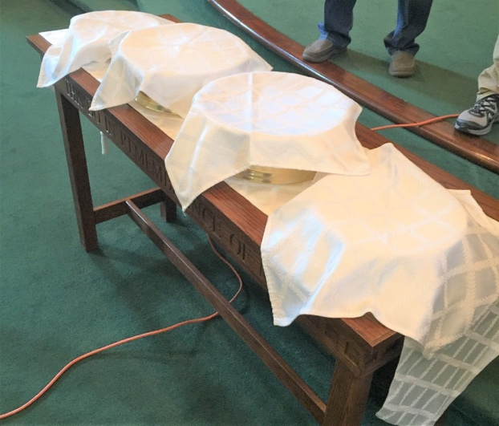
(This picture show two stacks of two and two stacks of one)
- Place an appropriate amount of sacraments on a small plate and locate it where the musicians can access it if appropriate.
- Place sacraments (4) on small plate and put it on counter in audio/visual room.
- Place an appropriate amount of sacraments for those in the foyer.
Between 9:30 am Service and 11:00am Service
- Pick up all used cups in the pews.
- Restock to have four full trays. (Combining the trays still in refrigerator with the four from Worship Center to have four completely filled trays)
- Select and brief the second service deacons.
After 11:00 am Service
- Pick up all used sacraments vessels
- Clean all trays with soap & water, dry them thoroughly, and put them away.
- Fold napkins and table runner and put them back in cupboard in kitchen.
- If runner or napkins were soiled get them to the Church Secretary for laundering.
- Turn table back around.

Thank you for your service and respect for this important event for our church.

Emergency Operations
(no little pre-packaged items)

The Grape Juice

- Prepare six juice trays.
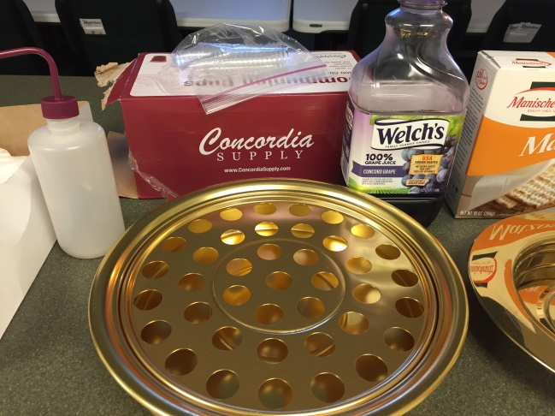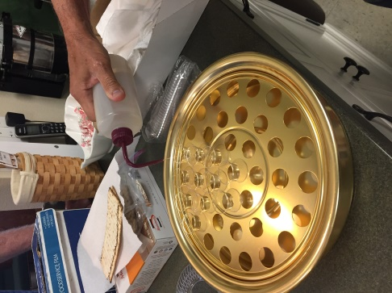

- Use four trays for the 9:00 service and then combine those 4 trays between services to have 2 full trays. Use those two trays and the two additional trays
that are still in the kitchen to achieve 4 full trays for the 10:30 service..
- Locate the grape juice in the cupboard or the grape juice may be in the refrigerator.
- There are several juice dispensers available (bottles with straws).
- Place the cups in the trays and fill each cup about half way with juice. Take care not to overfill because it can get messy when the trays are transported. Clean up any over-splash. Everything must be pristine and proper. Wipe away any drips and splatters.
- Stack the juice trays. Cover with plastic wrap, which is under the counter where the Sunday donuts are placed, and place in the refrigerator.
- Clean the juice squirt bottle with soap and water. Do not put the squirt top on the bottle so it can dry.

The Matzos/Bread/Crackers

- Prepare six bread plates.
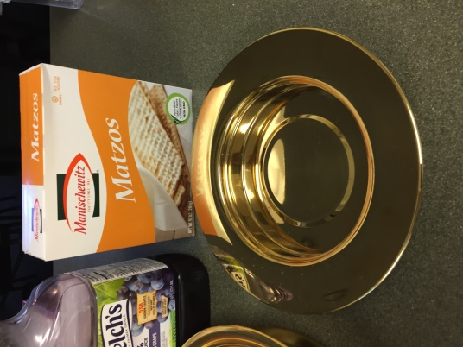

- The Matzos are located in the cupboard
- Break the Matzos into small pieces about ½” x ½”. About 40-50 in each plate. Some like to break off the dark brown edges as they taste like brunt wood.

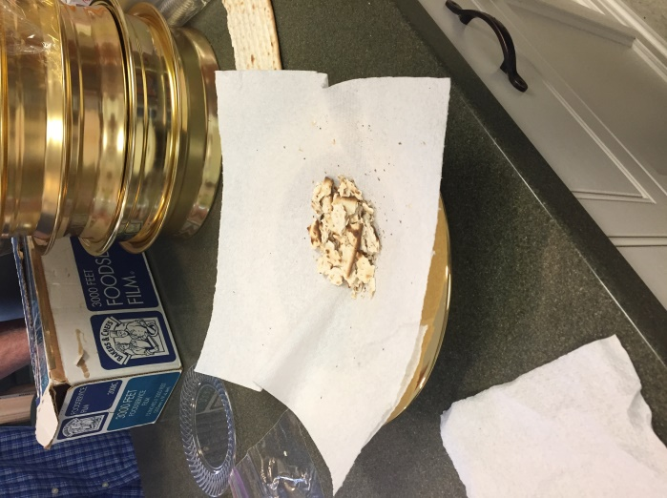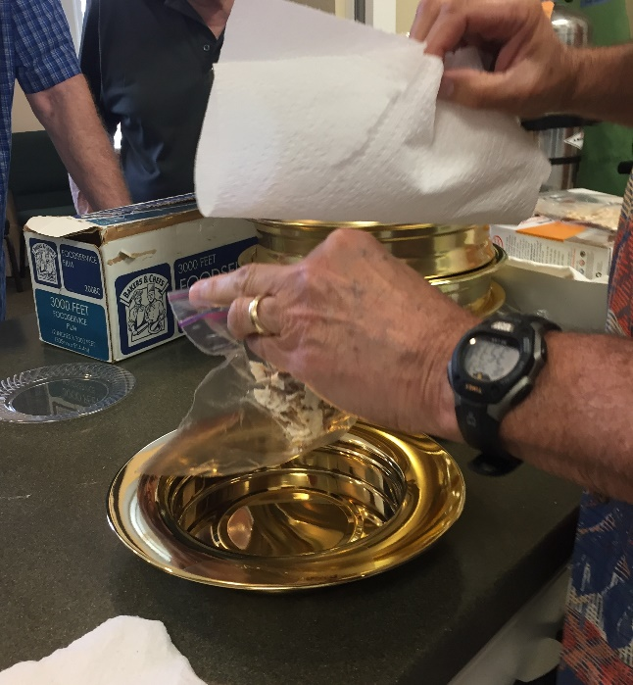

- Place the Matzo pieces into zip-lock bags to keep them fresh until Sunday morning. DO NOT put the Matzos in the refrigerator…they’ll get soggy.

Corrections/Additions/Edits for the
Communion Checklist

1.

2.

3.

4.

5.

6.

7.

8.

This addendum is approved.

Phil Gerbino
Deacon Chairman

