From: Clinton E. "Sandy" McNabb [mailto:mink@cebridge.net]
Sent: Saturday, May 19, 2018 4:10 PM
To: Al Olivares; Carey Stehling; Dick Humalainen; Frank Jacobs; John Altermann; Leon Hudman; Max Martin; Neil Mendes; Randy Goff
Cc: Fred; Gary Alston; 'braztex919@aol.com'; 'Ken Johnson'; 'tericrist@suddenlink.net'; Pastor Cary
Subject: FW: Deacon News

Brother deacons,

Here’s my monthly Deacon News email. Use it at your pleasure.

To forward to your group:
- Click on the forward button
- Delete everything from the top down to the Deacon News banner.
- Replace my name with yours at the bottom
- Delete everybody I sent it to originally
- Put in your group names
- Click the send button.
You’re done!

See you in Church!

Sandy


EXAMPLE

From: Clinton E. "Sandy" McNabb [mailto:mink@cebridge.net]
Sent: Saturday, May 19, 2018 3:49 PM
To: Sandy McNabb
Subject: Deacon News



Greetings Group,

Church Business Meeting: Here’s a great opportunity to see important things happening in our church. There will be a called business meeting at 6:30 pm, Wednesday, May 23rd at the church. Five new deacons, as well as the trustees will be presented for your approval. And, the church is very excited to show you the plans for the new building. The expected cost will come in at $1.6 million. The building fund presently has about $900,000 in cash. There is $600,000 left in the current building’s mortgage with a balloon payment in 2024. There will be discussion about combining loans for more favorable financing overall. The main purpose will be to seek your approval on the construction and loan. This is BIG for us! Be a part of it.

__________________________________________________________

New Building Floor Plan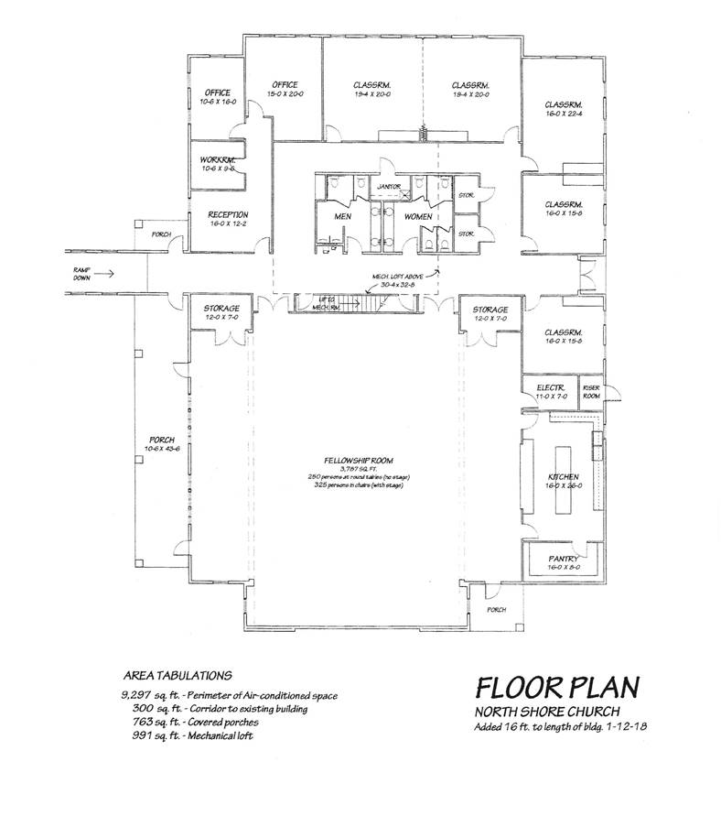

Five New Deacons In Greek, deacon means servant. Deacons help the Pastor and work for you and the church. Five new deacons will be presented to the church at this Wednesday’s business meeting. Come welcome them and give them your recognition. We’re about to “work ‘em hard!”.
- Johnnie “Fred” Borden
- Tim Christ
- Al Greene
- Ken Johnson
- Gary Altson

From the Deacons’ meeting:

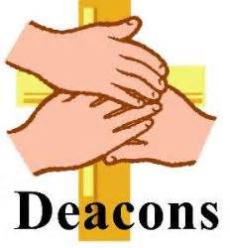
- The new building and it’s financing was discussed. Looks like it’s coming faster than expected and we can certainly use it. See you Wednesday night at the church.
- There is a need to realign deacon group members since we now have five groups that are not assigned to a deacon. So, if you have a desire to move to another deacon for any reason please contact Max Martin, (936) 597-9076 or mmmartinjr@hotmail.com
- Carey Stehling is the Connections Deacon. If you want to get connected to the church in anyway, I can probably send you in the right direction. Just call. You’ll be hearing more about “getting connected” soon.
- In this Deacon News I’d like to tell you about something we are pretty excited about. We’ve just created a new position, New Member Deacon. Neil Mendes will be serving in that capacity. His mission is to do his best to get the new members connected to the activities of our church…to the extent they would like to participate. Neil will not have a traditional deacon group. Instead, each new member will be in his group until they are connected in the church and there is logical criteria to be assigned to a regular deacon group.

____________________________________________________________


Men’s Breakfast

Gentlemen, mark your calendar for 8:00 am, Saturday, June 23rd. The speaker will be Russ Massey.

Larry Schmidt, Head Chef
____________________________________________________________

The “Spring Fling” was a big success and enjoyed by all. Good food, food fellowship, great singing, AND, extremely funny, side-splitting jokes (everybody nod their head now).
Many thanks to Emily, Donna, the deacons, and all those you made it happen. I’m looking forward to next year!

___________________________________________________________

Emergency Teams: Wanna help out in the church? No skills required; just a desire to that care of our congregation when required. We’ll train you!
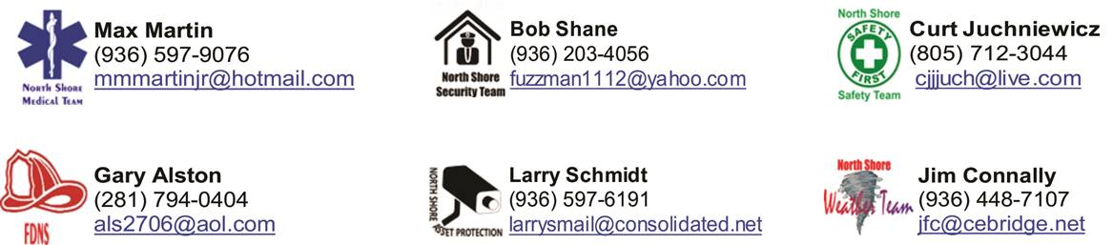

____________________________________________________________


Greeters and Welcome Desk
The church needs good folks to be greeters and serve welcome desk. No experience required. AND, the church is doubling the pay! This is can be any Sunday of your choosing. If you’d like to help out, please contact Mike Roy, mroy07@aol.com or 936) 597-7717. I think you’ll find it a blessing.

____________________________________________________________


Is this email any good for you?
Please let me know how I can improve it for you. What do you want to know about?

____________________________________________________________

Finally, and most importantly,

How can the church better serve you?
Can I be of any assistance?
Is there anything that you would like to share with Pastor Cary about what is happening in your life….Anniversaries, births, good fortune, not so good, illness, operations, spiritual needs, family issues, anything? Prayers are powerful and always received. You can contact Pastor Cary at 410 Camden Hills West, Montgomery TX 77356, or (936) 597-7000, or cary.smith@northshorechurch.com. You can use the prayer request form in the back of the pews, or I’ll be happy to relay a message.

I’m here to serve you in the church,

Sandy McNabb
(936) 449-6820

