Opening Checklist
Revised 11/20/2023 (S. McNabb)

(Reference Locations – Attachment 1 at the end of this checklist)

- Use you key to enter the church.
- Disarm the security system at either door. When you open the door there will be a continuous beep until you disarm the system.
  - Enter your code. LEDs will say “DISARMED” and there will be three beeps
  - If you have problems call Ivan (936) 203-5458‬ or Sandy McNabb (281) 615-7978‬.‬‬‬‬

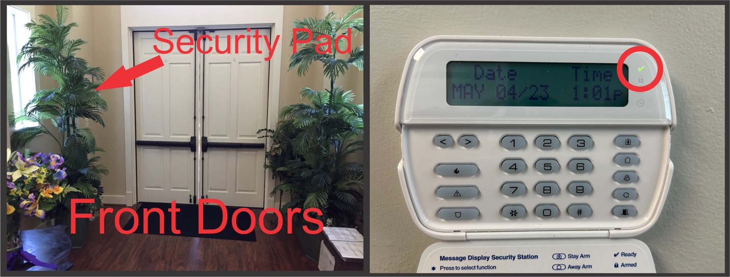

- Unlock the North doors (from the porte-cochere)

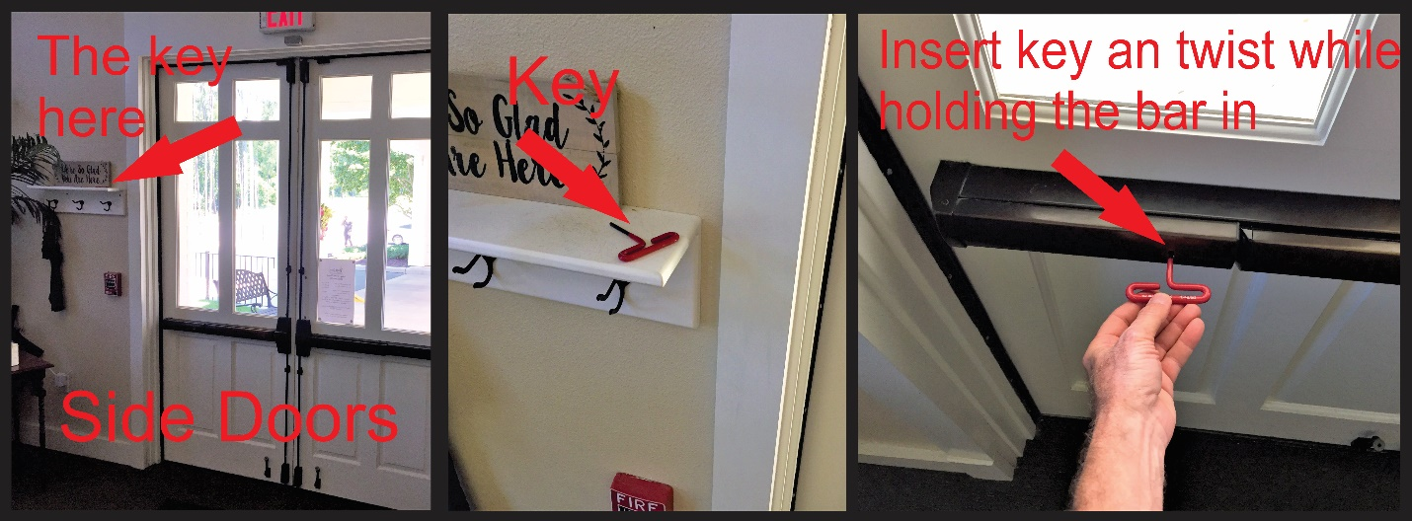

- Open the inside doors (3) from the foyer to the sanctuary

- Turn all lights
  - Foyer – All ON

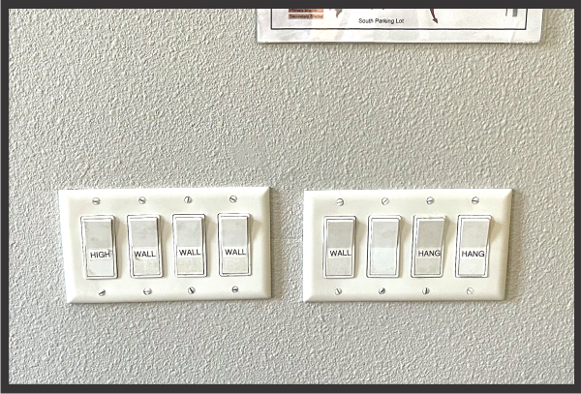

  - Sanctuary - to turn ON the Sanctuary lights from inside the closet, press the middle "manual" button and position slider #1 at approx 80%, slider #4 at 100%, and sliders #2 & #3 at 0%. NOTE: A simpler way to set Sanctuary lights is to press the button on the keypad to the right of the Pastors office door. (It's second button down on left side)

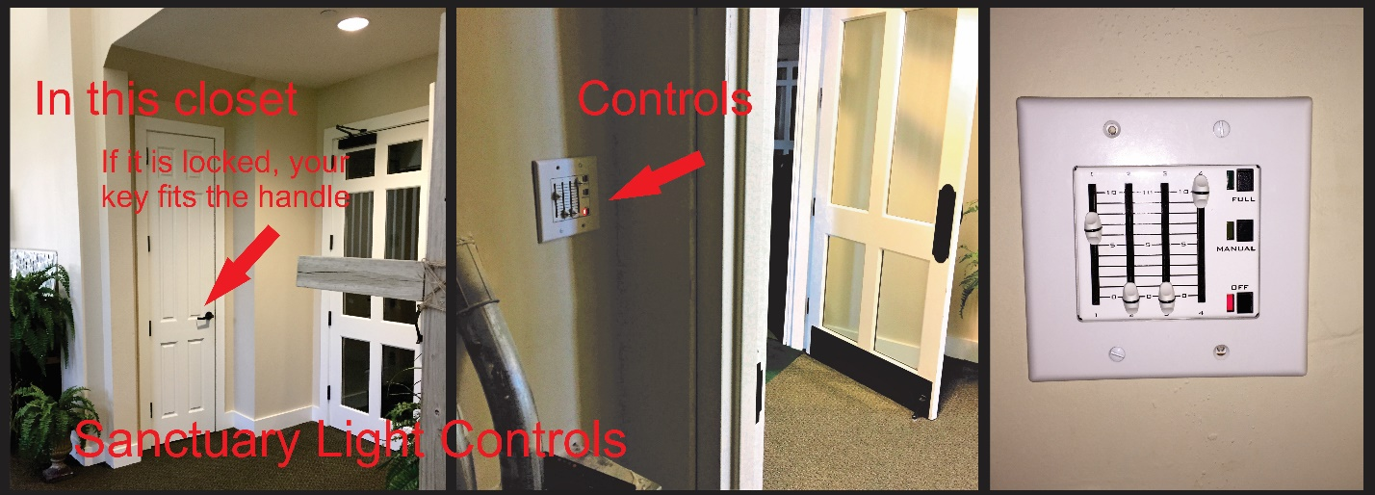

  - Hallway to the Restrooms

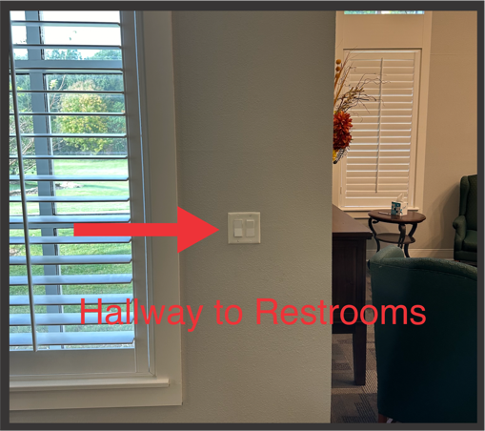

  - Turn on Lights in the Emergency Teams Office, Sunday School Room, and the Restrooms.

  - Lobby in front of the Coffee Bar

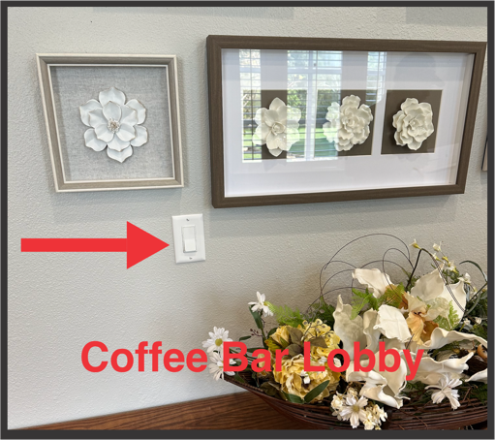

  - Coffee Bar

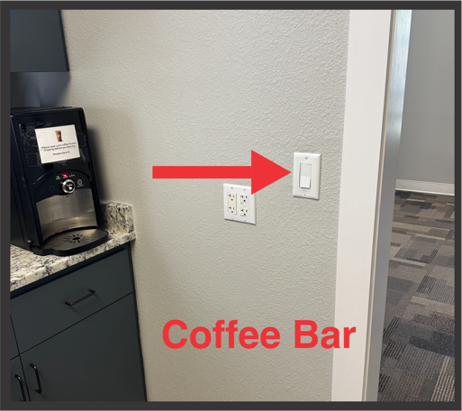
  - Fellowship Hall

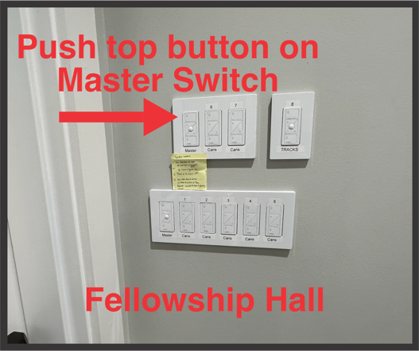

  - Lower the divider door and close the doors to the Kitchen (the ice maker makes noise)

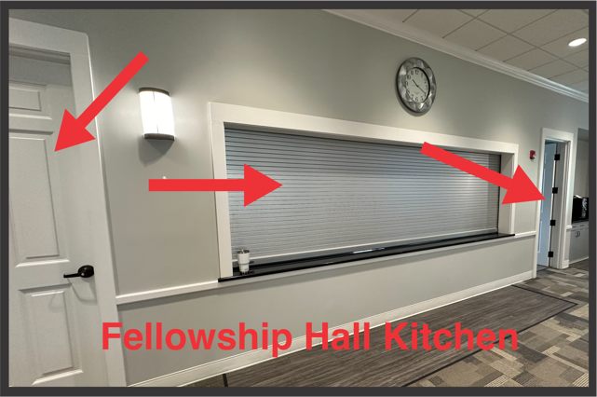

  - If this is a night time operation, turn on the South Parking Lot lights

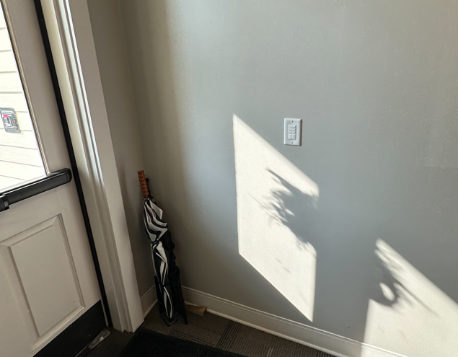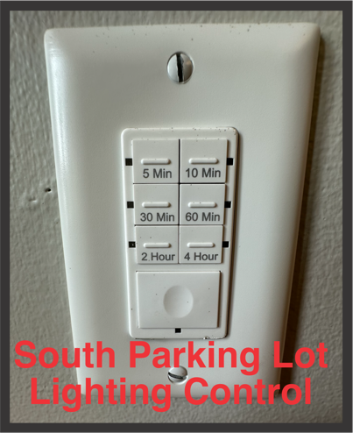

- Setting Thermostats: If adjustment is needed contact David Ray, Johnnie Borden, JJ Cox, Matt Etter, Cindy Armor, or Cyndie Sells.

- Welcome Wagon (golf cart): Get keys in the desk drawer in the Emergency Teams Room. Remove the Welcome Wagon to the Porte Cochere.

- If the Porte Cochere needs sweeping go to the maintenance office and get the leaf blower and blow down to the first parking slots. Return blower.

Thank you for taking care of our church.

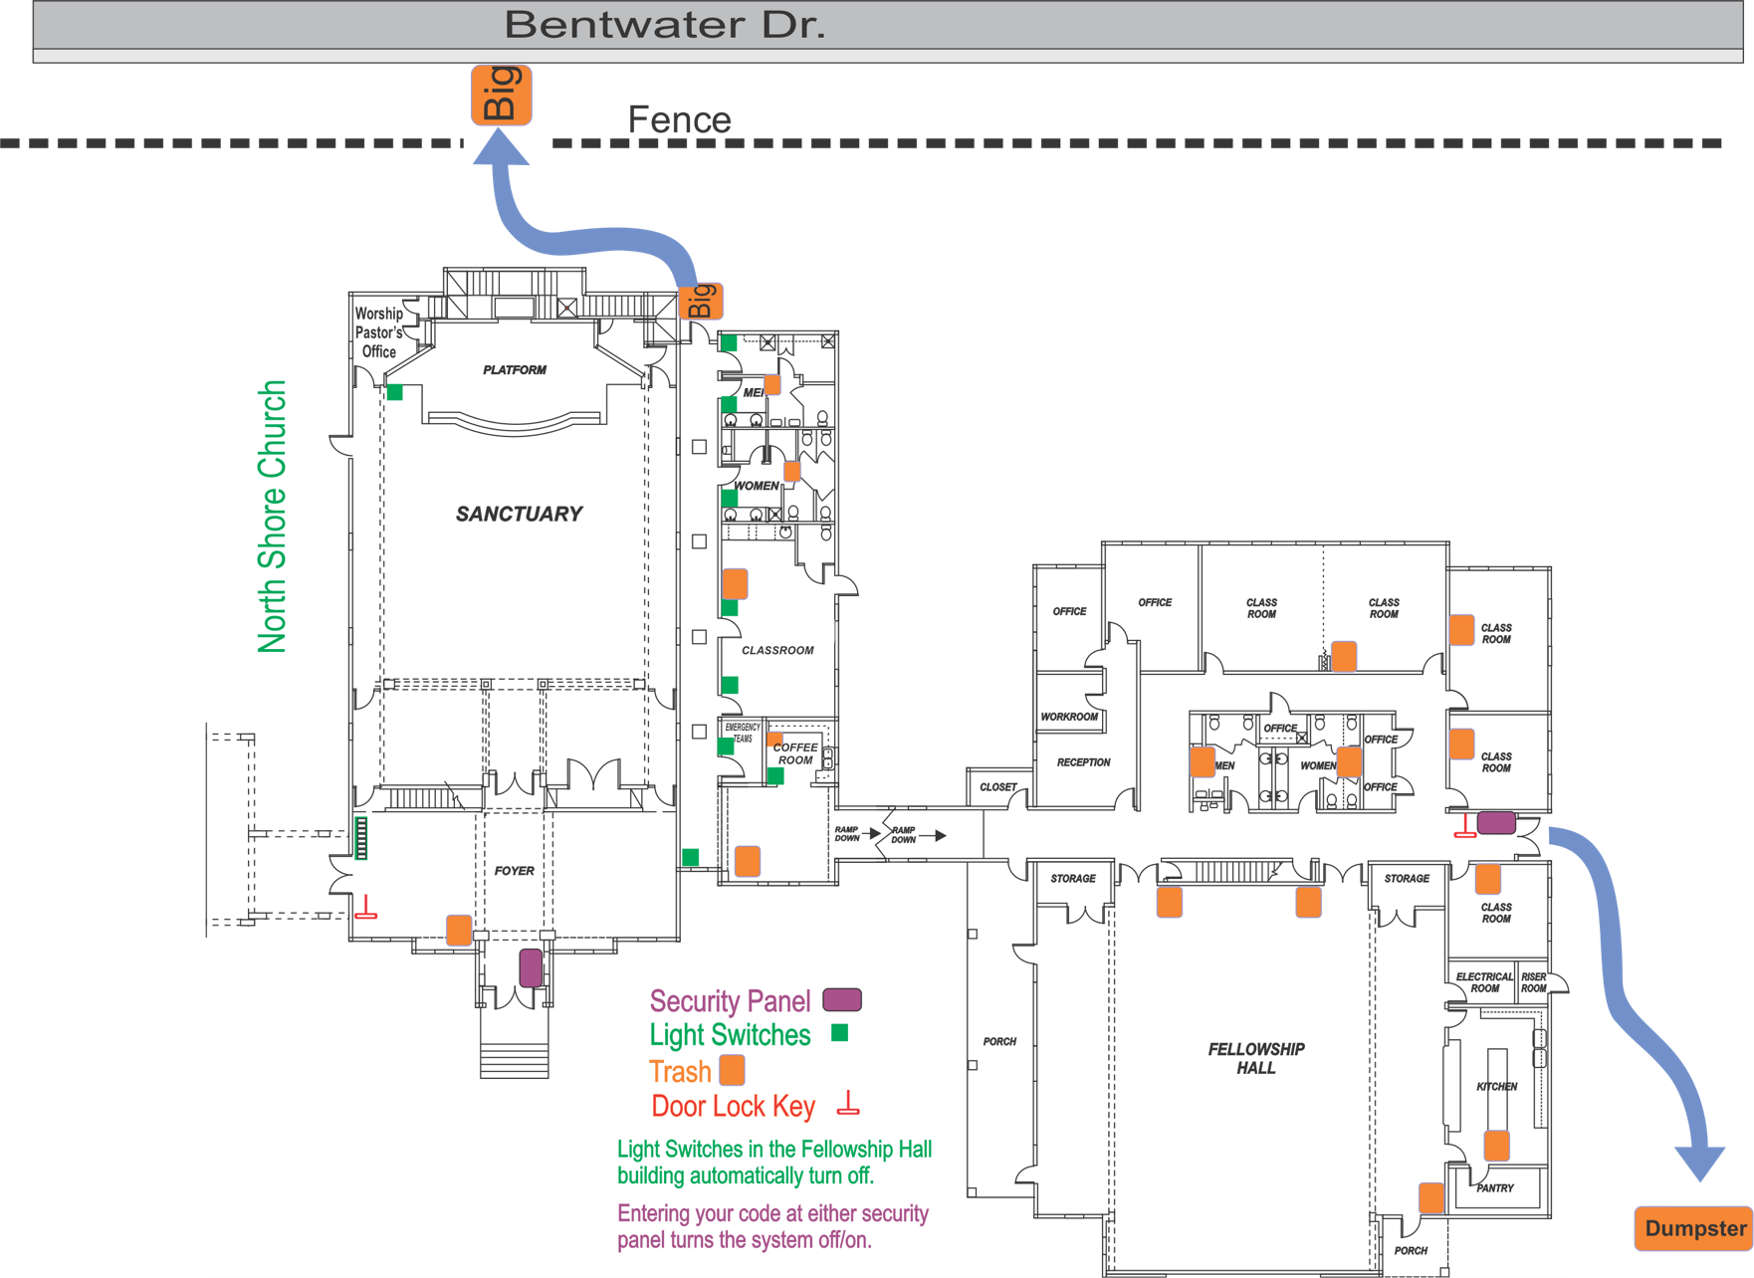
Corrections/Additions/Edits for the
Opening Checklist

1.

2.

3.

4.

5.

6.

7.

8.

This addendum is approved.

Phil Gerbino
Deacon Chairman

