Closing Checklist
Revised 11/20/2023 (S. McNabb)

(Reference Locations – Attachment 1 at the end of this checklist)

- Empty the trash

  - There are trash cans in most all rooms in the church. See Locations – Attachment
  - New trash bags are in the janitor’s closet

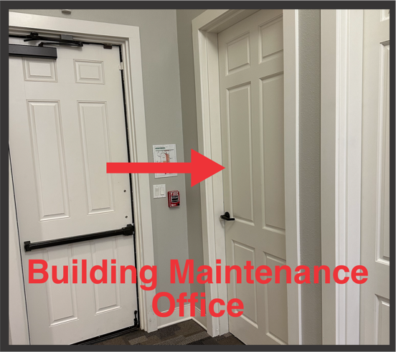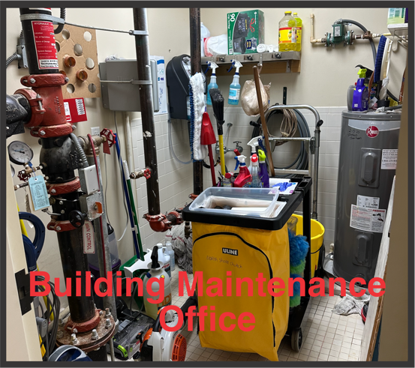

- Take the trash to the dumpster at the South parking lot or the outside trash can at the end of the sanctuary hallway.

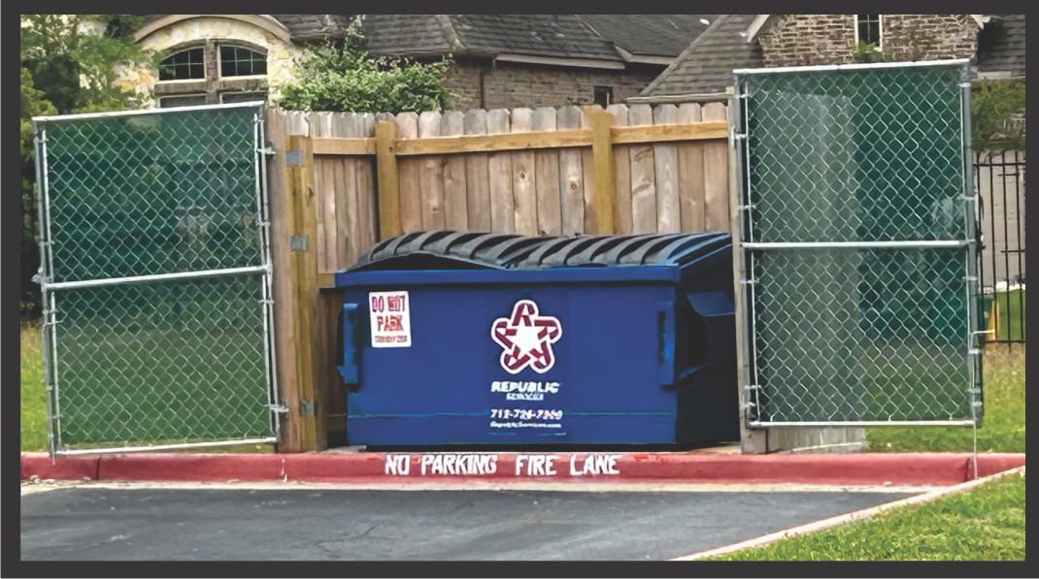

OR

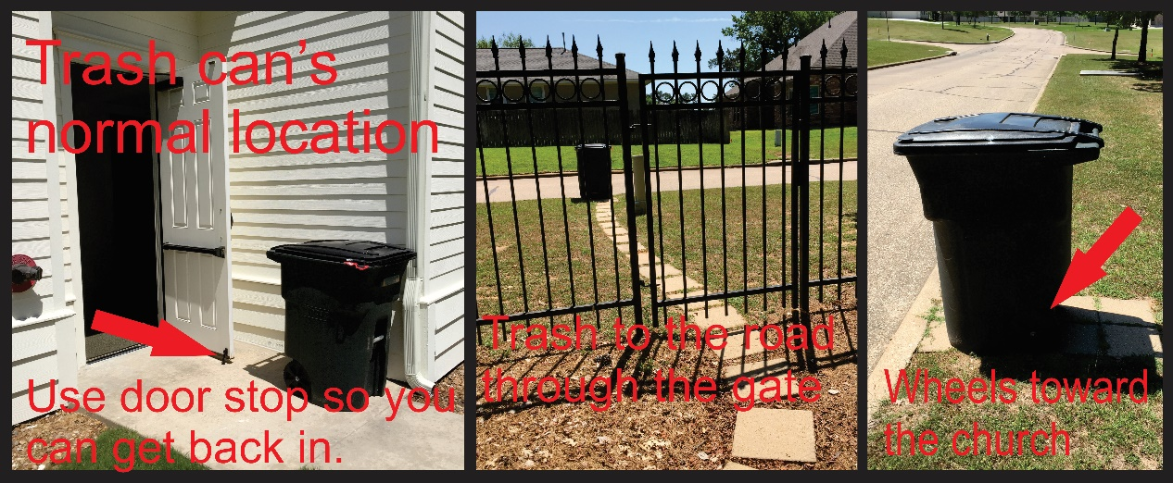

- Close the inside doors (3) from the foyer to the sanctuary

- Confirm all the exterior doors are closed and locked

- Lock entry doors on the South side and North side
  - The red handled allen wrench to lock the door is on the shelf next to the North door
  - Insert the key in a small hole on the handle and turn. The handle will pop out.

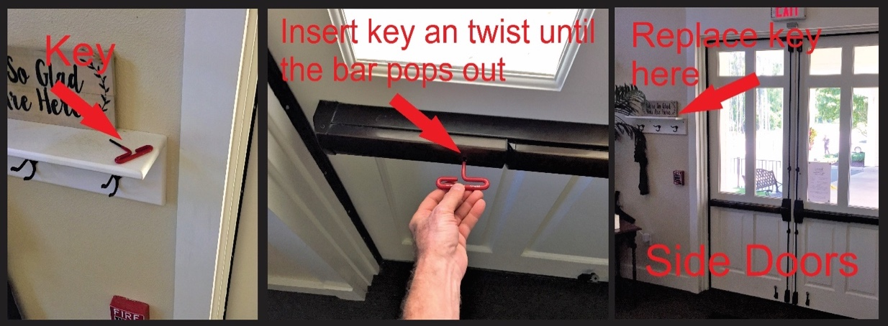

  - The South entry door key is next to the controller.

- Turn off ALL lights (please do not turn off lights while people are still in areas). The lights in the new building turn off automatically except those in the Hall. Push the lower button on the Master Switch.

  - Foyer
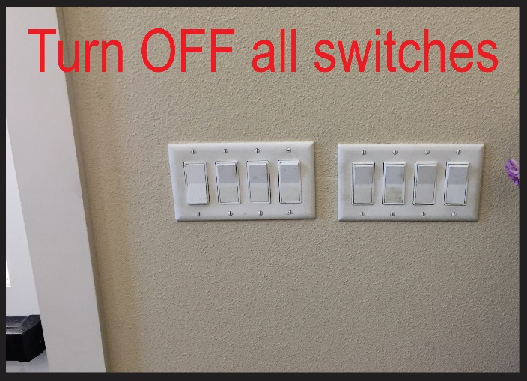

  - Sanctuary

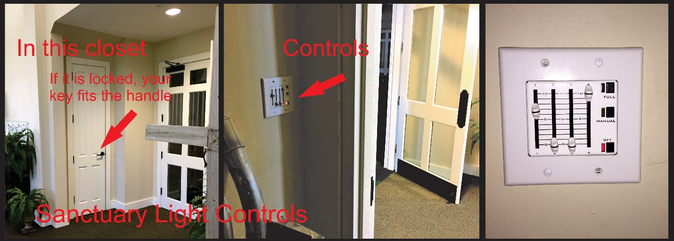

  - Hall area
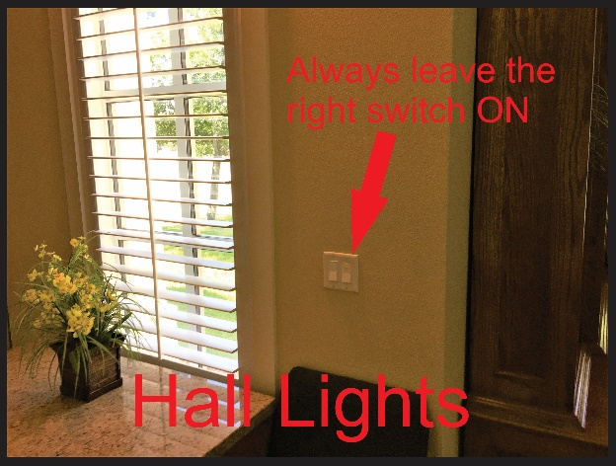

  - Don’t forget the Restrooms, Emergency Teams Room, Coffee Bar, Coffee Bar Lobby, and Hallway.

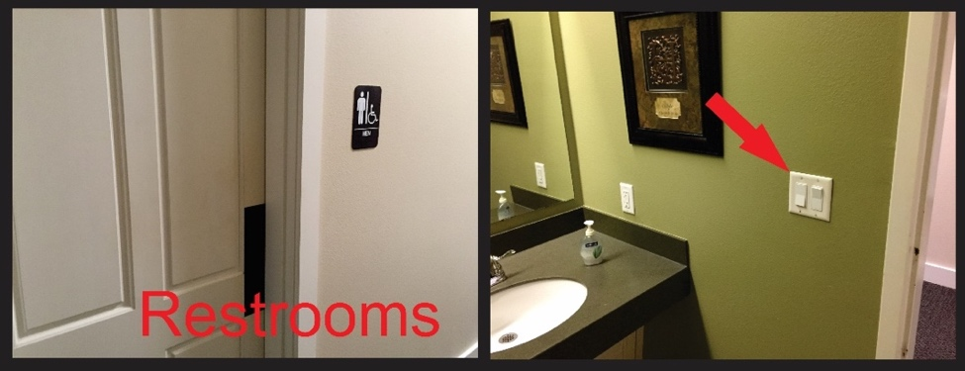
- Welcome Wagon (Golf Cart) Pull the Welcome Wagon into the Foyer. Place the keys in the top drawer of the Emergency Teams Desk.

- In general, look around and tiddy up the church before leaving.

- Arm the security sytstem – Make sure you are the last person in the building. The system can be armed at the panel at the North door or South door.
  - Important: First check for a little green, lighted checkmark at the top, right corner of the controller. If it is not ON, then the system has an open circuit (door ajar) and it is not ready to be armed. You must discover the issue and resolve it before proceeding.
  - Enter your code. There will be a series of beeps indicating that the system will be armed.
  - Exit the building – You’ve got 120 seconds
  - If you have problems call Ivan (936) 203-5458‬ or Mike Penny (281) 744-2967‬.‬‬

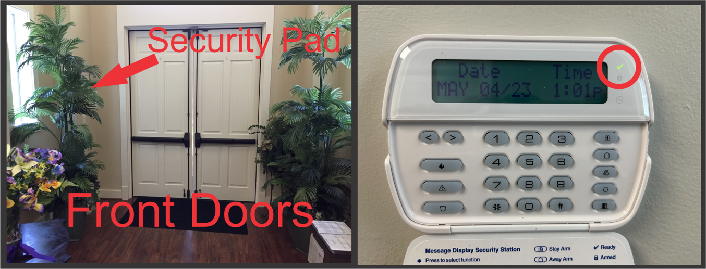
‬‬

Thank you for taking care of our church.

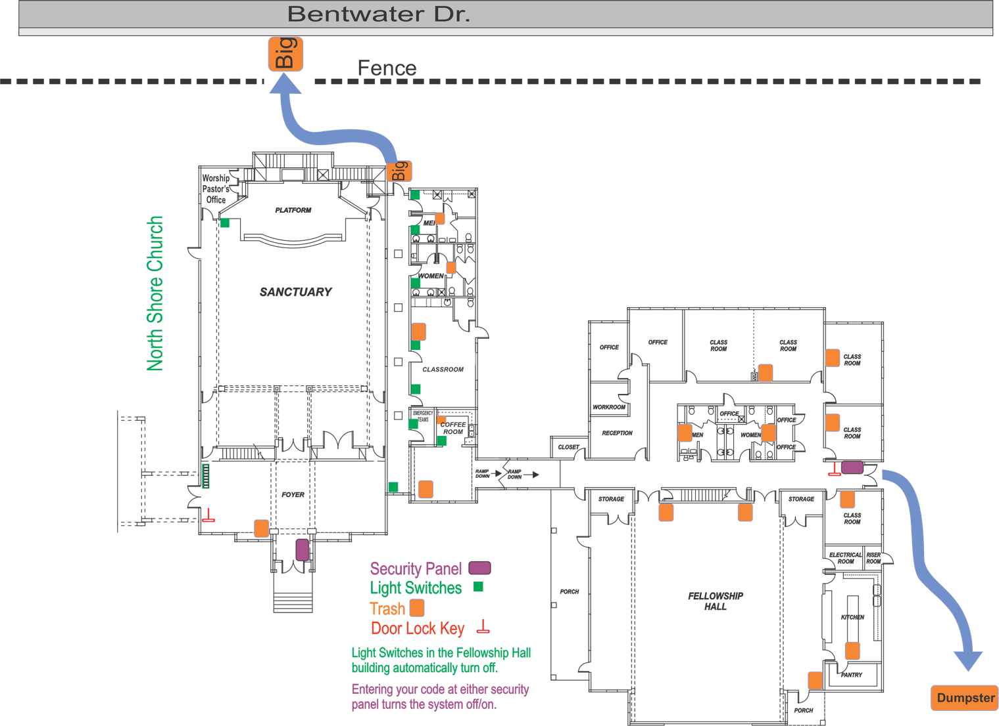

Corrections/Additions/Edits for the
Closing Checklist

1.

2.

3.

4.

5.

6.

7.

8.

This addendum is approved.

Phil Gerbino
Deacon Chairman

