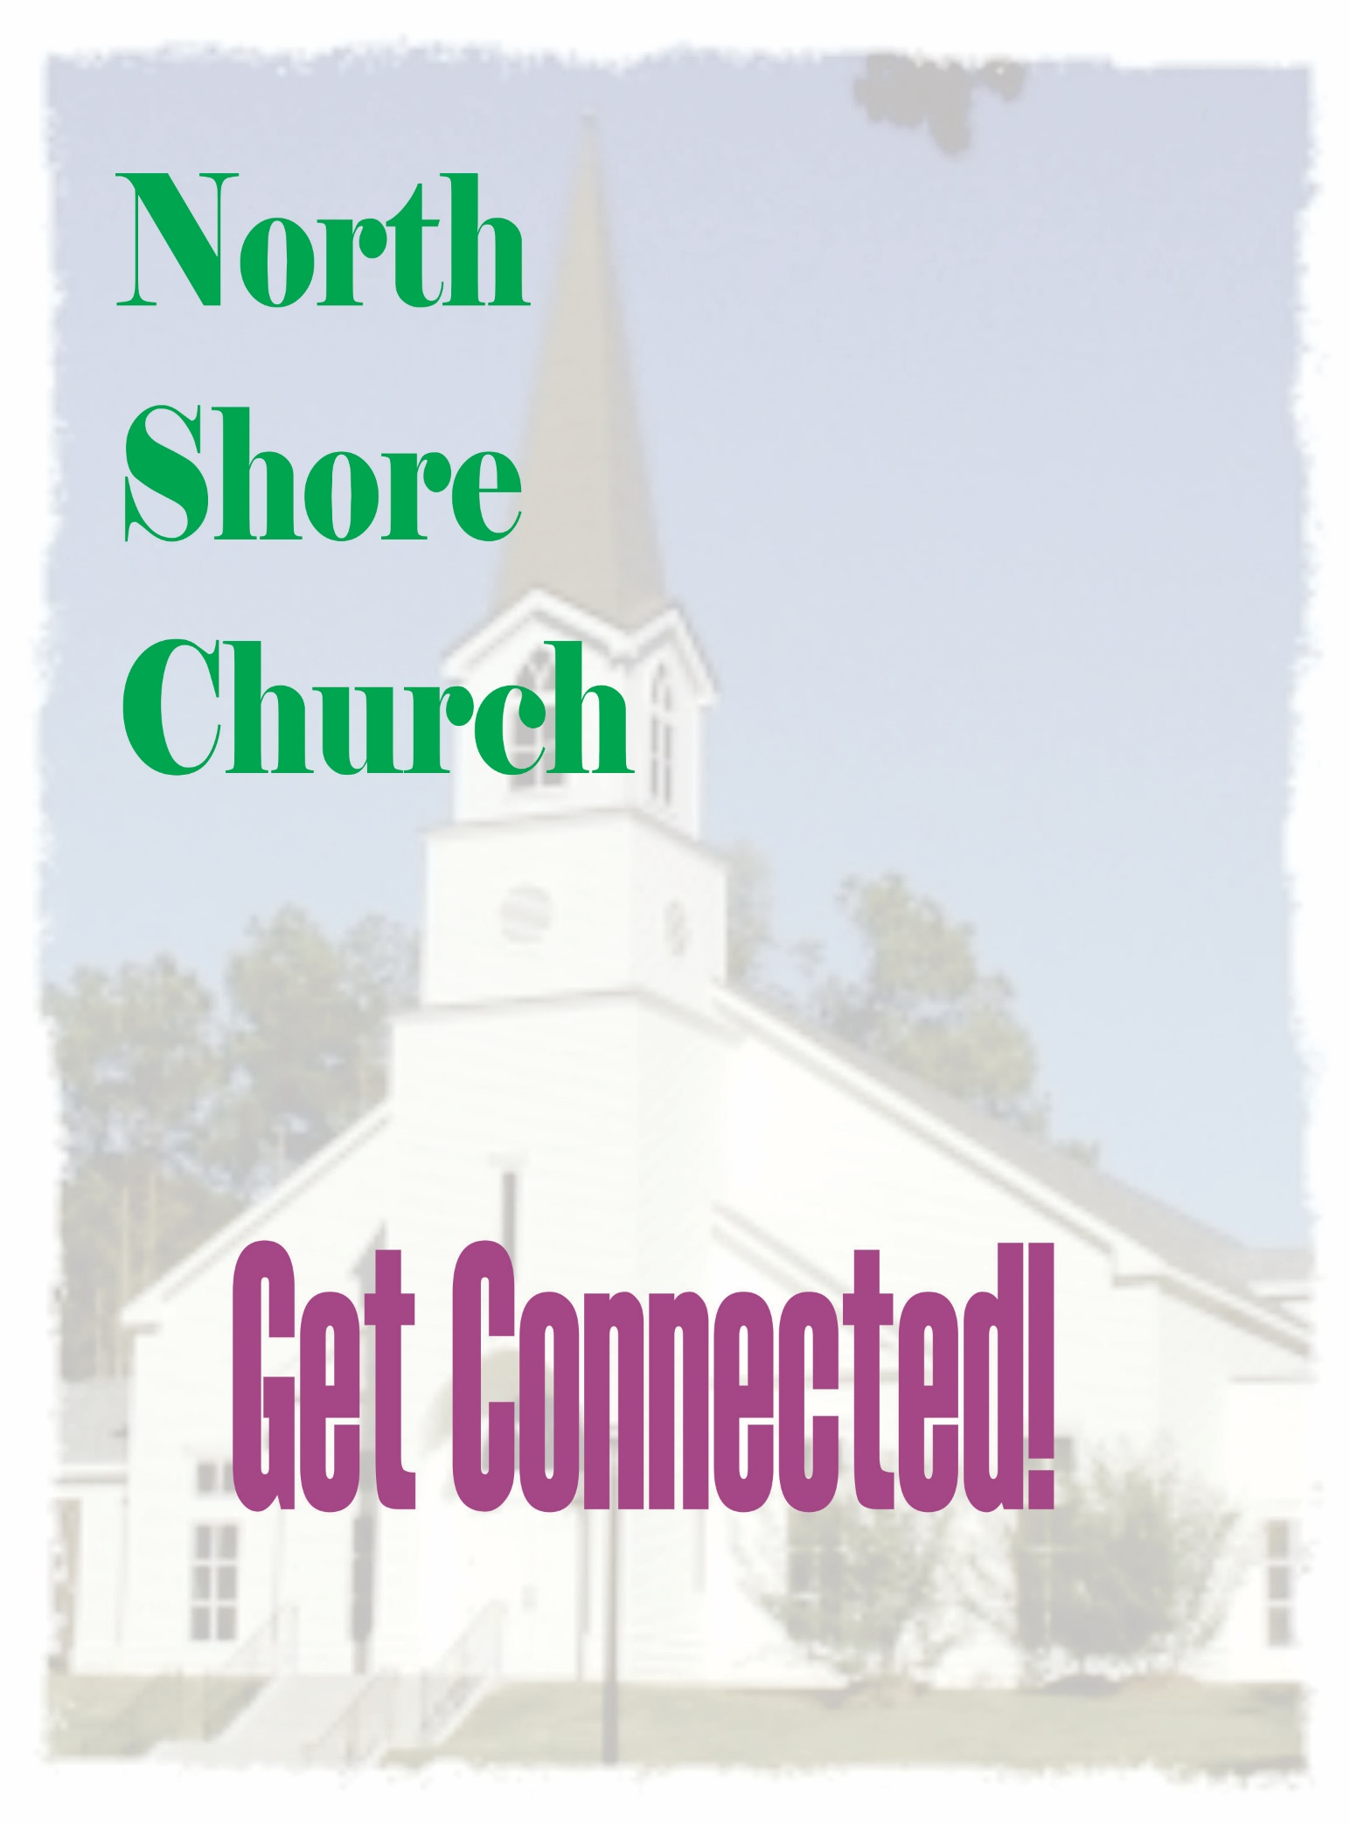
North Shore Church Connections

- Worship
  - Choir – Matt Etter – (832) 729-6497 matt.etter@northshorechurch.org
  - Ushers, Greeters & Welcome desk – Johnnie Borden
  - Offering –Johnnie Borden
  - Audio Visual – Danny White (936) 203-0137
  - Children’s Director– Tarah Glaze (832)588-3826 tarah.glaze@northshorechurch.org
  - Decorating – Emily Altermann (281) 684-7405 emilyaltermann@hotmail.com

- Sunday School
  - Co-ed – Sunday 9:30AM Karen Solcher (832)279-3422 karen.perkins.solcher@gmail.com
  - Co-ed – Sunday 11:00AM Multiple Teachers
  - Ladies – Sunday 11:00AM Joyce Lacy joycelacy@rocketmail.com
  - Kids – Sunday 9:30AM Tarah Glaze (832) 588-3826 tarah.glaze@gmail.com
  - Children’s Church- Sunday 11:00AM Tarah Glaze

- Prayer Groups

  - Ladies Monday morning 10 AM- Glenda Hudman (936) 449-1113 thehudmans@suddenlink.net

- Small Groups – J.J. Cox (936) 597-7000 jjcox@northshorechurch.org
  - Meets throughout the week at members’ homes

- Bible Study (Weekly)

  - Women’s
    - Wednesday 1:00PM- Stacey Buick (936) 718-8176 staceybuick@yahoo.com
Youth
- Wednesday’s 6:00PM- Matt Etter832-729-6497 matt.etter@northshorechurch.org
Men’s
- Thursday’s 7:30AM- David Novelli (713) 806-1389

- Men’s Ministries
  - Men’s Breakfast- Charles Green (832) 465-6752 green111742@yahoo.com

- Women’s Ministries
  - Sewing Spirits-Geneva Montgomery (281) 989-5942 gummy2@suddenlink.net
  - Women’s Prayer Ministry- Glenda Hudman (936) 449-1113

- Outreach
  - Gideon’s – Larry Lockner (713) 705-4804
  - Care Connection- Matt Etter (832) 729-6497 matt.etter@northshorechurch.org

- Missions
  - TLC Food Pantry – Doris Coleman (281) 450-9574
  - Piercing Word – Gaye Watkins (936) 718-7997 gaye.watkins@live.com
  - Village Schools International – Gary & Barbara Kott (936) 537-5749 kottgl@gmail.com
  - Pregnancy Assistance Center – Lynn Musi (832) 746-8950 lynnmusi57@gmail.com
  - Casa de Luz (Dominican Republic) –Karen Solcher (832) 279-3444 karen.perkins.solcher@gmail.com
  - Under/Over Fellowship – Scott & Martha Inglis (973) 960-7050 cscott_inglis@yahoo.com
  - Tyndale Theological Seminary – David & Becca King (936) 537-0624 jdk_rs@hotmail.com
  - Journey Home- Lisa Daniels (713) 299-7136
  - Christian Evangelical Ministries (C.E.M.): Joyce Lacy (817) 223-4646 joycelacy@rocketmail.com
  - Sewing Spirits- Geneva Montgomery (281) 989-5942 gummy2@suddenlink.net
  - Equipping Network- Kit & Lynn Marye (225) 772-4422 kitmarye@gmail.com
  - Mighty Oaks Foundation- Matt Register (713)-302-3240 matt@rrea.com

- Church Support Committees &Teams
  - Finance – Patt McCuistion (936) 525-0327 mccuistion7@yahoo.com
  - Photography – Connie McNabb (832) 888-1007 drcc.mcnabb@gmail.com
  - Church Emergency Teams - Sandy McNabb (936) 449-6820 agilemink@gmail.com
    - Medical – Bob Faseler (409) 749-9277 Bobfaseler@gmail.com
    - Security – Sandy McNabb (936) 449-6820 agilemink@gmail.com
    - Safety -Sandy McNabb (936)449-6820 agilemink@gmail.com
    - Weather - Jim Connally (936) 448-7107 jfc@cebridge.net
    - Fire – Frank Jacobs (936) 597-9340 frankjacobs216@gmail.com

  - Building and Grounds Projects –
    - Ivan Powell (936) 203-5458 ipowell0460@gmail.com
  - Deacons – Chairman -Phil Gerbino (215) 284-5880 pgerbino47@yahoo.com
    - New Member Deacon – Terry Gent (936) 597-9234 tgentmass@aol.com

