How To Install The TBC Mobile App

For Android Users
(Samsung, Google Pixel, Sony, Motorola, HTC, etc.)

Instructions:

- Locate the Play Store application Icon in your Android device. If you have trouble locating the icon you can use the search option in your device to locate the application icon.

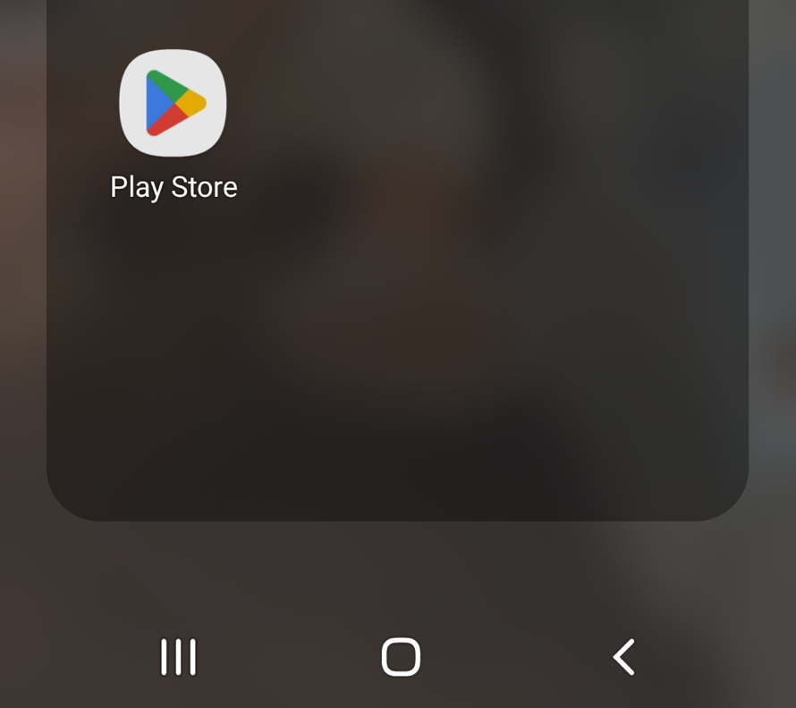

- Once you have located the Play Store application (shown in the image above) select the icon to open the application.

- Once the application opens you will see a screen similar to the image shown below. Select the “APPs” option shown in the image below. This will limit your search to applications only to assist in locating the TBC application.

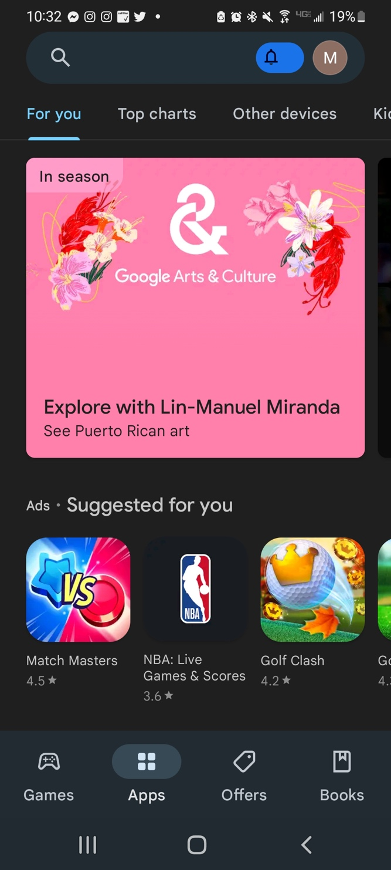n.

- In the search menu type in ‘tabernacle Baptist church’ as shown below press enter or the search option to initiate your search.

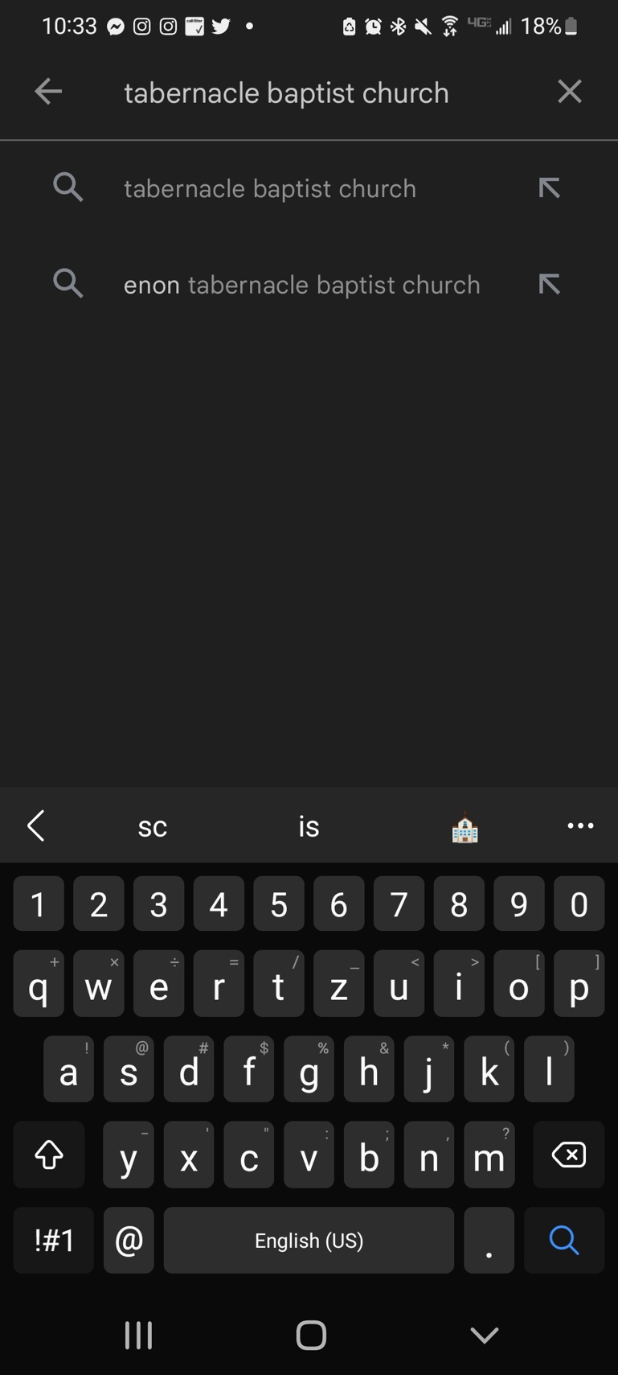

- Next your search results will appear. There will be a list of applications shown in your search results. The TBC application will be named ‘Tabernacle Baptist Church SC’. The image below shows the correct application to select.

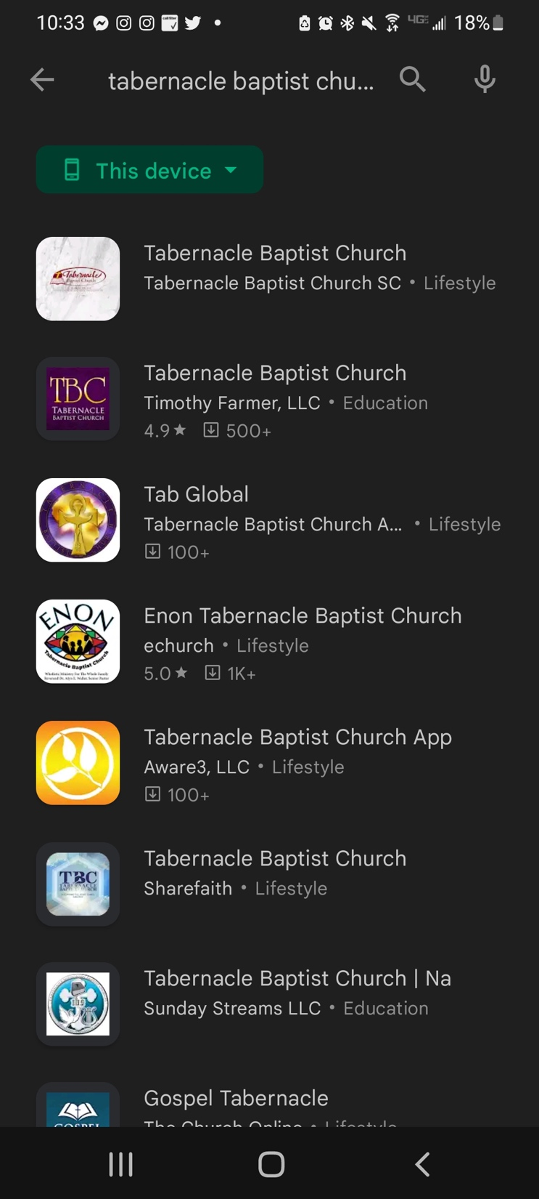

- Select the TBC application icon. 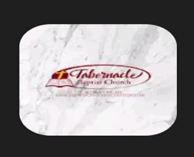
- The screen shown below will appear giving you the option to install/download the application. Select ‘Install’.
***Please note that in some cases may you be required to enter android login credentials (email & password). This may vary based on your security requirements.

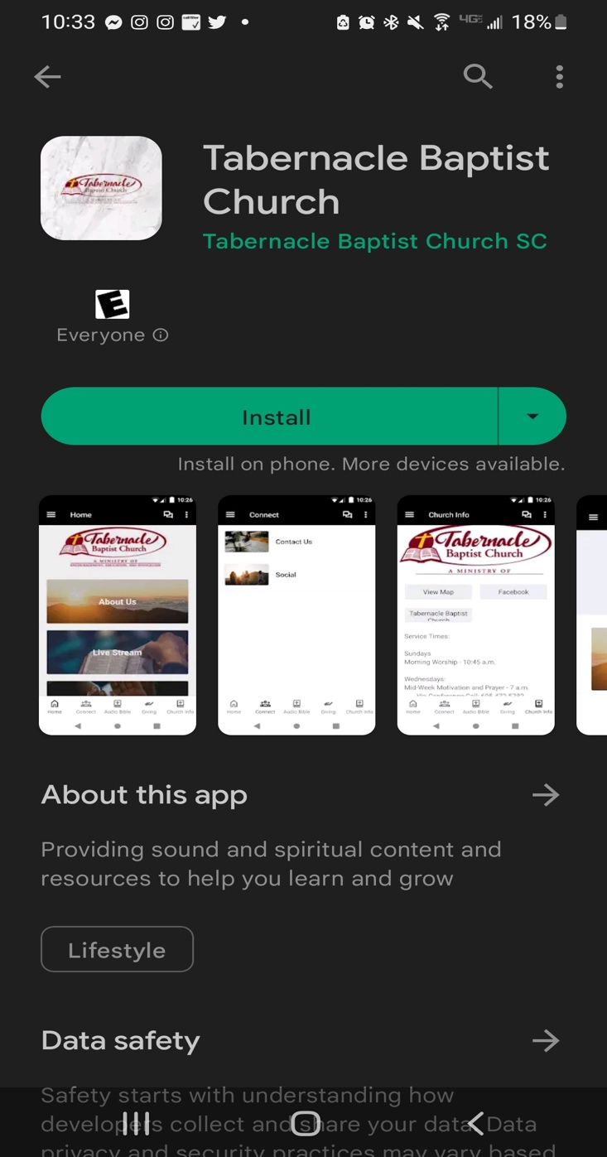

- Once the install to your phone is complete you see the ‘Open’ option as shown in the image below. Selecting the ‘Open’ button will open the application on your device.

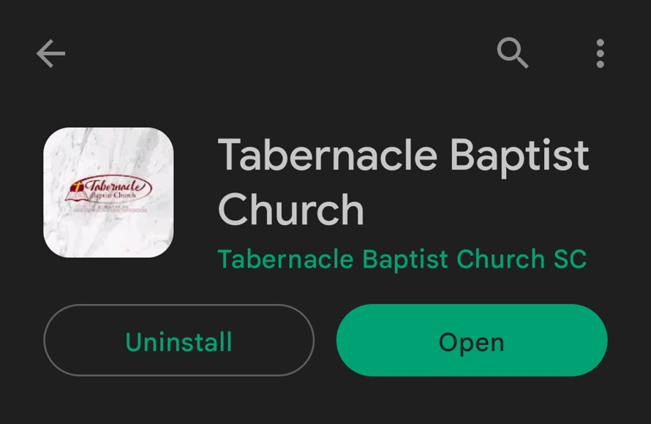

- The TBC application icon will now appear in your list of applications on your android device.

- Once the application opens you will see the ‘Home’ page view shown below.

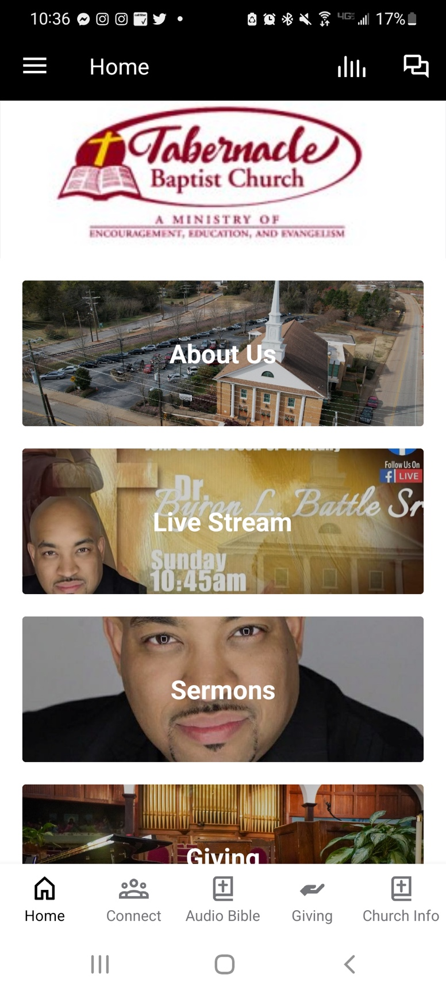

You have now successfully downloaded the TBC application!

If you would like to log in and set up your profile you can follow the steps below. Setting up your profile allows you to connect with TBC, TBC Ministries, receive messages, notifications and so much more!

- In the left upper corner of the “Home” screen, select the thee stacked bars shown in the image below.

- Next select the ‘Log In or Sign Up” option shown in the image below.

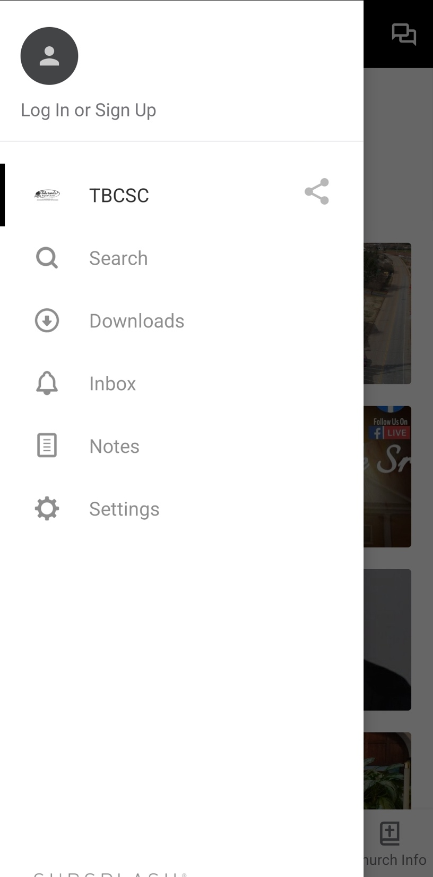

- To sign up or create your profile, you can use your email address or Facebook credentials.
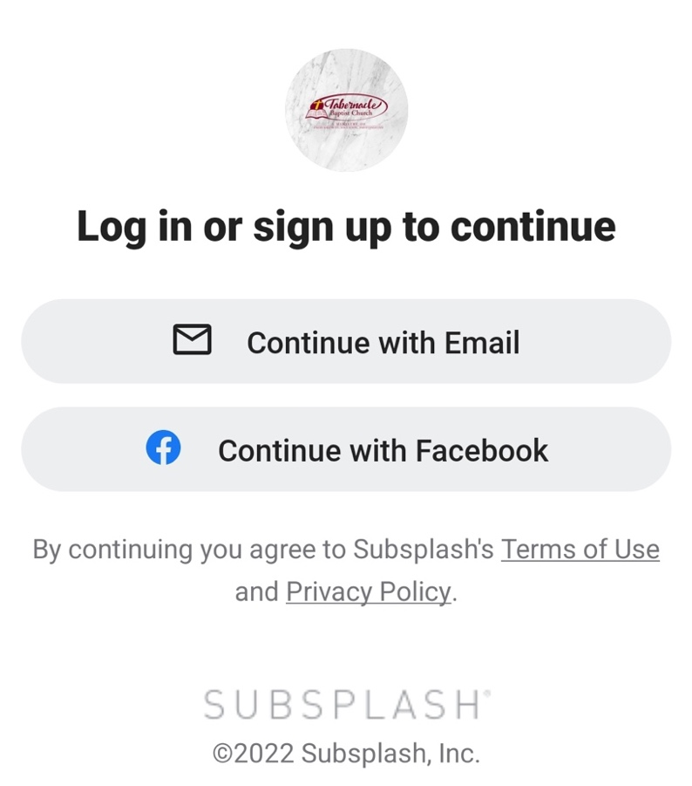

- In the ‘Create an account’ screen enter your name, email address, and create a password. Once you have entered you information select ‘Create account’.

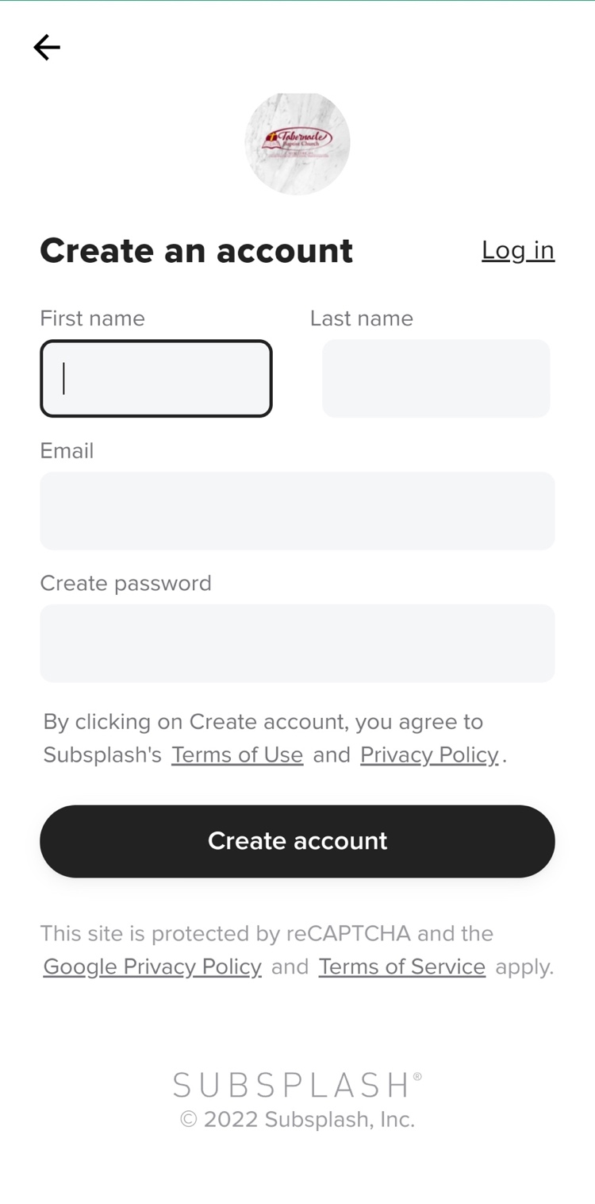

Using the mail address and password you created you should now be able to log in to your account.
