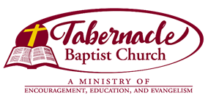
Now Hiring--Drummer
Tabernacle Baptist Church
400 S. Hudson St, Greenville SC 29601
864-235-3201
Part-Time

Position Summary: Play for worship service and outside engagements. Work under the direction of the Minister of Music.

Job Duties and Responsibilities
- Meets regularly with Church Music Ministry to coordinate worship services.
- Works with other musicians as required.

Job Skills and Requirements
- Must be proficient in all types of Church music.
- Strong organizational and planning skills.
- Excellent verbal, written, and interpersonal communication abilities with strong emphasis on listening and problem solving.
- Must be able to play by ear.
- Must submit to background investigation and pre-employment drug screening.
- Willingness to explore different forms of music for use in worship services.
- Flexibility to work with all age groups and other musicians.
- Ability to work cooperatively within the church staff as well as with members of other ministries and committees to meet goals.
- Timely attendance during stated or negotiated hours.

Qualifications
- Minimum 2 years of experience as a Church Musician

