March 30, 2025
Traditional Worship
11:15 AM

First Evangelical Lutheran Church
19419 Royalton Road
Strongsville, Ohio

Mission Statement
Living God’s love through our devotion to
service, worship, and one another.

Good Morning!
If you are a visitor today,



Sunday Schedule for Next Week, 04/06/2025
Contemporary Worship at 9:00 AM
Sunday School at 10:15 AM
Traditional Worship at 11:15 AM

To contact the Church, call the office at 440-238-7890
or email firstchurchalive@hotmail.com
Secretary Office Hours are Monday, Thursday, Friday 8 AM to 11 AM
Pastor Kathy - 440-666-8758 or revklk@gmail.com

CONTACT INFORMATION
Don’t forget that if you ever have any questions or concerns,
you may contact your Council representatives:
Darren Whitford: 330-524-3670 dgwhitford1114@gmail.com
June Zakrajsek: 440-336-1678 jfzakrajsek@gmail.com
Stacey McNamara: 440-567-9532 staceymac104@gmail.com
Janet Kaiser: 216-215-4572 janetmackaiser@gmail.com
Ken Holda: 440-665-2836 kenjholda@gmail.com
Gary Walters: 216-645-8472 gwaltersoh@yahoo.com
Dawn Zima: 440-821-6545 dzima@cox.net

Evangelical Lutheran Worship
Setting 3

Please turn off all electronic devices during our time of worship.

PRELUDE David Gooding
“Amabile ” Renee Alfor

PRAYER of PREPARATION
Gracious God, help us to know the power of your love and forgiveness. Amen

WELCOME AND ANNOUNCEMENTS

Stand

CONFESSION and FORGIVENESS
All may make the sign of the cross, the sign that is marked at baptism, as the presiding minister begins.

P Blessed be the holy Trinity, ☩ one God,
who forgives all our sin,
whose mercy endures forever.
C Amen.

P Let us return to God, confessing our sin in the assurance of God’s abiding love.

Silence is kept for reflection.

P Compassionate One,
C you are slow to anger and abounding in steadfast love,
but our lives do not always reflect you
and your love for the world.
We do not show others the tender compassion
you have shown to us.
We do not welcome others with the radical hospitality
you grant to all people.
We oppress others,
even though you have set us free again and again.
We squander the abundant gifts of the earth.
Transform our lives
and guide us again in the way of the cross.
Amen.

P Beloved in Christ,
God’s arms are always stretched open wide
to welcome the wandering ones home.
In ☩ Christ your sins are forgiven.
You have a place in God’s house forever.
C Amen.

Gathering Song ELW# 807 “Come, Thou Fount Of Every Blessing”

GREETING
P The grace of our Lord Jesus Christ, the love of God,
and the communion of the Holy Spirit be with you all.
C And also with you.
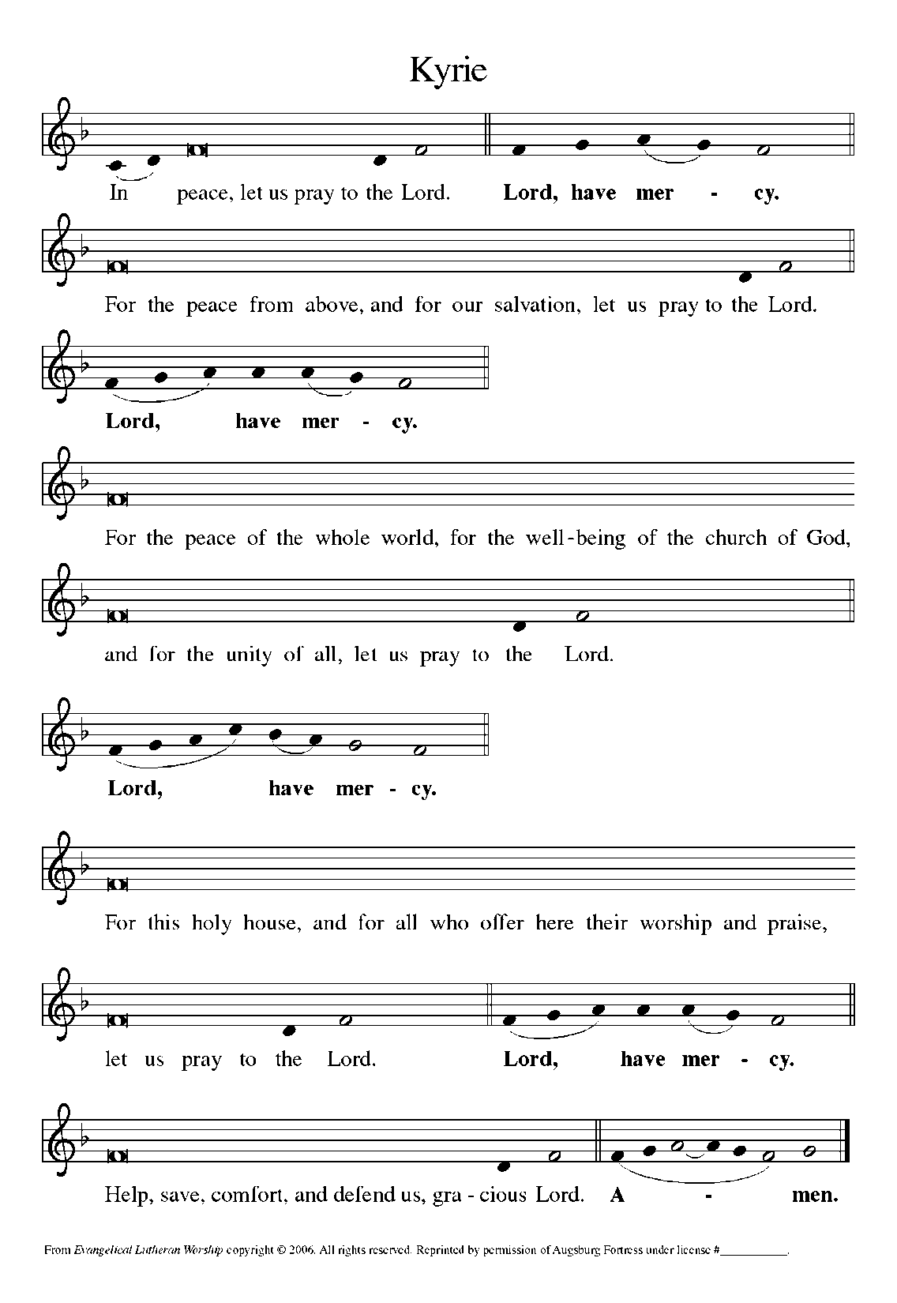
Prayer of the Day
P Let us pray. God of compassion, you welcome the wayward, and you embrace us all with your mercy. By our baptism clothe us with garments of your grace, and feed us at the table of your love, through Jesus Christ, our Savior and Lord, who lives and reigns with you and the Holy Spirit, one God, now and forever.
C Amen

Sit

First Reading: Joshua 5:9-12
By celebrating the Passover and eating the produce of the promised land instead of the miraculous manna that had sustained them in the desert, the Israelites symbolically bring their forty years of wilderness wandering to an end at Gilgal.

The Lord said to Joshua, “Today I have rolled away from you the disgrace of Egypt.” And so that place is called Gilgal to this day.
While the Israelites were camped in Gilgal they kept the passover in the evening on the fourteenth day of the month in the plains of Jericho. On the day after the passover, on that very day, they ate the produce of the land, unleavened cakes and parched grain. The manna ceased on the day they ate the produce of the land, and the Israelites no longer had manna; they ate the crops of the land of Canaan that year.

After the reading: R The Word of the Lord. C Thanks be to God.

Second Reading: 2 Corinthians 5:16-21
One way to describe the gospel is the promise that in Christ everything is transformed into newness. All mistakes, all deliberate sins, all old history is reconciled with Christ’s resurrection. This is Paul’s strong message to the congregation in the city of Corinth.

From now on, therefore, we regard no one from a human point of view; even though we once knew Christ from a human point of view, we know him no longer in that way. So if anyone is in Christ, there is a new creation: everything old has passed away; see, everything has become new! All this is from God, who reconciled us to himself through Christ, and has given us the ministry of reconciliation; that is, in Christ God was reconciling the world to himself, not counting their trespasses against them, and entrusting the message of reconciliation to us. So we are ambassadors for Christ, since God is making his appeal through us; we entreat you on behalf of Christ, be reconciled to God. For our sake he made him to be sin who knew no sin, so that in him we might become the righteousness of God.

After the reading: R The Word of the Lord. C Thanks be to God.

Stand

Gospel Acclamation
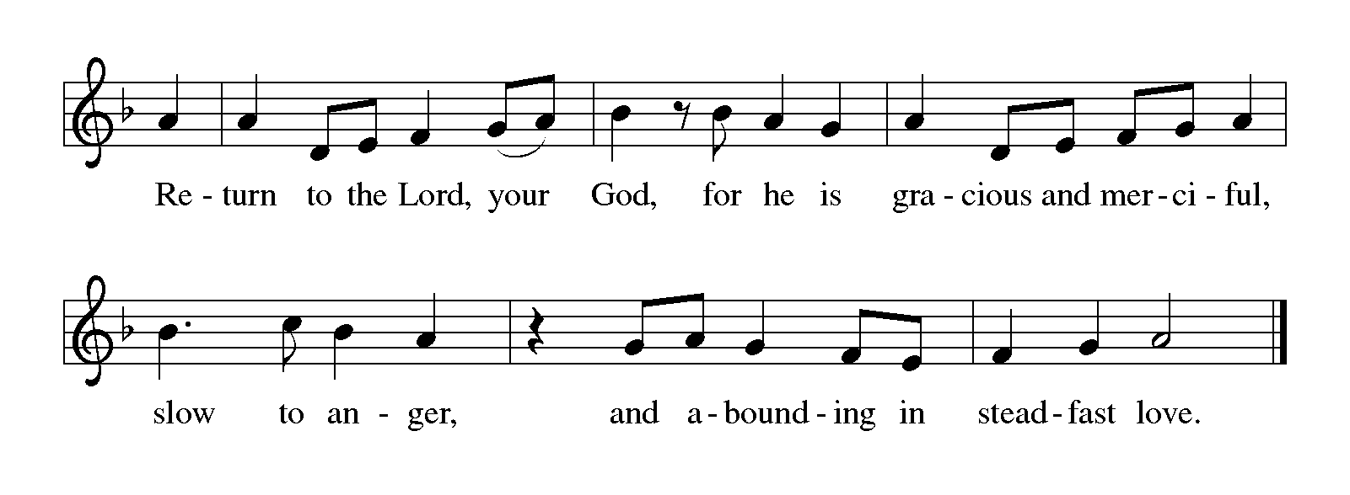

Gospel
P The Holy Gospel according to St. Luke, the 15th Chapter
C Glory to you, O Lord.

GOSPEL: Luke 15:1-3, 11b-32
Now all the tax collectors and sinners were coming near to listen to [Jesus.] And the Pharisees and the scribes were grumbling and saying, “This fellow welcomes sinners and eats with them.”
So he told them this parable: “There was a man who had two sons. The younger of them said to his father, ‘Father, give me the share of the property that will belong to me.’ So he divided his property between them. A few days later the younger son gathered all he had and traveled to a distant country, and there he squandered his property in dissolute living. When he had spent everything, a severe famine took place throughout that country, and he began to be in need. So he went and hired himself out to one of the citizens of that country, who sent him to his fields to feed the pigs. He would gladly have filled himself with the pods that the pigs were eating; and no one gave him anything. But when he came to himself he said, ‘How many of my father’s hired hands have bread enough and to spare, but here I am dying of hunger! I will get up and go to my father, and I will say to him, “Father, I have sinned against heaven and before you; I am no longer worthy to be called your son; treat me like one of your hired hands.” ’ So he set off and went to his father. But while he was still far off, his father saw him and was filled with compassion; he ran and put his arms around him and kissed him. Then the son said to him, ‘Father, I have sinned against heaven and before you; I am no longer worthy to be called your son.’ But the father said to his slaves, ‘Quickly, bring out a robe—the best one—and put it on him; put a ring on his finger and sandals on his feet. And get the fatted calf and kill it, and let us eat and celebrate; for this son of mine was dead and is alive again; he was lost and is found!’ And they began to celebrate.
“Now his elder son was in the field; and when he came and approached the house, he heard music and dancing. He called one of the slaves and asked what was going on. He replied, ‘Your brother has come, and your father has killed the fatted calf, because he has got him back safe and sound.’ Then he became angry and refused to go in. His father came out and began to plead with him. But he answered his father, ‘Listen! For all these years I have been working like a slave for you, and I have never disobeyed your command; yet you have never given me even a young goat so that I might celebrate with my friends. But when this son of yours came back, who has devoured your property with prostitutes, you killed the fatted calf for him!’ Then the father said to him, ‘Son, you are always with me, and all that is mine is yours. But we had to celebrate and rejoice, because this brother of yours was dead and has come to life; he was lost and has been found.’ ”

After the reading:
P The Gospel of the Lord.
C Praise to you, O Christ.

Sit
CHILDREN’s sharing time

Sermon “Grace Beyond Belief”

Stand

Hymn of the Day ELW #588 “There's A Wideness In God's Mercy”

APOSTLES' CREED
I believe in God, the Father almighty,
creator of heaven and earth.

I believe in Jesus Christ, God's only Son, our Lord,
who was conceived by the Holy Spirit,
born of the virgin Mary,
suffered under Pontius Pilate,
was crucified, died, and was buried;
he descended to the dead.
On the third day he rose again;
he ascended into heaven,
he is seated at the right hand of the Father,
and he will come to judge the living and the dead.

I believe in the Holy Spirit,
the holy catholic church,
the communion of saints,
the forgiveness of sins,
the resurrection of the body,
and the life everlasting. Amen

Sit

PRESENTATION of the gifts
An offering is gathered for the mission of the church, including the care of those in need.

MUSIC Bell Choir
I Love You, Lord arr. Patricia Sanders Cota

Stand
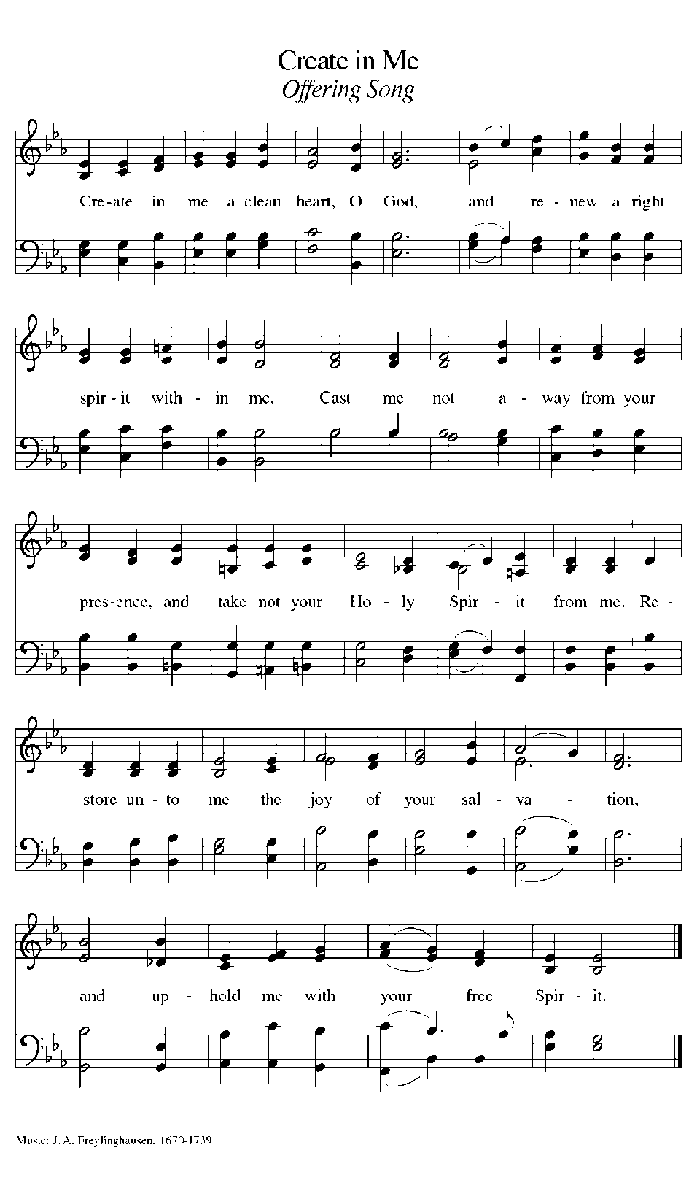

Prayers of Intercession
P Led by the Spirit, let us turn to God in prayer for the church, the world, and all those in need.

After each portion of the prayers:
P God, in your mercy
C receive our prayer.

The prayers conclude:
P Receive the prayers of your people and draw all things together in your love, in the name of Jesus, who leads us from death to life.
C Amen

LORD’S PRAYER
Our Father in heaven,
hallowed be your name,
your kingdom come,
your will be done,
on earth as in heaven.
Give us today our daily bread.
Forgive us our sins
as we forgive those who sin against us.
Save us from the time of trial
and deliver us from evil.
For the kingdom, the power, and the glory are yours,
now and forever. Amen

Blessing
P God our tender parent,
God the crucified one,
God the reconciling Spirit,
☩ bless you now and forever.
C Amen.

Sending Song ELW #631 “Love Divine, All Loves Excelling”

Dismissal
P Go in peace. Care for others as God cares for you.
C Thanks be to God!

POSTLUDE David Gooding
“Con Moto” George Bristow

Reprinted from Sundays and Seasons v.20240102.1159
Copyright © 2024 Augsburg Fortress. All rights reserved.
Used by permission of Augsburg Fortress.
Reprinted by permission of Augsburg Fortress under license #SB176674

PRAYER CONCERNS
Hospitalized/Home and Recuperating
Don McKelvey, Karil Piskur, Clark Buckley, Paula McKee, Marj Gray, Carla Kulka, Pastor Dave Anderson, Dennis Bailey, Dawn Evangelista, The Salay Family, Eleanor Preston
Military Members
Austin Holley, Deacon Nemet, Matthew and Teresa Dittman, Haley Uline
Stephen Ministry Team
Maureen Harris, Sam Reichert, Becky Piper, Beth David, Pat Sauernheimer, Pam Simpson, Marsha Ginley, Phil King, and Bob Strong
On-going Prayers
Natalie David, Linda Stanley, Nighman Family, Heidi Balicki, Tia (Simpson) Russell, The Fox Family, Ron and Joanne Cvelbar, Cheryl Mooney, Elaine, Rob Shoens, Connie, Michael Otto, Jessica Walsh, Sue Widdows, Wanda Woods, Stephania, Susan & George Bodovetz, Carol Rosenblum, Bonnie Bailey, Josh, Cynthia, Sara, Darlene and Jim Cassidy, Carrie Deal, Curt Kowalewski, Sarah Franko, Bill Bartkus, Jim Taylor, Sue Sutton, Chelsea, Erica Kaminski, Jeanette Paus, Matt & Pat, Claudia Lenarz, Kevin, Zach Russell, Andrew Lee, Ryan Kuchta, Morgan Popple, Trish Nolder, Peter Duffy, Roberta Ress, Salay Family, Richard, Karyn Kasnik, Scott Hurley, John Walker
Homebound
Mary Jane Knaack, June Beck, Marj Wilder, Audie Kiplinger, Sheryl Clark, Ron & Mary Jane Warzel

ANNOUNCEMENTS

OFFICE STAFFING NOTE
Pastor Kathy will be out of the office March 31st through April 4th. ﻿Please call the church office 440-238-7890 or the office administrator directly - Vanessa, 216-548-5345, if you have a pastoral emergency during that time.

FIRST CHURCH WOMEN’S BOOK CLUB - APRIL
Our next book is The Mostly True Story of Tanner and Louise by Colleen Oakley. We'll meet at 88 Fox Hollow in Brunswick on April 26th at 10:00. Happy reading!

FIRST CHURCH WOMEN’S BOOK CLUB – MAY
Mark your calendar for May 17 when we will be joined by author Angie Hockman. We will be discussing her book, Dream On at 10:00 at 88 Fox Hollow in Brunswick. Hope you can join us.

STRONGSVILLE EMERGENCY FOOD BANK - DONATIONS
The Strongsville Food Bank is in need of the following items: Ramen Soup, Pork & Beans, Mac & Cheese, Tuna Fish (all sizes) Canned Vegetables, Jelly: Squeeze Bottle, 30 oz, 32 ox, Peanut Butter (all sizes), Boxed Baked Goods, Snacks. Also Hygiene Products - Soap, Deodorant, Shampoo, Conditioner, Toothpaste, Toothbrushes, Razors.

SUMMER VBS IS BACK – VOLUNTEERS NEEDED
Road Trip On The Go With God June 23 - 26, 2025, 9 AM – 11:30 AM
Join Scout as he takes us on a Road Trip full of wonderful adventures.

Be part of making this Road Trip a fun experience for the ‘Travelers’ (kids), while they learn God is always with them. Each session has an easy-to-use guide for planning your program and the tools needed to accomplish a fun-filled adventure. Please sign up to be a session leader or helper by filling out the volunteer form, by using this link https://bit.ly/2025flcvbs or scanning the QR code
If you have any questions, please give me a call: Vicki Hughes 216-559-4156
EASTER BREAKFAST
Join us Easter Sunday – 04/20/2025 from 8 AM to 11 AM for fellowship and Easter Breakfast.

PASSION READERS NEEDED
We need 6 people at each service for the Passion Reading on Palm Sunday, 04/13. Please use the sign up sheet in the Welcome Center to volunteer.


MILITARY PRAYER REQUESTS
If you know someone in the military serving our country, we want to include them in prayer. Please scan the QR code or go to bit.ly/FLCMilitaryPrayers to add them to the list


ONLINE GIVING OPTION
Due to requests for people to have the option to give their offering electronically, we are providing a QR code to allow anyone who would like to give electronically.

STEPHEN MINISTRY UPDATE
Our Stephen Ministers have completed their training! They will be commissioned on April 13 at the 9:00 service and introduced at the 11:15 service. Join us as we recognize this milestone in our journey to establish this important ministry.

If you or someone you know in our congregation would benefit from having a Stephen Minister, please contact Beth David at (440) 212-6859 for more information.

PRODUCE DISTRIBUTION AT NEW COVENANT LUTHERAN CHURCH
New Covenant Lutheran Church, our sister church in East Cleveland, will begin their 2025 monthly produce distribution schedule on Saturday, April 26th. Anyone interested in participating should contact Bruce Holderead at vancepack@yahoo.com or 440-655-1523.

BICYCLE RELOCATION PROGRAM
Do you have a bicycle (adult- or child-size) that could use a second life? Please contact Pierre David and he will pick it up, repair it so that it is “like new” (if necessary), and then take to the Redeemer Crisis Center on W. 30th Street in Cleveland. Pierre can be contacted at pdavid@bw.edu or 216-213-8386

EASTER GARDEN FLOWER SALES

Order forms for the Easter Garden Flowers and Resurrection Cross Flowers will be available beginning this week. Please look for them at the table in the Welcome Center. The last day to order flowers and provide dedications will be Monday, April, 7th. Thank you in advance for making the church beautiful at Easter. You can also use the QR code or the bit.ly/EasterGarden25 for an online link to place your order


SPRING CLEANING
Please join us on Saturday 04/12 or Saturday 04/19 from 9 am- noon for our Annual Spring Cleaning of the church. Use the QR code or the bitly link https://bit.ly/FLCClean2025 to sign up!


The Worship Bulletins are given to the Glory of God by
The Cassidy Family in celebration of Todd & Andrea’s 20th Anniversary

Thank you to the following volunteers:
Reader
Wayne Mosley
Ushers
Reiner Mueller, Rolf Gaab
Counters
Gayle Kovach, Mark Schultz,
Rita Ross
Altar Guild
Trish Nolder, Sheri Gist,
Beth David

Last Week’s Attendance
9 AM - 63
11:15 AM- 71
Online – 20

Upcoming Worship Times
Dates – Times
April Worship Times
04/06 – 9 AM & 11:15 AM
Palm Sunday
04/13 – 9 AM & 11:15 AM
Maundy Thursday
04/17 – 7:30 PM
Good Friday
04/18 – 7:30 PM
Easter Sunday
04/20 -8:45 AM, 9 AM, 11:15 AM

WEEKLY ACTIVITIES
Monday, 03/31
AA – 8:00 PM
Confirmation Class – 7 PM – 9 PM
Tuesday, 04/01
Stephen Ministry – 6:00 PM – 8:30 PM
Al Anon - 7:00 PM
Thursday, 04/03
Celebration Meeting – 6:30 PM

