


P.O. BOX 20165
Lehigh Valley, PA 18002-0165

484-767-0501 (Hannah’s cell)
hajobo1998@gmail.com
www.yfclv.org

P.O. BOX 20165
Lehigh Valley, PA 18002-0165

484-767-0501 (Hannah’s cell)
Hajobo1998@gmail.com
www.yfclv.org
LEHIGH VALLEY

P.O. BOX 20165
Lehigh Valley, PA 18002-0165

484-221-5886 (John’s cell)
campuslifelv@aol.com
www.yfclv.org

August 2026

Dear,

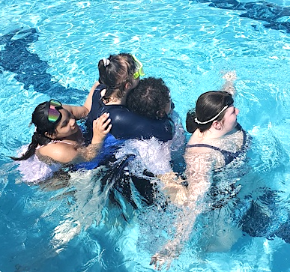
Greetings friends and family! I hope you’ve had a wonderful summer filled with rest and air conditioning. Those of us who work in the educational world are fighting the inevitable as we ease back into the school year (at least we still have Labor Day weekend!). We at Campus Life are gearing up for next week’s first club meeting (pray for us!).
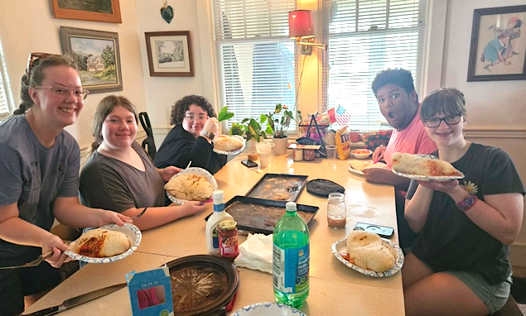
For our final summer event, we hosted a “Make-Your-Own-Stromboli” day. I vastly overestimated how much dough would be needed per kid, resulting in each student having a 10-pound Stromboli by the end of it all (to-go boxes were provided for everyone). The smoke alarms may have gone off once or twice, but thankfully no firemen were needed.
This past month, I was blessed to experience a full-circle moment with one of our Campus Life Alumni. “April” came to Christ through Campus Life and has been attending church with me for the past few years ever since graduating from CL. This month, April signed up for baptism and she asked me to be the one to baptize her. All glory to the one that seeks after the lost!
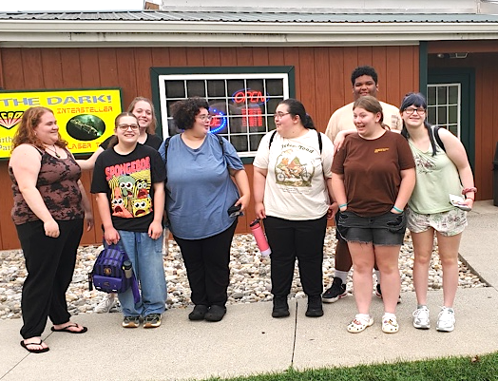
As we enter into the school year, I ask that you would keep our youth in prayer. Pray that God will continue growing the seeds that have been planted. Pray for the students who have made the step of committing their life to Christ, that we would have wisdom in discipling them in this season. We will be officially starting up our weekly Campus Life meetings on Thursday, September 10th, if you would commit to praying with us on this date. This year will look a little different starting out with less volunteers, so please be in prayer for more workers for the field. Pray that we would be able to reach more lost and searching youth for Christ this year. As always, thank you for your partnership in continual prayers and financial gifts.
May Christ bless you and keep you and your family in the coming weeks.

Hannah Bovard
Campus Life Director
484-767-0501

