


P.O. BOX 20165
Lehigh Valley, PA 18002-0165

484-767-0501 (Hannah’s cell)
hajobo1998@gmail.com
www.yfclv.org

P.O. BOX 20165
Lehigh Valley, PA 18002-0165

484-767-0501 (Hannah’s cell)
Hajobo1998@gmail.com
www.yfclv.org
LEHIGH VALLEY

P.O. BOX 20165
Lehigh Valley, PA 18002-0165

484-221-5886 (John’s cell)
campuslifelv@aol.com
www.yfclv.org

May 2026

Dear,
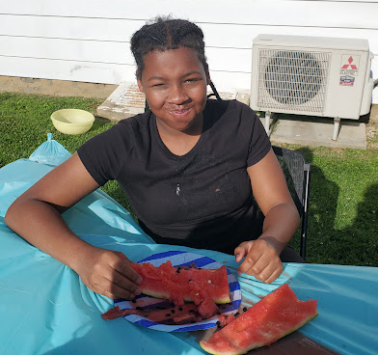
Hello friends and family! I hope you had a wonderful Memorial day weekend filled with hotdogs and hamburgers (ours certainly was!). Summer is swiftly approaching as those in the education field are speedily trying to wrap up the school year so they can finally sing their favorite song (School’s Out for Summer!...Almost). One more week to go!

This week we wrapped up our year with our end-of-year Campus Life Bash featuring our “What-Would-You-Do-For-A-Buck” gauntlet. Challenges included eating a turkey and gravy dinner (in baby food form), drinking Toothpaste flavored soda, sampling a delicacy of cooked bugs, and washing it all down with a lemon or two. We rounded out the evening with a watermelon eating contest and our annual “Dew Spew” (Alka-Seltzer and Mountain Dew is a deadly combo). All in all, a fun and hilarious end to the year.
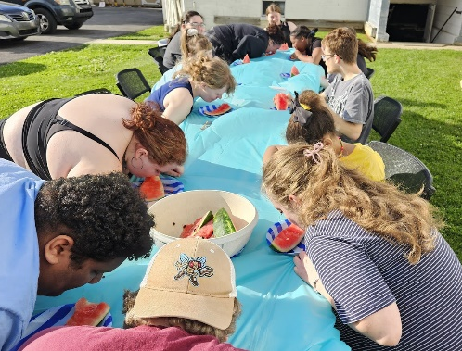
We ended our time by urging our kids to continue to ask the hard questions about God and to truly seek after answers. Please pray that our students would have the courage to pursue the questions on their hearts about Christ and that they wouldn’t forget all they have learned this year. Pray that they would be led to the Savior who holds all the answers.
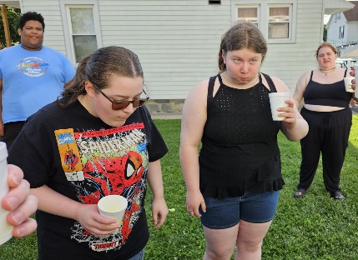
As we head into the summer, please be praying for our upcoming Heatwave trip (June 28-July 2), for spiritual protection and that lives would be changed. I would like to specially thank those who have given already, you are such a blessing!! If you haven’t already, please consider sending a gift to help sponsor one of our kids who would otherwise be unable to attend. Any amount makes a difference!!
Something I ask you to keep in prayer this summer is our need for new volunteers. After this summer, two of our volunteers will be stepping away from Campus Life (Ben and Katie). Our volunteers are what help to make our program run smoothly, so I ask that you would pray for the future of our program and that God would raise up new leaders with a heart for the lost over the summer. Please pray for the Lord’s wisdom for myself as we navigate this new challenge.
Keep us all in prayer as we head into our summer programming. Pray that the summer would be a time of spiritual rejuvenation and rest. Thank you as always for your prayers and your continual financial gifts to this ministry. May God bless you and keep you in the coming weeks.

Hannah Bovard
Campus Life Director
484-767-0501

