Rustburg United Methodist Church

IN HIS SERVICE – APRIL 2026

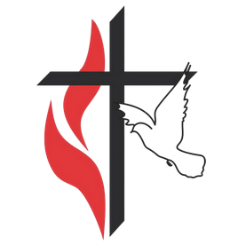


"I give you a new commandment, that you love one another. Just as I have loved you, you also should love one another."
~ John 12:34

I retired last year and have been blessed to be able to travel, to go on journeys, so to speak. The travel agency offers descriptions of trips and sets out itineraries. There is always an asterisk after the description. There is a question at the asterisk. Is this trip right for you? The trips I choose always say: Expect 3-4 hours of walking daily. You may need to walk on uneven and challenging terrain, navigate steep steps or slopes, and encounter cobblestone streets. You should also expect considerable time standing. This caveat holds true; yet, I choose to go.

The disciples had been journeying with Jesus for three years. They gathered with Jesus to observe the Passover Feast. During this time together, on what we now call Maundy Thursday, Jesus humbly washes the feet of his disciples, even the one who will betray him. He gives them a new commandment, to love one another as He had loved them. He establishes the sacrament of communion, instructing them “do this in remembrance of me”.

Then came the asterisk in the description of their journey. They are warned about “uneven and challenging terrain and navigating steep steps or slopes”. Jesus tells them that he will soon be betrayed by one of them. He forewarns them that will scatter and abandon him, as it was written in the scriptures. When Peter declares his steadfastness, Jesus tells Peter that he will deny him three times.

Jesus’ predictions are fulfilled. Judas betrays him, Peter denies him, the disciples scatter or go into hiding. At this point, the disciples believe the journey has ended. Jesus is crucified to reconcile the world to God. After the resurrection of Christ, grace and mercy are extended to the disciples and they are reconciled with Christ. Before the Ascension, Jesus instructs them to spread the gospel and make disciples of all the nations. This time the disciples are ready. They resume their journey and choose to go.
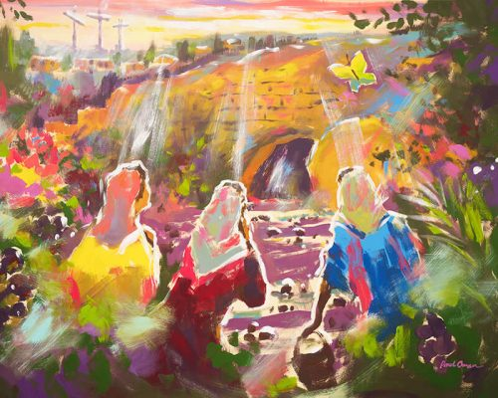
We are today’s disciples.
Even though, at times,
we will walk on uneven and challenging terrain,
navigate steep steps or slopes,
and encounter cobblestone streets,
let us choose to go.
We do not walk alone.
Grace & Peace,
Terri Chaplin, Associate Lay Leader, River View Region
Via Mountain View District of the United Methodist Church Enews; April 1, 2026
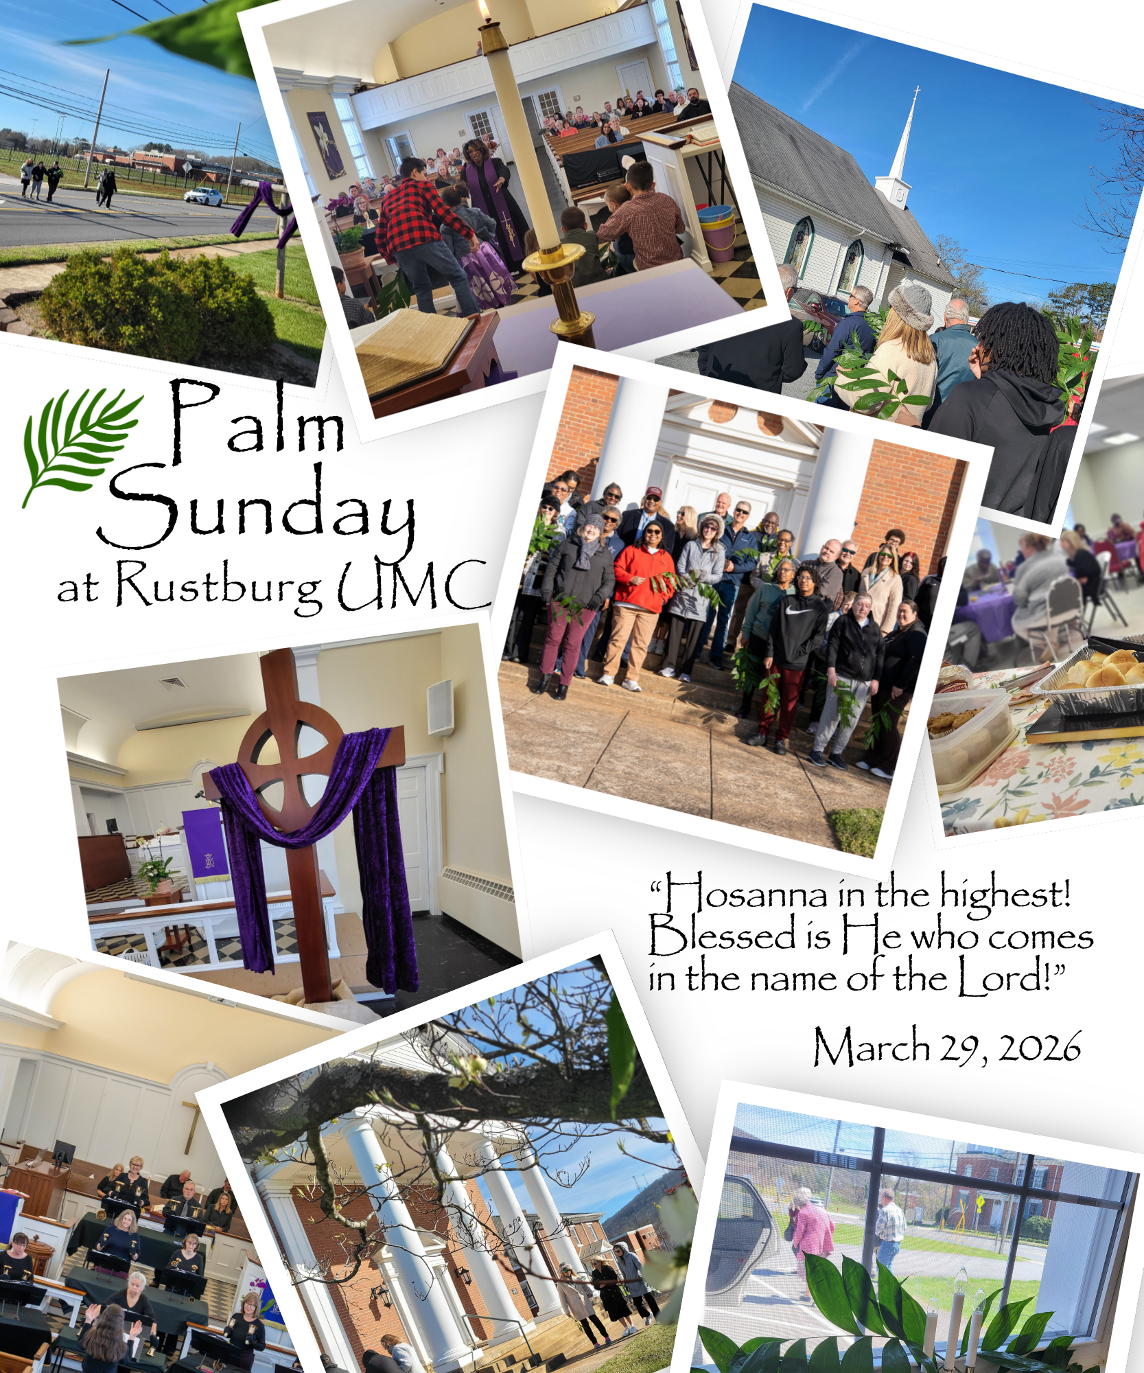

United Women in Faith

Please come and join us on the 2nd Wednesday of each month in the Small Fellowship Hall at 10:00 AM.

We’ll have our regular meeting at April 8, at 10:00 AM.

Love in Christ;
Donna Cameron | President of UWF

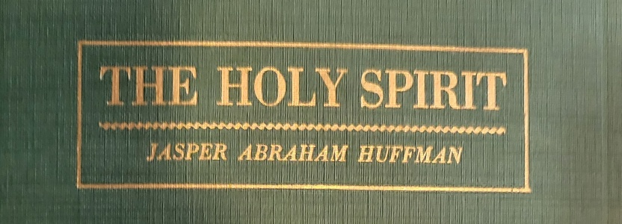
Bible Study

Led By: Dr. C.R. Brooks
12 Noon
Wednesdays: April 1,8,15,22,29

We are using the Revised Standard Bible, Standard Lesson Commentary and The Holy Spirit by Jasper A. Huffman for 2026 Wednesday Bible Study.

You can find the Commentary – NIV or King James translation – at Mardel’s, Amazon, etc. Huffman’s The Holy Spirit can be borrowed or purchased at Bible Study when available.


Happy 150th Year RUMC!
1876 – 2026, Central Methodist Church | Rustburg UMC
Come celebrate with us Sunday, September 20th!
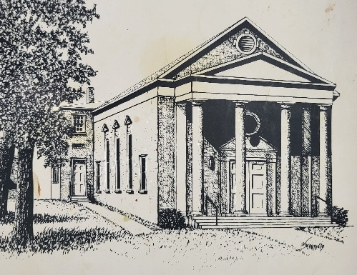

If you would like to volunteer to be on the Souvenir Booklet Committee, Please Contact Cathy Phillips
434-258-7757 or: dctmphillips@yahoo.com


2026 RUMC Directory

Directory will be printed in the month of April! It’s updated and also serves as a yearbook for 2025.
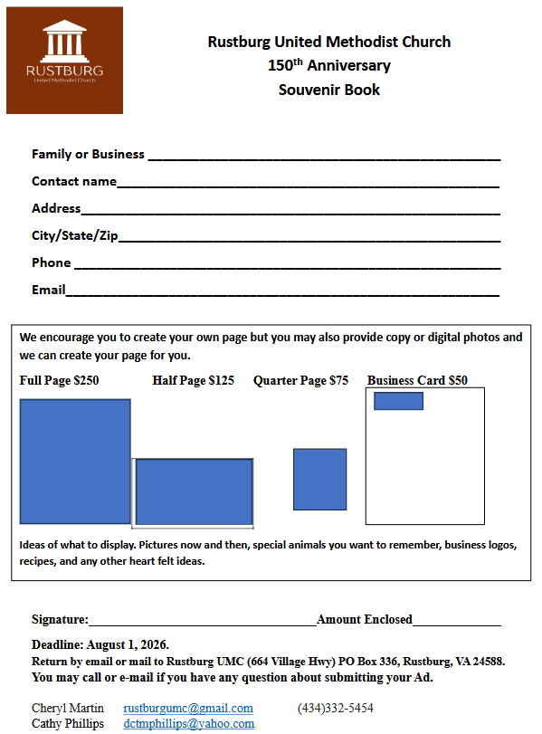
2026 Rustburg United Methodist Church Souvenir Book

Because Rustburg UMC church is God’s people and not just a building;

We invite families, friends, neighbors, businesses (both bygone and still in business) to join and support us as we celebrate 150 years as a church family in Rustburg, Virginia.

Our 150th year Souvenir Book will tell stories of struggles, joys, hopes, whims, successes as we reveal what 150 years has been to our church and church families in the Rustburg area: both past and present.

We invite our family tree of the nine churches in the Methodist Church South and the community that surrounded us to contribute to the story. The Souvenir Book will include pictures of families, old stores, buildings, homes of the past and their proximity to people of the Rustburg church. It will include the parsonage, surrounded by a moat in the foothills of Campbell County; stories of children who watched the transformation of the county, the church and the families around them. One man, now in his eighties, tells the story of how he snuck into the building through a window to look around when the addition was being added to Central Methodist, later RUMC, in 1953 (may his parents rest in peace).

Dating as far back as 1876, We went from a 9 point to a 4 point before going to stand-alone. Was your family in the county as Central Methodist Episcopal moved from the nine-point charge to a stationary church as Rustburg UMC? The original Campbell County Charge was: White’s Methodist, Rehoboth, Hay’s Chapel, Central, Mt. Zion, Wesleybury, Salem, Sharon, Ivy Branch-Mt. Asa. Did you get married at the church? Were you or was your family member baptized or confirmed here? Was your family in the area and is there someone you want memorialized: their poem, a recipe, a piece of knowledge, etc.? Were they members of one of the original churches that made up the circuit, its choir or other ministry? Do you remember a story of your parents or one your grandparents talked about the church or people in the area? Was your grandfather or grandmother a pastor, farmer, lawyer or banker in the 1800s, 1900s, 2000s? Please purchase space to tell your story in honor of RUMC’s 150th birthday celebration.

As we look to our Grand Celebration in September 2026, we invite everyone in the area and across the country to contribute by August 1, 2026. We invite families and businesses to take a page and tell your history, send school pictures, and just congratulate the people of the church and its ministries on this exciting occasion. We invite you to contribute and celebrate with us. Pages are already being set aside at $250 for full pages, $125 half pages, $75 quarter pages and $50 to display a business card (past or present). Ask about special discount for current members of RUMC. You can lay out your page or send pictures and copy – or we can talk to you and we will transcribe it for you.

Thank you, in Jesus’ name.

Souvenir Book Committee Cheryl Martin
Rustburg UMC (434) 332-5454 | rustburgumc@gmail.com
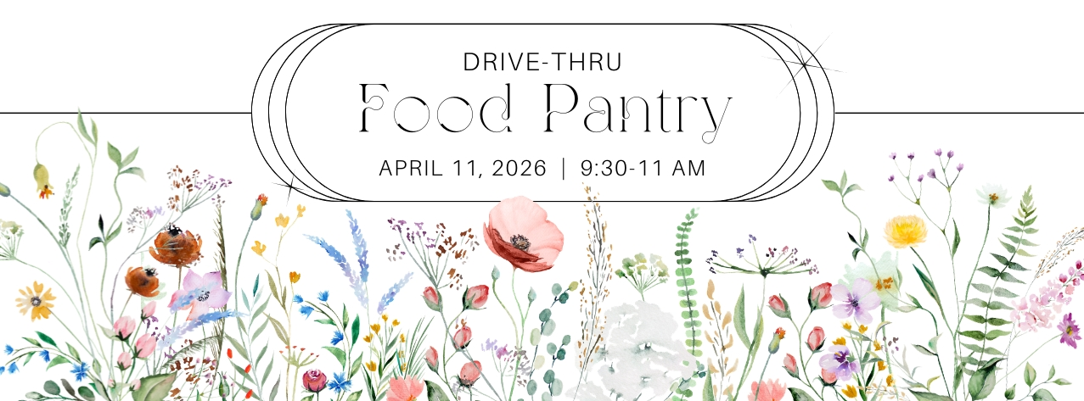

April Noisy Offering


Compassion International
Compassion International shares the hope of the gospel in word and action, releasing children from poverty in Jesus’ name. We care for vulnerable children — mind, body and soul — with programs delivered through local churches in their communities.
We believe children living in poverty should experience the fullness of life Jesus promised them (John 10:10). But to make this possible, we must restore the health, hope and opportunity that poverty has stolen from them.
Through child sponsorship, Compassion equips over 8,000 local churches in 29 countries to know, love and protect vulnerable children living in their communities. Together, we share the love of Jesus with each child and provide for their right-now and long-term needs.

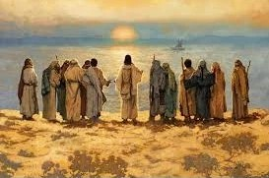
In order to support the work of the church treasurer, the Administrative Board seeks to build an Audit Committee. If you volunteer, or know of someone in the church community with a gift of accounting or love of numbers, please give Administrative Assistant Cheryl Martin your name and contact information.
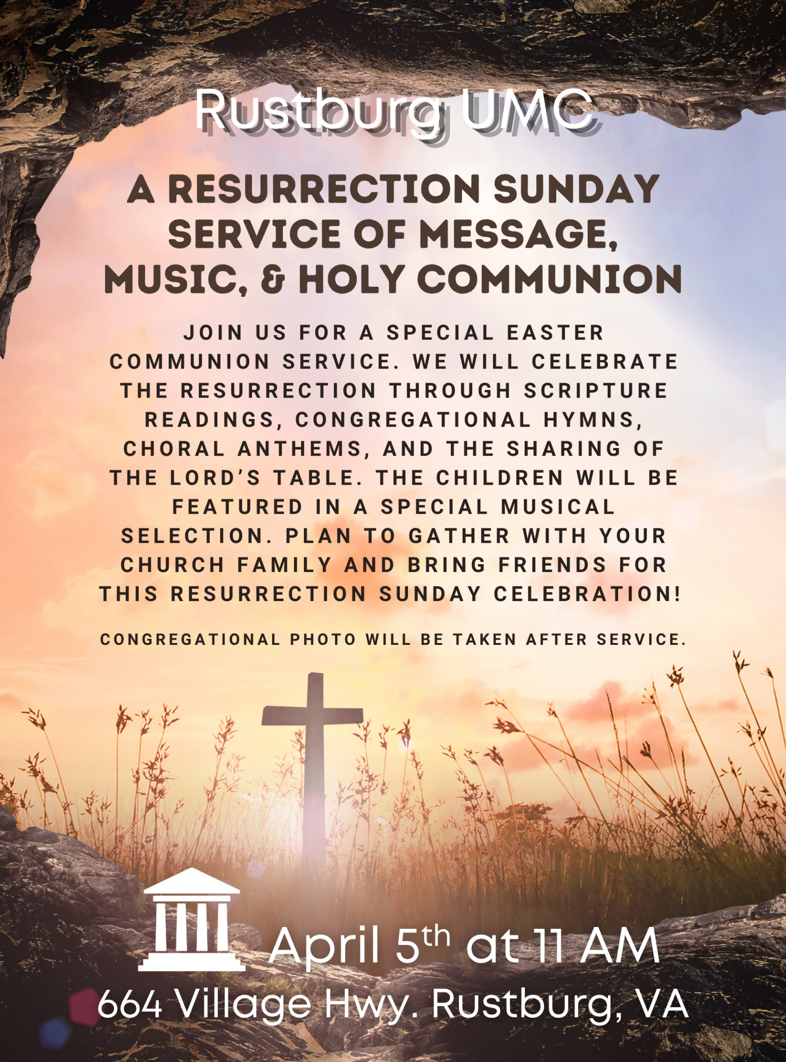
RUMC COMMUNITY EASTER EGG HUNT 2026
We held our annual community Easter Egg Hunt on Saturday March 28th. We had 57 children hunting 2,633 colored eggs and 20 golden eggs. Before the hunt, the children played games (cornhole, skee ball, bowling, ring toss, egg race, sack race, velcro ball toss, and a photo op). After the hunt, everyone came back to the gym for snacks and prizes were awarded for all golden egg winners and door prize winners. It was a great success and all the children had so much fun. – Sarah Hamlett

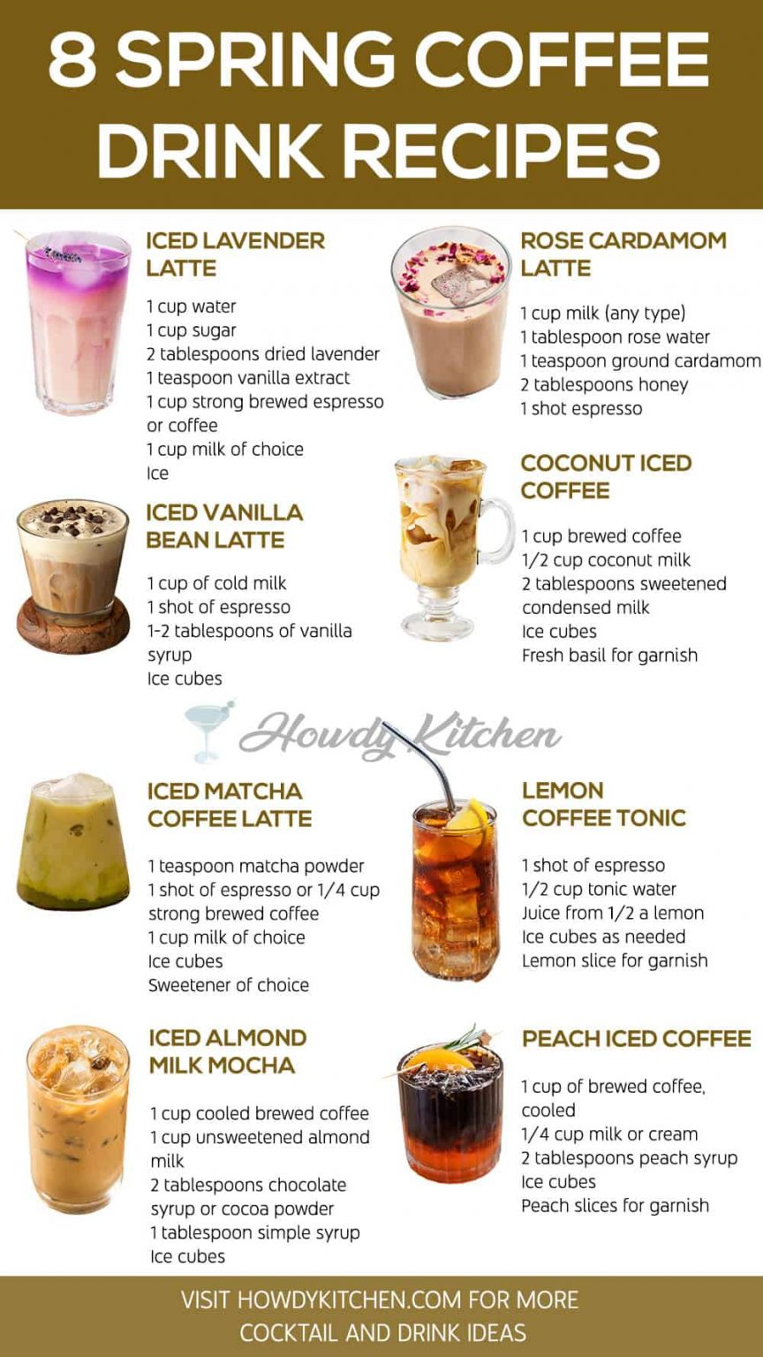
SPRING RECIPES
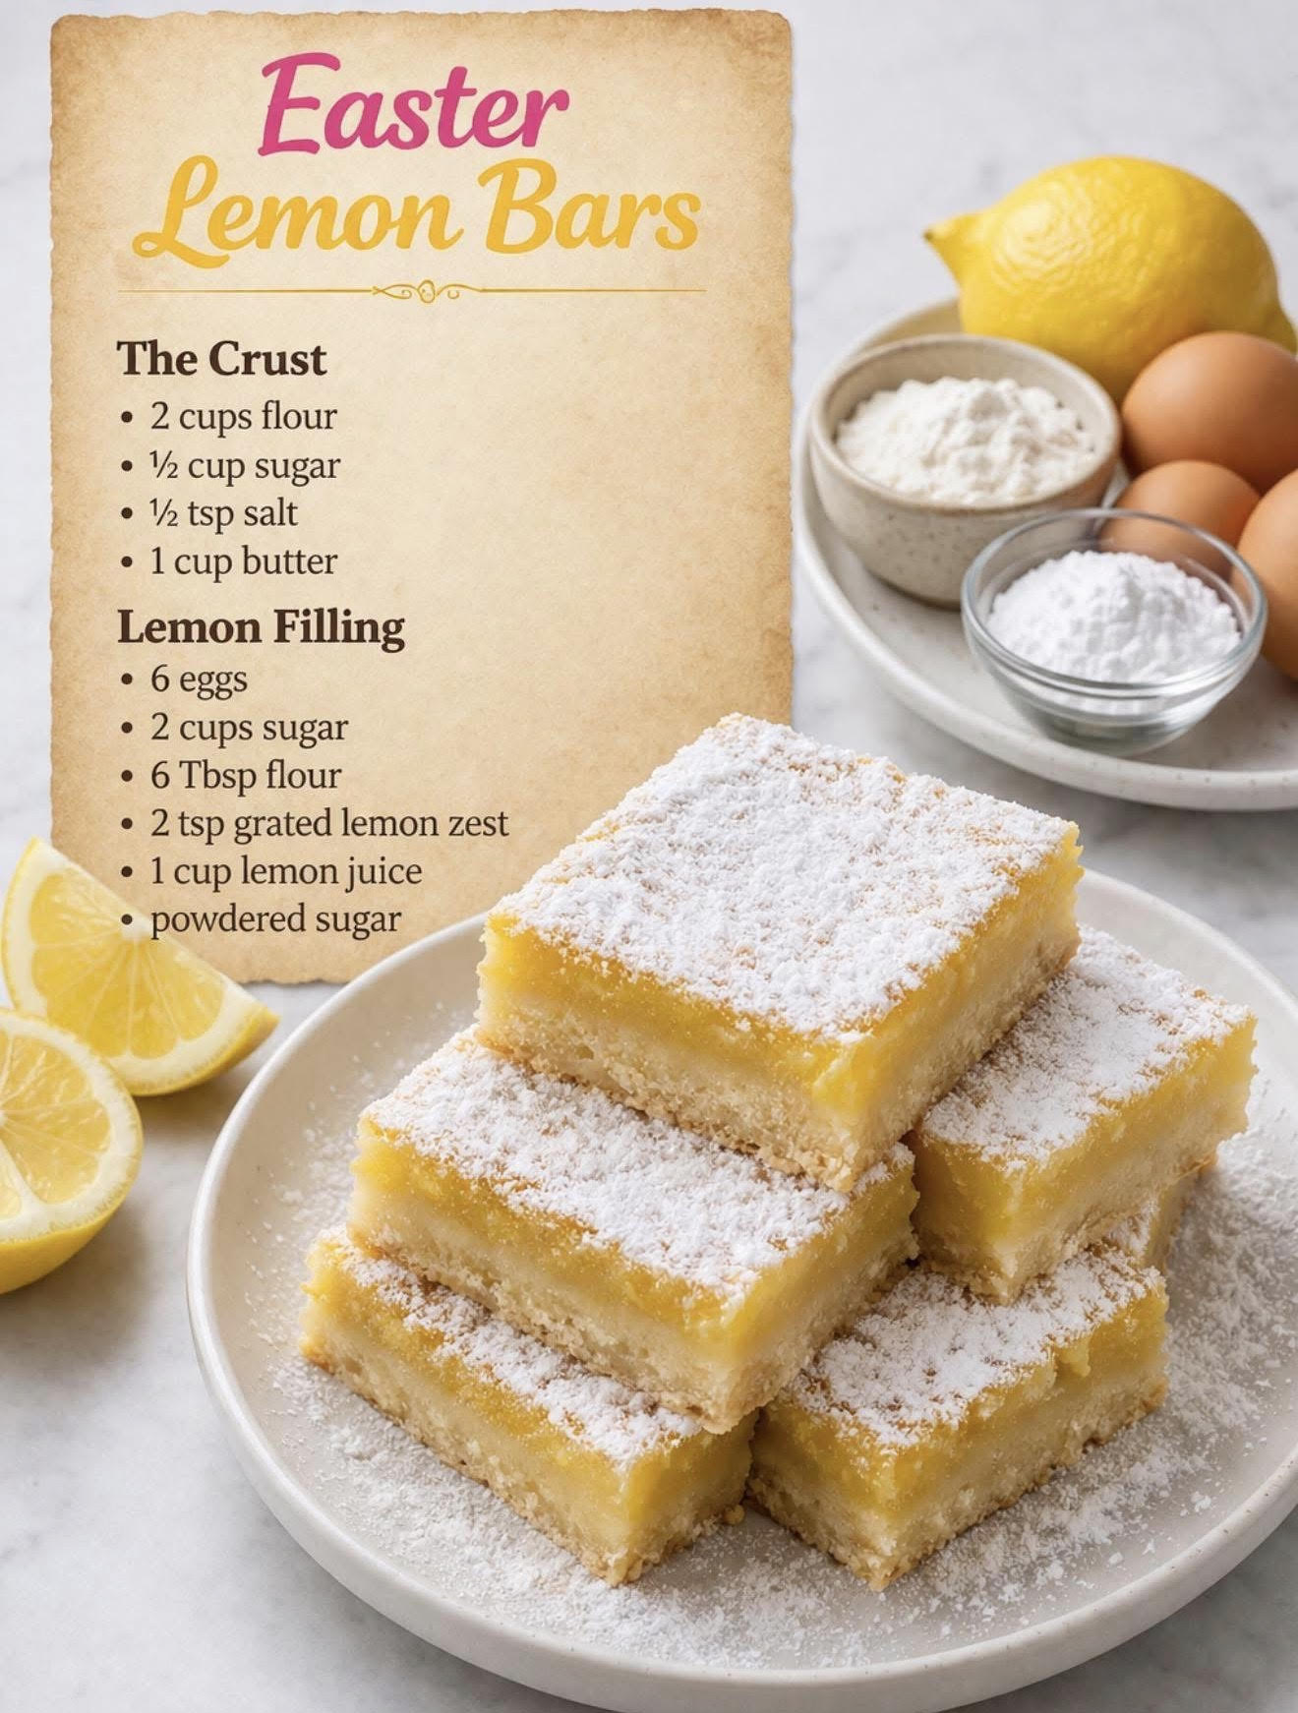
RUMC at NYC

In January, I received an unexpected email. Distinguished Concerts International New York reached out to me to see if some of our choir would be available to participate in a concert at Carnegie Hall! They found our choir from our online posts and were impressed with our sound and solid part-singing. The song they heard was by Joseph Martin, a world-renowned composer who is a legend in the choral community. This invitation includes a residency program of rehearsals and a concert conducted by Joseph Martin himself.
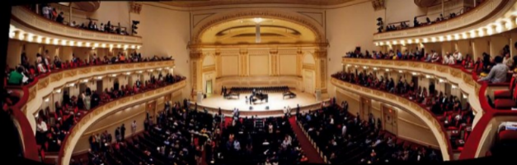
We are so excited to have this opportunity, especially since they found us! There is a significant cost involved with this program and travel. We are reaching out to our church family and community for financial support in this endeavor. It is such an honor to represent our small community in this manner. Please prayerfully consider how you can help. Our fundraising concert flyer is in this newsletter and we will have copies available for you to post.
Thank you for your support and prayers!
Gratefully,
Alice


Dear Alice and the Chancel Choir at Rustburg United Methodist Church,

In recognition of your dedication to musical excellence, and due to the high quality of your
audition recording, it is with great pleasure that I extend an invitation to you and the Chancel Choir at Rustburg United Methodist Church to participate in the world premiere of The Four Freedoms, a new work by Joseph Martin on the DCINY Concert Series in New York City. This performance is planned to take place on Monday, November 16th, 2026 in Isaac Stern Auditorium at Carnegie Hall under the baton of Joseph Martin himself.

Congratulations to you and your singers on this wonderful achievement and recognition! A limited number of ensembles have been selected for this special invitation. Your musicians will join with other outstanding choristers from around the world to form the Distinguished Concerts Singers International, a choir of distinction. DCINY, a professional production company with experience presenting at venues including Carnegie Hall and Lincoln Center for the Performing Arts, provides a quality performance experience in collaboration with high caliber musicians and soloists. The residency includes two half-days of rehearsals and clinics, culminating in a performance accompanied by Distinguished Concerts Orchestra, with Joseph Martin on the podium.

I am excited about the prospect of including you and your singers in pursuit of a glorious and memorable concert. It is only fitting that you are given this unique opportunity to perform in one of the world’s greatest concert halls, which itself represents excellence and musical achievement.
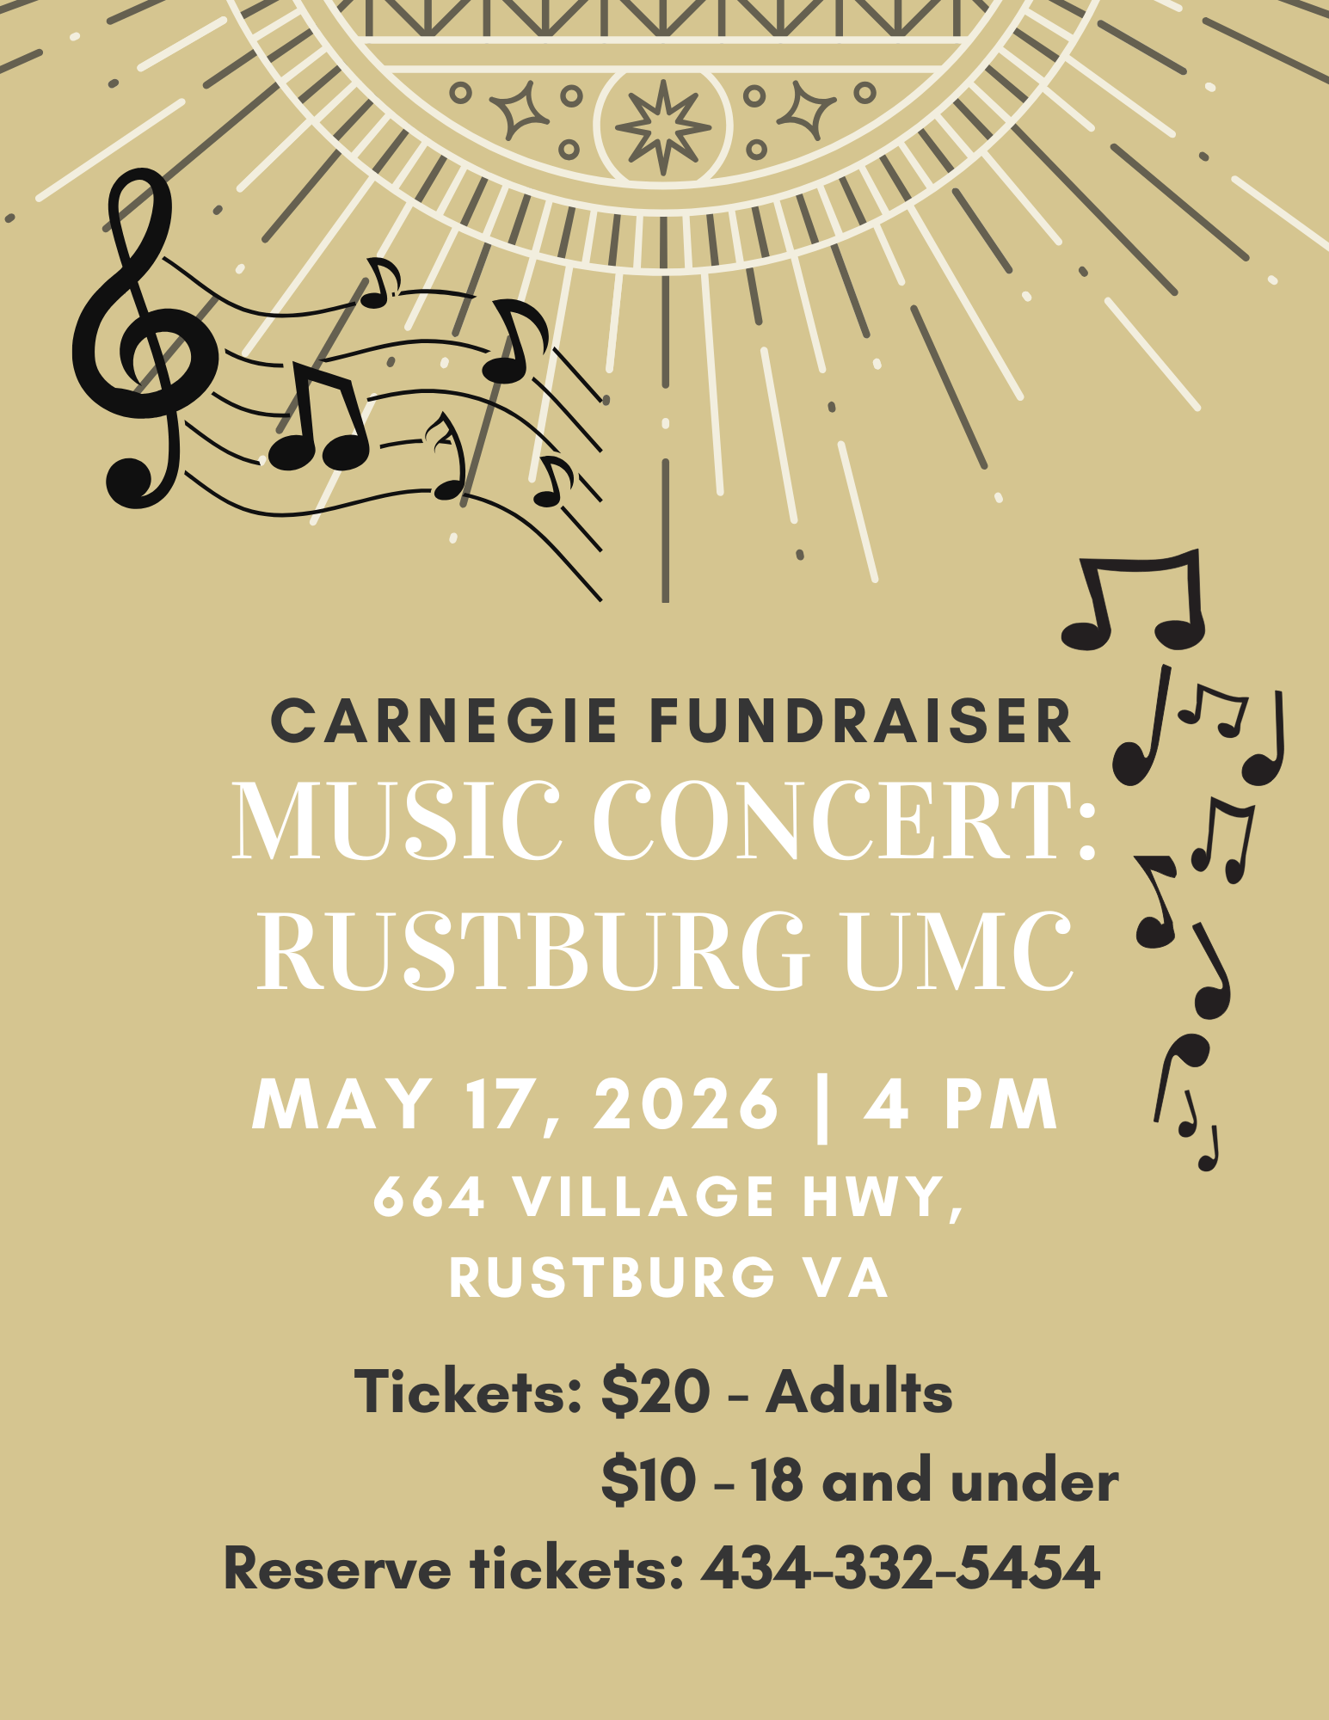



When: Friday April 24th 6 p.m.
Where: Shannon Hall’s 511 Colonial Highway, Rustburg, VA
Come for a FUN night of BUNCO and Left Right Center to raise money for the 150th Anniversary Celebration!
$15.oo Buy-In to Play. ALL Proceeds will go to a special gift to the church for the 150th Anniversary of the church. Not necessary to know how to play, instructions will be given.
Light refreshments will be provided.
We need a minimum of 12 to play (Max of 16). If we do not reach the min. we will cancel this event.
RSVP to Kelly Gladden or Shannon Hall by Sunday April 19th.

Magnolia 2026 Events
Save the Dates

Friday April 24th: Ladies Bunco Night Fundraiser for 150th Church Birthday Celebration
Saturday May 30th: Pharsalia Farms in Massy’s Mill Floral Arrangement Class
(RSVP’s will be required. More info in the May Newsletter)
June/July/August TBD
Sunday September 20th: Magnolia Ladies Ice Cream Social for 150th Birthday Celebration after the luncheon
Friday September 25th: Magnolia Bowling Night
Saturday October 17th: RUMC Fall Festival
Friday November 20th: Friendsgiving (RUMC Small Fellowship Hall)
Saturday December 5th: Christmas Cookie Exchange

 APRIL

Wed. 04/01 Bible Study w/ Rev. Brooks, 12 PM
Thurs. 04/02 Maundy Thursday Service, 7 PM
Fri. 04/03 Good Friday Tenebrae Service, 7 PM
Sun. 04/05 Resurrection Sunday | Communion
- Photo will be taken after service.
Wed. 04/08 United Women in Faith, 10 AM
Thurs. 04/09 Handbells, 6 PM | Choir, 7 PM
Sat. 04/11 Food Pantry, 9:30-11 AM
Sun. 04/12 Men's Group Meeting, 8:30 AM
Administrative Board, Following Worship
Sun. 04/26 Noisy Offering/Missions Moment: Compassion International
Wed. 04/22 Deadline for May Newsletter

Wed. April 1,8,15,22,29: Bible Study w/ Rev. Brooks, 12 PM
Thurs. April 2,9,16,30: Handbell Rehearsals, 6 PM
Choir Rehearsals, 7 PM

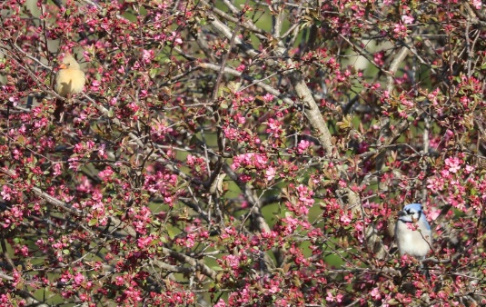
MARCH RUMC OFFERINGS
March Year-to-Date
Offering General 13,219.00 32,157.00
Budget (16,958.83) (50,876.49)
Short (3,679.83) (18,725.49)
Other Gen’l Income 4388.06 10,337.94
Budget Balance 708.23 (8,387.55)
“Birds in the Redbuds,” by Donna Cameron

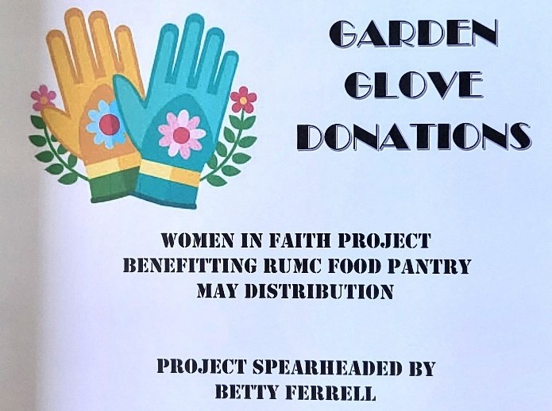

SPRING MISSION PROJECT

The United Women in Faith are collecting garden gloves for the May Food Pantry. Feel free to drop off in the box in the Narthex!

April Greeters
5 Betty Ferrell
12 Michelle Green & Serenity Rankin
19 Cheryl Martin
26 Sue Buchanan

RUMC Contact Info:

Acolytes: Cheryl Martin
Care & Share: Shirley Phillips
Children’s Church: Shannon Hall
Greeters: Betty Cyrus
Nursery: Mary Bailey
Ushers: Jerry Booth

April Ushers

Michael Metcalf & Ricky Pillow

May: Jerry Booth, Marvin Tweedy
June: Jimmy Cyrus, Donnie Hamlett
July: Robert Bailey, Jimmy Jewell
August: Michael Metcalf, Ricky Pillow
September: Jerry Booth, Marvin Tweedy
October: Jimmy Cyrus, Donnie Hamlett
November: Robert Bailey, Jimmy Jewell
December: Michael Metcalf, Ricky Pillow



Happy April Birthday

05 Levi Watson
06 Michael Metcalf
08 Laura J. Layne
10 Sharon Nolley
13 Steve Ferrell
17 Blane Johnson
18 Kye (K.J.) Bishoff
24 Joyce Rush
26 Mae Drinkard
29 Linda Goff
30 Taylor Phillips

01 Bill & Dale Torrence
06 Stuart & Jennifer Johnson
11 Kent & Amanda Perdue

Trained Acolytes
Kaleesi Bishoff David (Mac) MacMillan
KJ Bishoff Nicholas Macmillan
Serenity Rankin Jennivieve MacMillan
Presley Wiley Chrissy MacMacMillan
Teddy MacMillan
Church Closers

April: Donna & Lisa Cameron
April Sunday School
Donna & Sarah Hamlett
Alice Watson
David Hawkins
Pam Booth

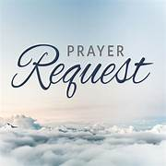
Prayer Requests: Ann Bailey, Family of Danny DeJarnette, Kim Saunders (Republican Grove UMC), Vicky Gamon (waiting for liver transplant), Lillian Johnson (Jenifer’s MIL), Pastor Sung and family, Dennis and Pam Cowart, Monnie and Barbara Coleman, Jessie (Shug) Phillips and family, Barbara Wiles, Atha Bailey, Nancy Bennett, JohnWyatt Newcomb, Cindy and Danny Torrence, Jackie Robinson (church custodian) has asked for prayers for her sister. Mary and Buster Frazier, Kenneth Grubbs, Joyce Rush, Marguerite Eimer, Betty McClung, May Nolley, Frank Merryman, Mary Alice Preston, Tina Shaver, Marsha Henderson, Bangladeshi families and Military Families.
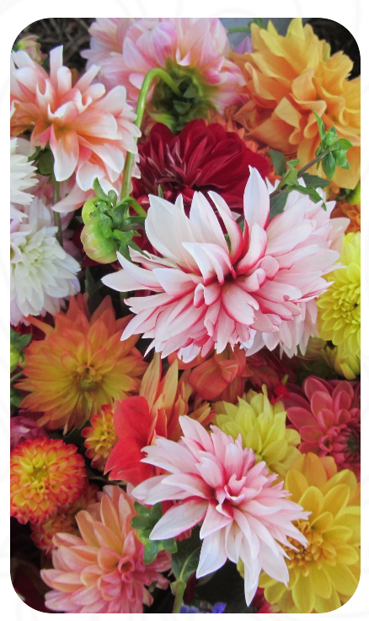
SAVE THE DATE
Saturday May 30th
Magnolia Ladies
Pharsalia Flower Farm
Tour, flower foraging and arranging
A trip to historic Pharsalia is scheduled for the Magnolia Ladies on Saturday, May 30. Pharsalia’s fresh cut flower farm capitalizes on the seasonal abundance of blooms available in Nelson County, Virginia. With a backdrop of the Blue Ridge Mountains, Foxie Morgan, grower and owner, cultivates native and specialty blooms for all seasons. Our visit will include a tour of the garden, flower foraging and an arranging class for a total of 2 hours for $85.00. We will need to arrive by 9:45 a.m. so that we can start at 10:00 a.m. Participants will need to provide clippers, a container or vase to use for your arrangement and a box to transport your arrangement home. Also plan to bring a bagged lunch to eat on the grounds following our class. RSVP’s will be required. More info in the May newsletter.

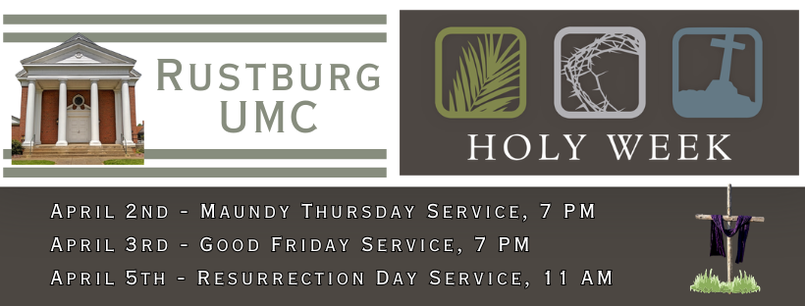
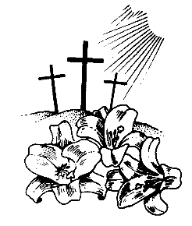
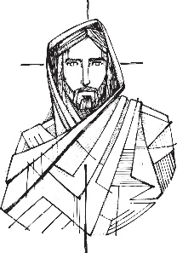
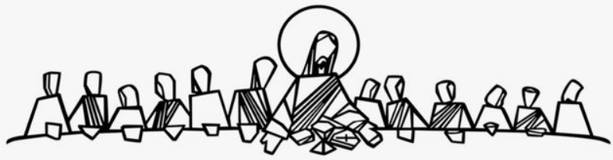
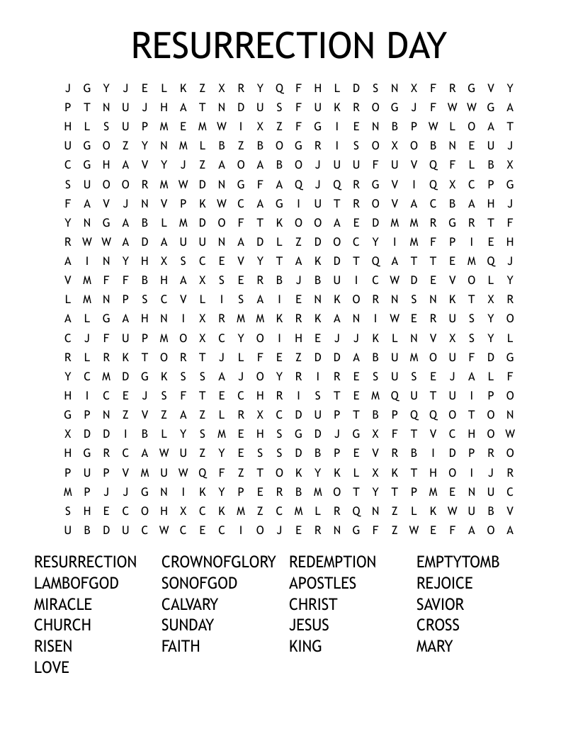
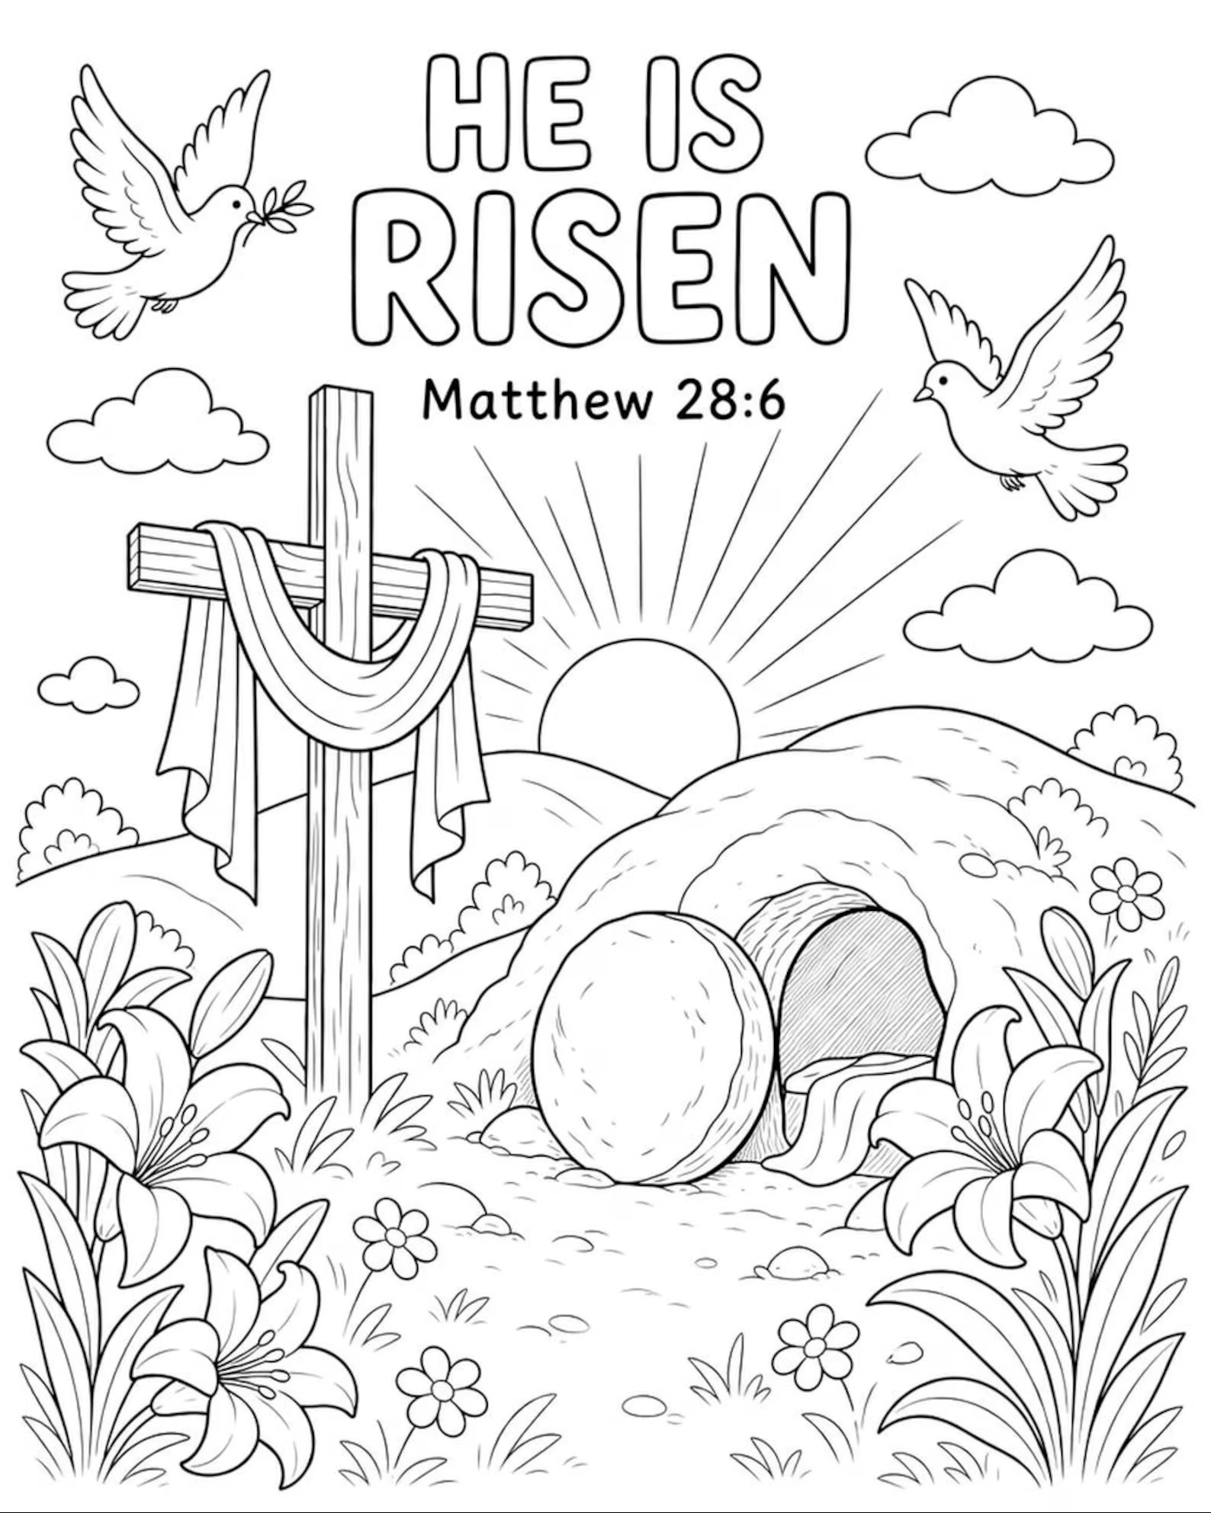
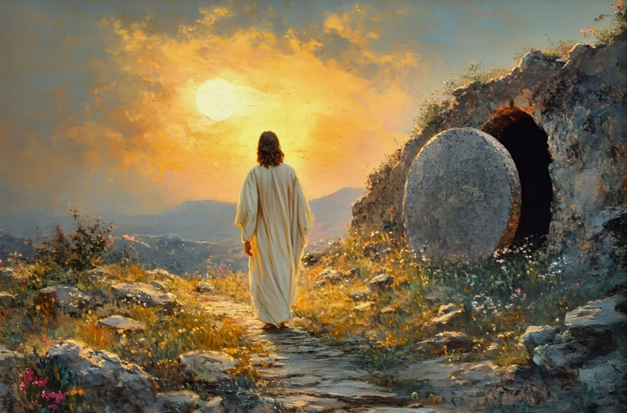
Rustburg UMC, P.O. Box 336
(664 Village Hwy.) Rustburg, VA 24588
RUMC Phone: 434-332-5454 | Email: rustburgumc@gmail.com
Office Hours: 11 AM to 2 PM; Tuesday, Wednesday, Thursday

Rev. C. R. Brooks, Ph.D.
Phone (cell): 434-895-6032 | 405-466-9786 | Email: revcrbrooks@aol.com
Lay Leadership Team: Pam Booth, Annette Patrick
Music Director: Alice Watson | Pianist: Heather Wilson
Administrative Assistant: Cheryl Martin
Communications Coordinator: Lisa Cameron

Our Mission: To make disciples of Jesus Christ for the transformation of the world.

Our Vision: To be disciples of Jesus Christ who are lifelong learners who influence others to serve.

Visit our church website at www.rustburgumc.org
Please like us on Facebook
www.facebook.com/RustburgUnitedMethodistChurch

