Men’s Retreat
2022
Sept 29th – Oct 2nd
Cost $50
Directions

Camp Kaskitowa
3799 108th Ave.
Allegan, MI 49010

From the church
- Start out going west on Walton Blvd toward Wimpole Dr.
Then 2.66 miles
- Turn left onto N Squirrel Rd.
Then 0.07 miles
- Turn right onto Five Points Dr.
  - Five Points Dr is just past E Walton Blvd
Then 0.46 miles
- Turn right onto University Dr.
Then 0.76 miles
- Merge onto I-75 N toward Flint.
Then 31.47 miles
- Keep left to take I-75 N toward Saginaw.
Then 4.91 miles
- Merge onto I-69 W via EXIT 117A toward Lansing.
Then 52.99 miles
- Merge onto I-96 W via EXIT 81 toward Grand Rapids.
Then 44.56 miles
- Take the MI-6 W exit, EXIT 46, toward Holland.
Then 0.91 miles
- Merge onto M-6 W.
Then 10.22 miles
- Merge onto US-131 S via EXIT 8.
Then 22.72 miles
- Take the MI-222 exit, EXIT 55, toward Martin/Allegan.
Then 0.20 miles
- Turn right onto 116th Ave/M-222. Continue to follow M-222.
Then 10.02 miles
- Turn left onto N Cedar St/M-222. Continue to follow N Cedar St.
  - N Cedar St is 0.1 miles past N Walnut St
  - If you reach Pine St you've gone a little too far
Then 0.23 miles
- Turn right onto Jenner Dr/M-40. Continue to follow M-40.
  - M-40 is just past Ely St
  - If you are on Marshall St and reach 2nd St you've gone about 0.3 miles too far
Then 3.47 miles
- Turn right onto 108th Ave.
  - 108th Ave is 0.2 miles past Pike Ct
  - If you are on M 40 and reach 106th Ave you've gone about 1 mile too far
Then 2.95 miles
3799 108th Ave, Allegan, MI 49010-9313, 3799 108TH AVE is on the right.
  - Your destination is 0.4 miles past 37th St
  - If you reach 38th St you've gone a little too far
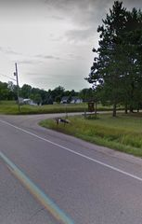
Camp Map
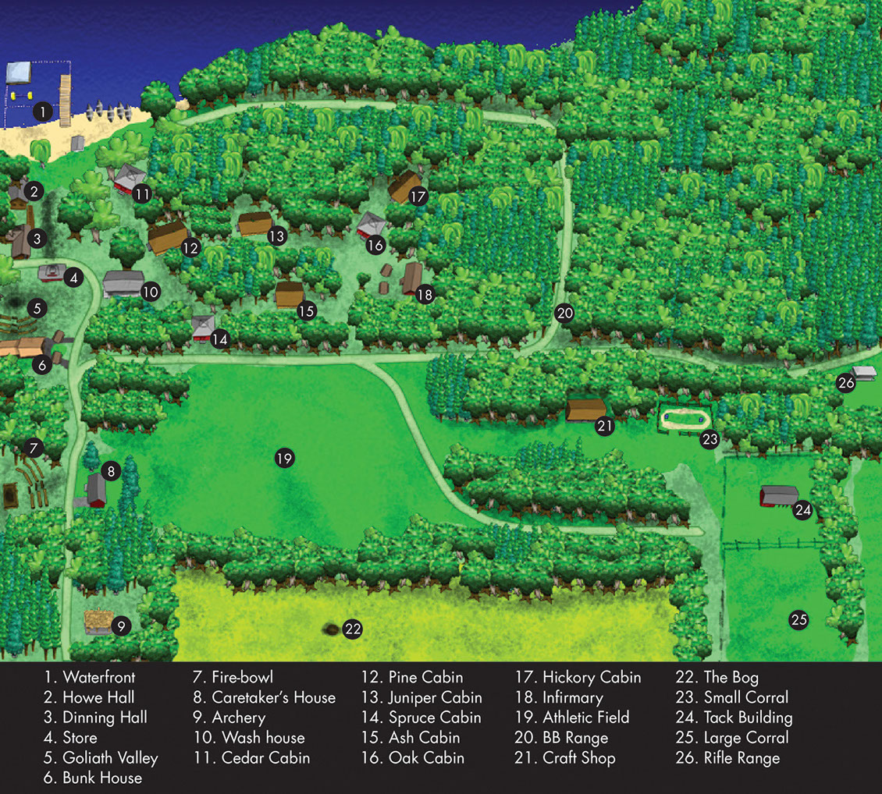
Parking
Before you reach the Bunk House there is an open area where you can park. You should see other vehicles there.

Cabins

Bunk house – for those who like to turn in early

Pine – For those who like to stay up a little late

Juniper – For teens/College Age and those who like to stay up all hours of the night

Schedule

Thursday

12pm - Arrival

This is a free day for those who wish to come up early. You are responsible for all of your own meals

Friday

Free day until Dinner

6pm – Dinner
8pm – Service

After service time for fellowship

Saturday

8am - Devotional
9am – Breakfast
12pm – Lunch
Option 1 – Stay at camp with small lunch provided
Option 2 - Lunch at the gun range if you go to shoot (TBD)
12pm – Gun range (TBD)
12pm-5pm – Free time
6pm – Dinner
8pm – Service

After Service time For fellowship

Sunday

9am – Breakfast
10am – Service
11am – Camp cleanup
12pm – Head Home
Meals

Friday

Dinner
Ribs/baked beans/
CornBread/Mac’n’cheese

Saturday

Breakfast
Breakfast Burritos

Lunch
(Option 1) – Sloppy Joes/soup/chili

(Option 2) – Hot Dogs (TBD)

Dinner
Lasagna/Spaghetti/
Chicken Fetticcine/
Garlic Bread/Salad

Sunday

Breakfast
Scrambled Eggs/Bacon/
Sausage/Biscuits & Gravy/
Pancakes

Things to Bring
1.) Bible
2.) Sleeping Bag
3.) Snacks
4.) Friends
5.) Shower supplies
6.) fishing equipment
7.) Poncho
8.) Clothes to suit warm and cold weather
9.) Flashlight
10.) good walking shoes
11.) cards/board games
12.) Golf Clubs
13.) Any Guns you would like to shoot at the gun range. (TBD)

