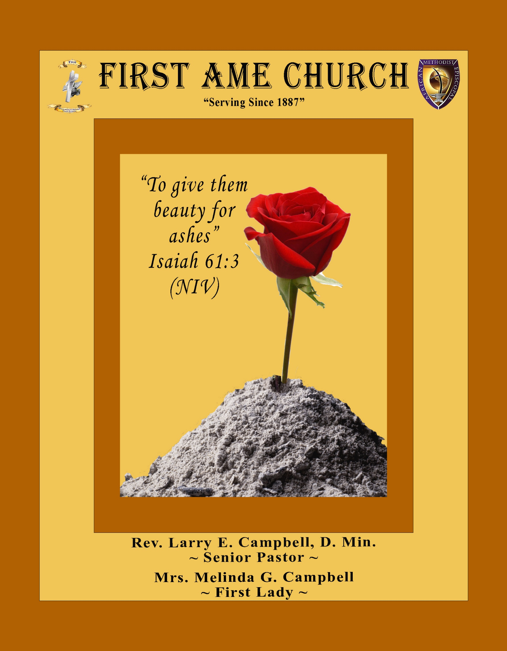
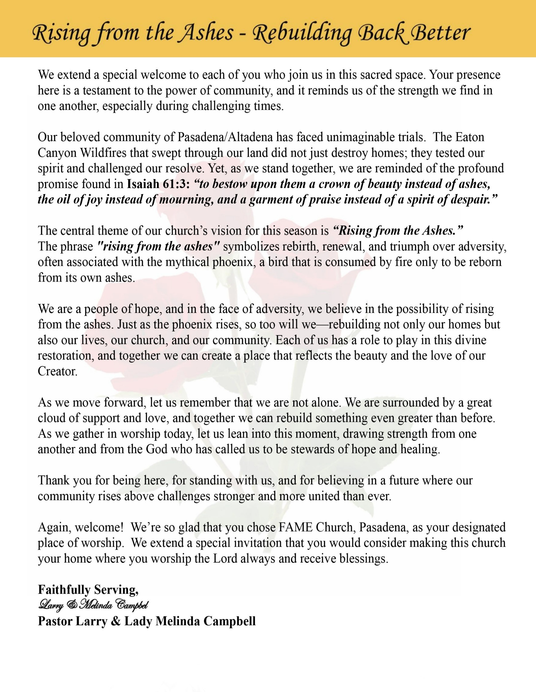

Sunday, April 5, 2026 | 9:30 a.m.

Rt. Rev. Francine A. Brookins, Esq., Presiding Bishop
Rev. Miriam Burnett, MD, MPH, Supervisor of Missions
Rev. Roosevelt Lindsey, Jr. Presiding Elder

The Rev. Dr. Larry E. Campbell ~ Senior Pastor ~ Minister

Mobile: (951) 587-1894 ~ Email: larrycampbell@famepasadena.org

Our First Lady: Mrs. Melinda G. Campbell

The Reverend Dr. Jennifer Oliver ~ Itinerant Elder -
The Reverend Dr. Nikia Smith-Robert ~ Itinerant Elder (Affiliated)
The Reverend Lois Woodard ~ Itinerant Elder Superannuated (Retired)
The Reverend Rochelle Wright Moore ~ Itinerant Deacon
The Reverend Deborah West-Jones ~ Local Elder
The Reverend Philis J. Griffin, MDiv ~ Local Elder
Dr. Phyllis Beech ~ Evangelist
Sister Tessie Bonner ~ Deaconess

Community Resource Center Director ~ Ms. Kischchen Hazelton Venerable
Church Administrative Assistant: Ms. Letha Rhymes

Church Office Hours:
Tue - Wed 9:00 am - 5:00 pm, & Fri 9:00 am -3:00 pm.
Closed for Lunch Daily: 12:00 pm - 1:00 pm.

Music Ministry
Dr. Timothy Davis, Minister of Music
Bro. Jimmy Watlington, Percussionist ~ Bro. Carlos Caldwell, Organist
Bro. Darien Dorsey, Keyboardist
Sis. Karen Law, Women’s Chorus Director ~ Sis. Tonia Graham, Children’s Choir Director
Bro. J. Renard Washington, New Generation’s Choir

FREE WI-FI service is available on the FAME Campus by accessing FAME 1700
Password: 6267980503

-3-

~ Order of Worship Experience ~



Celebrating Easter & Holy Communion Sunday

+++ The Altar Call +++
Praise & Worship
Doxology: “Praise God From Whom All Blessings Flow”
The Call to Worship — Easter & Holy Communion Sunday - Pastor Larry E. Campbell
Leader: Christ is risen!

People: He is risen indeed! Hallelujah!

Leader: The stone has been rolled away, the grave has been defeated, and death has lost its sting!

People: We come celebrating the risen King—Jesus is alive!

Leader: Early that Sunday morning, before the sun could rise, God had already done it!

People: And because He lives, we live! Because He got up, we get up!

Leader: Scripture declares, “O death, where is thy sting? O grave, where is thy victory?”

People: The victory belongs to Jesus—and we share in His triumph!

Leader: Today we gather at the empty tomb and at the Lord’s Table—remembering His sacrifice
and rejoicing in His resurrection.

People: We come to be renewed, restored, and revived!

Leader: Let the redeemed of the Lord say so! Let everything that has breath praise the Lord!
People: Our hands are lifted, our hearts are open, and our voices are raised!

Leader: Come on and give God glory—He got up with all power in His hands!

Unison: O Sing unto the Lord a new song, for He has done marvelous things. Make a
joyful noise unto the Lord, all the earth, sing His praises. (Psalm 98:1, 4)

-4-

The Hymn of Praise A.M.E. Hymnal #156
Christ the Lord Is Risen Today

Words: Charles Wesley, 1707-1788, and others

Christ the Lord is risen today, Al-le-lu-ia!
Sons of man and angels say, Al-le-lu-ia!
Raise your joy and triumphs high Al-le-lu-ia!
Sing, ye heavens, and earth reply, Al-le-lu-ia!

Lives again our glorious King, Al-le-lu-ia!
Where, O death, is now thy sting? Al-le-lu-ia!
Once He died, our souls to save, Al-le-lu-ia!
Where’s thy victory, boasting grave? Al-le-lu-ia!

Love’s redeeming work is done, Al-le-lu-ia!
Fought the fight, the battle won, Al-le-lu-ia!
Death in vain forbids Him rise, Al-le-lu-ia!
Christ hath opened paradise, Al-le-lu-ia!

Soar we now where Christ has led, Al-le-lu-ia!
Following our exalted Head, Al-le-lu-ia!
Made like Him, like Him we rise, Al-le-lu-ia!
Ours the cross, the grave, the skies, Al-le-lu-ia!

The Invocation Rev. Dr. Nikia Smith-Robert

Ministry of Music The Mass Choir

-5-

Scripture Lesson (Responsive Reading) Rev. Deborah West-Jones
(Please Stand for the Reading of God’s Words)

Philippians 3:1-16 (New Revised Standard Version Updated Edition)
Leader: Finally, my brothers and sisters, rejoice in the Lord. To write the same things to you is
not troublesome to me, and for you it is a source of steadfastness.

People: ² Beware of the dogs, beware of the evil workers, beware of those who mutilate
the flesh!

Leader: ³ For it is we who are the circumcision, who worship in the Spirit of God and boast in
Christ Jesus and have no confidence in the flesh— ⁴ even though I, too, have reason for
confidence in the flesh.

People: If anyone else has reason to be confident in the flesh, I have more: ⁵ circumcised on
the eighth day, a member of the people of Israel, of the tribe of Benjamin, a
Hebrew born of Hebrews; as to the law, a Pharisee; ⁶ as to zeal, a persecutor of the
church; as to righteousness under the law, blameless.

Leader: ⁷ Yet whatever gains I had, these I have come to regard as loss because of Christ
⁸ More than that, I regard everything as loss because of the surpassing value of
knowing Christ Jesus my Lord. For his sake I have suffered the loss of all things,
and I regard them as rubbish, in order that I may gain Christ ⁹ and be found in him,
not having a righteousness of my own that comes from the law but one that comes
through faith in Christ, the righteousness from God based on faith.

People: ¹⁰ I want to know Christ and the power of his resurrection and the sharing of
his sufferings by becoming like him in his death, ¹¹ if somehow I may attain the
resurrection from the dead.

Leader: ¹² Not that I have already obtained this or have already reached the goal, but I press
on to lay hold of that for which Christ has laid hold of me.

People: ¹³ Brothers and sisters, I do not consider that I have laid hold of it, but one
thing I have laid hold of: forgetting what lies behind and straining forward to
what lies ahead.

Leader: ¹⁴ I press on toward the goal, toward the prize of the heavenly call of God in Christ
Jesus.

Unison: ¹⁵ Let those of us, then, who are mature think this way, and if you think
differently about anything, this, too, God will reveal to you. ¹⁶ Only let us hold fast
to what we have attained.

-6-

The AFFIRMATION OF FAITH (The Apostle Creed) Evangelist Phyllis Beech

Minister: What do you Believe?

People: I believe in God the Father Almighty, Maker of heaven and earth, and in Jesus
Christ His only son our Lord who was conceived by the Holy Spirit, born of the Virgin Mary, suffered under Pontius Pilate, was crucified, dead and buried. The third day he arose from the dead; he ascended into heaven and sitteth at the right hand of God the Father Almighty; from thence he shall come to judge the quick and the dead. I believe in the Holy Spirit, the Church Universal, the communion of saints, the forgiveness of sins, the resurrection of the body and the life
everlasting. Amen.

THE PRELUDE TO THE DECALOGUE Rev. Rochelle Wright Moore

“From all that dwell below the skies, Let the Creator’s praise arise;
Let the Redeemer’s name be sung. Through every land, by every tongue.”

THE DECALOGUE (An Affirmation of God’s Law)

Minister: Let us express our commitment to keep God’s Law

People: God of our salvation, only You are God.
We will make no idols.
We will not invoke with malice your name, O God.
We will remember the Sabbath Day and keep it holy.
We will honor our father and our mother.
We will not commit murder.
We will not commit adultery.
We will not steal.
We will not be a false witness.
We will not covet anything that belongs to our neighbor.
Minister: Jesus said: “You shall love the Lord your God with all your heart, and with all your soul and with all your mind. This is the great and first commandment.”

ALL: Jesus also challenged us to love justly with a second commandment
which is like the first. We shall love our neighbor as ourselves! On these
commandments depend all the law and the prophets.

-7-

THE GLORIA PATRI
Glory be to the Father, and to the Son, and to the Holy Ghost.
As it was in the beginning, is now and ever shall be, world without end. Amen Amen!!

Abbreviated Announcements/ Visitor’s Welcome

Pastoral Remarks

The Offertory (Tithes~Gifts~Benevolent Offerings) Sis. Kischchen Hazelton, Steward Pro tem

In order to satisfy the steady increase of inflation, we are asking each member to consider increasing your Tithe, Offerings & Gifts.

The following Electronic GIVING Platforms are creditable methods to GIVE to FAME:

#1. GIVELIFY - Mobile Giving App available on the App Store. It’s easy to set up, just follow the guidelines.

#2. Cash App: $FirstAMEPASADENA

#3. Mail in your Tithes & Offering - If you would like to mail your tithes and offering by check or money order, please send it to: First AME Church, 1700 N. Raymond Avenue, Pasadena, CA 91103.

#4. Drop off your Tithes & Offering - During business hours in the basket outside of the office.

Choral Response: “All things come of Thee, O Lord; and of Thine own have we given Thee. Amen.”

CHILDREN’S CHURCH DISMISSAL

Sermonic Selection The Mass Choir

Proclamation of The Word: Pastor Larry E. Campbell

The Invitation (Public/Private)

-8-

The Sacrament of the Lord’s Supper or Holy Communion

THE SOLICITATION

You that do truly and earnestly repent of your sins, and are in love and charity with your neighbor, and intend to lead a new life, following the commandments of God, and walking from henceforth in His holy ways, draw near with faith and take this holy sacrament to your comfort; and make your humble confession to Almighty God.

THE GENERAL CONFESSION

Minister: Let us humbly confess our sins unto Almighty God.

Minister and People:

Almighty God, Father of our Lord Jesus Christ, Maker of all things, Judge of all men, we acknowledge and bewail our manifold sins and wickedness which we from time to time most grievously have committed by thought, word, and deed against Your divine Majesty, provoking most justly Your wrath and indignation against us. We do earnestly repent and are heartily sorry for these, our misdoings; the remembrance of them is grievous unto us. Have mercy upon us, have mercy upon us, most merciful Father for Your Son our Lord Jesus Christ’s sake; forgive us all that is past, and grant that we may ever hereafter serve and please You in newness of life, to the honor and glory of Your name through Jesus Christ our Lord.

Amen. (Choral). (You may be seated).

THE PRAYER OF PARDON

Almighty God, our Heavenly Father, who of Your great mercy has promised forgiveness of sins to all them that with hearty repentance and true faith turn unto You, have mercy upon us; pardon and deliver us from all our sins; confirm and strengthen us in all goodness; and bring us to everlasting life through Jesus Christ, our Lord.

Choral Response: Amen.

THE PRAYER OF CONSECRATION

Minister: Loving God, our Father in heaven, in Your great mercy You gave Your only Son, Jesus Christ, to die on the cross so we could be saved. Through His sacrifice — offered once and for all — He made a complete and perfect offering for the sins of the whole world. And in the gospel, He told us to keep remembering His precious death until He comes again.
So we ask You, merciful Father, hear our prayer. As we receive this bread and this cup, according to the way our Savior Jesus taught us, help us remember His suffering and death, and allow us to share in the blessing of His body and His blood.
On the night He was betrayed, Jesus took bread. After giving thanks, He broke it and gave it to His disciples, saying,
“Take and eat. This is my body, given for you. Do this to remember me.”
In the same way, after supper He took the cup. After giving thanks, He gave it to them and said,
“Drink from it, all of you. This is my blood of the new covenant, poured out for you and for many so that sins may be forgiven. Whenever you drink it, do this to remember me.” Amen!

THE LORD’S PRAYER (ALL)

THE ELEMENTS SHARED

-9-

ANNOUNCEMENTS

Easter Sunday Brunch Announcement
Join us immediately following our Easter worship service for a delicious Easter Brunch in the Fellowship Hall! All are warmly invited to come, share in a wonderful meal, and enjoy meaningful fellowship with one another as we continue celebrating the joy of the Resurrection. Bring your family, greet a friend, and stay for a time of food, laughter, and community.
Happy Easter! Christ is risen!

Men's Ministry - BIBLE STUDY
Time: Tuesday, April 7, 2026 | 6:00 p.m.
Meeting ID: 894 7536 6487
Passcode: 465177
One tap mobile: +16699006833,,89475366487#,,,,*465177# US (San Jose)

Women's Ministry – BIBLE STUDY
Time: Tuesday– April 7, 2026 | 6:00 p.m.
Meeting ID: 857 0061 9461; Passcode: 933892
One tap mobile +16699006833,,85700619461#,,,,,,0#,,933892# US (San Jose)

FAME Pasadena Youth Announcement
Who: Calling all FAME Pasadena YPDers, Youth, and Friends
What: Watch. Party - 5th District Virtual LTI (Leadership in Training Workshop)
Where: FAME Pasadena Church Classrooms
When: Saturday, April 11, 2026 8 - 9:00 am
Why: Join over 250 YPDer’s for connection, training, and fun!
Snacks will be provided to those who attend!
Contact: Gina Tervalon, YPD Director, 626-826-0722
Come ready to learn, grow, and be empowered for service. Your presence matters, and your leadership is needed!

Senior Ministry Monthly Luncheon
Tuesday, April 14, 2026 | 12:00 Noon - 1:30 p.m.
Join us for lunch to enjoy good food, good fellowship, and helpful information as we gather in the Fellowship Hall.

Virtual Church Conference
The presence of ALL members is requested at a Special Pastoral Church Conference
Tuesday, April 28, 2026 | 6:00 P.M.
Join Zoom Meeting
https://us02web.zoom.us/j/88158682168?pwd=lAbVIgNTklLRjAjdB3QuNJ5sQrWVD5.1

Meeting ID: 881 5868 2168
Passcode: 989473

-10-

ANNOUNCEMENTS (Continued)

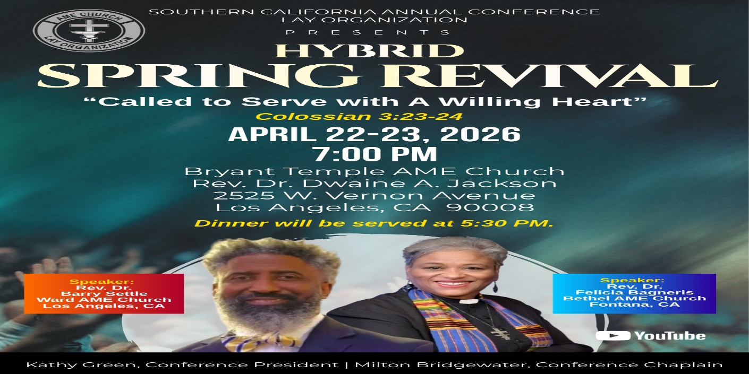

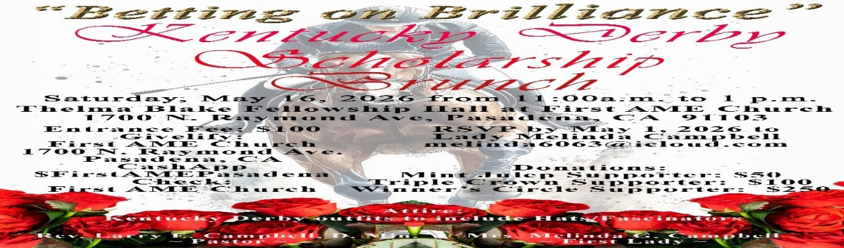

-11-

Scripture of the Day
He Is Risen. “Praise be to the God and Father of our Lord Jesus Christ! In his great mercy he has given us new birth into a living hope through the resurrection of Jesus Christ from the dead ...” 1 Peter 1:3

Quote of the Day
““The resurrection gives my life meaning and direction and the opportunity to start over no matter what my circumstances.” — Robert Flatt

Thought of the Week
“He is not here; for He is risen, as He said.” — Matthew 28:6
The resurrection of Jesus Christ is the defining declaration of our faith. It is God’s ultimate affirmation that life is stronger than death, hope is greater than despair, and love will always have the final word. What seemed like defeat on Friday was transformed into victory on Sunday morning.
When the women came to the tomb, they expected to find death—but instead, they encountered divine power. The stone was rolled away, not to let Jesus out, but to let us in—to witness that God had already done what seemed impossible.
The resurrection reminds us that God specializes in bringing life out of lifeless places. Dead dreams can live again. Broken hearts can be restored. Oppressed communities can rise with new strength and purpose. The same power that raised Jesus from the grave is at work in us, lifting us beyond fear, beyond struggle, and into new life.
On this day, we are called not only to celebrate the resurrection, but to live it—walking in faith, rising in hope, and standing in the victory that Christ has already secured.

Humor of the Week
There was this elderly couple who have been married for 60 years, never had an argument, never had a cross word. They were at a church function. Someone asked them the secret of their success. The man told how he always treated his wife with respect and how he took her on trips around the world. He said, “In fact, for our 25th wedding anniversary, I took her to Beijing China.” Everyone politely applauded. Someone said, “What did you do for your 50th wedding anniversary?” He said, “I went back and pick her up.” –

HOME DAILY BIBLE READINGS
April 6, 2026 – April 12, 2026 (Week 29, Malachi)
Monday Day 197 Ezekiel 40-42, Psalm 79:1-7
Tuesday Day 198 Ezekiel 43-45, Psalm 79:8-13
Wednesday Day 199 Ezekiel 46-48, Psalm 80:1-7
Thursday Day 200 Daniel 1-3, Psalm 80:8-15
Friday Day 201 Daniel 4-6, Psalm 80:16-19
Saturday Day 202 Daniel 7-9, Psalm 81:1-5
Sunday Day 203 Daniel 10-12, Psalm 81:6-12

-12-

Prayer Request(s)

Please notify the Church Office of Sick & Shut-in additions, deletions, or status/address changes.

Bishop Francine A. Brookins, Esq. Supervisor Miriam Burnett, MD
Presiding Elder Roosevelt & Dr. Kaye Lindsey Rev. Dr. Larry & Melinda Campbell
Richard Craig Hazel Clark Erica Woodard Jason Shirley Joshua Shirley Julian Shirley Ayanna Terry Cheryl Jamerson Gwendolyn Flowers Andrea Anderson Ocilda Files Danielle Clark Donita Towler Rev. Charles Brooks Doris Bailey Kimberly Woods Cynithia Grace Zechariah Robinson Diane Jordan Christopher McCarthy Wilma Haynes Jewell Malloy Calle Burns Noel Johnson Brittney Petty Taylor Family Deborah Burton Nettie McChristen Jacquelyn Walker Carita Smith
Rev. Rochelle Moore Lorene Butler Stella Pulliam Collette Blizzard The Caple Family Donita Towler
The Eaton Canyon Fire Victims Selene Cox Mel Beech

College Students

Let’s continue to support and pray for our beloved College Students

Isaiah Crowell Alecia Davis Chase Johnson Grant Blizzard

Tyler Johnson Richard Jones Tyrikk Lawson Makia Rose Talbert Isaiah Ringo Journey Rogers Elyse Sharp Kylee Sharp Zion Otano Elise Tervalon Grace Jones Jordan Patterson Kimberly Robinson Donovan Williams Jasmine Collins Brandon Bates Gabriel Blizzard

Sick and Shut-Ins
Andrew Oliver 1405 N. Roosevelt Avenue. Pasadena, CA 91104
Bettina Ayers Pasadena Meadows Nursing Home, 150 Bellefontaine St., Pas., CA 91105
Bobby Thomas 1052 E. Morada Place, Altadena, CA 91001
Carrie Wynne Senior Living Heritage, 161 N. Hemet St., Hemet, CA 92545
Doris Curd 11619 Woodcock Avenue, San Fernando, CA 91340
Edmund Riddle Active Care Mission Bay, 2440 Grand Avenue, San Diego, CA 92109
Eleanor Towler 975 E. Union Street, Unit #417, Pasadena, CA 91106
Elois Blizzard P. O. Box 3646, So. Pasadena, CA 91031
Emily Cormier-Ross 2549 La Fiesta Avenue, Altadena, CA 91001
Ernestine English 26 W. Fair Oaks Drive, Pasadena, CA 91103
Fred Caple 51 North 15th Street Haledon, NJ 07508
Gloria Cubit Clay 11745 Pierce St., Lake View Terrace, CA 91342
Hugh Hamberry 19225 Chole Rd., Apple Valley, CA 92307
Jeff Thomas 603 Tocino Dr. Duarte, CA 91010 | Mountain View Terrace
Jessie Smith 3925 S Jones BL, Apt 2118 Las Vegas, NV 89103| Spring Valley Community
Josephine Brown 15607 Saddleback Rd, Riverside, CA 92506
Linnie G. Nollie 2250 E. New York Drive, Altadena, CA 91001
Malika G. Hendry P. O. Box 94082, Pasadena, CA 91109
Mildred Lewis C/O Hazel Rohr, 884 W. Jane Court, Upland, CA 91786
Norma Burnett 618 Fairview Avenue, Unit #228, Arcadia, CA 91007
Opal Hampton 1030 Chevron Court, Pasadena, CA 91103
Paul Ratliff P.O. Box 40407 Pasadena, CA 91114
Ruthie Hopkins 1155 Via Verde , San Dimas, CA 91773
Virlyn Grant 15122 Orange Ave., Paramount, CA 90723
Wanda Nelson 3618 N. Fair Oaks Avenue, Altadena, CA 91001
William Hilliard 7504 Wynstone Pl., Fontana, CA 92336
Zell L. Hill 375 Barthe Drive, Pasadena, CA 91103

-13-

Sermon Notations

Scripture: _____________________________________________________________

Subject: _______________________________________________________________

Points of the Message: ___________________________________________________
_______________________________________________________________________
_______________________________________________________________________
_______________________________________________________________________
_______________________________________________________________________
_______________________________________________________________________
_______________________________________________________________________

Main Ideas of the Sermon: ________________________________________________
_______________________________________________________________________
_______________________________________________________________________
_______________________________________________________________________
_______________________________________________________________________
_______________________________________________________________________

Illustrations I want to remember: _________________________________________
_______________________________________________________________________
_______________________________________________________________________
_______________________________________________________________________
_______________________________________________________________________
_______________________________________________________________________
_______________________________________________________________________

What should I do as a result of this Sermon? ________________________________

_____________________________________________________
_____________________________________________________
_____________________________________________________
_____________________________________________________

-14-

