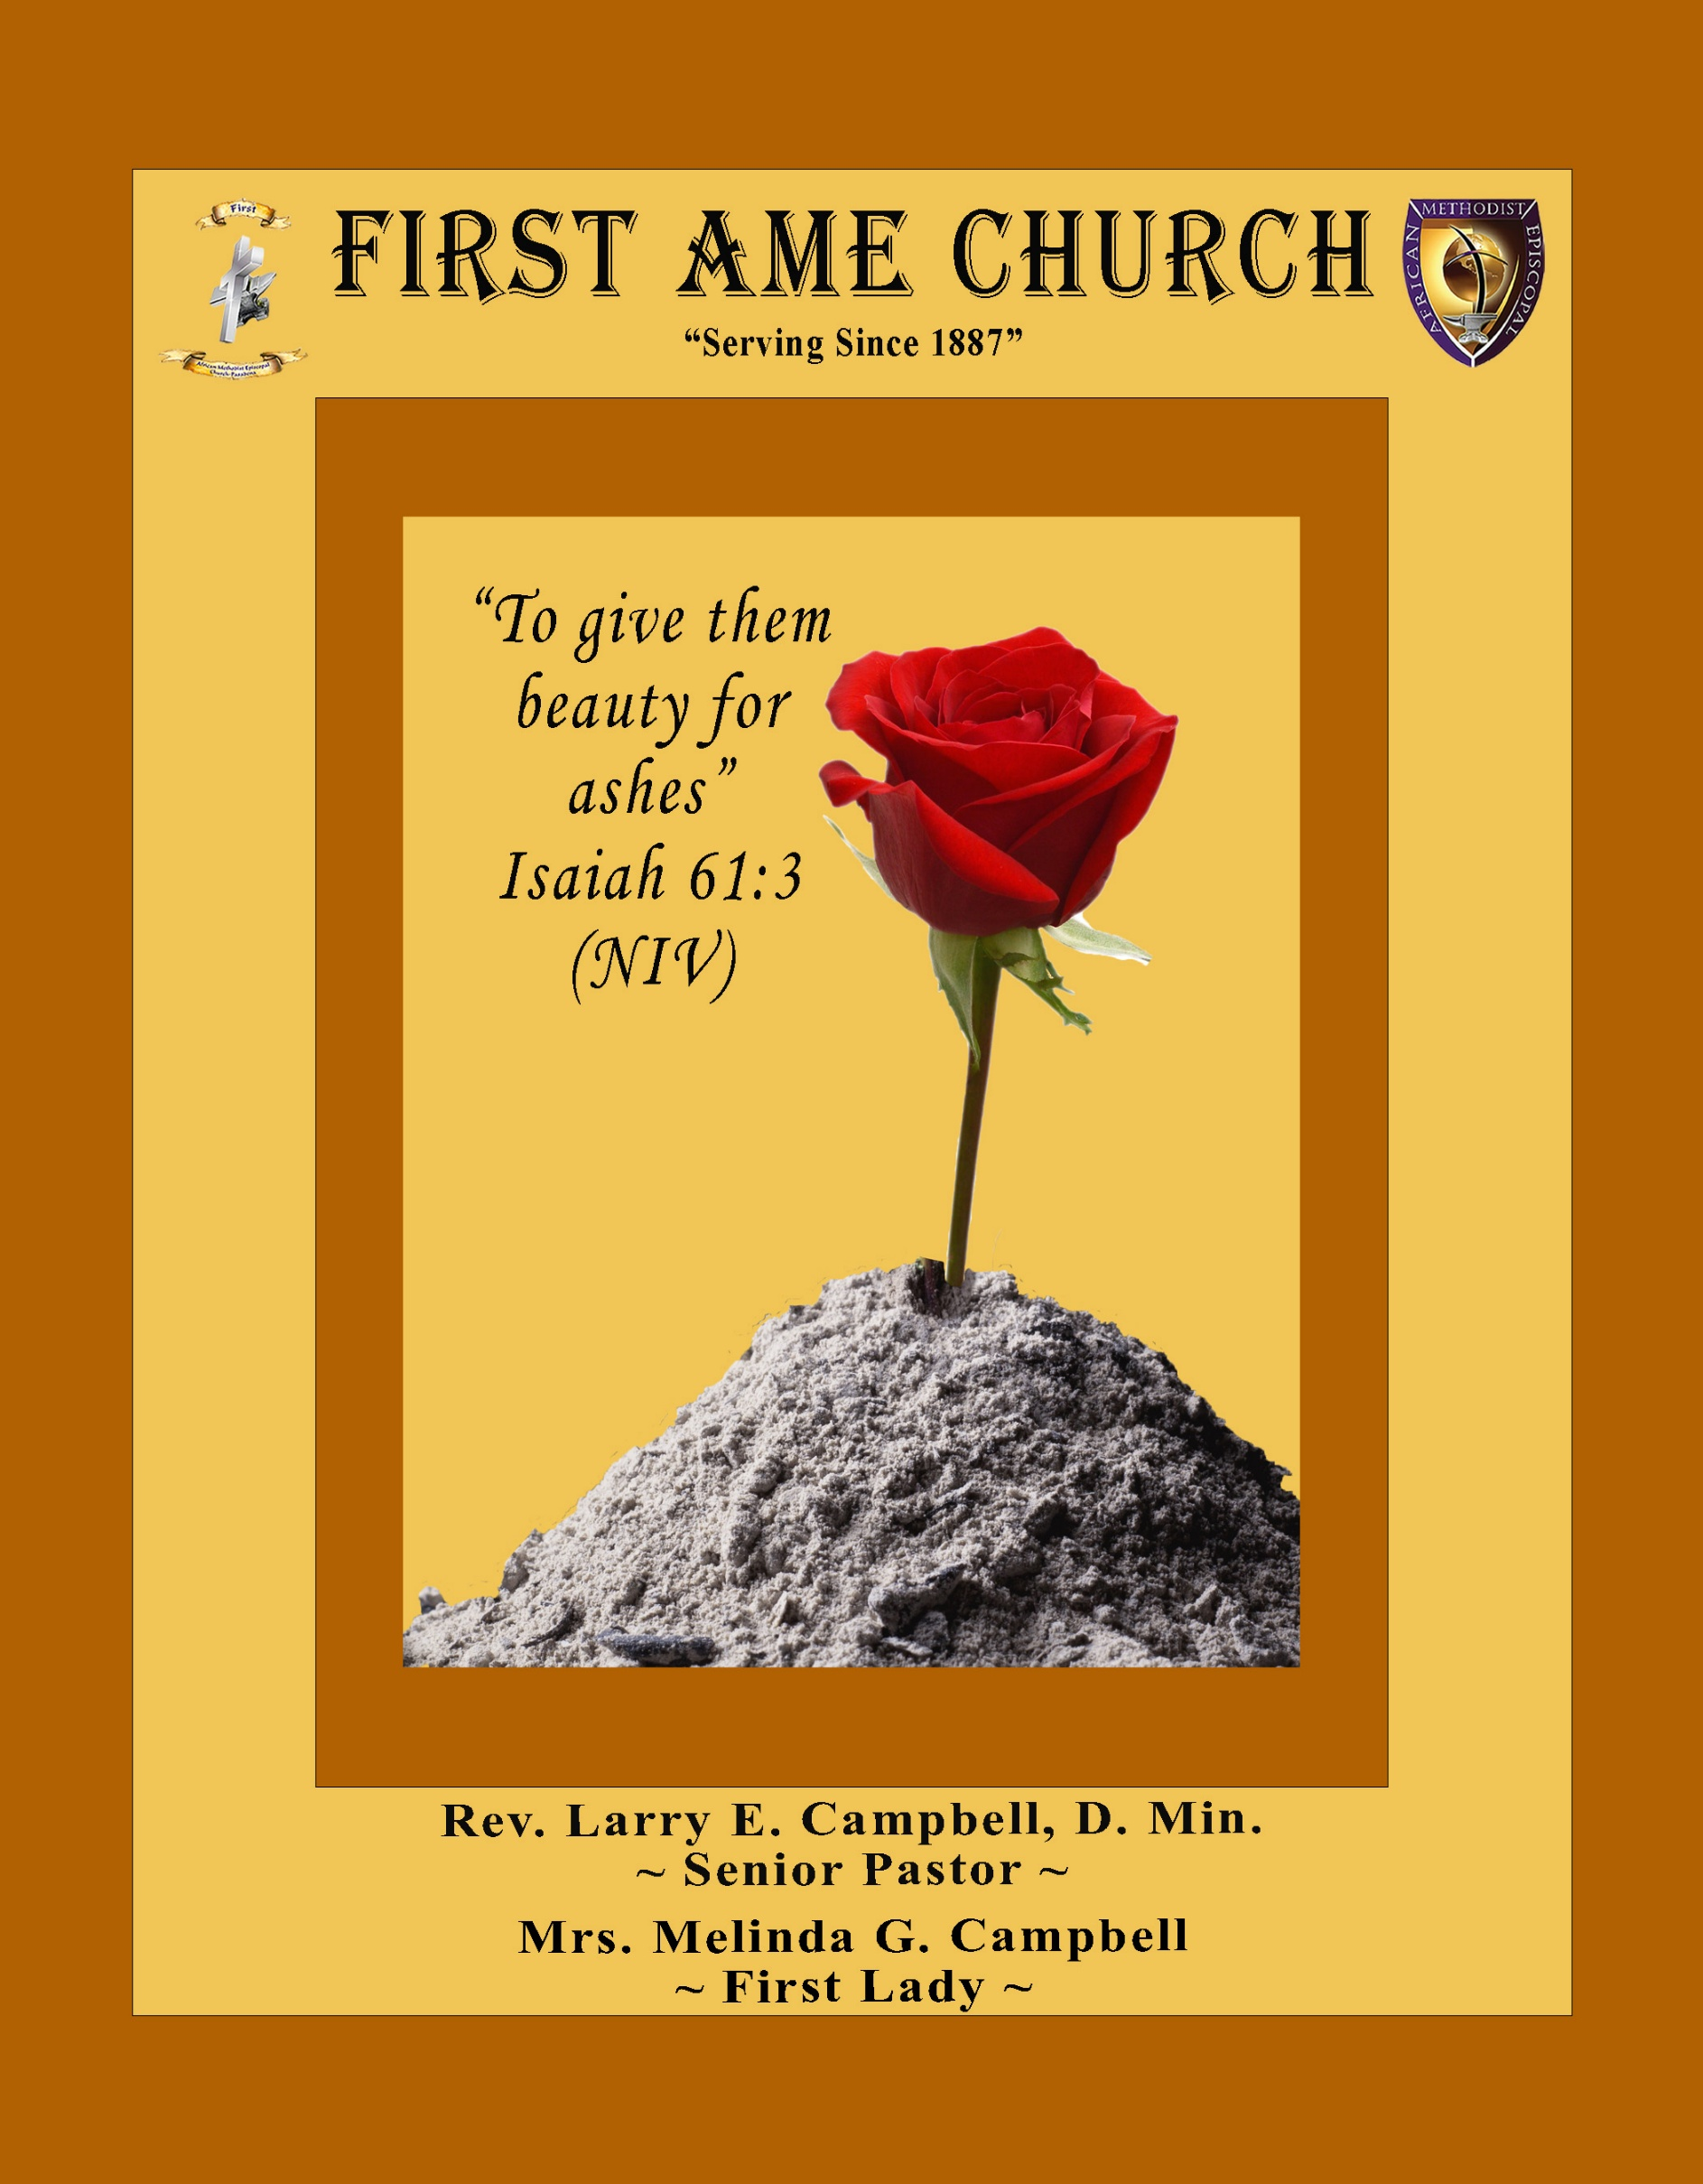
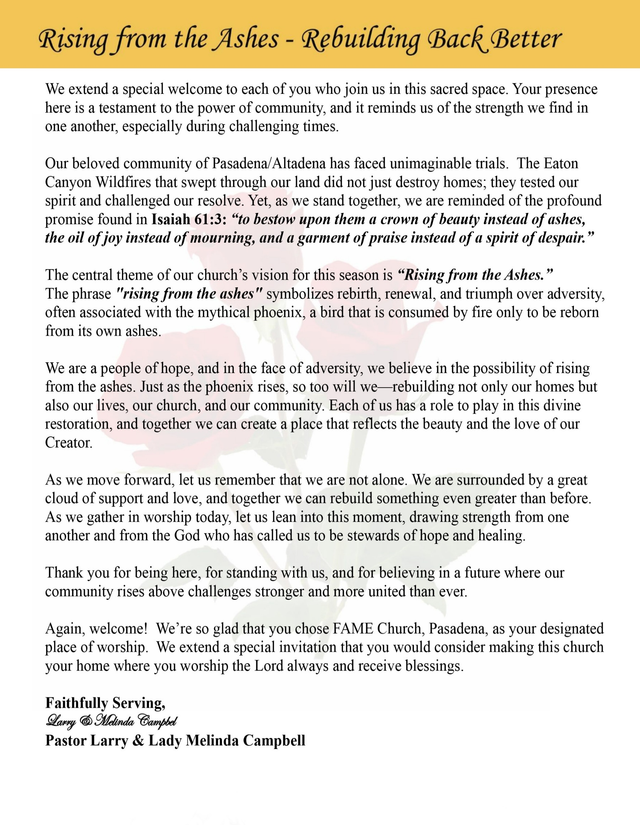

Sunday, April 12, 2026 | 9:30 a.m.

Rt. Rev. Francine A. Brookins, Esq., Presiding Bishop
Rev. Miriam Burnett, MD, MPH, Supervisor of Missions
Rev. Roosevelt Lindsey, Jr. Presiding Elder

The Rev. Dr. Larry E. Campbell ~ Senior Pastor ~ Minister

Mobile: (951) 587-1894 ~ Email: larrycampbell@famepasadena.org

Our First Lady: Mrs. Melinda G. Campbell

The Reverend Dr. Jennifer Oliver ~ Itinerant Elder -
The Reverend Dr. Nikia Smith-Robert ~ Itinerant Elder (Affiliated)
The Reverend Lois Woodard ~ Itinerant Elder Superannuated (Retired)
The Reverend Rochelle Wright Moore ~ Itinerant Deacon
The Reverend Deborah West-Jones ~ Local Elder
The Reverend Philis J. Griffin, MDiv ~ Local Elder
Dr. Phyllis Beech ~ Evangelist
Sister Tessie Bonner ~ Deaconess

Community Resource Center Director ~ Ms. Kischchen Hazelton Venerable
Church Administrative Assistant: Ms. Letha Rhymes

Church Office Hours:
Tue - Wed 9:00 am - 5:00 pm, & Fri 9:00 am -3:00 pm.
Closed for Lunch Daily: 12:00 pm - 1:00 pm.

Music Ministry
Dr. Timothy Davis, Minister of Music
Bro. Jimmy Watlington, Percussionist ~ Bro. Carlos Caldwell, Organist
Bro. Darien Dorsey, Keyboardist
Sis. Karen Law, Women’s Chorus Director ~ Sis. Tonia Graham, Children’s Choir Director
Bro. J. Renard Washington, New Generation’s Choir

FREE WI-FI service is available on the FAME Campus by accessing FAME 1700
Password: 6267980503

-3-

~ Order of Worship Experience ~

Warning: This order of worship is subject to change without warning or prior notice --- everything is governed by the Sovereignty of the Holy Spirit.

+ + + The Altar Call +++

Praise & Worship

Doxology: “Praise God From Whom All Blessings Flow”

The Call to Worship Bro. Jimmy Watlington

Leader: I was glad when they said unto me, let us go into the house of the Lord, our feet shall stand within Thy gates O Jerusalem! (Psalm 122:1)

People: For a day in Thy courts is better than a thousand. I had rather be a doorkeeper in the house of my God than to dwell in the tents of wickedness. (Psalm 84:10)

Leader: Because of the house of the Lord our God, I will seek Thy good.
(Psalm 122:9)

People: Those that be planted in the house of the Lord, shall flourish in the courts of our God. (Psalm 92:13)

Leader: Blessed are they that dwell in Thy house. Lord, I have loved Thy habitation, the place where Thy honor dwelleth. (Psalm 26:8)

People: For the Lord is in His holy temple; let all the earth keep silence before Him.
(Habakkuk 2:20)

Leader: Let the words of my mouth and the meditation of my heart, be acceptable in Thy sight, O Lord my strength and my redeemer. (Psalm 19:14)

Unison: O Sing unto the Lord a new song, for He has done marvelous things. Make a
joyful noise unto the Lord, all the earth, sing His praises. (Psalm 98:1, 4)

-4-

The Hymn of Praise A.M.E. Hymnal #21

TO GOD BE THE GLORY

(Words: Fanny J. Crosby, 1820-1915)

To God be the glory, great things He hath done;
So loved He the world that He gave us His Son,
Who yielded His life an atonement for sin,
And opened the life-gate that all may go in.

Refrain

Praise the Lord, praise the Lord, Let the earth hear His voice!
Praise the Lord, praise the Lord, Let the people rejoice!
O come to the Father, through Jesus the Son,
And give Him the glory, great things He hath done.

Refrain

O perfect redemption, the purchase of blood,
To every believer the promise of God;
The vilest offender who truly believes,
That moment from Jesus a pardon receives.

Refrain

Great things He hath taught us, Great things He hath done,
And great our rejoicing through Jesus the Son;
But purer, and higher, and greater will be
Our wonder, our transport, when Jesus we see.

Refrain

The Invocation Sis. Tonia Graham

Ministry of Music The Praise Team

-5-

Scripture Lesson Sis. Sherron Bennett
(Please Stand for the Reading of God’s Words)

Revelation 3:1-6 (New International Version) — To the Church in Sardis
3 “To the angel of the church in Sardis write:
These are the words of him who holds the seven spirits of God and the seven stars. I know your deeds; you have a reputation of being alive, but you are dead. ² Wake up! Strengthen what remains and is about to die, for I have found your deeds unfinished in the sight of my God. ³ Remember, therefore, what you have received and heard; hold it fast, and repent. But if you do not wake up, I will come like a thief, and you will not know at what time I will come to you.
⁴ Yet you have a few people in Sardis who have not soiled their clothes. They will walk with me, dressed in white, for they are worthy. ⁵ The one who is victorious will, like them, be dressed in white. I will never blot out the name of that person from the book of life, but will acknowledge that name before my Father and his angels. ⁶ Whoever has ears, let them hear what the Spirit says to the churches.

The Summary of the Decalogue Bro. Jay Washington
LEADER: From all that dwell below the skies…
SUNG: From all that dwell below the skies, Let the Creator’s praise arise; Let the
Redeemer’s Name be sung, through every land, by every tongue.
LEADER: Hear what Christ our Savior saith, Thou shalt love the Lord thy God with all thy
heart, with all thy soul, and with all thy mind. This is the first and great
commandment. And the second is like unto it: Thou shalt love thy neighbor
as thyself. On these two commandments hang all the law and the prophets.
SUNG: Glory be to the Father, and to the Son, and to the Holy Ghost; as it was in
the beginning, is now, and ever shall be, world without end. A~Men

Abbreviated Announcements/Visitor’s Welcome

-6-



Wedding Anniversaries
This Month

90 Plus Birthday Celebrations

April 4th James Ross will celebrate his 93rd birthday
April 8th Mildred Lewis will celebrate her 98th birthday

Birthdays Recognized for the Month


“The best Birthday wish that you can get for the day is that you may live each moment of your life to the very fullest, without any regrets.” Anonymous

Special Congregational Hymn (Sing along)
#450 Blessed Assurance, Jesus Is Mine

Tithes, Gifts, and Offering Litany (Theme: Holes in Your Pockets – Haggai 1:6-7)
Bro. Kenneth Caudle

Leader: Scripture declares, “You have sown much, and bring in little; you eat, but you do
not have enough… and he who earns wages, earns wages to put into a bag with
holes.”

People: Lord, we recognize that when we neglect You, our efforts are never enough.

Leader: God speaks again and says, “Consider your ways.”

People: Today, we pause and examine our hearts, our priorities, and our
stewardship.

Leader: Too often we wonder why blessings seem to slip through our hands…

People: But today we choose obedience over excuses, and faithfulness over fear.
[Continued on page 8]

-7-

Tithes, Gifts, and Offering Litany - (Continued)
Leader: When we honor God first, He redeems what we thought was lost.

People: We will no longer live with holes in our pockets, but with purpose in our giving.

Leader: As we bring our tithes and offerings, we declare that God is first in our lives.

People: We sow with expectation, trusting God to restore, replenish, and overflow.

Leader: We give not out of obligation, but out of gratitude and trust.

People: Lord, close every hole, rebuke lack, and bless what we release into Your hands.

Leader: Now, let us give with cheerful hearts and renewed commitment.

ALL: We have considered our ways, and today we choose to honor God with our tithes,
our gifts, and our offerings. Amen.

The following Electronic GIVING Platforms are creditable methods to GIVE to FAME:

#1. GIVELIFY - Mobile Giving App available on the App Store. It’s easy to set up, just follow the guidelines.

#2. Cash App: $FirstAMEPASADENA

#3. Mail in your Tithes & Offering - If you would like to mail your tithes and offering by check or money order, please send it to: First AME Church, 1700 N. Raymond Avenue, Pasadena, CA 91103.

#4. Drop off your Tithes & Offering - During business hours in the basket outside of the office.

Choral Response: “All things come of Thee, O Lord; and of Thine own have we given Thee. Amen.”

Children’s Church Dismissal

Sermonic Selection The Praise Team

The Preached Word Pastor Larry E. Campbell

The Doxology

The Benediction

-8-

Scripture of the Day
Stay Woke. “So then, let us not be like others, who are asleep, but let us be awake and sober". 1 Thessalonians 5:6

Quote of the Day
"One of the great liabilities of history is that all too many people fail to remain awake through great periods of social change." — Martin Luther King, Jr.

Thought of the Week
“Therefore let us not sleep, as others do, but let us watch and be sober.”
1 Thessalonians 5:6
In today’s culture, the phrase “stay woke” often means being aware—alert to what’s happening around you. Spiritually, God calls us to an even deeper awareness: to be awake to His presence, His truth, and His movement in our lives.
To stay spiritually woke means we don’t drift through life on autopilot. We pay attention to what God is saying. We guard our hearts, examine our choices, and remain sensitive to the Holy Spirit. It means we don’t become numb to sin, complacent in our faith, or distracted by the noise of the world.
Being awake also means being ready. Ready to serve, ready to love, ready to respond when God calls. When we are spiritually alert, we can discern truth from deception and walk in purpose rather than confusion.
Today, ask yourself: Am I spiritually alert, or have I grown comfortable and unaware? God is always speaking—stay awake so you don’t miss Him.
.
Humor of the Week
There was a pastor who found a dead mule on the church grounds. He called the health department. They said they couldn’t pick it up without authorization from the mayor. Well, the mayor was not known to be rude and hard to get along with. When the pastor called, the mayor didn’t disappoint. He started ranting and raving. Finally said, “why did you even call me, isn’t it your job to bury the dead?” The pastor asked God for the right response. He said, “Yes, mayor, it’s my job to bury the dead but I always like to notify the next of kin first.”

HOME DAILY BIBLE READINGS
April 13, 2026 – April 19, 2026 (Week 30, Matthew)
Monday Day 204 Hosea 1-7, Psalm 81:13-16
Tuesday Day 205 Hosea 8-14, Psalm 82
Wednesday Day 206 Joel, Psalm 83:1-8
Thursday Day 207 Amos 1-5, Psalm 83:9-18
Friday Day 208 Amos 6-9, Psalm 84:1-7
Saturday Day 209 Obadiah, Jonah, Psalm 84:8-12
Sunday Day 210 Micah, Nahum, Psalm 85:1-7

-9-

ANNOUNCEMENTS

WELCOME! WELCOME! WELCOME!
It is with great pleasure and joy that we officially welcome Mildred Compton and Gabrielle Lambert to the FAME Family kinship. We are truly blessed and very grateful for her presence and valued membership in our church family.

Senior Ministry Luncheon
You are invited to join us to enjoy good fellowship, good food, and helpful information at the FAME Senior Ministry gathering on Tues., April 14, 2026, 11:30 am |* Mix and Mingle: 11:30 -11:45 am| * Program: 11:45 - 12:45 TREASURES OF THE HEART |
* Lunch: 1:00 p.m.
Bring an object or a photo that is a treasure of your heart. It can be something that reflects your story of faith, resilience, fortitude, etc., to share with the group. Each participant will have 2-3 minutes to speak about their treasure. Remember: when one person shares, we all receive something - a lesson, a memory, a feeling, or even healing. So, let's share our treasure, honor our stories, uplift one another and grow closer as a family in faith. Each participant will receive a gift. Bring a friend. All are welcome.

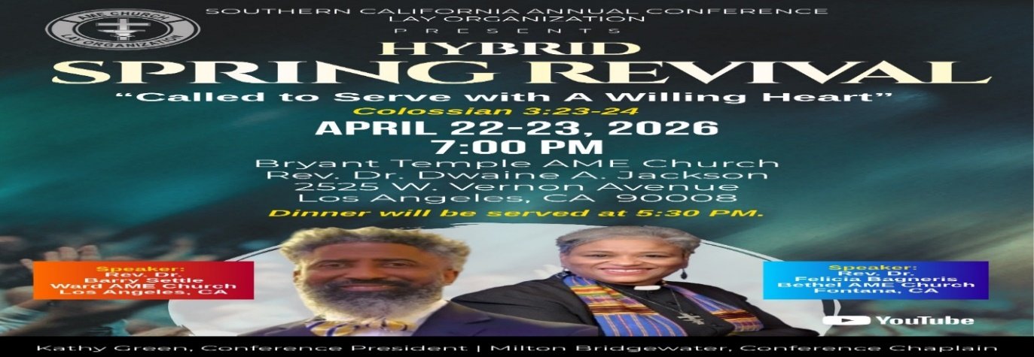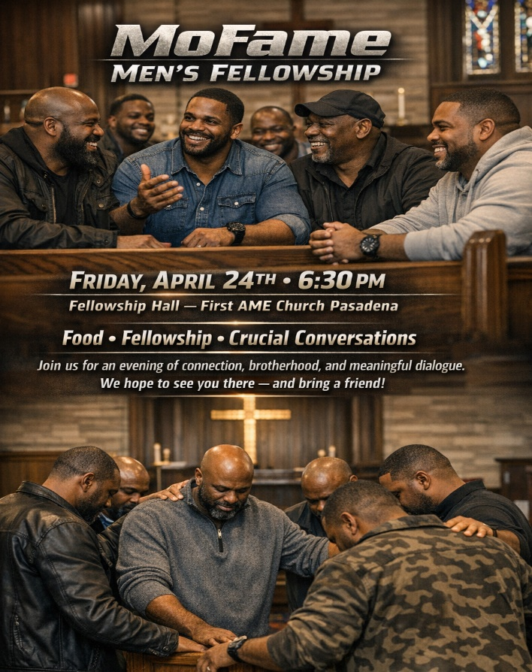

-10-

ANNOUNCEMENTS (Continued)

Virtual Church Conference
The presence of ALL members is requested at a Special Pastoral Church Conference
Tuesday, April 28, 2026 | 6:00 P.M.
Join Zoom Meeting
https://us02web.zoom.us/j/88158682168?pwd=lAbVIgNTklLRjAjdB3QuNJ5sQrWVD5.1
Meeting ID: 881 5868 2168 | Passcode: 989473





-11-

ANNOUNCEMENTS (Continued)

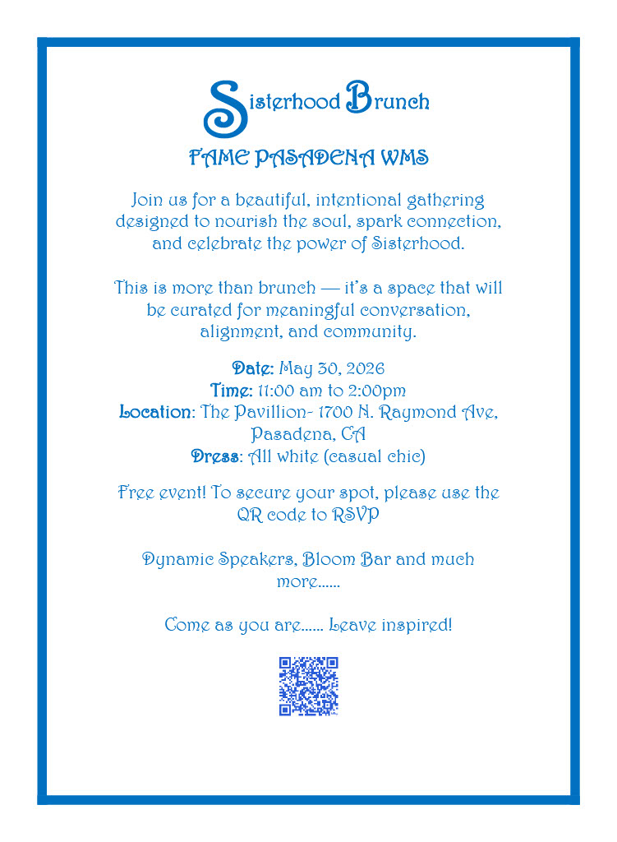

-12-

Prayer Request(s)
Please notify the Church Office of Sick & Shut-in additions, deletions, or status/address changes.

Bishop Francine A. Brookins, Esq. Supervisor Miriam Burnett, MD
Presiding Elder Roosevelt & Dr. Kaye Lindsey Rev. Dr. Larry & Melinda Campbell
Richard Craig Hazel Clark Erica Woodard Jason Shirley Joshua Shirley Julian Shirley Ayanna Terry Cheryl Jamerson Gwendolyn Flowers Andrea Anderson Ocilda Files Danielle Clark Donita Towler Rev. Charles Brooks Doris Bailey Kimberly Woods Cynithia Grace Zechariah Robinson Diane Jordan Christopher McCarthy Wilma Haynes Calle Burns Noel Johnson Brittney Petty Taylor Family Deborah Burton Nettie McChristen Jacquelyn Walker The Caple Family
Rev. Rochelle Moore Lorene Butler Stella Pulliam Collette Blizzard
The Eaton Canyon Fire Victims Selene Cox Mel Beech

College Students

Let’s continue to support and pray for our beloved College Students

Isaiah Crowell Alecia Davis Chase Johnson Grant Blizzard Gabriel Blizzard

Tyler Johnson Richard Jones Tyrikk Lawson Makia Rose Talbert Isaiah Ringo Journey Rogers Elyse Sharp Kylee Sharp Zion Otano Elise Tervalon Grace Jones Jordan Patterson Kimberly Robinson Donovan Williams Jasmine Collins Brandon Bates

Sick and Shut-Ins
Andrew Oliver 1405 N. Roosevelt Avenue. Pasadena, CA 91104
Barbara Buchanan 616 Rio Grande St. Pasadena, CA 91104
Bettina Ayers Pasadena Meadows Nursing Home, 150 Bellefontaine St., Pas., CA 91105
Bobby Thomas 1052 E. Morada Place, Altadena, CA 91001
Doris Curd 11619 Woodcock Avenue, San Fernando, CA 91340
Edmund Riddle Active Care Mission Bay, 2440 Grand Avenue, San Diego, CA 92109
Eleanor Towler 975 E. Union Street, Unit #417, Pasadena, CA 91106
Elois Blizzard P. O. Box 3646, So. Pasadena, CA 91031
Emily Cormier-Ross 2549 La Fiesta Avenue, Altadena, CA 91001
Ernestine English 26 W. Fair Oaks Drive, Pasadena, CA 91103
Fred Caple 51 North 15th Street Haledon, NJ 07508
Gloria Cubit Clay 11745 Pierce St., Lake View Terrace, CA 91342
Hugh Hamberry 19225 Chole Rd., Apple Valley, CA 92307
Jeff Thomas 603 Tocino Dr. Duarte, CA 91010 | Mountain View Terrace
Jessie Smith 3925 S Jones BL, Apt 2118 Las Vegas, NV 89103| Spring Valley Community
Josephine Brown 15607 Saddleback Rd, Riverside, CA 92506
Linnie G. Nollie 2250 E. New York Drive, Altadena, CA 91001
Malika G. Hendry P. O. Box 94082, Pasadena, CA 91109
Mildred Lewis C/O Hazel Rohr, 884 W. Jane Court, Upland, CA 91786
Norma Burnett 618 Fairview Avenue, Unit #228, Arcadia, CA 91007
Opal Hampton 1030 Chevron Court, Pasadena, CA 91103
Paul Ratliff P.O. Box 40407 Pasadena, CA 91114
Ruthie Hopkins 1155 Via Verde , San Dimas, CA 91773
Virlyn Grant 15122 Orange Ave., Paramount, CA 90723
Wanda Nelson 3618 N. Fair Oaks Avenue, Altadena, CA 91001
William Hilliard 7504 Wynstone Pl., Fontana, CA 92336
Zell L. Hill 375 Barthe Drive, Pasadena, CA 91103

-13-

Sermon Notations

Scripture: _____________________________________________________________

Subject: _______________________________________________________________

Points of the Message: ___________________________________________________
_______________________________________________________________________
_______________________________________________________________________
_______________________________________________________________________
_______________________________________________________________________
_______________________________________________________________________
_______________________________________________________________________

Main Ideas of the Sermon: ________________________________________________
_______________________________________________________________________
_______________________________________________________________________
_______________________________________________________________________
_______________________________________________________________________
_______________________________________________________________________

Illustrations I want to remember: _________________________________________
_______________________________________________________________________
_______________________________________________________________________
_______________________________________________________________________
_______________________________________________________________________
_______________________________________________________________________
_______________________________________________________________________

What should I do as a result of this Sermon? ________________________________

_____________________________________________________
_____________________________________________________
_____________________________________________________
_____________________________________________________

-14-

