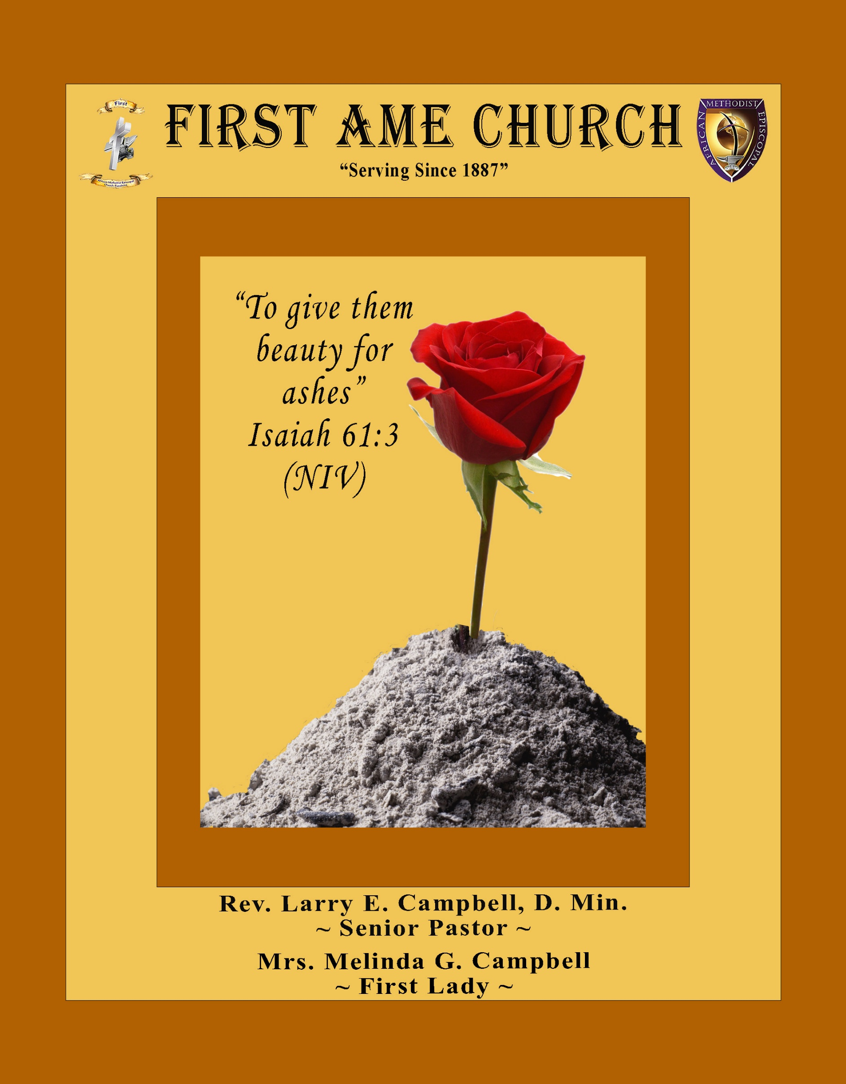
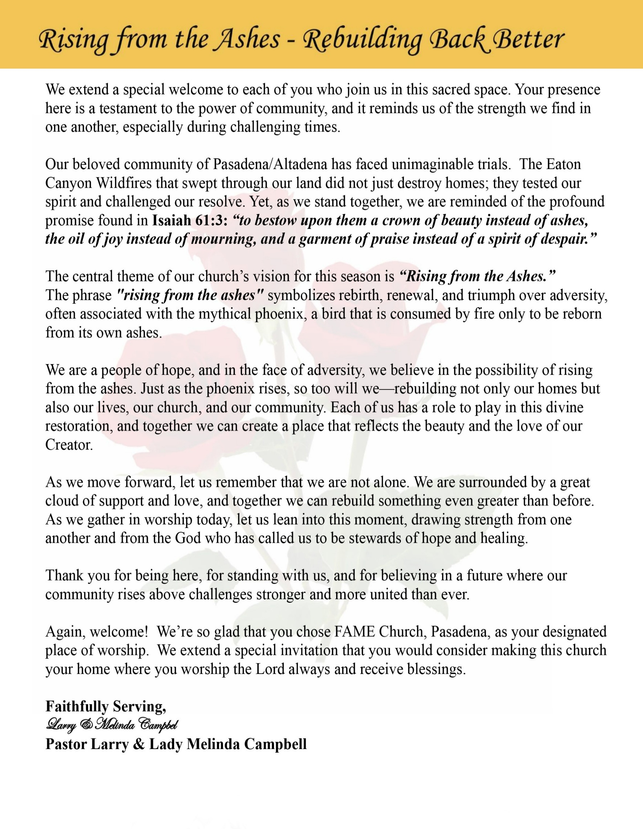

Sunday, April 19, 2026 | 9:30 a.m.

Rt. Rev. Francine A. Brookins, Esq., Presiding Bishop
Rev. Miriam Burnett, MD, MPH, Supervisor of Missions
Rev. Roosevelt Lindsey, Jr. Presiding Elder

The Rev. Dr. Larry E. Campbell ~ Senior Pastor ~ Minister

Mobile: (951) 587-1894 ~ Email: larrycampbell@famepasadena.org

Our First Lady: Mrs. Melinda G. Campbell

The Reverend Dr. Jennifer Oliver ~ Itinerant Elder -
The Reverend Dr. Nikia Smith-Robert ~ Itinerant Elder (Affiliated)
The Reverend Lois Woodard ~ Itinerant Elder Superannuated (Retired)
The Reverend Rochelle Wright Moore ~ Itinerant Deacon
The Reverend Deborah West-Jones ~ Local Elder
The Reverend Philis J. Griffin, MDiv ~ Local Elder
Dr. Phyllis Beech ~ Evangelist
Sister Tessie Bonner ~ Deaconess

Community Resource Center Director ~ Ms. Kischchen Hazelton Venerable
Church Administrative Assistant: Ms. Letha Rhymes

Church Office Hours:
Tue - Wed 9:00 am - 5:00 pm, & Fri 9:00 am -3:00 pm.
Closed for Lunch Daily: 12:00 pm - 1:00 pm.

Music Ministry
Dr. Timothy Davis, Minister of Music
Bro. Jimmy Watlington, Percussionist ~ Bro. Carlos Caldwell, Organist
Bro. Darien Dorsey, Keyboardist
Sis. Karen Law, Women’s Chorus Director ~ Sis. Tonia Graham, Children’s Choir Director
Bro. J. Renard Washington, New Generation’s Choir

FREE WI-FI service is available on the FAME Campus by accessing FAME 1700
Password: 6267980503

-3-

~ Order of Worship Experience ~

Warning: This order of worship is subject to change without warning or prior notice --- everything is governed by the Sovereignty of the Holy Spirit.

+ + + The Altar Call +++

Praise & Worship

Doxology: “Praise God From Whom All Blessings Flow”

The Call to Worship Bro. Charles Ludd, Jr., Esq.

Leader: I was glad when they said unto me, let us go into the house of the Lord, our feet shall stand within Thy gates O Jerusalem! (Psalm 122:1)

People: For a day in Thy courts is better than a thousand. I had rather be a doorkeeper in the house of my God than to dwell in the tents of wickedness. (Psalm 84:10)

Leader: Because of the house of the Lord our God, I will seek Thy good.
(Psalm 122:9)

People: Those that be planted in the house of the Lord, shall flourish in the courts of our God. (Psalm 92:13)

Leader: Blessed are they that dwell in Thy house. Lord, I have loved Thy habitation, the place where Thy honor dwelleth. (Psalm 26:8)

People: For the Lord is in His holy temple; let all the earth keep silence before Him.
(Habakkuk 2:20)

Leader: Let the words of my mouth and the meditation of my heart, be acceptable in Thy sight, O Lord my strength and my redeemer. (Psalm 19:14)

Unison: O Sing unto the Lord a new song, for He has done marvelous things. Make a
joyful noise unto the Lord, all the earth, sing His praises. (Psalm 98:1, 4)

-4-

The Congregational Song of Praise Every Praise

(Repeat Verse 3 times)
Every praise is to our God.
Every word of worship with one accord
Every praise every praise is to our God.
Sing hallelujah to our God
Glory hallelujah is due our God
Every praise every praise is to our God.

(Repeat Chorus 3 times)
God my Savior
God my Healer
God my Deliverer
Yes He is, yes He is

Yes He is, yes He is, yes He is, yes He is
Yes He is, yes He is, yes He is, yes He is

(Repeat Verse 2 times)
Every praise is to our God.
Every word of worship with one accord
Every praise, every praise, every praise, every praise
Every praise, every praise, every praise, every praise
Every praise, every praise, every praise, every praise
All of my worship, every praise,
Every praise, every praise
When you see me dancing, every praise
Every praise, every praise
When you see me shoutin', every praise
Every praise, every praise, every praise, every praise
Every praise, every praise, to our god
Is to our God

The Invocation Sis. Grenisha Holmes

Ministry of Music The Praise Team

-5-

Scripture Lesson Sis. Jessica Ludd, Esq.
(Please Stand for the Reading of God’s Words)

Luke 24:13-29 (New International Version) — “Under the Influence of Jesus”
Leader: ¹³ Now that same day two of them were going to a village called Emmaus, about
seven miles from Jerusalem. ¹⁴ They were talking with each other about everything
that had happened.

People: ¹⁵ As they talked and discussed these things with each other, Jesus himself
came up and walked along with them; ¹⁶ but they were kept from recognizing
him.

Leader: ¹⁷ He asked them, “What are you discussing together as you walk along?”
They stood still, their faces downcast. ¹⁸ One of them, named Cleopas, asked him,
“Are you the only one visiting Jerusalem who does not know the things that have
happened there in these days?”

People: ¹⁹ “What things?” he asked.

Leader: “About Jesus of Nazareth,” they replied. “He was a prophet, powerful in word and
deed before God and all the people. ²⁰ The chief priests and our rulers handed him
over to be sentenced to death, and they crucified him; ²¹ but we had hoped that he
was the one who was going to redeem Israel. And what is more, it is the third
day since all this took place.

People: ²² In addition, some of our women amazed us. They went to the tomb early this
morning ²³ but didn’t find his body. They came and told us that they had seen
a vision of angels, who said he was alive. ²⁴ Then some of our companions went
to the tomb and found it just as the women had said, but they did not see
Jesus.”

Leader: ²⁵ He said to them, “How foolish you are, and how slow to believe all that the
prophets have spoken! ²⁶ Did not the Messiah have to suffer these things and then
enter his glory?” ²⁷ And beginning with Moses and all the Prophets, he explained
to them what was said in all the Scriptures concerning himself.

ALL: ²⁸ As they approached the village to which they were going, Jesus continued on
as if he were going farther. ²⁹ But they urged him strongly, “Stay with us, for
it is nearly evening; the day is almost over.” So he went in to stay with them.

-6-

The Summary of the Decalogue Bro. Guy Woods
LEADER: From all that dwell below the skies…
SUNG: From all that dwell below the skies, Let the Creator’s praise arise; Let the
Redeemer’s Name be sung, through every land, by every tongue.
LEADER: Hear what Christ our Savior saith, Thou shalt love the Lord thy God with all thy
heart, with all thy soul, and with all thy mind. This is the first and great
commandment. And the second is like unto it: Thou shalt love thy neighbor
as thyself. On these two commandments hang all the law and the prophets.
SUNG: Glory be to the Father, and to the Son, and to the Holy Ghost; as it was in
the beginning, is now, and ever shall be, world without end. A~Men

Abbreviated Announcements/Visitor’s Welcome

K-FAME Radio
Children’s Dance Ministry Roses of Worship



Special Congregational Hymn (Sing along)
#332 Nearer, My God, to Thee

Tithes, Gifts, and Offering Litany (Centered around Malachi 3:6-12)
Sis. Juanita West-Tillman

Leader: For I am the Lord, I do not change; therefore, we are not consumed.

People: Because God is faithful, we can trust Him with all we have.

Leader: “Return to Me, and I will return to you,” says the Lord of hosts.

People: We return to God now through our giving, with grateful and obedient hearts.

Leader: Will a people rob God? Yet you have robbed Me in tithes and offerings.

People: Today we choose faithfulness over fear, generosity over withholding.
[Continued on page 8]

-7-

Tithes, Gifts, and Offering Litany [Continued]

Leader: Bring the whole tithe into the storehouse, that there may be food in My house.

People: We bring our best, knowing God is our source and our sustainer.

Leader: “Test Me in this,” says the Lord, “and see if I will not open the windows of heaven.”

People: We give in faith, believing God will pour out blessings we cannot contain.

Leader: I will rebuke the devourer and protect what you have sown.

People: We trust God to cover, keep, and multiply what we release.

Leader: All nations will call you blessed, for you will be a delightful land. As we give, we
declare we are blessed to be a blessing!

All Together: Lord, receive our tithes and offerings. We give with joy, expectation, and trust
in Your unchanging promise. Amen!

The following Electronic GIVING Platforms are creditable methods to GIVE to FAME:

#1. GIVELIFY - Mobile Giving App available on the App Store. It’s easy to set up, just follow the guidelines.

#2. Cash App: $FirstAMEPASADENA

#3. Mail in your Tithes & Offering - If you would like to mail your tithes and offering by check or money order, please send it to: First AME Church, 1700 N. Raymond Avenue, Pasadena, CA 91103.

#4. Drop off your Tithes & Offering - During business hours in the basket outside of the office.

Choral Response: “All things come of Thee, O Lord; and of Thine own have we given Thee. Amen.”

Children’s Church Dismissal

Sermonic Selection The Praise Team

The Preached Word Pastor Larry E. Campbell

The Doxology

The Benediction

-8-

Scripture of the Day
Who’s influencing You? “Do not be deceived: ‘Bad company corrupts good character.”
1 Corinthians 15:33

Quote of the Day
" Stay away from negative people. They have a problem for every solution.”
— Albert Einstein

Thought of the Week
Proverbs 13:20 – “He that walketh with wise men shall be wise: but a companion of fools shall be destroyed.”
Every day, whether we realize it or not, we are being shaped by the people around us. Conversations, relationships, environments—these are not neutral. They are forming our thinking, our decisions, and ultimately our destiny.
Proverbs 13:20 gives us a simple but powerful truth: who you walk with determines where you’re headed. If you surround yourself with wisdom—people who seek God, speak truth, and live with integrity—you will grow in wisdom. But if your circle pulls you away from God, normalizes poor choices, or feeds negativity, it will eventually cost you.
This isn’t just about friendships—it’s about influence.
Who has your ear?
Who has your attention?
Who has a seat at your table?
You can’t expect a wise life with foolish influences.
Sometimes growth requires hard decisions—distancing from certain voices and drawing closer to those who sharpen your faith. God often uses people as instruments of direction, correction, and blessing. Reflection: Take a moment and evaluate your circle. Are the people influencing you helping you become who God has called you to be?

Humor of the Week
A man goes to church one day and kneels before the altar,
"God, I know you are listening, I am really short of money, can I please win the lottery?"
A week passes, nothing happens so the man returns,
"God, please, please can I win the lottery, I promise to give half the money to the poor".
Another week passes, he becomes more desperate,
"Please God, let me win the lottery, I will give half the money to the poor and build a new church".
Just then there is a crack of thunder and a huge booming voice from the skies.
"Look, could you meet me halfway, can you at least buy a ticket?"

HOME DAILY BIBLE READINGS
April 20, 2026 – April 26, 2026 (Week 31, Mark)
Monday Day 211 Habakkuk, Zephaniah, Psalm 85:8-13
Tuesday Day 212 Haggai, Psalm 86:1-7
Wednesday Day 213 Zechariah 1-7, Psalm 86:8-13
Thursday Day 214 Zechariah 8-14, Psalm 86:13-17
Friday Day 215 Malachi, Psalm 87
Saturday Day 216 Matthew 1:1-2:18, Psalm 88:1-9
Sunday Day 217 Matthew 2:19-4:25, Psalm 88:10-18

-9-

ANNOUNCEMENTS

Everyone is encouraged to join our weekly Christian Education Sessions

VIRTUAL ADULT CHURCH SCHOOL
Sunday Mornings at 8:00 a.m.
http://us02web.zoom.us/j/844840183?pwd-sm0w1yvmvhOvC13175urZ2vr7M3EtU.1

HYBRID PASTOR’S WEEKLY BIBLE STUDY
Wednesdays at 11:00 a.m.
https://us02web.zoom.us/j/84484840183?pwd=sm0w1yvmvhOvC13l75urZ2vr7M3EtU.1
Meeting ID: 844 8484 0183 | Passcode: 357260

WEEKLY TELECONFERENCE PRAYERS SESSIONS
Wednesdays at 5:30 a.m. and 6:00 p.m.
Conference Call Number: (530_ 881-1212
Access Code: 234575160#

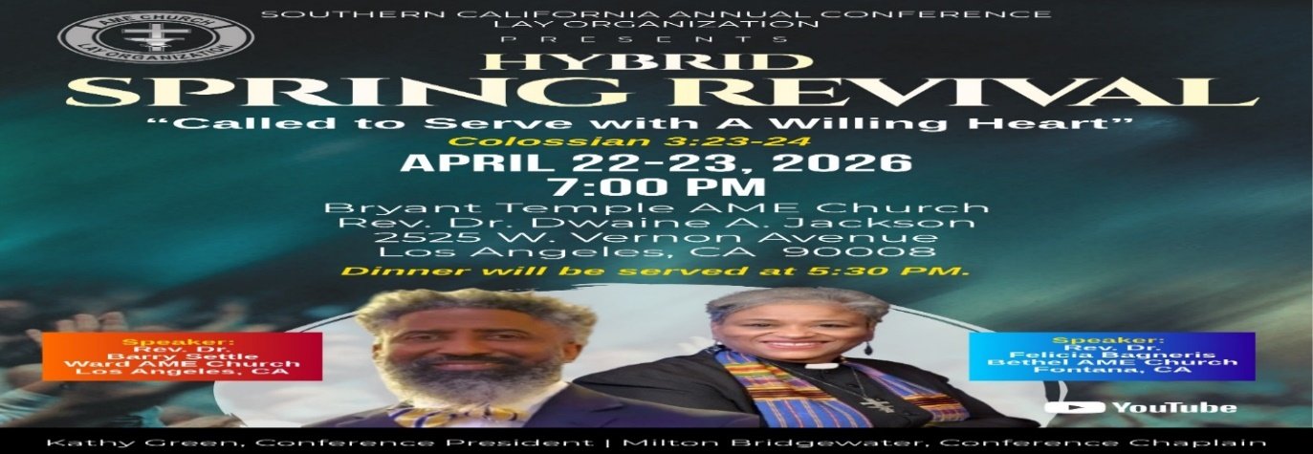

-10-

ANNOUNCEMENTS (Continued)

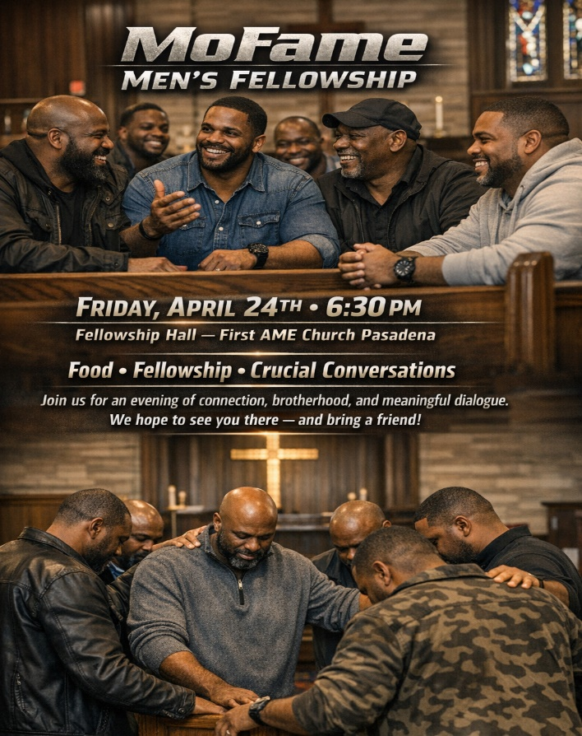

Virtual Church Conference
The presence of ALL members is requested at a Special Pastoral Church Conference
Tuesday, April 28, 2026 | 6:00 P.M.
Join Zoom Meeting
https://us02web.zoom.us/j/88158682168?pwd=lAbVIgNTklLRjAjdB3QuNJ5sQrWVD5.1
Meeting ID: 881 5868 2168 | Passcode: 989473



-11-

ANNOUNCEMENTS (Continued)





-12-

Prayer Request(s)
Please notify the Church Office of Sick & Shut-in additions, deletions, or status/address changes.

Bishop Francine A. Brookins, Esq. Supervisor Miriam Burnett, MD
Presiding Elder Roosevelt & Dr. Kaye Lindsey Rev. Dr. Larry & Melinda Campbell
Richard Craig Hazel Clark Erica Woodard Jason Shirley Joshua Shirley Julian Shirley Ayanna Terry Cheryl Jamerson Gwendolyn Flowers Andrea Anderson Ocilda Files Danielle Clark Donita Towler Rev. Charles Brooks Doris Bailey Kimberly Woods Cynithia Grace Zechariah Robinson Diane Jordan Christopher McCarthy Wilma Haynes Calle Burns Noel Johnson Brittney Petty Taylor Family Deborah Burton Nettie McChristen Jacquelyn Walker The Caple Family
Rev. Rochelle Moore Lorene Butler Stella Pulliam Collette Blizzard
The Eaton Canyon Fire Victims Selene Cox Mel Beech

College Students

Let’s continue to support and pray for our beloved College Students

Isaiah Crowell Alecia Davis Chase Johnson Grant Blizzard Gabriel Blizzard

Tyler Johnson Richard Jones Tyrikk Lawson Makia Rose Talbert Isaiah Ringo Journey Rogers Elyse Sharp Kylee Sharp Zion Otano Elise Tervalon Grace Jones Jordan Patterson Kimberly Robinson Donovan Williams Jasmine Collins Brandon Bates

Sick and Shut-Ins
Andrew Oliver 1405 N. Roosevelt Avenue. Pasadena, CA 91104
Barbara Buchanan 616 Rio Grande St. Pasadena, CA 91104
Bettina Ayers Pasadena Meadows Nursing Home, 150 Bellefontaine St., Pas., CA 91105
Bobby Thomas 1052 E. Morada Place, Altadena, CA 91001
Doris Curd 11619 Woodcock Avenue, San Fernando, CA 91340
Edmund Riddle Active Care Mission Bay, 2440 Grand Avenue, San Diego, CA 92109
Eleanor Towler 975 E. Union Street, Unit #417, Pasadena, CA 91106
Elois Blizzard P. O. Box 3646, So. Pasadena, CA 91031
Emily Cormier-Ross 2549 La Fiesta Avenue, Altadena, CA 91001
Ernestine English 26 W. Fair Oaks Drive, Pasadena, CA 91103
Fred Caple 51 North 15th Street Haledon, NJ 07508
Gloria Cubit Clay 11745 Pierce St., Lake View Terrace, CA 91342
Hugh Hamberry 19225 Chole Rd., Apple Valley, CA 92307
Jeff Thomas 603 Tocino Dr. Duarte, CA 91010 | Mountain View Terrace
Jessie Smith 3925 S Jones BL, Apt 2118 Las Vegas, NV 89103| Spring Valley Community
Josephine Brown 15607 Saddleback Rd, Riverside, CA 92506
Linnie G. Nollie 2250 E. New York Drive, Altadena, CA 91001
Malika G. Hendry P. O. Box 94082, Pasadena, CA 91109
Mildred Lewis C/O Hazel Rohr, 884 W. Jane Court, Upland, CA 91786
Norma Burnett 618 Fairview Avenue, Unit #228, Arcadia, CA 91007
Opal Hampton 1030 Chevron Court, Pasadena, CA 91103
Paul Ratliff P.O. Box 40407 Pasadena, CA 91114
Ruthie Hopkins 1155 Via Verde , San Dimas, CA 91773
Virlyn Grant 15122 Orange Ave., Paramount, CA 90723
Wanda Nelson 3618 N. Fair Oaks Avenue, Altadena, CA 91001
William Hilliard 7504 Wynstone Pl., Fontana, CA 92336
Zell L. Hill 375 Barthe Drive, Pasadena, CA 91103

-13-

Sermon Notations

Scripture: _____________________________________________________________

Subject: _______________________________________________________________

Points of the Message: ___________________________________________________
_______________________________________________________________________
_______________________________________________________________________
_______________________________________________________________________
_______________________________________________________________________
_______________________________________________________________________
_______________________________________________________________________

Main Ideas of the Sermon: ________________________________________________
_______________________________________________________________________
_______________________________________________________________________
_______________________________________________________________________
_______________________________________________________________________
_______________________________________________________________________

Illustrations I want to remember: _________________________________________
_______________________________________________________________________
_______________________________________________________________________
_______________________________________________________________________
_______________________________________________________________________
_______________________________________________________________________
_______________________________________________________________________

What should I do as a result of this Sermon? ________________________________

_____________________________________________________
_____________________________________________________
_____________________________________________________
_____________________________________________________

-14-

