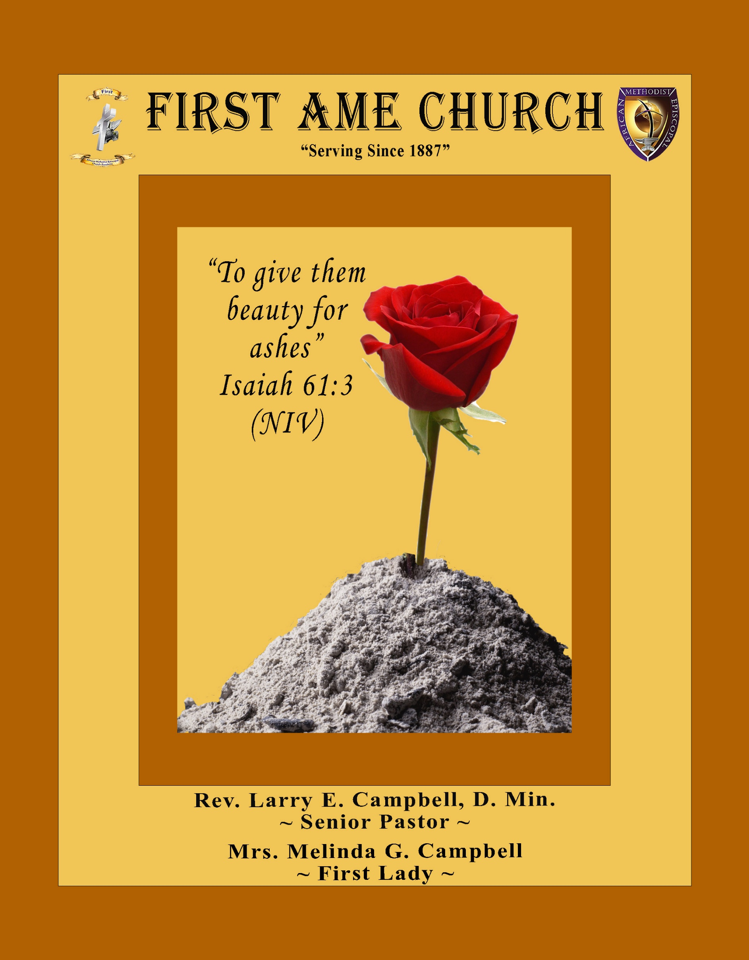
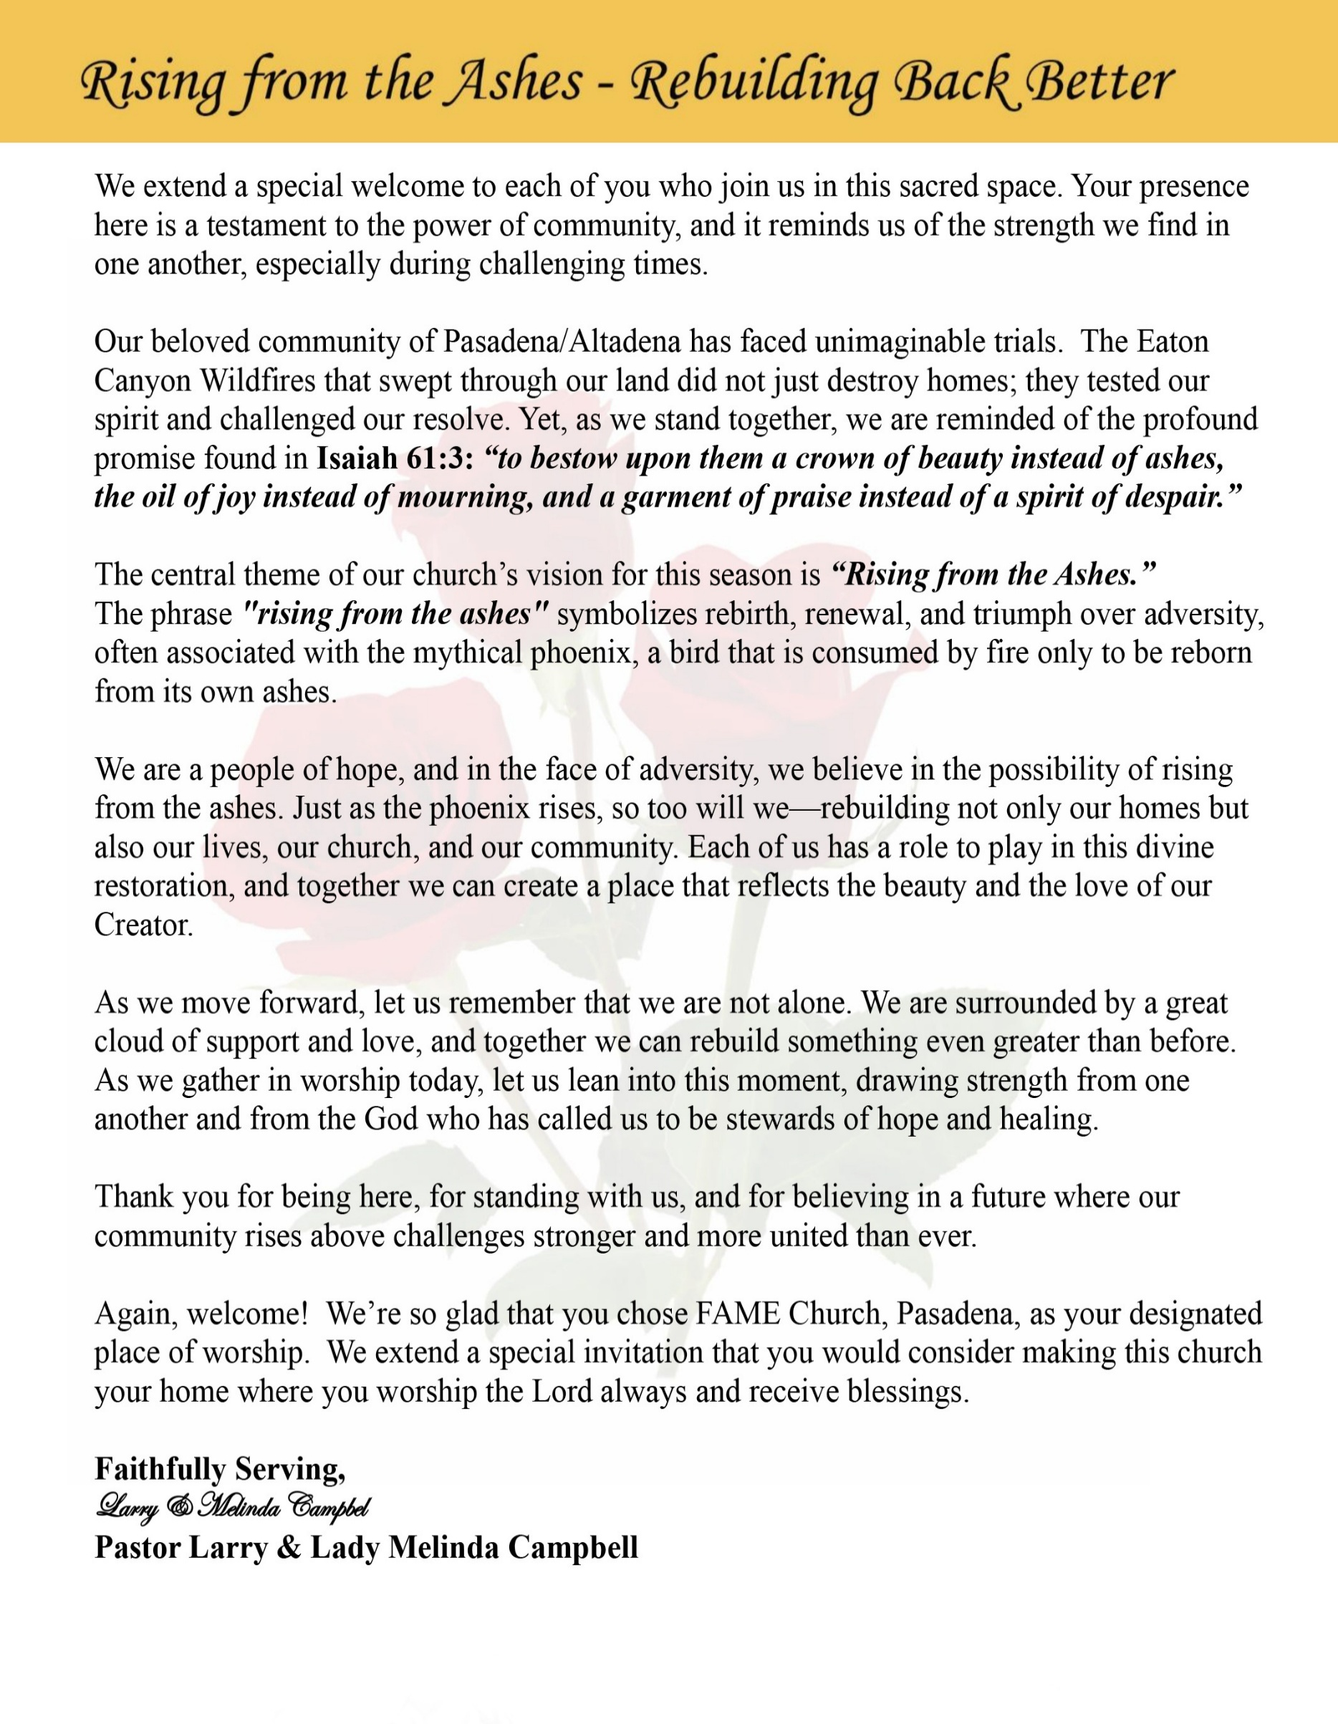

Sunday, April 26, 2026 | 9:30 a.m.

Rt. Rev. Francine A. Brookins, Esq., Presiding Bishop
Rev. Miriam Burnett, MD, MPH, Supervisor of Missions
Rev. Roosevelt Lindsey, Jr. Presiding Elder

The Rev. Dr. Larry E. Campbell ~ Senior Pastor ~ Minister

Mobile: (951) 587-1894 ~ Email: larrycampbell@famepasadena.org

Our First Lady: Mrs. Melinda G. Campbell

The Reverend Dr. Jennifer Oliver ~ Itinerant Elder -
The Reverend Dr. Nikia Smith-Robert ~ Itinerant Elder (Affiliated)
The Reverend Lois Woodard ~ Itinerant Elder Superannuated (Retired)
The Reverend Rochelle Wright Moore ~ Itinerant Deacon
The Reverend Deborah West-Jones ~ Local Elder
The Reverend Philis J. Griffin, MDiv ~ Local Elder
Dr. Phyllis Beech ~ Evangelist
Sister Tessie Bonner ~ Deaconess

Community Resource Center Director ~ Ms. Kischchen Hazelton Venerable
Church Administrative Assistant: Ms. Letha Rhymes

Church Office Hours:
Tue - Wed 9:00 am - 5:00 pm, & Fri 9:00 am -3:00 pm.
Closed for Lunch Daily: 12:00 pm - 1:00 pm.

Music Ministry
Dr. Timothy Davis, Minister of Music
Bro. Jimmy Watlington, Percussionist ~ Bro. Carlos Caldwell, Organist
Bro. Darien Dorsey, Keyboardist
Sis. Karen Law, Women’s Chorus Director ~ Sis. Tonia Graham, Children’s Choir Director
Bro. J. Renard Washington, New Generation’s Choir

FREE WI-FI service is available on the FAME Campus by accessing FAME 1700
Password: 6267980503

-3-

~ Order of Worship Experience ~

Warning: This order of worship is subject to change without warning or prior notice --- everything is governed by the Sovereignty of the Holy Spirit.

+ + + The Altar Call +++

Praise & Worship

Doxology: “Praise God From Whom All Blessings Flow”

The Call to Worship Bro. Dr. Paul Price

Leader: I was glad when they said unto me, let us go into the house of the Lord, our feet shall stand within Thy gates O Jerusalem! (Psalm 122:1)

People: For a day in Thy courts is better than a thousand. I had rather be a doorkeeper in the house of my God than to dwell in the tents of wickedness. (Psalm 84:10)

Leader: Because of the house of the Lord our God, I will seek Thy good.
(Psalm 122:9)

People: Those that be planted in the house of the Lord, shall flourish in the courts of our God. (Psalm 92:13)

Leader: Blessed are they that dwell in Thy house. Lord, I have loved Thy habitation, the place where Thy honor dwelleth. (Psalm 26:8)

People: For the Lord is in His holy temple; let all the earth keep silence before Him.
(Habakkuk 2:20)

Leader: Let the words of my mouth and the meditation of my heart, be acceptable in Thy sight, O Lord my strength and my redeemer. (Psalm 19:14)

Unison: O Sing unto the Lord a new song, for He has done marvelous things. Make a
joyful noise unto the Lord, all the earth, sing His praises. (Psalm 98:1, 4)

-4-

The Hymn of Praise A.M.E. Hymnal #390

Refrain:
I am on the battlefield for my Lord,
I'm on the battlefield for my Lord;
And I promised Him that I would serve Him till I die.
I am on the battlefield for my Lord.

1 I was alone and idle,
I was a sinner too,
I heard a voice from heaven
Say there is work to do,
I took the Master's hand,
And I joined the Christian band,
I'm on the battlefield for my Lord.

[Refrain]

2 I left my friends and kindred
Bound for the Promised Land,
The grace of God upon me,
The Bible in my hand,
In distant lands I trod,
Crying, sinner, come to God,
I'm on the battlefield for my Lord.

[Refrain]

3 Now when I met my Savior,
I met Him with a smile,
He healed my wounded spirit,
And owned me as His child,
Around the throne of grace,
He appoints my soul a place,
I'm on the battlefield for my Lord.

[Refrain]

The Invocation Bro. Versie Gaddis

Ministry of Music The Male Chorus

-5-

Scripture Lesson (Please Stand for the Reading of God’s Words)

Old Testament Bro. Melvin Sharpe
Psalm 23 (King James Version)
The Lord is my shepherd; I shall not want.
² He maketh me to lie down in green pastures: he leadeth me beside the still waters.
³ He restoreth my soul: he leadeth me in the paths of righteousness for his name's sake.
⁴ Yea, though I walk through the valley of the shadow of death, I will fear no evil: for thou art with me; thy rod and thy staff they comfort me.
⁵ Thou preparest a table before me in the presence of mine enemies: thou anointest my head with oil; my cup runneth over.
⁶ Surely goodness and mercy shall follow me all the days of my life: and I will dwell in the house of the Lord for ever.

New Testament (Responsive Reading) Bro. Emerson Sharpe
Romans 12:9-21 (New International Version) -- How to Treat Your Enemy
Leader: ⁹ Love must be sincere. Hate what is evil; cling to what is good.

People: ¹⁰ Be devoted to one another in love. Honor one another above
yourselves. ¹¹ Never be lacking in zeal, but keep your spiritual fervor,
serving the Lord.

Leader: ¹² Be joyful in hope, patient in affliction, faithful in prayer.

People: ¹³ Share with the Lord’s people who are in need. Practice hospitality.

Leader: ¹⁴ Bless those who persecute you; bless and do not curse. ¹⁵ Rejoice with those
who rejoice; mourn with those who mourn.

People: ¹⁶ Live in harmony with one another. Do not be proud, but be willing to
associate with people of low position. Do not be conceited.

Leader: ¹⁷ Do not repay anyone evil for evil. Be careful to do what is right in the eyes
of everyone. ¹⁸ If it is possible, as far as it depends on you, live at peace with
everyone.

People: ¹⁹ Do not take revenge, my dear friends, but leave room for God’s wrath, for
it is written: “It is mine to avenge; I will repay,” says the Lord.

Leader: ²⁰ On the contrary: “If your enemy is hungry, feed him; if he is thirsty, give him
something to drink.
ALL: In doing this, you will heap burning coals on his head.”²¹ Do not be overcome
By evil, but overcome evil with good.

-6-

The Summary of the Decalogue Bro. Bill Matlock

LEADER: From all that dwell below the skies…
SUNG: From all that dwell below the skies, Let the Creator’s praise arise; Let the
Redeemer’s Name be sung, through every land, by every tongue.
LEADER: Hear what Christ our Savior saith, Thou shalt love the Lord thy God with all thy
heart, with all thy soul, and with all thy mind. This is the first and great
commandment. And the second is like unto it: Thou shalt love thy neighbor
as thyself. On these two commandments hang all the law and the prophets.
SUNG: Glory be to the Father, and to the Son, and to the Holy Ghost; as it was in
the beginning, is now, and ever shall be, world without end. A~Men

Abbreviated Announcements/Visitor’s Welcome Dr. Brian K. Venerable



Special Congregational Hymn (Sing along)
#272 Pass Me Not, O Gentle Savior

-7-

The Offertory (Tithes ~ Gifts ~ Benevolent Offerings) Bro. Ray Bolton, Steward

The following Electronic GIVING Platforms are creditable methods to GIVE to FAME:

#1. GIVELIFY - Mobile Giving App available on the App Store. It’s easy to set up, just follow the guidelines.

#2. Cash App: $FirstAMEPASADENA

#3. Mail in your Tithes & Offering - If you would like to mail your tithes and offering by check or money order, please send it to: First AME Church, 1700 N. Raymond Avenue, Pasadena, CA 91103.

#4. Drop off your Tithes & Offering - During business hours in the basket outside of the office.

Choral Response: “All things come of Thee, O Lord; and of Thine own have we given Thee. Amen.”

Children’s Church Dismissal

Sermonic Selection The Male Chorus

The Preached Word Pastor Larry E. Campbell

The Invitation (Public/Private)

How to Join First A.M.E. Church of Pasadena
PROFESSION OF FAITH. If you have never been a member of any church, you may join by professing Jesus Christ as your personal Lord and Savior.

RENEWAL OF VOWS. If you have been a member of a church at one time, but have been in active, you may join by renewing your faith in Jesus Christ as Lord and Savior.

TRANSFER. If you are a member of another African Methodist Episcopal Church and you are in good standing, you may join by requesting that your membership be transferred to the First African Methodist Episcopal Church of Pasadena.

AFFILIATE MEMBER. Sometimes an individual has reasons for keeping /his/her membership in another church but would like to be an active member of First African Methodist Episcopal Church, too. This is possible as an affiliate member. __________________________________________________________________________________________

The Doxology

The Benediction

-8-

Scripture of the Day
Enemy Management. “You have heard that it was said, ‘Love your neighbor and hate your enemy.’ ⁴⁴ But I tell you, love your enemies and pray for those who persecute you, ⁴⁵ that you may be children of your Father in heaven. He causes his sun to rise on the evil and the good, and sends rain on the righteous and the unrighteous.” Matthew 5:43-45

Quote of the Day
"If you can cultivate the right attitude, your enemies are your best spiritual teachers because their presence provides you with the opportunity to enhance and develop tolerance, patience and understanding.” Dalai Lama

Thought of the Week
“Love your enemies and pray for those who persecute you.” — Matthew 5:44
Human enemies are a reality of life. Some are open in their opposition, while others are more subtle—speaking kindly in public but working against you in private. Either way, how you respond matters more than what they do.
Scripture does not call us to react—it calls us to respond with purpose. When we allow anger, revenge, or bitterness to take root, we give our enemies more power than they deserve. But when we choose love, wisdom, and restraint, we demonstrate the strength of God at work within us.
The apostle Paul reminds us not to be overcome by evil. That means evil will show up—but it does not have to win. Jesus takes it even further by calling us to love and pray for those who oppose us. This is not about excusing wrong behavior; it is about refusing to let someone else’s actions corrupt your spirit.

Humor of the Week
One day at church, a Pastor is preaching on Loving Your Enemies.
He expounds on the value of grace and forgiveness to all and how we are called to love our neighbors and our enemies as much as we love ourselves. The congregation is roused to action and filled with the Holy Spirit.
The pastor asks them all, "Will you go out into the world and love your enemies?"
Every hand in the congregation goes up except for one.
The pastor sees that it is a little old lady in the front row.
He asks the woman, "Why can't you love your enemies?"
The little old lady says, "Pastor, I can honestly say I have no enemies"
The pastor says, "That's incredible, may I ask how old you are?"
She says, "96".
The pastor says, "96 years old and no enemies? That's incredible. Would you mind sharing how you have achieved this?”
The little old lady totters to the front of the church, turns around to the congregation and says, “Simple, I outlived them all."

HOME DAILY BIBLE READINGS
April 27, 2026 – May 3, 2026 (Week 32, Luke)
Monday Day 218 Matthew 5:1-42, Psalm 89:1-8
Tuesday Day 219 Matthew 5:43-7:6, Psalm 89:9-17
Wednesday Day 220 Matthew 7:7-8:27, Psalm 89:18-29
Thursday Day 221 Matthew 8:28-9:38, Psalm 89:30-37
Friday Day 222 Matthew 10:1-10:42, Psalm 89:38-45
Saturday Day 223 Matthew 11:1-12:8, Psalm 89:46-52
Sunday Day 224 Matthew 12:9-12:50, Psalm 90:1-6

-9-

ANNOUNCEMENTS

Everyone is encouraged to join our weekly Christian Education Sessions

VIRTUAL ADULT CHURCH SCHOOL
Sunday Mornings at 8:00 a.m.
http://us02web.zoom.us/j/844840183?pwd-sm0w1yvmvhOvC13175urZ2vr7M3EtU.1

HYBRID PASTOR’S WEEKLY BIBLE STUDY
Wednesdays at 11:00 a.m.
https://us02web.zoom.us/j/84484840183?pwd=sm0w1yvmvhOvC13l75urZ2vr7M3EtU.1
Meeting ID: 844 8484 0183 | Passcode: 357260
WEEKLY TELECONFERENCE PRAYERS SESSIONS
Wednesdays at 5:30 a.m. and 6:00 p.m.
Conference Call Number: (530_ 881-1212
Access Code: 234575160#



-10-

ANNOUNCEMENTS (Continued)



Men's Ministry - BIBLE STUDY
Time: Tuesday, May 5, 2026 | 6:00 p.m.
Meeting ID: 894 7536 6487
Passcode: 465177
One tap mobile: +16699006833,,89475366487#,,,,*465177# US (San Jose)

Women's Ministry – BIBLE STUDY
Time: Tuesday– May 5, 2026 | 6:00 p.m.
Meeting ID: 857 0061 9461; Passcode: 933892
One tap mobile +16699006833,,85700619461#,,,,,,0#,,933892# US (San Jose)

Virtual Church Conference
The presence of ALL members is requested at a Special Pastoral Church Conference
Tuesday, May 7, 2026 | 6:00 P.M.
Join Zoom Meeting
https://us02web.zoom.us/j/88158682168?pwd=lAbVIgNTklLRjAjdB3QuNJ5sQrWVD5.1
Meeting ID: 881 5868 2168 | Passcode: 989473

Senior Ministry Luncheon
You are invited to join us to enjoy good fellowship, good food, and helpful information at the FAME Senior Ministry gathering on Tuesday, May 12, 2026 @ 11:30 a.m.
Bring a friend. All are welcome

-11-

ANNOUNCEMENTS (Continued)

Virtual Trustee Board Meeting
May 19, 2026 | 5:30 p.m.

Virtual Official Board Meeting
May 26, 2026 | 7:00 p.m.





-12-

Prayer Request(s)
Please notify the Church Office of Sick & Shut-in additions, deletions, or status/address changes.

Bishop Francine A. Brookins, Esq. Supervisor Miriam Burnett, MD
Presiding Elder Roosevelt & Dr. Kaye Lindsey Rev. Dr. Larry & Melinda Campbell
Richard Craig Hazel Clark Erica Woodard Jason Shirley Joshua Shirley Julian Shirley Ayanna Terry Cheryl Jamerson Gwendolyn Flowers Andrea Anderson Ocilda Files Danielle Clark Donita Towler Rev. Charles Brooks Doris Bailey Kimberly Woods Cynithia Grace Zechariah Robinson Diane Jordan Christopher McCarthy Wilma Haynes Calle Burns Noel Johnson Brittney Petty Taylor Family Deborah Burton Nettie McChristen Jacquelyn Walker The Caple Family
Rev. Rochelle Moore Lorene Butler Stella Pulliam Collette Blizzard
The Eaton Canyon Fire Victims Selene Cox Mel Beech

College Students

Let’s continue to support and pray for our beloved College Students

Isaiah Crowell Alecia Davis Chase Johnson Grant Blizzard Gabriel Blizzard

Tyler Johnson Richard Jones Tyrikk Lawson Makia Rose Talbert Isaiah Ringo Journey Rogers Elyse Sharp Kylee Sharp Zion Otano Elise Tervalon Grace Jones Jordan Patterson Kimberly Robinson Donovan Williams Jasmine Collins Brandon Bates

Sick and Shut-Ins
Andrew Oliver 1405 N. Roosevelt Avenue. Pasadena, CA 91104
Barbara Buchanan 616 Rio Grande St. Pasadena, CA 91104
Bettina Ayers Pasadena Meadows Nursing Home, 150 Bellefontaine St., Pas., CA 91105
Bobby Thomas 1052 E. Morada Place, Altadena, CA 91001
Doris Curd 11619 Woodcock Avenue, San Fernando, CA 91340
Edmund Riddle Active Care Mission Bay, 2440 Grand Avenue, San Diego, CA 92109
Eleanor Towler 975 E. Union Street, Unit #417, Pasadena, CA 91106
Elois Blizzard P. O. Box 3646, So. Pasadena, CA 91031
Emily Cormier-Ross 2549 La Fiesta Avenue, Altadena, CA 91001
Ernestine English 26 W. Fair Oaks Drive, Pasadena, CA 91103
Fred Caple 51 North 15th Street Haledon, NJ 07508
Gloria Cubit Clay 11745 Pierce St., Lake View Terrace, CA 91342
Hugh Hamberry 19225 Chole Rd., Apple Valley, CA 92307
Jeff Thomas 603 Tocino Dr. Duarte, CA 91010 | Mountain View Terrace
Jessie Smith 3925 S Jones BL, Apt 2118 Las Vegas, NV 89103| Spring Valley Community
Josephine Brown 15607 Saddleback Rd, Riverside, CA 92506
Linnie G. Nollie 2250 E. New York Drive, Altadena, CA 91001
Malika G. Hendry P. O. Box 94082, Pasadena, CA 91109
Mildred Lewis C/O Hazel Rohr, 884 W. Jane Court, Upland, CA 91786
Norma Burnett 618 Fairview Avenue, Unit #228, Arcadia, CA 91007
Opal Hampton 1030 Chevron Court, Pasadena, CA 91103
Paul Ratliff P.O. Box 40407 Pasadena, CA 91114
Ruthie Hopkins 1155 Via Verde , San Dimas, CA 91773
Virlyn Grant 15122 Orange Ave., Paramount, CA 90723
Wanda Nelson 3618 N. Fair Oaks Avenue, Altadena, CA 91001
William Hilliard 7504 Wynstone Pl., Fontana, CA 92336
Zell L. Hill 375 Barthe Drive, Pasadena, CA 91103

-13-

Sermon Notations

Scripture: _____________________________________________________________

Subject: _______________________________________________________________

Points of the Message: ___________________________________________________
_______________________________________________________________________
_______________________________________________________________________
_______________________________________________________________________
_______________________________________________________________________
_______________________________________________________________________
_______________________________________________________________________

Main Ideas of the Sermon: ________________________________________________
_______________________________________________________________________
_______________________________________________________________________
_______________________________________________________________________
_______________________________________________________________________
_______________________________________________________________________

Illustrations I want to remember: _________________________________________
_______________________________________________________________________
_______________________________________________________________________
_______________________________________________________________________
_______________________________________________________________________
_______________________________________________________________________
_______________________________________________________________________

What should I do as a result of this Sermon? ________________________________

_____________________________________________________
_____________________________________________________
_____________________________________________________
_____________________________________________________

-14-

