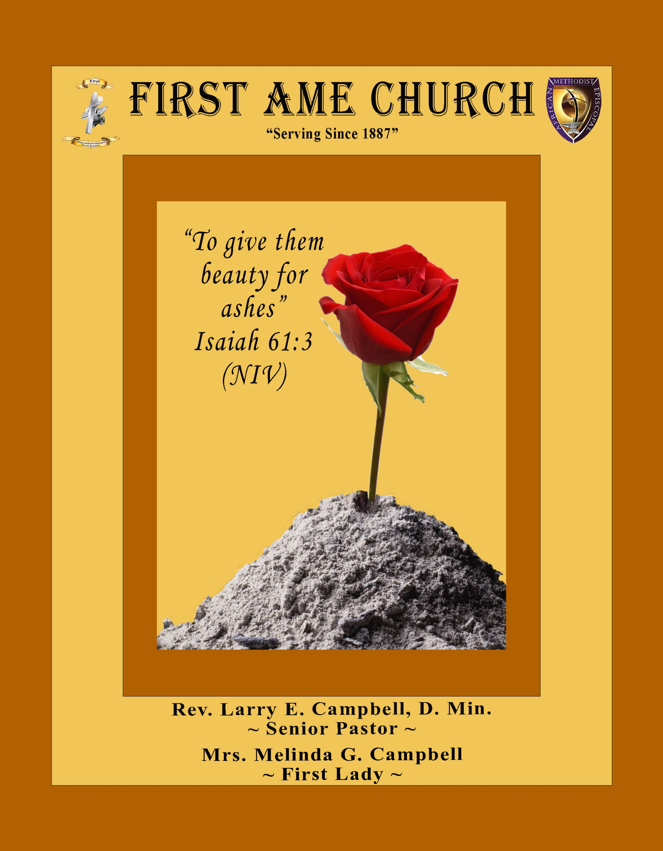
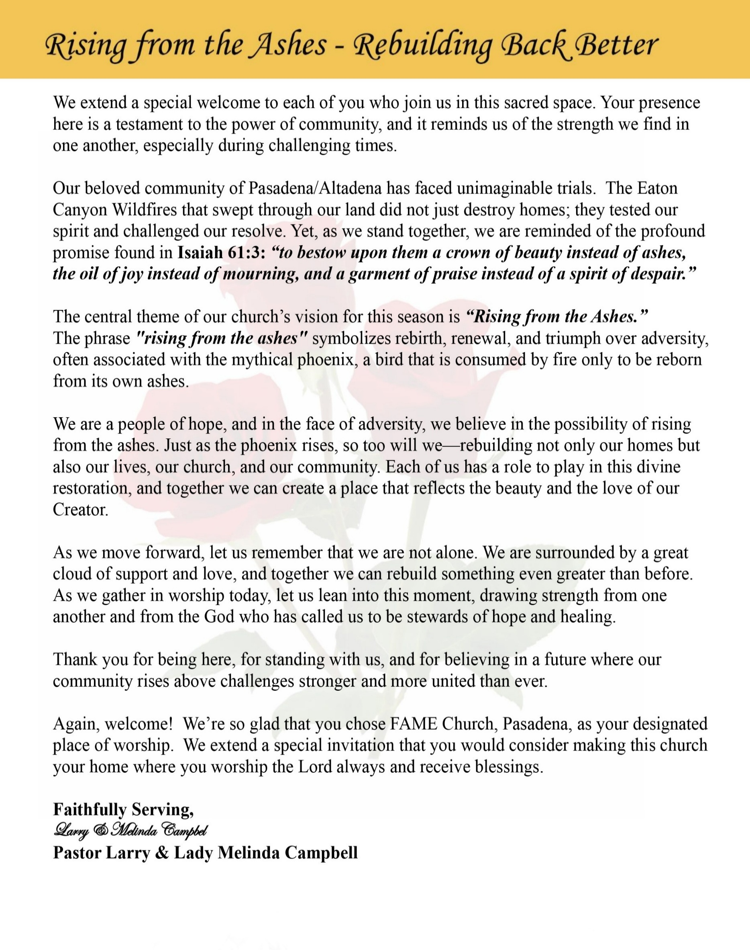

Sunday, August 16, 2026 | 9:30 a.m.

Rt. Rev. Francine A. Brookins, Esq., Presiding Bishop
Rev. Miriam Burnett, MD, MPH, Supervisor of Missions
Rev. Roosevelt Lindsey, Jr. Presiding Elder

The Rev. Dr. Larry E. Campbell ~ Senior Pastor ~ Minister

Mobile: (951) 587-1894 ~ Email: larrycampbell@famepasadena.org

Our First Lady: Mrs. Melinda G. Campbell

The Reverend Dr. Jennifer Oliver ~ Itinerant Elder -
The Reverend Dr. Nikia Smith-Robert ~ Itinerant Elder (Affiliated)
The Reverend Lois Woodard ~ Itinerant Elder Superannuated (Retired)
The Reverend Rochelle Wright Moore ~ Itinerant Deacon
The Reverend Deborah West-Jones ~ Local Elder
The Reverend Philis J. Griffin, MDiv ~ Local Elder
Dr. Phyllis Beech ~ Evangelist
Sister Tessie Bonner ~ Deaconess

Community Resource Center Director ~ Ms. Kischchen Hazelton Venerable
Church Administrative Assistant: Ms. Letha Rhymes

Church Office Hours:
Tue - Wed 9:00 am - 5:00 pm, & Fri 9:00 am -3:00 pm.
Closed for Lunch Daily: 12:00 pm - 1:00 pm.

Music Ministry
Dr. Timothy Davis, Minister of Music
Bro. Jimmy Watlington, Percussionist ~ Bro. Carlos Caldwell, Organist
Bro. Darien Dorsey, Keyboardist
Sis. Karen Law, Women’s Chorus Director ~ Sis. Tonia Graham, Children’s Choir Director
Bro. J. Renard Washington, New Generation’s Choir

FREE WI-FI service is available on the FAME Campus by accessing FAME 1700
Password: 6267980503

-3-

~ Order of Worship Experience ~

Warning: This order of worship is subject to change without warning or prior notice --- everything is governed by the Sovereignty of the Holy Spirit.
Praise & Worship

Doxology: “Praise God From Whom All Blessings Flow”

The Call to Worship

Leader: I was glad when they said unto me, let us go into the house of the Lord, our feet shall stand within Thy gates O Jerusalem! (Psalm 122:1)

People: For a day in Thy courts is better than a thousand. I had rather be a doorkeeper in the house of my God than to dwell in the tents of wickedness. (Psalm 84:10)

Leader: Because of the house of the Lord our God, I will seek Thy good.
(Psalm 122:9)

People: Those that be planted in the house of the Lord, shall flourish in the courts of our God. (Psalm 92:13)

Leader: Blessed are they that dwell in Thy house. Lord, I have loved Thy habitation, the place where Thy honor dwelleth. (Psalm 26:8)

People: For the Lord is in His holy temple; let all the earth keep silence before Him.
(Habakkuk 2:20)

Leader: Let the words of my mouth and the meditation of my heart, be acceptable in Thy sight, O Lord my strength and my redeemer. (Psalm 19:14)

Unison: O Sing unto the Lord a new song, for He has done marvelous things. Make a
joyful noise unto the Lord, all the earth, sing His praises. (Psalm 98:1, 4)

-4-

Congregational Worship Song

"Lord, I Lift Your Name On High"

Lord, I lift Your name on high
Lord, I love to sing Your praises
I'm so glad You're in my life
I'm so glad You came to save us

You came from Heaven to earth to show the way
From the earth to the cross my debt to pay
From the cross to the grave
From the grave to the sky
Lord, I lift Your name on high
Lord, I lift Your name on high
Lord, I love to sing Your praises
I'm so glad You're in my life
I'm so glad You came to save us

You came from Heaven to earth to show the way
From the earth to the cross my debt to pay
From the cross to the grave
From the grave to the sky
Lord, I lift Your name on high
Lord, I lift Your name on high

The Invocation

Ministry of Music New Generation Children Choir

-5-

Scripture Lesson
(Please Stand for the Reading of God’s Words)

Old Testament Responsive Reading

Judges 16:15-22 (The Message Bible) — Temptation
Leader: ¹⁵ Then Delilah said to Samson, “How can you say ‘I love you’ when you won’t
even trust me? Three times now you’ve toyed with me, like a cat with a mouse,
refusing to tell me the secret of your great strength.”

People: ¹⁶⁻¹⁷ She kept at it day after day, nagging and tormenting him. Finally, he was
fed up—he couldn’t take another minute of it. He spilled it. He told her, “A
razor has never touched my head. I’ve been God’s Nazirite from
conception. If I were shaved, my strength would leave me; I would be as
helpless as any other mortal.”

Leader ¹⁸ When Delilah realized that he had told her his secret, she sent for the
Philistine tyrants, telling them, “Come quickly—this time he’s told me the
truth.” They came, bringing the bribe money.

People: ¹⁹ When she got him to sleep, his head on her lap, she motioned to a man to cut
off the seven braids of his hair. Immediately he began to grow weak. His
strength drained from him.

Leader: ²⁰ Then she said, “The Philistines are on you, Samson!” He woke up, thinking, “I’ll
go out, like always, and shake free.” He didn’t realize that God had abandoned
him.

Unison: ²¹⁻²² The Philistines grabbed him, gouged out his eyes, and took him down to
Gaza. They shackled him in irons and put him to the work of grinding in the
prison. But his hair, though cut off, began to grow again.

New Testament
James 1:12-15 (The Message Bible) — Temptation
¹² Anyone who meets a testing challenge head-on and manages to stick it out is mighty fortunate. For such persons loyally in love with God, the reward is life and more life.
¹³⁻¹⁵ Don’t let anyone under pressure to give in to evil say, “God is trying to trip me up.” God is impervious to evil, and puts evil in no one’s way. The temptation to give in to evil comes from us and only us. We have no one to blame but the leering, seducing flare-up of our own lust. Lust gets pregnant and has a baby: sin! Sin grows up to adulthood and becomes a real killer.

-6-

The Summary of the Decalogue
LEADER: From all that dwell below the skies…
SUNG: From all that dwell below the skies, Let the Creator’s praise arise; Let the
Redeemer’s Name be sung, through every land, by every tongue.
LEADER: Hear what Christ our Savior saith, Thou shalt love the Lord thy God with all thy
heart, with all thy soul, and with all thy mind. This is the first and great
commandment. And the second is like unto it: Thou shalt love thy neighbor
as thyself. On these two commandments hang all the law and the prophets.
SUNG: Glory be to the Father, and to the Son, and to the Holy Ghost; as it was in
the beginning, is now, and ever shall be, world without end. A~Men

Abbreviated Announcements/Visitor’s Welcome

K-FAME - Radio
Announcements
Sharing the Updated, Progress and Successes of our Children & Youth



Special Congregational Hymn (Sing along)
Hymn #413— Yield Not to Temptation

-7-

The Offertory (Tithes ~ Gifts ~ Benevolent Offerings) Sis. Darlene Anderson, Steward

The following Electronic GIVING Platforms are creditable methods to GIVE to FAME:

#1. GIVELIFY - Mobile Giving App available on the App Store. It’s easy to set up just follow the guidelines.

#2. Cash App: $FirstAMEPASADENA

#3. Mail in your Tithes & Offering - If you would like to mail your tithes and offering by check or money order, please send it to: First AME Church, 1700 N. Raymond Avenue, Pasadena, CA 91103.

#4. Drop off your Tithes & Offering - During business hours in the basket outside of the office.

Choral Response: “All things come of Thee, O Lord; and of Thine own have we given Thee. Amen.”

Sermonic Selection The Praise Team

Proclamation of The Word Pastor Larry E. Campbell

The Invitation (Public/Private)

How to Join First A.M.E. Church of Pasadena
PROFESSION OF FAITH. If you have never been a member of any church, you may join by professing Jesus Christ as your personal Lord and Savior.

RENEWAL OF VOWS. If you have been a member of a church at one time, but have been in active, you may join by renewing your faith in Jesus Christ as Lord and Savior.

TRANSFER. If you are a member of another African Methodist Episcopal Church and you are in good standing, you may join by requesting that your membership be transferred to the First African Methodist Episcopal Church of Pasadena.

AFFILIATE MEMBER. Sometimes an individual has reasons for keeping /his/her membership in another church but would like to be an active member of First African Methodist Episcopal Church, too. This is possible as an affiliate member. ______________________________________________________________________________________________________________

The Doxology

The Benediction

-8-

Scripture of the Day
Temptation at the Table. “Watch and pray, that ye enter not into temptation: the spirit indeed is willing, but the flesh is weak.” Matthew 26:41

Quote of the Day
"It is not a sin to be tempted… The sin is in yielding to temptation instead of seeking God’s power to escape.” — Billy Graham

Thought of the Week
“Blessed is the man that endureth temptation: for when he is tried, he shall receive the crown of life.” — James 1:12 (KJV)
Every day presents us with choices. Some choices strengthen our faith, while others slowly pull us away from the person God is calling us to become. Temptation often makes the wrong choice appear easier, more attractive, or more satisfying in the moment.
But faith teaches us to look beyond the moment. Before giving in, ask: Where will this choice lead me? Will it strengthen my relationship with God, protect my character, and honor the life God has given me?
God never leaves us alone in moments of temptation. Through prayer, Scripture, the Holy Spirit, and the support of faithful people, God gives us strength to choose what is right.
A moment of temptation does not have to become a lifetime of regret. Choose what gives life. Choose what builds character. Choose what honors God.
Prayer: Lord, give us discernment in our choices, strength in our struggles, and courage to remain faithful to You. Amen.

Humor of the Week
A man trying to lose weight told his office coworkers he was finally cutting out his morning pastry habit.
A few weeks later, he walked into the office carrying a massive box of jelly-filled donuts. His friend looked at him and asked, "What happened?"
"Well, today on my way to work, I was driving past the bakery and I decided to pray," he said. "I prayed, 'God, if you don't want me to go to the bakery, don't let there be a parking place in front.'"
"And sure enough," he added, " after I circled the block about five times, a parking place opened right up in front of the door."

HOME DAILY BIBLE READINGS
August 17, 2026 – August 23, 2026 (Week 48, 1 Peter)
Monday Day 330 2 Corinthians 8-9, Proverbs 8
Tuesday Day 331 2 Corinthians 10-11, Proverbs 9
Wednesday Day 332 2 Corinthians 12-13, Proverbs 10
Thursday Day 333 Galatians 1-2, Proverbs 11
Friday Day 334 Galatians 3-4, Proverbs 12
Saturday Day 335 Galatians 5-6, Proverbs 13
Sunday Day 336 Ephesians 1-2, Proverbs 14

-9-

ANNOUNCEMENTS

FAME PASADENA MEN’S MINISTRY ANNUAL CELEBRATION

BROTHERS, LET’S COME TOGETHER!
Brothers, we are not simply gathering for an event—we are coming together to grow, connect, encourage, and strengthen one another.
Prayer keeps us covered and aligned with God’s will. Fellowship strengthens us because “iron sharpens iron” (Proverbs 27:17), and brothers need brothers to encourage, challenge, and support one another along life’s journey.
Worship keeps our hearts grateful and focused on Christ as we remember who God is and what He is doing in our lives, our families, our church, and our community.
This weekend is an opportunity to laugh together, pray together, worship together, and grow together. So, brothers, let’s show up, stand together, and celebrate what God is doing among the men of FAME Pasadena!
SATURDAY FELLOWSHIP: BACKYARD BBQ
Saturday, August 22, 2026 | 2:00 PM – 6:00 PM
Home of Brother Brian Williams
Come ready for delicious BBQ, great conversation, laughter, and tremendous brotherhood!
RSVP by replying via text or calling 626-360-6219.
Your RSVP is important, so we know how much BBQ to grill and how much food to prepare.

SUNDAY MEN’S DAY WORSHIP CELEBRATION
Sunday, August 23, 2026 | 9:30 AM
After enjoying fellowship on Saturday, let’s come together on Sunday morning for a powerful time of worship, praise, prayer, and celebration as we honor the men of our church.
SUNDAY ATTIRE
Please wear your African attire!
Let’s fill the sanctuary with the beauty, richness, and diversity of our African heritage as we celebrate Men of Purpose, Men of Faith, and Men of Action.
BRING YOURSELF—AND BRING A BROTHER!
Invite a friend, family member, coworker, neighbor, or young man to worship with us.

NEW MEMBERS’ ORIENTATION
The presence of all new members is warmly requested at our upcoming New Members’ Orientation Classes. These sessions are designed to help you grow in faith, fellowship, and understanding of the ministry and mission of the church. We look forward to journeying together as disciples of Christ and members of the household of faith.
Orientation Schedule
Fourth Session, August 22, 2026 | 10:00 A.M.
Fifth Session, August 29, 2026 | 10:00 A.M.
We encourage every new member to attend faithfully as we grow together in grace, service, and spiritual maturity.

Virtual Official Board Meeting
Tuesday, August 25, 2026 | 6:00 P.M.

-10-

ANNOUNCEMENTS (Continued)

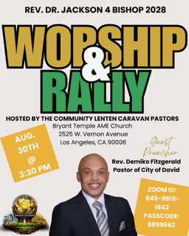

Men's Ministry - BIBLE STUDY
Time: Tuesday, September 1, 2026 | 6:00 p.m.
Meeting ID: 894 7536 6487 | Passcode: 465177
One tap mobile: +16699006833,,89475366487#,,,,*465177# US (San Jose)

Women's Ministry – BIBLE STUDY
Time: Tuesday, September 1, 2026 | 6:00 p.m.
Meeting ID: 857 0061 9461; Passcode: 933892
One tap mobile +16699006833,,85700619461#,,,,,,0#,,933892# US (San Jose)

WEEKLY BIBLE STUDY CLASSES
Please note that our weekly Bible Study classes (Wednesday Bible Study sessions and Wednesday Prayer Service sessions) will resume on Wednesday, September 2, 2026

Senior Ministry Luncheon
You are invited to join us to enjoy good fellowship, good food, and helpful information at the FAME Senior Ministry gathering on Tuesday, September 8, 2026 @ 11:30 a.m. Bring a friend. All are welcome

Budget Submission
All Auxiliary and Organization Presidents must submit their 2026-2027 draft budgets to Sis. Kischchen Hazelton Venerable by Friday, September 18, 2026.

SAVE THE DATE
FIRST A.M.E. CHURCH PASADENA
Celebrating 139 Years of Faithful Service to God and Our Beloved Community

Join us as we celebrate 139 years of God's faithfulness, grace, and abundant blessings upon the ministry of First African Methodist Episcopal Church, Pasadena. Together, we will honor our rich legacy of worship, witness, service, and unwavering commitment to proclaiming the Gospel of Jesus Christ while serving our beloved community.

Sunday, September 13, 2026 | 9:30 A.M. Worship Celebration
Come Celebrate Our Legacy ... Rejoice in Our Present ... Embrace Our Future!
Everyone Is Welcome!

-11-

ANNOUNCEMENTS (Continued)

🌟 FAME PASADENA IS MAKING HISTORY! 🌟
VOLUNTEERS NEEDED — THIS IS A FAMILY AFFAIR!

First AME Church Pasadena Family,
It is with great honor, excitement, and anticipation that we prepare to host the 102nd Session of the Southern California Annual Conference and Fifth District Planning Meeting!

Wednesday, October 21 – Thursday, October 29, 2026 | Hilton Los Angeles Airport

As we welcome clergy, delegates, lay members, and guests from across the Fifth Episcopal District, we have an opportunity to bring a taste of Pasadena to Los Angeles through our warmth, hospitality, excellence, and spirit of Christian service.

WE NEED YOU!
We are seeking dedicated volunteers to serve in the following areas:
Decorations & Hospitality --- Prayer Room Attendants
Conference Registration --- Ushers
Stewardesses --- Greeters & Hospitality
Health & Welfare

Whether you can serve for one day or throughout the conference, your presence and participation will make a difference! “Whatever you do, work at it with all your heart, as working for the Lord.” — Colossians 3:23. This is more than an assignment—it is an opportunity for FAME Pasadena to serve, welcome, represent, and shine!

REMEMBER: THIS IS A FAMILY AFFAIR!
Every member has a gift. Every gift has a place. Every person can make a difference.
If you are willing to serve, please contact the FAME Church Office immediately to sign up and receive additional information.

Let’s come together, roll up our sleeves, open our hearts, and show the Fifth District what FAME Pasadena hospitality looks like!

FAME PASADENA — SERVING WITH EXCELLENCE, WELCOMING WITH LOVE, AND REPRESENTING PASADENA WITH PRIDE!



-12-

Prayer Request(s)
Please notify the Church Office of Sick & Shut-in additions, deletions, or status/address changes.

Bishop Francine A. Brookins, Esq. Supervisor Miriam Burnett, MD Presiding Elder Roosevelt & Dr. Kaye Lindsey Rev. Dr. Larry & Melinda Campbell Richard Craig Hazel Clark Erica Woodard Jason Shirley Joshua Shirley Julian Shirley Ayanna Terry Cheryl Jamerson Gwendolyn Flowers Andrea Anderson Ocilda Files Danielle Clark Rev. Charles Brooks Kimberly Woods Cynithia Grace Calle Burns Noel Johnson The Taylor Family
Zechariah Robinson Christopher McCarthy Wilma Haynes Jacquelyn Walker Brittney Petty Selene Cox Deborah Burton Nettie McChristen The Caple Family Mel Beech Michael Dotson
Rev. Rochelle Moore Lorene Butler Stella Pulliam Collette Blizzard The Eaton Canyon Fire Victims

College Students

Let’s continue to support and pray for our beloved College Students

Isaiah Crowell Alecia Davis Chase Johnson Grant Blizzard Gabriel Blizzard

Tyler Johnson Richard Jones Tyrikk Lawson Makia Rose Talbert Isaiah Ringo Journey Rogers Elyse Sharp Kylee Sharp Zion Otano Elise Tervalon Grace Jones Jordan Patterson Kimberly Robinson Donovan Williams Jasmine Collins Brandon Bates

Sick and Shut-Ins
Andrew Oliver 1405 N. Roosevelt Avenue, Pasadena, CA 91104
Barbara Buchanan 616 Rio Grande St. Pasadena, CA 91104
Bettina Ayers Pasadena Meadows Nursing Home, 150 Bellefontaine St., Pas., CA 91105
Betty Betts Turner 1625 S Magnolia Ave Unit 4125 Monrovia, CA 91016
Bobby Thomas 1052 E. Morada Place, Altadena, CA 91001
Diane Jordan 1719 Fremont Ave., #302, S. Pasadena, CA 91030
Donita Towler 14148 Francisquito Ave, Baldwin Park, CA 91706
Doris Curd 11619 Woodcock Avenue, San Fernando, CA 91340
Edmund Riddle Active Care Mission Bay, 2440 Grand Avenue, San Diego, CA 92109
Eleanor Towler 975 E. Union Street, Unit #417, Pasadena, CA 91106
Elois Blizzard P. O. Box 3646, So. Pasadena, CA 91031
Emily Cormier-Ross 2549 La Fiesta Avenue, Altadena, CA 91001
Ernestine English 26 W. Fair Oaks Drive, Pasadena, CA 91103
Fred Caple 51 North 15th Street Haledon, NJ 07508
Hugh Hamberry 19225 Chole Rd., Apple Valley, CA 92307
Jessie Smith 3925 S Jones BL, Apt 2118 Las Vegas, NV 89103| Spring Valley Community
Josephine Brown 15607 Saddleback Rd, Riverside, CA 92506
Konata Doxey Monte Vista Healthcare Center, Duarte, CA 91010
Lenora Moore 2445 E. Del Mar Bl, #338 Pasadena, CA 91107
Linnie G. Nollie 2250 E. New York Drive, Altadena, CA 91001
Malika G. Hendry P. O. Box 94082, Pasadena, CA 91109
Mildred Lewis C/O Hazel Rohr, 884 W. Jane Court, Upland, CA 91786
Norma Burnett 618 Fairview Avenue, Unit #228, Arcadia, CA 91007
Opal Hampton 1030 Chevron Court, Pasadena, CA 91103
Paul Ratliff P.O. Box 40407 Pasadena, CA 91114
Virlyn Grant 15122 Orange Ave., Paramount, CA 90723
Wanda Nelson 3618 N. Fair Oaks Avenue, Altadena, CA 91001
William Hilliard 7504 Wynstone Pl., Fontana, CA 92336
Zell L. Hill 375 Barthe Drive, Pasadena, CA 91103

-13-

Sermon Notations

Scripture: _____________________________________________________________

Subject: _______________________________________________________________

Points of the Message: ___________________________________________________
_______________________________________________________________________
_______________________________________________________________________
_______________________________________________________________________
_______________________________________________________________________
_______________________________________________________________________
_______________________________________________________________________

Main Ideas of the Sermon: ________________________________________________
_______________________________________________________________________
_______________________________________________________________________
_______________________________________________________________________
_______________________________________________________________________
_______________________________________________________________________

Illustrations I want to remember: _________________________________________
_______________________________________________________________________
_______________________________________________________________________
_______________________________________________________________________
_______________________________________________________________________
_______________________________________________________________________
_______________________________________________________________________

What should I do as a result of this Sermon? ________________________________

_____________________________________________________
_____________________________________________________
_____________________________________________________
_____________________________________________________

-14-

