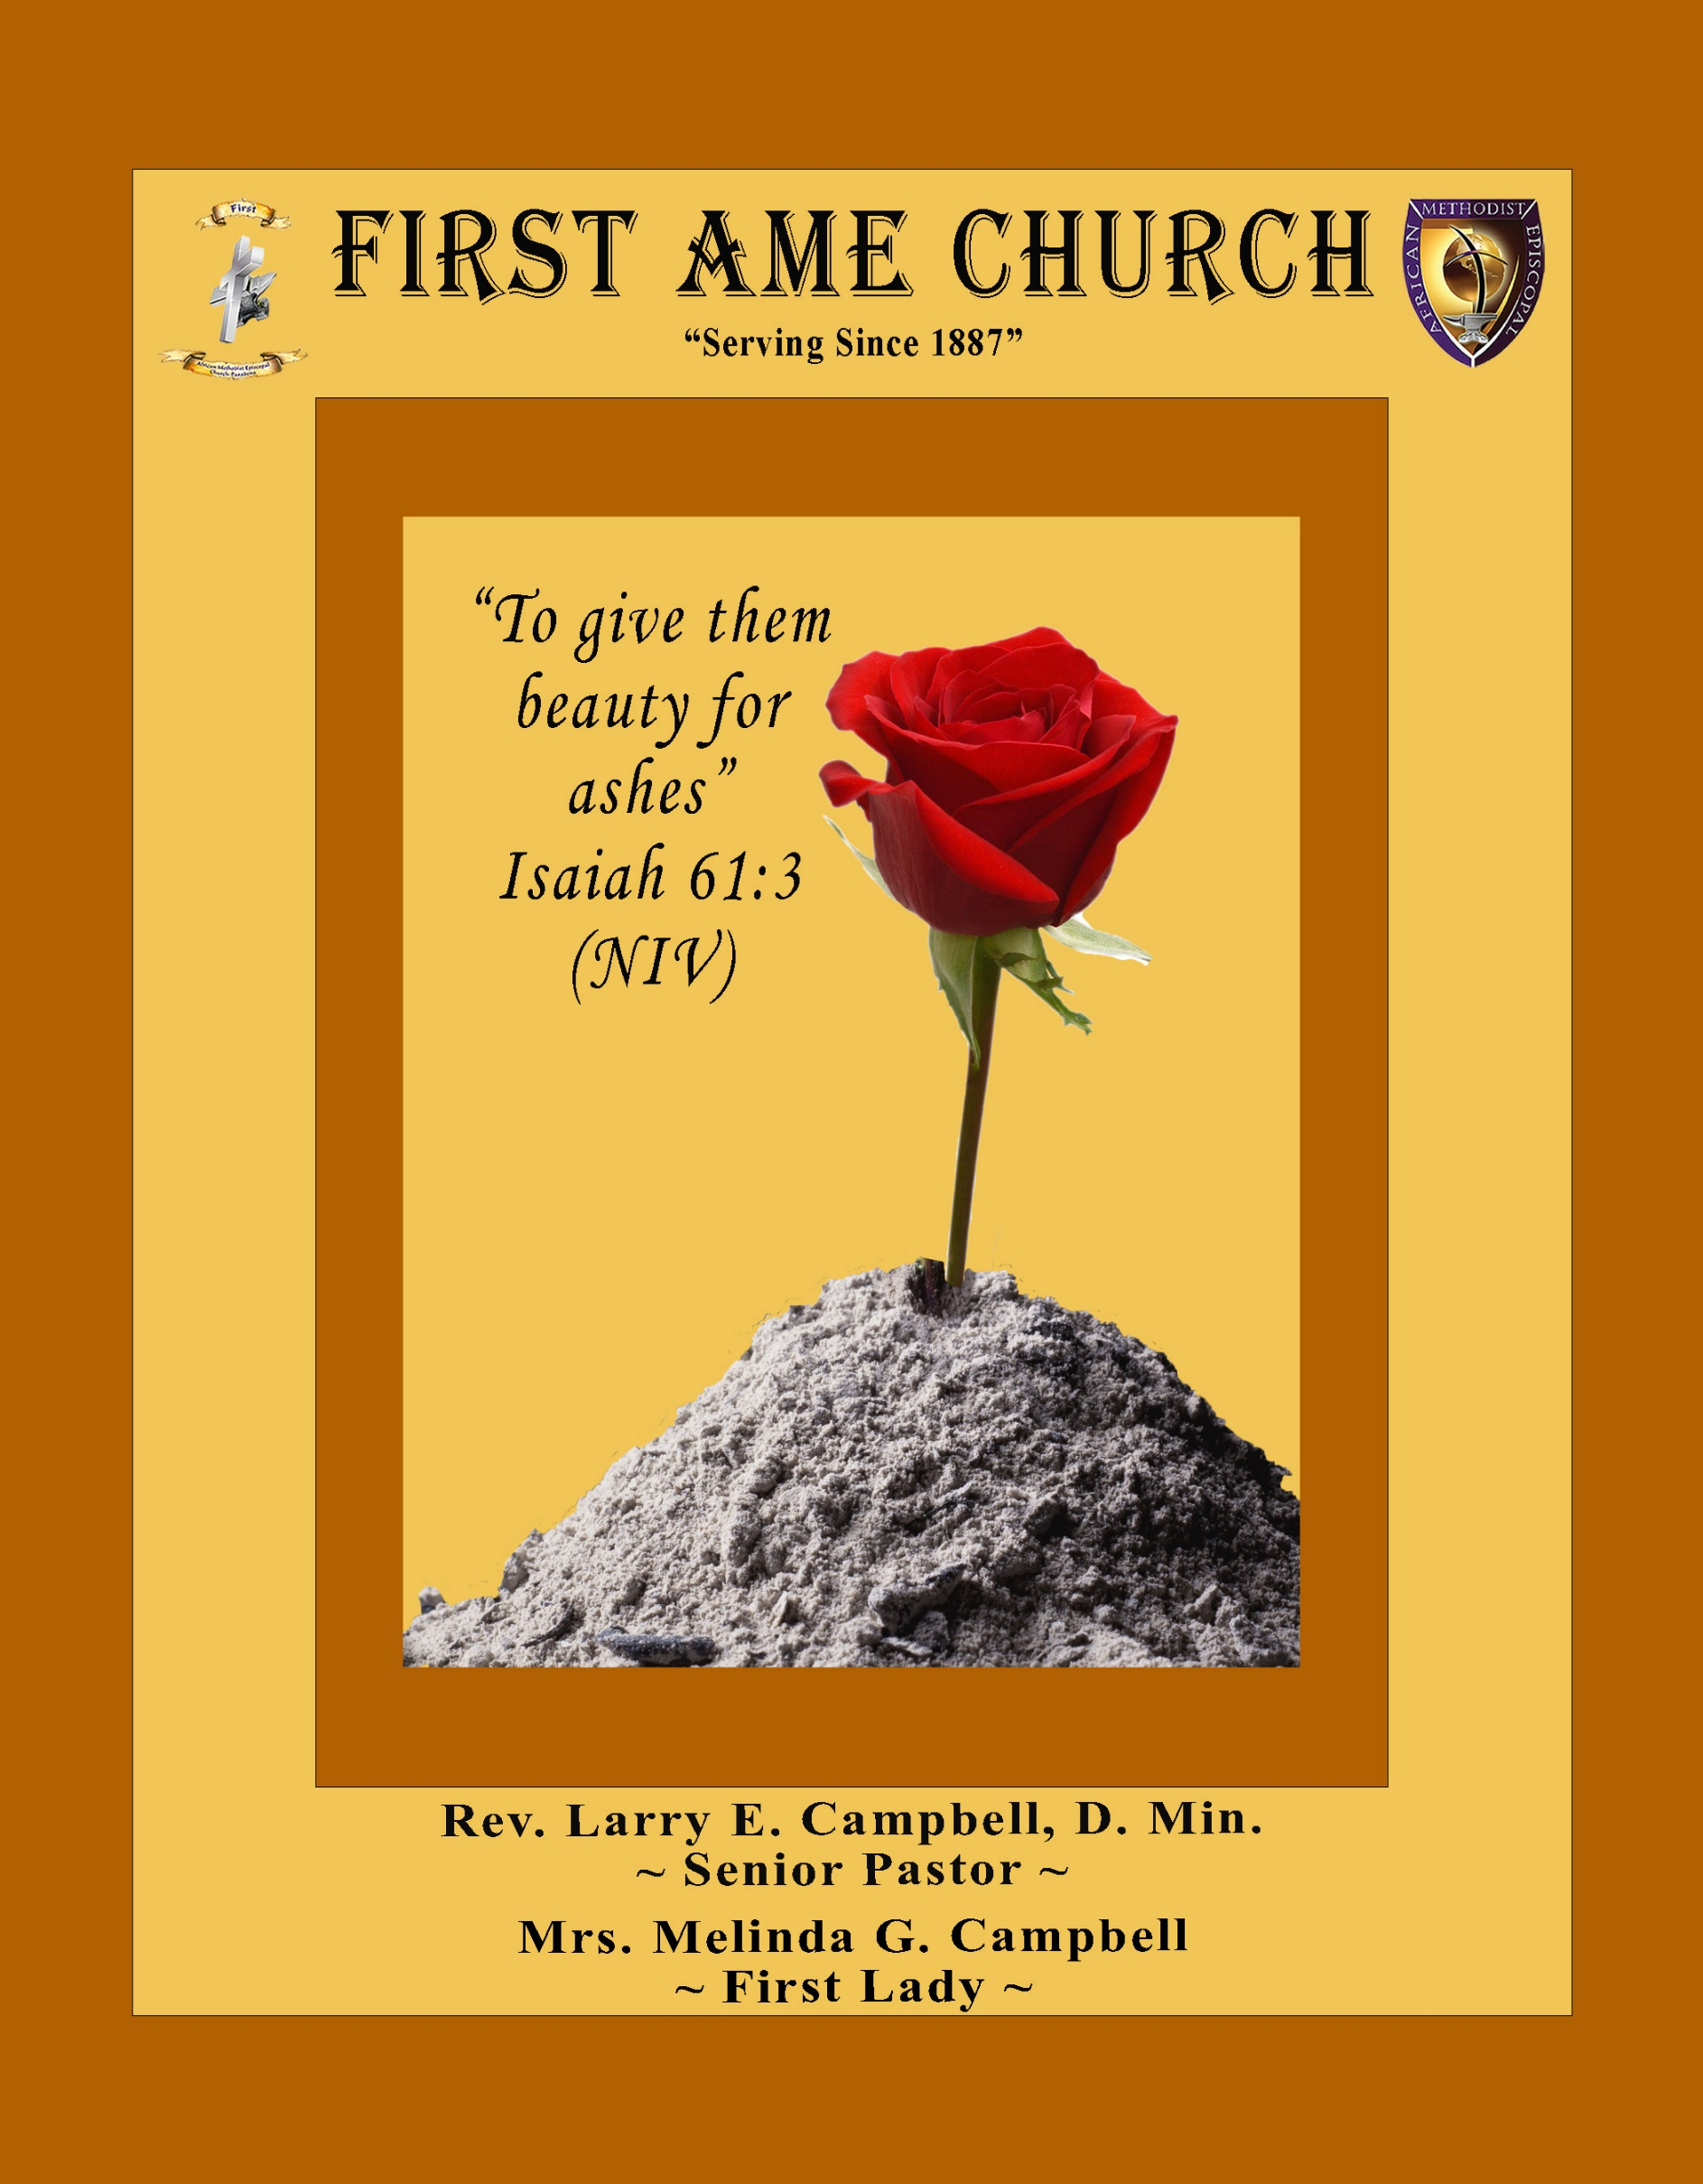
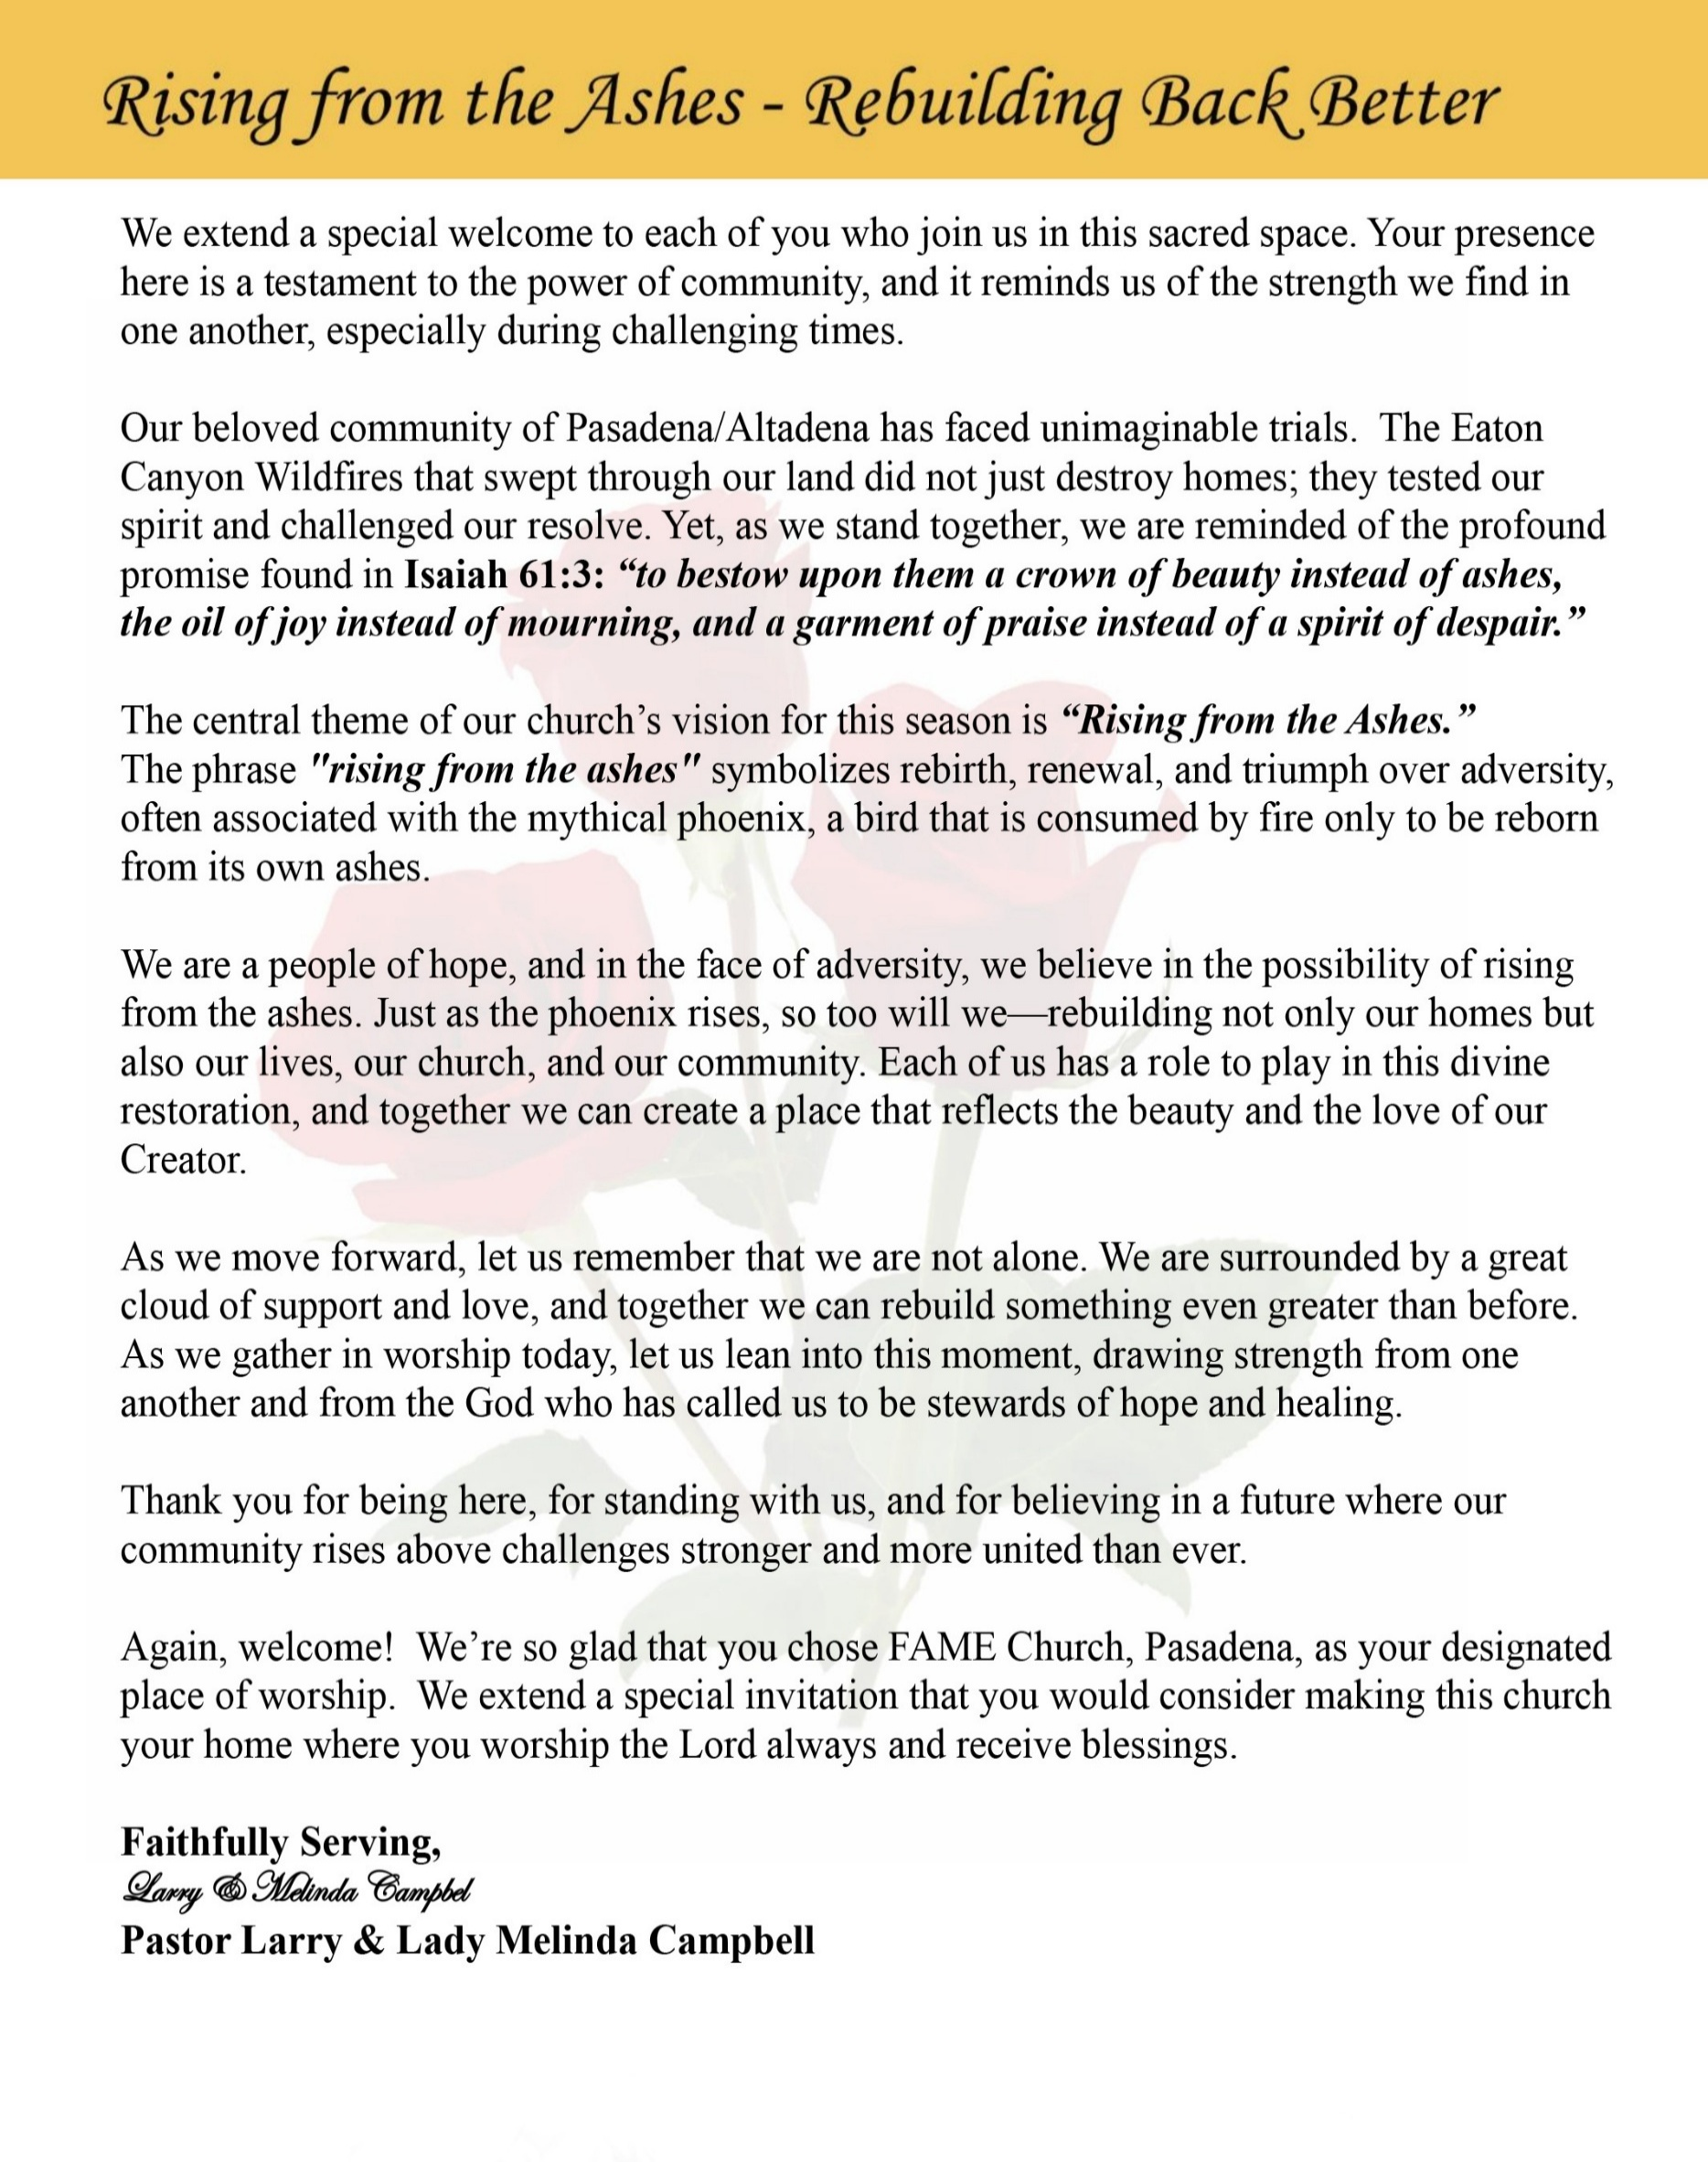

Sunday, August 23, 2026 | 9:30 a.m.

Rt. Rev. Francine A. Brookins, Esq., Presiding Bishop
Rev. Miriam Burnett, MD, MPH, Supervisor of Missions
Rev. Roosevelt Lindsey, Jr. Presiding Elder

The Rev. Dr. Larry E. Campbell ~ Senior Pastor ~ Minister

Mobile: (951) 587-1894 ~ Email: larrycampbell@famepasadena.org

Our First Lady: Mrs. Melinda G. Campbell

The Reverend Dr. Jennifer Oliver ~ Itinerant Elder -
The Reverend Dr. Nikia Smith-Robert ~ Itinerant Elder (Affiliated)
The Reverend Lois Woodard ~ Itinerant Elder Superannuated (Retired)
The Reverend Rochelle Wright Moore ~ Itinerant Deacon
The Reverend Deborah West-Jones ~ Local Elder
The Reverend Philis J. Griffin, MDiv ~ Local Elder
Dr. Phyllis Beech ~ Evangelist
Sister Tessie Bonner ~ Deaconess

Community Resource Center Director ~ Ms. Kischchen Hazelton Venerable
Church Administrative Assistant: Ms. Letha Rhymes

Church Office Hours:
Tue - Wed 9:00 am - 5:00 pm, & Fri 9:00 am -3:00 pm.
Closed for Lunch Daily: 12:00 pm - 1:00 pm.

Music Ministry
Dr. Timothy Davis, Minister of Music
Bro. Jimmy Watlington, Percussionist ~ Bro. Carlos Caldwell, Organist
Bro. Darien Dorsey, Keyboardist
Sis. Karen Law, Women’s Chorus Director ~ Sis. Tonia Graham, Children’s Choir Director
Bro. J. Renard Washington, New Generation’s Choir

FREE WI-FI service is available on the FAME Campus by accessing FAME 1700
Password: 6267980503

-3-

~ Order of Worship Experience ~

Warning: This order of worship is subject to change without warning or prior notice --- everything is governed by the Sovereignty of the Holy Spirit



Strong in Faith, Called to Lead

~ Altar Call ~
Praise & Worship

Doxology: “Praise God From Whom All Blessings Flow”

The Call to Worship Bro. Versie Gaddis

Leader: I was glad when they said unto me, let us go into the house of the Lord, our feet shall stand within Thy gates O Jerusalem! (Psalm 122:1)

People: For a day in Thy courts is better than a thousand. I had rather be a doorkeeper in the house of my God than to dwell in the tents of wickedness. (Psalm 84:10)

Leader: Because of the house of the Lord our God, I will seek Thy good. (Psalm 122:9)

People: Those that be planted in the house of the Lord, shall flourish in the courts of our God. (Psalm 92:13)

Leader: Blessed are they that dwell in Thy house. Lord, I have loved Thy habitation, the place where Thy honor dwelleth. (Psalm 26:8)

People: For the Lord is in His holy temple; let all the earth keep silence before Him.
(Habakkuk 2:20)

Leader: Let the words of my mouth and the meditation of my heart, be acceptable in Thy sight, O Lord my strength and my redeemer. (Psalm 19:14)

Unison: O Sing unto the Lord a new song, for He has done marvelous things. Make a
joyful noise unto the Lord, all the earth, sing His praises. (Psalm 98:1, 4)

-4-

The Hymn of Praise A.M.E. Hymnal #221

How to Reach the Masses
(Life Him Up)

(Words: Johnson Oatman, Jr., 1856-1926)

How to reach the masses those of every birth,
For an answer Jesus gave the key;
“And I, if I be lifted up from the earth,
Will draw all men unto me.”

Refrain
Lift Him up (Lift the precious Savior up,)
Lift Him up (Lift the precious Savior up,)
Still He speaks from eternity:
“And I, if I be lifted up from the earth,
Will draw all men unto Me.”

Oh! the world is hungry for the Living Bread.
Lift the Savior up for them to see;
Trust Him and do not doubt the words that He said,
“I’ll draw all men unto Me.”
Refrain

Don’t exalt the preacher, don’t exalt the pew,
Preach the gospel simple full and free;
Prove Him and you will find that promise is true,
I’ll draw all men unto Me.”
Refrain

Lift Him up by living as a Christian ought,
Let the world in you the Savior see;
Then all will gladly follow Him who once taught,
“I’ll draw all men unto Me.”
Refrain

The Invocation Bro. Al Brown
Ministry of Music The Male Chorus

-5-

Scripture Lesson
(Please Stand for the Reading of God’s Words)

Men’s Day Scriptural Responsive Litany Bro. Costello Brown
Leader: People of God, we gather today celebrating our men while recognizing that all of us are
called to stand strong in faith and faithfully lead and serve wherever God has placed us.

People: We will “watch, stand fast in the faith... be strong.” (1 Corinthians 16:13)

Leader: God calls us to be courageous in uncertain times, trusting not in our own strength, but in
the presence and power of God.

People: “Be strong and of a good courage; be not afraid… for the Lord thy God is with thee
whithersoever thou goest.” (Joshua 1:9)

Leader: God calls us to lead by example—in our homes, our church, our community, and
throughout society—standing for what is right, serving those in need, and becoming a
light in dark places.

People: “Let your light so shine before men, that they may see your good works, and glorify
your Father which is in heaven.” (Matthew 5:16)

Leader: God reminds us that we were never meant to walk this journey alone. We are called to
encourage one another, strengthen one another, and help one another become all that God
has called us to be.

People: “Iron sharpeneth iron; so a man sharpeneth the countenance of his friend.”
(Proverbs 27:17)

Leader: And when our faith is tested, Christ calls us not only to remain strong ourselves, but to
reach back and strengthen somebody else.

People: “I have prayed for thee, that thy faith fail not: and when thou art converted, strengthen
thy brethren.” (Luke 22:32)

Leader: Men of God, stand strong in faith. Lead with integrity. Serve with humility. Love your
families. Strengthen your brothers. Encourage the next generation. Make a difference
wherever God has planted you.

People: We will stand together, serve together, strengthen one another, and lead by faith!

Leader: People of God, what is our declaration?

ALL: STRONG IN FAITH! CALLED TO LEAD! Called to serve, called to
strengthen, and called to make a difference—for the glory of God! Amen!

-6-

The Summary of the Decalogue Bro. Clarence Stubblefield
LEADER: From all that dwell below the skies…
SUNG: From all that dwell below the skies, Let the Creator’s praise arise; Let the
Redeemer’s Name be sung, through every land, by every tongue.
LEADER: Hear what Christ our Savior saith, Thou shalt love the Lord thy God with all thy
heart, with all thy soul, and with all thy mind. This is the first and great
commandment. And the second is like unto it: Thou shalt love thy neighbor
as thyself. On these two commandments hang all the law and the prophets.
SUNG: Glory be to the Father, and to the Son, and to the Holy Ghost; as it was in
the beginning, is now, and ever shall be, world without end. A~Men

Abbreviated Announcements Dr. Brian K. Venerable

Words of Welcome/Encouragement Men’s Ministry President, Bro. Brian K. Williams



Special Congregational Hymn (Sing along)
Hymn #461— Love Lifted Me

LITANY FOR TITHES, GIFTS, AND OFFERINGS — Giving by Grace
~Bro Todd Skinner – Steward~
Leader: People of God, everything we have is a gift of God’s grace. Every blessing, every
resource, and every opportunity comes from His gracious hand.

People: “Every good gift and every perfect gift is from above.” (James 1:17)

Leader: Because God has given so freely to us, we give—not out of fear or obligation, but
with gratitude, joy, and faith.

People: “Freely ye have received, freely give.” (Matthew 10:8)

Leader: As we bring our tithes, gifts, and offerings, may our giving become an expression
of worship and a testimony of God’s grace.

People: “God loveth a cheerful giver.” (2 Corinthians 9:7)

Leader: May God receive what we give and use it to bless His Church, strengthen our
community, and advance His Kingdom.

ALL: Congregation: By God’s grace we have received; by God’s grace we gladly
give. Lord, receive our gifts and use them for Your glory. Amen.

-7-

The Offertory (Tithes ~ Gifts ~ Benevolent Offerings) Bro. Todd Skinner, Steward

The following Electronic GIVING Platforms are creditable methods to GIVE to FAME:

#1. GIVELIFY - Mobile Giving App available on the App Store. It’s easy to set up just follow the guidelines.

#2. Cash App: $FirstAMEPASADENA

#3. Mail in your Tithes & Offering - If you would like to mail your tithes and offering by check or money order, please send it to: First AME Church, 1700 N. Raymond Avenue, Pasadena, CA 91103.

#4. Drop off your Tithes & Offering - During business hours in the basket outside of the office.

Choral Response: “All things come of Thee, O Lord; and of Thine own have we given Thee. Amen.”

Sermonic Selection The Male Chorus

Introduction of Guest Preacher Pastor

Proclamation of The Word Rev. Dr. Dwaine A. Jackson
Pastor — Bryant Temple A.M.E. Church, Los Angeles

The Invitation (Public/Private)

How to Join First A.M.E. Church of Pasadena
PROFESSION OF FAITH. If you have never been a member of any church, you may join by professing Jesus Christ as your personal Lord and Savior.

RENEWAL OF VOWS. If you have been a member of a church at one time, but have been in active, you may join by renewing your faith in Jesus Christ as Lord and Savior.

TRANSFER. If you are a member of another African Methodist Episcopal Church and you are in good standing, you may join by requesting that your membership be transferred to the First African Methodist Episcopal Church of Pasadena.

AFFILIATE MEMBER. Sometimes an individual has reasons for keeping /his/her membership in another church but would like to be an active member of First African Methodist Episcopal Church, too. This is possible as an affiliate member. ______________________________________________________________________________________________________________

The Doxology

The Benediction

-8-

Scripture of the Day
Strong in Faith. “Be on your guard; stand firm in the faith; be courageous; be strong. ¹⁴ Do everything in love.” 1 Corinthians 16:13-14

Quote of the Day
“Strong faith does not require us to see every step. Strong faith requires us to trust God enough to take the next step.” Rev. Dr. Martin Luther King, Jr.

Thought of the Week
“Finally, my brethren, be strong in the Lord, and in the power of his might.” Ephesians 6:10
Being strong in faith does not mean that we never become tired, discouraged, or afraid. It means that when our strength runs low, we know where to go for more.
Paul does not tell us simply to “be strong.” He says, “Be strong in the Lord.” There is a difference. Our strength has limits, but God's strength does not. Our courage may weaken, but God's power remains. Our faith may be tested, but God is still faithful.
Men and women of faith will face difficult days, unexpected battles, and seasons when the road ahead is uncertain. Yet we do not have to face them in our own strength. God gives us strength to stand when life tries to knock us down, lead when others need direction, serve when there is work to be done, and encourage others when they become weary.
Strong faith is not about proving how strong we are. It is about demonstrating how strong our God is. So, whatever you face today, stand strong, keep believing, keep serving, and keep trusting God. Be strong in the Lord—and let His strength become your strength.

Humor of the Week
THE READING OF THE WILL
A lawyer meets with the family of a recently deceased millionaire for the reading of the will.
"To my loving wife, Rose, who really loved me and always stood by me, I leave the house and $2 million," the attorney reads.
"To my darling daughter, Jessica, who looked after me in sickness and kept the business going profitably, I leave the yacht, the business and $1 million."
"And finally," the lawyer concludes, "to my cousin Louie, who didn’t work, who lived with us, who never washed a dish or helped out, who never recognized Rose’s or my birthdays or anniversaries, who argued with me and who thought I would never mention him in my will…
Hello Louie!”

HOME DAILY BIBLE READINGS
August 24, 2026 – August 30, 2026 (Week 49, 2 Peter)
Monday Day 337 Ephesians 3-4, Proverbs 15
Tuesday Day 338 Ephesians 5-6, Proverbs 16
Wednesday Day 339 Philippians 1-2, Proverbs 17
Thursday Day 340 Philippians 3-4, Proverbs 18
Friday Day 341 Colossians 1-2, Proverbs 19
Saturday Day 342 Colossians 3-4, Proverbs 20
Sunday Day 343 1 Thessalonians 1-2, Proverbs 21

-9-

ANNOUNCEMENTS

BEREAVEMENT NOTIFICATION
It is with deep sorrow and heartfelt sympathy that we announce the passing of Mr. Leon Washington, Jr., beloved husband of Gwendolyn Washington and dear son of Leon and Alleen Washington.
A Special Memorial Service celebrating his life will be held:
Friday, September 4, 2026 |10:00 a.m.
First African Methodist Episcopal Church of Pasadena
During this difficult season of bereavement, we ask that you keep the entire Washington family lifted in your thoughts and prayers. May they find comfort in God's presence, strength in His promises, and peace in knowing that “earth has no sorrow that heaven cannot heal.” Please continue to surround the Washington family with your love, prayers, and support.

BEREAVEMENT NOTIFICATION
It is with deep sorrow and heartfelt sympathy that we announce the passing of Brother Odis “Konata” Doxey, beloved husband of Sister Lateefah Doxey and cherished member of the Doxey family.
Brother Konata was a faithful and dedicated member of First A.M.E. Church, Pasadena, who gave generously of his time, talents, and service to the ministry of the Church. Over the years, he faithfully served on the Trustee Board, assisted with Church Transportation, and shared his gifts through the Theater Guild.
Konata will be remembered not only for the positions in which he served, but for his faithful presence, willing spirit, and commitment to the life and ministry of FAME Pasadena. His years of service have left a lasting imprint upon our church family.
We ask the entire FAME Church family to keep Sister Lateefah, Hasan, and the entire Doxey family lifted in prayer during this season of bereavement. May the God of all comfort strengthen them, surround them with His love, and grant them peace in the days ahead.
Homegoing/Memorial Service arrangements will be shared as they become available.
With Christian Sympathy,

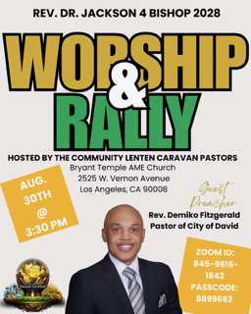

-10-

ANNOUNCEMENTS (Continued)

WELCOME! WELCOME! WELCOME! It is with great pleasure and joy that we officially welcome Bro. Thurston Johnson to the FAME Family kinship. We are truly blessed and very grateful for his presence and valued membership in our church family.

Men's Ministry - BIBLE STUDY
Time: Tuesday, September 1, 2026 | 6:00 p.m.
Meeting ID: 894 7536 6487 | Passcode: 465177
One tap mobile: +16699006833,,89475366487#,,,,*465177# US (San Jose)

Women's Ministry – BIBLE STUDY
Time: Tuesday, September 1, 2026 | 6:00 p.m.
Meeting ID: 857 0061 9461; Passcode: 933892
One tap mobile +16699006833,,85700619461#,,,,,,0#,,933892# US (San Jose)

WEEKLY BIBLE STUDY CLASSES
Please note that our weekly Bible Study classes (Wednesday Bible Study sessions and Wednesday Prayer Service sessions) will resume on Wednesday, September 2, 2026

Senior Ministry Luncheon
You are invited to join us to enjoy good fellowship, good food, and helpful information at the FAME Senior Ministry gathering on Tuesday, September 8, 2026 @ 11:30 a.m. Bring a friend. All are welcome.

Budget Submission
All Auxiliary and Organization Presidents must submit their 2026-2027 draft budgets to Sis. Kischchen Hazelton Venerable by Friday, September 18, 2026.

FIRST A.M.E. CHURCH PASADENA
Celebrating 139 Years of Faithful Service
The Heritage Committee invites you and your family to join us in celebrating our 139th Church Anniversary. The Theme is: HONORING OUR PAST; EMBRACING OUR FUTURE. This will be a Family Affair, so please join us as we Praise God for His rich blessings on Sunday, September 13, 2026, at 9:30 AM. A wonderful meal will be served following the worship service.

Los Angeles South/ Las Vegas District Cluster
Presiding Elder Roosevelt Lindsey will hold the Fourth Quarterly Cluster on Saturday, September 19, 2026, at 10:00 a.m. The event will take place at Bryant Temple AME Church. The participating churches include Christ Our Redeemer, Bethel LA, Bethel Barstow, Brookins-Kirkland, First Pasadena, Greater Harvest, Bethel Oxnard, Brown Memorial, Walker Temple, Rose of Sharon, Johnson Chapel Santa Ana, Holy Trinity Long Beach, Bryant Temple, and Grant Long Beach. All ministers, officers, and church members are invited to attend.

-11-

ANNOUNCEMENTS (Continued)

🌟 FAME PASADENA IS MAKING HISTORY! 🌟
VOLUNTEERS NEEDED — THIS IS A FAMILY AFFAIR!

First AME Church Pasadena Family,
It is with great honor, excitement, and anticipation that we prepare to host the 102nd Session of the Southern California Annual Conference and Fifth District Planning Meeting!

Wednesday, October 21 – Thursday, October 29, 2026 | Hilton Los Angeles Airport

As we welcome clergy, delegates, lay members, and guests from across the Fifth Episcopal District, we have an opportunity to bring a taste of Pasadena to Los Angeles through our warmth, hospitality, excellence, and spirit of Christian service.

WE NEED YOU!
We are seeking dedicated volunteers to serve in the following areas:
Decorations & Hospitality --- Prayer Room Attendants
Conference Registration --- Ushers
Stewardesses --- Greeters & Hospitality
Health & Welfare

Whether you can serve for one day or throughout the conference, your presence and participation will make a difference! “Whatever you do, work at it with all your heart, as working for the Lord.” — Colossians 3:23. This is more than an assignment—it is an opportunity for FAME Pasadena to serve, welcome, represent, and shine!

REMEMBER: THIS IS A FAMILY AFFAIR!
Every member has a gift. Every gift has a place. Every person can make a difference.
If you are willing to serve, please contact the FAME Church Office immediately to sign up and receive additional information.

Let’s come together, roll up our sleeves, open our hearts, and show the Fifth District what FAME Pasadena hospitality looks like!

FAME PASADENA — SERVING WITH EXCELLENCE, WELCOMING WITH LOVE, AND REPRESENTING PASADENA WITH PRIDE!

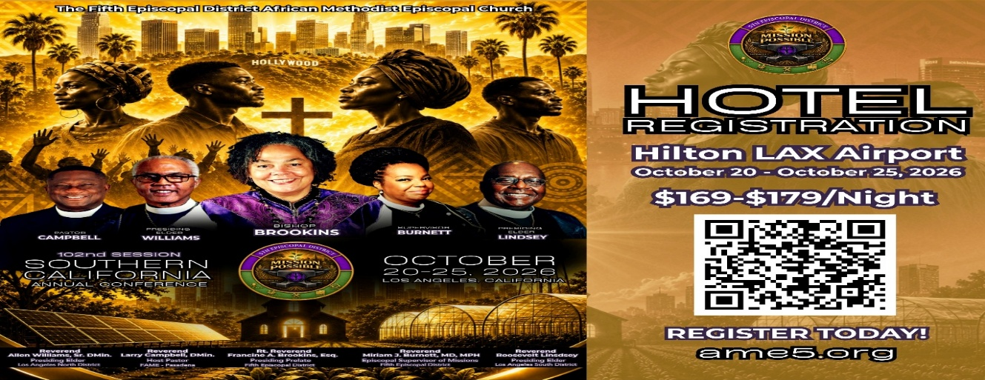

-12-

Prayer Request(s)
Please notify the Church Office of Sick & Shut-in additions, deletions, or status/address changes.

Bishop Francine A. Brookins, Esq. Supervisor Miriam Burnett, MD Presiding Elder Roosevelt & Dr. Kaye Lindsey Rev. Dr. Larry & Melinda Campbell Richard Craig Hazel Clark Erica Woodard Jason Shirley Joshua Shirley Julian Shirley Ayanna Terry Cheryl Jamerson Gwendolyn Flowers Andrea Anderson Ocilda Files Danielle Clark Rev. Charles Brooks Kimberly Woods Cynithia Grace Calle Burns Noel Johnson The Taylor Family
Zechariah Robinson Christopher McCarthy Wilma Haynes Jacquelyn Walker Brittney Petty Selene Cox Deborah Burton Nettie McChristen The Caple Family Mel Beech Michael Dotson
Rev. Rochelle Moore Lorene Butler Stella Pulliam Collette Blizzard The Eaton Canyon Fire Victims

College Students

Let’s continue to support and pray for our beloved College Students

Isaiah Crowell Alecia Davis Chase Johnson Grant Blizzard Gabriel Blizzard

Tyler Johnson Richard Jones Tyrikk Lawson Makia Rose Talbert Isaiah Ringo Journey Rogers Elyse Sharp Kylee Sharp Zion Otano Elise Tervalon Grace Jones Jordan Patterson Kimberly Robinson Donovan Williams Jasmine Collins Brandon Bates

Sick and Shut-Ins
Andrew Oliver 1405 N. Roosevelt Avenue, Pasadena, CA 91104
Barbara Buchanan 616 Rio Grande St. Pasadena, CA 91104
Bettina Ayers Pasadena Meadows Nursing Home, 150 Bellefontaine St., Pas., CA 91105
Betty Betts Turner 1625 S Magnolia Ave Unit 4125 Monrovia, CA 91016
Bobby Thomas 1052 E. Morada Place, Altadena, CA 91001
Diane Jordan 1719 Fremont Ave., #302, S. Pasadena, CA 91030
Donita Towler 14148 Francisquito Ave, Baldwin Park, CA 91706
Doris Curd 11619 Woodcock Avenue, San Fernando, CA 91340
Edmund Riddle Active Care Mission Bay, 2440 Grand Avenue, San Diego, CA 92109
Eleanor Towler 975 E. Union Street, Unit #417, Pasadena, CA 91106
Elois Blizzard P. O. Box 3646, So. Pasadena, CA 91031
Emily Cormier-Ross 2549 La Fiesta Avenue, Altadena, CA 91001
Ernestine English 26 W. Fair Oaks Drive, Pasadena, CA 91103
Fred Caple 51 North 15th Street Haledon, NJ 07508
Hugh Hamberry 19225 Chole Rd., Apple Valley, CA 92307
Jessie Smith 3925 S Jones BL, Apt 2118 Las Vegas, NV 89103| Spring Valley Community
Josephine Brown 15607 Saddleback Rd, Riverside, CA 92506
Konata Doxey Monte Vista Healthcare Center, Duarte, CA 91010
Lenora Moore 2445 E. Del Mar Bl, #338 Pasadena, CA 91107
Linnie G. Nollie 2250 E. New York Drive, Altadena, CA 91001
Malika G. Hendry P. O. Box 94082, Pasadena, CA 91109
Mildred Lewis C/O Hazel Rohr, 884 W. Jane Court, Upland, CA 91786
Norma Burnett 618 Fairview Avenue, Unit #228, Arcadia, CA 91007
Opal Hampton 1030 Chevron Court, Pasadena, CA 91103
Paul Ratliff P.O. Box 40407 Pasadena, CA 91114
Virlyn Grant 15122 Orange Ave., Paramount, CA 90723
Wanda Nelson 3618 N. Fair Oaks Avenue, Altadena, CA 91001
William Hilliard 7504 Wynstone Pl., Fontana, CA 92336
Zell L. Hill 375 Barthe Drive, Pasadena, CA 91103

-13-

Sermon Notations

Scripture: _____________________________________________________________

Subject: _______________________________________________________________

Points of the Message: ___________________________________________________
_______________________________________________________________________
_______________________________________________________________________
_______________________________________________________________________
_______________________________________________________________________
_______________________________________________________________________
_______________________________________________________________________

Main Ideas of the Sermon: ________________________________________________
_______________________________________________________________________
_______________________________________________________________________
_______________________________________________________________________
_______________________________________________________________________
_______________________________________________________________________

Illustrations I want to remember: _________________________________________
_______________________________________________________________________
_______________________________________________________________________
_______________________________________________________________________
_______________________________________________________________________
_______________________________________________________________________
_______________________________________________________________________

What should I do as a result of this Sermon? ________________________________

_____________________________________________________
_____________________________________________________
_____________________________________________________
_____________________________________________________

-14-

