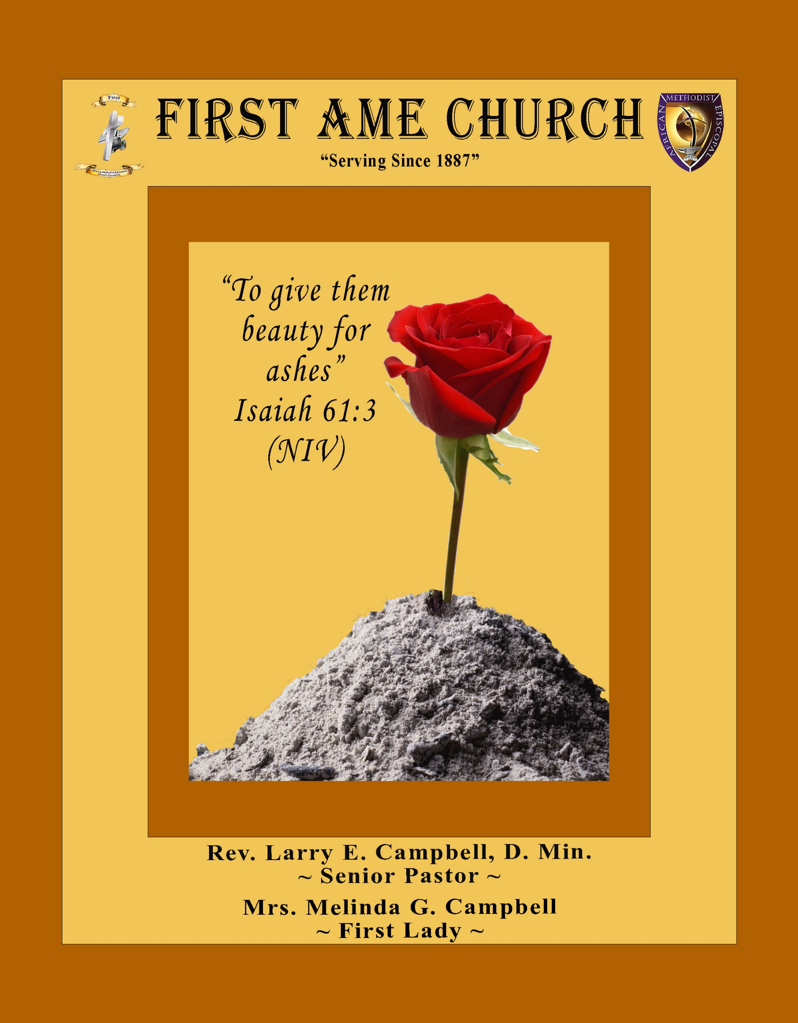
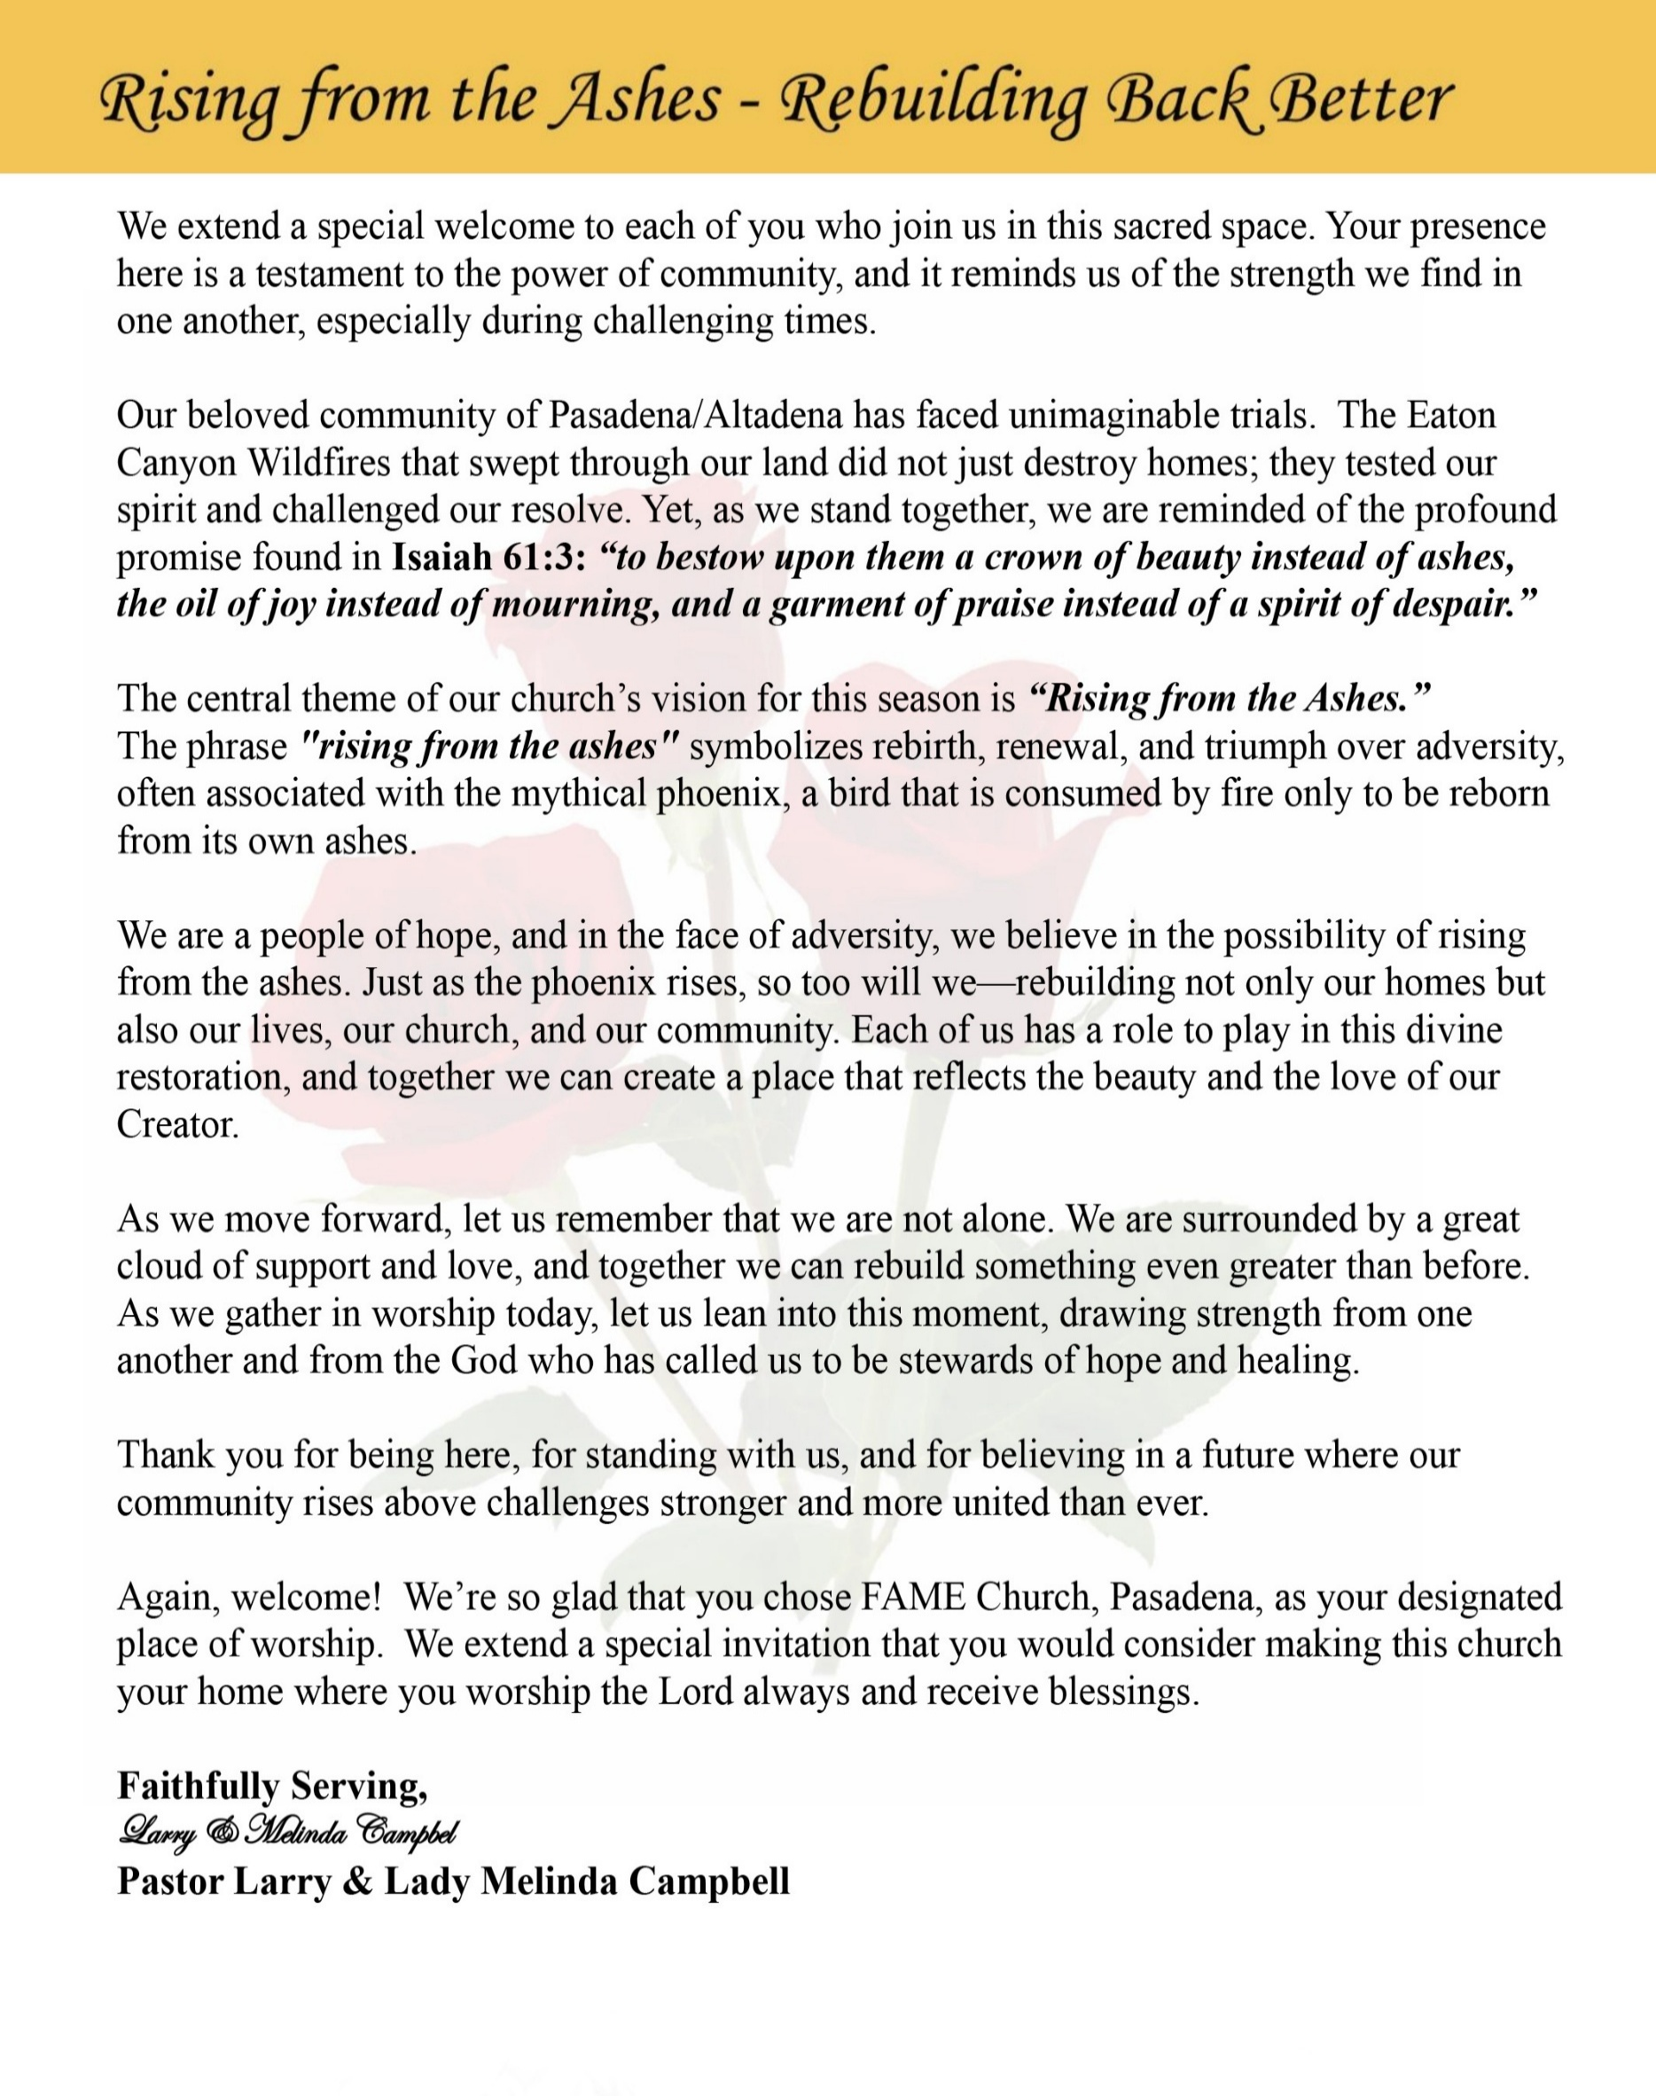

Sunday, August 30, 2026 | 9:30 a.m.

Rt. Rev. Francine A. Brookins, Esq., Presiding Bishop
Rev. Miriam Burnett, MD, MPH, Supervisor of Missions
Rev. Roosevelt Lindsey, Jr. Presiding Elder

The Rev. Dr. Larry E. Campbell ~ Senior Pastor ~ Minister

Mobile: (951) 587-1894 ~ Email: larrycampbell@famepasadena.org

Our First Lady: Mrs. Melinda G. Campbell

The Reverend Dr. Jennifer Oliver ~ Itinerant Elder -
The Reverend Dr. Nikia Smith-Robert ~ Itinerant Elder (Affiliated)
The Reverend Lois Woodard ~ Itinerant Elder Superannuated (Retired)
The Reverend Rochelle Wright Moore ~ Itinerant Deacon
The Reverend Deborah West-Jones ~ Local Elder
The Reverend Philis J. Griffin, MDiv ~ Local Elder
Dr. Phyllis Beech ~ Evangelist
Sister Tessie Bonner ~ Deaconess

Community Resource Center Director ~ Ms. Kischchen Hazelton Venerable
Church Administrative Assistant: Ms. Letha Rhymes

Church Office Hours:
Tue - Wed 9:00 am - 5:00 pm, & Fri 9:00 am -3:00 pm.
Closed for Lunch Daily: 12:00 pm - 1:00 pm.

Music Ministry
Dr. Timothy Davis, Minister of Music
Bro. Jimmy Watlington, Percussionist ~ Bro. Carlos Caldwell, Organist
Bro. Darien Dorsey, Keyboardist
Sis. Karen Law, Women’s Chorus Director ~ Sis. Tonia Graham, Children’s Choir Director
Bro. J. Renard Washington, New Generation’s Choir

FREE WI-FI service is available on the FAME Campus by accessing FAME 1700
Password: 6267980503

-3-

~ Order of Worship Experience ~

Warning: This order of worship is subject to change without warning or prior notice --- everything is governed by the Sovereignty of the Holy Spirit

Worship Leader: Olivia Wilson Women’s Missionary Society

~ Altar Call ~
Praise & Worship

Doxology: “Praise God From Whom All Blessings Flow”

The Call to Worship Sis. Marva Sampson

Leader: I was glad when they said unto me, let us go into the house of the Lord, our feet shall stand within Thy gates O Jerusalem! (Psalm 122:1)

People: For a day in Thy courts is better than a thousand. I had rather be a doorkeeper in the house of my God than to dwell in the tents of wickedness. (Psalm 84:10)

Leader: Because of the house of the Lord our God, I will seek Thy good. (Psalm 122:9)

People: Those that be planted in the house of the Lord, shall flourish in the courts of our God. (Psalm 92:13)

Leader: Blessed are they that dwell in Thy house. Lord, I have loved Thy habitation, the place where Thy honor dwelleth. (Psalm 26:8)

People: For the Lord is in His holy temple; let all the earth keep silence before Him.
(Habakkuk 2:20)

Leader: Let the words of my mouth and the meditation of my heart, be acceptable in Thy sight, O Lord my strength and my redeemer. (Psalm 19:14)

Unison: O Sing unto the Lord a new song, for He has done marvelous things. Make a
joyful noise unto the Lord, all the earth, sing His praises. (Psalm 98:1, 4)

-4-

The Hymn of Praise African American Heritage Hymnal #291
O How I Love Jesus

1 There is a name I love to hear,
I love to sing its worth;
it sounds like music in my ear,
the sweetest name on earth.

Refrain:
O how I love Jesus,
O how I love Jesus,
O how I love Jesus,
because he first loved me!

2 It tells me of a Savior's love,
who died to set me free;
it tells me of his precious blood,
the sinner's perfect plea.

[Refrain]

3 It tells of one whose loving heart
can feel my deepest woe;
who in each sorrow bears a part
that none can bear below.

[Refrain]

The Invocation Sis. Valitta Sharpe

Ministry of Music The Women Chorus

-5-

Scripture Lesson
(Please Stand for the Reading of God’s Words)

Old Testament First Lady Melinda G. Campbell

Psalm 1 (New Revised Standard Version Updated Edition)
¹ Happy are those who do not follow the advice of the wicked or take the path that sinners tread or sit in the seat of scoffers, ² but their delight is in the law of the Lord, and on his law they meditate day and night. ³ They are like trees planted by streams of water, which yield their fruit in its season, and their leaves do not wither. In all that they do, they prosper.
⁴ The wicked are not so but are like chaff that the wind drives away. ⁵ Therefore the wicked will not stand in the judgment nor sinners in the congregation of the righteous, ⁶ for the Lord watches over the way of the righteous, but the way of the wicked will perish.

New Testament Sis. Catherine Graham
Romans 16:17-20 (New International Version)
¹⁷ I urge you, brothers and sisters, to watch out for those who cause divisions and put obstacles in your way that are contrary to the teaching you have learned. Keep away from them. ¹⁸ For such people are not serving our Lord Christ, but their own appetites. By smooth talk and flattery they deceive the minds of naive people. ¹⁹ Everyone has heard about your obedience, so I rejoice because of you; but I want you to be wise about what is good, and innocent about what is evil. ²⁰ The God of peace will soon crush Satan under your feet.
The grace of our Lord Jesus be with you.

-6-

The Summary of the Decalogue Sis. Lorna (Dee) Washington
LEADER: From all that dwell below the skies…
SUNG: From all that dwell below the skies, Let the Creator’s praise arise; Let the
Redeemer’s Name be sung, through every land, by every tongue.
LEADER: Hear what Christ our Savior saith, Thou shalt love the Lord thy God with all thy
heart, with all thy soul, and with all thy mind. This is the first and great
commandment. And the second is like unto it: Thou shalt love thy neighbor
as thyself. On these two commandments hang all the law and the prophets.
SUNG: Glory be to the Father, and to the Son, and to the Holy Ghost; as it was in
the beginning, is now, and ever shall be, world without end. A~Men

Abbreviated Announcements/ Welcome



Special Congregational Hymn (Sing along)
Hymn #196— There’s a Sweet, Sweet, Spirit

LITANY FOR TITHES, GIFTS, AND OFFERINGS — Giving by Grace
Sis. Pamela J. Hughes, Steward
Leader: People of God, everything we have is a gift of God’s grace. Every blessing, every
resource, and every opportunity comes from His gracious hand.

People: “Every good gift and every perfect gift is from above.” (James 1:17)

Leader: Because God has given so freely to us, we give—not out of fear or obligation, but
with gratitude, joy, and faith.

People: “Freely ye have received, freely give.” (Matthew 10:8)

Leader: As we bring our tithes, gifts, and offerings, may our giving become an expression
of worship and a testimony of God’s grace.

People: “God loveth a cheerful giver.” (2 Corinthians 9:7)

Leader: May God receive what we give and use it to bless His Church, strengthen our
community, and advance His Kingdom.

ALL: Congregation: By God’s grace we have received; by God’s grace we gladly
give. Lord, receive our gifts and use them for Your glory. Amen.

-7-

The Offertory (Tithes ~ Gifts ~ Benevolent Offerings) Sis. Pamela J. Hughes, Steward

The following Electronic GIVING Platforms are creditable methods to GIVE to FAME:

#1. GIVELIFY - Mobile Giving App available on the App Store. It’s easy to set up just follow the guidelines.

#2. Cash App: $FirstAMEPASADENA

#3. Mail in your Tithes & Offering - If you would like to mail your tithes and offering by check or money order, please send it to: First AME Church, 1700 N. Raymond Avenue, Pasadena, CA 91103.

#4. Drop off your Tithes & Offering - During business hours in the basket outside of the office.

Choral Response: “All things come of Thee, O Lord; and of Thine own have we given Thee. Amen.”

Children’s Church Dismissal

Sermonic Selection The Women Chorus

Proclamation of The Word Pastor Larry E. Campbell

The Invitation (Public/Private)

How to Join First A.M.E. Church of Pasadena
PROFESSION OF FAITH. If you have never been a member of any church, you may join by professing Jesus Christ as your personal Lord and Savior.

RENEWAL OF VOWS. If you have been a member of a church at one time, but have been in active, you may join by renewing your faith in Jesus Christ as Lord and Savior.

TRANSFER. If you are a member of another African Methodist Episcopal Church and you are in good standing, you may join by requesting that your membership be transferred to the First African Methodist Episcopal Church of Pasadena.

AFFILIATE MEMBER. Sometimes an individual has reasons for keeping /his/her membership in another church but would like to be an active member of First African Methodist Episcopal Church, too. This is possible as an affiliate member. ______________________________________________________________________________________________________________

The Doxology

The Benediction

-8-

Scripture of the Day
Character Control. “Those who belong to Christ Jesus have crucified the flesh with its passions and desires. ²⁵ Since we live by the Spirit, let us keep in step with the Spirit. ²⁶ Let us not become conceited, provoking and envying each other.” Galatians 5:22-26

Quote of the Day
“Never let someone else’s lack of character cause you to lose yours.” Author Unknown

Thought of the Week
CHARACTER CONTROL
“He that is slow to anger is better than the mighty; and he that ruleth his spirit than he that taketh a city.” — Proverbs 16:32 (KJV)
One of the greatest demonstrations of spiritual maturity is not controlling other people—it is controlling ourselves.
We cannot always control what people say, how they behave, or how they treat us. But through the power of the Holy Spirit, we can control how we respond. Someone else’s bad behavior does not have to become our bad behavior.
Proverbs teaches us that the person who can “ruleth his spirit” possesses greater strength than someone who conquers a city. Real strength is knowing when to speak, when to remain silent, when to walk away, and when to refuse to allow another person’s foolishness to change your character.
Remember: Don’t give someone else remote control over your character. When they can control your reaction, you have given them power they were never meant to possess.
This week, when you are challenged, offended, or provoked, ask yourself: “Will my response reflect their character—or Christ’s character?”

Humor of the Week
Two Washington politicians had locked themselves out of their car, and unfortunately some important papers they needed for a meeting were inside. "Let's use a coat hanger to pull up the lock," suggested the first.
"Oh, no," argued the second. "Someone might see us and think we were trying to break in."
"Then we could use my pocketknife to cut away the rubber around the window and stick our fingers through to pull up the lock."
"No, no! People would think we're too stupid to know how to use a coat hanger to open cars."
"Well, we'd better do something fast. The top's down and it's starting to rain."

HOME DAILY BIBLE READINGS
August 31, 2026 – September 6, 2026 (Week 50, 1 John)
Monday Day 344 1 Thessalonians 4-5, Proverbs 22
Tuesday Day 345 2 Thessalonians 1-3, Proverbs 23
Wednesday Day 346 1 Timothy 1-6, Proverbs 24
Thursday Day 347 2 Timothy 1-4, Proverbs 25
Friday Day 348 Titus 1-3, Proverbs 26
Saturday Day 349 Philemon 1:1-25, Proverbs 27
Sunday Day 350 Hebrew 3-4, Proverbs 28

-9-

ANNOUNCEMENTS

WELCOME! WELCOME! WELCOME! It is with great pleasure and joy that we officially welcome Bro. Collin Hobbs to the FAME Family kinship. We are truly blessed and very grateful for his presence and valued membership in our church family.

FAME PASADENA IS MAKING HISTORY!
VOLUNTEERS NEEDED — THIS IS A FAMILY AFFAIR!
It is with great honor, excitement, and anticipation, FAME Pasadena will host the 102nd Session of the Southern California Annual Conference and Fifth District Planning Meeting, taking place:
Wednesday, October 21 – Thursday, October 29, 2026
Hilton Los Angeles Airport
As we welcome clergy, delegates, lay members, and guests from across the Fifth Episcopal District, we have a wonderful opportunity to bring the spirit of Pasadena to Los Angeles through our warmth, hospitality, excellence, and Christian service.
WE NEED YOU!
We are seeking dedicated volunteers to serve in the following areas:
Decorations & Hospitality Greeters & Hospitality
Prayer Room Attendants Health & Welfare
Conference Registration Transportation
Ushers Logisticians
Stewardesses
📢 SPECIAL VOLUNTEER BRIEFING & REGISTRATION
A special volunteer briefing and registration will be held in the Fellowship Hall TODAY during our Sunday Community Luncheon. Please plan to attend, learn more about the various areas of service, and register to volunteer.

MEMORIAL SERVICE
Honoring the Life of Mr. Leon Washington, Jr.
Friday, September 4, 2026 |10:00 a.m.
First African Methodist Episcopal Church of Pasadena
During this difficult season of bereavement, we ask that you keep the entire Washington family lifted in your thoughts and prayers.

MEMORIAL SERVICE
Honoring the Life of Brother Otis “Konata” Doxey,
Thursday, September 10, 2026 |11:00 a.m.
First African Methodist Episcopal Church of Pasadena
During this difficult season of bereavement, we ask that you keep the entire Doxey family lifted in your thoughts and prayers.

Women's Ministry – BIBLE STUDY
Time: Tuesday, September 1, 2026 | 6:00 p.m.
Meeting ID: 857 0061 9461; Passcode: 933892
One tap mobile +16699006833,,85700619461#,,,,,,0#,,933892# US (San Jose)

-10-

ANNOUNCEMENTS (Continued)

Men's Ministry - BIBLE STUDY
Time: Tuesday, September 1, 2026 | 6:00 p.m.
Meeting ID: 894 7536 6487 | Passcode: 465177
One tap mobile: +16699006833,,89475366487#,,,,*465177# US (San Jose)

WEEKLY BIBLE STUDY CLASSES
Please note that our weekly Bible Study classes (Wednesday Bible Study sessions and Wednesday Prayer Service sessions) will resume on Wednesday, September 2, 2026

Senior Ministry Luncheon
You are invited to join us to enjoy good fellowship, good food, and helpful information at the FAME Senior Ministry gathering on Tuesday, September 8, 2026 @ 11:30 a.m. Bring a friend. All are welcome.

Budget Submission
All Auxiliary and Organization Presidents must submit their 2026-2027 draft budgets to Sis. Kischchen Hazelton Venerable by Friday, September 18, 2026.

FIRST A.M.E. CHURCH PASADENA
Celebrating 139 Years of Faithful Service
The Heritage Committee invites you and your family to join us in celebrating our 139th Church Anniversary. The Theme is: HONORING OUR PAST; EMBRACING OUR FUTURE. This will be a Family Affair, so please join us as we Praise God for His rich blessings on Sunday, September 13, 2026, at 9:30 AM. A wonderful meal will be served following the worship service.

Los Angeles South/ Las Vegas District Cluster
Presiding Elder Roosevelt Lindsey will hold the Fourth Quarterly Cluster on Saturday, September 19, 2026, at 10:00 a.m. The event will take place at Bryant Temple AME Church. The participating churches include Christ Our Redeemer, Bethel LA, Bethel Barstow, Brookins-Kirkland, First Pasadena, Greater Harvest, Bethel Oxnard, Brown Memorial, Walker Temple, Rose of Sharon, Johnson Chapel Santa Ana, Holy Trinity Long Beach, Bryant Temple, and Grant Long Beach. All ministers, officers, and church members are invited to attend.

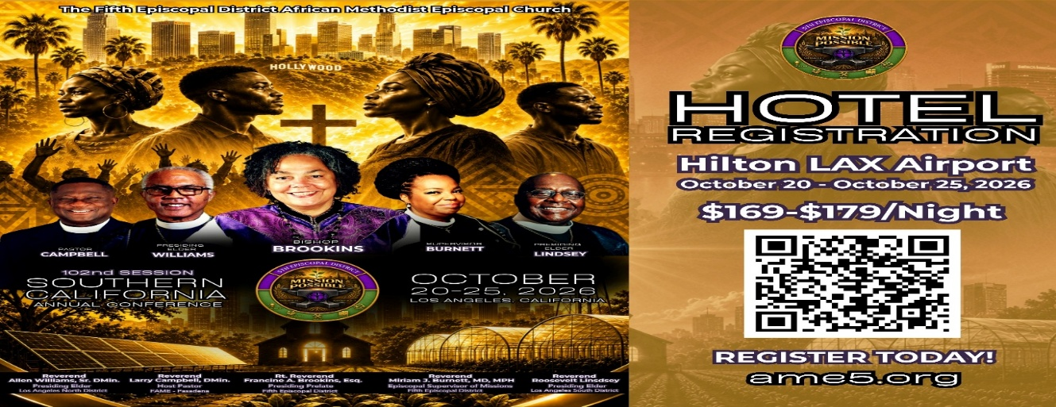-

-11-

ANNOUNCEMENTS (Continued)

CALLING ALL VENDORS!
We are asking every member of the FAME Pasadena family to help us identify businesses, entrepreneurs, artisans, community organizations, and vendors who may be interested in showcasing and selling their products or services during the Annual Conference. This is an excellent opportunity for vendors to connect with more than 1,500 Conference attendees, promote their businesses, and market their products and services.
VENDOR BOOTH INFORMATION
Each vendor space includes:
One six-foot table with linen
Two chairs
Pre-assigned booth space
Opportunity to purchase additional booth spaces as needed
Vendor Fee: $500 for the week or $150 per day (Vendor rental fees are non-refundable.)
Booth Setup: Tuesday, October 20, 2026, at 7:00 a.m.
Daily Hours: 8:00 a.m. until approximately 10:00 p.m., or one-half hour after Evening Worship Service.
For more information, please contact the church office at (626) 798-0503 or Joann Forté- Wormley, Vendor Chairperson, at (818) 434-4140.

Digital Souvenir Journal
As we are preparing to host the S.C.A.C. gathering, we are asking for the assistance of our entire church family in helping identify individuals, businesses, organizations, and community partners who may be interested in participating in the Digital Souvenir Journal. WE NEED YOUR HELP!

Please help us reach potential Journal Ad Participants who would like to:
Advertise their business or organization
Promote a ministry, special event, or program
Honor or congratulate a loved one
Extend greetings to the Annual Conference
Show their support for the African Methodist Episcopal Church and its ministry.

TWO WAYS TO PARTICIPATE:
📖 Single-Page Digital Advertisement
🎥 30-Second Video Message
The commemorative journal will showcase greetings and support from elected officials, corporate leaders, nonprofit organizations, businesses, churches, and community partners, providing an opportunity to highlight the broad impact of the AME Church.

Single Page Ad-$150 each
Ads should be 8.5x11 portrait/landscape. There is no additional charge for color ads. Artwork should be at 300 dpi. The accepted file formats are JPEG, PDF, and TIF

Videos/Single Page- $200 Single and Video Broadcasting 1920x1080 camera-ready digital files when submitted.
If you know someone who may be interested, please have them contact Rev. Van E. White at (540) 842-1738 or van.white75@gmail.com

-12-

Prayer Request(s)
Please notify the Church Office of Sick & Shut-in additions, deletions, or status/address changes.

Bishop Francine A. Brookins, Esq. Supervisor Miriam Burnett, MD Presiding Elder Roosevelt & Dr. Kaye Lindsey Rev. Dr. Larry & Melinda Campbell Richard Craig Hazel Clark Erica Woodard Jason Shirley Joshua Shirley Julian Shirley Ayanna Terry Cheryl Jamerson Gwendolyn Flowers Andrea Anderson Ocilda Files Danielle Clark Rev. Charles Brooks Kimberly Woods Cynithia Grace Calle Burns Noel Johnson The Taylor Family
Zechariah Robinson Christopher McCarthy Wilma Haynes Jacquelyn Walker Brittney Petty Selene Cox Deborah Burton Nettie McChristen The Caple Family Mel Beech Michael Dotson
Rev. Rochelle Moore Lorene Butler Stella Pulliam Collette Blizzard The Eaton Canyon Fire Victims

College Students

Let’s continue to support and pray for our beloved College Students

Isaiah Crowell Alecia Davis Chase Johnson Grant Blizzard Gabriel Blizzard

Tyler Johnson Richard Jones Tyrikk Lawson Makia Rose Talbert Isaiah Ringo Journey Rogers Elyse Sharp Kylee Sharp Zion Otano Elise Tervalon Grace Jones Jordan Patterson Kimberly Robinson Donovan Williams Jasmine Collins Brandon Bates

Sick and Shut-Ins
Andrew Oliver 1405 N. Roosevelt Avenue, Pasadena, CA 91104
Barbara Buchanan 616 Rio Grande St. Pasadena, CA 91104
Bettina Ayers Pasadena Meadows Nursing Home, 150 Bellefontaine St., Pas., CA 91105
Betty Betts Turner 1625 S Magnolia Ave Unit 4125 Monrovia, CA 91016
Bobby Thomas 1052 E. Morada Place, Altadena, CA 91001
Diane Jordan 1719 Fremont Ave., #302, S. Pasadena, CA 91030
Donita Towler 14148 Francisquito Ave, Baldwin Park, CA 91706
Doris Curd 11619 Woodcock Avenue, San Fernando, CA 91340
Edmund Riddle Active Care Mission Bay, 2440 Grand Avenue, San Diego, CA 92109
Eleanor Towler 975 E. Union Street, Unit #417, Pasadena, CA 91106
Elois Blizzard P. O. Box 3646, So. Pasadena, CA 91031
Emily Cormier-Ross 2549 La Fiesta Avenue, Altadena, CA 91001
Ernestine English 26 W. Fair Oaks Drive, Pasadena, CA 91103
Fred Caple 51 North 15th Street Haledon, NJ 07508
Hugh Hamberry 19225 Chole Rd., Apple Valley, CA 92307
Jessie Smith 3925 S Jones BL, Apt 2118 Las Vegas, NV 89103| Spring Valley Community
Josephine Brown 15607 Saddleback Rd, Riverside, CA 92506
Lenora Moore 2445 E. Del Mar Bl, #338 Pasadena, CA 91107
Linnie G. Nollie 2250 E. New York Drive, Altadena, CA 91001
Malika G. Hendry P. O. Box 94082, Pasadena, CA 91109
Mildred Lewis C/O Hazel Rohr, 884 W. Jane Court, Upland, CA 91786
Norma Burnett 618 Fairview Avenue, Unit #228, Arcadia, CA 91007
Opal Hampton 1030 Chevron Court, Pasadena, CA 91103
Paul Ratliff P.O. Box 40407 Pasadena, CA 91114
Virlyn Grant 15122 Orange Ave., Paramount, CA 90723
Wanda Nelson 3618 N. Fair Oaks Avenue, Altadena, CA 91001
William Hilliard 7504 Wynstone Pl., Fontana, CA 92336
Zell L. Hill 375 Barthe Drive, Pasadena, CA 91103

-13-

Sermon Notations

Scripture: _____________________________________________________________

Subject: _______________________________________________________________

Points of the Message: ___________________________________________________
_______________________________________________________________________
_______________________________________________________________________
_______________________________________________________________________
_______________________________________________________________________
_______________________________________________________________________
_______________________________________________________________________

Main Ideas of the Sermon: ________________________________________________
_______________________________________________________________________
_______________________________________________________________________
_______________________________________________________________________
_______________________________________________________________________
_______________________________________________________________________

Illustrations I want to remember: _________________________________________
_______________________________________________________________________
_______________________________________________________________________
_______________________________________________________________________
_______________________________________________________________________
_______________________________________________________________________
_______________________________________________________________________

What should I do as a result of this Sermon? ________________________________

_____________________________________________________
_____________________________________________________
_____________________________________________________
_____________________________________________________

-14-

