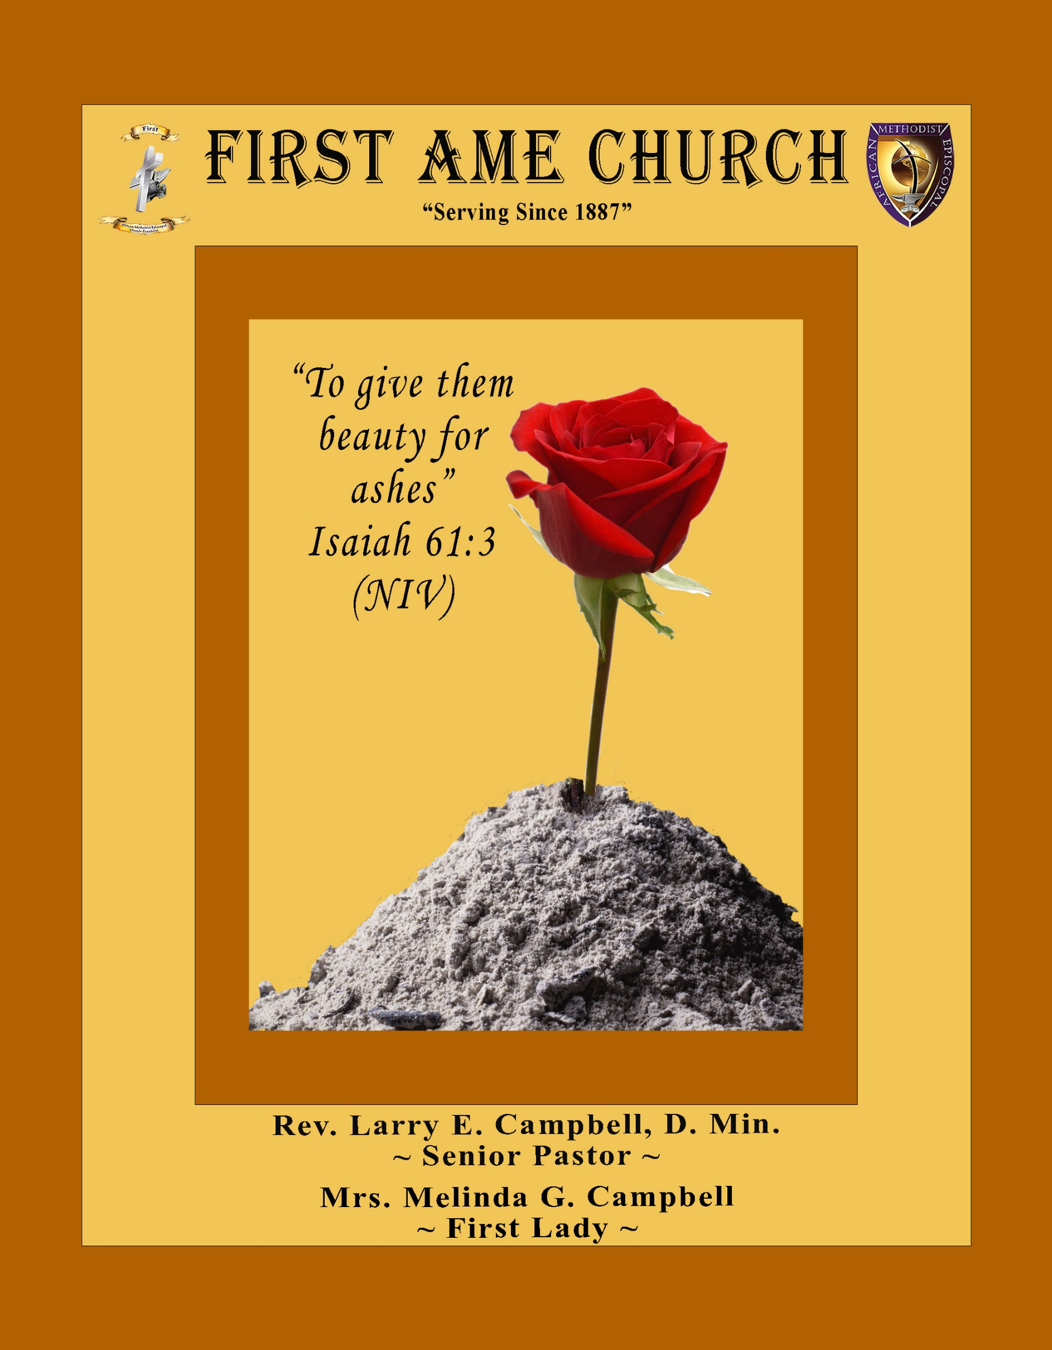
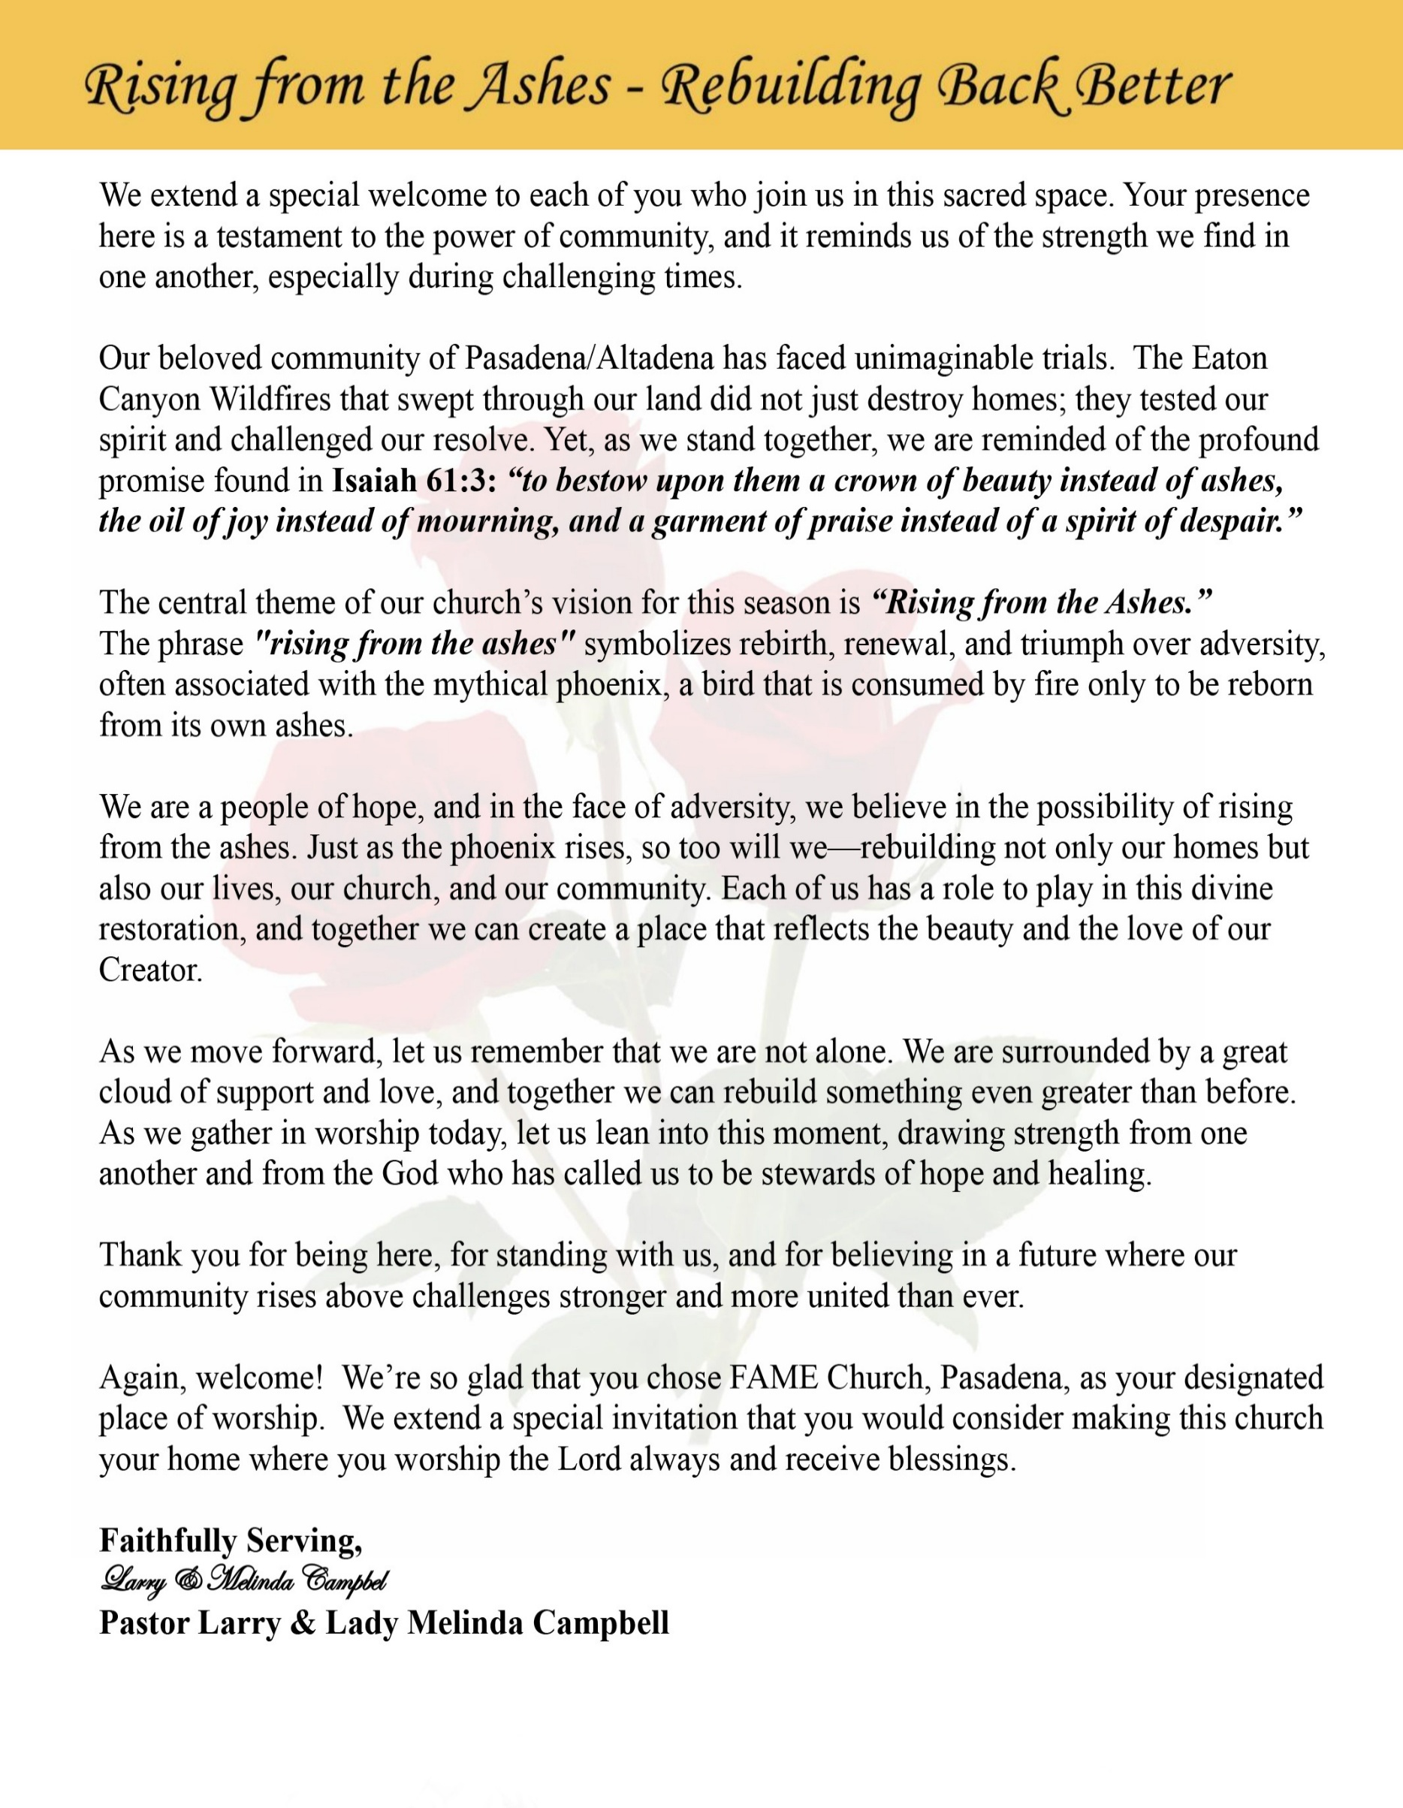

Sunday, July 5, 2026 | 9:30 a.m.

Rt. Rev. Francine A. Brookins, Esq., Presiding Bishop
Rev. Miriam Burnett, MD, MPH, Supervisor of Missions
Rev. Roosevelt Lindsey, Jr. Presiding Elder

The Rev. Dr. Larry E. Campbell ~ Senior Pastor ~ Minister

Mobile: (951) 587-1894 ~ Email: larrycampbell@famepasadena.org

Our First Lady: Mrs. Melinda G. Campbell

The Reverend Dr. Jennifer Oliver ~ Itinerant Elder -
The Reverend Dr. Nikia Smith-Robert ~ Itinerant Elder (Affiliated)
The Reverend Lois Woodard ~ Itinerant Elder Superannuated (Retired)
The Reverend Rochelle Wright Moore ~ Itinerant Deacon
The Reverend Deborah West-Jones ~ Local Elder
The Reverend Philis J. Griffin, MDiv ~ Local Elder
Dr. Phyllis Beech ~ Evangelist
Sister Tessie Bonner ~ Deaconess

Community Resource Center Director ~ Ms. Kischchen Hazelton Venerable
Church Administrative Assistant: Ms. Letha Rhymes

Church Office Hours:
Tue - Wed 9:00 am - 5:00 pm, & Fri 9:00 am -3:00 pm.
Closed for Lunch Daily: 12:00 pm - 1:00 pm.

Music Ministry
Dr. Timothy Davis, Minister of Music
Bro. Jimmy Watlington, Percussionist ~ Bro. Carlos Caldwell, Organist
Bro. Darien Dorsey, Keyboardist
Sis. Karen Law, Women’s Chorus Director ~ Sis. Tonia Graham, Children’s Choir Director
Bro. J. Renard Washington, New Generation’s Choir

FREE WI-FI service is available on the FAME Campus by accessing FAME 1700
Password: 6267980503

-3-

~ Order of Worship Experience ~



+++ The Altar Call +++
Praise & Worship

Doxology: “Praise God From Whom All Blessings Flow”

The Call to Worship Rev. Dr. Nikia Smith Robert

Leader: I was glad when they said unto me, let us go into the house of the Lord, our feet shall stand within Thy gates O Jerusalem! (Psalm 122:1)

People: For a day in Thy courts is better than a thousand. I had rather be a doorkeeper in the house of my God than to dwell in the tents of wickedness. (Psalm 84:10)

Leader: Because of the house of the Lord our God, I will seek Thy good.
(Psalm 122:9)

People: Those that be planted in the house of the Lord, shall flourish in the courts of our God. (Psalm 92:13)

Leader: Blessed are they that dwell in Thy house. Lord, I have loved Thy habitation, the place where Thy honor dwelleth. (Psalm 26:8)

People: For the Lord is in His holy temple; let all the earth keep silence before Him.
(Habakkuk 2:20).

Leader: Let the words of my mouth and the meditation of my heart, be acceptable in Thy sight, O Lord my strength and my redeemer. (Psalm 19:14)

Unison: O Sing unto the Lord a new song, for He has done marvelous things. Make a
joyful noise unto the Lord, all the earth, sing His praises. (Psalm 98:1, 4)

-4-

The Hymn of Praise A.M.E. Hymnal #243
Down at the Cross

Words: Elisha A. Hoffman, 1839-1929

Down at the cross where my Savior died,
Down where for cleansing from sin I cried,
There to my heart was the blood applied:
Glory to His name!

(Refrain)
Glory to His name, Glory to His name;
There to my heart was the blood applied;
Glory to His name!

I am so wondrously saved from sin,
Jesus so sweetly abides within,
There at the cross where He took me in:
Glory to His name!

Refrain

O precious fountain that saves from sin,
I am so glad I have entered in;
There Jesus saves me and keeps me clean;
Glory to His name!

Refrain

Come to this fountain so rich and sweet;
Cast thy poor soul at the Savior’s feet;
Plunge in today and be made complete;
Glory to His name!

Refrain

The Invocation Rev. Rochelle Wright-Moore

Ministry of Music The Mass Choir

-5-

Scripture Lesson
(Please Stand for the Reading of God’s Words)

Old Testament Bro. Versie Gaddis
Psalm 32:1-5 (New International Version) — The Joy of Forgiveness
¹ Blessed is the one whose transgressions are forgiven, whose sins are covered. ² Blessed is the one
whose sin the Lord does not count against them and in whose spirit is no deceit. ³ When I kept silent,
my bones wasted away through my groaning all day long. ⁴ For day and night your hand was heavy on me; my strength was sapped as in the heat of summer. ⁵ Then I acknowledged my sin to you
and did not cover up my iniquity. I said, “I will confess my transgressions to the Lord.” And you forgave the guilt of my sin.

New Testament Evangelist Phyllis Beech
Matthew 18:21-35 (New International Version) — The Parable of the Unmerciful Servant
Leader: ²¹ Then Peter came to Jesus and asked, “Lord, how many times shall I forgive my brother
or sister who sins against me? Up to seven times?”

People: ²² Jesus answered, “I tell you, not seven times, but seventy-seven times.

Leader: ²³ “Therefore, the kingdom of heaven is like a king who wanted to settle accounts with his
servants. ²⁴ As he began the settlement, a man who owed him ten thousand bags of
gold was brought to him. ²⁵ Since he was not able to pay, the master ordered that he and
his wife and his children and all that he had be sold to repay the debt.

People: ²⁶ “At this the servant fell on his knees before him. ‘Be patient with me,’ he begged,
‘and I will pay back everything.’ ²⁷ The servant’s master took pity on him, canceled
the debt and let him go.

Leader: ²⁸ “But when that servant went out, he found one of his fellow servants who owed him a
hundred silver coins.^{[c]} He grabbed him and began to choke him. ‘Pay back what you owe
me!’ he demanded.

People: ²⁹ “His fellow servant fell to his knees and begged him, ‘Be patient with me, and I will
pay it back.’

Leader: ³⁰ “But he refused. Instead, he went off and had the man thrown into prison until he could
pay the debt. ³¹ When the other servants saw what had happened, they were outraged and
went and told their master everything that had happened.

People: ³² “Then the master called the servant in. ‘You wicked servant,’ he said, ‘I canceled
all that debt of yours because you begged me to. ³³ Shouldn’t you have had mercy on
your fellow servant just as I had on you?’

Leader: ³⁴ In anger his master handed him over to the jailers to be tortured, until he should pay
back all he owed.

Unison: ³⁵ “This is how my heavenly Father will treat each of you unless you forgive your
brother or sister from your heart.”

-6-

The AFFIRMATION OF FAITH (The Apostle Creed)

Minister: What do you Believe?

People: I believe in God the Father Almighty, Maker of heaven and earth, and in Jesus
Christ His only son our Lord who was conceived by the Holy Spirit, born of the Virgin Mary, suffered under Pontius Pilate, was crucified, dead and buried. The third day he arose from the dead; he ascended into heaven and sitteth at the right hand of God the Father Almighty; from thence he shall come to judge the quick and the dead. I believe in the Holy Spirit, the Church Universal, the communion of saints, the forgiveness of sins, the resurrection of the body and the life
everlasting. Amen.

THE PRELUDE TO THE DECALOGUE

“From all that dwell below the skies, Let the Creator’s praise arise;
Let the Redeemer’s name be sung. Through every land, by every tongue.”

THE DECALOGUE (An Affirmation of God’s Law)

Minister: Let us express our commitment to keep God’s Law

People: God of our salvation, only You are God.
We will make no idols.
We will not invoke with malice your name, O God.
We will remember the Sabbath Day and keep it holy.
We will honor our father and our mother.
We will not commit murder.
We will not commit adultery.
We will not steal.
We will not be a false witness.
We will not covet anything that belongs to our neighbor.
Minister: Jesus said: “You shall love the Lord your God with all your heart, and with all your soul and with all your mind. This is the great and first commandment.”

ALL: Jesus also challenged us to love justly with a second commandment
which is like the first. We shall love our neighbor as ourselves! On these
commandments depend all the law and the prophets.

-7-

THE GLORIA PATRI
Glory be to the Father, and to the Son, and to the Holy Ghost.
As it was in the beginning, is now and ever shall be, world without end. Amen Amen!!

Abbreviated Announcements/ Visitor’s Welcome

The Offertory (Tithes~Gifts~Benevolent Offerings) Sis. Juanita West-Tillman, Steward

In order to satisfy the steady increase of inflation, we are asking each member to consider increasing your Tithe, Offerings & Gifts.

The following Electronic GIVING Platforms are creditable methods to GIVE to FAME:

#1. GIVELIFY - Mobile Giving App available on the App Store. It’s easy to set up, just follow the guidelines.

#2. Cash App: $FirstAMEPASADENA

#3. Mail in your Tithes & Offering - If you would like to mail your tithes and offering by check or money order, please send it to: First AME Church, 1700 N. Raymond Avenue, Pasadena, CA 91103.

#4. Drop off your Tithes & Offering - During business hours in the basket outside of the office.

Choral Response: “All things come of Thee, O Lord; and of Thine own have we given Thee. Amen.”

CHILDREN’S CHURCH DISMISSAL

Sermonic Selection The Mass Choir

Proclamation of The Word: Rev. Dr. Nikia Smith Robert

The Invitation (Public/Private)

-8-

The Sacrament of the Lord’s Supper or Holy Communion

THE SOLICITATION

You that do truly and earnestly repent of your sins, and are in love and charity with your neighbor, and intend to lead a new life, following the commandments of God, and walking from henceforth in His holy ways, draw near with faith and take this holy sacrament to your comfort; and make your humble confession to Almighty God.

THE GENERAL CONFESSION

Minister: Let us humbly confess our sins unto Almighty God.

Minister and People:

Almighty God, Father of our Lord Jesus Christ, Maker of all things, Judge of all men, we acknowledge and bewail our manifold sins and wickedness which we from time to time most grievously have committed by thought, word, and deed against Your divine Majesty, provoking most justly Your wrath and indignation against us. We do earnestly repent and are heartily sorry for these, our misdoings; the remembrance of them is grievous unto us. Have mercy upon us, have mercy upon us, most merciful Father for Your Son our Lord Jesus Christ’s sake; forgive us all that is past, and grant that we may ever hereafter serve and please You in newness of life, to the honor and glory of Your name through Jesus Christ our Lord.

Amen. (Choral). (You may be seated).

THE PRAYER OF PARDON

Almighty God, our Heavenly Father, who of Your great mercy has promised forgiveness of sins to all them that with hearty repentance and true faith turn unto You, have mercy upon us; pardon and deliver us from all our sins; confirm and strengthen us in all goodness; and bring us to everlasting life through Jesus Christ, our Lord.

Choral Response: Amen.

THE PRAYER OF CONSECRATION

Minister: Loving God, our Father in heaven, in Your great mercy You gave Your only Son, Jesus Christ, to die on the cross so we could be saved. Through His sacrifice — offered once and for all — He made a complete and perfect offering for the sins of the whole world. And in the gospel, He told us to keep remembering His precious death until He comes again.
So we ask You, merciful Father, hear our prayer. As we receive this bread and this cup, according to the way our Savior Jesus taught us, help us remember His suffering and death, and allow us to share in the blessing of His body and His blood.
On the night He was betrayed, Jesus took bread. After giving thanks, He broke it and gave it to His disciples, saying,
“Take and eat. This is my body, given for you. Do this to remember me.”
In the same way, after supper He took the cup. After giving thanks, He gave it to them and said,
“Drink from it, all of you. This is my blood of the new covenant, poured out for you and for many so that sins may be forgiven. Whenever you drink it, do this to remember me.” Amen!

THE LORD’S PRAYER (ALL)
THE ELEMENTS SHARED
THE BENEDICTION

-9-

ANNOUNCEMENTS

BEREAVEMENT NOTICE: It is with heavy hearts that we announce the passing of Brother Jeff Thomas, a beloved and dear senior member of the FAME Church Family. Brother Thomas passed away Sunday, June 28, 2026, at 1:30 a.m. We extend our prayers and deepest sympathies to the Thomas Family during this difficult season of bereavement. May God's comforting presence surround them with His peace, strength, and abiding love.
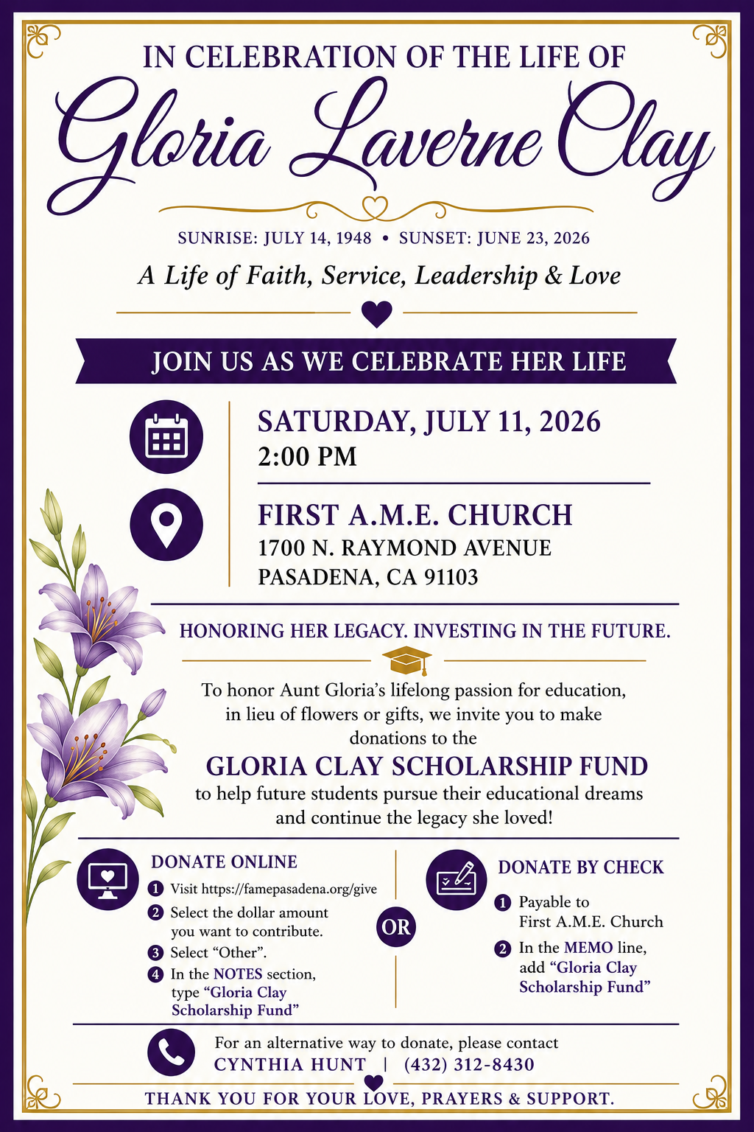

-10-

ANNOUNCEMENTS (Continued)

20/20 (14.0)
The 20/20 initiative is a Church-wide fundraising project managed by Stewards. This project was established to assist with our Annual Connectional Budget. Financial gifts donated through the 20/20 initiative are added to our collected conference claims and assist greatly in meeting the first and second half of our Connectional Budgetary obligations. The Steward Board is requesting 150 participants for the conference year 2025-2026. The first half of our budget is due in February 2026. In addition to the 18 officers and we are asking 132 people to give 20 dollars per week for 20 weeks in addition to your regular tithes, gifts and offerings. Please mark your envelopes 20/20 and allocate $20.00. Our goal is to raise $60,000. Again, this will satisfy all budgetary needs on the conference level without utilizing any operational funds. Please see or contact any Steward to participate; we are looking forward to your commitment.

New Members’ Orientation
The presence of all new members is warmly requested at our upcoming New Members’ Orientation Classes. These sessions are designed to help you grow in faith, fellowship, and understanding of the ministry and mission of the church. We look forward to journeying together as disciples of Christ and members of the household of faith.
Orientation Schedule
Fourth Session: Wednesday, July 8 | 5:00 p.m.
Fifth Session: Wednesday, July 15 | 5:00 p.m.
Sixth Session: Saturday, July 18 | 10:00 a.m.
We encourage every new member to attend faithfully as we grow together in grace, service, and spiritual maturity.

VACATION BIBLE SCHOOL 2026
Registration is now open for First AME Church's Vacation Bible School, July 21–24, 2026. This year's theme is Kingdom Quest: Seeking the Great Treasure. Participants of all ages will explore the Parables of Jesus and discover valuable lessons about God's Kingdom. We are also seeking volunteer teachers, assistants, and ministry workers to help make this experience meaningful and successful. Please send your contact information to the following registration sites if you would like to attend or volunteer.
VBS Student Registration: https://forms.gle/BVbm6phYvBCdheYa7
VBS Volunteer Registration: https://forms.gle/dQrZA41dMnR7xJ3E9
Join us as we seek the greatest treasure found in the parables of Jesus Christ!

Background Check Reminder
This is a reminder that all adults aged 18 and older who work with children and youth in our church are required to complete the necessary background screening in compliance with the 5th Episcopal District requirements. Assistance is available to help ensure all volunteers and workers remain in compliance. Please contact the church office or Sis. Gina Tervalon for additional information and next steps.

WEEKLY BIBLE STUDY CLASSES.
Please note that the following organized spiritual development sessions will be on hiatus during the months of July and August 2026.
Pastoral Bible Studies
Wednesday Prayer Meetings/ Men/Women Bible Studies/ Senior Ministry
Let’s use this time to rejuvenate and spend quality time with our families. Classes will resume in the first week of September.

-11-

Scripture of the Day
Let Go and Forgive. ¹⁴ For if you forgive other people when they sin against you, your heavenly Father will also forgive you. ¹⁵ But if you do not forgive others their sins, your Father will not forgive your sins.” Matthew 6:14-15

Quote of the Day
“Forgiveness is unlocking the door to set someone free and realizing you were the prisoner." Max Lucado

Thought of the Week
The Freedom of Forgiveness. "Be ye kind one to another, tenderhearted, forgiving one another, even as God for Christ's sake hath forgiven you." — Ephesians 4:32
Forgiveness is one of the greatest gifts God has given His children. It does not deny the hurt, excuse the offense, or erase the memory of painful experiences. Rather, forgiveness is a decision to release resentment, trust God with justice, and refuse to allow bitterness to rule our hearts.
Through Jesus Christ, God has freely forgiven our sins. As recipients of His amazing grace, we are called to extend that same grace to others. While forgiveness may not always restore every relationship, it always opens the door for God to bring healing, peace, and spiritual freedom to the one who forgives.
Today, ask God to help you release every burden of unforgiveness. When we forgive, we reflect the heart of Christ and make room for His peace to reign in our lives.

Kindness, Compassion, Patience, and Empathy
A taxi driver arrived to pick up an elderly woman late at night. After waiting, he decided to knock on her door instead of leaving. The woman was very old and moved slowly with a small suitcase. Her apartment looked empty and filled with memories from the past. The driver kindly helped carry her bag and assisted her to the cab. The woman thanked him for treating her with kindness and respect. During the ride, she asked him to drive through downtown instead of taking the shortest route. She revealed that she was going to a hospice and did not have much time left to live. The driver turned off the taxi meter and agreed to take her wherever she wanted. For the next two hours, they drove around places connected to her memories. She visited locations from her youth, marriage, and working life. Sometimes she quietly looked at buildings without speaking.
Eventually, she asked the driver to take her to the hospice. Staff members were waiting for her arrival when they reached the building. The woman offered to pay the fare, but the driver refused. Before leaving, the driver hugged her warmly. She thanked him for giving her a final moment of happiness. The experience deeply affected the driver emotionally. He realized small acts of kindness can become the most important moments in life. The story teaches compassion, patience, empathy, and the importance of making people feel valued.

HOME DAILY BIBLE READINGS
July 6, 2026 – July 12, 2026 (Week 42, 1 Thessalonians)
Monday Day 288 Acts 1-2, Psalm 119:65-96
Tuesday Day 289 Acts 3-5, Psalm 119:97-136
Wednesday Day 290 Acts 6:1-15; 7:1-43, Psalm 119:137-160
Thursday Day 291 Acts 7:44-60; 8:1-40, Psalm 119:161-176
Friday Day 292 Acts 9:1-43, Psalm 120
Saturday Day 293 Acts 10:1-48, Psalm 121
Sunday Day 294 Acts 11:1-30; 12:1-25, Psalm 122

-12-

Prayer Request(s)
Please notify the Church Office of Sick & Shut-in additions, deletions, or status/address changes.

Bishop Francine A. Brookins, Esq. Supervisor Miriam Burnett, MD
Presiding Elder Roosevelt & Dr. Kaye Lindsey Rev. Dr. Larry & Melinda Campbell
Richard Craig Hazel Clark Erica Woodard Jason Shirley Joshua Shirley Julian Shirley Ayanna Terry Cheryl Jamerson Gwendolyn Flowers Andrea Anderson Ocilda Files Danielle Clark Donita Towler Rev. Charles Brooks Doris Bailey Kimberly Woods Cynithia Grace Zechariah Robinson Diane Jordan Christopher McCarthy Wilma Haynes Calle Burns Noel Johnson Brittney Petty Taylor Family Deborah Burton Nettie McChristen Jacquelyn Walker Rev. Rochelle Moore
Lorene Butler Stella Pulliam Collette Blizzard Konata Doxey
The Eaton Canyon Fire Victims Selene Cox Mel Beech

College Students

Let’s continue to support and pray for our beloved College Students

Isaiah Crowell Alecia Davis Chase Johnson Grant Blizzard

Tyler Johnson Richard Jones Tyrikk Lawson Makia Rose Talbert Isaiah Ringo Journey Rogers Elyse Sharp Kylee Sharp Zion Otano Elise Tervalon Grace Jones Jordan Patterson Kimberly Robinson Donovan Williams Jasmine Collins Brandon Bates Gabriel Blizzard

Sick and Shut-Ins
Andrew Oliver 1405 N. Roosevelt Avenue, Pasadena, CA 91104
Barbara Buchanan 616 Rio Grande St. Pasadena, CA 91104
Bettina Ayers Pasadena Meadows Nursing Home, 150 Bellefontaine St., Pas., CA 91105
Betty Betts Turner USC Keck Rehabilitation, 300 W Huntington Dr., Arcadia, CA 91007
Bobby Thomas 1052 E. Morada Place, Altadena, CA 91001
Doris Curd 11619 Woodcock Avenue, San Fernando, CA 91340
Edmund Riddle Active Care Mission Bay, 2440 Grand Avenue, San Diego, CA 92109
Eleanor Towler 975 E. Union Street, Unit #417, Pasadena, CA 91106
Elois Blizzard P. O. Box 3646, So. Pasadena, CA 91031
Emily Cormier-Ross 2549 La Fiesta Avenue, Altadena, CA 91001
Ernestine English 26 W. Fair Oaks Drive, Pasadena, CA 91103
Fred Caple 51 North 15th Street Haledon, NJ 07508
Hugh Hamberry 19225 Chole Rd., Apple Valley, CA 92307
Jessie Smith 3925 S Jones BL, Apt 2118 Las Vegas, NV 89103| Spring Valley Community
Josephine Brown 15607 Saddleback Rd, Riverside, CA 92506
Konata Doxey South Pasadena Care Center, 904 Mission St., South Pasadena, CA 91030
Linnie G. Nollie 2250 E. New York Drive, Altadena, CA 91001
Malika G. Hendry P. O. Box 94082, Pasadena, CA 91109
Mildred Lewis C/O Hazel Rohr, 884 W. Jane Court, Upland, CA 91786
Norma Burnett 618 Fairview Avenue, Unit #228, Arcadia, CA 91007
Opal Hampton 1030 Chevron Court, Pasadena, CA 91103
Paul Ratliff P.O. Box 40407 Pasadena, CA 91114
Virlyn Grant 15122 Orange Ave., Paramount, CA 90723
Wanda Nelson 3618 N. Fair Oaks Avenue, Altadena, CA 91001
William Hilliard 7504 Wynstone Pl., Fontana, CA 92336
Zell L. Hill 375 Barthe Drive, Pasadena, CA 91103

-13-

Sermon Notations

Scripture: _____________________________________________________________

Subject: _______________________________________________________________

Points of the Message: ___________________________________________________
_______________________________________________________________________
_______________________________________________________________________
_______________________________________________________________________
_______________________________________________________________________
_______________________________________________________________________
_______________________________________________________________________

Main Ideas of the Sermon: ________________________________________________
_______________________________________________________________________
_______________________________________________________________________
_______________________________________________________________________
_______________________________________________________________________
_______________________________________________________________________

Illustrations I want to remember: _________________________________________
_______________________________________________________________________
_______________________________________________________________________
_______________________________________________________________________
_______________________________________________________________________
_______________________________________________________________________
_______________________________________________________________________

What should I do as a result of this Sermon? ________________________________

_____________________________________________________
_____________________________________________________
_____________________________________________________
_____________________________________________________

-14-

