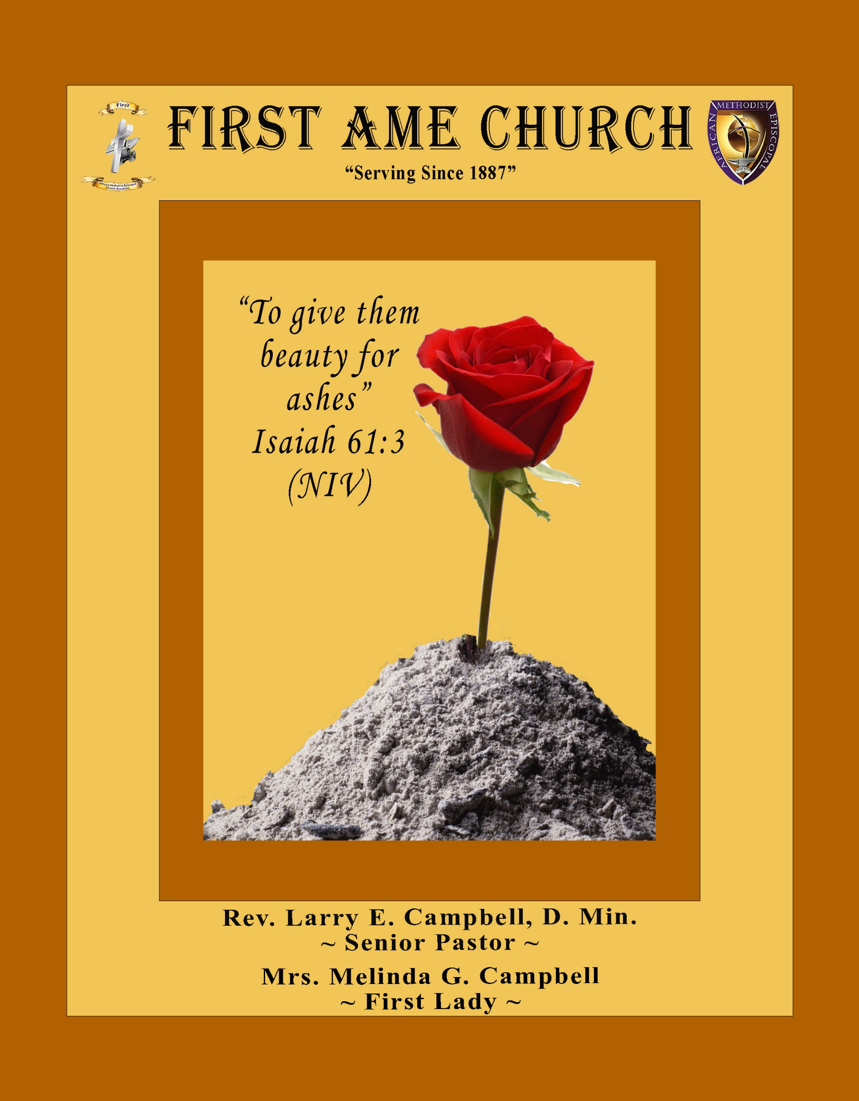
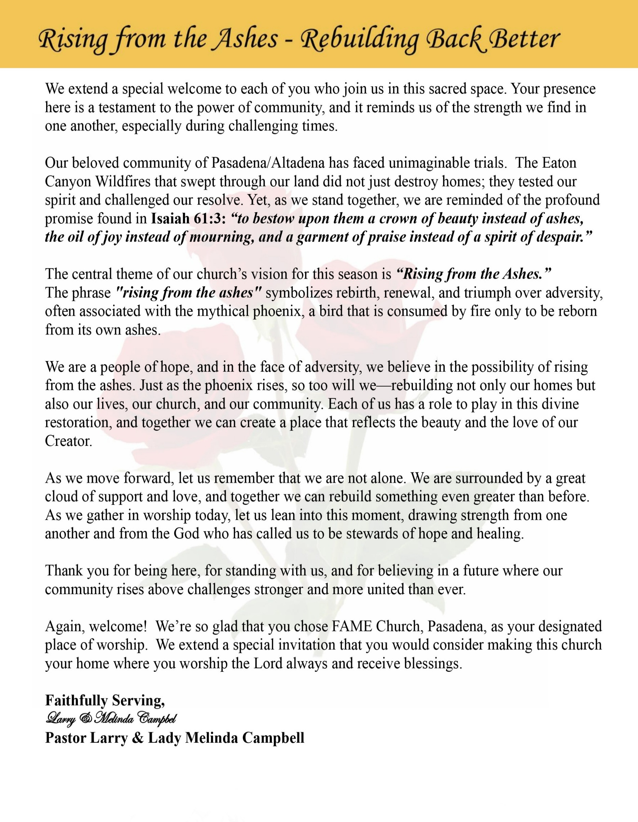

Sunday, July 12, 2026 | 9:30 a.m.

Rt. Rev. Francine A. Brookins, Esq., Presiding Bishop
Rev. Miriam Burnett, MD, MPH, Supervisor of Missions
Rev. Roosevelt Lindsey, Jr. Presiding Elder

The Rev. Dr. Larry E. Campbell ~ Senior Pastor ~ Minister

Mobile: (951) 587-1894 ~ Email: larrycampbell@famepasadena.org

Our First Lady: Mrs. Melinda G. Campbell

The Reverend Dr. Jennifer Oliver ~ Itinerant Elder -
The Reverend Dr. Nikia Smith-Robert ~ Itinerant Elder (Affiliated)
The Reverend Lois Woodard ~ Itinerant Elder Superannuated (Retired)
The Reverend Rochelle Wright Moore ~ Itinerant Deacon
The Reverend Deborah West-Jones ~ Local Elder
The Reverend Philis J. Griffin, MDiv ~ Local Elder
Dr. Phyllis Beech ~ Evangelist
Sister Tessie Bonner ~ Deaconess

Community Resource Center Director ~ Ms. Kischchen Hazelton Venerable
Church Administrative Assistant: Ms. Letha Rhymes

Church Office Hours:
Tue - Wed 9:00 am - 5:00 pm, & Fri 9:00 am -3:00 pm.
Closed for Lunch Daily: 12:00 pm - 1:00 pm.

Music Ministry
Dr. Timothy Davis, Minister of Music
Bro. Jimmy Watlington, Percussionist ~ Bro. Carlos Caldwell, Organist
Bro. Darien Dorsey, Keyboardist
Sis. Karen Law, Women’s Chorus Director ~ Sis. Tonia Graham, Children’s Choir Director
Bro. J. Renard Washington, New Generation’s Choir

FREE WI-FI service is available on the FAME Campus by accessing FAME 1700
Password: 6267980503

-3-

~ Order of Worship Experience ~

Warning: This order of worship is subject to change without warning or prior notice --- everything is governed by the Sovereignty of the Holy Spirit.
Praise & Worship

Doxology: “Praise God From Whom All Blessings Flow”

The Call to Worship Bro. Donovan Williams

Leader: I was glad when they said unto me, let us go into the house of the Lord, our feet shall stand within Thy gates O Jerusalem! (Psalm 122:1)

People: For a day in Thy courts is better than a thousand. I had rather be a doorkeeper in the house of my God than to dwell in the tents of wickedness. (Psalm 84:10)

Leader: Because of the house of the Lord our God, I will seek Thy good.
(Psalm 122:9)

People: Those that be planted in the house of the Lord, shall flourish in the courts of our God. (Psalm 92:13)

Leader: Blessed are they that dwell in Thy house. Lord, I have loved Thy habitation, the place where Thy honor dwelleth. (Psalm 26:8)

People: For the Lord is in His holy temple; let all the earth keep silence before Him.
(Habakkuk 2:20)

Leader: Let the words of my mouth and the meditation of my heart, be acceptable in Thy sight, O Lord my strength and my redeemer. (Psalm 19:14)

Unison: O Sing unto the Lord a new song, for He has done marvelous things. Make a
joyful noise unto the Lord, all the earth, sing His praises. (Psalm 98:1, 4)

-4-

The Hymn of Praise - African American Heritage Hymnal #291 Not The AME Hymnal

O How I Love Jesus

(Words: Isaac Watts, 1674-1748)

1 There is a name I love to hear,
I love to sing its worth;
it sounds like music in my ear,
the sweetest name on earth.

Refrain:
O how I love Jesus,
O how I love Jesus,
O how I love Jesus,
because he first loved me!

2 It tells me of a Savior's love,
who died to set me free;
it tells me of his precious blood,
the sinner's perfect plea.

[Refrain]

3 It tells of one whose loving heart
can feel my deepest woe;
who in each sorrow bears a part
that none can bear below.

[Refrain]

The Invocation Sis. Jade Williams

Ministry of Music The Praise Team

-5-

Scripture Lesson Sis. Gabrielle Lambert
(Please Stand for the Reading of God’s Words)

Acts 3:1-10 (New International Version) — Peter Heals a Lame Beggar
Leader: One day Peter and John were going up to the temple at the time of prayer—at
three in the afternoon.

People: ² Now a man who was lame from birth was being carried to the temple
gate called Beautiful, where he was put every day to beg from those going
into the temple courts.

Leader: ³ When he saw Peter and John about to enter, he asked them for money.

People: ⁴ Peter looked straight at him, as did John. Then Peter said, “Look at
us!” ⁵ So the man gave them his attention, expecting to get something from
them.

Leader: ⁶ Then Peter said, “Silver or gold I do not have, but what I do have I give you. In
the name of Jesus Christ of Nazareth, walk.”

People: ⁷ Taking him by the right hand, he helped him up, and instantly the man’s
feet and ankles became strong.

Leader: ⁸ He jumped to his feet and began to walk. Then he went with them into the
temple courts, walking and jumping, and praising God.

Unison: ⁹ When all the people saw him walking and praising God, ¹⁰ they recognized
him as the same man who used to sit begging at the temple gate called
Beautiful, and they were filled with wonder and amazement at what had
happened to him.

The Summary of the Decalogue Bro. Lamont Coleman
LEADER: From all that dwell below the skies…
SUNG: From all that dwell below the skies, Let the Creator’s praise arise; Let the
Redeemer’s Name be sung, through every land, by every tongue.
LEADER: Hear what Christ our Savior saith, Thou shalt love the Lord thy God with all thy
heart, with all thy soul, and with all thy mind. This is the first and great
commandment. And the second is like unto it: Thou shalt love thy neighbor
as thyself. On these two commandments hang all the law and the prophets.
SUNG: Glory be to the Father, and to the Son, and to the Holy Ghost; as it was in
the beginning, is now, and ever shall be, world without end. A~Men

-6-

Abbreviated Announcements/Visitor’s Welcome



Wedding


90 Plus Birthday Celebrations
Sis. Dorothy Moss Celebrated her 91st birthday on June 21st
Bro. Fred Caple Celebrated his 95th birthday on July 5th

Birthdays Recognized for the Month


“The best Birthday wish that you can get for the day is that you may live each moment of your life to the very fullest, without any regrets.” Anonymous

Special Congregational Hymn (Sing along)
Hymn #272 — Pass Me Not, O Gentle Savior

-7-

The Offertory (Tithes ~ Gifts ~ Benevolent Offerings) Bro. Kenneth Caudle

The following Electronic GIVING Platforms are creditable methods to GIVE to FAME:

#1. GIVELIFY - Mobile Giving App available on the App Store. It’s easy to set up, just follow the guidelines.

#2. Cash App: $FirstAMEPASADENA

#3. Mail in your Tithes & Offering - If you would like to mail your tithes and offering by check or money order, please send it to: First AME Church, 1700 N. Raymond Avenue, Pasadena, CA 91103.

#4. Drop off your Tithes & Offering - During business hours in the basket outside of the office.

Choral Response: “All things come of Thee, O Lord; and of Thine own have we given Thee. Amen.”

Sermonic Selection The Praise Team

Proclamation of The Word Pastor Larry E. Campbell

The Invitation (Public/Private)

How to Join First A.M.E. Church of Pasadena
PROFESSION OF FAITH. If you have never been a member of any church, you may join by professing Jesus Christ as your personal Lord and Savior.

RENEWAL OF VOWS. If you have been a member of a church at one time, but have been in active, you may join by renewing your faith in Jesus Christ as Lord and Savior.

TRANSFER. If you are a member of another African Methodist Episcopal Church and you are in good standing, you may join by requesting that your membership be transferred to the First African Methodist Episcopal Church of Pasadena.

AFFILIATE MEMBER. Sometimes an individual has reasons for keeping /his/her membership in another church but would like to be an active member of First African Methodist Episcopal Church, too. This is possible as an affiliate member. ______________________________________________________________________________________________________________
The Doxology

The Benediction

-8-

Scripture of the Day
Those Denied Access. " Do not rob the poor because he is poor, Nor oppress the afflicted at the gate; ²³ For the Lord will plead their cause, And plunder the soul of those who plunder them.." Proverbs 22:22-23

Quote of the Day
“As long as poverty, injustice and gross inequality persist in our world, none of us can truly rest.” — Nelson Mandela

Thought of the Week
“He shall open, and none shall shut; and he shall shut, and none shall open.” — Isaiah 22:22
Throughout life, we will encounter doors. Some doors represent opportunities. Some doors represent relationships. Some doors represent dreams, assignments, and new beginnings. Yet, there are seasons when we stand before doors that refuse to open. We experience disappointment, rejection, delays, and moments when life seems to say: “Access Denied.”
However, Isaiah reminds us of an important truth: God is the ultimate keeper of the door.
People may have influence, positions, and authority, but God has the final say. What God opens, no person can close. What God releases, no obstacle can stop. What God has prepared, no opposition can prevent.
Sometimes a closed door is not rejection—it is God’s protection. Sometimes God closes doors because He sees what we cannot see and knows what we do not know. Every closed door does not mean the journey is over; sometimes it means God is directing us toward a better door.
Our hope is not in the doors controlled by others, but in the God who holds the key. When God opens the door, He provides the strength, resources, wisdom, and favor needed to walk through it.
So when life says, “Access Denied,” keep trusting the One who controls every door. God still opens doors that no one can shut. Because when God says “Access Granted,” nothing can stand in the way.

Humor of the Week
A census taker walked up to a woman who was sitting on a porch. After introducing himself, he said, "How many children do you have?"
The woman answered, "Four."
The census taker asked, "May I have their names, please?" The woman replied, "Eenie, Meenie, Minie, and George."
Confused, the census taker said, "May I ask why you named your fourth child 'George'?"
"Surely, because we didn't want any Moe."

HOME DAILY BIBLE READINGS
July 13, 2026 – July 19, 2026 (Week 43, 1 Timothy)
Monday Day 295 Acts 13:1-52, Psalm 123
Tuesday Day 296 Acts 14:1-28; 15:1-21, Psalm 124
Wednesday Day 297 Acts 15:22-41; 16:1-24, Psalm 125
Thursday Day 298 Acts 16:25-40; 17:1-34, Psalm 126
Friday Day 299 Acts 18:1-28, Psalm 127
Saturday Day 300 Acts 19:1-41, Psalm 128
Sunday Day 301 Acts 20:1-38, Psalm 129

-9-

ANNOUNCEMENTS

BEREAVEMENT NOTICE
It is with heavy hearts and profound sadness that we announce the passing of Brother Jeff Thomas, a beloved senior member of the First AME Church (FAME) Family. Brother Thomas peacefully entered eternal rest on Sunday, June 28, 2026, at 1:30 a.m.

A Memorial Service celebrating the life of Brother Jeff Thomas will be held on:
Thursday, July 23, 2026, 11:00 a.m.
at First AME Church
1700 N. Raymond, Pasadena, CA 91103
Additional service details will be shared as they become available.

May God's comforting presence surround the Thomas family with His peace, strengthen them by His grace, and uphold them with His everlasting love. We ask the entire First AME Church Family to keep the Thomas family in your prayers during this time of loss.

20/20 (14.0)
The 20/20 initiative is a Church-wide fundraising project managed by Stewards. This project was established to assist with our Annual Connectional Budget. Financial gifts donated through the 20/20 initiative are added to our collected conference claims and assist greatly in meeting the first and second half of our Connectional Budgetary obligations. The Steward Board is requesting 150 participants for the conference year 2025-2026. The first half of our budget is due in February 2026. In addition to the 18 officers and we are asking 132 people to give 20 dollars per week for 20 weeks in addition to your regular tithes, gifts and offerings. Please mark your envelopes 20/20 and allocate $20.00. Our goal is to raise $60,000. Again, this will satisfy all budgetary needs on the conference level without utilizing any operational funds. Please see or contact any Steward to participate; we are looking forward to your commitment.

New Members’ Orientation
The presence of all new members is warmly requested at our upcoming New Members’ Orientation Classes. These sessions are designed to help you grow in faith, fellowship, and understanding of the ministry and mission of the church. We look forward to journeying together as disciples of Christ and members of the household of faith.
Orientation Schedule
Fifth Session: Wednesday, July 15 | 5:00 p.m.
Sixth Session: Saturday, July 18 | 10:00 a.m.
We encourage every new member to attend faithfully as we grow together in grace, service, and spiritual maturity.

-10-

ANNOUNCEMENTS (Continued)

VACATION BIBLE SCHOOL 2026
Registration is now open for First AME Church's Vacation Bible School, July 21–24, 2026. This year's theme is Kingdom Quest: Seeking the Great Treasure. Participants of all ages will explore the Parables of Jesus and discover valuable lessons about God's Kingdom. We are also seeking volunteer teachers, assistants, and ministry workers to help make this experience meaningful and successful. Please send your contact information to the following registration sites if you would like to attend or volunteer.
VBS Student Registration: https://forms.gle/BVbm6phYvBCdheYa7
VBS Volunteer Registration: https://forms.gle/dQrZA41dMnR7xJ3E9
Join us as we seek the greatest treasure found in the parables of Jesus Christ!

Background Check Reminder
This is a reminder that all adults aged 18 and older who work with children and youth in our church are required to complete the necessary background screening in compliance with the 5th Episcopal District requirements. Assistance is available to help ensure all volunteers and workers remain in compliance. Please contact the church office or Sis. Gina Tervalon for additional information and next steps.

Annual Children & Youth Day Celebration
Sunday, July 19, 2026

Friends & Family Day
Sunday, July 26, 2026

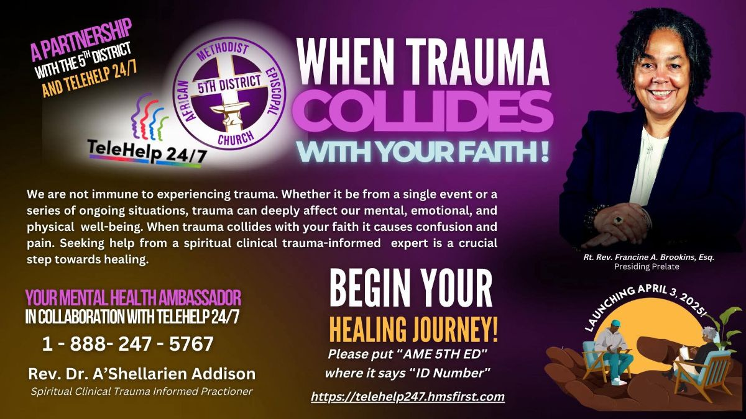

-11-

ANNOUNCEMENTS (Continued)

FAME CHURCH UNDERGRADUATE SCHOLARSHIP OPPORTUNITIES

Marie Sumpter Scholarship
Previous recipients enrolled in an Institution of Higher Education (Church Membership Scholarships)
* Applicant must be a member of First A.M.E. Church or be an active participant in the Church.
* Students must be planning to attend a University, Community College, Technical Trade, or
Business Schools.
* Students must be planning to attend a Community College, Technical Trade, or Business
Schools, and must have a minimum Grade Point Average (GPA) of at least 2.0.
* University students must have a GPA of 2.5.

Florida Brown Scholarship
(2026) Graduating High School Seniors (Community-Based Scholarships)
* Applicant must be a member of the local Community who has been accepted to a
University, Community College, Technical Trade or Business School.
* Applicant must be recommended by a member of First A.M.E. Church.
* Applicant must be a graduating high school senior in the year of the application.
* Applicant must have a minimum grade point average (GPA) of 3.0.

ALL Scholarship Applications are now available in the church office and in the Fellowship Hall. FAME-Pasadena students planning to attend trade school, community college or four-year university should apply. Non-FAME Students from the community are encouraged to apply for the Florida Brown Scholarship. The due date for ALL applications is July 31, 2026.

WEEKLY BIBLE STUDY CLASSES. Please note that the following organized spiritual development sessions will be on hiatus during the month of July and August 2026
Pastoral Bible Studies
Wednesday Prayers Meetings
Men/Women Bible Studies
Senior Ministry
Let’s use this time to rejuvenate and spend quality time with our families. Classes will resume the first week of September.

-12-

Prayer Request(s)
Please notify the Church Office of Sick & Shut-in additions, deletions, or status/address changes.

Bishop Francine A. Brookins, Esq. Supervisor Miriam Burnett, MD Presiding Elder Roosevelt & Dr. Kaye Lindsey Rev. Dr. Larry & Melinda Campbell Richard Craig Hazel Clark Erica Woodard Jason Shirley Joshua Shirley Julian Shirley Ayanna Terry Cheryl Jamerson Gwendolyn Flowers Andrea Anderson Ocilda Files Danielle Clark Rev. Charles Brooks Kimberly Woods Cynithia Grace Calle Burns Noel Johnson The Taylor Family
Zechariah Robinson Christopher McCarthy Wilma Haynes Jacquelyn Walker Brittney Petty Selene Cox Deborah Burton Nettie McChristen The Caple Family Mel Beech Michael Dotson
Rev. Rochelle Moore Lorene Butler Stella Pulliam Collette Blizzard The Eaton Canyon Fire Victims

College Students

Let’s continue to support and pray for our beloved College Students

Isaiah Crowell Alecia Davis Chase Johnson Grant Blizzard Gabriel Blizzard

Tyler Johnson Richard Jones Tyrikk Lawson Makia Rose Talbert Isaiah Ringo Journey Rogers Elyse Sharp Kylee Sharp Zion Otano Elise Tervalon Grace Jones Jordan Patterson Kimberly Robinson Donovan Williams Jasmine Collins Brandon Bates

Sick and Shut-Ins
Andrew Oliver 1405 N. Roosevelt Avenue, Pasadena, CA 91104
Barbara Buchanan 616 Rio Grande St. Pasadena, CA 91104
Bettina Ayers Pasadena Meadows Nursing Home, 150 Bellefontaine St., Pas., CA 91105
Betty Betts Turner USC Keck Rehabilitation, 300 W Huntington Dr., Arcadia, CA 91007
Bobby Thomas 1052 E. Morada Place, Altadena, CA 91001
Diane Jordan 1719 Fremont Ave., #302, S. Pasadena, CA 91030
Donita Towler 301 N. 3rd Street, #C, Alhambra, CA 91801
Doris Curd 11619 Woodcock Avenue, San Fernando, CA 91340
Edmund Riddle Active Care Mission Bay, 2440 Grand Avenue, San Diego, CA 92109
Eleanor Towler 975 E. Union Street, Unit #417, Pasadena, CA 91106
Elois Blizzard P. O. Box 3646, So. Pasadena, CA 91031
Emily Cormier-Ross 2549 La Fiesta Avenue, Altadena, CA 91001
Ernestine English 26 W. Fair Oaks Drive, Pasadena, CA 91103
Fred Caple 51 North 15th Street Haledon, NJ 07508
Gloria Cubit Clay 11745 Pierce St., Lake View Terrace, CA 91342
Hugh Hamberry 19225 Chole Rd., Apple Valley, CA 92307
Jeff Thomas 603 Tocino Dr. Duarte, CA 91010 | Mountain View Terrace
Jessie Smith 3925 S Jones BL, Apt 2118 Las Vegas, NV 89103| Spring Valley Community
Josephine Brown 15607 Saddleback Rd, Riverside, CA 92506
Konata Doxey Monte Vista Healthcare Center, Duarte, CA 91010
Lenora Moore 2445 E Del Mar Bl, #338 Pasadena, CA 91107
Linnie G. Nollie 2250 E. New York Drive, Altadena, CA 91001
Malika G. Hendry P. O. Box 94082, Pasadena, CA 91109
Mildred Lewis C/O Hazel Rohr, 884 W. Jane Court, Upland, CA 91786
Norma Burnett 618 Fairview Avenue, Unit #228, Arcadia, CA 91007
Opal Hampton 1030 Chevron Court, Pasadena, CA 91103
Paul Ratliff P.O. Box 40407 Pasadena, CA 91114
Virlyn Grant 15122 Orange Ave., Paramount, CA 90723
Wanda Nelson 3618 N. Fair Oaks Avenue, Altadena, CA 91001
William Hilliard 7504 Wynstone Pl., Fontana, CA 92336
Zell L. Hill 375 Barthe Drive, Pasadena, CA 91103

-13-

Sermon Notations

Scripture: _____________________________________________________________

Subject: _______________________________________________________________

Points of the Message: ___________________________________________________
_______________________________________________________________________
_______________________________________________________________________
_______________________________________________________________________
_______________________________________________________________________
_______________________________________________________________________
_______________________________________________________________________

Main Ideas of the Sermon: ________________________________________________
_______________________________________________________________________
_______________________________________________________________________
_______________________________________________________________________
_______________________________________________________________________
_______________________________________________________________________

Illustrations I want to remember: _________________________________________
_______________________________________________________________________
_______________________________________________________________________
_______________________________________________________________________
_______________________________________________________________________
_______________________________________________________________________
_______________________________________________________________________

What should I do as a result of this Sermon? ________________________________

_____________________________________________________
_____________________________________________________
_____________________________________________________
_____________________________________________________

-14-

