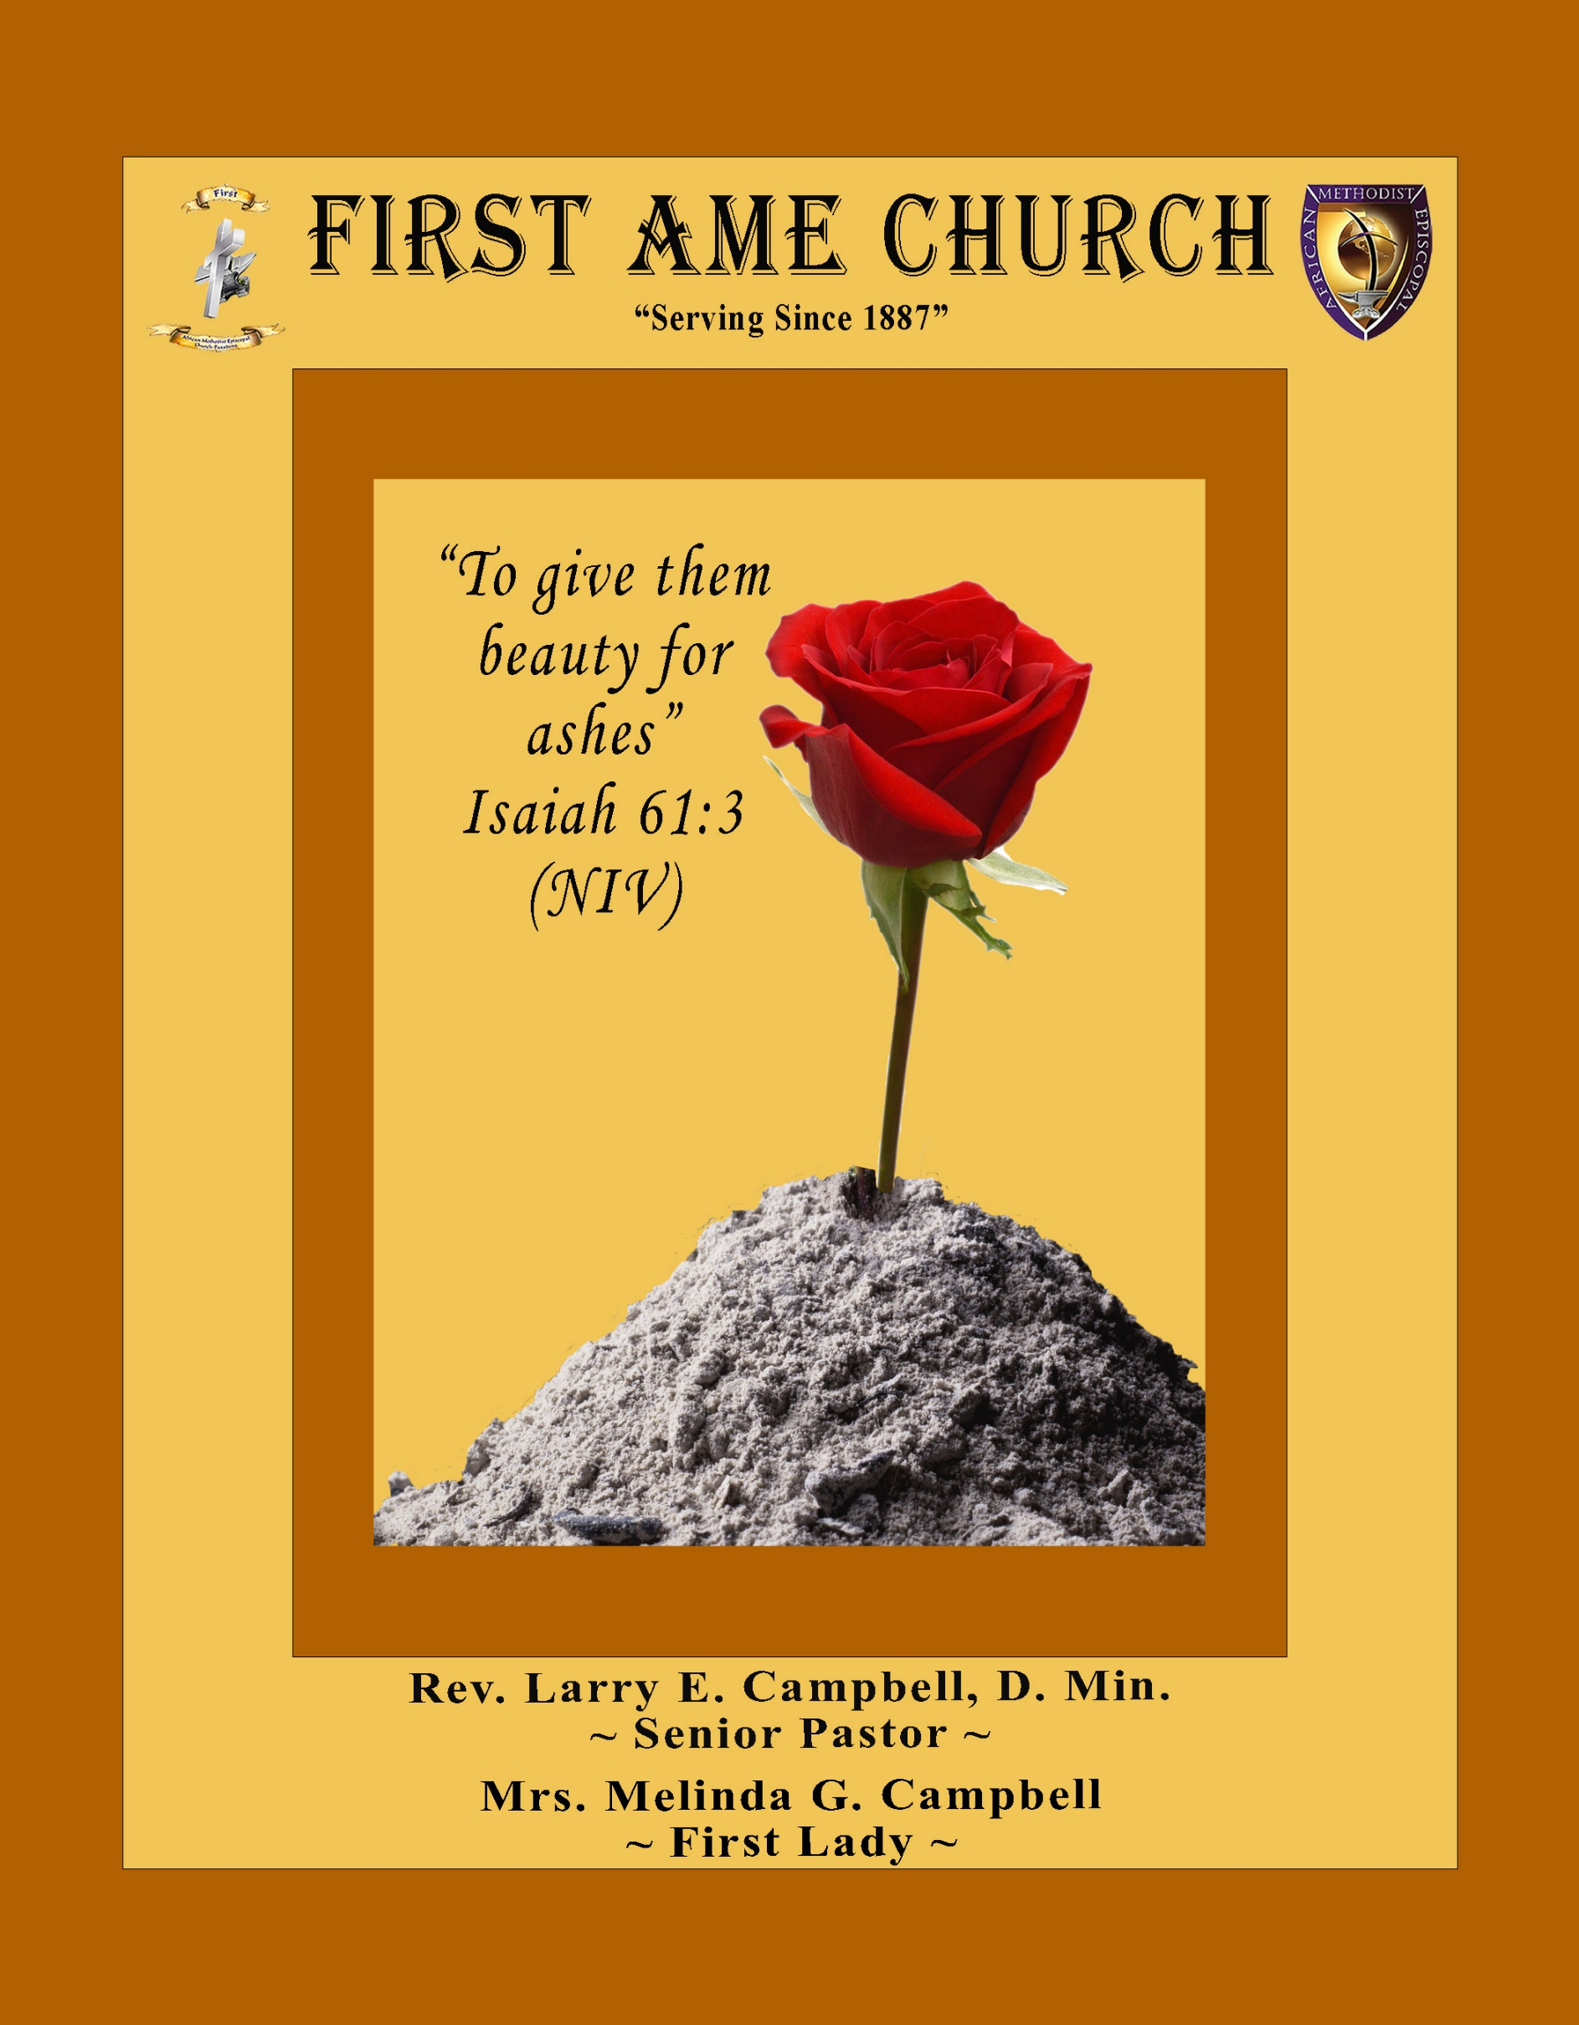
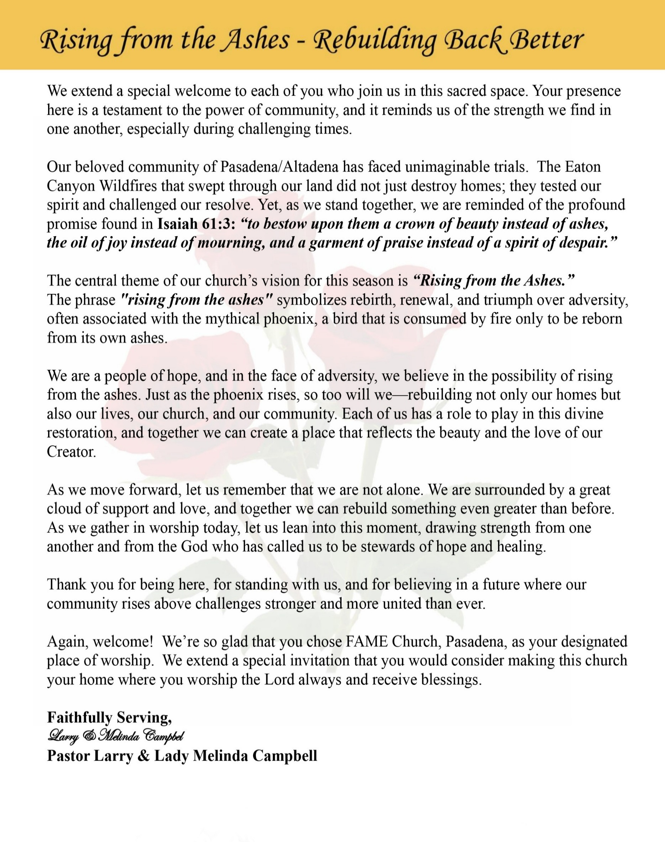

Sunday, July 19, 2026 | 9:30 a.m.

Rt. Rev. Francine A. Brookins, Esq., Presiding Bishop
Rev. Miriam Burnett, MD, MPH, Supervisor of Missions
Rev. Roosevelt Lindsey, Jr. Presiding Elder

The Rev. Dr. Larry E. Campbell ~ Senior Pastor ~ Minister

Mobile: (951) 587-1894 ~ Email: larrycampbell@famepasadena.org

Our First Lady: Mrs. Melinda G. Campbell

The Reverend Dr. Jennifer Oliver ~ Itinerant Elder -
The Reverend Dr. Nikia Smith-Robert ~ Itinerant Elder (Affiliated)
The Reverend Lois Woodard ~ Itinerant Elder Superannuated (Retired)
The Reverend Rochelle Wright Moore ~ Itinerant Deacon
The Reverend Deborah West-Jones ~ Local Elder
The Reverend Philis J. Griffin, MDiv ~ Local Elder
Dr. Phyllis Beech ~ Evangelist
Sister Tessie Bonner ~ Deaconess

Community Resource Center Director ~ Ms. Kischchen Hazelton Venerable
Church Administrative Assistant: Ms. Letha Rhymes

Church Office Hours:
Tue - Wed 9:00 am - 5:00 pm, & Fri 9:00 am -3:00 pm.
Closed for Lunch Daily: 12:00 pm - 1:00 pm.

Music Ministry
Dr. Timothy Davis, Minister of Music
Bro. Jimmy Watlington, Percussionist ~ Bro. Carlos Caldwell, Organist
Bro. Darien Dorsey, Keyboardist
Sis. Karen Law, Women’s Chorus Director ~ Sis. Tonia Graham, Children’s Choir Director
Bro. J. Renard Washington, New Generation’s Choir

FREE WI-FI service is available on the FAME Campus by accessing FAME 1700
Password: 6267980503

-3-

~ Order of Worship Experience ~

Warning: This order of worship is subject to change without warning or prior notice --- everything is governed by the Sovereignty of the Holy Spirit


Young People’s Division
~ Altar Call ~
Praise & Worship

Doxology: “Praise God From Whom All Blessings Flow”

The Call to Worship Master Cubby & Princess Jasmine Ludd

Leader: I was glad when they said unto me, let us go into the house of the Lord, our feet shall stand within Thy gates O Jerusalem! (Psalm 122:1)

People: For a day in Thy courts is better than a thousand. I had rather be a doorkeeper in the house of my God than to dwell in the tents of wickedness. (Psalm 84:10)

Leader: Because of the house of the Lord our God, I will seek Thy good.
(Psalm 122:9)

People: Those that be planted in the house of the Lord, shall flourish in the courts of our God. (Psalm 92:13)

Leader: Blessed are they that dwell in Thy house. Lord, I have loved Thy habitation, the place where Thy honor dwelleth. (Psalm 26:8)

People: For the Lord is in His holy temple; let all the earth keep silence before Him.
(Habakkuk 2:20)

Leader: Let the words of my mouth and the meditation of my heart, be acceptable in Thy sight, O Lord my strength and my redeemer. (Psalm 19:14)

Unison: O Sing unto the Lord a new song, for He has done marvelous things. Make a
joyful noise unto the Lord, all the earth, sing His praises. (Psalm 98:1, 4)

-4-

The Congregational Song of Praise Every Praise

(Repeat Verse 3 times)
Every praise is to our God.
Every word of worship with one accord
Every praise every praise is to our God.
Sing hallelujah to our God
Glory hallelujah is due our God
Every praise every praise is to our God.

(Repeat Chorus 3 times)
God my Savior
God my Healer
God my Deliverer
Yes He is, yes He is

Yes He is, yes He is, yes He is, yes He is
Yes He is, yes He is, yes He is, yes He is

(Repeat Verse 2 times)
Every praise is to our God.
Every word of worship with one accord
Every praise, every praise, every praise, every praise
Every praise, every praise, every praise, every praise
Every praise, every praise, every praise, every praise
All of my worship, every praise,
Every praise, every praise
When you see me dancing, every praise
Every praise, every praise
When you see me shoutin', every praise
Every praise, every praise, every praise, every praise
Every praise, every praise, to our god
Is to our God

The Invocation Princess Scholar Jeffery

Ministry of Music The Praise Team

-5-

Scripture Lesson
(Please Stand for the Reading of God’s Words)
Old Testament Mr. Grant Blizzard
Deuteronomy 11:16-21 (New International Version) — Teaching Our Children
¹⁶ Be careful, or you will be enticed to turn away and worship other gods and bow down to them. ¹⁷ Then the Lord’s anger will burn against you, and he will shut up the heavens so that it will not rain and the ground will yield no produce, and you will soon perish from the good land the Lord is giving you. ¹⁸ Fix these words of mine in your hearts and minds; tie them as symbols on your hands and bind them on your foreheads. ¹⁹ Teach them to your children, talking about them when you sit at home and when you walk along the road, when you lie down and when you get up. ²⁰ Write them on the doorframes of your houses and on your gates, ²¹ so that your days and the days of your children may be many in the land the Lord swore to give your ancestors, as many as the days that the heavens are above the earth.

New Testament

Luke 2:41-52 (New International Version) — The Boy Jesus at the Temple
Leader: Every year Jesus’ parents went to Jerusalem for the Festival of the Passover.

People: ⁴² When he was twelve years old, they went up to the festival, according to the
custom.

Leader: ⁴³ After the festival was over, while his parents were returning home, the boy Jesus
stayed behind in Jerusalem, but they were unaware of it. ⁴⁴ Thinking he was in
their company, they traveled on for a day. Then they began looking for him among
their relatives and friends.

People: ⁴⁵ When they did not find him, they went back to Jerusalem to look for
him. ⁴⁶ After three days they found him in the temple courts, sitting among the
teachers, listening to them and asking them questions.

Leader: ⁴⁷ Everyone who heard him was amazed at his understanding and his answers.

People: ⁴⁸ When his parents saw him, they were astonished. His mother said to him,
“Son, why have you treated us like this? Your father and I have been
anxiously searching for you.”

Leader: ⁴⁹ “Why were you searching for me?” he asked. “Didn’t you know I had to be in my
Father’s house?”

People: ⁵⁰ But they did not understand what he was saying to them.

Leader: ⁵¹ Then he went down to Nazareth with them and was obedient to them. But his mother
treasured all these things in her heart.

Unison: ⁵² And Jesus grew in wisdom and stature, and in favor with God and man.

-6-

The Summary of the Decalogue Master Omega Gaddis

LEADER: From all that dwell below the skies…
SUNG: From all that dwell below the skies, Let the Creator’s praise arise; Let the
Redeemer’s Name be sung, through every land, by every tongue.
LEADER: Hear what Christ our Savior saith, Thou shalt love the Lord thy God with all thy
heart, with all thy soul, and with all thy mind. This is the first and great
commandment. And the second is like unto it: Thou shalt love thy neighbor
as thyself. On these two commandments hang all the law and the prophets.
SUNG: Glory be to the Father, and to the Son, and to the Holy Ghost; as it was in
the beginning, is now, and ever shall be, world without end. A~Men

Abbreviated Announcements/Visitor’s Welcome

K-FAME Radio



Special Congregational Hymn (Sing along)
Hymn #450— Blessed Assurance

-7-

The Offertory (Tithes ~ Gifts ~ Benevolent Offerings) Sis. Darlene Anderson - Steward

The following Electronic GIVING Platforms are creditable methods to GIVE to FAME:

#1. GIVELIFY - Mobile Giving App available on the App Store. It’s easy to set up, just follow the guidelines.

#2. Cash App: $FirstAMEPASADENA

#3. Mail in your Tithes & Offering - If you would like to mail your tithes and offering by check or money order, please send it to: First AME Church, 1700 N. Raymond Avenue, Pasadena, CA 91103.

#4. Drop off your Tithes & Offering - During business hours in the basket outside of the office.

Choral Response: “All things come of Thee, O Lord; and of Thine own have we given Thee. Amen.”

Sermonic Selection The Praise Team

Proclamation of The Word Pastor Larry E. Campbell

The Invitation (Public/Private)

How to Join First A.M.E. Church of Pasadena
PROFESSION OF FAITH. If you have never been a member of any church, you may join by professing Jesus Christ as your personal Lord and Savior.

RENEWAL OF VOWS. If you have been a member of a church at one time, but have been in active, you may join by renewing your faith in Jesus Christ as Lord and Savior.

TRANSFER. If you are a member of another African Methodist Episcopal Church and you are in good standing, you may join by requesting that your membership be transferred to the First African Methodist Episcopal Church of Pasadena.

AFFILIATE MEMBER. Sometimes an individual has reasons for keeping /his/her membership in another church but would like to be an active member of First African Methodist Episcopal Church, too. This is possible as an affiliate member. ______________________________________________________________________________________________________________
The Doxology

The Benediction

-8-

Scripture of the Day
Faith Over Pressure. “Therefore, I urge you, brothers and sisters, in view of God’s mercy, to offer your bodies as a living sacrifice, holy and pleasing to God—this is your true and proper worship. ² Do not conform to the pattern of this world, but be transformed by the renewing of your mind. Then you will be able to test and approve what God’s will is—his good, pleasing and perfect will." Romans 12:1-2

Quote of the Day
"The strongest generation is not the one with the most talent, technology, or opportunity. The strongest generation is the one that knows God, trusts His Word, and refuses to bow to the pressures of the world." — Rev. Dr. Larry E. Campbell

Thought of the Week
Today's children are growing up in a world filled with competing voices, constant distractions, and tremendous pressure to conform. Yet Scripture reminds us that true strength is not measured by popularity, intelligence, or success. It is measured by a life anchored in God.
The psalmist declares, "How can a young person stay on the path of purity? By living according to your word" (Psalm 119:9). Likewise, the Apostle Paul encourages us, "Do not conform to the pattern of this world, but be transformed by the renewing of your mind" (Romans 12:2).
As parents, grandparents, teachers, mentors, and the church family, our calling is to help raise a generation that loves God, stands on His truth, and lives courageously for Christ. When children know God personally and trust His promises, they are equipped to stand firm regardless of the pressures they face.

Humor of the Week
There were two small brothers in the community who were always causing trouble, and the mother was at her wits end. She decided to enlist the help of the preacher and asked him to talk to the boys. The preacher brought in one of the boys and sat him down and said, "where's God?" The boy sat there, not saying a word. Again he says, "where's God?" and the boy continues to stare. Finally, the preacher, exasperated, says rather loudly, "Son, where's God?" The little boy jumps up and runs home to find his brother and tells him, "God's missing, and they think we did it!"

HOME DAILY BIBLE READINGS
July 20, 2026 – July 26, 2026 (Week 44, 2 Timothy)
Monday Day 302 Acts 21:1-40, Psalm 130
Tuesday Day 303 Acts 22:1-30; 23:1-11, Psalm 131
Wednesday Day 304 Acts 23:12-35; 24:1-27, Psalm 132
Thursday Day 305 Acts 25:1-27; 26:1-32, Psalm 133
Friday Day 306 Acts 27:1-44, Psalm 134
Saturday Day 307 Acts 28:1-31, Psalm 135
Sunday Day 308 Romans 1:1-32; 2:1-16, Psalm 136

-9-

ANNOUNCEMENTS



Memorial Service
Honoring and celebrating the life and legacy
of
Mr. Jeff Byrd Thomas, Jr.
Thursday, July 23, 2026, 11:00 a.m.
First AME Church, 1700 N. Raymond, Pasadena, CA 91103
May God’s comforting presence surround the Thomas family with His peace, strengthen them by His grace, and uphold them with His everlasting love. We ask the entire First AME Church Family to keep the Thomas family in your prayers during this time of loss.

-10-

ANNOUNCEMENTS (Continued)

New Members’ Orientation
The presence of all new members is warmly requested at our upcoming New Members’ Orientation Classes. These sessions are designed to help you grow in faith, fellowship, and understanding of the ministry and mission of the church. We look forward to journeying together as disciples of Christ and members of the household of faith.
Orientation Schedule
Final Recap & Review Session: Saturday, July 26 | 10:00 a.m.
We encourage every new member to attend faithfully as we grow together in grace, service, and spiritual maturity.



-11-

ANNOUNCEMENTS (Continued)



FAME CHURCH UNDERGRADUATE SCHOLARSHIP OPPORTUNITIES
Marie Sumpter Scholarship
Previous recipients enrolled in an Institution of Higher Education (Church Membership Scholarships)
* Applicant must be a member of First A.M.E. Church or be an active participant in the Church.
* Students must be planning to attend a University, Community College, Technical Trade, or
Business Schools.
* Students must be planning to attend a Community College, Technical Trade, or Business
Schools, and must have a minimum Grade Point Average (GPA) of at least 2.0.
* University students must have a GPA of 2.5.

Florida Brown Scholarship
(2026) Graduating High School Seniors (Community-Based Scholarships)
* Applicant must be a member of the local Community who has been accepted to a
University, Community College, Technical Trade or Business School.
* Applicant must be recommended by a member of First A.M.E. Church.
* Applicant must be a graduating high school senior in the year of the application.
* Applicant must have a minimum grade point average (GPA) of 3.0.

ALL Scholarship Applications are now available in the church office and in the Fellowship Hall. FAME-Pasadena students planning to attend trade school, community college or four-year university should apply. Non-FAME Students from the community are encouraged to apply for the Florida Brown Scholarship. The due date for ALL applications is July 31, 2026.

-12-

Prayer Request(s)
Please notify the Church Office of Sick & Shut-in additions, deletions, or status/address changes.

Bishop Francine A. Brookins, Esq. Supervisor Miriam Burnett, MD Presiding Elder Roosevelt & Dr. Kaye Lindsey Rev. Dr. Larry & Melinda Campbell Richard Craig Hazel Clark Erica Woodard Jason Shirley Joshua Shirley Julian Shirley Ayanna Terry Cheryl Jamerson Gwendolyn Flowers Andrea Anderson Ocilda Files Danielle Clark Rev. Charles Brooks Kimberly Woods Cynithia Grace Calle Burns Noel Johnson The Taylor Family
Zechariah Robinson Christopher McCarthy Wilma Haynes Jacquelyn Walker Brittney Petty Selene Cox Deborah Burton Nettie McChristen The Caple Family Mel Beech Michael Dotson Richard Perkins
Rev. Rochelle Moore Lorene Butler Stella Pulliam Collette Blizzard The Eaton Canyon Fire Victims

College Students

Let’s continue to support and pray for our beloved College Students

Isaiah Crowell Alecia Davis Chase Johnson Grant Blizzard Gabriel Blizzard

Tyler Johnson Richard Jones Tyrikk Lawson Makia Rose Talbert Isaiah Ringo Journey Rogers Elyse Sharp Kylee Sharp Zion Otano Elise Tervalon Grace Jones Jordan Patterson Kimberly Robinson Donovan Williams Jasmine Collins Brandon Bates

Sick and Shut-Ins
Andrew Oliver 1405 N. Roosevelt Avenue, Pasadena, CA 91104
Barbara Buchanan 616 Rio Grande St. Pasadena, CA 91104
Bettina Ayers Pasadena Meadows Nursing Home, 150 Bellefontaine St., Pas., CA 91105
Betty Betts Turner USC Keck Rehabilitation, 300 W Huntington Dr., Arcadia, CA 91007
Bobby Thomas 1052 E. Morada Place, Altadena, CA 91001
Diane Jordan 1719 Fremont Ave., #302, S. Pasadena, CA 91030
Donita Towler 301 N. 3rd Street #C, Alhambra, CA 91801
Doris Curd 11619 Woodcock Avenue, San Fernando, CA 91340
Edmund Riddle Active Care Mission Bay, 2440 Grand Avenue, San Diego, CA 92109
Eleanor Towler 975 E. Union Street, Unit #417, Pasadena, CA 91106
Elois Blizzard P. O. Box 3646, So. Pasadena, CA 91031
Emily Cormier-Ross 2549 La Fiesta Avenue, Altadena, CA 91001
Ernestine English 26 W. Fair Oaks Drive, Pasadena, CA 91103
Fred Caple 51 North 15th Street Haledon, NJ 07508
Hugh Hamberry 19225 Chole Rd., Apple Valley, CA 92307
Jessie Smith 3925 S Jones BL, Apt 2118 Las Vegas, NV 89103| Spring Valley Community
Josephine Brown 15607 Saddleback Rd, Riverside, CA 92506
Konata Doxey Monte Vista Healthcare Center, Duarte, CA 91010
Lenora Moore 2445 E Del Mar Bl, #338 Pasadena, CA 91107
Linnie G. Nollie 2250 E. New York Drive, Altadena, CA 91001
Malika G. Hendry P. O. Box 94082, Pasadena, CA 91109
Mildred Lewis C/O Hazel Rohr, 884 W. Jane Court, Upland, CA 91786
Norma Burnett 618 Fairview Avenue, Unit #228, Arcadia, CA 91007
Opal Hampton 1030 Chevron Court, Pasadena, CA 91103
Paul Ratliff P.O. Box 40407 Pasadena, CA 91114
Virlyn Grant 15122 Orange Ave., Paramount, CA 90723
Wanda Nelson 3618 N. Fair Oaks Avenue, Altadena, CA 91001
William Hilliard 7504 Wynstone Pl., Fontana, CA 92336
Zell L. Hill 375 Barthe Drive, Pasadena, CA 91103

-13-

Sermon Notations

Scripture: _____________________________________________________________

Subject: _______________________________________________________________

Points of the Message: ___________________________________________________
_______________________________________________________________________
_______________________________________________________________________
_______________________________________________________________________
_______________________________________________________________________
_______________________________________________________________________
_______________________________________________________________________

Main Ideas of the Sermon: ________________________________________________
_______________________________________________________________________
_______________________________________________________________________
_______________________________________________________________________
_______________________________________________________________________
_______________________________________________________________________

Illustrations I want to remember: _________________________________________
_______________________________________________________________________
_______________________________________________________________________
_______________________________________________________________________
_______________________________________________________________________
_______________________________________________________________________
_______________________________________________________________________

What should I do as a result of this Sermon? ________________________________

_____________________________________________________
_____________________________________________________
_____________________________________________________
_____________________________________________________

-14-

