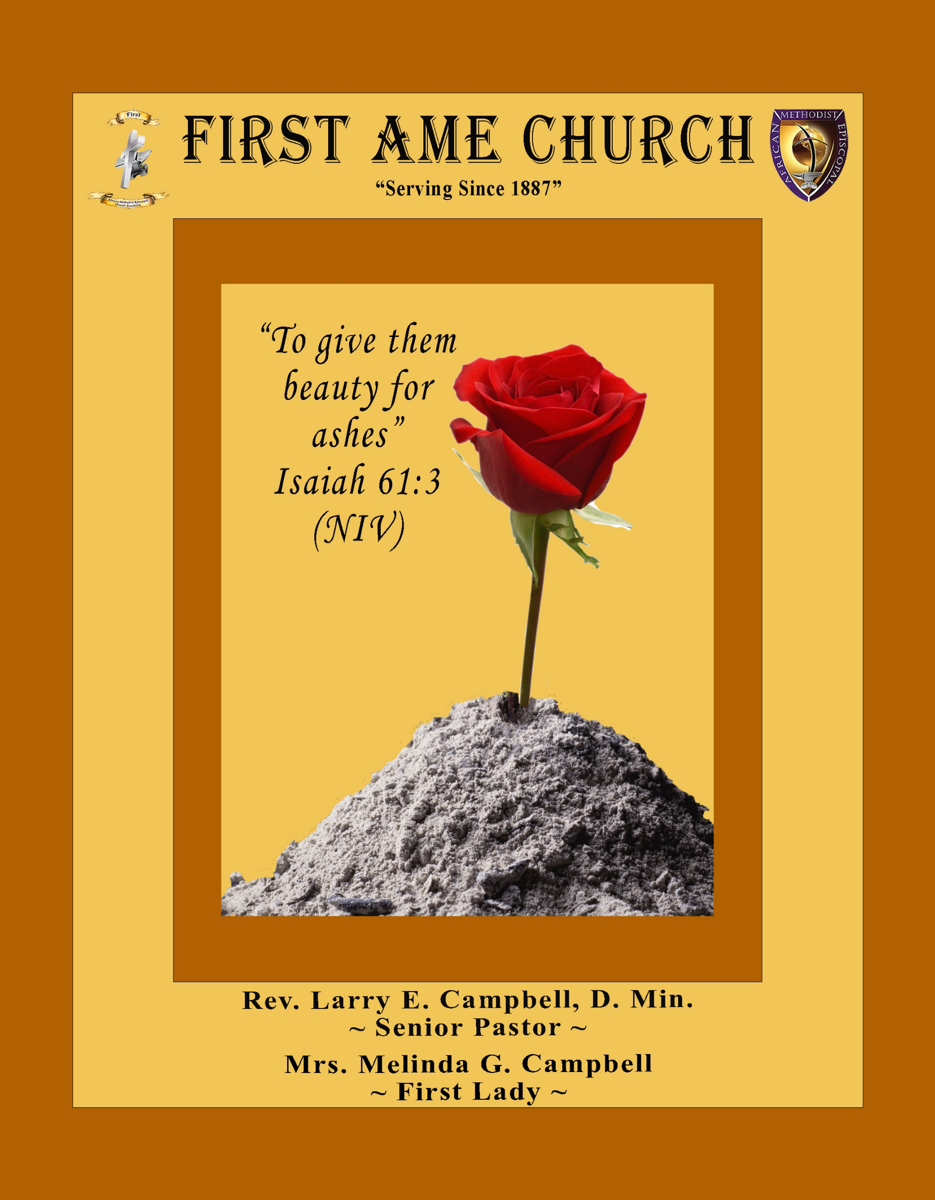
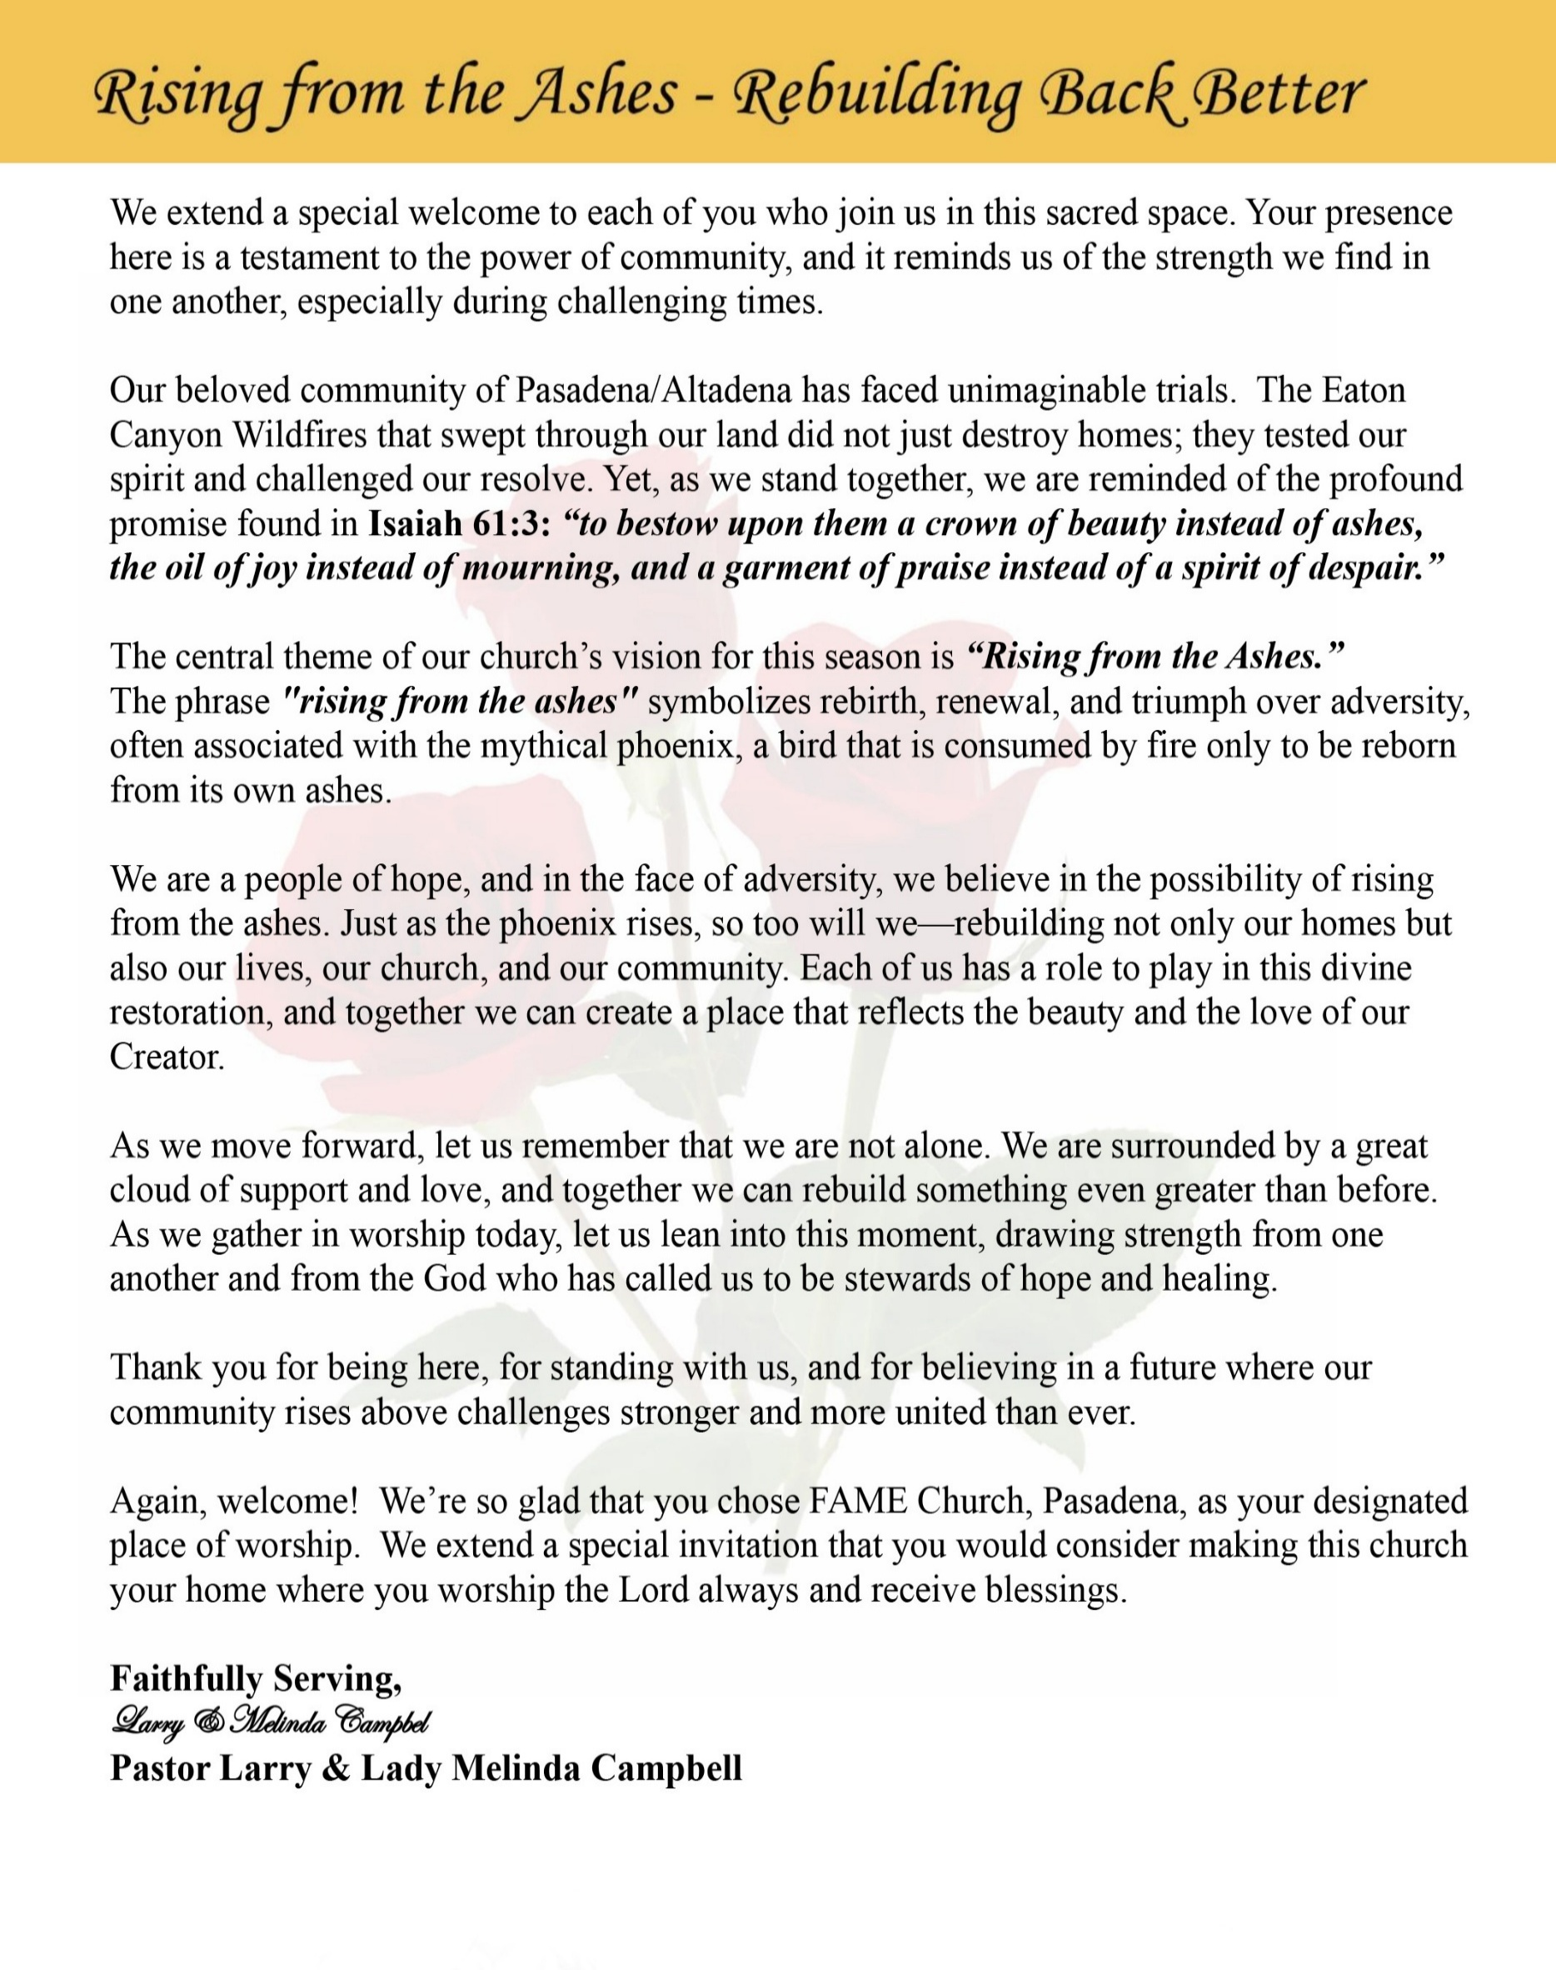

Sunday, July 26, 2026 | 9:30 a.m.

Rt. Rev. Francine A. Brookins, Esq., Presiding Bishop
Rev. Miriam Burnett, MD, MPH, Supervisor of Missions
Rev. Roosevelt Lindsey, Jr. Presiding Elder

The Rev. Dr. Larry E. Campbell ~ Senior Pastor ~ Minister

Mobile: (951) 587-1894 ~ Email: larrycampbell@famepasadena.org

Our First Lady: Mrs. Melinda G. Campbell

The Reverend Dr. Jennifer Oliver ~ Itinerant Elder -
The Reverend Dr. Nikia Smith-Robert ~ Itinerant Elder (Affiliated)
The Reverend Lois Woodard ~ Itinerant Elder Superannuated (Retired)
The Reverend Rochelle Wright Moore ~ Itinerant Deacon
The Reverend Deborah West-Jones ~ Local Elder
The Reverend Philis J. Griffin, MDiv ~ Local Elder
Dr. Phyllis Beech ~ Evangelist
Sister Tessie Bonner ~ Deaconess

Community Resource Center Director ~ Ms. Kischchen Hazelton Venerable
Church Administrative Assistant: Ms. Letha Rhymes

Church Office Hours:
Tue - Wed 9:00 am - 5:00 pm, & Fri 9:00 am -3:00 pm.
Closed for Lunch Daily: 12:00 pm - 1:00 pm.

Music Ministry
Dr. Timothy Davis, Minister of Music
Bro. Jimmy Watlington, Percussionist ~ Bro. Carlos Caldwell, Organist
Bro. Darien Dorsey, Keyboardist
Sis. Karen Law, Women’s Chorus Director ~ Sis. Tonia Graham, Children’s Choir Director
Bro. J. Renard Washington, New Generation’s Choir

FREE WI-FI service is available on the FAME Campus by accessing FAME 1700
Password: 6267980503

-3-

~ Order of Worship Experience ~

Warning: This order of worship is subject to change without warning or prior notice --- everything is governed by the Sovereignty of the Holy Spirit



~ Altar Call ~
Praise & Worship

Doxology: “Praise God From Whom All Blessings Flow”

The Call to Worship Bro. Brian K. Williams
Leader: I was glad when they said unto me, let us go into the house of the Lord, our feet shall stand within Thy gates O Jerusalem! (Psalm 122:1)

People: For a day in Thy courts is better than a thousand. I had rather be a doorkeeper in the house of my God than to dwell in the tents of wickedness. (Psalm 84:10)

Leader: Because of the house of the Lord our God, I will seek Thy good.
(Psalm 122:9)

People: Those that be planted in the house of the Lord, shall flourish in the courts of our God. (Psalm 92:13)

Leader: Blessed are they that dwell in Thy house. Lord, I have loved Thy habitation, the place where Thy honor dwelleth. (Psalm 26:8)

People: For the Lord is in His holy temple; let all the earth keep silence before Him.
(Habakkuk 2:20)

Leader: Let the words of my mouth and the meditation of my heart, be acceptable in Thy sight, O Lord my strength and my redeemer. (Psalm 19:14)

Unison: O Sing unto the Lord a new song, for He has done marvelous things. Make a
joyful noise unto the Lord, all the earth, sing His praises. (Psalm 98:1, 4)

-4-

The Hymn of Praise A.M.E. Hymnal #513
Time Is Filled with Swift Transition
(Hold to God’s Unchanging Hand)

1 Time is filled with swift transition,
naught of earth unmoved can stand;
Build your hopes on things eternal,
hold to God’s unchanging hand!

Refrain:
Hold to God’s unchanging hand!
Hold to God’s unchanging hand!
Build your hopes on things eternal,
hold to God’s unchanging hand!

2 Trust in Him who will not leave you,
whatsoever years may bring;
If by earthly friends forsaken,
still more closely to Him cling.

[Refrain]

3 Covet not this world’s vain riches
that so rapidly decay;
Seek to gain the heav’nly treasures,
they will never pass away!

[Refrain]

4 When your journey is completed,
if to God you have been true,
fair and bright the home in glory,
your enraptured soul will view!

[Refrain]

The Invocation Bro. Versie Gaddis

Ministry of Music The Praise Team

-5-

Scriptural Response on the Danger of Favoritism Dr. Thomas Scotton
(Please Stand for the Reading of God’s Words)
Leader: Beloved, God has called us to be one family in Christ, showing no partiality, for
every person is created in His image.

People: Lord, teach us to love without favoritism and to welcome without prejudice.

Leader: The Scripture declares, "My brothers and sisters, believers in our glorious Lord Jesus
Christ must not show favoritism." (James 2:1)

People Forgive us, O God, for the times we have judged by appearance rather than by
the heart.

Leader: The Lord reminds us, "Man looketh on the outward appearance, but the LORD
looketh on the heart." (1 Samuel 16:7)

People: Help us to see people through Your eyes and to love them with Your heart.

Leader: God is no respecter of persons, but welcomes all who fear Him and seek His
righteousness. (Acts 10:34–35)

People: May our homes and our church reflect the inclusive love of Jesus Christ.

Leader: Christ Himself has broken down every dividing wall of hostility and made us one.
(Ephesians 2:14)

People: Remove every wall of prejudice, pride, discrimination, and favoritism from
among us.

Leader: The royal law commands us, "You shall love your neighbor as yourself." (James 2:8)

People: Empower us to love every neighbor without distinction or condition.

Leader: Let us never honor wealth above character, position above people, or appearance
above compassion.

People: Let our words, our actions, and our attitudes reflect the grace we have received.

Leader: The Apostle Paul reminds us, "There is neither Jew nor Greek... for ye are all one in
Christ Jesus." (Galatians 3:28)

People: Unite us as one body, one family, and one church under the Lordship of Jesus
Christ.

Leader: Jesus welcomed the weary, the forgotten, the poor, the stranger, the child, and the
sinner.

People: As Christ has welcomed us, so let us welcome one another with joy and love.

Leader: Let us remember the words of our Savior: "By this shall all men know that ye are my
disciples, if ye have love one to another." (John 13:35)
All Together: Gracious God, deliver us from the sin of favoritism. Create in us clean hearts
that reflect Your impartial love. May our families, our friendships, and our
congregation be places where all are received with dignity, treated with
compassion, and embraced by grace. Let every person who enters our doors
know that they belong because they are loved by You. Through Jesus Christ
our Lord we pray. Amen.

-6-

The Summary of the Decalogue Bro. Rodney D. Wallace

LEADER: From all that dwell below the skies…
SUNG: From all that dwell below the skies, Let the Creator’s praise arise; Let the
Redeemer’s Name be sung, through every land, by every tongue.
LEADER: Hear what Christ our Savior saith, Thou shalt love the Lord thy God with all thy
heart, with all thy soul, and with all thy mind. This is the first and great
commandment. And the second is like unto it: Thou shalt love thy neighbor
as thyself. On these two commandments hang all the law and the prophets.
SUNG: Glory be to the Father, and to the Son, and to the Holy Ghost; as it was in
the beginning, is now, and ever shall be, world without end. A~Men

Abbreviated Announcements/Visitor’s Welcome Dr. Brian K. Venerable



Special Congregational Hymn (Sing along)
Hymn #390— I am on the Battlefield for My Lord

The Offertory (Tithes ~ Gifts ~ Benevolent Offerings) Bro. Todd Skinner - Steward

The following Electronic GIVING Platforms are creditable methods to GIVE to FAME:

#1. GIVELIFY - Mobile Giving App available on the App Store. It’s easy to set up, just follow the guidelines.

#2. Cash App: $FirstAMEPASADENA

#3. Mail in your Tithes & Offering - If you would like to mail your tithes and offering by check or money order, please send it to: First AME Church, 1700 N. Raymond Avenue, Pasadena, CA 91103.

#4. Drop off your Tithes & Offering - During business hours in the basket outside of the office.

Choral Response: “All things come of Thee, O Lord; and of Thine own have we given Thee. Amen.”

-7-

Family & Friends Day Responsive Litany Bro. Henry Sharp
Leader: This is the day the Lord has made; let us rejoice and be glad in it! Today we celebrate the gift of
family, friends, and the fellowship of God's people.

People: We thank You, Lord, for those who love us, encourage us, and walk beside us in every
season of life.

Leader: The Psalmist declared, "Behold, how good and how pleasant it is for brethren to dwell
together in unity!" (Psalm 133:1)

People: Lord, unite our hearts in love, peace, and fellowship.

Leader: Jesus said, "This is my commandment, That ye love one another, as I have loved you."
(John 15:12)

People: Help us to love one another with compassion, kindness, and grace.

Leader: Your Word reminds us, "Two are better than one... For if they fall, the one will lift up his
fellow." (Ecclesiastes 4:9–10)

People: Strengthen our families, bless our friendships, and help us to encourage one another
daily.

Leader: Today we welcome every guest, every visitor, every family member, and every friend in
the spirit of Christ.

People: May all who enter this place experience the warmth of Christian love and the joy of
belonging.

Leader: Jesus declared, "By this shall all men know that ye are my disciples, if ye have love one to
another." (John 13:35)

People: May our love for one another be our greatest witness to the world.

ALL: Heavenly Father, thank You for the gift of family, the blessing of faithful friends, and
the joy of belonging to Your family. Make this church a place where all are welcomed,
all are valued, and all are loved. Through Jesus Christ our Lord, we pray. Amen.

Sermonic Selection The Praise Team

Proclamation of The Word Pastor Larry E. Campbell

The Invitation (Public/Private)

The Doxology

The Benediction

-8-

Scripture of the Day
Showing No Favoritism. “All who are wicked will be punished with trouble and suffering. It doesn't matter if they are Jews or Gentiles. ¹⁰ But all who do right will be rewarded with glory, honor, and peace, whether they are Jews or Gentiles. ¹¹ God doesn't have any favorites!" Romans 2:9-11

Quote of the Day
" Favoritism creates a sense of injustice, fostering resentment and division."
— Unknown"

Thought of the Week
Love Without Partiality. "There is neither Jew nor Greek, there is neither bond nor free, there is neither male nor female: for ye are all one in Christ Jesus." — Galatians 3:28 (KJV)
The gospel tears down the walls that the world builds. Society often separates people by race, wealth, education, social status, or personal background, but Jesus unites us through His love. At the cross, no one is more important than another, and no one is beyond the reach of God's grace.
As believers, we are called to see others through the eyes of Christ—not through the lens of prejudice or preference. Every person we encounter is created in the image of God and worthy of dignity, compassion, and respect. When we choose love over favoritism, we reflect the heart of Christ and become a living testimony of His Kingdom.
Today, ask yourself: Do my words, actions, and attitudes make others feel welcomed, valued, and loved? May our homes, our friendships, and our church be places where everyone experiences the inclusive love of Jesus Christ.

Humor of the Week
Mrs. Smartt was fumbling in her purse for her offering when a large television remote fell out and clattered into the aisle.
The curious usher bent over to retrieve it for her and whispered, “Do you always carry your TV remote to church?”
“No,” she replied, “but my husband refused to come with me this morning, and I figured this was the most evil thing I could do to him legally.”

HOME DAILY BIBLE READINGS
July 27, 2026 – August 2, 2026 (Week 45, 2 Titus)
Monday Day 309 Romans 2:17-29; 3:1-31, Psalm 137
Tuesday Day 310 Romans 4:1-25; 5:1-21, Psalm 138
Wednesday Day 311 Romans 6:1-23; 7:1-25, Psalm 139
Thursday Day 312 Romans 8:1-39, Psalm 140
Friday Day 313 Romans 9:1-33; 10:1-21, Psalm 141
Saturday Day 314 Romans 11:1-36; 12:1-21, Psalm 142
Sunday Day 315 Romans 13:1-14; 14; 14:1-23, Psalm 143

-9-

ANNOUNCEMENTS

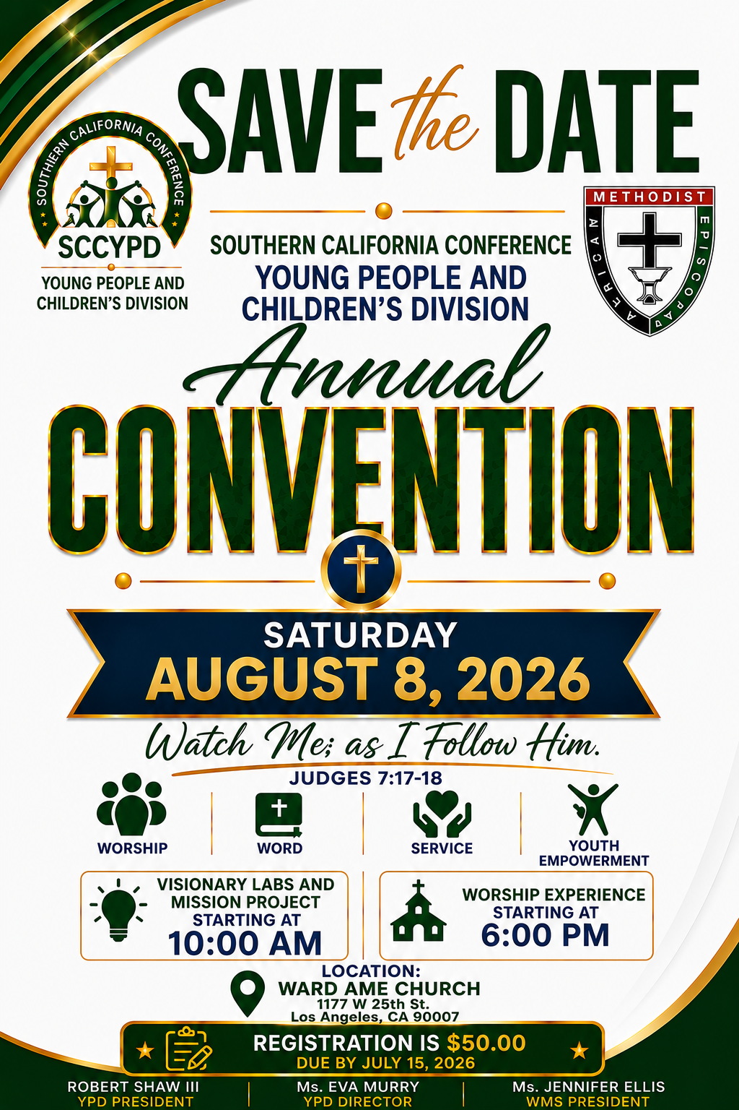

New Members’ Orientation
The presence of all new members is warmly requested at our upcoming New Members’ Orientation Classes. These sessions are designed to help you grow in faith, fellowship, and understanding of the ministry and mission of the church. We look forward to journeying together as disciples of Christ and members of the household of faith.
Orientation Schedule
First Session: Saturday, August 1, 2026 | 10:00 A.M.
Second Session: Saturday, August 8, 2026 |10:00 A.M.
Third Session: Saturday, August 15, 2026 |10:00 A.M.
We encourage every new member to attend faithfully as we grow together in grace, service, and spiritual maturity.

-10-

ANNOUNCEMENTS (Continued)

Steward Board Meeting
Thursday, August 6, 2026 | 6:00 P.M.

Virtual Trustee Board Meeting
Tuesday, August 11, 2026 | 5:30 P.M.

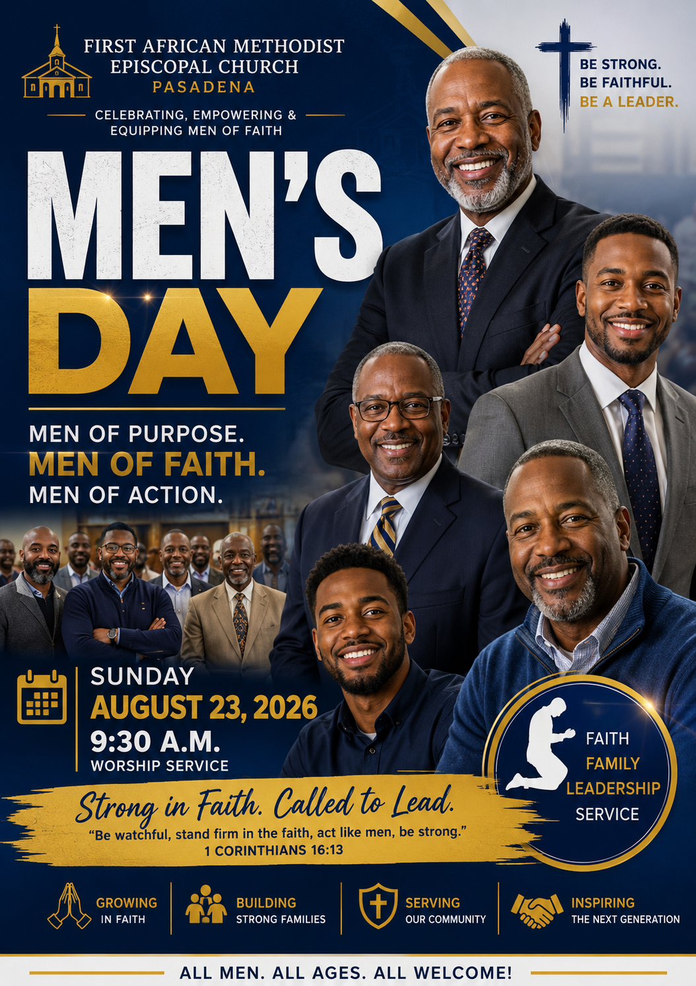

Virtual Official Board Meeting
Tuesday, August 25, 2026 | 6:00 P.M.

-11-

ANNOUNCEMENTS (Continued)



FAME CHURCH UNDERGRADUATE SCHOLARSHIP OPPORTUNITIES
Marie Sumpter Scholarship
Previous recipients enrolled in an Institution of Higher Education (Church Membership Scholarships)
* Applicant must be a member of First A.M.E. Church or be an active participant in the Church.
* Students must be planning to attend a University, Community College, Technical Trade, or
Business Schools.
* Students must be planning to attend a Community College, Technical Trade, or Business
Schools, and must have a minimum Grade Point Average (GPA) of at least 2.0.
* University students must have a GPA of 2.5.

Florida Brown Scholarship
(2026) Graduating High School Seniors (Community-Based Scholarships)
* Applicant must be a member of the local Community who has been accepted to a
University, Community College, Technical Trade or Business School.
* Applicant must be recommended by a member of First A.M.E. Church.
* Applicant must be a graduating high school senior in the year of the application.
* Applicant must have a minimum grade point average (GPA) of 3.0.

ALL Scholarship Applications are now available in the church office and in the Fellowship Hall. FAME-Pasadena students planning to attend trade school, community college or four-year university should apply. Non-FAME Students from the community are encouraged to apply for the Florida Brown Scholarship. The due date for ALL applications is July 31, 2026.

-12-

Prayer Request(s)
Please notify the Church Office of Sick & Shut-in additions, deletions, or status/address changes.

Bishop Francine A. Brookins, Esq. Supervisor Miriam Burnett, MD Presiding Elder Roosevelt & Dr. Kaye Lindsey Rev. Dr. Larry & Melinda Campbell Richard Craig Hazel Clark Erica Woodard Jason Shirley Joshua Shirley Julian Shirley Ayanna Terry Cheryl Jamerson Gwendolyn Flowers Andrea Anderson Ocilda Files Danielle Clark Rev. Charles Brooks Kimberly Woods Cynithia Grace Calle Burns Noel Johnson The Taylor Family
Zechariah Robinson Christopher McCarthy Wilma Haynes Jacquelyn Walker Brittney Petty Selene Cox Deborah Burton Nettie McChristen The Caple Family Mel Beech Michael Dotson Richard Perkins
Rev. Rochelle Moore Lorene Butler Stella Pulliam Collette Blizzard The Eaton Canyon Fire Victims

College Students

Let’s continue to support and pray for our beloved College Students

Isaiah Crowell Alecia Davis Chase Johnson Grant Blizzard Gabriel Blizzard

Tyler Johnson Richard Jones Tyrikk Lawson Makia Rose Talbert Isaiah Ringo Journey Rogers Elyse Sharp Kylee Sharp Zion Otano Elise Tervalon Grace Jones Jordan Patterson Kimberly Robinson Donovan Williams Jasmine Collins Brandon Bates

Sick and Shut-Ins
Andrew Oliver 1405 N. Roosevelt Avenue, Pasadena, CA 91104
Barbara Buchanan 616 Rio Grande St. Pasadena, CA 91104
Bettina Ayers Pasadena Meadows Nursing Home, 150 Bellefontaine St., Pas., CA 91105
Betty Betts Turner USC Keck Rehabilitation, 300 W Huntington Dr., Arcadia, CA 91007
Bobby Thomas 1052 E. Morada Place, Altadena, CA 91001
Diane Jordan 1719 Fremont Ave., #302, S. Pasadena, CA 91030
Donita Towler 301 N. 3rd Street #C, Alhambra, CA 91801
Doris Curd 11619 Woodcock Avenue, San Fernando, CA 91340
Edmund Riddle Active Care Mission Bay, 2440 Grand Avenue, San Diego, CA 92109
Eleanor Towler 975 E. Union Street, Unit #417, Pasadena, CA 91106
Elois Blizzard P. O. Box 3646, So. Pasadena, CA 91031
Emily Cormier-Ross 2549 La Fiesta Avenue, Altadena, CA 91001
Ernestine English 26 W. Fair Oaks Drive, Pasadena, CA 91103
Fred Caple 51 North 15th Street Haledon, NJ 07508
Hugh Hamberry 19225 Chole Rd., Apple Valley, CA 92307
Jessie Smith 3925 S Jones BL, Apt 2118 Las Vegas, NV 89103| Spring Valley Community
Josephine Brown 15607 Saddleback Rd, Riverside, CA 92506
Konata Doxey Monte Vista Healthcare Center, Duarte, CA 91010
Lenora Moore 2445 E Del Mar Bl, #338 Pasadena, CA 91107
Linnie G. Nollie 2250 E. New York Drive, Altadena, CA 91001
Malika G. Hendry P. O. Box 94082, Pasadena, CA 91109
Mildred Lewis C/O Hazel Rohr, 884 W. Jane Court, Upland, CA 91786
Norma Burnett 618 Fairview Avenue, Unit #228, Arcadia, CA 91007
Opal Hampton 1030 Chevron Court, Pasadena, CA 91103
Paul Ratliff P.O. Box 40407 Pasadena, CA 91114
Virlyn Grant 15122 Orange Ave., Paramount, CA 90723
Wanda Nelson 3618 N. Fair Oaks Avenue, Altadena, CA 91001
William Hilliard 7504 Wynstone Pl., Fontana, CA 92336
Zell L. Hill 375 Barthe Drive, Pasadena, CA 91103

-13-

Sermon Notations

Scripture: _____________________________________________________________

Subject: _______________________________________________________________

Points of the Message: ___________________________________________________
_______________________________________________________________________
_______________________________________________________________________
_______________________________________________________________________
_______________________________________________________________________
_______________________________________________________________________
_______________________________________________________________________

Main Ideas of the Sermon: ________________________________________________
_______________________________________________________________________
_______________________________________________________________________
_______________________________________________________________________
_______________________________________________________________________
_______________________________________________________________________

Illustrations I want to remember: _________________________________________
_______________________________________________________________________
_______________________________________________________________________
_______________________________________________________________________
_______________________________________________________________________
_______________________________________________________________________
_______________________________________________________________________

What should I do as a result of this Sermon? ________________________________

_____________________________________________________
_____________________________________________________
_____________________________________________________
_____________________________________________________

-14-

