
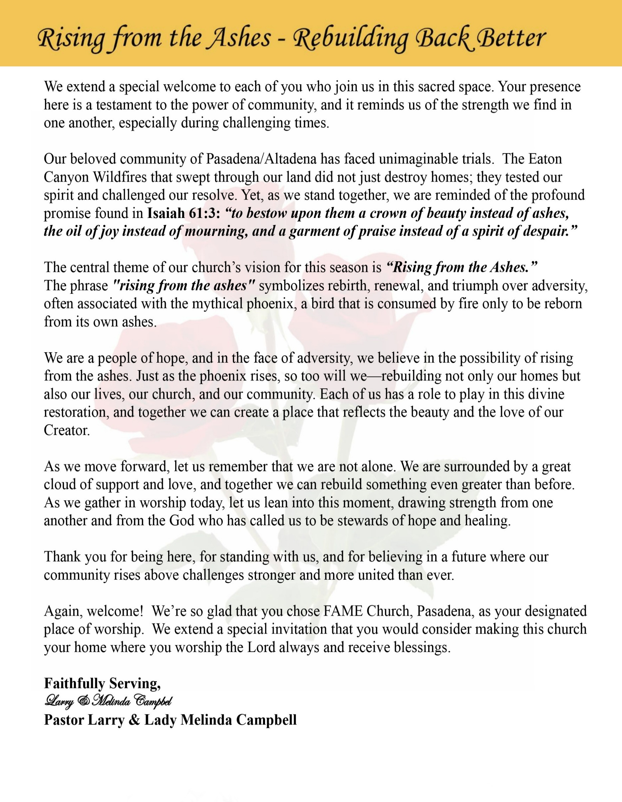

Sunday, June 14, 2026 | 9:30 a.m.

Rt. Rev. Francine A. Brookins, Esq., Presiding Bishop
Rev. Miriam Burnett, MD, MPH, Supervisor of Missions
Rev. Roosevelt Lindsey, Jr. Presiding Elder

The Rev. Dr. Larry E. Campbell ~ Senior Pastor ~ Minister

Mobile: (951) 587-1894 ~ Email: larrycampbell@famepasadena.org

Our First Lady: Mrs. Melinda G. Campbell

The Reverend Dr. Jennifer Oliver ~ Itinerant Elder -
The Reverend Dr. Nikia Smith-Robert ~ Itinerant Elder (Affiliated)
The Reverend Lois Woodard ~ Itinerant Elder Superannuated (Retired)
The Reverend Rochelle Wright Moore ~ Itinerant Deacon
The Reverend Deborah West-Jones ~ Local Elder
The Reverend Philis J. Griffin, MDiv ~ Local Elder
Dr. Phyllis Beech ~ Evangelist
Sister Tessie Bonner ~ Deaconess

Community Resource Center Director ~ Ms. Kischchen Hazelton Venerable
Church Administrative Assistant: Ms. Letha Rhymes

Church Office Hours:
Tue - Wed 9:00 am - 5:00 pm, & Fri 9:00 am -3:00 pm.
Closed for Lunch Daily: 12:00 pm - 1:00 pm.

Music Ministry
Dr. Timothy Davis, Minister of Music
Bro. Jimmy Watlington, Percussionist ~ Bro. Carlos Caldwell, Organist
Bro. Darien Dorsey, Keyboardist
Sis. Karen Law, Women’s Chorus Director ~ Sis. Tonia Graham, Children’s Choir Director
Bro. J. Renard Washington, New Generation’s Choir

FREE WI-FI service is available on the FAME Campus by accessing FAME 1700
Password: 6267980503

-3-

~ Order of Worship Experience ~

Warning: This order of worship is subject to change without warning or prior notice --- everything is governed by the Sovereignty of the Holy Spirit.

Graduation/Student’s Special Achievements Sunday Celebration
Praise & Worship

Doxology: “Praise God From Whom All Blessings Flow”
The Call to Worship

Leader: I was glad when they said unto me, let us go into the house of the Lord, our feet shall stand within Thy gates O Jerusalem! (Psalm 122:1)

People: For a day in Thy courts is better than a thousand. I had rather be a doorkeeper in the house of my God than to dwell in the tents of wickedness. (Psalm 84:10)

Leader: Because of the house of the Lord our God, I will seek Thy good.
(Psalm 122:9)

People: Those that be planted in the house of the Lord, shall flourish in the courts of our God. (Psalm 92:13)

Leader: Blessed are they that dwell in Thy house. Lord, I have loved Thy habitation, the place where Thy honor dwelleth. (Psalm 26:8)

People: For the Lord is in His holy temple; let all the earth keep silence before Him.
(Habakkuk 2:20)

Leader: Let the words of my mouth and the meditation of my heart, be acceptable in Thy sight, O Lord my strength and my redeemer. (Psalm 19:14)

Unison: O Sing unto the Lord a new song, for He has done marvelous things. Make a
joyful noise unto the Lord, all the earth, sing His praises. (Psalm 98:1, 4)

-4-

The Worship Song of Praise Every Praise
(Repeat Verse 3 times)
Every praise is to our God.
Every word of worship with one accord
Every praise every praise is to our God.
Sing hallelujah to our God
Glory hallelujah is due our God
Every praise every praise is to our God.

(Repeat Chorus 3 times)
God my Savior
God my Healer
God my Deliverer
Yes He is, yes He is

Yes He is, yes He is, yes He is, yes He is
Yes He is, yes He is, yes He is, yes He is

(Repeat Verse 2 times)
Every praise is to our God.
Every word of worship with one accord
Every praise, every praise, every praise, every praise
Every praise, every praise, every praise, every praise
Every praise, every praise, every praise, every praise
All of my worship, every praise,
Every praise, every praise
When you see me dancing, every praise
Every praise, every praise
When you see me shoutin', every praise
Every praise, every praise, every praise, every praise
Every praise, every praise, to our god
Is to our God

The Invocation

Ministry of Music The Praise Team

-5-

Scripture Lesson
(Please Stand for the Reading of God’s Words)

Jeremiah 1:4-8 (New International Version) — The Call of Jeremiah
⁴ The word of the Lord came to me, saying, ⁵ “Before I formed you in the womb I knew you, before you were born I set you apart; I appointed you as a prophet to the nations.” ⁶ “Alas, Sovereign Lord,” I said, “I do not know how to speak; I am too young.” ⁷ But the Lord said to me, “Do not say, ‘I am too young.’ You must go to everyone I send you to and say whatever I command you. ⁸ Do not be afraid of them, for I am with you and will rescue you,” declares the Lord.

The Summary of the Decalogue
LEADER: From all that dwell below the skies…
SUNG: From all that dwell below the skies, Let the Creator’s praise arise; Let the
Redeemer’s Name be sung, through every land, by every tongue.
LEADER: Hear what Christ our Savior saith, Thou shalt love the Lord thy God with all thy
heart, with all thy soul, and with all thy mind. This is the first and great
commandment. And the second is like unto it: Thou shalt love thy neighbor
as thyself. On these two commandments hang all the law and the prophets.
SUNG: Glory be to the Father, and to the Son, and to the Holy Ghost; as it was in
the beginning, is now, and ever shall be, world without end. A~Men

Abbreviated Announcements/Visitor’s Welcome



Wedding


-6-

90 Plus Birthday Celebrations
Sis. Eleanor Towler Celebrated her 93rd birthday on June 11th
Sis. Dorothy Moss will Celebrate her 91st birthday on June 21st

Birthdays Recognized for the Month


“The best Birthday wish that you can get for the day is that you may live each moment of your life to the very fullest, without any regrets.” Anonymous

Special Congregational Hymn (Sing along)
Hymn #525 — What a Fellowship, What a Joy Divine

The Offertory (Tithes ~ Gifts ~ Benevolent Offerings) Sis. Natalya Romo-Jones, Steward

The following Electronic GIVING Platforms are creditable methods to GIVE to FAME:

#1. GIVELIFY - Mobile Giving App available on the App Store. It’s easy to set up, just follow the guidelines.

#2. Cash App: $FirstAMEPASADENA

#3. Mail in your Tithes & Offering - If you would like to mail your tithes and offering by check or money order, please send it to: First AME Church, 1700 N. Raymond Avenue, Pasadena, CA 91103.

#4. Drop off your Tithes & Offering - During business hours in the basket outside of the office.

Choral Response: “All things come of Thee, O Lord; and of Thine own have we given Thee. Amen.”

Graduation Day & Student Achievement Sunday Litany
Leader: Today we gather to celebrate the accomplishments of our students and graduates
and to give thanks for God's faithfulness throughout their educational journey.

People: The Lord has done great things for us, and we are filled with joy.
(Psalm 126:3)

Leader: We thank God for the wisdom, perseverance, and strength that have enabled our
students to achieve their goals.

People: We can do all things through Christ who strengthens us. (Philippians 4:13)

(Continued on page 8)

-7-

Graduation Day & Student Achievement Sunday Litany (Continued)

Leader: We give thanks for teachers, principals, counselors, coaches, and school staff who have
guided, encouraged, and inspired our students.

People: May God bless all who labor to educate and uplift our children.

Leader: We give thanks for parents, grandparents, guardians, and family members whose love,
sacrifice, and support have made these achievements possible.

People: Train up a child in the way he should go. (Proverbs 22:6)

Leader: We thank God for Sunday School teachers, Christian educators, mentors, and church
leaders who have nurtured both faith and character.

People: Your Word is a lamp unto our feet and a light unto our path. (Psalm 119:105)

Leader: As our students and graduates move forward, may they trust God to guide their future and
fulfill His purpose for their lives.

People: Trust in the Lord with all your heart, and He shall direct your paths. (Proverbs 3:5-6)

Leader: Let us celebrate all that God has done and all that God will continue to do through these
young people.

People: To God be the glory for every achievement, every opportunity, and every blessing. Amen.

***Celebration of Achievements (Kindergarten, Preschool, Elementary)***

***Celebration of Achievements (Middle School & High School)***

***Celebration of Achievements
(High School Graduates & College Graduates)***

Sermonic Selection The Praise Team

The Preached Word Pastor Larry E. Campbell

The Doxology

The Benediction

-8-

Scripture of the Day
Destined by God. "For I know the plans I have for you, declares the Lord, plans to prosper you and not to harm you, plans to give you hope and a future." Jeremiah 29:11

Quote of the Day
"Your destiny is not determined by your history, your hardships, or your haters; it is determined by God's purpose for your life." — Unknown

Thought of the Week
"For we are His workmanship, created in Christ Jesus for good works, which God prepared beforehand that we should walk in them." — Ephesians 2:10
Life often presents us with unexpected detours, delays, and disappointments. Yet, as believers, we are reminded that our lives are not governed by chance, but by the providence of God. Before we were born, God knew us, called us, and designed us with purpose. Every gift, every experience, and even every challenge can become part of God's preparation for our destiny.
Being destined by God does not mean the journey will be easy. Joseph endured betrayal, Moses spent years in the wilderness, and Esther faced uncertainty before fulfilling God's purpose. Their stories remind us that God's destiny is often revealed through a process of preparation.
Whatever season you find yourself in today, trust that God is still at work. The path may not always be clear, but His purpose is certain. Walk confidently, knowing that the God who created you has also called you, equipped you, and destined you for His glory.

Humor of the Week
A teacher was giving a lesson on the Old Testament and asked one of her students, “Tommy, who knocked down the walls of Jericho?”
Tommy answered, “Well, it wasn’t me.”
Worried about this lack of Bible knowledge, the teacher called Tommy’s mother.
His mother said, “Look, my son’s a good kid. If he says he didn’t knock the wall down, he didn’t knock the wall down.”
More worried, the teacher called Tommy’s father. He listened to her story and said, “Well, look, I don’t want any trouble. Just tell me how much this wall costs, and I’ll take care of it.”

HOME DAILY BIBLE READINGS
June 15, 2026 – June 21, 2026 (Week 39, Ephesians)
Monday Day 267 Luke 20:1-47, Psalm 107:9-22
Tuesday Day 268 Luke 21:1-38, Psalm 107:23-32
Wednesday Day 269 Luke 22:1-46, Psalm 107:33-42
Thursday Day 270 Luke 22:47-71, Psalm 108
Friday Day 271 Luke 23:1-56, Psalm 109:1-15
Saturday Day 272 Luke 24:1-53, Psalm 109:16-25
Sunday Day 273 Luke 1:1-51, Psalm 109:26-31

-9-

ANNOUNCEMENTS

20/20 (14.0)
The 20/20 initiative is a Church-wide fundraising project managed by Stewards. This project was established to assist with our Annual Connectional Budget. Financial gifts donated through the 20/20 initiative are added to our collected conference claims and assist greatly in meeting the first and second half of our Connectional Budgetary obligations. The Steward Board is requesting 150 participants for the conference year 2025-2026. The first half of our budget is due in February 2026. In addition to the 18 officers and we are asking 132 people to give 20 dollars per week for 20 weeks in addition to your regular tithes, gifts and offerings. Please mark your envelopes 20/20 and allocate $20.00. Our goal is to raise $60,000. Again, this will satisfy all budgetary needs on the conference level without utilizing any operational funds. Please see or contact any Steward to participate; we are looking forward to your commitment.

New Members’ Orientation
The presence of all new members is warmly requested at our upcoming New Members’ Orientation Classes. These sessions are designed to help you grow in faith, fellowship, and understanding of the ministry and mission of the church. We look forward to journeying together as disciples of Christ and members of the household of faith.
Orientation Schedule
Third Session: Wednesday, June 24 | 5:00 p.m.
Fourth Session: Wednesday, July 1 | 5:00 p.m.
Fifth Session: Wednesday, July 8 | 5:00 p.m.
Sixth Session: Wednesday, July 15 | 5:00 p.m.
We encourage every new member to attend faithfully as we grow together in grace, service, and spiritual maturity.

Trustee Board: Virtual, Tuesday, June 16, 2026 | 5:30 pm

Official Board Meeting: Virtual, June 17, 2026 | 6:30 pm

Celebrating God’s Gift of FATHERHOOD: Sunday, June 21, 2026 | 9:30 am

-10-

ANNOUNCEMENTS (Continued)



Background Check Reminder
This is a reminder that all adults aged 18 and older who work with children and youth in our church are required to complete the necessary background screening in compliance with the 5th Episcopal District requirements. Assistance is available to help ensure all volunteers and workers remain in compliance. Please contact the church office or Sis. Gina Tervalon for additional information and next steps.

-11-

ANNOUNCEMENTS (Continued)

WEEKLY BIBLE STUDY CLASSES. Please note that the following organized spiritual development sessions will be on hiatus during the month of July and August 2026
Pastoral Bible Studies
Wednesday Prayers Meetings
Men/Women Bible Studies
Senior Ministry
Let’s use this time to rejuvenate and spend quality time with our families. Classes will resume the first week of September.

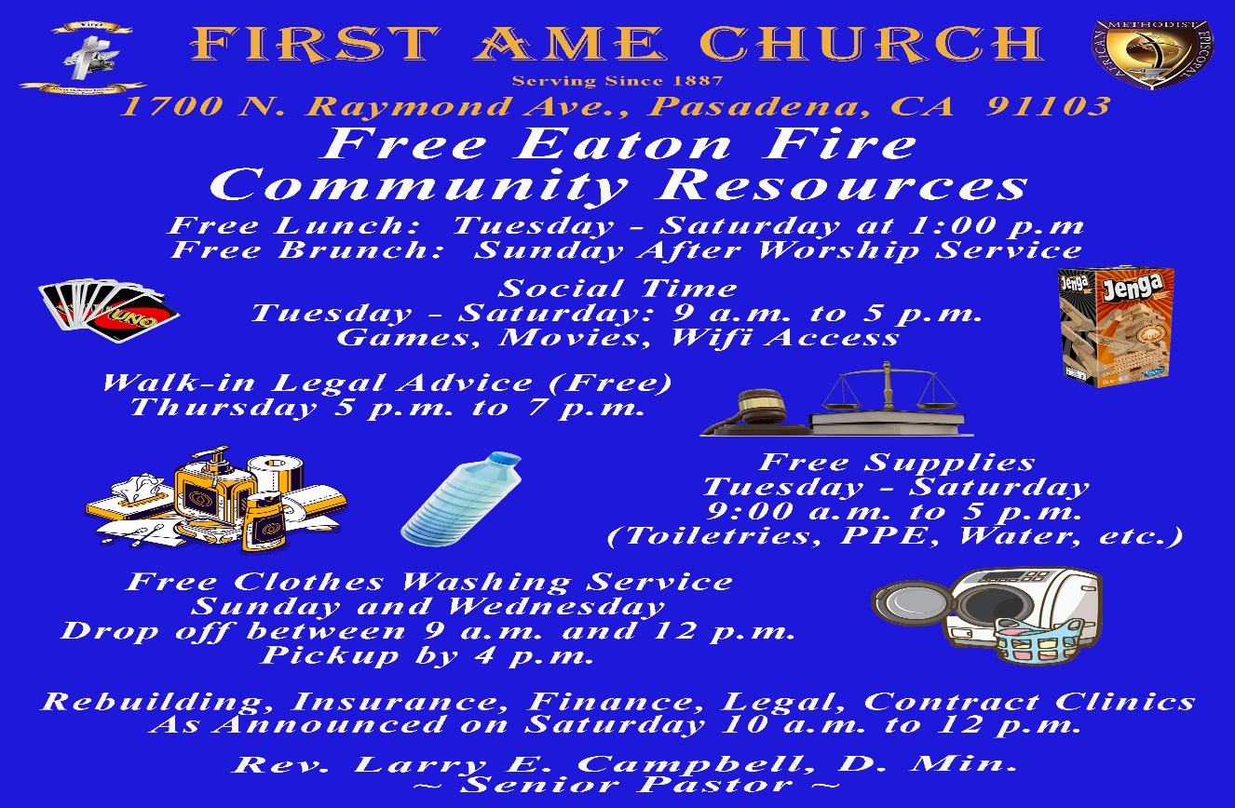-

-12-

Prayer Request(s)
Please notify the Church Office of Sick & Shut-in additions, deletions, or status/address changes.

Bishop Francine A. Brookins, Esq. Supervisor Miriam Burnett, MD
Presiding Elder Roosevelt & Dr. Kaye Lindsey Rev. Dr. Larry & Melinda Campbell
Richard Craig Hazel Clark Erica Woodard Jason Shirley Joshua Shirley Julian Shirley Ayanna Terry Cheryl Jamerson Gwendolyn Flowers Andrea Anderson Ocilda Files Danielle Clark Donita Towler Rev. Charles Brooks Doris Bailey Kimberly Woods Cynithia Grace Zechariah Robinson Diane Jordan Christopher McCarthy Wilma Haynes Calle Burns Noel Johnson Brittney Petty Taylor Family Deborah Burton Nettie McChristen Jacquelyn Walker The Caple Family
Rev. Rochelle Moore Lorene Butler Stella Pulliam Collette Blizzard
The Eaton Canyon Fire Victims Selene Cox Mel Beech

College Students

Let’s continue to support and pray for our beloved College Students

Isaiah Crowell Alecia Davis Chase Johnson Grant Blizzard

Tyler Johnson Richard Jones Tyrikk Lawson Makia Rose Talbert Isaiah Ringo Journey Rogers Elyse Sharp Kylee Sharp Zion Otano Elise Tervalon Grace Jones Jordan Patterson Kimberly Robinson Donovan Williams Jasmine Collins Brandon Bates Gabriel Blizzard

Sick and Shut-Ins
Andrew Oliver 1405 N. Roosevelt Avenue, Pasadena, CA 91104
Barbara Buchanan 616 Rio Grande St. Pasadena, CA 91104
Bettina Ayers Pasadena Meadows Nursing Home, 150 Bellefontaine St., Pas., CA 91105
Betty Betts Turner USC Keck Rehabilitation, 300 W Huntington Dr., Arcadia, CA 91007
Bobby Thomas 1052 E. Morada Place, Altadena, CA 91001
Doris Curd 11619 Woodcock Avenue, San Fernando, CA 91340
Edmund Riddle Active Care Mission Bay, 2440 Grand Avenue, San Diego, CA 92109
Eleanor Towler 975 E. Union Street, Unit #417, Pasadena, CA 91106
Elois Blizzard P. O. Box 3646, So. Pasadena, CA 91031
Emily Cormier-Ross 2549 La Fiesta Avenue, Altadena, CA 91001
Ernestine English 26 W. Fair Oaks Drive, Pasadena, CA 91103
Fred Caple 51 North 15th Street Haledon, NJ 07508
Gloria Cubit Clay 11745 Pierce St., Lake View Terrace, CA 91342
Hugh Hamberry 19225 Chole Rd., Apple Valley, CA 92307
Jeff Thomas 603 Tocino Dr. Duarte, CA 91010 | Mountain View Terrace
Jessie Smith 3925 S Jones BL, Apt 2118 Las Vegas, NV 89103| Spring Valley Community
Josephine Brown 15607 Saddleback Rd, Riverside, CA 92506
Konata Doxey Monte Vista Healthcare Center, Duarte, CA 91010
Linnie G. Nollie 2250 E. New York Drive, Altadena, CA 91001
Malika G. Hendry P. O. Box 94082, Pasadena, CA 91109
Mildred Lewis C/O Hazel Rohr, 884 W. Jane Court, Upland, CA 91786
Norma Burnett 618 Fairview Avenue, Unit #228, Arcadia, CA 91007
Opal Hampton 1030 Chevron Court, Pasadena, CA 91103
Paul Ratliff P.O. Box 40407 Pasadena, CA 91114
Virlyn Grant 15122 Orange Ave., Paramount, CA 90723
Wanda Nelson 3618 N. Fair Oaks Avenue, Altadena, CA 91001
William Hilliard 7504 Wynstone Pl., Fontana, CA 92336
Zell L. Hill 375 Barthe Drive, Pasadena, CA 91103

-13-

Sermon Notations

Scripture: _____________________________________________________________

Subject: _______________________________________________________________

Points of the Message: ___________________________________________________
_______________________________________________________________________
_______________________________________________________________________
_______________________________________________________________________
_______________________________________________________________________
_______________________________________________________________________
_______________________________________________________________________

Main Ideas of the Sermon: ________________________________________________
_______________________________________________________________________
_______________________________________________________________________
_______________________________________________________________________
_______________________________________________________________________
_______________________________________________________________________

Illustrations I want to remember: _________________________________________
_______________________________________________________________________
_______________________________________________________________________
_______________________________________________________________________
_______________________________________________________________________
_______________________________________________________________________
_______________________________________________________________________

What should I do as a result of this Sermon? ________________________________

_____________________________________________________
_____________________________________________________
_____________________________________________________
_____________________________________________________

-14-

