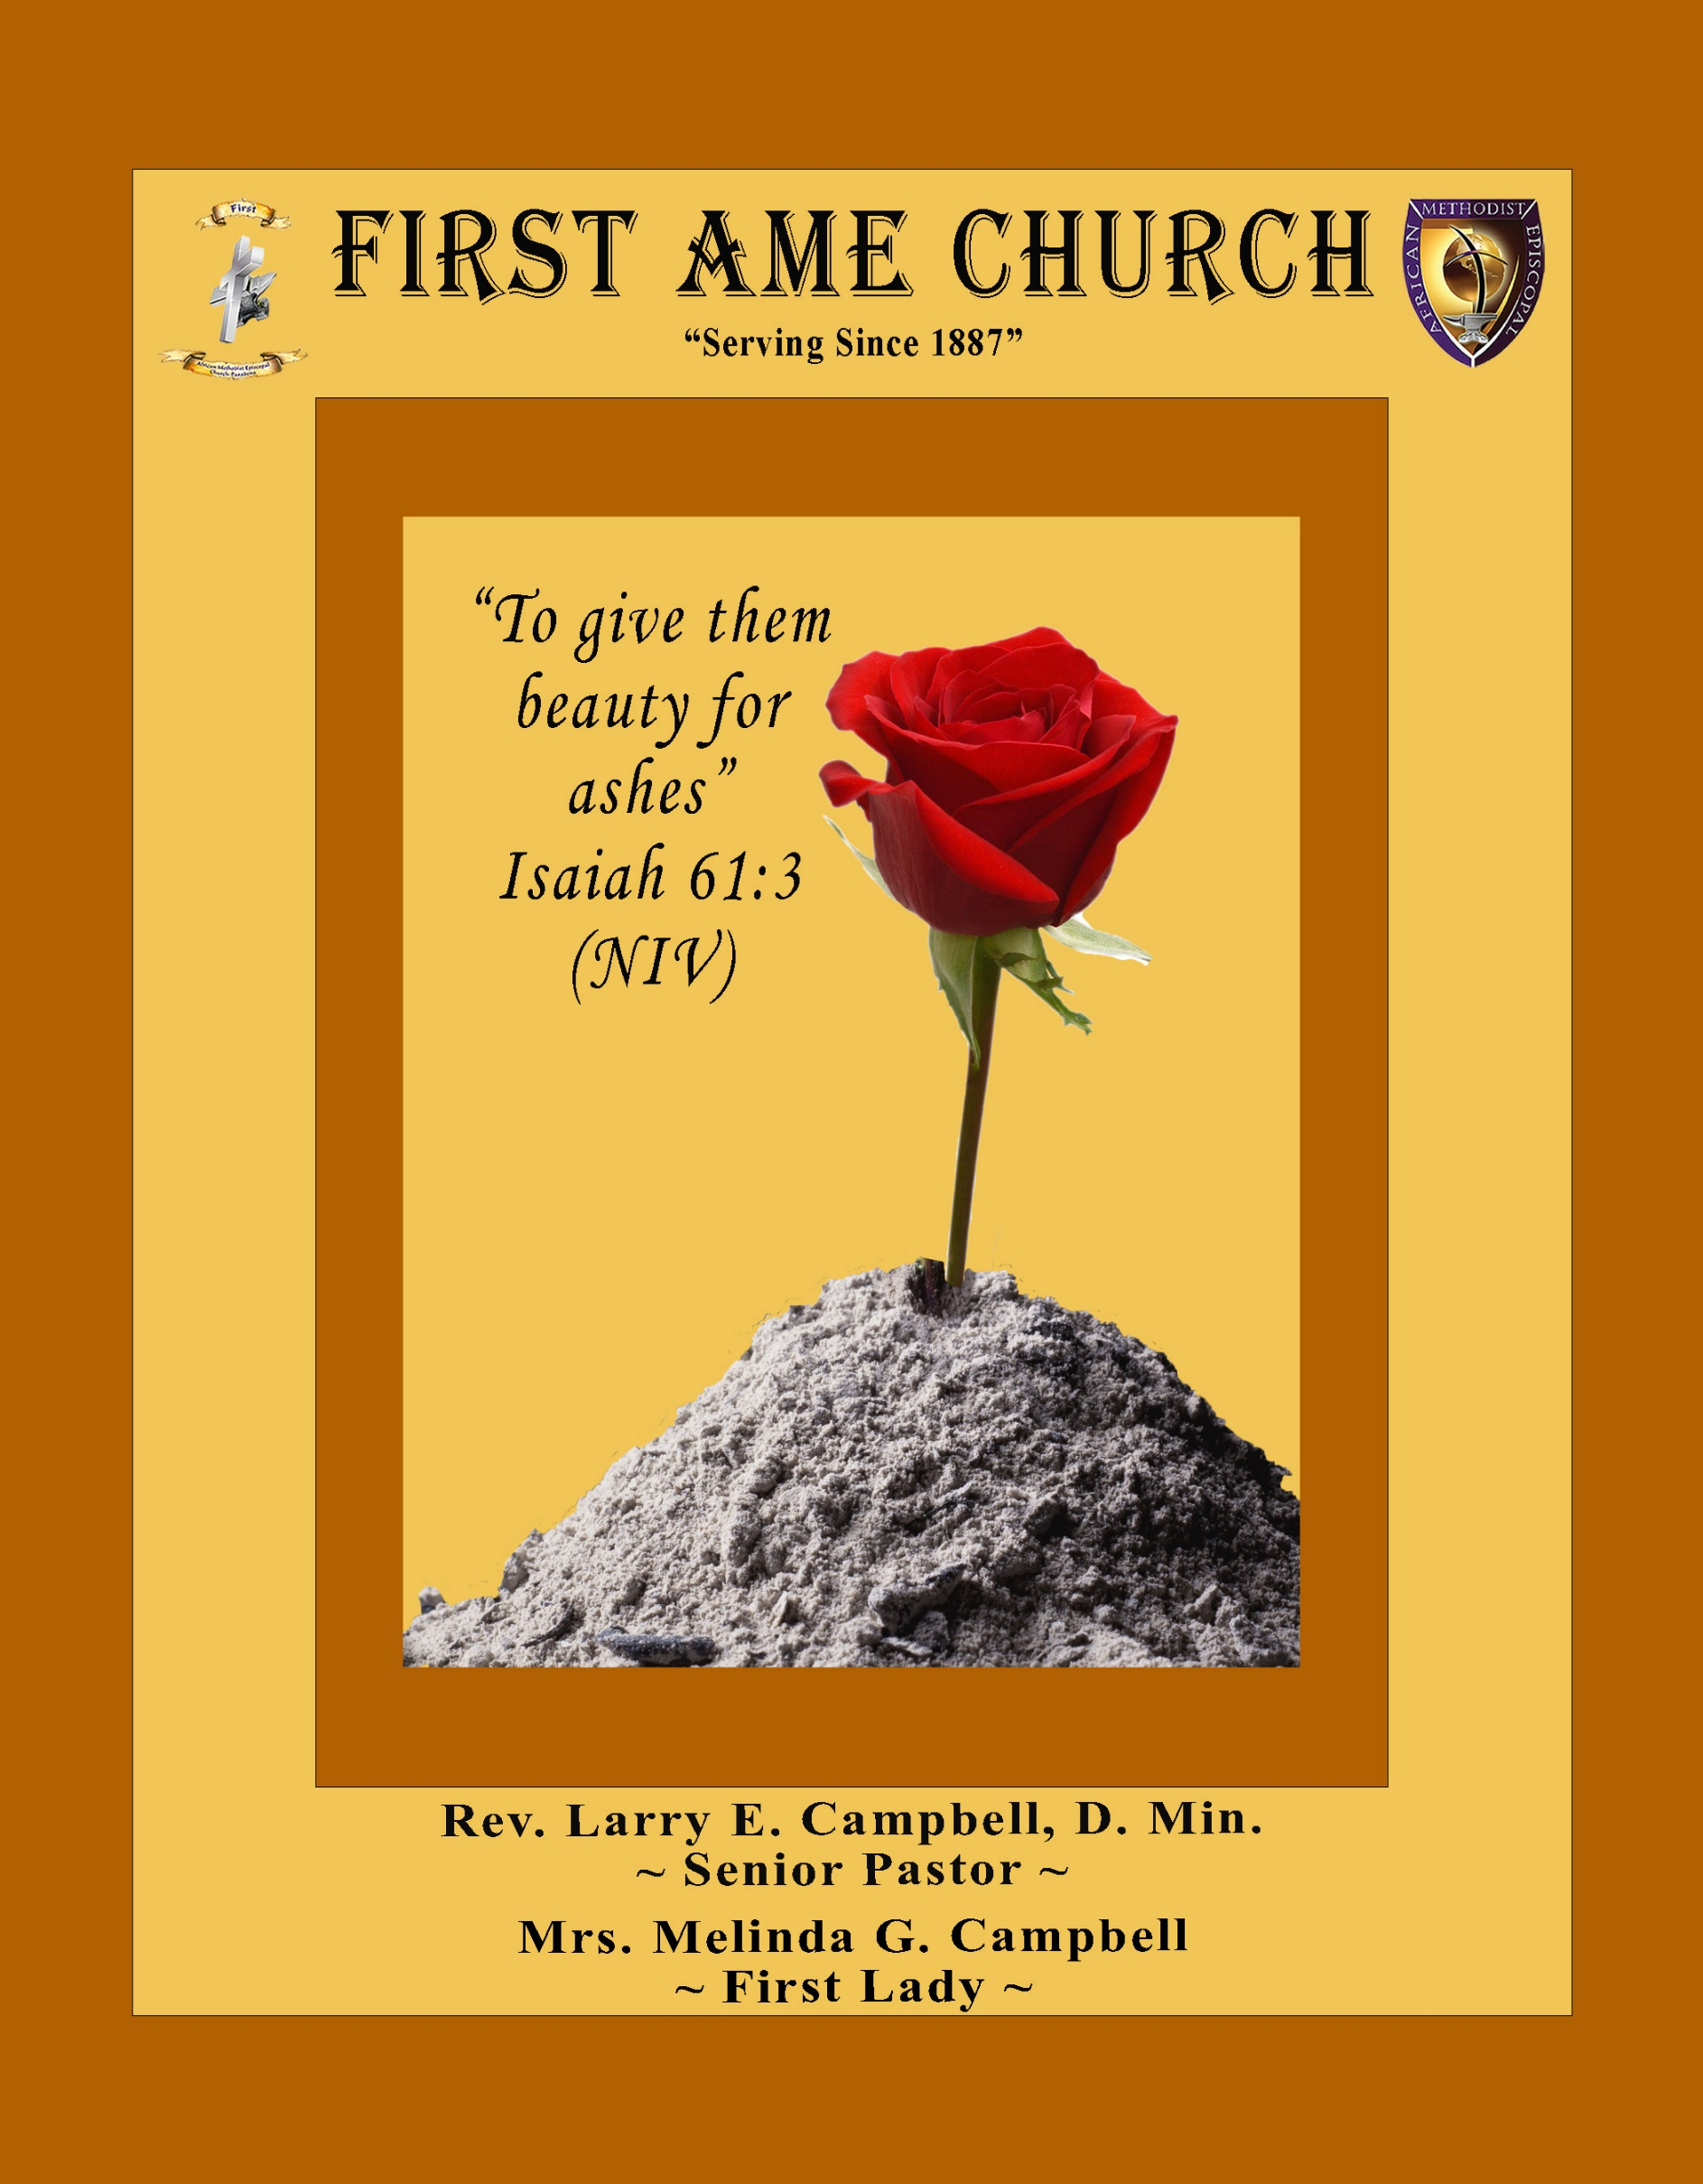
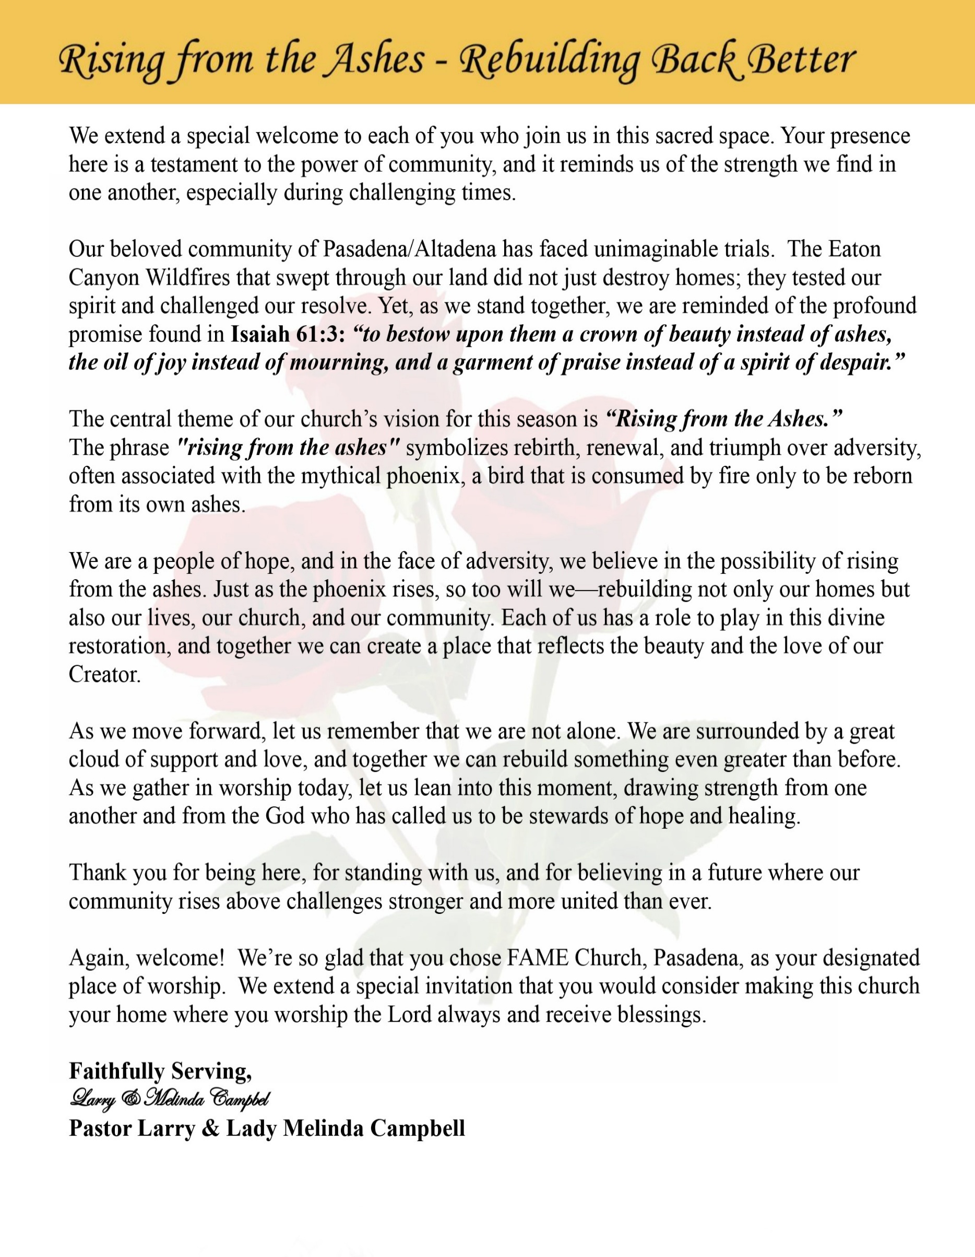

Sunday, June 21, 2026 | 9:30 a.m.

Rt. Rev. Francine A. Brookins, Esq., Presiding Bishop
Rev. Miriam Burnett, MD, MPH, Supervisor of Missions
Rev. Roosevelt Lindsey, Jr. Presiding Elder

The Rev. Dr. Larry E. Campbell ~ Senior Pastor ~ Minister

Mobile: (951) 587-1894 ~ Email: larrycampbell@famepasadena.org

Our First Lady: Mrs. Melinda G. Campbell

The Reverend Dr. Jennifer Oliver ~ Itinerant Elder -
The Reverend Dr. Nikia Smith-Robert ~ Itinerant Elder (Affiliated)
The Reverend Lois Woodard ~ Itinerant Elder Superannuated (Retired)
The Reverend Rochelle Wright Moore ~ Itinerant Deacon
The Reverend Deborah West-Jones ~ Local Elder
The Reverend Philis J. Griffin, MDiv ~ Local Elder
Dr. Phyllis Beech ~ Evangelist
Sister Tessie Bonner ~ Deaconess

Community Resource Center Director ~ Ms. Kischchen Hazelton Venerable
Church Administrative Assistant: Ms. Letha Rhymes

Church Office Hours:
Tue - Wed 9:00 am - 5:00 pm, & Fri 9:00 am -3:00 pm.
Closed for Lunch Daily: 12:00 pm - 1:00 pm.

Music Ministry
Dr. Timothy Davis, Minister of Music
Bro. Jimmy Watlington, Percussionist ~ Bro. Carlos Caldwell, Organist
Bro. Darien Dorsey, Keyboardist
Sis. Karen Law, Women’s Chorus Director ~ Sis. Tonia Graham, Children’s Choir Director
Bro. J. Renard Washington, New Generation’s Choir

FREE WI-FI service is available on the FAME Campus by accessing FAME 1700
Password: 6267980503

-3-

~ Order of Worship Experience ~

Warning: This order of worship is subject to change without warning or prior notice --- everything is governed by the Sovereignty of the Holy Spirit.



Praise & Worship

Doxology: “Praise God From Whom All Blessings Flow”
The Call to Worship Bro’s OT, Derrell, & Tim Triplett

Leader: I was glad when they said unto me, let us go into the house of the Lord, our feet shall stand within Thy gates O Jerusalem! (Psalm 122:1)

People: For a day in Thy courts is better than a thousand. I had rather be a doorkeeper in the house of my God than to dwell in the tents of wickedness. (Psalm 84:10)

Leader: Because of the house of the Lord our God, I will seek Thy good.
(Psalm 122:9)

People: Those that be planted in the house of the Lord, shall flourish in the courts of our God. (Psalm 92:13)

Leader: Blessed are they that dwell in Thy house. Lord, I have loved Thy habitation, the place where Thy honor dwelleth. (Psalm 26:8)

People: For the Lord is in His holy temple; let all the earth keep silence before Him.
(Habakkuk 2:20)

Leader: Let the words of my mouth and the meditation of my heart, be acceptable in Thy sight, O Lord my strength and my redeemer. (Psalm 19:14)

Unison: O Sing unto the Lord a new song, for He has done marvelous things. Make a
joyful noise unto the Lord, all the earth, sing His praises. (Psalm 98:1, 4)

-4-

The Worship Song of Praise I Command My Soul

I Command My Soul
Bishop Neil Ellis

I command my soul to bless the Lord x4
Soul, soul Bless the Lord X4

I command my voice to sing His praise X4
Voice, voice Sing His Praise x4

I command my hands to give Him praise x4
Hands, hands, Give Him praise x4

I command my feet to leap for joy x4
Feet, feet Leap for joy x4
Hands, hands, Give Him praise x4
Voice, voice, Sing His Praise x4
Soul, soul Bless the Lord x4

The Invocation Bro. Leon Washington & Family

Ministry of Music The Praise Team

-5-

Special Father’s Scriptural Litany Bro’s LaWayne, Donovan, & Sis. Jade Williams
Leader: This Father's Day, we honor fathers, grandfathers, and all father figures
among us.
Congregation: We celebrate the strength, love, and guidance of our fathers.
Leader: As Proverbs 22:6 teaches, “Train up a child in the way he should go;
even when he is old he will not depart from it.”
Congregation: We thank our fathers for their wisdom and teachings.
Leader: Psalm 103:13 reminds us, “As a father shows compassion to his children, so
the Lord shows compassion to those who fear him.”
Congregation: We honor the compassion and care shown by our fathers.
Leader: In Ephesians 6:4, we are called, “Fathers, do not provoke your children to
anger, but bring them up in the discipline and instruction of the Lord.”
Congregation: We appreciate the discipline and love that guide us.
Leader: Malachi 4:6 says, “He will turn the hearts of the fathers to their children,
and the hearts of the children to their fathers.”
Congregation: We pray for unity and love between fathers and children.
Leader: We remember those fathers who have passed, and the legacy they leave
behind.
Congregation: Their love and teachings live on in our hearts.
Leader: Let us pray for strength and protection for all fathers in our community.
Congregation: May they be blessed with wisdom and courage.
Leader: May we continue to uplift and support one another, as a family united in
love.
ALL: Amen!

-6-

The Summary of the Decalogue

LEADER: From all that dwell below the skies…
SUNG: From all that dwell below the skies, Let the Creator’s praise arise; Let the
Redeemer’s Name be sung, through every land, by every tongue.
LEADER: Hear what Christ our Savior saith, Thou shalt love the Lord thy God with all thy
heart, with all thy soul, and with all thy mind. This is the first and great
commandment. And the second is like unto it: Thou shalt love thy neighbor
as thyself. On these two commandments hang all the law and the prophets.
SUNG: Glory be to the Father, and to the Son, and to the Holy Ghost; as it was in
the beginning, is now, and ever shall be, world without end. A~Men

Abbreviated Announcements / Welcome Announcement Clerk

K-FAME Radio



Special Father’s Day Presentations

Special Congregational Hymn (Sing along)
Hymn #226 — Amazing Grace! How Sweet The Sound

The Offertory (Tithes ~ Gifts ~ Benevolent Offerings) Sis. Natalya Romo-Jones, Steward

The following Electronic GIVING Platforms are creditable methods to GIVE to FAME:

#1. GIVELIFY - Mobile Giving App available on the App Store. It’s easy to set up, just follow the guidelines.

#2. Cash App: $FirstAMEPASADENA

#3. Mail in your Tithes & Offering - If you would like to mail your tithes and offering by check or money order, please send it to: First AME Church, 1700 N. Raymond Avenue, Pasadena, CA 91103.

#4. Drop off your Tithes & Offering - During business hours in the basket outside of the office.

Choral Response: “All things come of Thee, O Lord; and of Thine own have we given Thee. Amen.”

-7-

Litany of Remembrance of the Mother Emanuel Massacre Minister
Leader: O God, our help throughout the ages and our Sustainer for years to come, we thank you
for the lives of our brothers and sisters of Mother Emanuel AME and all the ways they
they have blessed us.

People: Some are still with us. Some are no more.

Leader: May the remembrance of their love, their courage, and their compassion call us to
gratitude throughout our lives that generations yet to come may give you praise for their
legacy until that day when you make all things new.

People: We pray that the power of the Holy Spirit will continue to comfort and heal all that
have been affected by this tragedy. We pray that your love will surround them on
this day and continue to give them the strength and power to continue their
journeys of faith.

Leader: We know that the Emanuel 9 did not die in vain. We pray that you make us a living
testimony of their lives and that their stories, told through us, will bring love, justice, and
harmony to the world.

All: In a time filled with tragedy we dare to hope for a time yet to come in which the
slaughter of innocents, greed, the ambitions of power, and cultural, racial and
religious bigotries are but memories of a dim and unenlightened past.

Liturgy of Remembrance (Emanuel 9 - Victims and Survivors) Pastor
The Call to Remembrance
Today we pause to remember with thanksgiving and sorrow those faithful 9 martyrs at Mother Emanuel AME Church who fell victim to racism and hatred and now live in eternal victory in Christ Jesus. We pause to remember and call before the Lord:

The Reverend Clementa Pinckney Depayne Middleton Doctor Tywanza Sanders
The Reverend Daniel Simmons Cynthia Hurd Ethel Lance
The Reverend Sharonda Coleman-Singleton Susie Jackson Mayra Thompson

We also give thanks today for those who survived the Emanuel tragedy and for their continued witness to the relentless love of God. May God continue to strengthen them as they live to tell the story.

Sermonic Selection The Praise Team

The Preached Word Pastor Larry E. Campbell

The Doxology

The Benediction

-8-

Scripture of the Day
God’s Complete Restoration. "The God of all grace, who called you to his eternal glory in Christ, will himself restore, establish, strengthen, and support you after you have suffered a little while." 1 Peter 5:10

Quote of the Day
"God can take your mess and turn it into a message, your test into a testimony, and your trial into a triumph." — T. D. Jakes.

Thought of the Week
“And I will restore to you the years that the locust hath eaten...” — Joel 2:25 (KJV)
Life has a way of leaving scars. There are seasons when loss, disappointment, failure, or unexpected hardships seem to steal precious years from us. We look back and wonder what might have been if circumstances had been different. Yet the promise of God is that He is a God of restoration.
Through the prophet Joel, God assured His people that He could restore what had been lost. While He may not erase the memories of our struggles, He can bring healing where there has been hurt, hope where there has been despair, and purpose where there has been pain. God's restoration is not merely about recovering what was lost; it is about renewing our faith, strengthening our character, and revealing His grace in our lives.
No matter what you have endured, trust that God is still at work. The same God who restored Israel is able to restore joy after sorrow, peace after turmoil, and strength after weakness. What appears broken in our hands is never beyond repair in God's hands.

Humor of the Week
A young boy had just gotten his driving permit. He asked his father, who was a minister, if they could discuss his use of the car. His father said to him, "I'll make a deal with you. You bring your grades up, study your Bible a little, and get your hair cut, then we will talk about it."
A month later the boy came back and again asked his father if they could discuss his use of the car. His father said, "Son, I'm really proud of you. You have brought your grades up, you've studied your Bible diligently, but you didn't get your hair cut!"
The young man waited a moment and replied, "You know Dad, I've been thinking about that. You know Samson had long hair, Moses had long hair, Noah had long hair, and even Jesus had long hair." His father replied, "Yes son, and they walked everywhere they went!"

HOME DAILY BIBLE READINGS
June 22, 2026 – June 28, 2026 (Week 40, Philippians)
Monday Day 274 John 2:1-25, Psalm 110
Tuesday Day 275 John 3:1-36, Psalm 111
Wednesday Day 276 John 4:1-54, Psalm 112
Thursday Day 277 John 5:1-47, Psalm 113
Friday Day 278 John 6:1-40, Psalm 114
Saturday Day 279 John 6:41-71, Psalm 115
Sunday Day 280 John 7:1-53, Psalm 116

-9-

ANNOUNCEMENTS

From the Pastor’s Pen
Dear FAME Church Family,

On this Father’s Day, we pause to honor and celebrate the fathers, grandfathers, stepfathers, godfathers, mentors, and father figures who have made a lasting impact on our lives. We thank God for the men who have loved, sacrificed, guided, protected, and prayed for their families through both joyful and challenging seasons.

Fatherhood is more than a title—it is a calling. Godly fathers help shape character, instill values, and provide examples of faith, integrity, and perseverance. Though no father is perfect, we are grateful for those who strive each day to reflect the love, grace, compassion, and strength of our Heavenly Father.

We also recognize that Father’s Day can bring mixed emotions. For some, it is a day of celebration; for others, it is a day of remembrance, loss, or longing. May we all find comfort in knowing that God is "the Father of mercies and the God of all comfort"
(2 Corinthians 1:3), who walks with us in every season of life.

As we honor fathers today, let us also give thanks for our Heavenly Father, whose love never fails, whose grace never runs out, and whose arms are always open to receive His children.

On behalf of First African Methodist Episcopal Church, we extend heartfelt Father's Day greetings to all fathers and father figures. May God continue to bless you with wisdom, strength, joy, and peace as you fulfill your divine calling.

Happy Father’s Day!
Rev. Dr. Larry E. & Melinda W. Campbell

20/20 (14.0)
The 20/20 initiative is a Church-wide fundraising project managed by Stewards. This project was established to assist with our Annual Connectional Budget. Financial gifts donated through the 20/20 initiative are added to our collected conference claims and assist greatly in meeting the first and second half of our Connectional Budgetary obligations. The Steward Board is requesting 150 participants for the conference year 2025-2026. The first half of our budget is due in February 2026. In addition to the 18 officers and we are asking 132 people to give 20 dollars per week for 20 weeks in addition to your regular tithes, gifts and offerings. Please mark your envelopes 20/20 and allocate $20.00. Our goal is to raise $60,000. Again, this will satisfy all budgetary needs on the conference level without utilizing any operational funds. Please see or contact any Steward to participate; we are looking forward to your commitment.

-10-

ANNOUNCEMENTS (Continued)

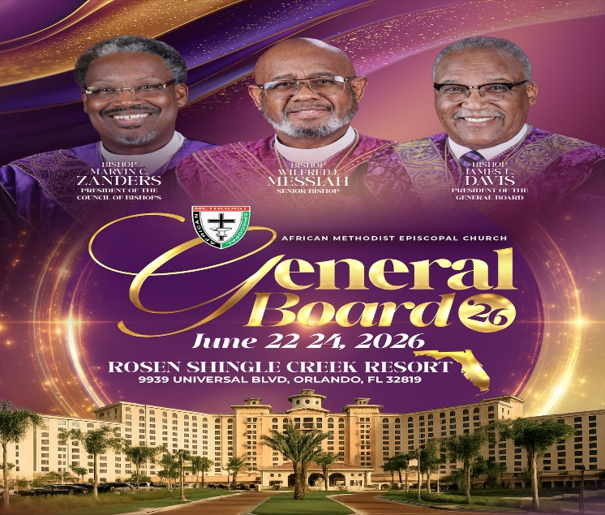

New Members’ Orientation
The presence of all new members is warmly requested at our upcoming New Members’ Orientation Classes. These sessions are designed to help you grow in faith, fellowship, and understanding of the ministry and mission of the church. We look forward to journeying together as disciples of Christ and members of the household of faith.
Orientation Schedule
Third Session: Wednesday, July 1 | 5:00 p.m.
Fourth Session: Wednesday, July 8 | 5:00 p.m.
Fifth Session: Wednesday, July 15 | 5:00 p.m.
We encourage every new member to attend faithfully as we grow together in grace, service, and spiritual maturity.

-11-

ANNOUNCEMENTS (Continued)

WEEKLY BIBLE STUDY CLASSES. Please note that the following organized spiritual development sessions will be on hiatus during the month of July and August 2026.
Pastoral Bible Studies Wednesday Prayer Meetings
Men/Women Bible Studies Senior Ministry
Let’s use this time to rejuvenate and spend quality time with our families. Classes will resume the first week of September.

VACATION BIBLE SCHOOL 2026
Registration is now open for First AME Church's Vacation Bible School, July 21–24, 2026. This year's theme is Kingdom Quest: Seeking the Great Treasure. Participants of all ages will explore the Parables of Jesus and discover valuable lessons about God's Kingdom. We are also seeking volunteer teachers, assistants, and ministry workers to help make this experience meaningful and successful. Please send your contact information to blairmathlete@att.net if you would like to attend or volunteer. Join us as we seek the greatest treasure found in the parables of Jesus Christ!

Background Check Reminder
This is a reminder that all adults aged 18 and older who work with children and youth in our church are required to complete the necessary background screening in compliance with the 5th Episcopal District requirements. Assistance is available to help ensure all volunteers and workers remain in compliance. Please contact the church office or Sis. Gina Tervalon for additional information and next steps.

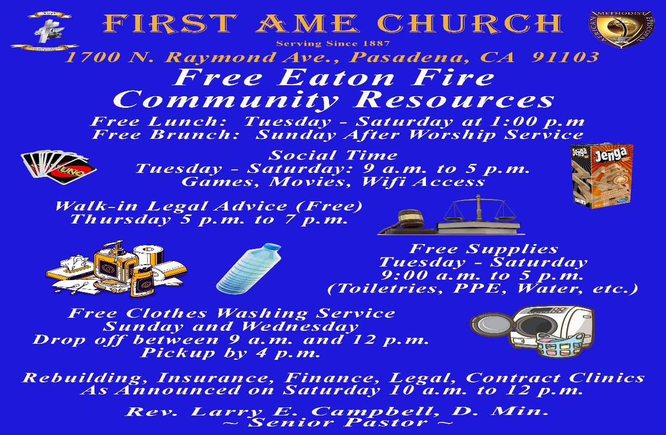-

-12-

Prayer Request(s)
Please notify the Church Office of Sick & Shut-in additions, deletions, or status/address changes.

Bishop Francine A. Brookins, Esq. Supervisor Miriam Burnett, MD
Presiding Elder Roosevelt & Dr. Kaye Lindsey Rev. Dr. Larry & Melinda Campbell
Richard Craig Hazel Clark Erica Woodard Jason Shirley Joshua Shirley Julian Shirley Ayanna Terry Cheryl Jamerson Gwendolyn Flowers Andrea Anderson Ocilda Files Danielle Clark Donita Towler Rev. Charles Brooks Doris Bailey Kimberly Woods Cynithia Grace Zechariah Robinson Diane Jordan Christopher McCarthy Wilma Haynes Calle Burns Noel Johnson Brittney Petty Taylor Family Deborah Burton Nettie McChristen Jacquelyn Walker The Caple Family
Rev. Rochelle Moore Lorene Butler Stella Pulliam Collette Blizzard
The Eaton Canyon Fire Victims Selene Cox Mel Beech

College Students

Let’s continue to support and pray for our beloved College Students

Isaiah Crowell Alecia Davis Chase Johnson Grant Blizzard

Tyler Johnson Richard Jones Tyrikk Lawson Makia Rose Talbert Isaiah Ringo Journey Rogers Elyse Sharp Kylee Sharp Zion Otano Elise Tervalon Grace Jones Jordan Patterson Kimberly Robinson Donovan Williams Jasmine Collins Brandon Bates Gabriel Blizzard

Sick and Shut-Ins
Andrew Oliver 1405 N. Roosevelt Avenue, Pasadena, CA 91104
Barbara Buchanan 616 Rio Grande St. Pasadena, CA 91104
Bettina Ayers Pasadena Meadows Nursing Home, 150 Bellefontaine St., Pas., CA 91105
Betty Betts Turner USC Keck Rehabilitation, 300 W Huntington Dr., Arcadia, CA 91007
Bobby Thomas 1052 E. Morada Place, Altadena, CA 91001
Doris Curd 11619 Woodcock Avenue, San Fernando, CA 91340
Edmund Riddle Active Care Mission Bay, 2440 Grand Avenue, San Diego, CA 92109
Eleanor Towler 975 E. Union Street, Unit #417, Pasadena, CA 91106
Elois Blizzard P. O. Box 3646, So. Pasadena, CA 91031
Emily Cormier-Ross 2549 La Fiesta Avenue, Altadena, CA 91001
Ernestine English 26 W. Fair Oaks Drive, Pasadena, CA 91103
Fred Caple 51 North 15th Street Haledon, NJ 07508
Gloria Cubit Clay 11745 Pierce St., Lake View Terrace, CA 91342
Hugh Hamberry 19225 Chole Rd., Apple Valley, CA 92307
Jeff Thomas 603 Tocino Dr. Duarte, CA 91010 | Mountain View Terrace
Jessie Smith 3925 S Jones BL, Apt 2118 Las Vegas, NV 89103| Spring Valley Community
Josephine Brown 15607 Saddleback Rd, Riverside, CA 92506
Konata Doxey Monte Vista Healthcare Center, Duarte, CA 91010
Linnie G. Nollie 2250 E. New York Drive, Altadena, CA 91001
Malika G. Hendry P. O. Box 94082, Pasadena, CA 91109
Mildred Lewis C/O Hazel Rohr, 884 W. Jane Court, Upland, CA 91786
Norma Burnett 618 Fairview Avenue, Unit #228, Arcadia, CA 91007
Opal Hampton 1030 Chevron Court, Pasadena, CA 91103
Paul Ratliff P.O. Box 40407 Pasadena, CA 91114
Virlyn Grant 15122 Orange Ave., Paramount, CA 90723
Wanda Nelson 3618 N. Fair Oaks Avenue, Altadena, CA 91001
William Hilliard 7504 Wynstone Pl., Fontana, CA 92336
Zell L. Hill 375 Barthe Drive, Pasadena, CA 91103

-13-

Sermon Notations

Scripture: _____________________________________________________________

Subject: _______________________________________________________________

Points of the Message: ___________________________________________________
_______________________________________________________________________
_______________________________________________________________________
_______________________________________________________________________
_______________________________________________________________________
_______________________________________________________________________
_______________________________________________________________________

Main Ideas of the Sermon: ________________________________________________
_______________________________________________________________________
_______________________________________________________________________
_______________________________________________________________________
_______________________________________________________________________
_______________________________________________________________________

Illustrations I want to remember: _________________________________________
_______________________________________________________________________
_______________________________________________________________________
_______________________________________________________________________
_______________________________________________________________________
_______________________________________________________________________
_______________________________________________________________________

What should I do as a result of this Sermon? ________________________________

_____________________________________________________
_____________________________________________________
_____________________________________________________
_____________________________________________________

-14-

