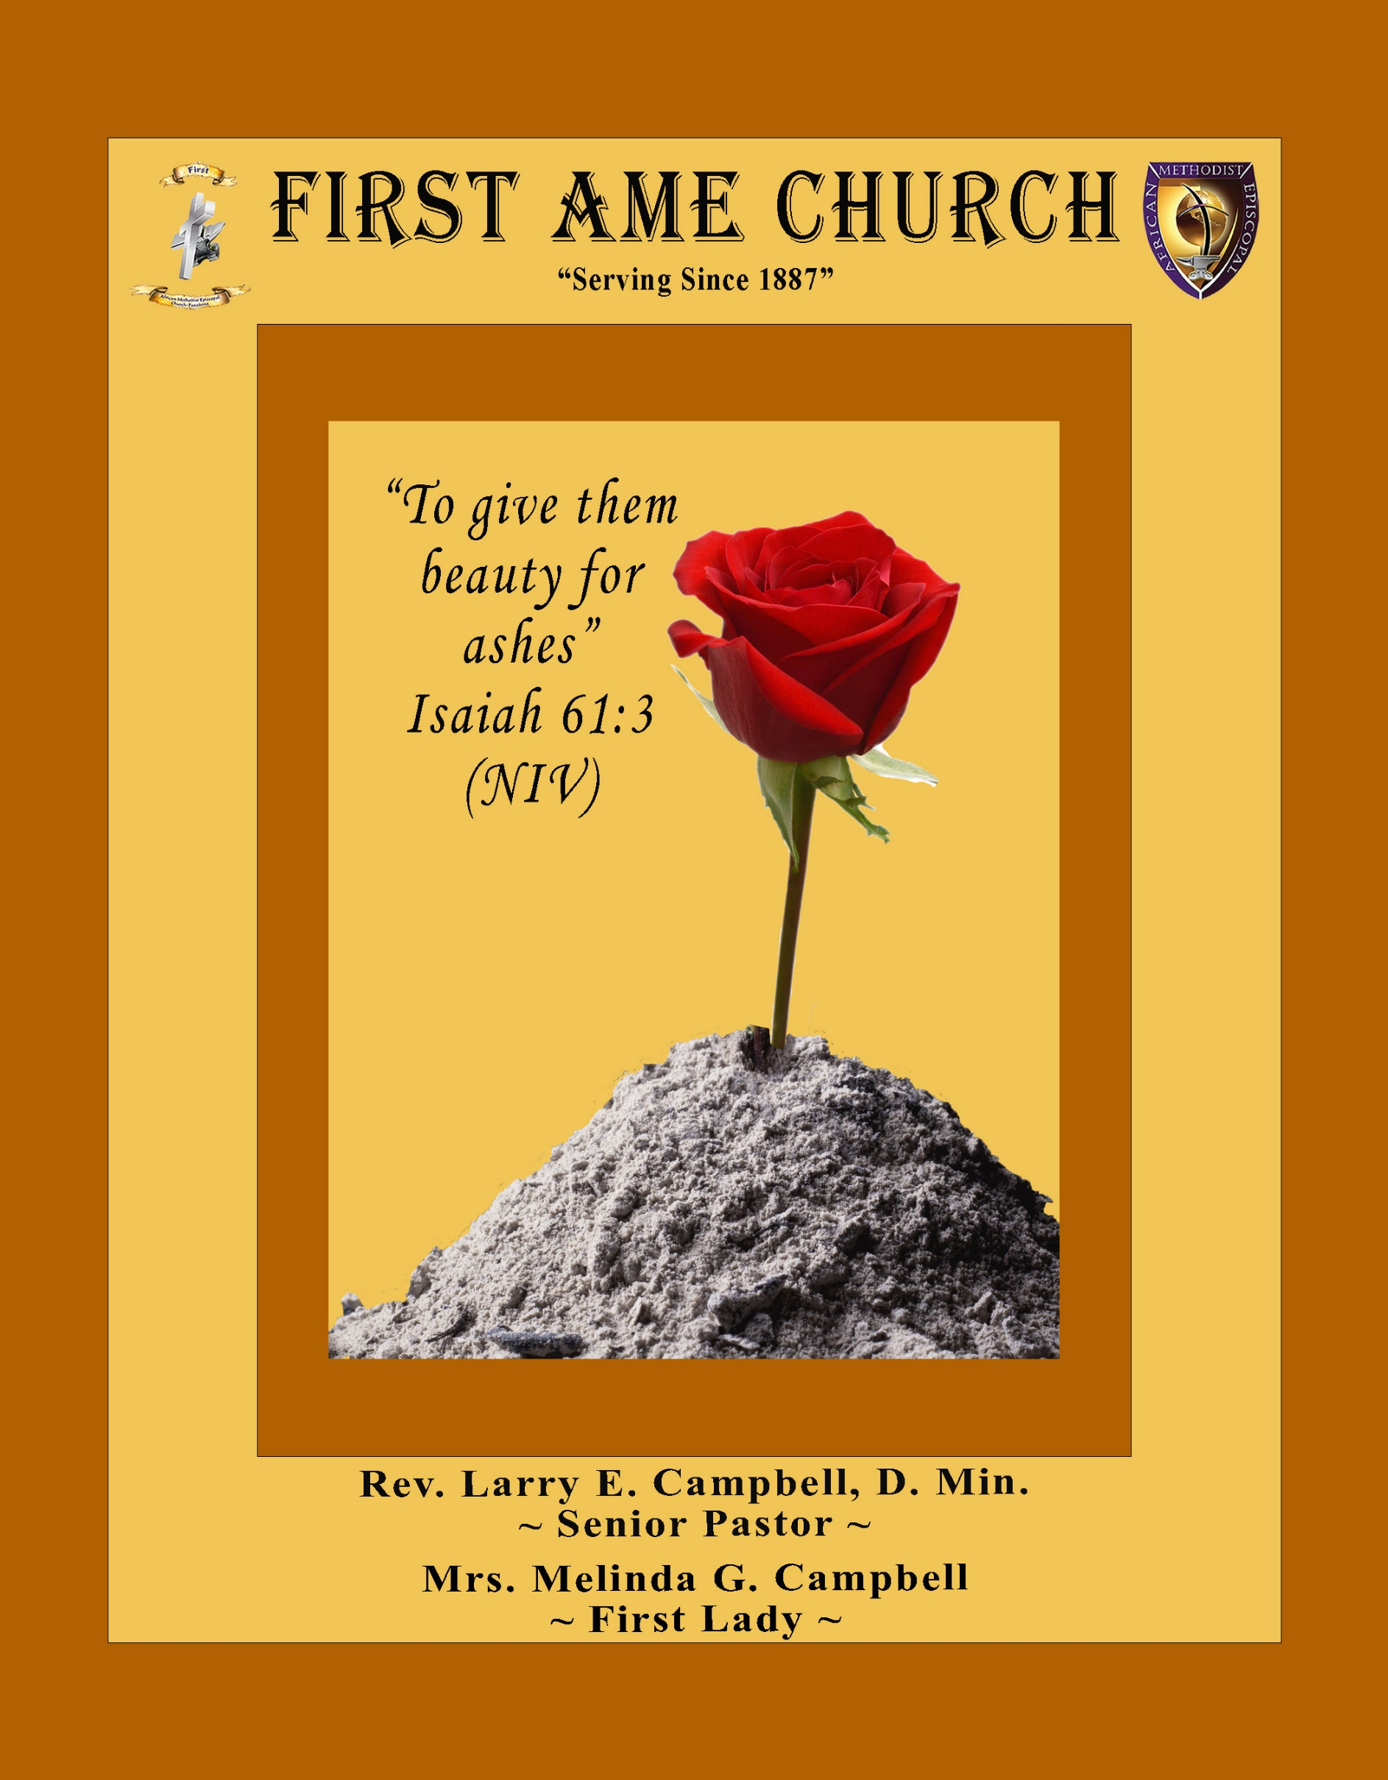
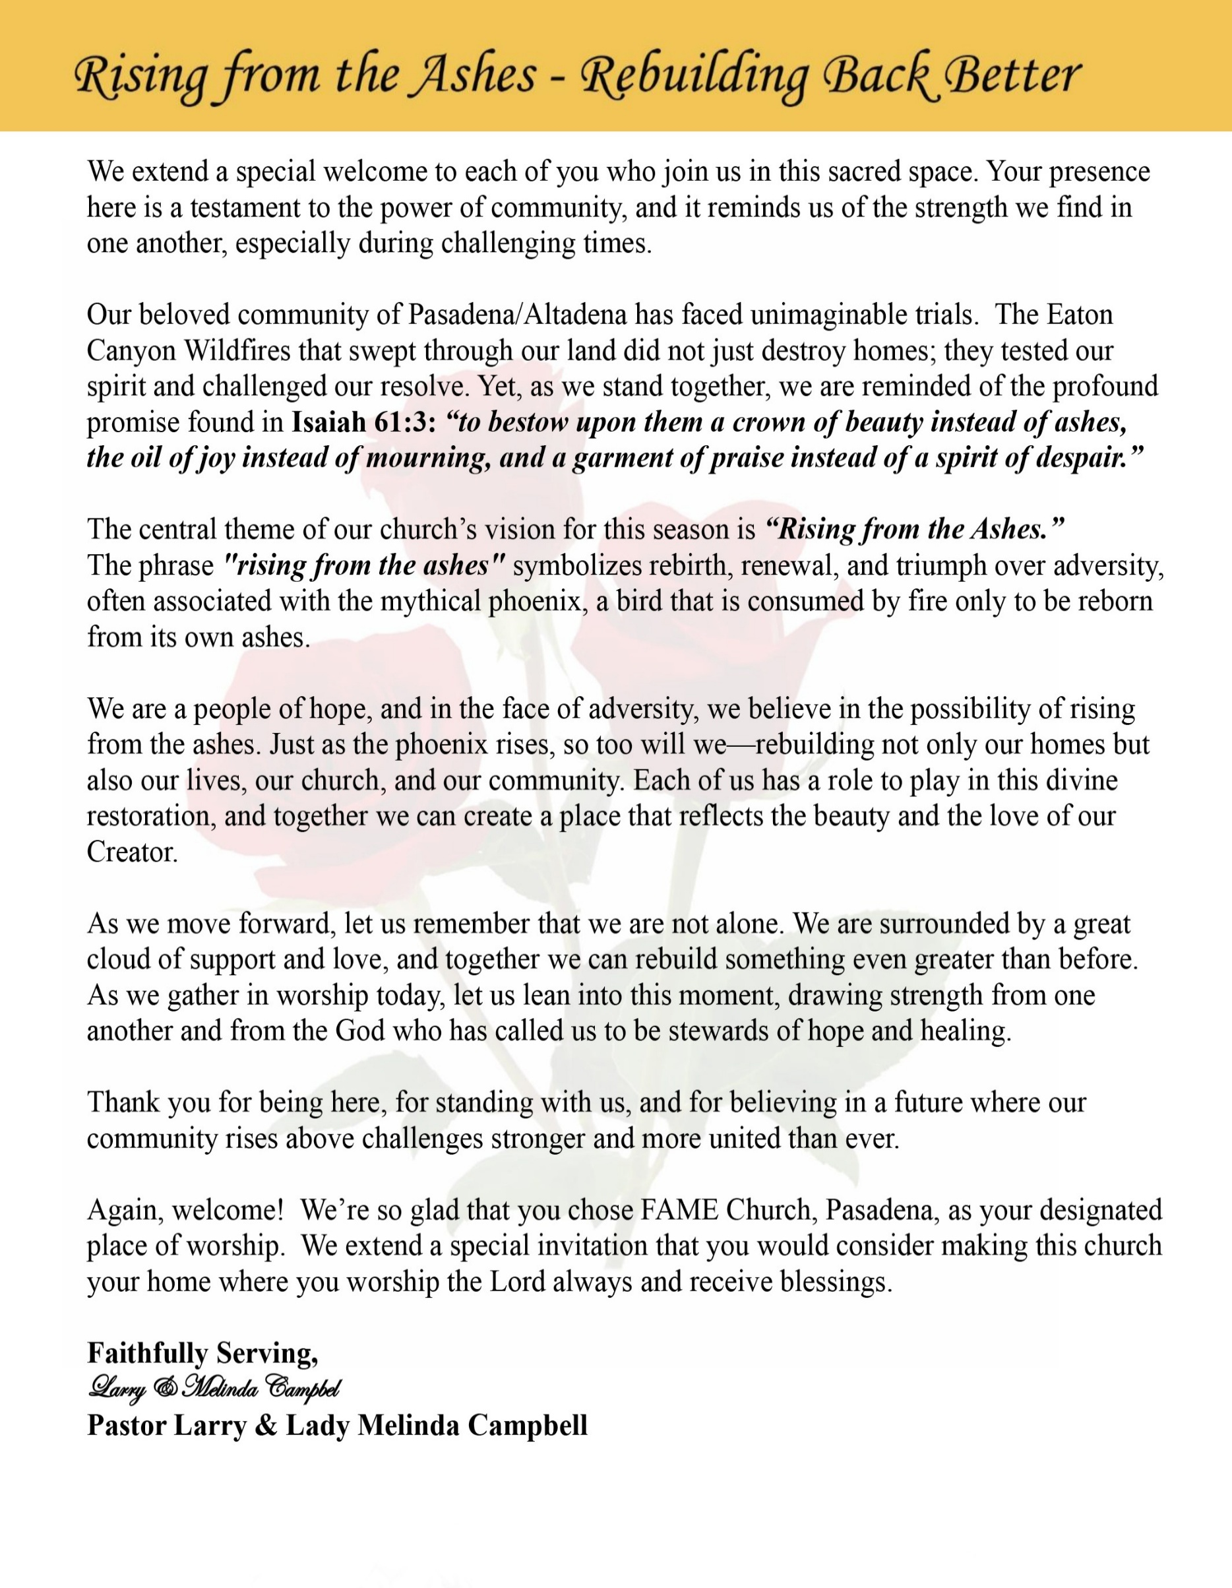

Sunday, June 28, 2026 | 9:30 a.m.

Rt. Rev. Francine A. Brookins, Esq., Presiding Bishop
Rev. Miriam Burnett, MD, MPH, Supervisor of Missions
Rev. Roosevelt Lindsey, Jr. Presiding Elder

The Rev. Dr. Larry E. Campbell ~ Senior Pastor ~ Minister

Mobile: (951) 587-1894 ~ Email: larrycampbell@famepasadena.org

Our First Lady: Mrs. Melinda G. Campbell

The Reverend Dr. Jennifer Oliver ~ Itinerant Elder -
The Reverend Dr. Nikia Smith-Robert ~ Itinerant Elder (Affiliated)
The Reverend Lois Woodard ~ Itinerant Elder Superannuated (Retired)
The Reverend Rochelle Wright Moore ~ Itinerant Deacon
The Reverend Deborah West-Jones ~ Local Elder
The Reverend Philis J. Griffin, MDiv ~ Local Elder
Dr. Phyllis Beech ~ Evangelist
Sister Tessie Bonner ~ Deaconess

Community Resource Center Director ~ Ms. Kischchen Hazelton Venerable
Church Administrative Assistant: Ms. Letha Rhymes

Church Office Hours:
Tue - Wed 9:00 am - 5:00 pm, & Fri 9:00 am -3:00 pm.
Closed for Lunch Daily: 12:00 pm - 1:00 pm.

Music Ministry
Dr. Timothy Davis, Minister of Music
Bro. Jimmy Watlington, Percussionist ~ Bro. Carlos Caldwell, Organist
Bro. Darien Dorsey, Keyboardist
Sis. Karen Law, Women’s Chorus Director ~ Sis. Tonia Graham, Children’s Choir Director
Bro. J. Renard Washington, New Generation’s Choir

FREE WI-FI service is available on the FAME Campus by accessing FAME 1700
Password: 6267980503

-3-

~ Order of Worship Experience ~

Warning: This order of worship is subject to change without warning or prior notice --- everything is governed by the Sovereignty of the Holy Spirit.

Praise & Worship

Doxology: “Praise God From Whom All Blessings Flow”

The Call to Worship Bro. Kenny McPheeters

Leader: I was glad when they said unto me, let us go into the house of the Lord, our feet shall stand within Thy gates O Jerusalem! (Psalm 122:1)

People: For a day in Thy courts is better than a thousand. I had rather be a doorkeeper in the house of my God than to dwell in the tents of wickedness. (Psalm 84:10)

Leader: Because of the house of the Lord our God, I will seek Thy good.
(Psalm 122:9)

People: Those that be planted in the house of the Lord, shall flourish in the courts of our God. (Psalm 92:13)

Leader: Blessed are they that dwell in Thy house. Lord, I have loved Thy habitation, the place where Thy honor dwelleth. (Psalm 26:8)

People: For the Lord is in His holy temple; let all the earth keep silence before Him.
(Habakkuk 2:20)

Leader: Let the words of my mouth and the meditation of my heart, be acceptable in Thy sight, O Lord my strength and my redeemer. (Psalm 19:14)

Unison: O Sing unto the Lord a new song, for He has done marvelous things. Make a
joyful noise unto the Lord, all the earth, sing His praises. (Psalm 98:1, 4)

-4-

The Hymn of Praise A.M.E. Hymnal #221
How to Reach the Masses
(Lift Him Up)
Words: Johnson Oatman, Jr., 1856-1926

How to reach the masses those of every birth,
For an answer Jesus gave the key;
“And I, if I be lifted up from the earth,
Will draw all men unto me.”

Refrain
Lift Him up (Lift the precious Savior up,)
Lift Him up (Lift the precious Savior up,)
Still He speaks from eternity:
“And I, if I be lifted up from the earth,
Will draw all men unto Me.”

Oh! the world is hungry for the Living Bread.
Lift the Savior up for them to see;
Trust Him and do not doubt the words that He said,
“I’ll draw all men unto Me.”

Refrain

Don’t exalt the preacher, don’t exalt the pew,
Preach the gospel simple full and free;
Prove Him and you will find that promise is true,
I’ll draw all men unto Me.”

Refrain

Lift Him up by living as a Christian ought,
Let the world in you the Savior see;
Then all will gladly follow Him who once taught,
“I’ll draw all men unto Me.”

Refrain

The Invocation Bro. Versie Gaddis
Ministry of Music The Male Chorus

-5-

Scriptural Litany of Christian Discipleship Bro. Costello Brown

Leader: Jesus said, "If anyone would come after Me, let him deny himself, take up his cross
daily, and follow Me." (Luke 9:23)

People: Lord Jesus, we choose to follow You with our whole hearts.

Leader: "Love the Lord your God with all your heart, with all your soul, and with all your
strength." (Deuteronomy 6:5)

People: Teach us to love You above all else and to walk faithfully in Your ways.

Leader: "This Book of the Law shall not depart from your mouth, but you shall meditate on it day
and night." (Joshua 1:8)

People: May Your Word be our guide, our wisdom, and our daily bread.

Leader: "Your word I have hidden in my heart, that I might not sin against You." (Psalm 119:11)

People: Write Your truth upon our hearts and shape us into faithful disciples.

Leader: Jesus said, "Abide in Me, and I in you... for without Me you can do nothing."
(John 15:4-5)

People: Help us remain connected to Christ, the True Vine, that our lives may bear lasting
fruit.

Leader: "By this everyone will know that you are My disciples, if you love one another."
(John 13:35)

People: May our faith be seen not only in our words but also in our actions.

Leader: "Trust in the Lord with all your heart and lean not on your own understanding."
(Proverbs 3:5-6)

People: Guide our steps, direct our paths, and strengthen our faith.

Leader: Jesus declared, "Go therefore and make disciples of all nations." (Matthew 28:19-20)

People: Send us into our homes, neighborhoods, schools, workplaces, and communities as
faithful witnesses of Jesus Christ.

Leader: The Apostle Paul reminds us, "The things you have heard from me... entrust to faithful
people who will be able to teach others also." (2 Timothy 2:2)

Unison: Gracious God, thank You for calling us to be disciples of Jesus Christ. Strengthen us
by Your Holy Spirit to love You with all our hearts, to follow Christ with unwavering
devotion, to serve others with humility, and to share the Good News with boldness.
Make us faithful learners of Your Word, joyful servants of Your Kingdom, and
living witnesses of Your grace. May our lives point others to Jesus Christ, in whose
name we pray. Amen.

-6-

The Summary of the Decalogue Bro. Adrian Panton

LEADER: From all that dwell below the skies…
SUNG: From all that dwell below the skies, Let the Creator’s praise arise; Let the
Redeemer’s Name be sung, through every land, by every tongue.
LEADER: Hear what Christ our Savior saith, Thou shalt love the Lord thy God with all thy
heart, with all thy soul, and with all thy mind. This is the first and great
commandment. And the second is like unto it: Thou shalt love thy neighbor
as thyself. On these two commandments hang all the law and the prophets.
SUNG: Glory be to the Father, and to the Son, and to the Holy Ghost; as it was in
the beginning, is now, and ever shall be, world without end. A~Men

Abbreviated Announcements / Welcome Dr. Brian K. Venerable

Special Congregational Hymn (Sing along)
Hymn #450 — Blessed Assurance”

The Offertory (Tithes ~ Gifts ~ Benevolent Offerings) Bro. Ray Bolton, Steward

The following Electronic GIVING Platforms are creditable methods to GIVE to FAME:

#1. GIVELIFY - Mobile Giving App available on the App Store. It’s easy to set up, just follow the guidelines.

#2. Cash App: $FirstAMEPASADENA

#3. Mail in your Tithes & Offering - If you would like to mail your tithes and offering by check or money order, please send it to: First AME Church, 1700 N. Raymond Avenue, Pasadena, CA 91103.

#4. Drop off your Tithes & Offering - During business hours in the basket outside of the office.

Choral Response: “All things come of Thee, O Lord; and of Thine own have we given Thee. Amen.”

-7-

Introduction of Guest Preacher Kischchen A. Hazelton Venerable-Steward Protem

Sermonic Selection The Male Chorus

The Preached Word The Reverend John E. Cager, III
Presiding Elder – Midwest North District – Midwest Conference – Fifth Episcopal District

The Invitation (Public/Private)

How to Join First A.M.E. Church of Pasadena
PROFESSION OF FAITH. If you have never been a member of any church, you may join by professing Jesus Christ as your personal Lord and Savior.

RENEWAL OF VOWS. If you have been a member of a church at one time, but have been in active, you may join by renewing your faith in Jesus Christ as Lord and Savior.

TRANSFER. If you are a member of another African Methodist Episcopal Church and you are in good standing, you may join by requesting that your membership be transferred to the First African Methodist Episcopal Church of Pasadena.

AFFILIATE MEMBER. Sometimes an individual has reasons for keeping /his/her membership in another church but would like to be an active member of First African Methodist Episcopal Church, too. This is possible as an affiliate member.

The Doxology

The Benediction

-8-

Scripture of the Day
Christian Discipleship. "Go therefore and make disciples of all the nations, baptizing them in the name of the Father and of the Son and of the Holy Spirit, ²⁰ teaching them to observe all things that I have commanded you; and lo, I am with you always, even to the end of the age. Amen Matthew 28:19-20

Quote of the Day
""Discipleship is the process of becoming who Jesus would be if He were you."
Dallas Williard
Thought of the Week
"Then Jesus said to His disciples, 'Whoever wants to be My disciple must deny themselves and take up their cross daily and follow Me.'" — Luke 9:23 (NIV)
Christian discipleship is more than believing in Jesus—it is becoming like Jesus. It is a daily commitment to walk in His footsteps, obey His Word, and reflect His love in a world that desperately needs His light. Jesus never promised that following Him would be easy, but He did promise that it would be worth it.
A disciple is not merely a church attendee or a hearer of God's Word; a disciple is a learner, a follower, and a servant who seeks to honor Christ in every area of life. True discipleship is demonstrated not only in worship on Sunday but also in how we live on Monday—through our attitudes, our relationships, our service, our forgiveness, and our witness.
As we grow in Christ, we become living examples of His grace. Our homes become places of faith, our workplaces become fields for ministry, and our communities become opportunities to share the hope of the Gospel. Jesus' final command was not simply to make converts but to "make disciples" (Matthew 28:19), reminding us that every believer is called to grow spiritually and help others do the same.
Today, let us renew our commitment to follow Jesus with our whole hearts. May our lives reflect His character, our words proclaim His truth, and our actions reveal His love. For the greatest testimony of a disciple is a life that points others to Christ.

Humor of the Week
One day, a little girl is sitting and watching her mother do the dishes at the kitchen sink. She suddenly notices that her mother has several strands of white hair sticking out in contrast to her brunette hair. She looks at her mother and inquisitively asks: “Why are some of your hairs white, Mum?”
Her mother replied: “Well, every time that you do something wrong and make me cry or unhappy, one of my hairs turns white.”
The little girl thought about this revelation for a while and then asked: “Mumma, how come all of grandma’s hairs are white?”
HOME DAILY BIBLE READINGS
June 29, 2026 – July 5, 2026 (Week 41, Colossians)
Monday Day 281 John 8:1-59, Psalm 117
Tuesday Day 282 John 9:1-41, Psalm 118:1-7
Wednesday Day 283 John 10:1-42, Psalm 118:8-14
Thursday Day 284 John 11-13, Psalm 118:15-21
Friday Day 285 John 14-15, Psalm 118:22-29
Saturday Day 286 John 16-17, Psalm 119:1-32
Sunday Day 287 John 18-21, Psalm 119:33-64

-9-

ANNOUNCEMENTS

BEREAVEMENT NOTICE

Dear Church Family,
"For we know that if our earthly house of this tabernacle were dissolved, we have a building of God, a house not made with hands, eternal in the heavens." — 2 Corinthians 5:1 (KJV)

With heartfelt sorrow, we share the passing of Sister Gloria Clay Cubit, a beloved and faithful member of the First African Methodist Episcopal Church family.

Sister Gloria served the Lord and His Church with unwavering dedication for many years. She faithfully served as Church School Superintendent, Church School Teacher, and Vacation Bible School Coordinator, helping to nurture generations of children, youth, and adults in the knowledge and love of Jesus Christ. Her faithful service, gentle spirit, and steadfast commitment to Christian education have left an enduring legacy in the life of our congregation.

While our hearts are saddened by her passing, we rejoice in the blessed assurance that she is now at rest in the presence of the Lord.

We ask the entire FAME Church Family to keep the Clay and Cubit families in your prayers during this difficult season of bereavement. May God's comforting presence surround them with His peace, strength, and abiding love.

20/20 (14.0)
The 20/20 initiative is a Church-wide fundraising project managed by Stewards. This project was established to assist with our Annual Connectional Budget. Financial gifts donated through the 20/20 initiative are added to our collected conference claims and assist greatly in meeting the first and second half of our Connectional Budgetary obligations. The Steward Board is requesting 150 participants for the conference year 2025-2026. The first half of our budget is due in February 2026. In addition to the 18 officers and we are asking 132 people to give 20 dollars per week for 20 weeks in addition to your regular tithes, gifts and offerings. Please mark your envelopes 20/20 and allocate $20.00. Our goal is to raise $60,000. Again, this will satisfy all budgetary needs on the conference level without utilizing any operational funds. Please see or contact any Steward to participate; we are looking forward to your commitment.

-10-

ANNOUNCEMENTS (Continued)

New Members’ Orientation
The presence of all new members is warmly requested at our upcoming New Members’ Orientation Classes. These sessions are designed to help you grow in faith, fellowship, and understanding of the ministry and mission of the church. We look forward to journeying together as disciples of Christ and members of the household of faith.
Orientation Schedule
Third Session: Wednesday, July 1 | 5:00 p.m.
Fourth Session: Wednesday, July 8 | 5:00 p.m.
Fifth Session: Wednesday, July 15 | 5:00 p.m.
We encourage every new member to attend faithfully as we grow together in grace, service, and spiritual maturity.

VACATION BIBLE SCHOOL 2026
Registration is now open for First AME Church's Vacation Bible School, July 21–24, 2026. This year's theme is Kingdom Quest: Seeking the Great Treasure. Participants of all ages will explore the Parables of Jesus and discover valuable lessons about God's Kingdom. We are also seeking volunteer teachers, assistants, and ministry workers to help make this experience meaningful and successful. Please send your contact information to the following registration sites if you would like to attend or volunteer.
VBS Student Registration: https://forms.gle/BVbm6phYvBCdheYa7
VBS Volunteer Registration: https://forms.gle/dQrZA41dMnR7xJ3E9
Join us as we seek the greatest treasure found in the parables of Jesus Christ!

Background Check Reminder
This is a reminder that all adults aged 18 and older who work with children and youth in our church are required to complete the necessary background screening in compliance with the 5th Episcopal District requirements. Assistance is available to help ensure all volunteers and workers remain in compliance. Please contact the church office or Sis. Gina Tervalon for additional information and next steps.

WEEKLY BIBLE STUDY CLASSES.
Please note that the following organized spiritual development sessions will be on hiatus during the months of July and August 2026.
Pastoral Bible Studies
Wednesday Prayer Meetings
Men/Women Bible Studies
Senior Ministry
Let’s use this time to rejuvenate and spend quality time with our families. Classes will resume in the first week of September.

-11-

ANNOUNCEMENTS (Continued)

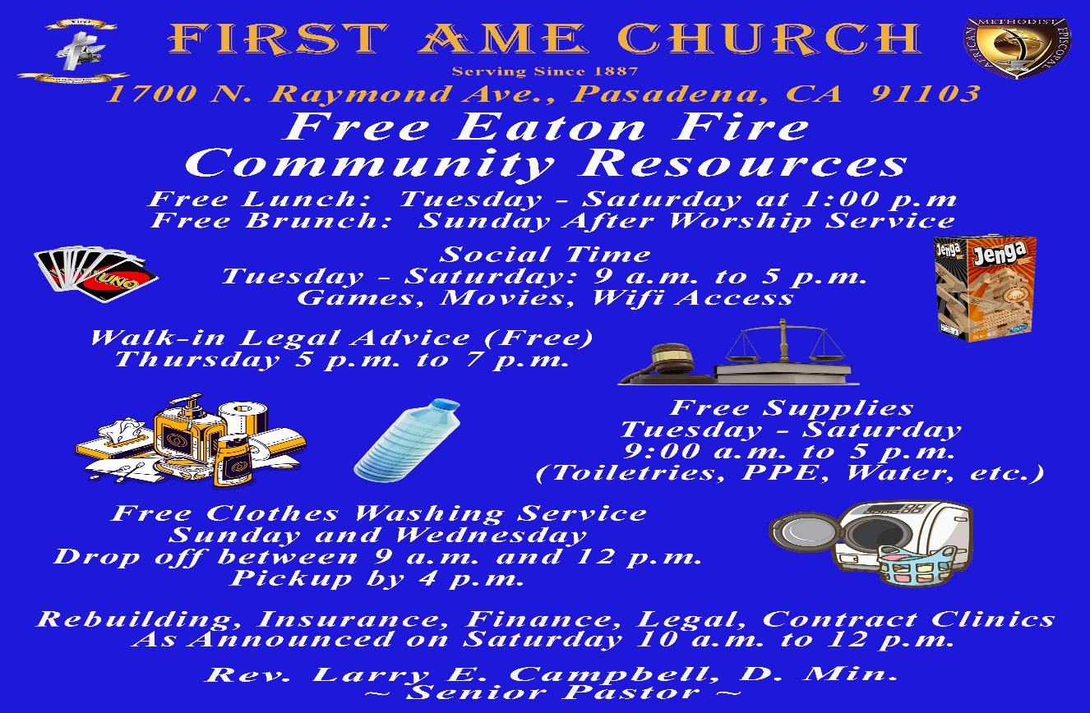-

-12-

Prayer Request(s)
Please notify the Church Office of Sick & Shut-in additions, deletions, or status/address changes.

Bishop Francine A. Brookins, Esq. Supervisor Miriam Burnett, MD
Presiding Elder Roosevelt & Dr. Kaye Lindsey Rev. Dr. Larry & Melinda Campbell
Richard Craig Hazel Clark Erica Woodard Jason Shirley Joshua Shirley Julian Shirley Ayanna Terry Cheryl Jamerson Gwendolyn Flowers Andrea Anderson Ocilda Files Danielle Clark Donita Towler Rev. Charles Brooks Doris Bailey Kimberly Woods Cynithia Grace Zechariah Robinson Diane Jordan Christopher McCarthy Wilma Haynes Calle Burns Noel Johnson Brittney Petty Taylor Family Deborah Burton Nettie McChristen Jacquelyn Walker The Caple Family
Rev. Rochelle Moore Lorene Butler Stella Pulliam Collette Blizzard
The Eaton Canyon Fire Victims Selene Cox Mel Beech

College Students

Let’s continue to support and pray for our beloved College Students

Isaiah Crowell Alecia Davis Chase Johnson Grant Blizzard

Tyler Johnson Richard Jones Tyrikk Lawson Makia Rose Talbert Isaiah Ringo Journey Rogers Elyse Sharp Kylee Sharp Zion Otano Elise Tervalon Grace Jones Jordan Patterson Kimberly Robinson Donovan Williams Jasmine Collins Brandon Bates Gabriel Blizzard

Sick and Shut-Ins
Andrew Oliver 1405 N. Roosevelt Avenue, Pasadena, CA 91104
Barbara Buchanan 616 Rio Grande St. Pasadena, CA 91104
Bettina Ayers Pasadena Meadows Nursing Home, 150 Bellefontaine St., Pas., CA 91105
Betty Betts Turner USC Keck Rehabilitation, 300 W Huntington Dr., Arcadia, CA 91007
Bobby Thomas 1052 E. Morada Place, Altadena, CA 91001
Doris Curd 11619 Woodcock Avenue, San Fernando, CA 91340
Edmund Riddle Active Care Mission Bay, 2440 Grand Avenue, San Diego, CA 92109
Eleanor Towler 975 E. Union Street, Unit #417, Pasadena, CA 91106
Elois Blizzard P. O. Box 3646, So. Pasadena, CA 91031
Emily Cormier-Ross 2549 La Fiesta Avenue, Altadena, CA 91001
Ernestine English 26 W. Fair Oaks Drive, Pasadena, CA 91103
Fred Caple 51 North 15th Street Haledon, NJ 07508
Hugh Hamberry 19225 Chole Rd., Apple Valley, CA 92307
Jeff Thomas 603 Tocino Dr. Duarte, CA 91010 | Mountain View Terrace
Jessie Smith 3925 S Jones BL, Apt 2118 Las Vegas, NV 89103| Spring Valley Community
Josephine Brown 15607 Saddleback Rd, Riverside, CA 92506
Konata Doxey South Pasadena Care Center, 904 Mission St. South Pasadena 91030
Linnie G. Nollie 2250 E. New York Drive, Altadena, CA 91001
Malika G. Hendry P. O. Box 94082, Pasadena, CA 91109
Mildred Lewis C/O Hazel Rohr, 884 W. Jane Court, Upland, CA 91786
Norma Burnett 618 Fairview Avenue, Unit #228, Arcadia, CA 91007
Opal Hampton 1030 Chevron Court, Pasadena, CA 91103
Paul Ratliff P.O. Box 40407 Pasadena, CA 91114
Virlyn Grant 15122 Orange Ave., Paramount, CA 90723
Wanda Nelson 3618 N. Fair Oaks Avenue, Altadena, CA 91001
William Hilliard 7504 Wynstone Pl., Fontana, CA 92336
Zell L. Hill 375 Barthe Drive, Pasadena, CA 91103

-13-

Sermon Notations

Scripture: _____________________________________________________________

Subject: _______________________________________________________________

Points of the Message: ___________________________________________________
_______________________________________________________________________
_______________________________________________________________________
_______________________________________________________________________
_______________________________________________________________________
_______________________________________________________________________
_______________________________________________________________________

Main Ideas of the Sermon: ________________________________________________
_______________________________________________________________________
_______________________________________________________________________
_______________________________________________________________________
_______________________________________________________________________
_______________________________________________________________________

Illustrations I want to remember: _________________________________________
_______________________________________________________________________
_______________________________________________________________________
_______________________________________________________________________
_______________________________________________________________________
_______________________________________________________________________
_______________________________________________________________________

What should I do as a result of this Sermon? ________________________________

_____________________________________________________
_____________________________________________________
_____________________________________________________
_____________________________________________________

-14-

