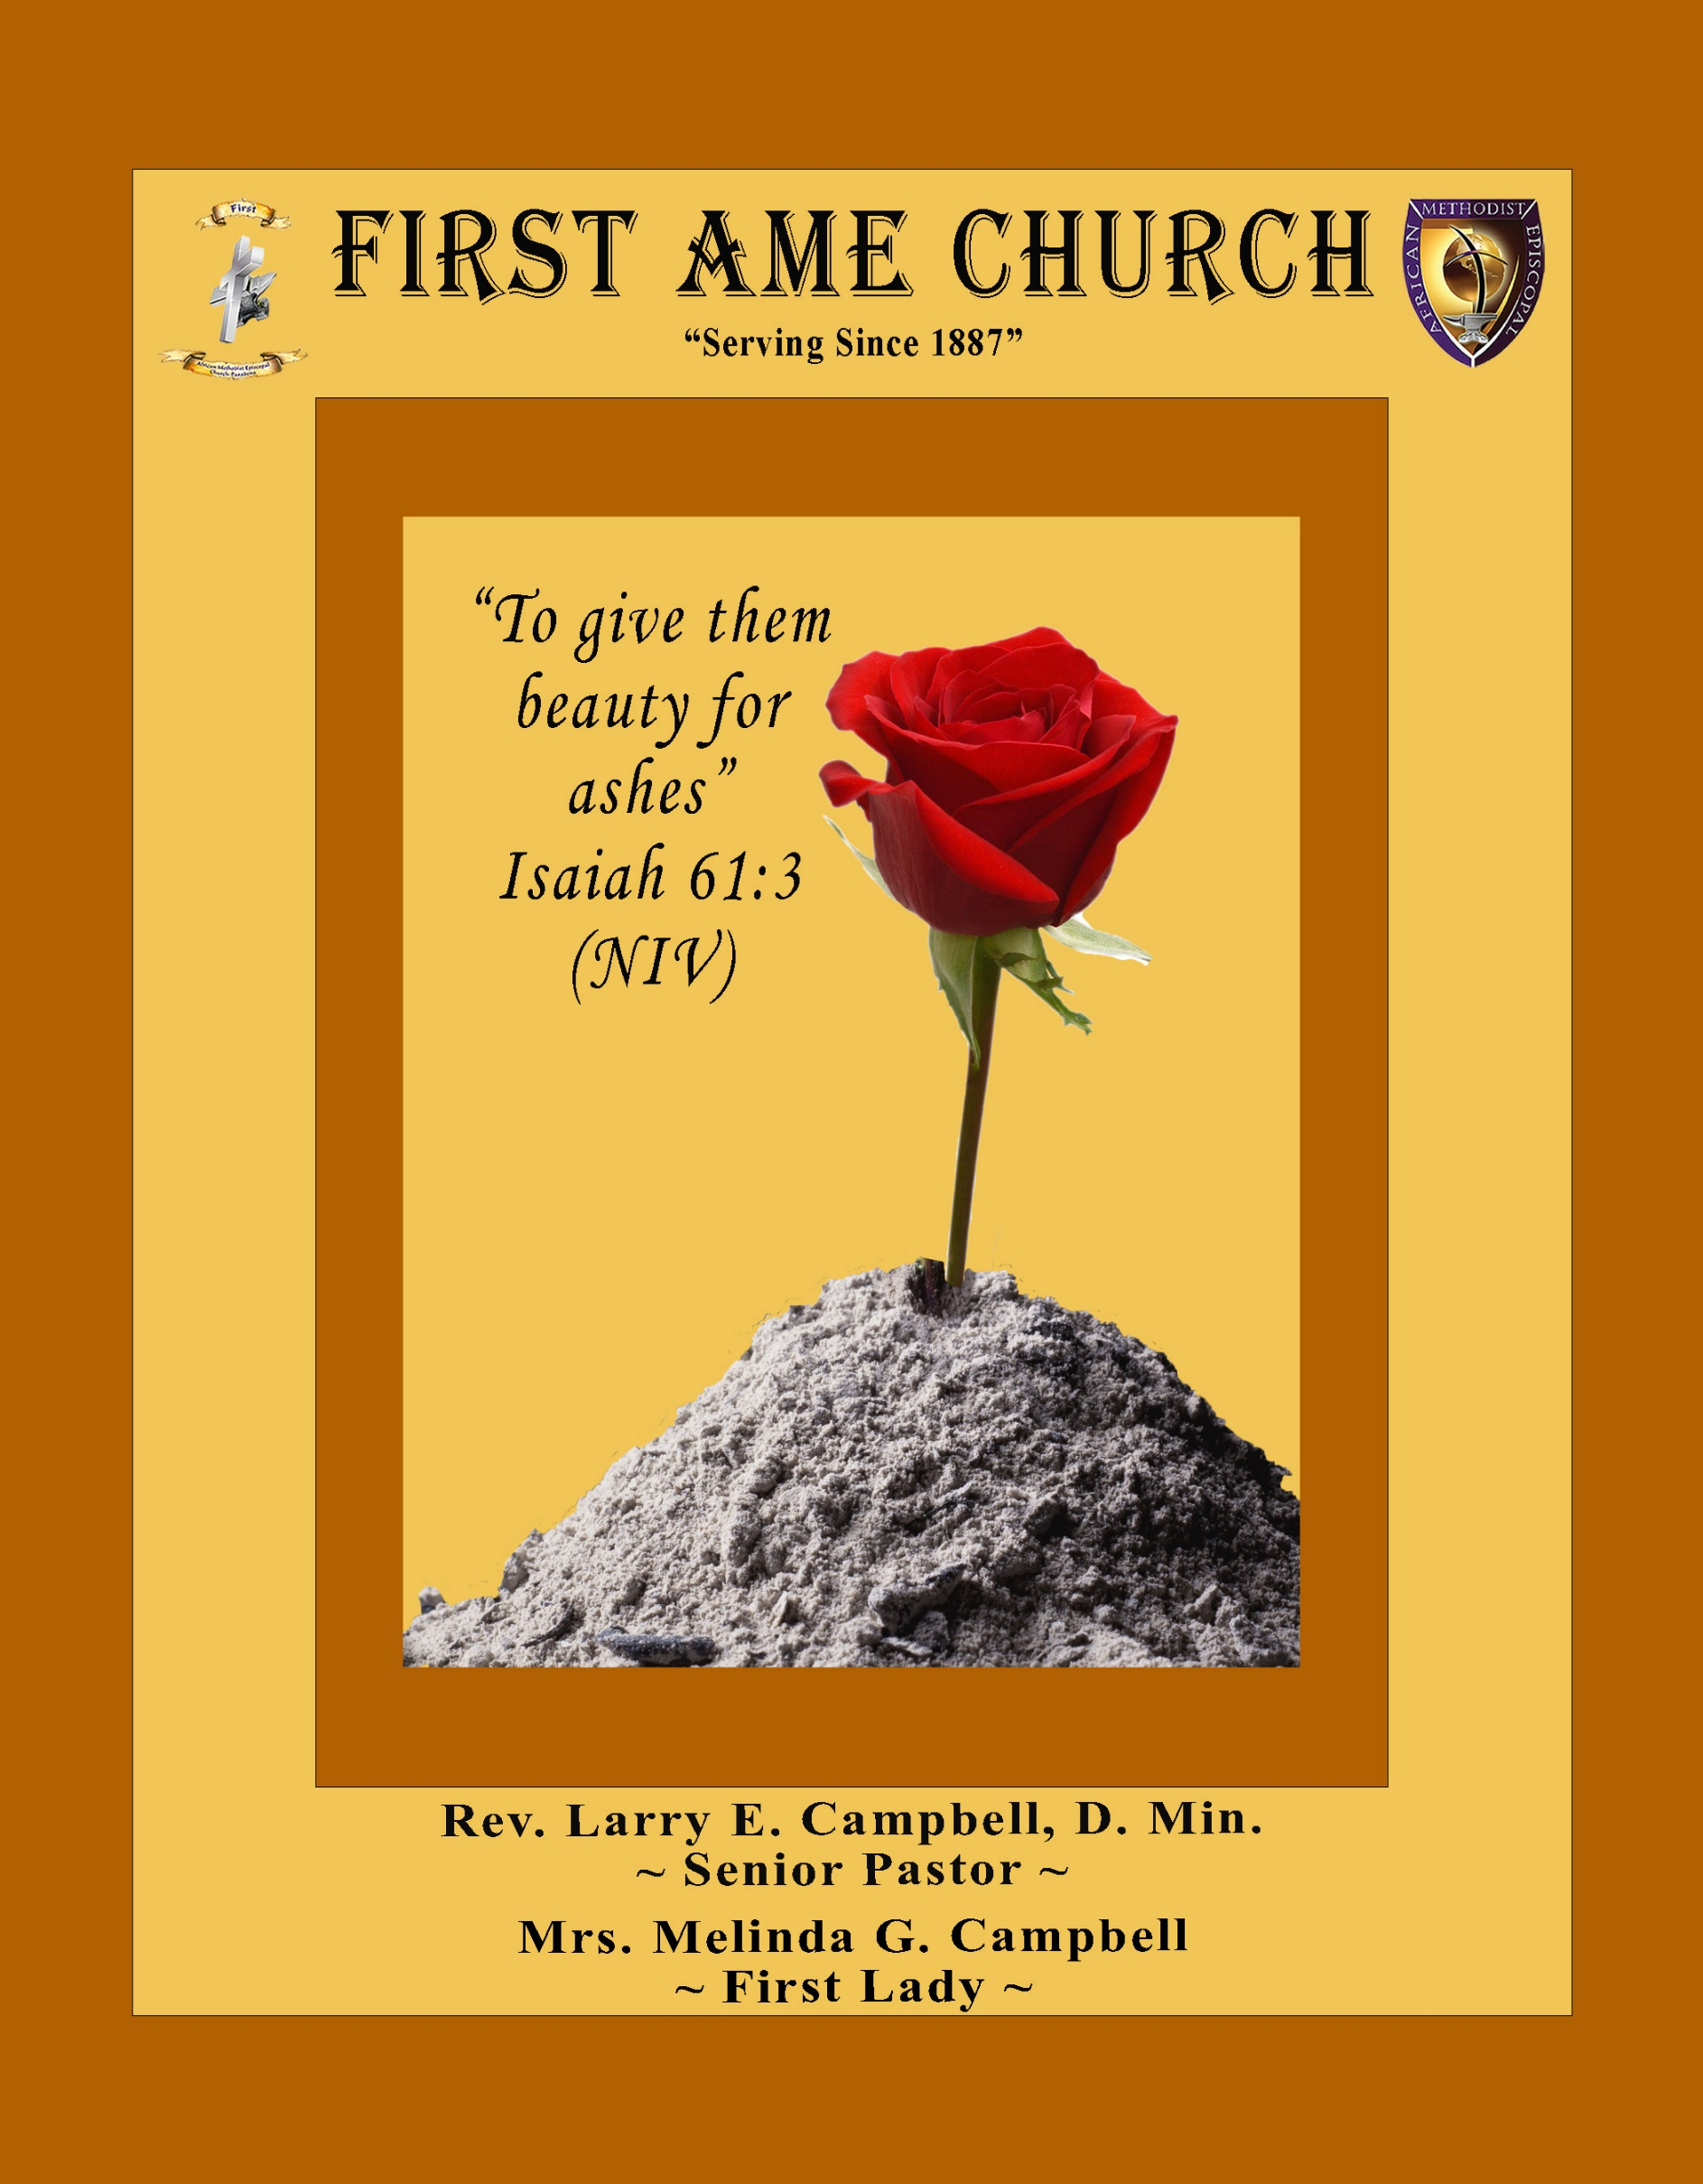
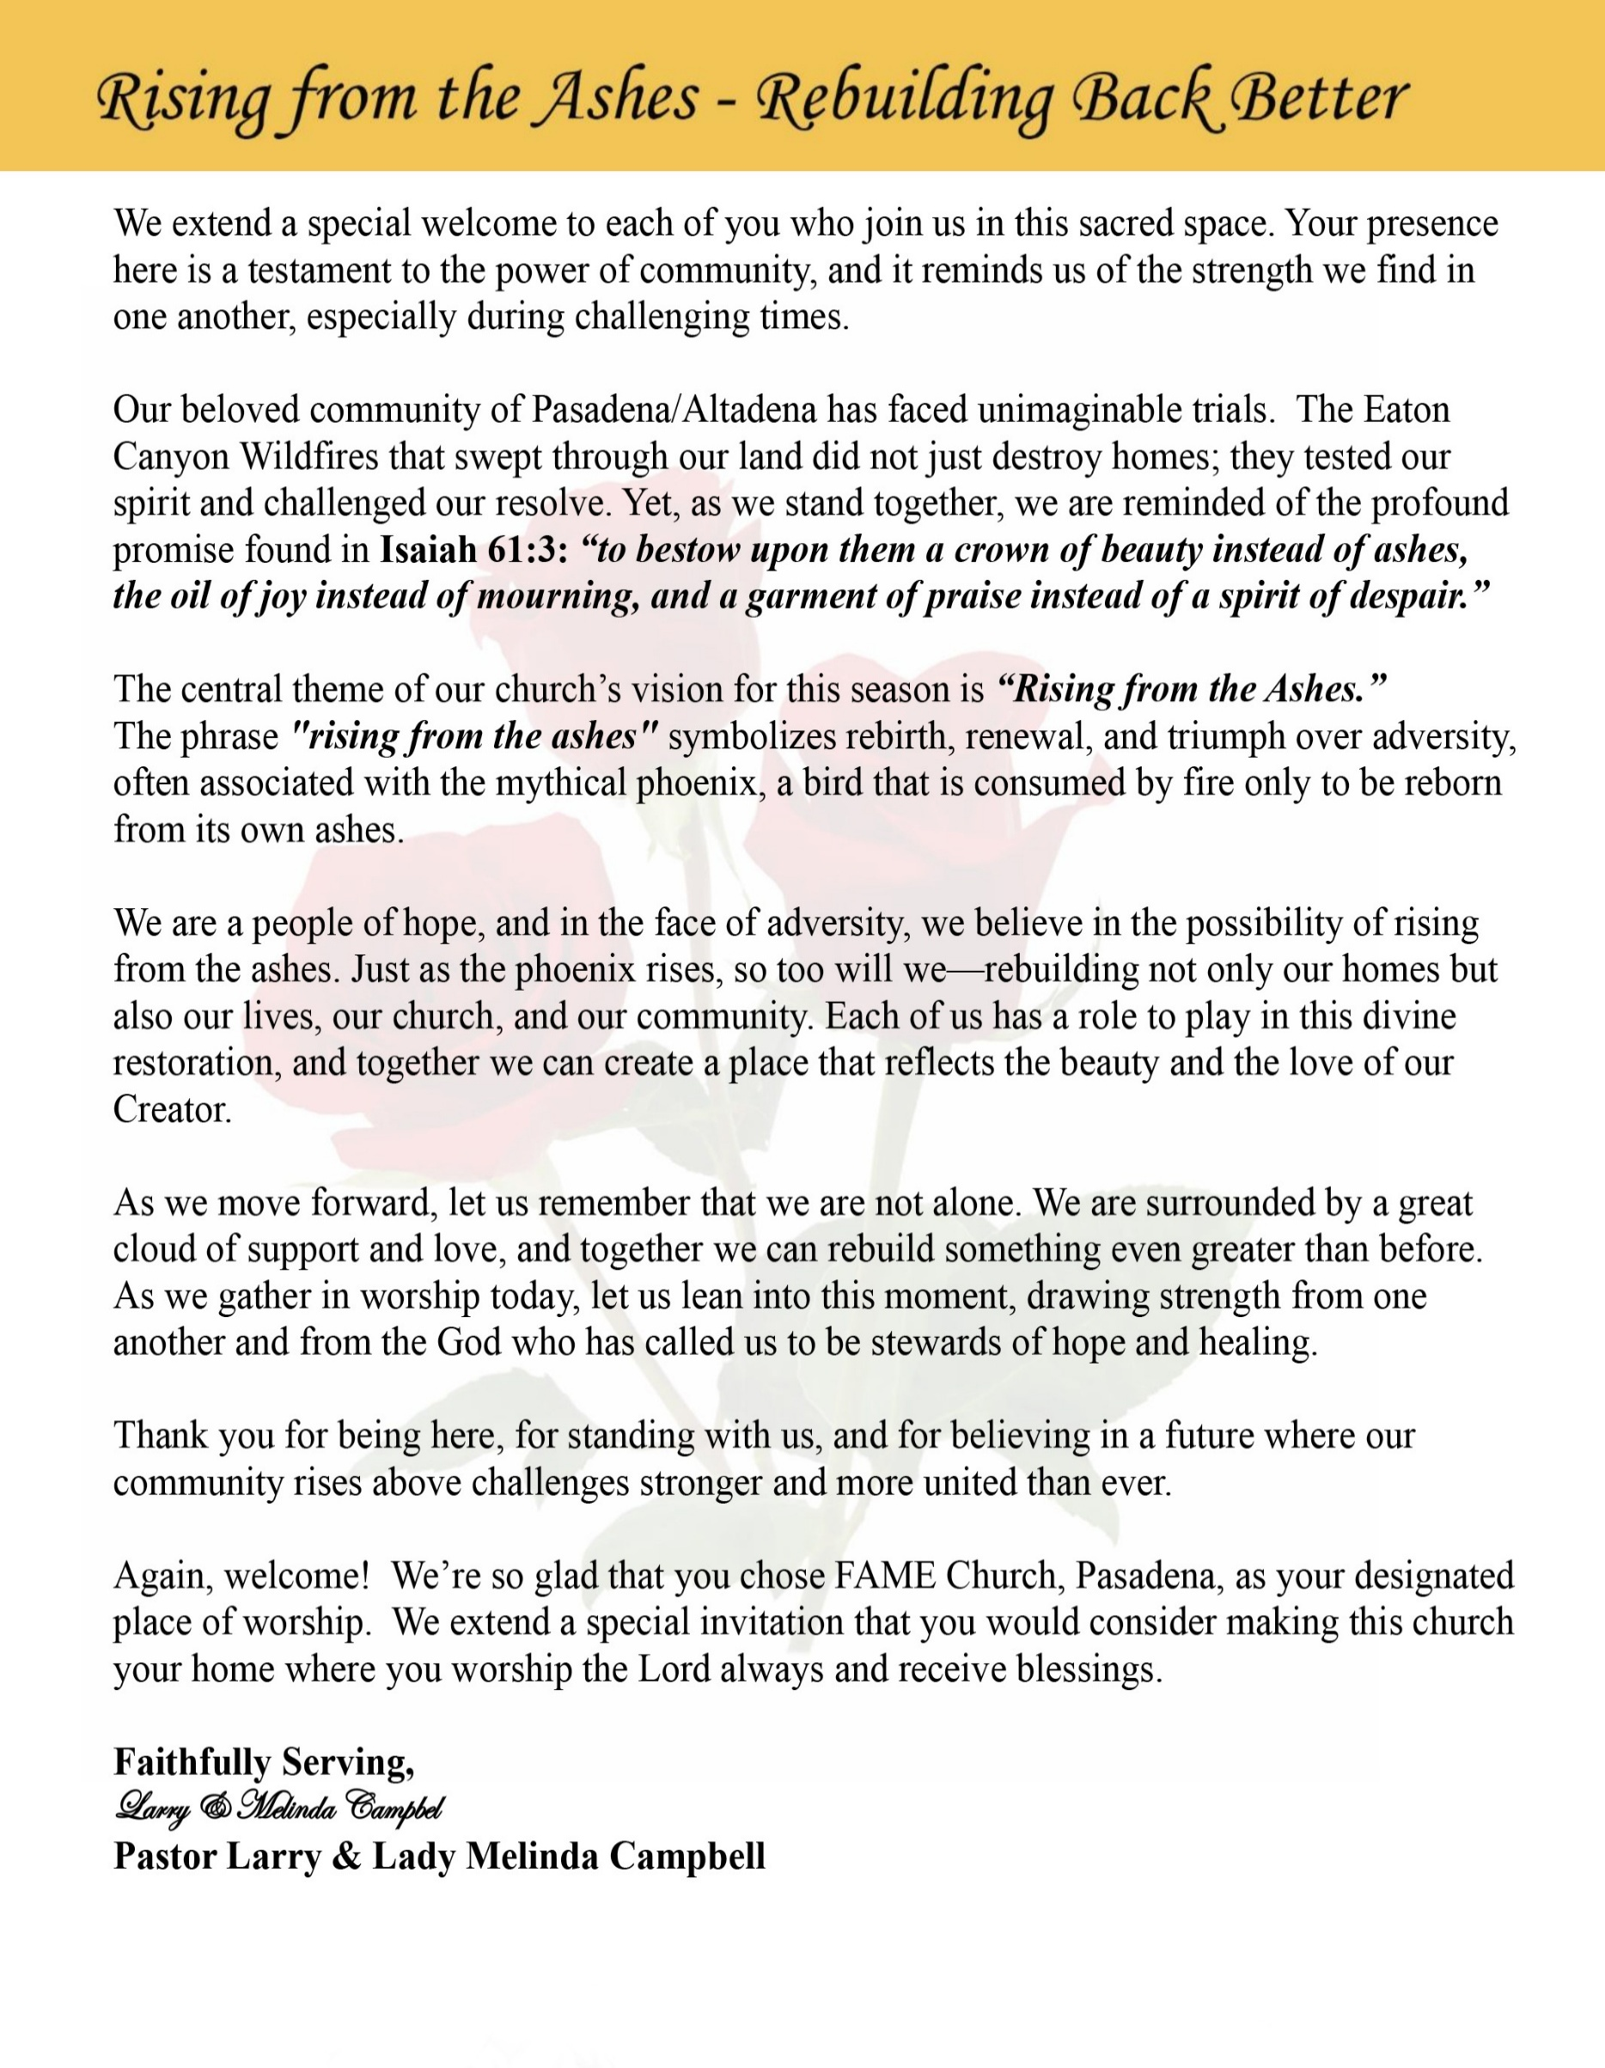

Sunday, June 7 , 2026 | 9:30 a.m.

Rt. Rev. Francine A. Brookins, Esq., Presiding Bishop
Rev. Miriam Burnett, MD, MPH, Supervisor of Missions
Rev. Roosevelt Lindsey, Jr. Presiding Elder

The Rev. Dr. Larry E. Campbell ~ Senior Pastor ~ Minister

Mobile: (951) 587-1894 ~ Email: larrycampbell@famepasadena.org

Our First Lady: Mrs. Melinda G. Campbell

The Reverend Dr. Jennifer Oliver ~ Itinerant Elder -
The Reverend Dr. Nikia Smith-Robert ~ Itinerant Elder (Affiliated)
The Reverend Lois Woodard ~ Itinerant Elder Superannuated (Retired)
The Reverend Rochelle Wright Moore ~ Itinerant Deacon
The Reverend Deborah West-Jones ~ Local Elder
The Reverend Philis J. Griffin, MDiv ~ Local Elder
Dr. Phyllis Beech ~ Evangelist
Sister Tessie Bonner ~ Deaconess

Community Resource Center Director ~ Ms. Kischchen Hazelton Venerable
Church Administrative Assistant: Ms. Letha Rhymes

Church Office Hours:
Tue - Wed 9:00 am - 5:00 pm, & Fri 9:00 am -3:00 pm.
Closed for Lunch Daily: 12:00 pm - 1:00 pm.

Music Ministry
Dr. Timothy Davis, Minister of Music
Bro. Jimmy Watlington, Percussionist ~ Bro. Carlos Caldwell, Organist
Bro. Darien Dorsey, Keyboardist
Sis. Karen Law, Women’s Chorus Director ~ Sis. Tonia Graham, Children’s Choir Director
Bro. J. Renard Washington, New Generation’s Choir

FREE WI-FI service is available on the FAME Campus by accessing FAME 1700
Password: 6267980503

-3-

~ Order of Worship Experience ~



+++ The Altar Call +++
Praise & Worship

Doxology: “Praise God From Whom All Blessings Flow”

The Call to Worship Pastor Larry E. Campbell

Leader: I was glad when they said unto me, let us go into the house of the Lord, our feet shall stand within Thy gates O Jerusalem! (Psalm 122:1)

People: For a day in Thy courts is better than a thousand. I had rather be a doorkeeper in the house of my God than to dwell in the tents of wickedness. (Psalm 84:10)

Leader: Because of the house of the Lord our God, I will seek Thy good.
(Psalm 122:9)

People: Those that be planted in the house of the Lord, shall flourish in the courts of our God. (Psalm 92:13)

Leader: Blessed are they that dwell in Thy house. Lord, I have loved Thy habitation, the place where Thy honor dwelleth. (Psalm 26:8)

People: For the Lord is in His holy temple; let all the earth keep silence before Him.
(Habakkuk 2:20).

Leader: Let the words of my mouth and the meditation of my heart, be acceptable in Thy sight, O Lord my strength and my redeemer. (Psalm 19:14)

Unison: O Sing unto the Lord a new song, for He has done marvelous things. Make a
joyful noise unto the Lord, all the earth, sing His praises. (Psalm 98:1, 4)

-4-

The Hymn of Praise A.M.E. Hymnal #405
What Can Wash Away My Sins
(Nothing but the Blood)

(Words and Tune: Robert Lowery, 1826-1899)

1 What can wash away my sin?
Nothing but the blood of Jesus.
What can make me whole again?
Nothing but the blood of Jesus.

Refrain:
O precious is the flow
that makes me white as snow;
no other fount I know;
nothing but the blood of Jesus.

2 For my pardon this I see:
nothing but the blood of Jesus.
For my cleansing this my plea:
nothing but the blood of Jesus.
[Refrain]

3 Nothing can for sin atone:
nothing but the blood of Jesus.
Naught of good that I have done:
nothing but the blood of Jesus.
[Refrain]

4 This is all my hope and peace:
nothing but the blood of Jesus.
This is all my righteousness:
nothing but the blood of Jesus.

[Refrain]

The Invocation Rev. Deborah West-Jones

Ministry of Music The Mass Choir

-5-

Scripture Lesson
(Please Stand for the Reading of God’s Words)

Old Testament Bro. Versie Gaddis
Jeremiah 17:5-10 (New Living Translation) — Wisdom from the Lord
⁵ This is what the Lord says: “Cursed are those who put their trust in mere humans, who rely on human strength and turn their hearts away from the Lord. ⁶ They are like stunted shrubs in the desert,
with no hope for the future. They will live in the barren wilderness, in an uninhabited salty land.
⁷ “But blessed are those who trust in the Lord and have made the Lord their hope and confidence.
⁸ They are like trees planted along a riverbank, with roots that reach deep into the water. Such trees are not bothered by the heat or worried by long months of drought. Their leaves stay green, and they never stop producing fruit. ⁹ “The human heart is the most deceitful of all things, and desperately wicked. Who really knows how bad it is?
¹⁰ But I, the Lord, search all hearts and examine secret motives. I give all people their due rewards,
according to what their actions deserve.”

New Testament Evangelist Phyllis Beech
James 1:19-27 (New International Version) — Listening and Doing
Leader: ¹⁹ My dear brothers and sisters, take note of this: Everyone should be quick to listen, slow
to speak and slow to become angry, ²⁰ because human anger does not produce the
righteousness that God desires.

People: ²¹ Therefore, get rid of all moral filth and the evil that is so prevalent and humbly
accept the word planted in you, which can save you.

Leader: ²² Do not merely listen to the word, and so deceive yourselves. Do what it says.

People: ²³ Anyone who listens to the word but does not do what it says is like someone who
looks at his face in a mirror ²⁴ and, after looking at himself, goes away and
immediately forgets what he looks like.

Leader: ²⁵ But whoever looks intently into the perfect law that gives freedom, and continues in it—
not forgetting what they have heard, but doing it—they will be blessed in what they do.

People: ²⁶ Those who consider themselves religious and yet do not keep a tight rein on their
tongues deceive themselves, and their religion is worthless.

Leader: ²⁷ Religion that God our Father accepts as pure and faultless is this: to look after orphans
and widows in their distress and to keep oneself from being polluted by the world.

Unison: ²⁶ If you claim to be religious but don’t control your tongue, you are fooling yourself,
and your religion is worthless. ²⁷ Pure and genuine religion in the sight of God the
Father means caring for orphans and widows in their distress and refusing to let the
world corrupt you.

-6-

The AFFIRMATION OF FAITH (The Apostle Creed) Rev. Rochelle Wright-Moore

Minister: What do you Believe?

People: I believe in God the Father Almighty, Maker of heaven and earth, and in Jesus
Christ His only son our Lord who was conceived by the Holy Spirit, born of the Virgin Mary, suffered under Pontius Pilate, was crucified, dead and buried. The third day he arose from the dead; he ascended into heaven and sitteth at the right hand of God the Father Almighty; from thence he shall come to judge the quick and the dead. I believe in the Holy Spirit, the Church Universal, the communion of saints, the forgiveness of sins, the resurrection of the body and the life
everlasting. Amen.

THE PRELUDE TO THE DECALOGUE

“From all that dwell below the skies, Let the Creator’s praise arise;
Let the Redeemer’s name be sung. Through every land, by every tongue.”

THE DECALOGUE (An Affirmation of God’s Law)

Minister: Let us express our commitment to keep God’s Law

People: God of our salvation, only You are God.
We will make no idols.
We will not invoke with malice your name, O God.
We will remember the Sabbath Day and keep it holy.
We will honor our father and our mother.
We will not commit murder.
We will not commit adultery.
We will not steal.
We will not be a false witness.
We will not covet anything that belongs to our neighbor.
Minister: Jesus said: “You shall love the Lord your God with all your heart, and with all your soul and with all your mind. This is the great and first commandment.”

ALL: Jesus also challenged us to love justly with a second commandment
which is like the first. We shall love our neighbor as ourselves! On these
commandments depend all the law and the prophets.

-7-

THE GLORIA PATRI
Glory be to the Father, and to the Son, and to the Holy Ghost.
As it was in the beginning, is now and ever shall be, world without end. Amen Amen!!

Abbreviated Announcements/ Visitor’s Welcome

Pastoral Remarks

The Offertory (Tithes~Gifts~Benevolent Offerings) Sis. Lynnette Burke, Steward

In order to satisfy the steady increase of inflation, we are asking each member to consider increasing your Tithe, Offerings & Gifts.

The following Electronic GIVING Platforms are creditable methods to GIVE to FAME:

#1. GIVELIFY - Mobile Giving App available on the App Store. It’s easy to set up, just follow the guidelines.

#2. Cash App: $FirstAMEPASADENA

#3. Mail in your Tithes & Offering - If you would like to mail your tithes and offering by check or money order, please send it to: First AME Church, 1700 N. Raymond Avenue, Pasadena, CA 91103.

#4. Drop off your Tithes & Offering - During business hours in the basket outside of the office.

Choral Response: “All things come of Thee, O Lord; and of Thine own have we given Thee. Amen.”

CHILDREN’S CHURCH DISMISSAL

Sermonic Selection The Mass Choir

Proclamation of The Word: Pastor Larry E. Campbell

The Invitation (Public/Private)

-8-

The Sacrament of the Lord’s Supper or Holy Communion

THE SOLICITATION

You that do truly and earnestly repent of your sins, and are in love and charity with your neighbor, and intend to lead a new life, following the commandments of God, and walking from henceforth in His holy ways, draw near with faith and take this holy sacrament to your comfort; and make your humble confession to Almighty God.

THE GENERAL CONFESSION

Minister: Let us humbly confess our sins unto Almighty God.

Minister and People:

Almighty God, Father of our Lord Jesus Christ, Maker of all things, Judge of all men, we acknowledge and bewail our manifold sins and wickedness which we from time to time most grievously have committed by thought, word, and deed against Your divine Majesty, provoking most justly Your wrath and indignation against us. We do earnestly repent and are heartily sorry for these, our misdoings; the remembrance of them is grievous unto us. Have mercy upon us, have mercy upon us, most merciful Father for Your Son our Lord Jesus Christ’s sake; forgive us all that is past, and grant that we may ever hereafter serve and please You in newness of life, to the honor and glory of Your name through Jesus Christ our Lord.

Amen. (Choral). (You may be seated).

THE PRAYER OF PARDON

Almighty God, our Heavenly Father, who of Your great mercy has promised forgiveness of sins to all them that with hearty repentance and true faith turn unto You, have mercy upon us; pardon and deliver us from all our sins; confirm and strengthen us in all goodness; and bring us to everlasting life through Jesus Christ, our Lord.

Choral Response: Amen.

THE PRAYER OF CONSECRATION

Minister: Loving God, our Father in heaven, in Your great mercy You gave Your only Son, Jesus Christ, to die on the cross so we could be saved. Through His sacrifice — offered once and for all — He made a complete and perfect offering for the sins of the whole world. And in the gospel, He told us to keep remembering His precious death until He comes again.
So we ask You, merciful Father, hear our prayer. As we receive this bread and this cup, according to the way our Savior Jesus taught us, help us remember His suffering and death, and allow us to share in the blessing of His body and His blood.
On the night He was betrayed, Jesus took bread. After giving thanks, He broke it and gave it to His disciples, saying,
“Take and eat. This is my body, given for you. Do this to remember me.”
In the same way, after supper He took the cup. After giving thanks, He gave it to them and said,
“Drink from it, all of you. This is my blood of the new covenant, poured out for you and for many so that sins may be forgiven. Whenever you drink it, do this to remember me.” Amen!

THE LORD’S PRAYER (ALL)
THE ELEMENTS SHARED
THE BENEDICTION

-9-

ANNOUNCEMENTS

Senior Ministry Luncheon
You are invited to join us to enjoy good fellowship, good food, and helpful information at the FAME Senior Ministry gathering on Tuesday, June 9, 2026 @ 11:30 a.m. Bring a friend. All are welcome.

Steward Board Meeting
June 11, 2026 | 6:30 p.m.

New Members’ Orientation
The presence of all new members is warmly requested at our upcoming New Members’ Orientation Classes. These sessions are designed to help you grow in faith, fellowship, and understanding of the ministry and mission of the church. We look forward to journeying together as disciples of Christ and members of the household of faith.
Orientation Schedule
First Session: Saturday, June 13 | 9:00 a.m. to 12 NOON
Second Session: Wednesday, June 24 | 5:00 p.m.
Third Session: Wednesday, July 1 | 5:00 p.m.
Fourth Session: Wednesday, July 8 | 5:00 p.m.
Fifth Session: Wednesday, July 15 | 5:00 p.m.
We encourage every new member to attend faithfully as we grow together in grace, service, and spiritual maturity.

The Celebration of Life for Bishop T. Larry Kirkland, Sr.

CELEBRATION OF LIFE
Friday, June 12, 2026, at 11 A.M. PDT
First African Methodist Episcopal Church
2270 S. Harvard Boulevard, Los Angeles, CA 90018
The Reverend Dr. Timothy E. Tyler, Pastor

Livestream
Fifth Episcopal District YouTube: https://www.youtube.com/c/5thDistrictAME
Fifth Episcopal District Facebook: https://www.facebook.com/5thDistrictAME

SERVICE SCHEDULE
10:00 a.m. – Visitation
11:00 a.m. – Celebration of Life Service
Please continue to keep the Kirkland family in your prayers during this season of bereavement and thanksgiving for a life of faithful service.

-10-

ANNOUNCEMENTS (Continued)

We will celebrate the Special Achievements of our students and recognize our high school and college graduates. Please use the appropriate link below to submit your high school or college graduate's information and the special achievements of those not graduating (Pre-K through College).

﻿For high school graduates, please submit a kindergarten (or other early elementary picture) and a high school graduation picture to admin@famepasadena.org. For college graduates, please submit a college freshman picture and a college graduation picture to admin@famepasadena.org.

Please complete the forms and submit pictures by Monday, June 8, 2026.

College Graduates: College Graduates 2026 – Fill out form
High School Graduates: High School Graduate 2026 – Fill out form
Special Achievements: (Pre-School through College Students who are not graduating):
Special Achievements 2026 – Fill out form

If you have any questions, please contact Rev. Van Edward White at vwhite@famepasadena.org

Annual Graduation/Special Achievement Sunday
Sunday, June 14, 2026 | 9:30 am
Special Academic Achievement of our Children. Followed by a special time of food & fellowship in our Fellowship Hall. We will celebrate the Special Achievements of our students and recognize our high school and college graduates.

Trustee Board: Virtual Tuesday, June 16, 2026 | 5:30 pm

Virtual Official Board Meeting: June 17, 2026 | 6:30 pm

Celebrating God’s Gift of FATHERHOOD: Sunday, June 21, 2026 | 9:30 am

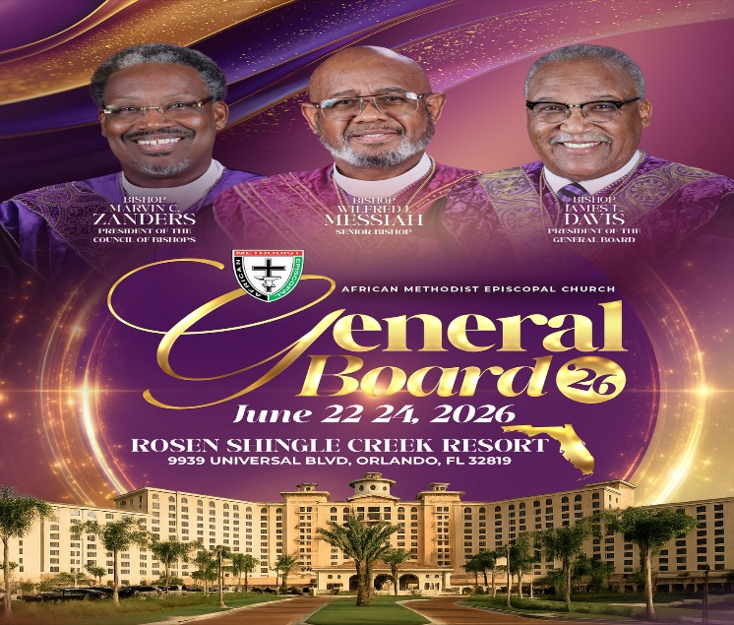

Background Check Reminder

This is a reminder that all adults aged 18 and older who work with children and youth in our church are required to complete the necessary background screening in compliance with the 5th Episcopal District requirements. Assistance is available to help ensure all volunteers and workers remain in compliance. Please contact the church office or Sis. Gina Tervalon for additional information and next steps.



-11-

Scripture of the Day
Self-Reflection. "Let us search out and examine our ways, and turn back to the Lord."
Lamentation 3:40

Quote of the Day
"What lies behind us and what lies before us are tiny matters compared to what lies within us." — Ralph Waldo Emerson

Thought of the Week
"Let us search out and examine our ways, and turn back to the Lord." — Lamentations 3:40
In a world filled with noise, distractions, and constant demands, we rarely take time to pause and look within. Yet Scripture repeatedly calls us to self-reflection—not to dwell on our failures, but to evaluate our lives in the light of God's grace and truth.
Self-reflection is the spiritual discipline of examining our thoughts, attitudes, actions, and priorities before God. Christ? Have I allowed worry, pride, bitterness, or complacency to take root in my heart?
King David prayed, "Search me, O God, and know my heart; test me and know my anxious thoughts" (Psalm 139:23). David understood that true self-examination begins when we invite God to reveal what we cannot see on our own. As we worship today, may we take a moment to reflect on our walk with God. Let us celebrate where He has brought us, confess where we have fallen short, and commit ourselves anew to following His will. Reflection is not about looking backward with regret; it is about looking inward with honesty and forward with hope. When we examine our hearts and surrender them to God, He transforms us from the inside out.

Humor of the Week
An elderly man rear-ended a guy driving an expensive European sports car. Enraged, the guy hops out and confronts the old man. He yells,
"Look what you did to my car! You're going to give me $10,000 right now or I'm going to beat you to a pulp!"
"Oh my…" the old man said nervously. "I don't have that kind of money. Let me call my son.” he said with hope. “He trains dolphins and he will know what to do." "Dolphins!" the other driver huffed, while rolling his eyes. The old man pulled out his phone, dialed his son, and just as his son answered, the irate man snatched the phone away from the old man.
"So, YOU'RE a dolphin trainer, huh?” The irate man yelled, “Well, your old man here just rear-ended my car and I need TEN GRAND right now, or I'm going to beat you AND your old man to a pulp!"
"I'll be there in 10 minutes," says the voice calmly on the other end.
Exactly 10 minutes later, a Jeep pulls up and a guy hops out and proceeds to pulverize the bully, leaving him in a heap on the side of the road. When he finished, he walked over to his father and said,
"For the last time dad, I train Seals… Navy Seals. NOT dolphins!”

HOME DAILY BIBLE READINGS
June 8, 2026 – June 14, 2026 (Week 38, John)
Monday Day 260 Luke 13:1-35, Psalm 106:1-5
Tuesday Day 261 Luke 14:1-35, Psalm 106:6-15
Wednesday Day 262 Luke 15:1-32, Psalm 106:16-27
Thursday Day 263 Luke 16:1-31, Psalm 106:28-33
Friday Day 264 Luke 17:1-37, Psalm 106:34-46
Saturday Day 265 Luke 18:1-43, Psalm 106:47-48
Sunday Day 266 Luke 19:1-48, Psalm 107:1-8

-12-

Prayer Request(s)
Please notify the Church Office of Sick & Shut-in additions, deletions, or status/address changes.

Bishop Francine A. Brookins, Esq. Supervisor Miriam Burnett, MD
Presiding Elder Roosevelt & Dr. Kaye Lindsey Rev. Dr. Larry & Melinda Campbell
Richard Craig Hazel Clark Erica Woodard Jason Shirley Joshua Shirley Julian Shirley Ayanna Terry Cheryl Jamerson Gwendolyn Flowers Andrea Anderson Ocilda Files Danielle Clark Donita Towler Rev. Charles Brooks Doris Bailey Kimberly Woods Cynithia Grace Zechariah Robinson Diane Jordan Christopher McCarthy Wilma Haynes Calle Burns Noel Johnson Brittney Petty Taylor Family Deborah Burton Nettie McChristen Jacquelyn Walker Donita Towler
Rev. Rochelle Moore Lorene Butler Stella Pulliam Collette Blizzard Konata Doxey
The Eaton Canyon Fire Victims Selene Cox Mel Beech

College Students

Let’s continue to support and pray for our beloved College Students

Isaiah Crowell Alecia Davis Chase Johnson Grant Blizzard

Tyler Johnson Richard Jones Tyrikk Lawson Makia Rose Talbert Isaiah Ringo Journey Rogers Elyse Sharp Kylee Sharp Zion Otano Elise Tervalon Grace Jones Jordan Patterson Kimberly Robinson Donovan Williams Jasmine Collins Brandon Bates Gabriel Blizzard

Sick and Shut-Ins
Andrew Oliver 1405 N. Roosevelt Avenue, Pasadena, CA 91104
Barbara Buchanan 616 Rio Grande St. Pasadena, CA 91104
Bettina Ayers Pasadena Meadows Nursing Home, 150 Bellefontaine St., Pas., CA 91105
Betty Betts Turner USC Keck Rehabilitation, 300 W Huntington Dr., Arcadia, CA 91007
Bobby Thomas 1052 E. Morada Place, Altadena, CA 91001
Doris Curd 11619 Woodcock Avenue, San Fernando, CA 91340
Edmund Riddle Active Care Mission Bay, 2440 Grand Avenue, San Diego, CA 92109
Eleanor Towler 975 E. Union Street, Unit #417, Pasadena, CA 91106
Elois Blizzard P. O. Box 3646, So. Pasadena, CA 91031
Emily Cormier-Ross 2549 La Fiesta Avenue, Altadena, CA 91001
Ernestine English 26 W. Fair Oaks Drive, Pasadena, CA 91103
Fred Caple 51 North 15th Street Haledon, NJ 07508
Gloria Cubit Clay 11745 Pierce St., Lake View Terrace, CA 91342
Hugh Hamberry 19225 Chole Rd., Apple Valley, CA 92307
Jeff Thomas 603 Tocino Dr. Duarte, CA 91010 | Mountain View Terrace
Jessie Smith 3925 S Jones BL, Apt 2118 Las Vegas, NV 89103| Spring Valley Community
Josephine Brown 15607 Saddleback Rd, Riverside, CA 92506
Konata Doxey Monte Vista Healthcare Center, Duarte, CA 91010
Linnie G. Nollie 2250 E. New York Drive, Altadena, CA 91001
Malika G. Hendry P. O. Box 94082, Pasadena, CA 91109
Mildred Lewis C/O Hazel Rohr, 884 W. Jane Court, Upland, CA 91786
Norma Burnett 618 Fairview Avenue, Unit #228, Arcadia, CA 91007
Opal Hampton 1030 Chevron Court, Pasadena, CA 91103
Paul Ratliff P.O. Box 40407 Pasadena, CA 91114
Virlyn Grant 15122 Orange Ave., Paramount, CA 90723
Wanda Nelson 3618 N. Fair Oaks Avenue, Altadena, CA 91001
William Hilliard 7504 Wynstone Pl., Fontana, CA 92336
Zell L. Hill 375 Barthe Drive, Pasadena, CA 91103

-13-

Sermon Notations

Scripture: _____________________________________________________________

Subject: _______________________________________________________________

Points of the Message: ___________________________________________________
_______________________________________________________________________
_______________________________________________________________________
_______________________________________________________________________
_______________________________________________________________________
_______________________________________________________________________
_______________________________________________________________________

Main Ideas of the Sermon: ________________________________________________
_______________________________________________________________________
_______________________________________________________________________
_______________________________________________________________________
_______________________________________________________________________
_______________________________________________________________________

Illustrations I want to remember: _________________________________________
_______________________________________________________________________
_______________________________________________________________________
_______________________________________________________________________
_______________________________________________________________________
_______________________________________________________________________
_______________________________________________________________________

What should I do as a result of this Sermon? ________________________________

_____________________________________________________
_____________________________________________________
_____________________________________________________
_____________________________________________________

-14-

