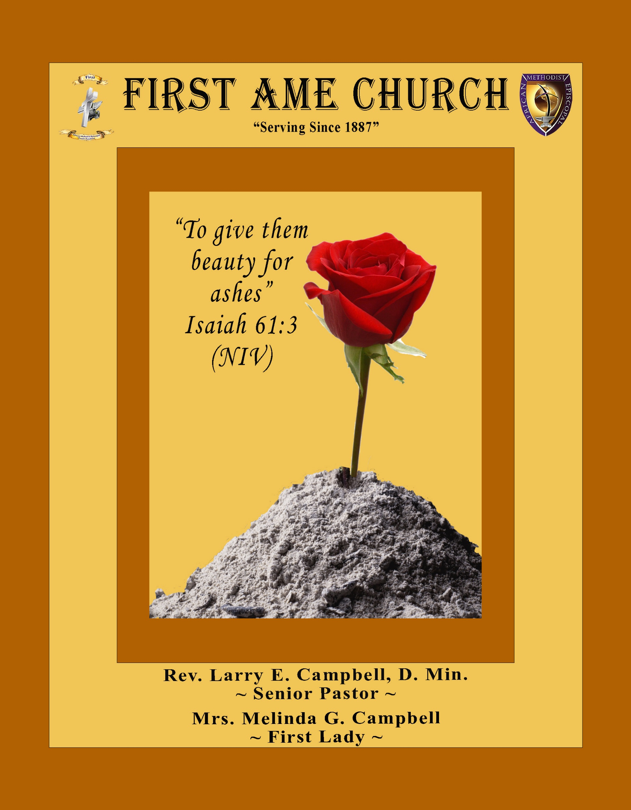
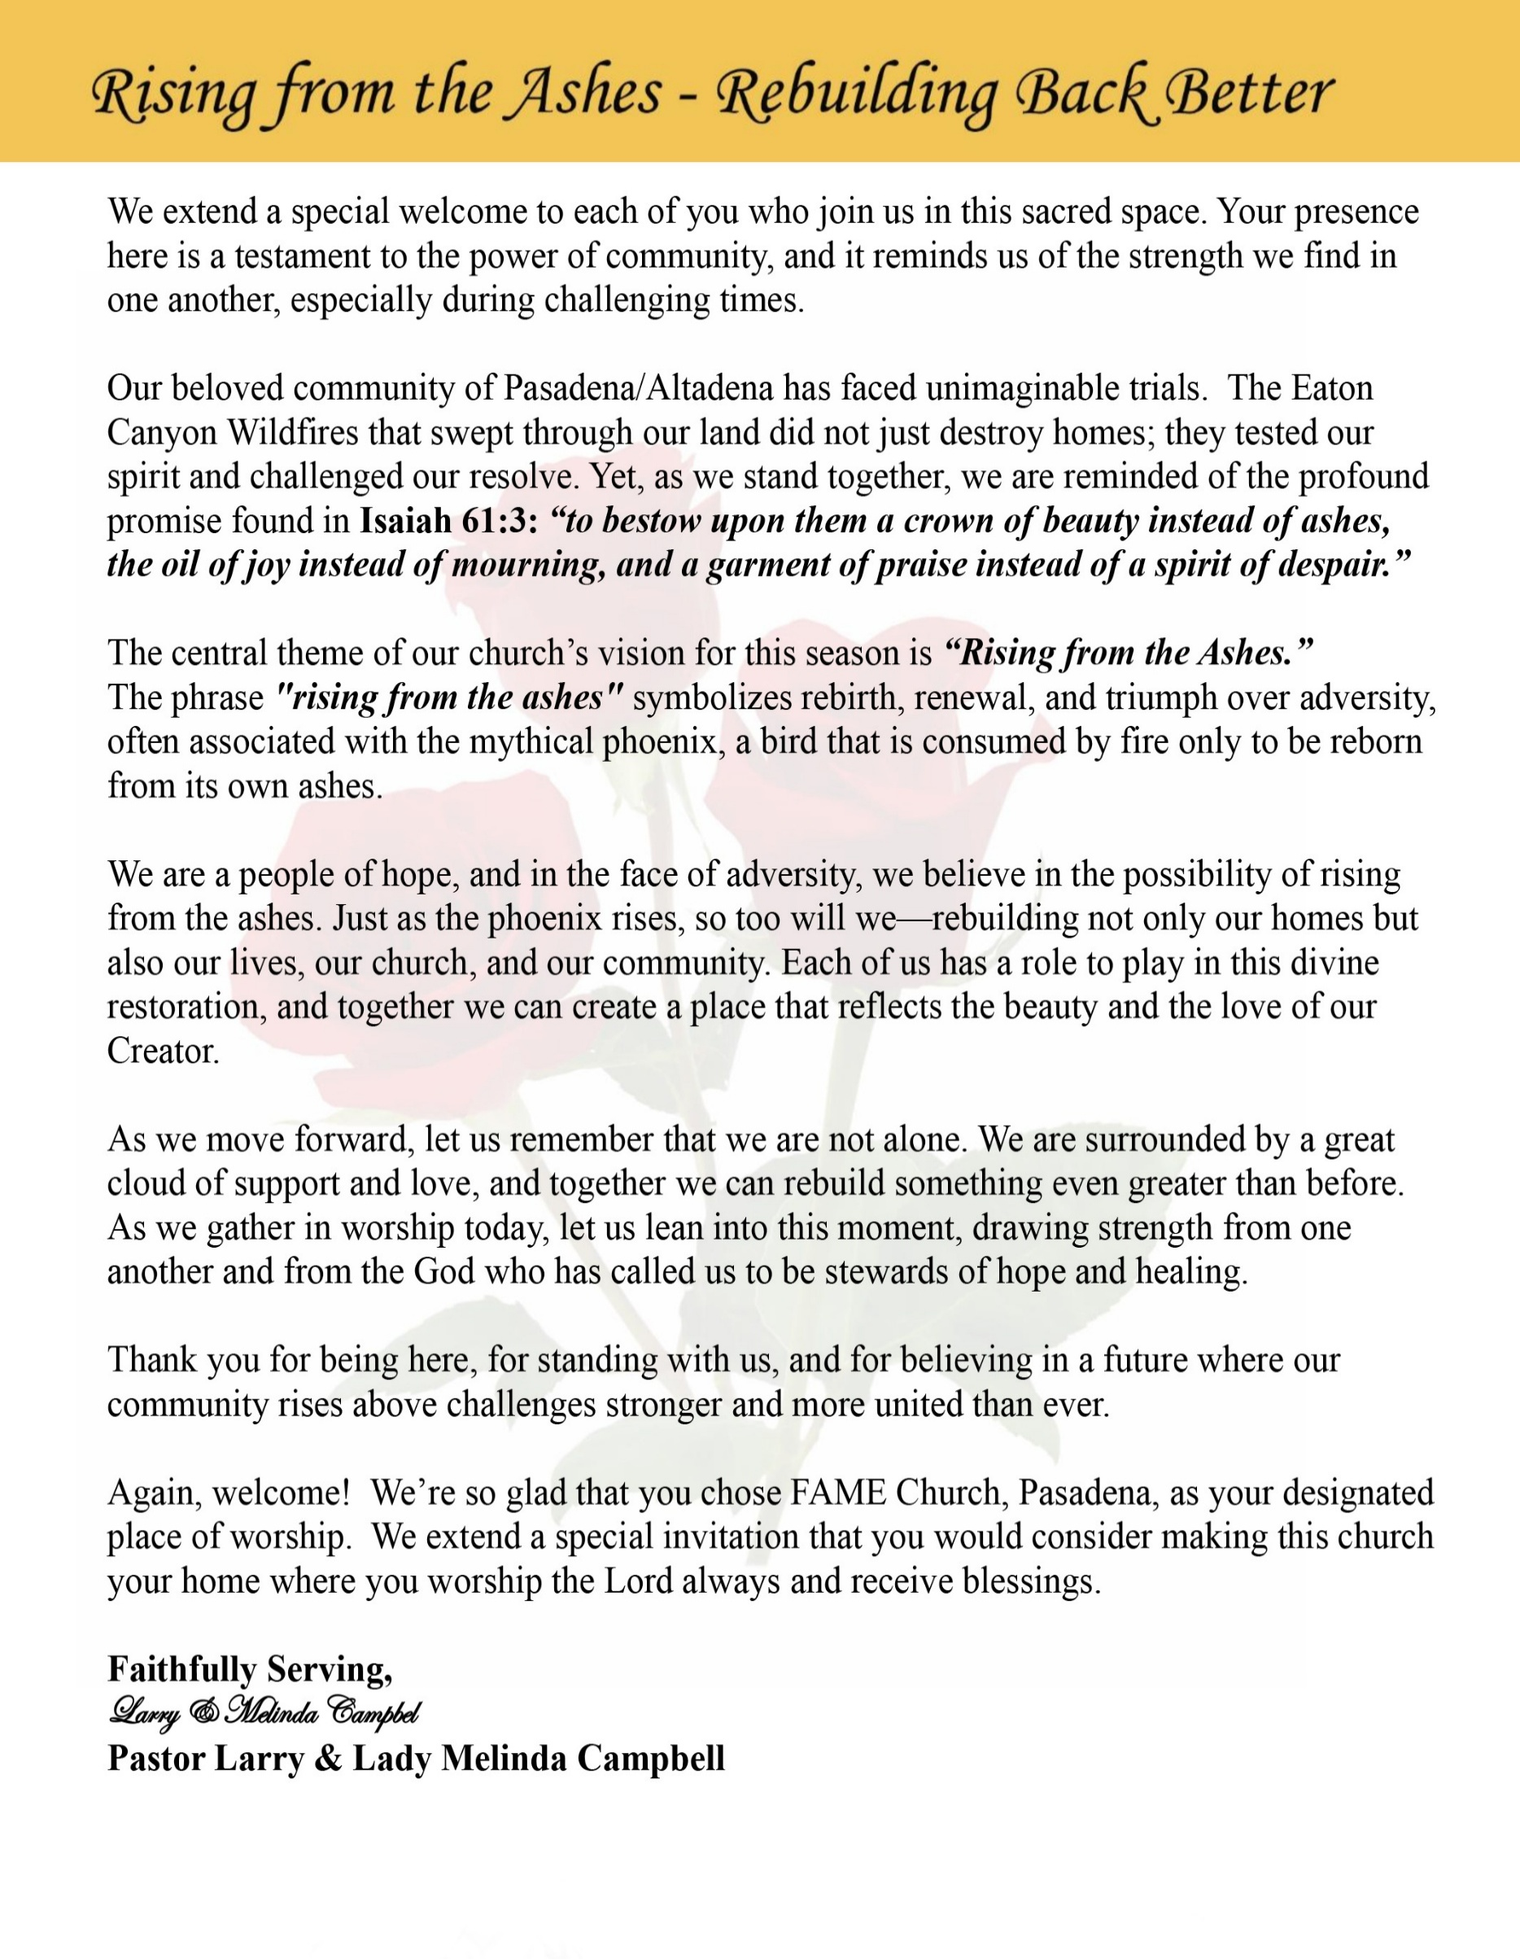

Sunday, March 1, 2026 | 9:30 a.m.

Rt. Rev. Francine A. Brookins, Esq., Presiding Bishop
Rev. Miriam Burnett, MD, MPH, Supervisor of Missions
Rev. Roosevelt Lindsey, Jr. Presiding Elder

The Rev. Dr. Larry E. Campbell ~ Pastor ~ Minister

Mobile: (951) 587-1894 ~ Email: larrycampbell@famepasadena.org

Our First Lady: Mrs. Melinda G. Campbell

The Reverend Dr. Jennifer Oliver ~ Itinerant Elder -
The Reverend Dr. Nikia Smith-Robert ~ Itinerant Elder (Affiliated)
The Reverend Lois Woodard ~ Itinerant Elder Superannuated (Retired)
The Reverend Rochelle Wright Moore ~ Itinerant Deacon
The Reverend Deborah West-Jones ~ Local Elder
The Reverend Philis J. Griffin, MDiv ~ Local Elder
Dr. Phyllis Beech ~ Evangelist

Community Resource Center Director ~ Ms. Kischchen Hazelton Venerable
Church Administrative Assistant: Ms. Letha Rhymes

Church Office Hours:
Tue - Wed 9:00 am - 5:00 pm, & Fri 9:00 am -3:00 pm.
Closed for Lunch Daily: 12:00 pm - 1:00 pm.

Music Ministry
Dr. Timothy Davis, Minister of Music
Bro. Jimmy Watlington, Percussionist ~ Bro. Carlos Caldwell, Organist
Bro. Darien Dorsey, Keyboardist
Sis. Karen Law, Women’s Chorus Director ~ Sis. Tonia Graham, Children’s Choir Director
Bro. J. Renard Washington, New Generation’s Choir

FREE WI-FI service is available on the FAME Campus by accessing FAME 1700
Password: 6267980503

-3-

~ Order of Worship Experience ~



+++ The Altar Call +++
Praise & Worship

Doxology: “Praise God From Whom All Blessings Flow”

The Call to Worship Pastor Larry E. Campbell

Leader: I was glad when they said unto me, let us go into the house of the Lord, our feet shall stand within Thy gates O Jerusalem! (Psalm 122:1)

People: For a day in Thy courts is better than a thousand. I had rather be a doorkeeper in the house of my God than to dwell in the tents of wickedness. (Psalm 84:10)

Leader: Because of the house of the Lord our God, I will seek Thy good.
(Psalm 122:9)

People: Those that be planted in the house of the Lord, shall flourish in the courts of our God. (Psalm 92:13)

Leader: Blessed are they that dwell in Thy house. Lord, I have loved Thy habitation, the place where Thy honor dwelleth. (Psalm 26:8)

People: For the Lord is in His holy temple; let all the earth keep silence before Him.
(Habakkuk 2:20).

Leader: Let the words of my mouth and the meditation of my heart, be acceptable in Thy sight, O Lord my strength and my redeemer. (Psalm 19:14)

Unison: O Sing unto the Lord a new song, for He has done marvelous things. Make a
joyful noise unto the Lord, all the earth, sing His praises. (Psalm 98:1, 4)

-4-

The Hymn of Praise A.M.E. Hymnal #256
There Is a Fountain Filled with Blood
Words: William Cowper, 1731-1800

1 There is a fountain filled with blood
Drawn from Immanuel's veins;
And sinners, plunged beneath that flood,
Lose all their guilty stains:
Lose all their guilty stains,
Lose all their guilty stains;
And sinners, plunged beneath that flood,
Lose all their guilty stains.

2 The dying thief rejoiced to see
That fountain in his day;
And there may I, though vile as he,
Wash all my sins away:
Wash all my sins away,
Wash all my sins away;
And there may I, though vile as he,
Wash all my sins away.

3 E'er since by faith, I saw the stream
Thy flowing wounds supply,
Redeeming love has been my theme,
And shall be till I die:
And shall be till I die,
And shall be till I die;
Redeeming love has been my theme,
And shall be till I die.

4 When this poor lisping, stamm'ring tongue
Lies silent in the grave,
Then in a nobler, sweeter song
I'll sing Thy pow'r to save:
I'll sing Thy pow'r to save,
I'll sing Thy pow'r to save;
Then in a nobler, sweeter song
I'll sing Thy pow'r to save.

The Invocation Rev. Deborah West-Jones

Ministry of Music The Mass Choir

-5-

Scripture Lesson (Responsive Reading) Evangelist Phyllis Beech

(Please Stand for the Reading of God’s Words)
Exodus 12:1-13 (New International Version) — Applying the Blood
Leader: The Lord said to Moses and Aaron in Egypt, ² “This month is to be for you the
first month, the first month of your year. ³ Tell the whole community of Israel that
on the tenth day of this month each man is to take a lamb for his family, one for
each household.

People: ⁴ If any household is too small for a whole lamb, they must share one with
Their nearest neighbor, having taken into account the number of people
there are. You are to determine the amount of lamb needed in accordance
with what each person will eat.

Leader: ⁵ The animals you choose must be year-old males without defect, and you may
take them from the sheep or the goats.

People: ⁶ Take care of them until the fourteenth day of the month, when all the
members of the community of Israel must slaughter them at twilight. ⁷ Then
they are to take some of the blood and put it on the sides and tops of the
doorframes of the houses where they eat the lambs. ⁸ That same night they
are to eat the meat roasted over the fire, along with bitter herbs, and bread
made without yeast.

Leader: ⁹ Do not eat the meat raw or boiled in water, but roast it over a fire—with the
head, legs and internal organs. ¹⁰ Do not leave any of it till morning; if some
is left till morning, you must burn it.

People: ¹¹ This is how you are to eat it: with your cloak tucked into your belt, your
sandals on your feet and your staff in your hand. Eat it in haste; it is
the Lord’s Passover.

Leader: ¹² “On that same night I will pass through Egypt and strike down every
firstborn of both people and animals, and I will bring judgment on all the gods of
Egypt. I am the Lord.

Unison: ¹³ The blood will be a sign for you on the houses where you are, and when I
see the blood, I will pass over you. No destructive plague will touch you when
I strike Egypt.

-6-

The AFFIRMATION OF FAITH (The Apostle Creed)

Minister: What do you Believe?

People: I believe in God the Father Almighty, Maker of heaven and earth, and in Jesus
Christ His only son our Lord who was conceived by the Holy Spirit, born of the Virgin Mary, suffered under Pontius Pilate, was crucified, dead and buried. The third day he arose from the dead; he ascended into heaven and sitteth at the right hand of God the Father Almighty; from thence he shall come to judge the quick and the dead. I believe in the Holy Spirit, the Church Universal, the communion of saints, the forgiveness of sins, the resurrection of the body and the life
everlasting. Amen.

THE PRELUDE TO THE DECALOGUE Pastor

“From all that dwell below the skies, Let the Creator’s praise arise;
Let the Redeemer’s name be sung. Through every land, by every tongue.”

THE DECALOGUE (An Affirmation of God’s Law)

Minister: Let us express our commitment to keep God’s Law

People: God of our salvation, only You are God.
We will make no idols.
We will not invoke with malice your name, O God.
We will remember the Sabbath Day and keep it holy.
We will honor our father and our mother.
We will not commit murder.
We will not commit adultery.
We will not steal.
We will not be a false witness.
We will not covet anything that belongs to our neighbor.
Minister: Jesus said: “You shall love the Lord your God with all your heart, and with all your soul and with all your mind. This is the great and first commandment.”

ALL: Jesus also challenged us to love justly with a second commandment
which is like the first. We shall love our neighbor as ourselves! On these
commandments depend all the law and the prophets.

-7-

THE GLORIA PATRI
Glory be to the Father, and to the Son, and to the Holy Ghost.
As it was in the beginning, is now and ever shall be, world without end. Amen Amen!!

Abbreviated Announcements/ Visitor’s Welcome

Pastoral Remarks

The Offertory (Tithes ~ Gifts ~ Benevolent Offerings) Sis. Mable Davis, Steward

In order to satisfy the steady increase of inflation, we are asking each member to consider increasing your Tithe, Offerings & Gifts.

The following Electronic GIVING Platforms are creditable methods to GIVE to FAME:

#1. GIVELIFY - Mobile Giving App available on the App Store. It’s easy to set up, just follow the guidelines.

#2. Cash App: $FirstAMEPASADENA

#3. Mail in your Tithes & Offering - If you would like to mail your tithes and offering by check or money order, please send it to: First AME Church, 1700 N. Raymond Avenue, Pasadena, CA 91103.

#4. Drop off your Tithes & Offering - During business hours in the basket outside of the office.

Choral Response: “All things come of Thee, O Lord; and of Thine own have we given Thee. Amen.”

Children’s Church Dismissal
Sermonic Selection The Mass Choir

Proclamation of The Word: Pastor Larry E. Campbell

The Invitation (Public/Private)

-8-

The Sacrament of the Lord’s Supper or Holy Communion

THE SOLICITATION

You that do truly and earnestly repent of your sins, and are in love and charity with your neighbor, and intend to lead a new life, following the commandments of God, and walking from henceforth in His holy ways, draw near with faith and take this holy sacrament to your comfort; and make your humble confession to Almighty God.

THE GENERAL CONFESSION

Minister: Let us humbly confess our sins unto Almighty God.

Minister and People:

Almighty God, Father of our Lord Jesus Christ, Maker of all things, Judge of all men, we acknowledge and bewail our manifold sins and wickedness which we from time to time most grievously have committed by thought, word, and deed against Your divine Majesty, provoking most justly Your wrath and indignation against us. We do earnestly repent and are heartily sorry for these, our misdoings; the remembrance of them is grievous unto us. Have mercy upon us, have mercy upon us, most merciful Father for Your Son our Lord Jesus Christ’s sake; forgive us all that is past, and grant that we may ever hereafter serve and please You in newness of life, to the honor and glory of Your name through Jesus Christ our Lord.

Amen. (Choral). (You may be seated).

THE PRAYER OF PARDON

Almighty God, our Heavenly Father, who of Your great mercy has promised forgiveness of sins to all them that with hearty repentance and true faith turn unto You, have mercy upon us; pardon and deliver us from all our sins; confirm and strengthen us in all goodness; and bring us to everlasting life through Jesus Christ, our Lord.

Choral Response: Amen.

THE PRAYER OF CONSECRATION

Minister: Loving God, our Father in heaven, in Your great mercy You gave Your only Son, Jesus Christ, to die on the cross so we could be saved. Through His sacrifice — offered once and for all — He made a complete and perfect offering for the sins of the whole world. And in the gospel, He told us to keep remembering His precious death until He comes again.
So we ask You, merciful Father, hear our prayer. As we receive this bread and this cup, according to the way our Savior Jesus taught us, help us remember His suffering and death, and allow us to share in the blessing of His body and His blood.
On the night He was betrayed, Jesus took bread. After giving thanks, He broke it and gave it to His disciples, saying,
“Take and eat. This is my body, given for you. Do this to remember me.”
In the same way, after supper He took the cup. After giving thanks, He gave it to them and said,
“Drink from it, all of you. This is my blood of the new covenant, poured out for you and for many so that sins may be forgiven. Whenever you drink it, do this to remember me.” Amen!

THE LORD’S PRAYER (ALL)

THE ELEMENTS SHARED

-9-

ANNOUNCEMENTS

5th District Rise Up and Pray Altar Call
Greetings FAME Church Family
There is a spiritual stirring happening around the 5th District Altar—a tangible reminder that when God’s people pray, heaven responds. We are witnessing fresh evidence that God is moving, healing, and aligning His church. Now is the time to lean in together.
At the request of Bishop Brookins, the Southern California Conference will lead the Rise Up and Pray Altar Call each Sunday throughout March 2026. This is more than a meeting—it is a sacred moment of unity, intercession, and spiritual empowerment for our churches, communities, and world.

Rise Up and Pray - Sundays · 6:00–6:30 PM (Pacific) · Zoom
Each session will include focused three-minute prayers covering:
Bishop & Supervisor
5th District Presiding Elders
5th District Pastors
5th District Laity
5th District Projects
5th District Legal Matters
5th District Children & Youth
5th Annual Conferences Series
Community & World
The gathering will conclude with prayer and remarks from Bishop Brookins.
March Leadership Schedule
March 1 — SCC Ministerial Alliance (SCCMA)
March 8 — SCAC Laity Organization
March 15 — SCC WMS / YPD
March 22 — SCC Women In Ministry
March 29 — SCC Sons of Allen
(Zoom link shared each Sunday around 12 Noon.)
Let us seize this moment as a conference family. When we rise together in prayer, we position ourselves for revival, wisdom, and breakthrough. Let’s fill the room. Let’s lift one voice. Let’s Rise Up and Pray.
Rev. Larry E. Campbell, D. Min.



-10-

ANNOUNCEMENTS (Continued)

Men's Ministry - BIBLE STUDY
Time: Tuesday, MARCH 10, 2026 | 6:00 p.m.
Meeting ID: 894 7536 6487
Passcode: 465177
One tap mobile: +16699006833,,89475366487#,,,,*465177# US (San Jose)

Women's Ministry – BIBLE STUDY
Time: Tuesday– MARCH 10, 2026 | 6:00 p.m.
Meeting ID: 857 0061 9461; Passcode: 933892
One tap mobile +16699006833,,85700619461#,,,,,,0#,,933892# US (San Jose)



Virtual Trustee Board Meeting
Tuesday, March 17, 2026 | 5:30 p.m.

Save the Date Annual Women’s Day Celebration
Sunday, March 22, 2026

Official Board Meeting
Tuesday March 31, 2026 | 7:00p.m.

-11-

Scripture of the Day
The Blood of Jesus. “¹⁸ For you know that it was not with perishable things such as silver or gold that you were redeemed from the empty way of life handed down to you from your ancestors, ¹⁹ but with the precious blood of Christ, a lamb without blemish or defect.” 1 Peter 1:18-19

Quote of the Day
“Be assured that there is no sin you have ever committed that the blood of Jesus Christ cannot cleanse.” Billy Graham

Thought of the Week
Covered by the Blood
The blood of Jesus is the language of God’s love spoken over our lives. It reminds us that we are not defined by our failures, but by His sacrifice. At the cross, Jesus didn’t just suffer — He redeemed, restored, and reconciled us back to God.
His blood still speaks today. It speaks forgiveness where there is guilt, peace where there is turmoil, and hope where there is despair. Because of His blood, we don’t have to strive to earn God’s love — we live from the assurance that we are already loved and accepted.
So when you feel unworthy or weary, remember: you are covered. The same blood that saved you sustains you, and the same grace that forgave you walks with you every day.
Prayer:
Lord, thank You for the precious blood of Jesus that cleanses, restores, and gives me new life. Help me to live today in the freedom and gratitude of Your sacrifice. Amen.

Humor of the Week
A woman reading her Bible on a plane is questioned by her neighbor about whether she believes in Jonah and the whale. She says yes. He asks, "How can you prove it?" She replies, "I'll ask him when I get to heaven." He sneers, "What if he's not there?" She answers, "Then you can ask him".
HOME DAILY BIBLE READINGS
March 2, 2026 – March 8, 2026 (Week 24, Amos)
Monday Day 162 Isaiah 49-53, Psalm 68:15-23
Tuesday Day 163 Isaiah 54-58, Psalm 68:24-31
Wednesday Day 164 Isaiah 59-63, Psalm 68:32-35
Thursday Day 165 Isaiah 64-66, Psalm 69:1-5
Friday Day 166 Jeremiah 1-3, Psalm 69: 6-12
Saturday Day 167 Jeremiah 4-6, Psalm 69:13-18
Sunday Day 168 Jeremiah 7-9, Psalm 69:19-28

-12-

Prayer Request(s)
Please notify the Church Office of Sick & Shut-in additions, deletions, or status/address changes.

Bishop Francine A. Brookins, Esq. Supervisor Miriam Burnett, MD
Presiding Elder Roosevelt & Dr. Kaye Lindsey Rev. Dr. Larry & Melinda Campbell
Richard Craig Hazel Clark Erica Woodard Jason Shirley Joshua Shirley Julian Shirley Ayanna Terry Cheryl Jamerson Gwendolyn Flowers Andrea Anderson Ocilda Files Danielle Clark Donita Towler Rev. Charles Brooks Doris Bailey Kimberly Woods Cynithia Grace Zechariah Robinson Diane Jordan Christopher McCarthy Wilma Haynes Jewell Malloy Calle Burns Noel Johnson Brittney Petty Taylor Family Deborah Burton Nettie McChristen Jacquelyn Walker Carita Smith
Rev. Rochelle Moore Lorene Butler Stella Pulliam Collette Blizzard The Caple Family Donita Towler
The Eaton Canyon Fire Victims Selene Cox Mel Beech

College Students

Let’s continue to support and pray for our beloved College Students

Isaiah Crowell Alecia Davis Chase Johnson Grant Blizzard

Tyler Johnson Richard Jones Tyrikk Lawson Makia Rose Talbert Isaiah Ringo Journey Rogers Elyse Sharp Kylee Sharp Zion Otano Elise Tervalon Grace Jones Jordan Patterson Kimberly Robinson Donovan Williams Jasmine Collins Brandon Bates Gabriel Blizzard

Sick and Shut-Ins
Andrew Oliver 1405 N. Roosevelt Avenue. Pasadena, CA 91104
Bettina Ayers Pasadena Meadows Nursing Home, 150 Bellefontaine St., Pas., CA 91105
Bobby Thomas 1052 E. Morada Place, Altadena, CA 91001
Carrie Wynne Senior Living Heritage, 161 N. Hemet St., Hemet, CA 92545
Doris Curd 11619 Woodcock Avenue, San Fernando, CA 91340
Edmund Riddle Active Care Mission Bay, 2440 Grand Avenue, San Diego, CA 92109
Eleanor Towler 975 E. Union Street, Unit #417, Pasadena, CA 91106
Elois Blizzard P. O. Box 3646, So. Pasadena, CA 91031
Emily Cormier-Ross 2549 La Fiesta Avenue, Altadena, CA 91001
Ernestine English 26 W. Fair Oaks Drive, Pasadena, CA 91103
Fred Caple 51 North 15th Street Haledon, NJ 07508
Gloria Cubit Clay 11745 Pierce St., Lake View Terrace, CA 91342
Hugh Hamberry 19225 Chole Rd., Apple Valley, CA 92307
Jeff Thomas 603 Tocino Dr. Duarte, CA 91010 | Mountain View Terrace
Jessie Smith 3925 S Jones BL, Apt 2118 Las Vegas, NV 89103| Spring Valley Community
Josephine Brown 15607 Saddleback Rd, Riverside, CA 92506
Linnie G. Nollie 2250 E. New York Drive, Altadena, CA 91001
Malika G. Hendry P. O. Box 94082, Pasadena, CA 91109
Mildred Lewis C/O Hazel Rohr, 884 W. Jane Court, Upland, CA 91786
Norma Burnett 618 Fairview Avenue, Unit #228, Arcadia, CA 91007
Opal Hampton 1030 Chevron Court, Pasadena, CA 91103
Paul Ratliff P.O. Box 40407 Pasadena, CA 91114
Ruthie Hopkins 1155 Via Verde , San Dimas, CA 91773
Virlyn Grant 15122 Orange Ave., Paramount, CA 90723
Wanda Nelson 3618 N. Fair Oaks Avenue, Altadena, CA 91001
William Hilliard 7504 Wynstone Pl., Fontana, CA 92336
Zell L. Hill 375 Barthe Drive, Pasadena, CA 91103

-13-

Sermon Notations

Scripture: _____________________________________________________________

Subject: _______________________________________________________________

Points of the Message: ___________________________________________________
_______________________________________________________________________
_______________________________________________________________________
_______________________________________________________________________
_______________________________________________________________________
_______________________________________________________________________
_______________________________________________________________________

Main Ideas of the Sermon: ________________________________________________
_______________________________________________________________________
_______________________________________________________________________
_______________________________________________________________________
_______________________________________________________________________
_______________________________________________________________________

Illustrations I want to remember: _________________________________________
_______________________________________________________________________
_______________________________________________________________________
_______________________________________________________________________
_______________________________________________________________________
_______________________________________________________________________
_______________________________________________________________________

What should I do as a result of this Sermon? ________________________________

_____________________________________________________
_____________________________________________________
_____________________________________________________
_____________________________________________________

-14-

