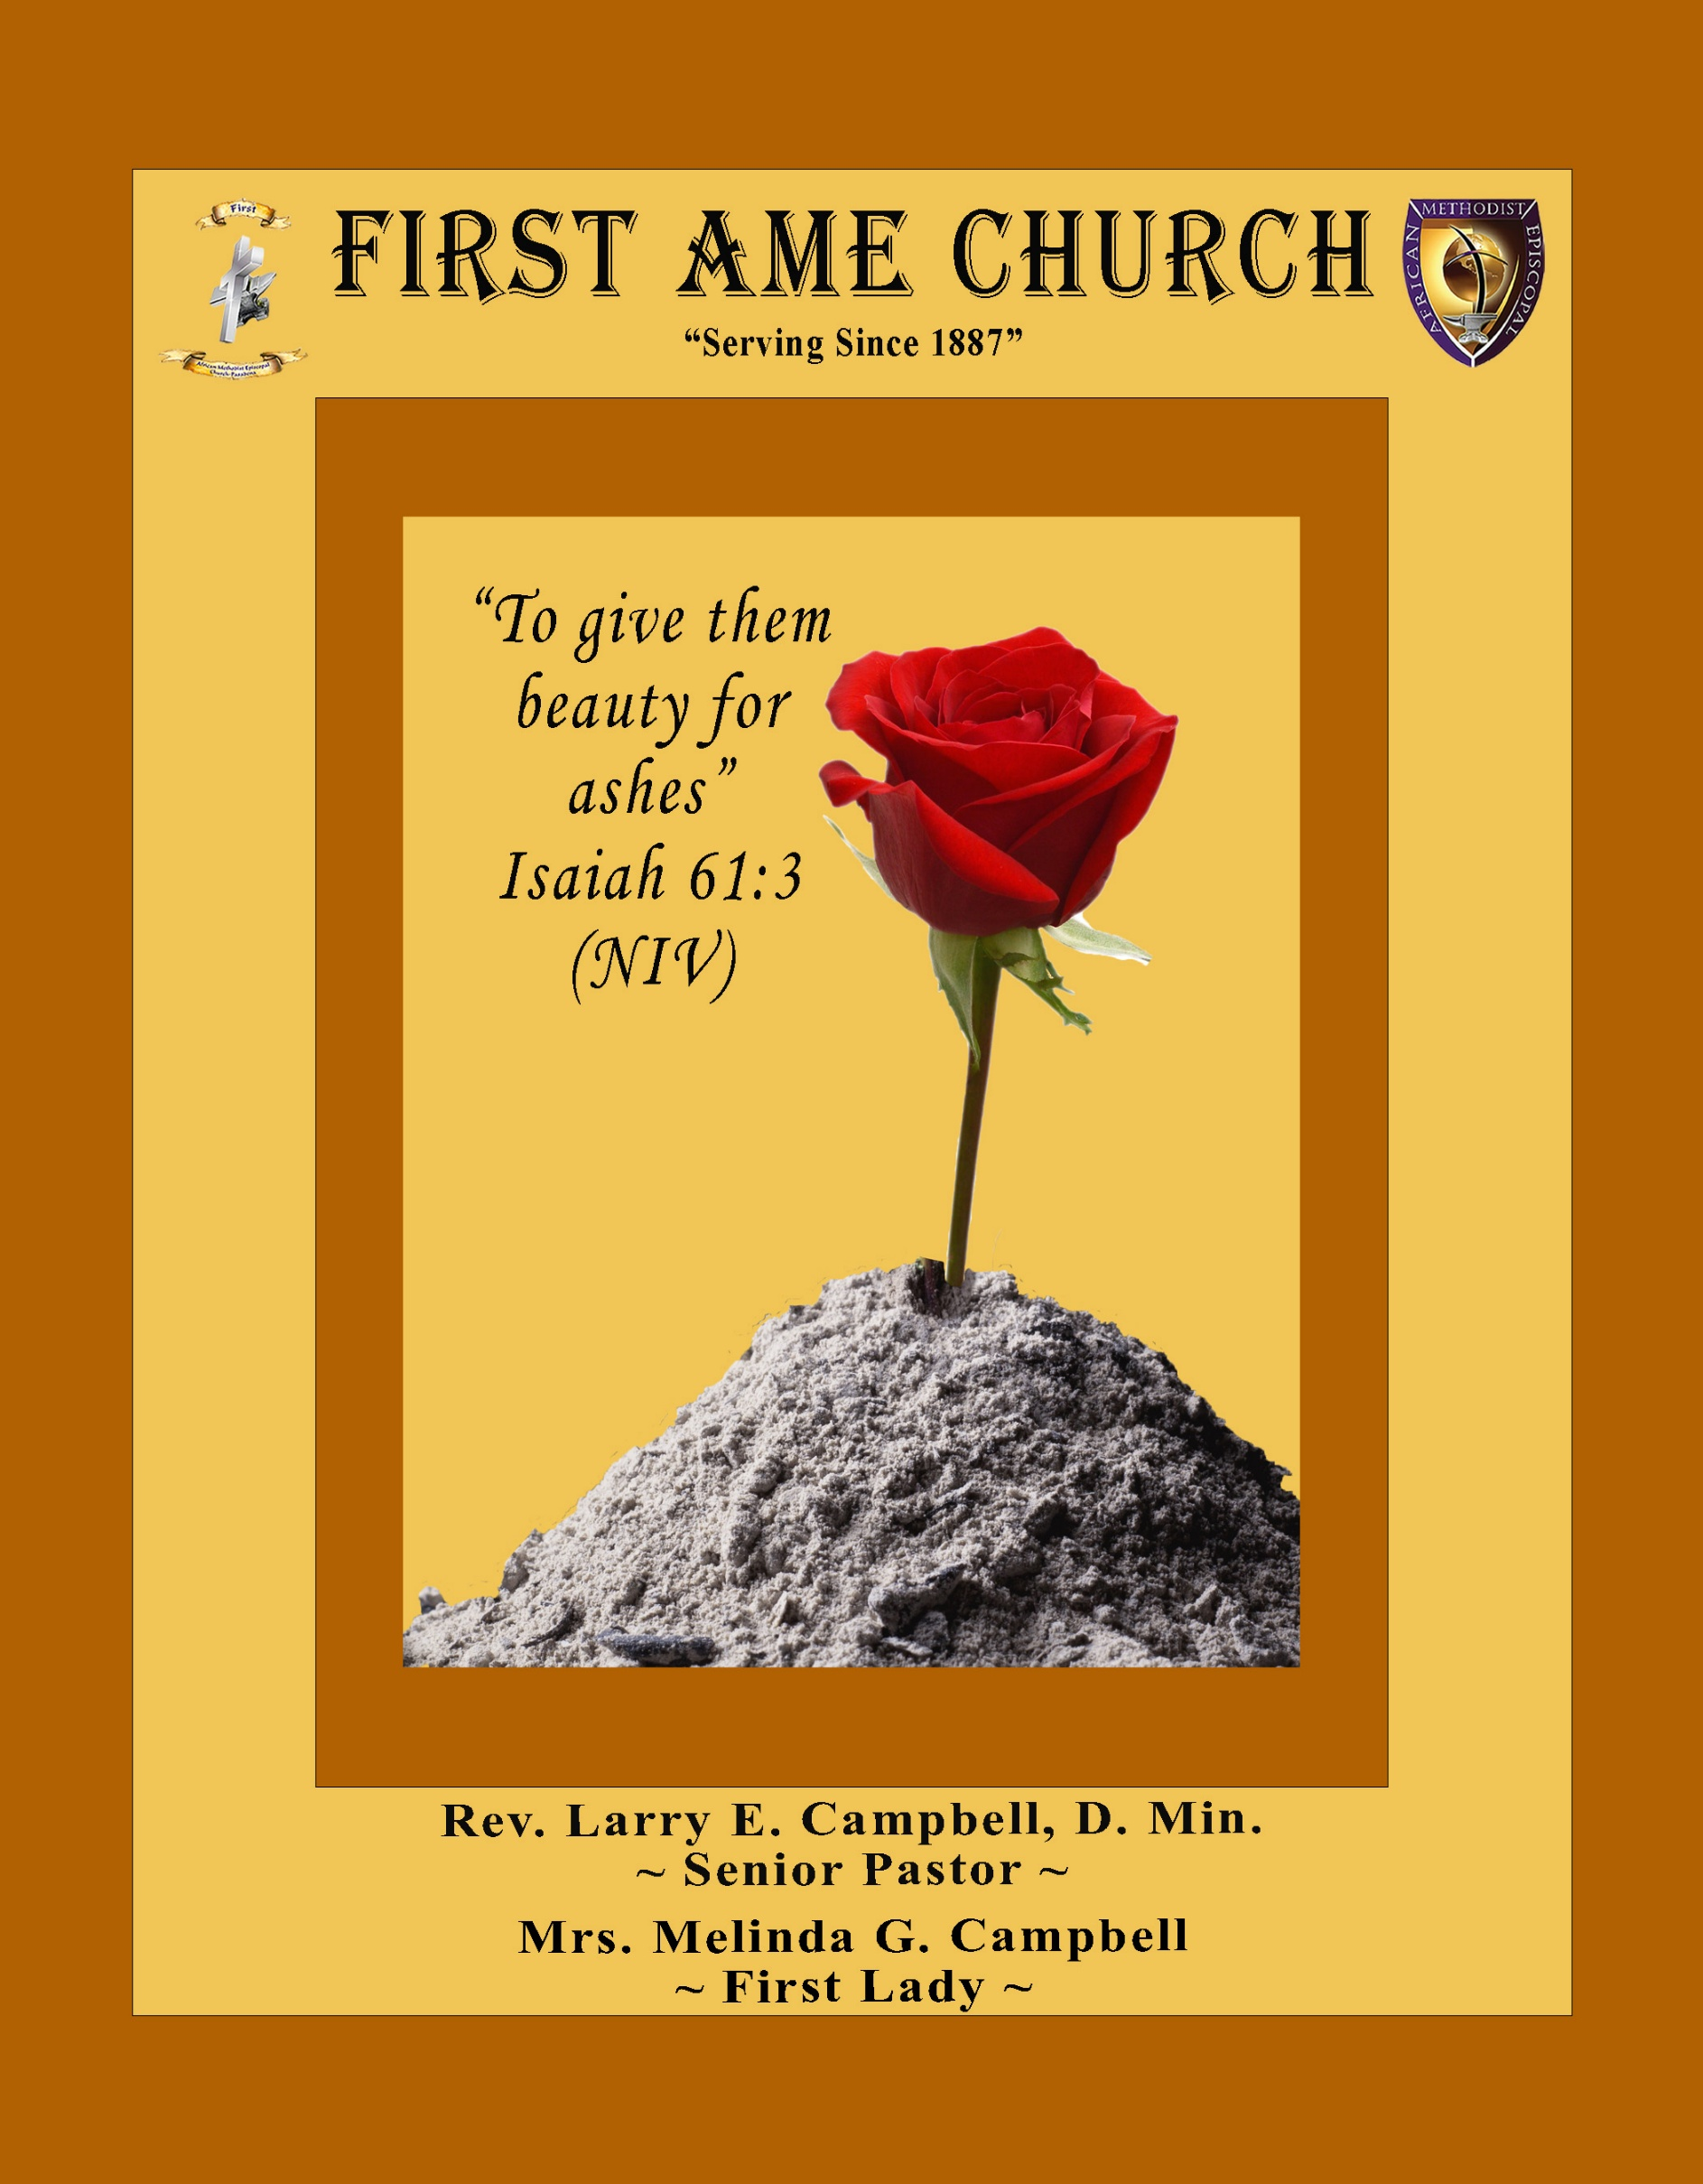
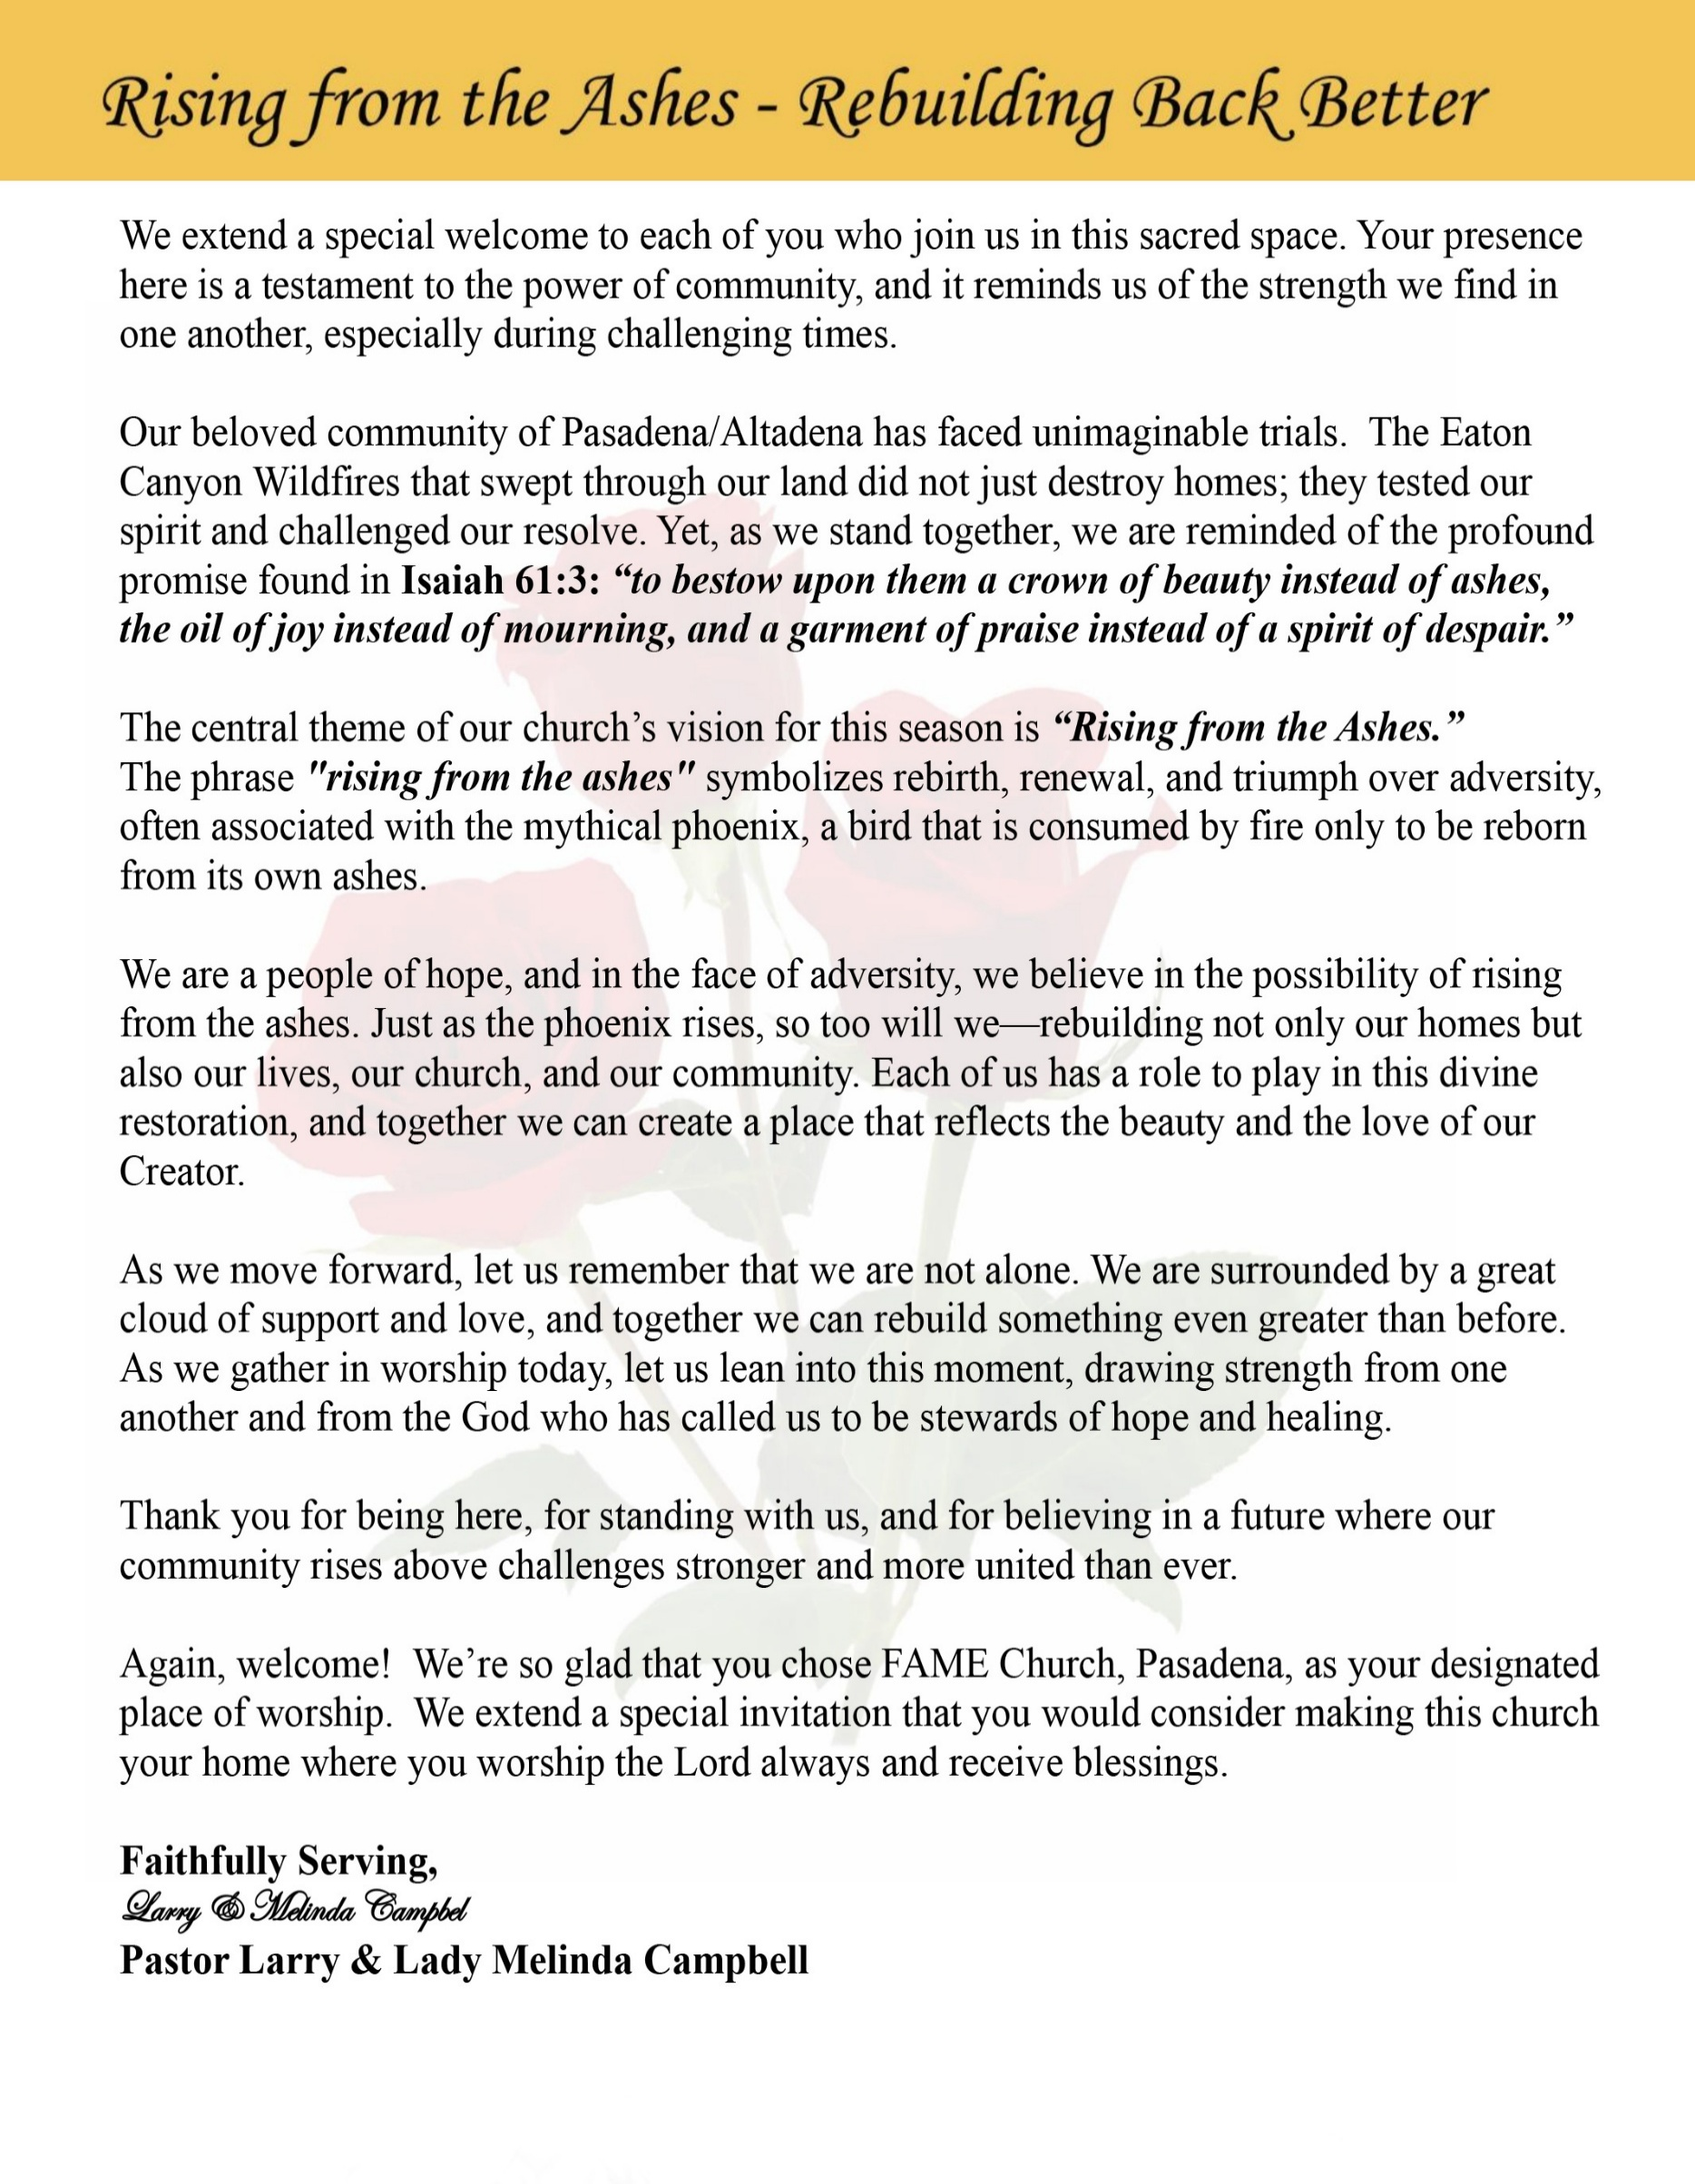

Sunday, March 15 2026 | 9:30 a.m.

Rt. Rev. Francine A. Brookins, Esq., Presiding Bishop
Rev. Miriam Burnett, MD, MPH, Supervisor of Missions
Rev. Roosevelt Lindsey, Jr. Presiding Elder

The Rev. Dr. Larry E. Campbell ~ Senior Pastor ~ Minister

Mobile: (951) 587-1894 ~ Email: larrycampbell@famepasadena.org

Our First Lady: Mrs. Melinda G. Campbell

The Reverend Dr. Jennifer Oliver ~ Itinerant Elder -
The Reverend Dr. Nikia Smith-Robert ~ Itinerant Elder (Affiliated)
The Reverend Lois Woodard ~ Itinerant Elder Superannuated (Retired)
The Reverend Rochelle Wright Moore ~ Itinerant Deacon
The Reverend Deborah West-Jones ~ Local Elder
The Reverend Philis J. Griffin, MDiv ~ Local Elder
Dr. Phyllis Beech ~ Evangelist
Sister Tessie Bonner ~ Deaconess

Community Resource Center Director ~ Ms. Kischchen Hazelton Venerable
Church Administrative Assistant: Ms. Letha Rhymes

Church Office Hours:
Tue - Wed 9:00 am - 5:00 pm, & Fri 9:00 am -3:00 pm.
Closed for Lunch Daily: 12:00 pm - 1:00 pm.

Music Ministry
Dr. Timothy Davis, Minister of Music
Bro. Jimmy Watlington, Percussionist ~ Bro. Carlos Caldwell, Organist
Bro. Darien Dorsey, Keyboardist
Sis. Karen Law, Women’s Chorus Director ~ Sis. Tonia Graham, Children’s Choir Director
Bro. J. Renard Washington, New Generation’s Choir

FREE WI-FI service is available on the FAME Campus by accessing FAME 1700
Password: 6267980503

-3-

~ Order of Worship Experience ~
Warning: This order of worship is subject to change without warning or prior notice --- everything is governed by the Sovereignty of the Holy Spirit.

Purple Sunday
Stewardship of the MIND
through
Dementia & Alzheimer Awareness

+ + + The Altar Call +++
Praise & Worship

Doxology: “Praise God From Whom All Blessings Flow”

The Call to Worship Princess Scholar Jeffery
Leader: I was glad when they said unto me, let us go into the house of the Lord, our feet shall stand within Thy gates O Jerusalem! (Psalm 122:1)

People: For a day in Thy courts is better than a thousand. I had rather be a doorkeeper in the house of my God than to dwell in the tents of wickedness. (Psalm 84:10)

Leader: Because of the house of the Lord our God, I will seek Thy good.
(Psalm 122:9)

People: Those that be planted in the house of the Lord, shall flourish in the courts of our God. (Psalm 92:13)

Leader: Blessed are they that dwell in Thy house. Lord, I have loved Thy habitation, the place where Thy honor dwelleth. (Psalm 26:8)

People: For the Lord is in His holy temple; let all the earth keep silence before Him.
(Habakkuk 2:20)

Leader: Let the words of my mouth and the meditation of my heart, be acceptable in Thy sight, O Lord my strength and my redeemer. (Psalm 19:14)

Unison: O Sing unto the Lord a new song, for He has done marvelous things. Make a
joyful noise unto the Lord, all the earth, sing His praises. (Psalm 98:1, 4)

-4-

The Worship Song of Praise Every Praise
(Repeat Verse 3 times)
Every praise is to our God.
Every word of worship with one accord
Every praise every praise is to our God.
Sing hallelujah to our God
Glory hallelujah is due our God
Every praise every praise is to our God.

(Repeat Chorus 3 times)
God my Savior
God my Healer
God my Deliverer
Yes He is, yes He is

Yes He is, yes He is, yes He is, yes He is
Yes He is, yes He is, yes He is, yes He is

(Repeat Verse 2 times)
Every praise is to our God.
Every word of worship with one accord
Every praise, every praise, every praise, every praise
Every praise, every praise, every praise, every praise
Every praise, every praise, every praise, every praise
All of my worship, every praise,
Every praise, every praise
When you see me dancing, every praise
Every praise, every praise
When you see me shoutin', every praise
Every praise, every praise, every praise, every praise
Every praise, every praise, to our god
Is to our God

Every praise, every praise, I got to praise you, every praise
Every praise, every praise, I got to thank him, every praise
Every praise, every praise, He's been so good, every praise
Every praise, every praise, He's been so kind, every praise
Every praise, every praise, every praise, every praise
Is to our God

The Invocation Mr. Grant Blizzard

Ministry of Music The Praise Team

-5-

Purple Sunday Scriptural Based Litany | Miss Charlotte Cole – YPD
| Sis. Aldra Allison, OWWMS, President
(Please Stand for the Reading of God’s Words)
Honoring and Supporting Those Living with Dementia and Alzheimer’s Disease
Leader: Beloved people of God, we gather today clothed in purple, remembering those whose
memories are fading but whose dignity remains. The Word of God reminds us:
"Gray hair is a crown of glory; it is gained in a righteous life." — Proverbs 16:31

People: Lord, help us honor and cherish those who have walked before us.

Leader: The scripture teaches us: "Even to your old age and gray hairs I am He, I am He who will
sustain you." — Isaiah 46:4

People: God of mercy, sustain those living with dementia and Alzheimer’s, and remind them
they are never forgotten by You.

Leader: God calls us to care for one another in love: "Carry each other's burdens, and in this way
you will fulfill the law of Christ." — Galatians 6:2

People: Strengthen caregivers, families, and loved ones who faithfully walk this difficult
journey.

Leader: When confusion and memory loss create fear and uncertainty, we remember the
promise of God: "The Lord is my shepherd; I shall not want." — Psalm 23:1

People: Guide those who feel lost in their minds, and lead them beside still waters of
peace.

Leader: For those who sit beside hospital beds, hold trembling hands, and repeat the same loving
words again and again, the scripture reminds us: “Love is patient, love is kind… it always
protects, always trusts, always hopes, always perseveres." — 1 Corinthians 13:4,7

People: Lord, fill caregivers with patience, compassion, and strength.

Leader: Even when memories fade, God’s love remains constant: "I have loved you with an
everlasting love." — Jeremiah 31:3

People: Thank You, Lord, that Your love never forgets us.

Leader: As a community of faith, we commit ourselves to compassion and advocacy:
"Whatever you did for one of the least of these brothers and sisters of mine, you did for
me." — Matthew 25:40

People: Help us serve with dignity, kindness, and unwavering love.

Leader: And when the road becomes long and the burden feels heavy, we stand on the promise of
God: "Let us not grow weary in doing good, for at the proper time we will reap a harvest
if we do not give up." — Galatians 6:9

People: Lord, renew our strength as we care for one another.

Leader: For every person living with dementia, for every caregiver, for every family walking this
path—
All Together: May the peace of God guard our hearts and minds in Christ Jesus. Amen.

-6-

The Summary of the Decalogue Master Omega Gaddis & Bro. Versie Gaddis
LEADER: From all that dwell below the skies…
SUNG: From all that dwell below the skies, Let the Creator’s praise arise; Let the
Redeemer’s Name be sung, through every land, by every tongue.
LEADER: Hear what Christ our Savior saith, Thou shalt love the Lord thy God with all thy
heart, with all thy soul, and with all thy mind. This is the first and great
commandment. And the second is like unto it: Thou shalt love thy neighbor
as thyself. On these two commandments hang all the law and the prophets.
SUNG: Glory be to the Father, and to the Son, and to the Holy Ghost; as it was in
the beginning, is now, and ever shall be, world without end. A~Men

Abbreviated Announcements/Visitor’s Welcome

K-FAME Radio
Pastor’s Remarks

Special Congregational Hymn (Sing along)
#394 We are Often Tossed and Driven

Tithes, Gifts, and Offering Litany (Responsive) Sis. Juanita West-Tillman, Steward
Leader: People of God, the earth is the Lord’s and the fullness thereof. Everything we have comes
from the gracious hand of God.

People: And because God has been good to us, we come to worship Him with our giving.

Leader: The scripture declares in Malachi 3:10, “Bring the whole tithe into the storehouse, that
there may be food in my house.”

People: Lord, we bring our tithes because we trust Your promise and honor Your Word.

Leader: God has blessed us with life, health, strength, and provisions we did not earn on our own.

People: So we give back to God with grateful hearts.

Leader: When we give, we support the work of the Kingdom—feeding the hungry, helping the
hurting, and strengthening the ministry of the church.

People: Our gifts become seeds that bless our community and glorify God.

Leader: The Word reminds us in 2 Corinthians 9:7, “God loves a cheerful giver.”

People: So we give not grudgingly, but joyfully.

[Continued on page 8]

-7-

Tithes, Gifts, and Offering Litany (Continued)
Leader: If God has opened doors for you…

People: We give Him praise through our giving.

Leader: If God has made a way out of no way…

People: We give Him honor through our giving.

Leader: If God has kept you through danger seen and unseen…

People: We give Him glory through our giving.

Leader: Because the truth is—God has been better to us than we have been to ourselves.

People: And we cannot beat God giving, no matter how hard we try.

Leader: Let us now bring our tithes, gifts, and offerings as an act of worship unto the Lord.

All Together: All things come of Thee, O Lord, and of Thine own have we given Thee. Amen

The following Electronic GIVING Platforms are creditable methods to GIVE to FAME:

#1. GIVELIFY - Mobile Giving App available on the App Store. It’s easy to set up, just follow the guidelines.

#2. Cash App: $FirstAMEPASADENA

#3. Mail in your Tithes & Offering - If you would like to mail your tithes and offering by check or money order, please send it to: First AME Church, 1700 N. Raymond Avenue, Pasadena, CA 91103.

#4. Drop off your Tithes & Offering - During business hours in the basket outside of the office.

Choral Response: “All things come of Thee, O Lord; and of Thine own have we given Thee. Amen.”

Children’s Church Dismissal

Sermonic Selection The Praise Team

The Preached Word Pastor Larry E. Campbell

The Doxology

The Benediction

-8-

Scripture of the Day
Value of Caregiving. “For God is not unjust. He will not forget how hard you have worked for him and how you have shown your love to him by caring for other believers, as you still do." Hebrews 6:10

Quote of the Day
"To care for those who once cared for us is one of the highest honors." - Tia Walker,"

Thought of the Week
"Carry each other's burdens, and in this way you will fulfill the law of Christ." — Galatians 6:2
Caring for others is one of the clearest ways we reflect the heart of God. Throughout scripture, we see that faith is not only something we believe—it is something we live out in how we treat one another. When someone is hurting, confused, grieving, or struggling, God calls us to walk beside them.
Sometimes caring for others looks like grand acts of generosity, but more often it shows up in small, quiet ways—sitting with someone who is lonely, listening when someone needs to talk, helping someone who can no longer do what they once did for themselves, or offering patience when life becomes difficult.
Jesus showed us this kind of compassion. He touched the sick, comforted the brokenhearted, and lifted up those society overlooked. When we care for others, we continue the ministry of Christ in the world.
Caring for others can sometimes feel heavy, especially when we walk with people through illness, aging, or memory loss. But God reminds us that we do not carry these burdens alone. The same God who calls us to care for others also gives us strength, patience, and love for the journey.
Every act of kindness, every moment of compassion, and every gesture of care becomes a living testimony of God’s love.

Humor of the Week
The new CEO of a company comes into work determined to turn things around. Trying to prove himself to his new employees he looks around the office and sees a guy leaning against a wall doing nothing. He approaches the guy and asks him, "What do you think you're doing?"
The man replies, "I'm just killing time, waiting to get paid."
The CEO is furious, "What do you make a week?"
The man tells him, "About $200 a week."
The CEO pulls out his wallet and hands the man $400 and says, "There's your two weeks, now get out of here!" After the man leaves he turns to his employees and asks, "What do you think about that?"
One of the employees stands up and says, "I think he just got the largest tip he's ever gotten on a single pizza."

HOME DAILY BIBLE READINGS
March 16, 2026 – March 22, 2026 (Week 26, Habakkuk)
Monday Day 176 Jeremiah 35-37, Psalm 73:1-9
Tuesday Day 177 Jeremiah 38-41, Psalm 73:10-14
Wednesday Day 178 Jeremiah 42-45, Psalm 73:15-28
Thursday Day 179 Jeremiah 46-48, Psalm 74:1-8
Friday Day 180 Jeremiah 49-50, Psalm 74:9-17
Saturday Day 181 Jeremiah 51-52, Psalm 74:18-23
Sunday Day 182 Lamentations 1-3, Psalm 75:1-5

-9-

ANNOUNCEMENTS

Purple Sunday – Dementia & Alzheimer’s Awareness
Today our church observes Purple Sunday, a special time set aside to raise awareness, offer prayer, and show compassion for individuals and families affected by Dementia and Alzheimer’s disease. Purple is the color widely used around the world to represent Alzheimer’s awareness and to remind us that every person experiencing memory loss still deserves dignity, care, and love.
Dementia is one of the fastest-growing health challenges in our nation. In the United States, more than 7 million Americans age 65 and older are living with Alzheimer’s disease, the most common form of dementia. About 1 in 9 seniors over the age of 65 is affected, and that number is expected to grow significantly as our population ages.
Behind every diagnosis is a family. Across the country, more than 11 million family members and friends serve as caregivers, providing countless hours of love, patience, and support for their loved ones. These caregivers often face emotional, physical, and financial challenges while faithfully walking alongside those they love.
Dementia also has a significant impact within our community. Research shows that older African Americans are about twice as likely to develop Alzheimer’s or other forms of dementia, which makes education, compassion, and community support even more important within our churches and neighborhoods.
Purple Sunday reminds us that the church has a sacred role to play. As people of faith, we are called to:
• Show compassion to those living with memory loss
• Support caregivers and families
• Raise awareness and remove stigma
• Advocate for research and resources
• Reflect Christ’s love through patience, dignity, and care
Today we wear purple to stand in solidarity with those whose memories may fade, but whose worth in God’s eyes never fades.
As your pastor, I want to remind us that memory loss does not erase a person’s value, their story, or their place in the family of God. Even when a loved one may forget our name, God never forgets theirs. The same God who said, “Even to your old age and gray hairs I am He, and I will sustain you” continues to hold every life in His loving hands.
So today, let us be the church that remembers when others cannot, that loves with patience when the journey becomes difficult, and that surrounds every caregiver and every family with compassion. And may we always remember this truth:
Even when memories fade, God’s love never does. 💜
~Rev. Dr. Larry E. Campbell ~

-10-

ANNOUNCEMENTS (Continued)

Special Called Trustee Board Meeting
Immediately after worship service today

5th District at the Altar together
Rise Up & Pray
6:00 PM Pacific Every Sunday
The Southern California Annual Conference is leading the prayer sessions during March.
March Leadership Schedule
March 1 — SCC Ministerial Alliance (SCCMA)
March 8 — SCAC Laity Organization
March 15 — SCC WMS / YPD
March 22 — SCC Women In Ministry
March 29 — SCC Sons of Allen

Meeting ID 817 7575 8872, Password - Music
Let us seize this moment as a conference family. When we rise together in prayer, we position ourselves for revival, wisdom, and breakthrough. Let’s fill the room. Let’s lift one voice. Let’s Rise Up and Pray.

Especially for you!
You are Invited to our Annual Women’s Day Celebration
Sunday, March 22, 2026 | 9:30 a.m.
Theme: “Planted with Purpose.”
Jeremiah 17:7–8 and Colossians 2:6–7
~
Women who trust God are planted in Him, rooted in Christ, and nurtured by His Love, growing strong, fruitful and full of purpose
~
Come and receive your Seeds of Self-Worth Toolkit!
The Women’s Day Committee is requesting that all women wear a solid-colored outfit. In addition, we ask that you prayerfully consider a $100 gift in support of Women’s Day!
Special Guest Speaker
The Reverend Sheriolyn Curry-Hodge
Presiding Elder, Mountain Valley District, Desert Mountain Annual Conference

-11-

ANNOUNCEMENTS (Continued)

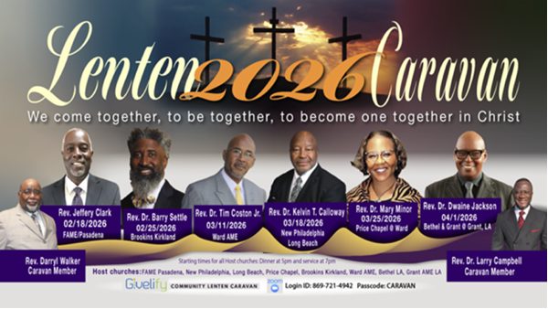3/18/26
Rev. Dr. Kelvin T. Calloway
New Philadelphia AME

3/25/26
Rev. Dr. Mary Minor
Price Chapel @ Ward AME

4/01/26
Rev. Dr. Dwaine Jackson
Bethel AME & Grant AME at
Grant AME Church

Stewardship & Finance Committee Meeting
Thursday, March 26, 2026 | 7:00 p.m.

Official Board Meeting
Tuesday, March 31, 2026 | 7:00p.m.

Southern California Conference Ministerial Alliance
Presents
Seven Last Words of Christ
Friday, April 3, 2026 | 12:00 PM PST
First AME Church, Los Angeles

-12-

Prayer Request(s)
Please notify the Church Office of Sick & Shut-in additions, deletions, or status/address changes.

Bishop Francine A. Brookins, Esq. Supervisor Miriam Burnett, MD
Presiding Elder Roosevelt & Dr. Kaye Lindsey Rev. Dr. Larry & Melinda Campbell
Richard Craig Hazel Clark Erica Woodard Jason Shirley Joshua Shirley Julian Shirley Ayanna Terry Cheryl Jamerson Gwendolyn Flowers Andrea Anderson Ocilda Files Danielle Clark Donita Towler Rev. Charles Brooks Doris Bailey Kimberly Woods Cynithia Grace Zechariah Robinson Diane Jordan Christopher McCarthy Wilma Haynes Jewell Malloy Calle Burns Noel Johnson Brittney Petty Taylor Family Deborah Burton Nettie McChristen Jacquelyn Walker Carita Smith
Rev. Rochelle Moore Lorene Butler Stella Pulliam Collette Blizzard The Caple Family Donita Towler
The Eaton Canyon Fire Victims Selene Cox Mel Beech

College Students

Let’s continue to support and pray for our beloved College Students

Isaiah Crowell Alecia Davis Chase Johnson Grant Blizzard

Tyler Johnson Richard Jones Tyrikk Lawson Makia Rose Talbert Isaiah Ringo Journey Rogers Elyse Sharp Kylee Sharp Zion Otano Elise Tervalon Grace Jones Jordan Patterson Kimberly Robinson Donovan Williams Jasmine Collins Brandon Bates Gabriel Blizzard

Sick and Shut-Ins
Andrew Oliver 1405 N. Roosevelt Avenue. Pasadena, CA 91104
Bettina Ayers Pasadena Meadows Nursing Home, 150 Bellefontaine St., Pas., CA 91105
Bobby Thomas 1052 E. Morada Place, Altadena, CA 91001
Carrie Wynne Senior Living Heritage, 161 N. Hemet St., Hemet, CA 92545
Doris Curd 11619 Woodcock Avenue, San Fernando, CA 91340
Edmund Riddle Active Care Mission Bay, 2440 Grand Avenue, San Diego, CA 92109
Eleanor Towler 975 E. Union Street, Unit #417, Pasadena, CA 91106
Elois Blizzard P. O. Box 3646, So. Pasadena, CA 91031
Emily Cormier-Ross 2549 La Fiesta Avenue, Altadena, CA 91001
Ernestine English 26 W. Fair Oaks Drive, Pasadena, CA 91103
Fred Caple 51 North 15th Street Haledon, NJ 07508
Gloria Cubit Clay 11745 Pierce St., Lake View Terrace, CA 91342
Hugh Hamberry 19225 Chole Rd., Apple Valley, CA 92307
Jeff Thomas 603 Tocino Dr. Duarte, CA 91010 | Mountain View Terrace
Jessie Smith 3925 S Jones BL, Apt 2118 Las Vegas, NV 89103| Spring Valley Community
Josephine Brown 15607 Saddleback Rd, Riverside, CA 92506
Linnie G. Nollie 2250 E. New York Drive, Altadena, CA 91001
Malika G. Hendry P. O. Box 94082, Pasadena, CA 91109
Mildred Lewis C/O Hazel Rohr, 884 W. Jane Court, Upland, CA 91786
Norma Burnett 618 Fairview Avenue, Unit #228, Arcadia, CA 91007
Opal Hampton 1030 Chevron Court, Pasadena, CA 91103
Paul Ratliff P.O. Box 40407 Pasadena, CA 91114
Ruthie Hopkins 1155 Via Verde , San Dimas, CA 91773
Virlyn Grant 15122 Orange Ave., Paramount, CA 90723
Wanda Nelson 3618 N. Fair Oaks Avenue, Altadena, CA 91001
William Hilliard 7504 Wynstone Pl., Fontana, CA 92336
Zell L. Hill 375 Barthe Drive, Pasadena, CA 91103

-13-

Sermon Notations

Scripture: _____________________________________________________________

Subject: _______________________________________________________________

Points of the Message: ___________________________________________________
_______________________________________________________________________
_______________________________________________________________________
_______________________________________________________________________
_______________________________________________________________________
_______________________________________________________________________
_______________________________________________________________________

Main Ideas of the Sermon: ________________________________________________
_______________________________________________________________________
_______________________________________________________________________
_______________________________________________________________________
_______________________________________________________________________
_______________________________________________________________________

Illustrations I want to remember: _________________________________________
_______________________________________________________________________
_______________________________________________________________________
_______________________________________________________________________
_______________________________________________________________________
_______________________________________________________________________
_______________________________________________________________________

What should I do as a result of this Sermon? ________________________________

_____________________________________________________
_____________________________________________________
_____________________________________________________
_____________________________________________________

-14-

