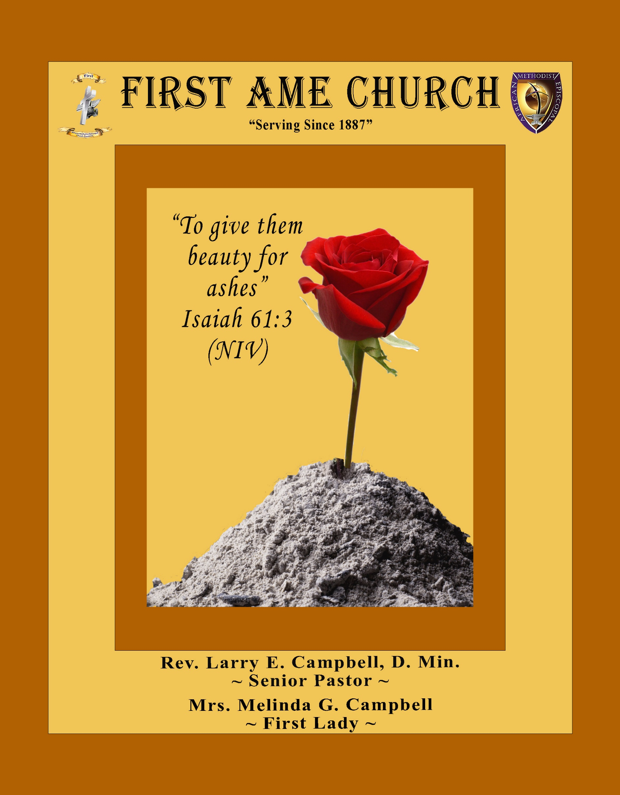
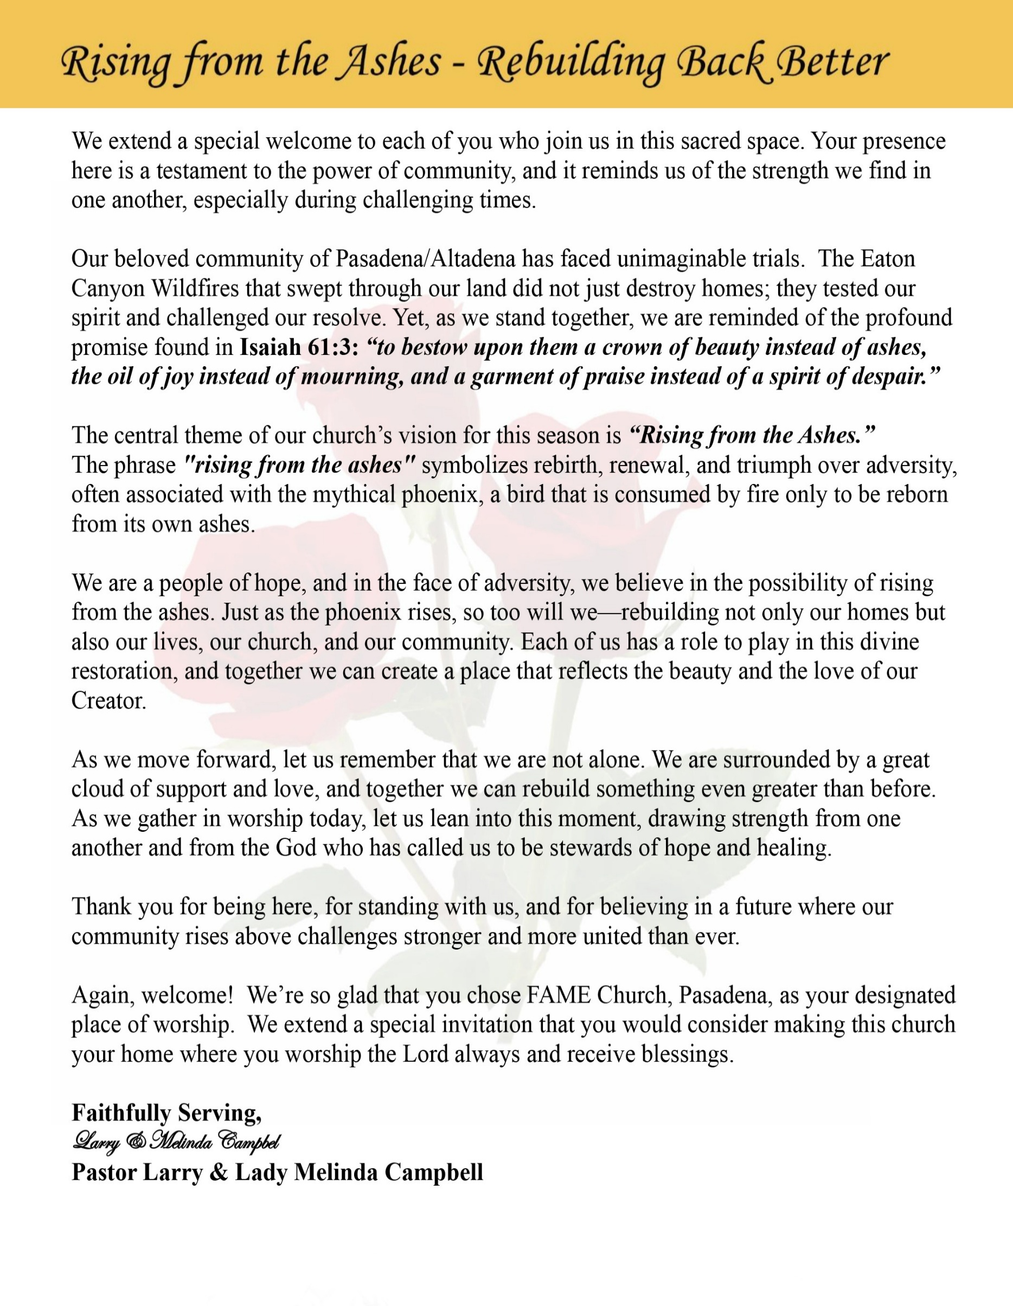

Sunday, March 22, 2026 | 9:30 a.m.

Rt. Rev. Francine A. Brookins, Esq., Presiding Bishop
Rev. Miriam Burnett, MD, MPH, Supervisor of Missions
Rev. Roosevelt Lindsey, Jr. Presiding Elder

The Rev. Dr. Larry E. Campbell ~ Senior Pastor ~ Minister

Mobile: (951) 587-1894 ~ Email: larrycampbell@famepasadena.org

Our First Lady: Mrs. Melinda G. Campbell

The Reverend Dr. Jennifer Oliver ~ Itinerant Elder -
The Reverend Dr. Nikia Smith-Robert ~ Itinerant Elder (Affiliated)
The Reverend Lois Woodard ~ Itinerant Elder Superannuated (Retired)
The Reverend Rochelle Wright Moore ~ Itinerant Deacon
The Reverend Deborah West-Jones ~ Local Elder
The Reverend Philis J. Griffin, MDiv ~ Local Elder
Dr. Phyllis Beech ~ Evangelist
Sister Tessie Bonner ~ Deaconess

Community Resource Center Director ~ Ms. Kischchen Hazelton Venerable
Church Administrative Assistant: Ms. Letha Rhymes

Church Office Hours:
Tue - Wed 9:00 am - 5:00 pm, & Fri 9:00 am -3:00 pm.
Closed for Lunch Daily: 12:00 pm - 1:00 pm.

Music Ministry
Dr. Timothy Davis, Minister of Music
Bro. Jimmy Watlington, Percussionist ~ Bro. Carlos Caldwell, Organist
Bro. Darien Dorsey, Keyboardist
Sis. Karen Law, Women’s Chorus Director ~ Sis. Tonia Graham, Children’s Choir Director
Bro. J. Renard Washington, New Generation’s Choir

FREE WI-FI service is available on the FAME Campus by accessing FAME 1700
Password: 6267980503

-3-

~ Order of Worship Experience ~
Warning: This order of worship is subject to change without warning or prior notice --- everything is governed by the Sovereignty of the Holy Spirit.

Annual Women’s Day Celebration
Women Planted with Purpose

+ + + The Altar Call +++
Praise & Worship

Doxology: “Praise God From Whom All Blessings Flow”

The Call to Worship Sis. Johnanne Washington
Leader: I was glad when they said unto me, let us go into the house of the Lord, our feet shall stand within Thy gates O Jerusalem! (Psalm 122:1)

People: For a day in Thy courts is better than a thousand. I had rather be a doorkeeper in the house of my God than to dwell in the tents of wickedness. (Psalm 84:10)

Leader: Because of the house of the Lord our God, I will seek Thy good.
(Psalm 122:9)

People: Those that be planted in the house of the Lord, shall flourish in the courts of our God. (Psalm 92:13)

Leader: Blessed are they that dwell in Thy house. Lord, I have loved Thy habitation, the place where Thy honor dwelleth. (Psalm 26:8)

People: For the Lord is in His holy temple; let all the earth keep silence before Him.
(Habakkuk 2:20)

Leader: Let the words of my mouth and the meditation of my heart, be acceptable in Thy sight, O Lord my strength and my redeemer. (Psalm 19:14)

Unison: O Sing unto the Lord a new song, for He has done marvelous things. Make a
joyful noise unto the Lord, all the earth, sing His praises. (Psalm 98:1, 4)

-4-

The Hymn of Praise A.M.E. Hymnal #525
What a Fellowship, What a Joy Divine
(Leaning on the Everlasting Arms)

Words: Elisha A. Hoffman, 1839-1929

What a fellowship, what a joy divine,
Leaning on the everlasting arms;
What a blessedness, what a peace is mine,
Leaning on the everlasting arms.

Refrain

Leaning (Leaning on Jesus,) Leaning (Leaning on Jesus,)
Safe and secure from all alarms;
Leaning (Leaning on Jesus,) Leaning (Leaning on Jesus,)
Leaning on the everlasting arms.

Refrain

O how sweet to walk in this pilgrim way,
Leaning on the everlasting arms;
O, how bright the path grows from day to day,
Leaning on the everlasting arms.

Refrain

What have I to dread,
What have I to fear,
Leaning on the everlasting arms?
I have blessed peace with my Lord so near,
Leaning on the everlasting arms.

Refrain

The Invocation Sis. Robin Houston

Ministry of Music The Women’s Chorus

-5-

Scripture Lesson Sis. Debra Ray
Please stand for the reading of God’s Word
Old Testament
Jeremiah 17:5-8 (New International Version) — Planted with Purpose
⁵ This is what the Lord says:
“Cursed is the one who trusts in man,
who draws strength from mere flesh
and whose heart turns away from the Lord.
⁶ That person will be like a bush in the wastelands;
they will not see prosperity when it comes.
They will dwell in the parched places of the desert,
in a salt land where no one lives.
⁷ “But blessed is the one who trusts in the Lord,
whose confidence is in him.
⁸ They will be like a tree planted by the water
that sends out its roots by the stream.
It does not fear when heat comes; its leaves are always green.
It has no worries in a year of drought and never fails to bear fruit.”

New Testament Sis. Kim Rogers
Colossians 2:6-8 (New International Version) — Planted with Purpose
⁶ So then, just as you received Christ Jesus as Lord, continue to live your lives in him, ⁷ rooted and built up in him, strengthened in the faith as you were taught, and overflowing with thankfulness.
⁸ See to it that no one takes you captive through hollow and deceptive philosophy, which depends on human tradition and the elemental spiritual forces^{[a]} of this world rather than on Christ.

Occasion Miss Dana Dynamite Hazelton
Abbreviated Announcements/Visitor’s Welcome

Pastor’s Remarks

Special Congregational Hymn (Sing along)
#387 Just a Closer Walk with Thee

-6-

Tithes, Gifts, and Offering Litany (Responsive) Sis. Florentine Shirley - Steward
Leader: People of God, the earth is the Lord’s and the fullness thereof. Everything we have comes
from the gracious hand of God.

People: And because God has been good to us, we come to worship Him with our giving.

Leader: The scripture declares in Malachi 3:10, “Bring the whole tithe into the storehouse, that
there may be food in my house.”

People: Lord, we bring our tithes because we trust Your promise and honor Your Word.

Leader: God has blessed us with life, health, strength, and provisions we did not earn on our own.

People: So we give back to God with grateful hearts.

Leader: When we give, we support the work of the Kingdom—feeding the hungry, helping the
hurting, and strengthening the ministry of the church.

People: Our gifts become seeds that bless our community and glorify God.

Leader: The Word reminds us in 2 Corinthians 9:7, “God loves a cheerful giver.”

People: So we give not grudgingly, but joyfully.

Leader: If God has opened doors for you…

People: We give Him praise through our giving.

Leader: If God has made a way out of no way…

People: We give Him honor through our giving.

Leader: If God has kept you through danger seen and unseen…

People: We give Him glory through our giving.

Leader: Because the truth is—God has been better to us than we have been to ourselves.

People: And we cannot beat God giving, no matter how hard we try.

Leader: Let us now bring our tithes, gifts, and offerings as an act of worship unto the Lord.

All Together: All things come of Thee, O Lord, and of Thine own have we given Thee. Amen

The following Electronic GIVING Platforms are creditable methods to GIVE to FAME:

#1. GIVELIFY - Mobile Giving App available on the App Store. It’s easy to set up, just follow the guidelines.
#2. Cash App: $FirstAMEPASADENA
#3. Mail in your Tithes & Offering - If you would like to mail your tithes and offering by check or money order, please send it to: First AME Church, 1700 N. Raymond Avenue, Pasadena, CA 91103.
#4. Drop off your Tithes & Offering - During business hours in the basket outside of the office.

Choral Response: “All things come of Thee, O Lord; and of Thine own have we given Thee. Amen.”

-7-

Women’s Day Litany Sis. Vickie Reece-Simeon
Leader: This litany celebrates women as carriers of God’s grace and Sowers of hope, recognizing
their courage, strength, and nurturing spirit. It honors the diverse roles women play in
nurturing communities and planting seeds of change for a more just world. For the
women who came before us, who planted seeds of faith, justice, and courage in the hardest
soil,

People: We thank you, O God, for the seeds they sowed.

Leader: For the mothers, grandmothers, aunties, mentors and those who stood in the gap…those
who cultivate seeds of love and wisdom in our hearts,

People: We thank you, O God, for the seeds they sowed.

Leader: For the women who stand on the frontlines, planting seeds of hope in conflict
zones, and forgotten places,

People: We thank you, O God, for the seeds they sowed.

Leader: For the quiet creators, innovators, and workers who sow seeds of intelligence and
ingenuity,

People: We thank you, O God, for the seeds they sowed.

Leader: For the prophetic voices who sowed seeds of justice and truth, challenging us to grow,

People: We thank you, O God, for the seeds they sowed.

Leader: For the women who nurture our communities, fostering seed of compassion and
community,

People: We thank you, O God, for the seeds they sowed.

Leader: For all women who, like Sowers in the parable, scatter seeds in the kingdom, trusting in a
future harvest,

People: We thank you, O God, for the seeds they sowed.

Leader: Let us pray, creator God, bless all women and empower us to continue sowing seeds of
life. May our efforts, great and small, bring forth a harvest of peace, equality and joy.

ALL: AMEN
Sermonic Selection The Women’s Chorus

Introduction of Guest Preacher Lady Melinda Campbell

The Preached Word The Reverend Sheriolyn Curry-Hodge
Presiding Elder, Mountain Valley District, Desert Mountain Annual Conference
The Invitation to Discipleship

The Seed Planting Ceremony
The Doxology

The Benediction

-8-

Scripture of the Day
Planted with Purpose. “But blessed is the one who trusts in the Lord, whose confidence is in him. They will be like a tree planted by the water that sends out its roots by the stream. It does not fear when heat comes; its leaves are always green. It has no worries in a year of drought and never fails to bear fruit.” Jeremiah 17:7-8

Quote of the Day
“When God plants you in your purpose, there’s nothing like it. He guides, provides, and defends those who walk in His plan. When you’re walking in the purpose God has for you, you don’t have to strive—He’ll open the right doors, bring the right people, and protect what He’s called you to do.” Brenda Kunneman

Thought of the Week
Planted With a Purpose
Scripture: Colossians 2:6–7, “So then, just as you received Christ Jesus as Lord, continue to live your lives in him, rooted and built up in him, strengthened in the faith as you were taught, and overflowing with thankfulness.”
Just as a tree must be rooted in good soil to grow strong, our lives must be rooted in Christ. When we stay connected to Him, our faith grows deeper and our lives begin to bear fruit.
God plants us in places and seasons where our roots can grow stronger and our faith can mature. When we remain grounded in Christ, we are strengthened, encouraged, and able to bless others.
Remember: When you are rooted in Christ, your life is always planted with a purpose

Humor of the Week
A woman, cranky because her husband was late coming home again, decided to leave a note, saying, "I've had enough and have left you. Don't bother coming after me.”
Then she hid under the bed to see his reaction.
After a short while, the husband comes home and she could hear him in the kitchen before he comes into the bedroom. She could see him walk towards the dresser and pick up the note.
After a few minutes, he wrote something on it before picking up the phone and calling someone.
"She's finally gone...yeah I know, about bloody time, I'm coming to see you, put on that sexy French nightie.
I love you...can't wait to see you.”
He hung up, grabbed his keys and left.
She heard the car drive off as she came out from under the bed.
Seething with rage and with tears in her eyes she grabbed the note to see what he wrote...
"I can see your feet.
We're outta bread: be back in five minutes.
HOME DAILY BIBLE READINGS
March 23, 2026 – March 29, 2026 (Week 27, Zephaniah)
Monday Day 183 Lamentations 4-5, Psalm 75:6-10
Tuesday Day 184 Ezekiel 1-4, Psalm 76:1-6
Wednesday Day 185 Ezekiel 5-8, Psalm 76:7-12
Thursday Day 186 Ezekiel 9-12, Psalm 77:1-6
Friday Day 187 Ezekiel 13-15, Psalm 77:7-12
Saturday Day 188 Ezekiel 16-17, Psalm 77:13-20
Sunday Day 189 Ezekiel 18-20, Psalm 78:1-8

-9-

ANNOUNCEMENTS

WELCOME! WELCOME! WELCOME! It is with great pleasure and joy that we officially welcome Lamont Coleman, Marvis Derrick, Ashely Kyles, Jaleah Lewis, Xavion Lewis and Taylor Bell to the FAME Family kinship. We are truly blessed and very grateful for her presence and valued membership in our church family.

Dear FAME Church Family,
On this special Women’s Day, we give thanks to God for the faithful women whose lives and witness strengthen our church, families, and community. Scripture reminds us in Jeremiah 17:7–8 that those who trust in the Lord are “like a tree planted by the waters,” and in Colossians 2:6–7 we are encouraged to remain “rooted and built up in Christ.”

Today we celebrate women who are deeply rooted in faith—women who pray, serve, nurture, and lead with grace and courage. Like trees planted by living waters, their faith continues to bear fruit and inspire generations.

We thank God for the powerful witness of women whose trust in the Lord sustains the life and ministry of the church. May God continue to strengthen and bless every woman as she remains rooted in Christ and flourishing in His grace.
Grace and Peace,
Pastor Larry E. Campbell

5th District at the Altar together
Rise Up & Pray
6:00 PM Pacific Every Sunday
The Southern California Annual Conference is leading the prayer sessions during March.
March Leadership Schedule
March 1 — SCC Ministerial Alliance (SCCMA)
March 8 — SCAC Laity Organization
March 15 — SCC WMS / YPD
March 22 — SCC Women In Ministry
March 29 — SCC Sons of Allen

Meeting ID 817 7575 8872, Password - Music
Let us seize this moment as a conference family. When we rise together in prayer, we position ourselves for revival, wisdom, and breakthrough. Let’s fill the room. Let’s lift one voice. Let’s Rise Up and Pray.

-10-

ANNOUNCEMENTS (Continued)

Everyone is encouraged to join our weekly Christian Education Sessions

VIRTUAL ADULT CHURCH SCHOOL
Sunday Mornings at 8:00 a.m.
http://us02web.zoom.us/j/844840183?pwd-sm0w1yvmvhOvC13175urZ2vr7M3EtU.1

HYBRID PASTOR’S WEEKLY BIBLE STUDY
Wednesdays at 11:00 a.m.
https://us02web.zoom.us/j/84484840183?pwd=sm0w1yvmvhOvC13l75urZ2vr7M3EtU.1
Meeting ID: 844 8484 0183 | Passcode: 357260

WEEKLY TELECONFERENCE PRAYERS SESSIONS
Wednesdays at 5:30 a.m. and 6:00 p.m.
Conference Call Number: (530) 881-1212
Access Code: 234575160#

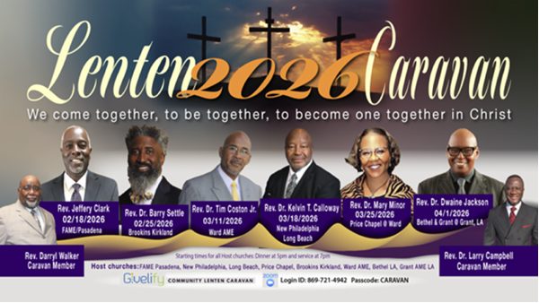3/25/26
Rev. Dr. Mary Minor
Price Chapel @ Ward AME

4/01/26
Rev. Dr. Dwaine Jackson
Bethel AME & Grant AME at
Grant AME Church

-11-

ANNOUNCEMENTS (Continued)

Stewardship & Finance Committee Meeting
Thursday, March 26, 2026 | 7:00 p.m.

Official Board Meeting
Tuesday, March 31, 2026 | 7:00 p.m.

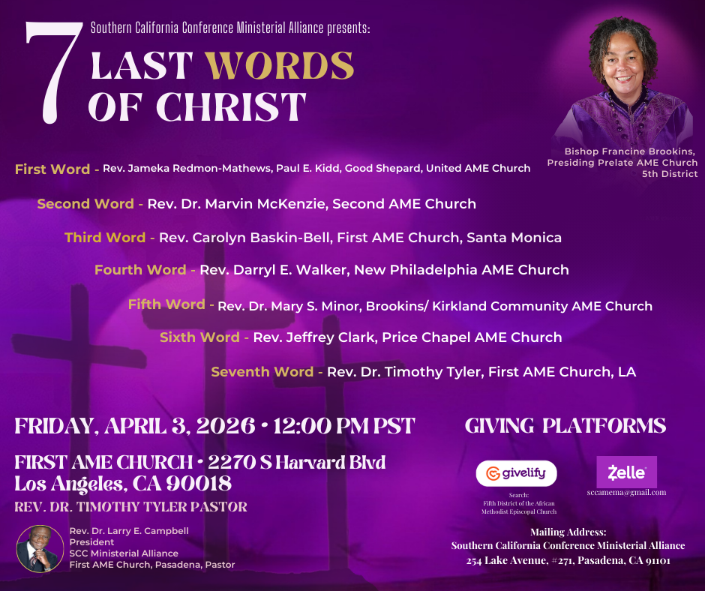

Resurrection Sunday
Sunrise Service
Sponsored by the Interdenominational Ministerial Alliance of Greater Pasadena
Sunday, April 5, 2026 | 6:00 a.m.
First A.M.E. Church, Pasadena

RESURRECTION SUNDAY SCHEDULE
April 5, 2026
8:00 a.m. ~ Children & Youth Easter Program
9:30 a.m. ~ Resurrection Service

-12-

Prayer Request(s)
Please notify the Church Office of Sick & Shut-in additions, deletions, or status/address changes.

Bishop Francine A. Brookins, Esq. Supervisor Miriam Burnett, MD
Presiding Elder Roosevelt & Dr. Kaye Lindsey Rev. Dr. Larry & Melinda Campbell
Richard Craig Hazel Clark Erica Woodard Jason Shirley Joshua Shirley Julian Shirley Ayanna Terry Cheryl Jamerson Gwendolyn Flowers Andrea Anderson Ocilda Files Danielle Clark Donita Towler Rev. Charles Brooks Doris Bailey Kimberly Woods Cynithia Grace Zechariah Robinson Diane Jordan Christopher McCarthy Wilma Haynes Jewell Malloy Calle Burns Noel Johnson Brittney Petty Taylor Family Deborah Burton Nettie McChristen Jacquelyn Walker Carita Smith
Rev. Rochelle Moore Lorene Butler Stella Pulliam Collette Blizzard The Caple Family Donita Towler
The Eaton Canyon Fire Victims Selene Cox Mel Beech

College Students

Let’s continue to support and pray for our beloved College Students

Isaiah Crowell Alecia Davis Chase Johnson Grant Blizzard

Tyler Johnson Richard Jones Tyrikk Lawson Makia Rose Talbert Isaiah Ringo Journey Rogers Elyse Sharp Kylee Sharp Zion Otano Elise Tervalon Grace Jones Jordan Patterson Kimberly Robinson Donovan Williams Jasmine Collins Brandon Bates Gabriel Blizzard

Sick and Shut-Ins
Andrew Oliver 1405 N. Roosevelt Avenue. Pasadena, CA 91104
Bettina Ayers Pasadena Meadows Nursing Home, 150 Bellefontaine St., Pas., CA 91105
Bobby Thomas 1052 E. Morada Place, Altadena, CA 91001
Carrie Wynne Senior Living Heritage, 161 N. Hemet St., Hemet, CA 92545
Doris Curd 11619 Woodcock Avenue, San Fernando, CA 91340
Edmund Riddle Active Care Mission Bay, 2440 Grand Avenue, San Diego, CA 92109
Eleanor Towler 975 E. Union Street, Unit #417, Pasadena, CA 91106
Elois Blizzard P. O. Box 3646, So. Pasadena, CA 91031
Emily Cormier-Ross 2549 La Fiesta Avenue, Altadena, CA 91001
Ernestine English 26 W. Fair Oaks Drive, Pasadena, CA 91103
Fred Caple 51 North 15th Street Haledon, NJ 07508
Gloria Cubit Clay 11745 Pierce St., Lake View Terrace, CA 91342
Hugh Hamberry 19225 Chole Rd., Apple Valley, CA 92307
Jeff Thomas 603 Tocino Dr. Duarte, CA 91010 | Mountain View Terrace
Jessie Smith 3925 S Jones BL, Apt 2118 Las Vegas, NV 89103| Spring Valley Community
Josephine Brown 15607 Saddleback Rd, Riverside, CA 92506
Linnie G. Nollie 2250 E. New York Drive, Altadena, CA 91001
Malika G. Hendry P. O. Box 94082, Pasadena, CA 91109
Mildred Lewis C/O Hazel Rohr, 884 W. Jane Court, Upland, CA 91786
Norma Burnett 618 Fairview Avenue, Unit #228, Arcadia, CA 91007
Opal Hampton 1030 Chevron Court, Pasadena, CA 91103
Paul Ratliff P.O. Box 40407 Pasadena, CA 91114
Ruthie Hopkins 1155 Via Verde , San Dimas, CA 91773
Virlyn Grant 15122 Orange Ave., Paramount, CA 90723
Wanda Nelson 3618 N. Fair Oaks Avenue, Altadena, CA 91001
William Hilliard 7504 Wynstone Pl., Fontana, CA 92336
Zell L. Hill 375 Barthe Drive, Pasadena, CA 91103

-13-

Sermon Notations

Scripture: _____________________________________________________________

Subject: _______________________________________________________________

Points of the Message: ___________________________________________________
_______________________________________________________________________
_______________________________________________________________________
_______________________________________________________________________
_______________________________________________________________________
_______________________________________________________________________
_______________________________________________________________________

Main Ideas of the Sermon: ________________________________________________
_______________________________________________________________________
_______________________________________________________________________
_______________________________________________________________________
_______________________________________________________________________
_______________________________________________________________________

Illustrations I want to remember: _________________________________________
_______________________________________________________________________
_______________________________________________________________________
_______________________________________________________________________
_______________________________________________________________________
_______________________________________________________________________
_______________________________________________________________________

What should I do as a result of this Sermon? ________________________________

_____________________________________________________
_____________________________________________________
_____________________________________________________
_____________________________________________________

-14-

