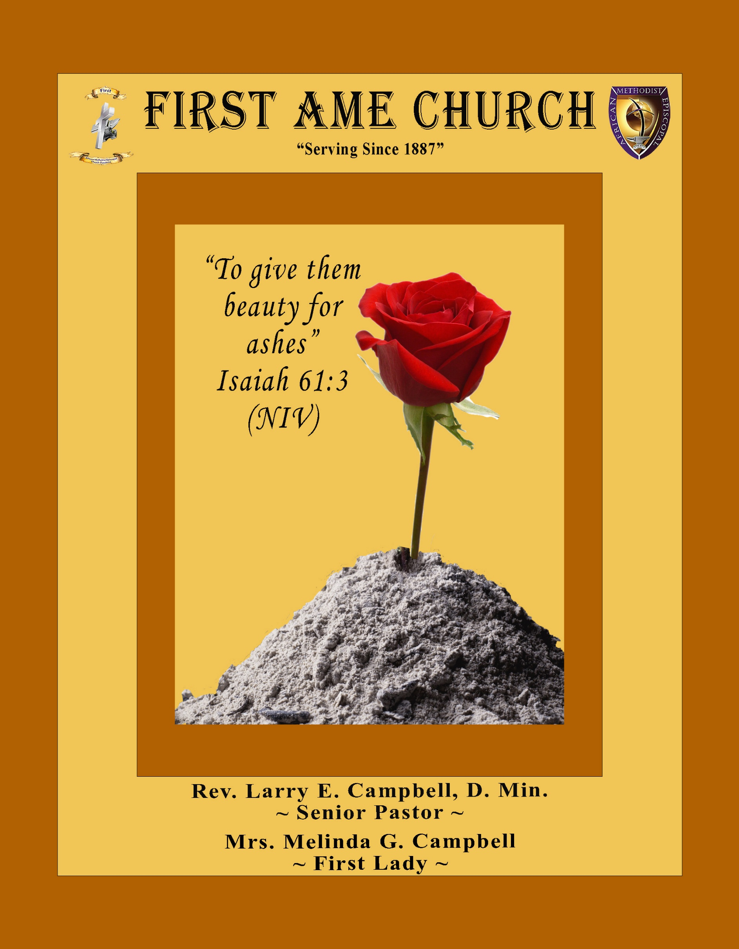
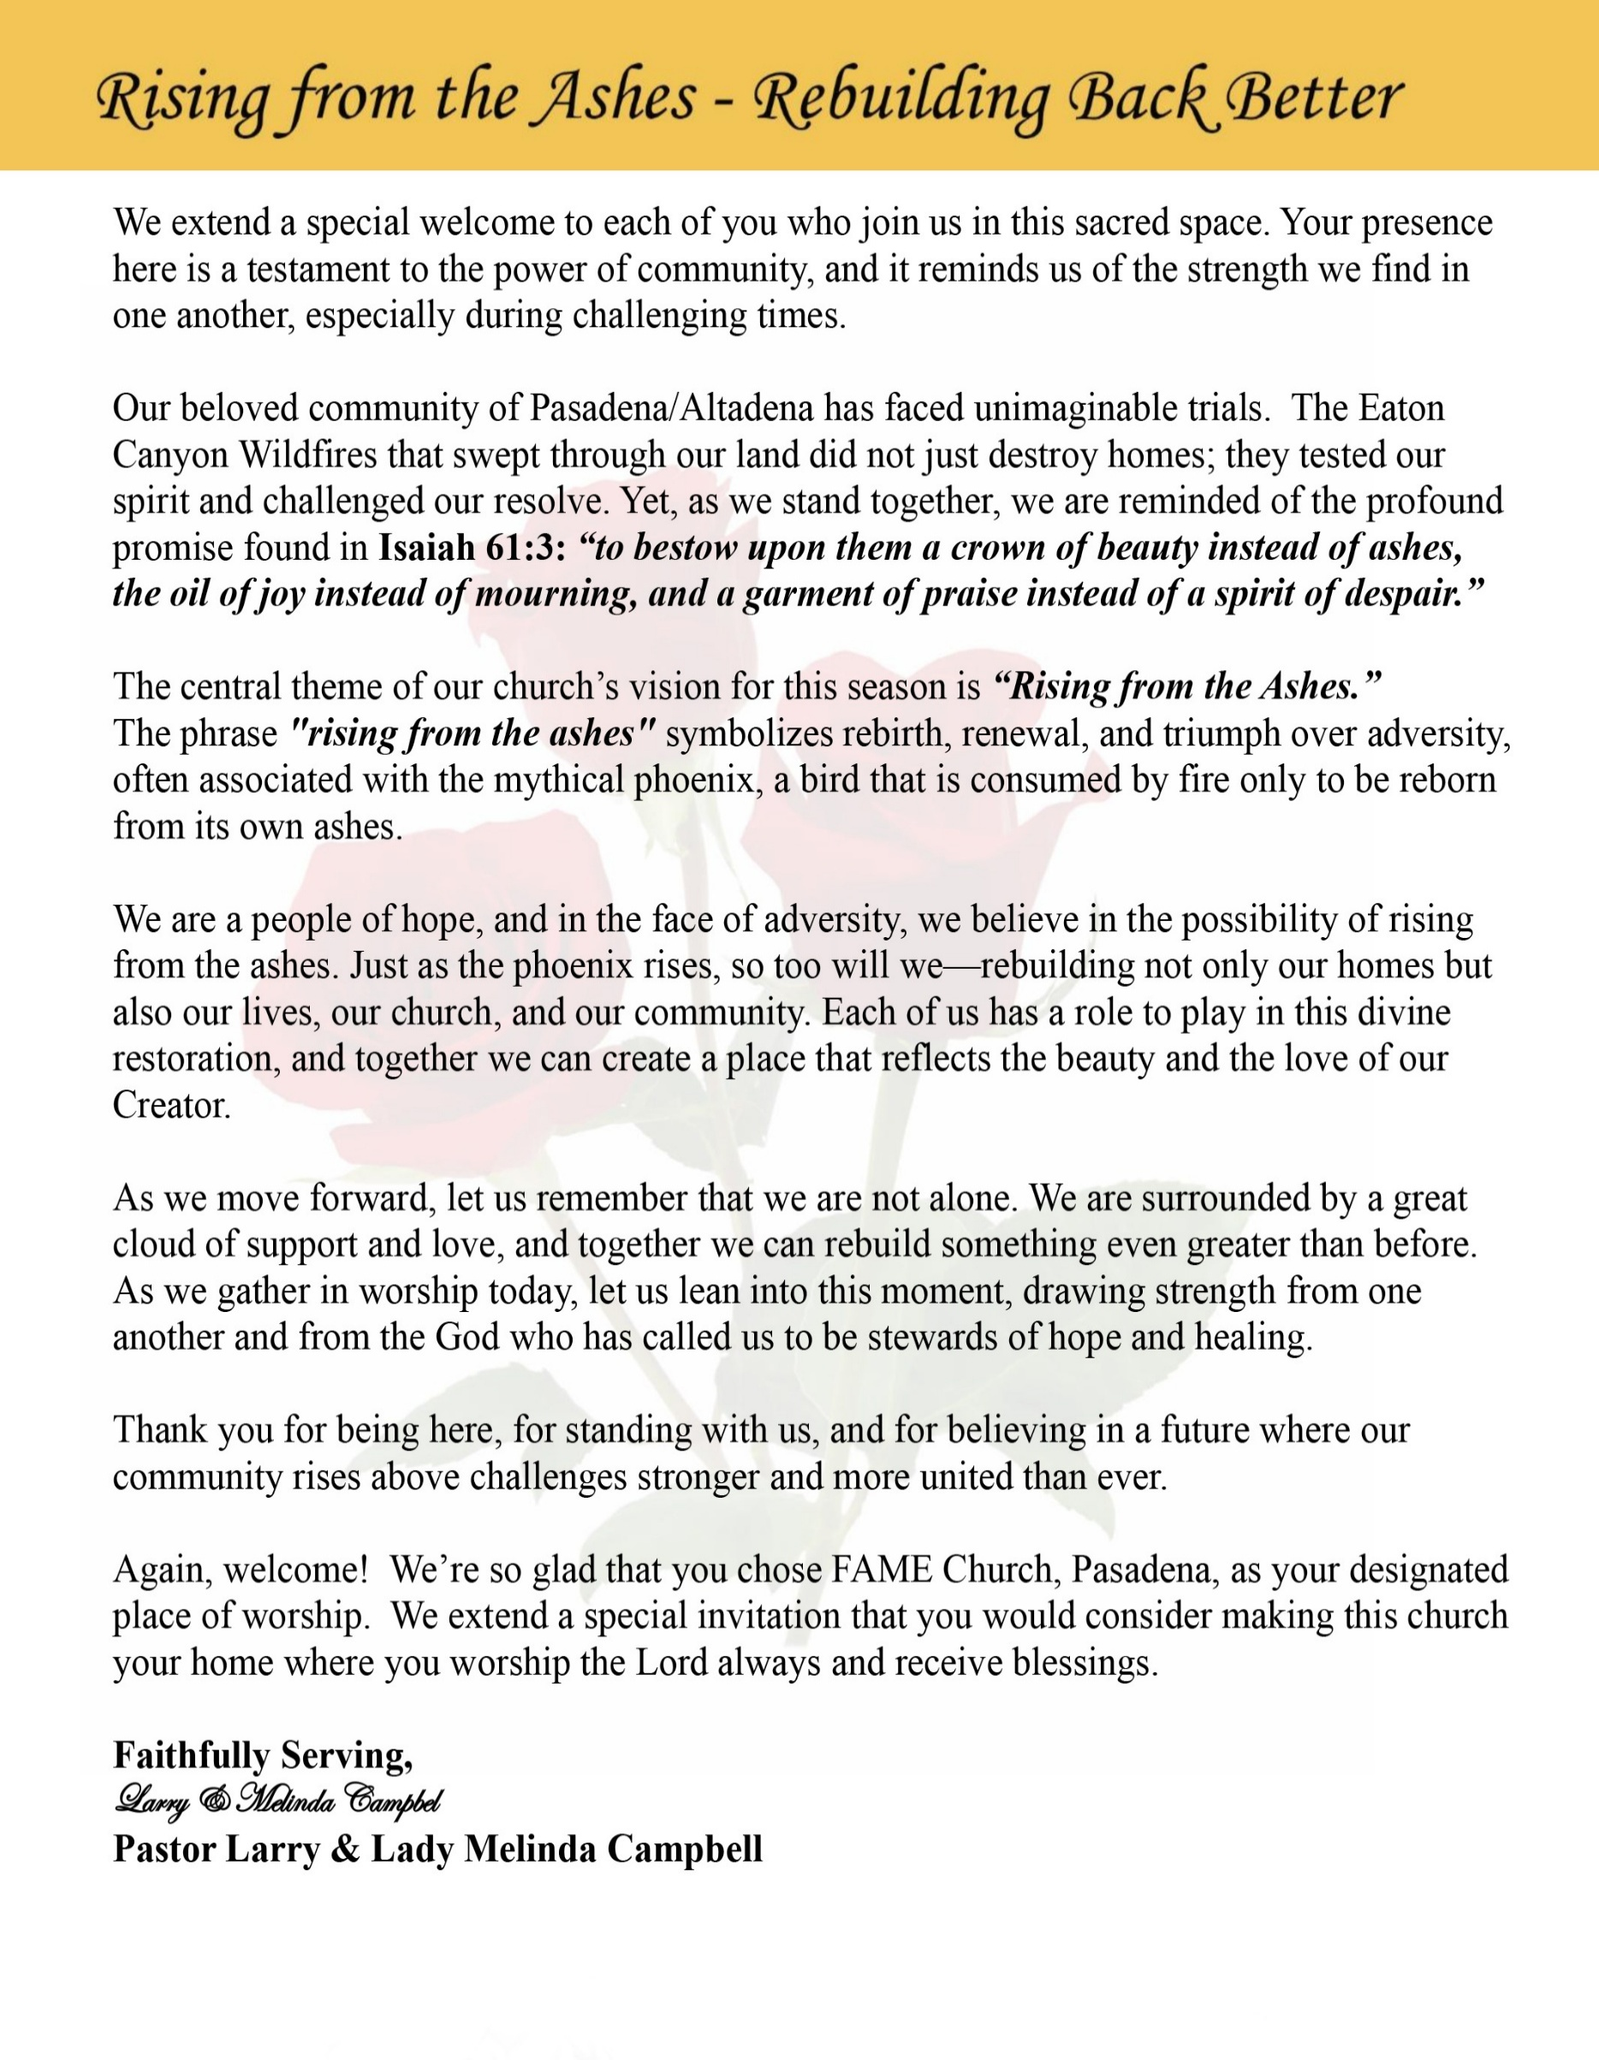

Sunday, March 29, 2026 | 9:30 a.m.

Rt. Rev. Francine A. Brookins, Esq., Presiding Bishop
Rev. Miriam Burnett, MD, MPH, Supervisor of Missions
Rev. Roosevelt Lindsey, Jr. Presiding Elder

The Rev. Dr. Larry E. Campbell ~ Senior Pastor ~ Minister

Mobile: (951) 587-1894 ~ Email: larrycampbell@famepasadena.org

Our First Lady: Mrs. Melinda G. Campbell

The Reverend Dr. Jennifer Oliver ~ Itinerant Elder -
The Reverend Dr. Nikia Smith-Robert ~ Itinerant Elder (Affiliated)
The Reverend Lois Woodard ~ Itinerant Elder Superannuated (Retired)
The Reverend Rochelle Wright Moore ~ Itinerant Deacon
The Reverend Deborah West-Jones ~ Local Elder
The Reverend Philis J. Griffin, MDiv ~ Local Elder
Dr. Phyllis Beech ~ Evangelist
Sister Tessie Bonner ~ Deaconess

Community Resource Center Director ~ Ms. Kischchen Hazelton Venerable
Church Administrative Assistant: Ms. Letha Rhymes

Church Office Hours:
Tue - Wed 9:00 am - 5:00 pm, & Fri 9:00 am -3:00 pm.
Closed for Lunch Daily: 12:00 pm - 1:00 pm.

Music Ministry
Dr. Timothy Davis, Minister of Music
Bro. Jimmy Watlington, Percussionist ~ Bro. Carlos Caldwell, Organist
Bro. Darien Dorsey, Keyboardist
Sis. Karen Law, Women’s Chorus Director ~ Sis. Tonia Graham, Children’s Choir Director
Bro. J. Renard Washington, New Generation’s Choir

FREE WI-FI service is available on the FAME Campus by accessing FAME 1700
Password: 6267980503

-3-

~ Order of Worship Experience ~

Warning: This order of worship is subject to change without warning or prior notice --- everything is governed by the Sovereignty of the Holy Spirit.


+++ The Altar Call +++

Praise & Worship

Doxology: “Praise God From Whom All Blessings Flow”

The Call to Worship Sis. Joann Fortè-Wormely- Pro tem
Leader: I was glad when they said unto me, let us go into the house of the Lord, our feet shall stand within Thy gates O Jerusalem! (Psalm 122:1)

People: For a day in Thy courts is better than a thousand. I had rather be a doorkeeper in the house of my God than to dwell in the tents of wickedness. (Psalm 84:10)

Leader: Because of the house of the Lord our God, I will seek Thy good.
(Psalm 122:9)

People: Those that be planted in the house of the Lord, shall flourish in the courts of our God. (Psalm 92:13)

Leader: Blessed are they that dwell in Thy house. Lord, I have loved Thy habitation, the place where Thy honor dwelleth. (Psalm 26:8)

People: For the Lord is in His holy temple; let all the earth keep silence before Him.
(Habakkuk 2:20)

Leader: Let the words of my mouth and the meditation of my heart, be acceptable in Thy sight, O Lord my strength and my redeemer. (Psalm 19:14)

Unison: O Sing unto the Lord a new song, for He has done marvelous things. Make a
joyful noise unto the Lord, all the earth, sing His praises. (Psalm 98:1, 4)

-4-

The Hymn of Praise A.M.E. Hymnal #5
All Hail the Power of Jesus’ Name
Words: Edward Perronet, 1726-1792

All hail the power of Jesus' Name!
Let angels prostrate fall
Bring forth the royal diadem
And crown Him, crown Him, crown Him, crown Him Lord of all
Ye chosen seed of Israel's race
Ye ransomed from the fall
Hail Him Who saves you by His grace
And crown Him, crown Him, crown Him, crown Him Lord of all
Let every kindred, every tribe
On this terrestrial ball
To Him all majesty ascribe
And crown Him, crown Him, crown Him, crown Him Lord of all
O that with yonder sacred throne
We at His feet may fall!
We'll join the everlasting song
And crown Him, crown Him, crown Him, crown Him Lord of all

The Invocation Bro. Dr. Brian K. Venerable

Ministry of Music The Praise Team

-5-

Scripture Lesson
(Please Stand for the Reading of God’s Words)

Palm Sunday Scripture Bro. Henry Sharp
Responsive Reading: Matthew 21:1-11 (NIV) Jesus Comes to Jerusalem as King
Leader: As they approached Jerusalem and came to Bethphage on the Mount of
Olives, Jesus sent two disciples, saying to them, “Go to the village ahead of you,
and at once you will find a donkey tied there, with her colt by her. Untie them and
bring them to me. If anyone says anything to you, say that the Lord needs them,
and he will send them right away.”

People: This took place to fulfill what was spoken through the prophet: “Say to Daughter
Zion, ‘See, your king comes to you, gentle and riding on a donkey, and on a colt,
the foal of a donkey.’”

Leader: The disciples went and did as Jesus had instructed them. They brought the donkey
and the colt and placed their cloaks on them for Jesus to sit on.

People: A very large crowd spread their cloaks on the road, while others cut branches
from the trees and spread them on the road. The crowds that went ahead of him
and those that followed shouted ….
“Hosanna to the Son of David!”
“Blessed is he who comes in the name of the Lord!”
“Hosanna in the highest heaven!”

Leader: When Jesus entered Jerusalem, the whole city was stirred and asked, “Who is
this?”

ALL: The crowds answered, “This is Jesus, the prophet from Nazareth in Galilee.”

The Summary of the Decalogue Bro. Charles Ludd, Jr., Esq.

LEADER: From all that dwell below the skies…
SUNG: From all that dwell below the skies, Let the Creator’s praise arise; Let the
Redeemer’s Name be sung, through every land, by every tongue.
LEADER: Hear what Christ our Savior saith, Thou shalt love the Lord thy God with all thy
heart, with all thy soul, and with all thy mind. This is the first and great
commandment. And the second is like unto it: Thou shalt love thy neighbor
as thyself. On these two commandments hang all the law and the prophets.
SUNG: Glory be to the Father, and to the Son, and to the Holy Ghost; as it was in
the beginning, is now, and ever shall be, world without end. A~Men

-6-

Abbreviated Announcements/Visitor’s Welcome

Pastor’s Remarks

Special Congregational Hymn (Sing along)
#321 Jesus, Keep Me Near the Cross

Palm Sunday Tithes, Gifts, and Offering Litany (Responsive) Sis. Anita Otaño, Trustee
Leader: On this Palm Sunday, we remember how the people laid their garments and palms
before Jesus as He entered Jerusalem.

People: We are to lay before You our gifts, our tithes, and our offerings.

Leader: With shouts of “Hosanna,” they honored the King who came in humility.

People: With grateful hearts, we honor You, O God, with all that we have.

Leader: As Christ gave Himself for the redemption of the world,

People: We give as an act of worship, surrender, and thanksgiving.

Leader: May these offerings be used to lift the lowly, restore the broken, and proclaim the
Good News.

People: May our giving reflect Your love and advance Your Kingdom.

Leader: Blessed is the One who comes in the name of the Lord.

Unison: Hosanna in the highest! We give with joy and praise. Amen.

The following Electronic GIVING Platforms are creditable methods to GIVE to FAME:

#1. GIVELIFY - Mobile Giving App available on the App Store. It’s easy to set up, just follow the guidelines.

#2. Cash App: $FirstAMEPASADENA

#3. Mail in your Tithes & Offering - If you would like to mail your tithes and offering by check or money order, please send it to: First AME Church, 1700 N. Raymond Avenue, Pasadena, CA 91103.
#4. Drop off your Tithes & Offering - During business hours in the basket outside of the office.

Choral Response: “All things come of Thee, O Lord; and of Thine own have we given Thee. Amen.”

-7-

Children’s Church Dismissal

Introduction of the Preacher Pastor Campbell

Sermonic Selection The Praise Team

Proclamation of The Word The Reverend Roosevelt Lindsey, Jr.
Presiding Elder — Los Angeles South/Las Vegas District

The Invitation (Public/Private)

How to Join First A.M.E. Church of Pasadena
PROFESSION OF FAITH. If you have never been a member of any church, you may join by professing Jesus Christ as your personal Lord and Savior.

RENEWAL OF VOWS. If you have been a member of a church at one time, but have been in active, you may join by renewing your faith in Jesus Christ as Lord and Savior.

TRANSFER. If you are a member of another African Methodist Episcopal Church and you are in good standing, you may join by requesting that your membership be transferred to the First African Methodist Episcopal Church of Pasadena.

AFFILIATE MEMBER. Sometimes an individual has reasons for keeping /his/her membership in another church but would like to be an active member of First African Methodist Episcopal Church, too. This is possible as an affiliate member.
The Doxology

The Benediction

-8-

Scripture of the Day
Palm Sunday. “Blessed is the king who comes in the name of the Lord! Peace in heaven and glory in the highest!” Luke 19:38

Quote of the Day
“Between the waving palms and the looming cross lies the mystery of a King who conquers through surrender.” — Henri Nouwen

Thought of the Week
“Blessed is the King who comes in the name of the Lord! Peace in heaven and glory in the highest!” — Luke 19:38
Palm Sunday stands as a sacred paradox—Jesus is welcomed as King with shouts of praise, yet He enters Jerusalem on a humble donkey, signaling a kingdom not built on power, but on peace, justice, and sacrificial love.
The crowd cried “Hosanna,” meaning “Save us now.” They longed for deliverance, though many did not yet understand the fullness of Christ’s mission. He came not merely to change their circumstances, but to transform their hearts and redeem their lives.
This moment calls us to examine our own response to Jesus. Do we praise Him only when He meets our expectations, or do we follow Him even when the path leads through uncertainty and sacrifice? Palm Sunday invites us to move beyond momentary celebration into committed discipleship.
As we wave our symbolic palms today, let us also lay down our burdens, our ambitions, and our need for control. Let us welcome Christ as He truly is—Savior, Servant, and Sovereign Lord.
.

Humor of the Week
Pastor Paul had been advised by his doctor to lose 30 pounds or risk serious health consequences. The good pastor took his new diet seriously, even changing his driving route to the church building to avoid his favorite bakery. One morning, however, he arrived for Bible study carrying a gigantic devil’s food cake. The class chuckled and chided him, but the good pastor’s smile remained cherubic.
“This is a very special cake,” he explained. “I accidentally drove by the bakery this morning and there in the window were a host of goodies. I felt this was no accident, so I prayed, ‘Lord, if you want me to have one of those delicious cakes, let me have a parking place directly in front of the bakery.’ And sure enough,” he continued, “the eighth time around the block, there it was!”
HOME DAILY BIBLE READINGS
March 30, 2026 – April 5, 2026 (Week 28, Haggai-Zechariah)
Monday Day 190 Ezekiel 21-22, Psalm 78:9-16
Tuesday Day 191 Ezekiel 23-24, Psalm 78:17-24
Wednesday Day 192 Ezekiel 25-27, Psalm 78:25-31
Thursday Day 193 Ezekiel 28-30, Psalm 78:32-39
Friday Day 194 Ezekiel 31-33, Psalm 78:40-49
Saturday Day 195 Ezekiel 34-36, Psalm 78:50-64
Sunday Day 196 Ezekiel 37-39, Psalm 78:65-72

-9-

ANNOUNCEMENTS

BEREAVEMENT NOTICE: We are saddened to announce the passing of Sister Carrie Wynne, beloved aunt of Sis. Jessie Smith and valued member of the FAME Church Family, on March 23, 2026. Her homegoing service is scheduled for 11:00 a.m., Tuesday, April 21, 2026, at FAME Church Pasadena. We extend our condolences to the Wynne, Smith, and Pullen families during this difficult time.

5th District at the Altar together
Rise Up & Pray
6:00 PM Pacific Every Sunday
The Southern California Annual Conference is leading the prayer sessions during March.
March Leadership Schedule
March 1 — SCC Ministerial Alliance (SCCMA)
March 8 — SCAC Laity Organization
March 15 — SCC WMS / YPD
March 22 — SCC Women In Ministry
March 29 — SCC Sons of Allen

Meeting ID 817 7575 8872, Password - Music
Let us seize this moment as a conference family. When we rise together in prayer, we position ourselves for revival, wisdom, and breakthrough. Let’s fill the room. Let’s lift one voice. Let’s Rise Up and Pray.

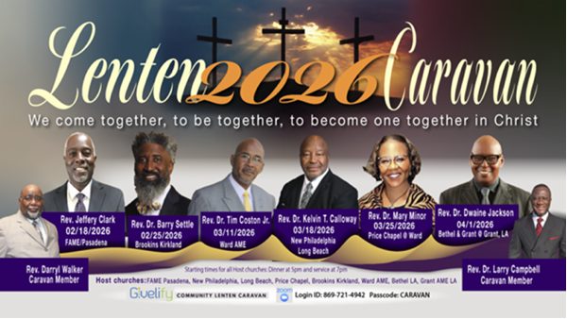4/01/26
Rev. Dr. Dwaine Jackson
Bethel AME & Grant AME at
Grant AME Church

-10-

ANNOUNCEMENTS (Continued)

Official Board Meeting
Tuesday, March 31, 2026 | 7:00 p.m.

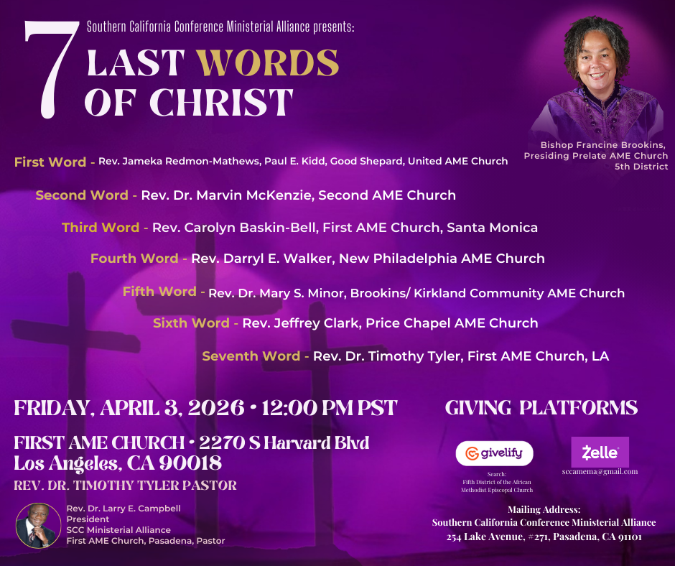
FAME RESURRECTION SUNDAY SCHEDULE
April 5, 2026
8:00 a.m. ~ Children & Youth Easter Program
9:30 a.m. ~ Resurrection Service

Southern California Arts Festival
If you are interested in participating in the Southern California Arts Festival and showcasing your talents, please see one of the following Lay members for an application: Linda Wright, Barbara Franklin, or Laura Terry. Scholarships are available.

-11-

ANNOUNCEMENTS (Continued)

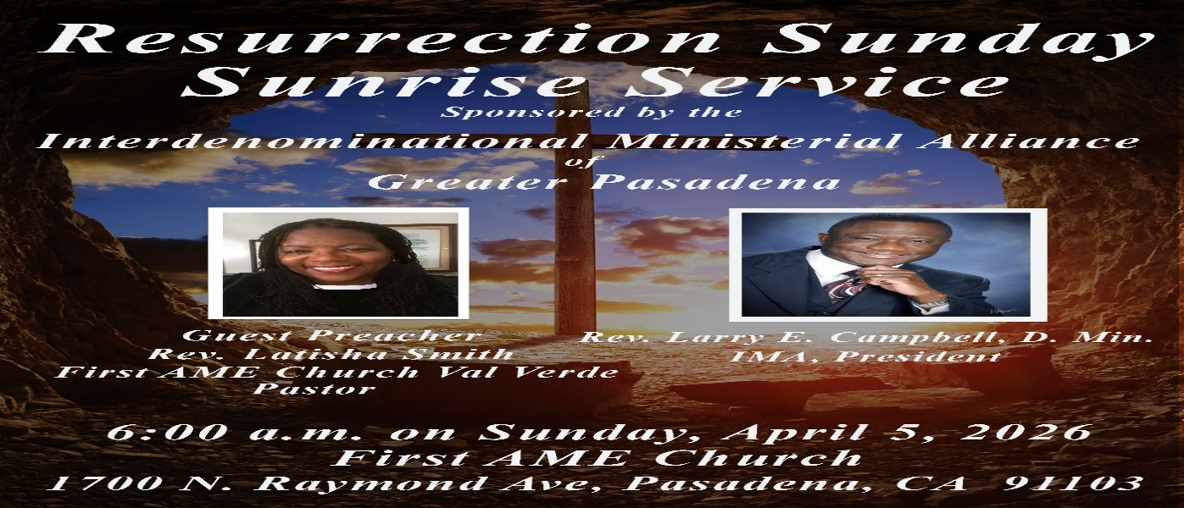

FAME Pasadena Youth Announcement
Who: Calling all FAME Pasadena YPDers, Youth, and Friends
What: Watch. Party - 5th District Virtual LTI (Leadership in Training Workshop)
Where: FAME Pasadena Church Classrooms
When: Saturday, April 11, 2026 8 - 9:00 am
Why: Join over 250 YPDer’s for connection, training, and fun!
Snacks will be provided to those who attend!
Contact: Gina Tervalon, YPD Director, 626-826-0722
Come ready to learn, grow, and be empowered for service. Your presence matters, and your leadership is needed!



-12-

Prayer Request(s)
Please notify the Church Office of Sick & Shut-in additions, deletions, or status/address changes.

Bishop Francine A. Brookins, Esq. Supervisor Miriam Burnett, MD
Presiding Elder Roosevelt & Dr. Kaye Lindsey Rev. Dr. Larry & Melinda Campbell
Richard Craig Hazel Clark Erica Woodard Jason Shirley Joshua Shirley Julian Shirley Ayanna Terry Cheryl Jamerson Gwendolyn Flowers Andrea Anderson Ocilda Files Danielle Clark Donita Towler Rev. Charles Brooks Doris Bailey Kimberly Woods Cynithia Grace Zechariah Robinson Diane Jordan Christopher McCarthy Wilma Haynes Jewell Malloy Calle Burns Noel Johnson Brittney Petty Taylor Family Deborah Burton Nettie McChristen Jacquelyn Walker Carita Smith
Rev. Rochelle Moore Lorene Butler Stella Pulliam Collette Blizzard The Caple Family Donita Towler
The Eaton Canyon Fire Victims Selene Cox Mel Beech

College Students

Let’s continue to support and pray for our beloved College Students

Isaiah Crowell Alecia Davis Chase Johnson Grant Blizzard

Tyler Johnson Richard Jones Tyrikk Lawson Makia Rose Talbert Isaiah Ringo Journey Rogers Elyse Sharp Kylee Sharp Zion Otano Elise Tervalon Grace Jones Jordan Patterson Kimberly Robinson Donovan Williams Jasmine Collins Brandon Bates Gabriel Blizzard

Sick and Shut-Ins
Andrew Oliver 1405 N. Roosevelt Avenue. Pasadena, CA 91104
Bettina Ayers Pasadena Meadows Nursing Home, 150 Bellefontaine St., Pas., CA 91105
Bobby Thomas 1052 E. Morada Place, Altadena, CA 91001
Carrie Wynne Senior Living Heritage, 161 N. Hemet St., Hemet, CA 92545
Doris Curd 11619 Woodcock Avenue, San Fernando, CA 91340
Edmund Riddle Active Care Mission Bay, 2440 Grand Avenue, San Diego, CA 92109
Eleanor Towler 975 E. Union Street, Unit #417, Pasadena, CA 91106
Elois Blizzard P. O. Box 3646, So. Pasadena, CA 91031
Emily Cormier-Ross 2549 La Fiesta Avenue, Altadena, CA 91001
Ernestine English 26 W. Fair Oaks Drive, Pasadena, CA 91103
Fred Caple 51 North 15th Street Haledon, NJ 07508
Gloria Cubit Clay 11745 Pierce St., Lake View Terrace, CA 91342
Hugh Hamberry 19225 Chole Rd., Apple Valley, CA 92307
Jeff Thomas 603 Tocino Dr. Duarte, CA 91010 | Mountain View Terrace
Jessie Smith 3925 S Jones BL, Apt 2118 Las Vegas, NV 89103| Spring Valley Community
Josephine Brown 15607 Saddleback Rd, Riverside, CA 92506
Linnie G. Nollie 2250 E. New York Drive, Altadena, CA 91001
Malika G. Hendry P. O. Box 94082, Pasadena, CA 91109
Mildred Lewis C/O Hazel Rohr, 884 W. Jane Court, Upland, CA 91786
Norma Burnett 618 Fairview Avenue, Unit #228, Arcadia, CA 91007
Opal Hampton 1030 Chevron Court, Pasadena, CA 91103
Paul Ratliff P.O. Box 40407 Pasadena, CA 91114
Ruthie Hopkins 1155 Via Verde , San Dimas, CA 91773
Virlyn Grant 15122 Orange Ave., Paramount, CA 90723
Wanda Nelson 3618 N. Fair Oaks Avenue, Altadena, CA 91001
William Hilliard 7504 Wynstone Pl., Fontana, CA 92336
Zell L. Hill 375 Barthe Drive, Pasadena, CA 91103

-13-

Sermon Notations

Scripture: _____________________________________________________________

Subject: _______________________________________________________________

Points of the Message: ___________________________________________________
_______________________________________________________________________
_______________________________________________________________________
_______________________________________________________________________
_______________________________________________________________________
_______________________________________________________________________
_______________________________________________________________________

Main Ideas of the Sermon: ________________________________________________
_______________________________________________________________________
_______________________________________________________________________
_______________________________________________________________________
_______________________________________________________________________
_______________________________________________________________________

Illustrations I want to remember: _________________________________________
_______________________________________________________________________
_______________________________________________________________________
_______________________________________________________________________
_______________________________________________________________________
_______________________________________________________________________
_______________________________________________________________________

What should I do as a result of this Sermon? ________________________________

_____________________________________________________
_____________________________________________________
_____________________________________________________
_____________________________________________________

-14-

