
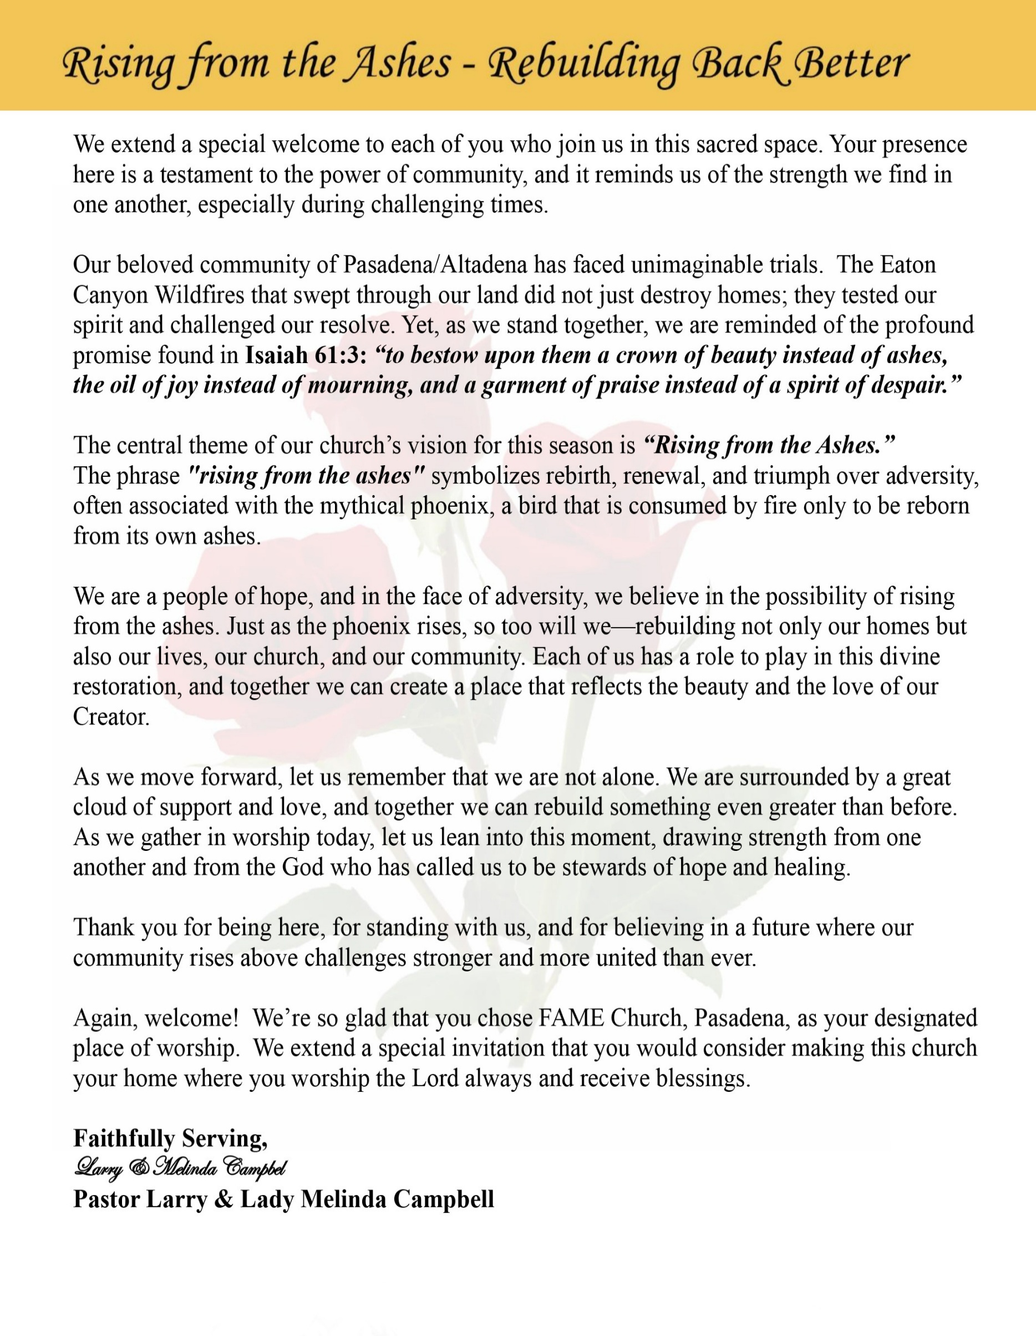

Sunday, March 8 2026 | 9:30 a.m.

Rt. Rev. Francine A. Brookins, Esq., Presiding Bishop
Rev. Miriam Burnett, MD, MPH, Supervisor of Missions
Rev. Roosevelt Lindsey, Jr. Presiding Elder

The Rev. Dr. Larry E. Campbell ~ Senior Pastor ~ Minister

Mobile: (951) 587-1894 ~ Email: larrycampbell@famepasadena.org

Our First Lady: Mrs. Melinda G. Campbell

The Reverend Dr. Jennifer Oliver ~ Itinerant Elder -
The Reverend Dr. Nikia Smith-Robert ~ Itinerant Elder (Affiliated)
The Reverend Lois Woodard ~ Itinerant Elder Superannuated (Retired)
The Reverend Rochelle Wright Moore ~ Itinerant Deacon
The Reverend Deborah West-Jones ~ Local Elder
The Reverend Philis J. Griffin, MDiv ~ Local Elder
Dr. Phyllis Beech ~ Evangelist
Sister Tessie Bonner ~ Deaconess

Community Resource Center Director ~ Ms. Kischchen Hazelton Venerable
Church Administrative Assistant: Ms. Letha Rhymes

Church Office Hours:
Tue - Wed 9:00 am - 5:00 pm, & Fri 9:00 am -3:00 pm.
Closed for Lunch Daily: 12:00 pm - 1:00 pm.

Music Ministry
Dr. Timothy Davis, Minister of Music
Bro. Jimmy Watlington, Percussionist ~ Bro. Carlos Caldwell, Organist
Bro. Darien Dorsey, Keyboardist
Sis. Karen Law, Women’s Chorus Director ~ Sis. Tonia Graham, Children’s Choir Director
Bro. J. Renard Washington, New Generation’s Choir

FREE WI-FI service is available on the FAME Campus by accessing FAME 1700
Password: 6267980503

-3-

~ Order of Worship Experience ~
Warning: This order of worship is subject to change without warning or prior notice --- everything is governed by the Sovereignty of the Holy Spirit.



+ + + The Altar Call +++
Praise & Worship

Doxology: “Praise God From Whom All Blessings Flow”

The Call to Worship Sis. Jessica Ludd, Esq.
Leader: I was glad when they said unto me, let us go into the house of the Lord, our feet shall stand within Thy gates O Jerusalem! (Psalm 122:1)

People: For a day in Thy courts is better than a thousand. I had rather be a doorkeeper in the house of my God than to dwell in the tents of wickedness. (Psalm 84:10)

Leader: Because of the house of the Lord our God, I will seek Thy good.
(Psalm 122:9)

People: Those that be planted in the house of the Lord, shall flourish in the courts of our God. (Psalm 92:13)

Leader: Blessed are they that dwell in Thy house. Lord, I have loved Thy habitation, the place where Thy honor dwelleth. (Psalm 26:8)

People: For the Lord is in His holy temple; let all the earth keep silence before Him.
(Habakkuk 2:20)

Leader: Let the words of my mouth and the meditation of my heart, be acceptable in Thy sight, O Lord my strength and my redeemer. (Psalm 19:14)

Unison: O Sing unto the Lord a new song, for He has done marvelous things. Make a
joyful noise unto the Lord, all the earth, sing His praises. (Psalm 98:1, 4)

-4-

The Hymn of Praise A.M.E. Hymnal #272

Pass Me Not, O Gentle Savior

Words: Fanny J. Crosby, 1820-1915
Tune: William H. Doane, 1832-1915

1 Pass me not, O gentle Savior,
hear my humble cry;
While on others Thou art calling,
do not pass me by.

Refrain:
Savior, Savior, hear my humble cry;
while on others Thou art calling,
do not pass me by.

2 Let me at a throne of mercy
find a sweet relief,
kneeling there in deep contrition;
help my unbelief.
[Refrain]

3 Trusting only in Thy merit,
Would I seek Thy face;
heal my wounded, broken spirit,
save me by Thy grace.
[Refrain]

4 Thou, the Spring of all my comfort,
more than life to me;
Whom have I on earth beside Thee?
Whom in heav'n but Thee?
[Refrain]

The Invocation Dr. Timothy Davis, Jr., Minister of Music

Ministry of Music The Praise Team

-5-

Scripture Lesson Sis. Jennifer C. Duval Jackson, Esq.
(Please Stand for the Reading of God’s Words)
Esther 4 (New International Version) —Mordecai Persuades Esther to Help
Leader: When Mordecai learned of all that had been done, he tore his clothes, put on sackcloth and
ashes, and went out into the city, wailing loudly and bitterly. ² But he went only as far as
the king’s gate, because no one clothed in sackcloth was allowed to enter it.

People: ³ In every province to which the edict and order of the king came, there was great
mourning among the Jews, with fasting, weeping and wailing. Many lay in sackcloth
and ashes.

Leader: ⁴ When Esther’s eunuchs and female attendants came and told her about Mordecai, she was
in great distress. She sent clothes for him to put on instead of his sackcloth, but he would
not accept them. ⁵ Then Esther summoned Hathak, one of the king’s eunuchs assigned to
attend her, and ordered him to find out what was troubling Mordecai and why.

People: ⁶ So Hathak went out to Mordecai in the open square of the city in front of the king’s
gate. ⁷ Mordecai told him everything that had happened to him, including the exact
amount of money Haman had promised to pay into the royal treasury for the
destruction of the Jews. ⁸ He also gave him a copy of the text of the edict for their
annihilation, which had been published in Susa, to show to Esther and explain it to
her, and he told him to instruct her to go into the king’s presence to beg for mercy and
plead with him for her people.

Leader: ⁹ Hathak went back and reported to Esther what Mordecai had said. ¹⁰ Then she instructed
him to say to Mordecai, ¹¹ “All the king’s officials and the people of the royal provinces
know that for any man or woman who approaches the king in the inner court without being
summoned the king has but one law: that they be put to death unless the king extends the
gold scepter to them and spares their lives. But thirty days have passed since I was called to
go to the king.”

People: ¹² When Esther’s words were reported to Mordecai, ¹³ he sent back this answer: “Do
not think that because you are in the king’s house you alone of all the Jews will
escape. ¹⁴ For if you remain silent at this time, relief and deliverance for the Jews will
arise from another place, but you and your father’s family will perish. And who
knows but that you have come to your royal position for such a time as this?”

Leader: ¹⁵ Then Esther sent this reply to Mordecai: ¹⁶ “Go, gather together all the Jews who are in
Susa, and fast for me. Do not eat or drink for three days, night or day. I and my attendants
will fast as you do. When this is done, I will go to the king, even though it is against the
law. And if I perish, I perish.”

Unison: ¹⁷ So Mordecai went away and carried out all of Esther’s instructions.

-6-

Pastoral Remarks

Wedding Anniversaries
This Month

90 Plus Birthday Celebrations

Juanita Hilson will celebrate her 98th birthday March 22nd
Emily Ross will celebrate her 91st birthday on March 27th

Birthdays Recognized for the Month


“The best Birthday wish that you can get for the day is that you may live each moment of your life to the very fullest, without any regrets.” Anonymous

Special Congregational Hymn (Sing along)
#364 My Hope is Built

Tithes, Gifts, and Offering Litany (Celebrating Women’s History Month)
Sis. Florentine Shirley, Steward
Leader: Today we pause to celebrate the faithful women of history—women who prayed, who
labored, who sacrificed, and who gave so the church could stand.

People: We thank God for the women who built the foundation of faith before us.

Leader: From the women who followed Jesus and supported His ministry, to the women who
prayed the church through difficult days.

People: From mothers who tithed even when resources were limited, to grandmothers who
Trusted God to provide daily bread.

Leader: Scripture reminds us that faithful women helped sustain the ministry of Jesus. “Joanna,
Susanna, and many others… were helping to support them out of their own means.”
— Luke 8:3

People: We celebrate the generous spirit of women who have always given to advance God’s
kingdom.

Leader: Women have always been pillars in the house of God—serving as teachers, missionaries,
prayer warriors, and faithful stewards.

People: We honor their courage, their sacrifice, and their unwavering faith.

(Continued on page 8)

-7-

Tithes, Gifts, and Offering Litany (Continued)
Leader: Today, as we bring our tithes, gifts, and offerings, we follow in the footsteps of women
who trusted God completely.

People: We give with grateful hearts, knowing that God blesses generosity.

Leader: Just as the widow offered her two small coins in faith, “This poor widow has put in more
than all the others.” — Mark 12:43

People: We offer our gifts not by measure of amount, but by the depth of our faith.

Leader: Let this moment remind us that through the faithfulness of women, churches were built,
ministries were sustained, and communities were uplifted.

People: Their legacy inspires us to give with joy and purpose.

Leader: Today we celebrate the women of yesterday, today, and tomorrow. And we commit
ourselves to continue their legacy of generosity.

All Together: God of our mothers and fathers, receive these tithes and offerings. Bless every
gift and every giver. May our giving honor the legacy of faithful women who helped
build your church through prayer, sacrifice, and generosity. Let these gifts strengthen
your ministry, uplift our community, and advance your kingdom in the earth.
In Jesus’ name we pray. Amen.

The following Electronic GIVING Platforms are creditable methods to GIVE to FAME:

#1. GIVELIFY - Mobile Giving App available on the App Store. It’s easy to set up, just follow the guidelines.

#2. Cash App: $FirstAMEPASADENA

#3. Mail in your Tithes & Offering - If you would like to mail your tithes and offering by check or money order, please send it to: First AME Church, 1700 N. Raymond Avenue, Pasadena, CA 91103.

#4. Drop off your Tithes & Offering - During business hours in the basket outside of the office.

Choral Response: “All things come of Thee, O Lord; and of Thine own have we given Thee. Amen.”

Children’s Church Dismissal

Sermonic Selection The Praise Team
The Preached Word Pastor Larry E. Campbell
The Doxology
The Benediction

-8-

Scripture of the Day
Speaking Up. “Speak up for those who have no voice, for the justice of all who are dispossessed. Speak up, judge righteously, and defend the cause of the oppressed and needy" (Proverbs 31:8-9).

Quote of the Day
"Your voice has great power; don't be afraid to utilize it when needed". Maya Angelou

Thought of the Week
God calls His people not only to pray and believe, but also to speak and stand for those who are vulnerable. Throughout Scripture, the Lord shows a special concern for the poor, the oppressed, and those whose voices are ignored. As followers of Christ, we are invited to reflect God's heart by advocating for justice and compassion.
Many people suffer quietly—families struggling to pay their bills, seniors living on limited income, children lacking basic necessities. Often their voices go unheard. Yet God places His people in positions where we can lift our voices on their behalf.
To speak up for those in need means more than sympathy. It means using our influence, our words, and our presence to ensure that dignity, fairness, and care are extended to everyone. Whether in the church, the community, or public spaces, our faith calls us to stand for what is right.
When we advocate for others, we reflect the ministry of Jesus Christ, who consistently lifted up the marginalized, healed the broken, and gave voice to those society overlooked.
Today, ask God to give you courage to speak truth with love and wisdom. Even a single voice raised for justice can become an instrument of God's grace.
.
Humor of the Week
Three pastors went to a pastor’s conference and were all sharing in one room. During the conversation one pastor said, "We never get to let our hair down. Let's each tell the area that we struggle in the most. Our greatest sin, so we can pray for each other."
The first pastor said "I hate to admit this, but I have a problem with gambling. Sometimes I sneak out at night, and gamble."
The second pastor said "I am ashamed to admit this, but I have a problem with cheating. I hardly ever pay my taxes."
The third pastor sat there silently. They waited and waited. He wouldn't budge. They said, "We're not leaving until you tell us your greatest sin."
He said "Alright, My secret sin is gossiping, and I just can’t wait to get out of this room."

HOME DAILY BIBLE READINGS
March 9, 2026 – March 15, 2026 (Week 25, Micah)
Monday Day 169 Jeremiah 10-13, Psalm 69:29-36
Tuesday Day 170 Jeremiah 14-17, Psalm 70
Wednesday Day 171 Jeremiah 18-22, Psalm 71:1-8
Thursday Day 172 Jeremiah 23-25, Psalm 71:9-14
Friday Day 173 Jeremiah 26-29, Psalm 71:15-18
Saturday Day 174 Jeremiah 30-31, Psalm 71:19-24
Sunday Day 175 Jeremiah 32-34, Psalm 72

-9-

ANNOUNCEMENTS

5th District Rise Up and Pray Altar Call
Greetings FAME Church Family
There is a spiritual stirring happening around the 5th District Altar—a tangible reminder that when God’s people pray, heaven responds. We are witnessing fresh evidence that God is moving, healing, and aligning His church. Now is the time to lean in together.
At the request of Bishop Brookins, the Southern California Conference will lead the Rise Up and Pray Altar Call each Sunday throughout March 2026. This is more than a meeting—it is a sacred moment of unity, intercession, and spiritual empowerment for our churches, communities, and world.

Rise Up and Pray - Sundays · 6:00–6:30 PM (Pacific) · Zoom
Each session will include focused three-minute prayers covering:
Bishop & Supervisor
5th District Presiding Elders
5th District Pastors
5th District Laity
5th District Projects
5th District Legal Matters
5th District Children & Youth
5th Annual Conferences Series
Community & World
The gathering will conclude with prayer and remarks from Bishop Brookins.
March Leadership Schedule
March 1 — SCC Ministerial Alliance (SCCMA)
March 8 — SCAC Laity Organization
March 15 — SCC WMS / YPD
March 22 — SCC Women In Ministry
March 29 — SCC Sons of Allen
Meeting ID 817 7575 8872,
Password - Music
Let us seize this moment as a conference family. When we rise together in prayer, we position ourselves for revival, wisdom, and breakthrough. Let’s fill the room. Let’s lift one voice. Let’s Rise Up and Pray.
Rev. Larry E. Campbell, D. Min.

Men's Ministry - BIBLE STUDY
Time: Tuesday, March 10, 2026 | 6:00 p.m.
Meeting ID: 894 7536 6487
Passcode: 465177
One tap mobile: +16699006833,,89475366487#,,,,*465177# US (San Jose)

Women's Ministry – BIBLE STUDY
Time: Tuesday, March 10, 2026 | 6:00 p.m.
Meeting ID: 857 0061 9461; Passcode: 933892
One tap mobile +16699006833,,85700619461#,,,,,,0#,,933892# US

-10-

ANNOUNCEMENTS (Continued)

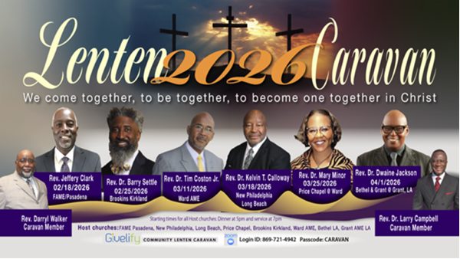
Remaining Schedule

3/11/26
Rev. Dr. Timothy O. Coston, Sr.
Ward AME

3/18/26
Rev. Dr. Kelvin T. Calloway
New Philadelphia AME

3/25/26
Rev. Dr. Mary Minor
Price Chapel @ Ward AME

4/01/26
Rev. Dr. Dwaine Jackson
Bethel AME & Grant AME at
Grant AME Church

4/03/26
Good Friday Worship
FAME Church, Los Angeles

-11-

ANNOUNCEMENTS (Continued)

A.M.E. Connectional Church
Purple Sunday
Stewardship of the Mind Through Alzheimer’s Awareness
Sunday, March 15, 2026
Everyone is encouraged to wear a “touch” of Purple

Virtual Trustee Board Meeting
Tuesday, March 17, 2026 | 5:30 p.m.

Save the Date
Annual Women’s Day Celebration
Sunday, March 22, 2026

Official Board Meeting
Tuesday, March 31, 2026 | 7:00p.m.

Southern California Conference Ministerial Alliance
Presents
Seven Last Words of Christ
Friday, April 3, 2026 | 12:00 PM PST
Frist AME Church, Los Angeles

Resurrection Day Service
Sunday, April 5, 2026 | 9:30 A.M.

-12-

Prayer Request(s)
Please notify the Church Office of Sick & Shut-in additions, deletions, or status/address changes.

Bishop Francine A. Brookins, Esq. Supervisor Miriam Burnett, MD
Presiding Elder Roosevelt & Dr. Kaye Lindsey Rev. Dr. Larry & Melinda Campbell
Richard Craig Hazel Clark Erica Woodard Jason Shirley Joshua Shirley Julian Shirley Ayanna Terry Cheryl Jamerson Gwendolyn Flowers Andrea Anderson Ocilda Files Danielle Clark Donita Towler Rev. Charles Brooks Doris Bailey Kimberly Woods Cynithia Grace Zechariah Robinson Diane Jordan Christopher McCarthy Wilma Haynes Jewell Malloy Calle Burns Noel Johnson Brittney Petty Taylor Family Deborah Burton Nettie McChristen Jacquelyn Walker Carita Smith
Rev. Rochelle Moore Lorene Butler Stella Pulliam Collette Blizzard The Caple Family Donita Towler
The Eaton Canyon Fire Victims Selene Cox Mel Beech

College Students

Let’s continue to support and pray for our beloved College Students

Isaiah Crowell Alecia Davis Chase Johnson Grant Blizzard

Tyler Johnson Richard Jones Tyrikk Lawson Makia Rose Talbert Isaiah Ringo Journey Rogers Elyse Sharp Kylee Sharp Zion Otano Elise Tervalon Grace Jones Jordan Patterson Kimberly Robinson Donovan Williams Jasmine Collins Brandon Bates Gabriel Blizzard

Sick and Shut-Ins
Andrew Oliver 1405 N. Roosevelt Avenue. Pasadena, CA 91104
Bettina Ayers Pasadena Meadows Nursing Home, 150 Bellefontaine St., Pas., CA 91105
Bobby Thomas 1052 E. Morada Place, Altadena, CA 91001
Carrie Wynne Senior Living Heritage, 161 N. Hemet St., Hemet, CA 92545
Doris Curd 11619 Woodcock Avenue, San Fernando, CA 91340
Edmund Riddle Active Care Mission Bay, 2440 Grand Avenue, San Diego, CA 92109
Eleanor Towler 975 E. Union Street, Unit #417, Pasadena, CA 91106
Elois Blizzard P. O. Box 3646, So. Pasadena, CA 91031
Emily Cormier-Ross 2549 La Fiesta Avenue, Altadena, CA 91001
Ernestine English 26 W. Fair Oaks Drive, Pasadena, CA 91103
Fred Caple 51 North 15th Street Haledon, NJ 07508
Gloria Cubit Clay 11745 Pierce St., Lake View Terrace, CA 91342
Hugh Hamberry 19225 Chole Rd., Apple Valley, CA 92307
Jeff Thomas 603 Tocino Dr. Duarte, CA 91010 | Mountain View Terrace
Jessie Smith 3925 S Jones BL, Apt 2118 Las Vegas, NV 89103| Spring Valley Community
Josephine Brown 15607 Saddleback Rd, Riverside, CA 92506
Linnie G. Nollie 2250 E. New York Drive, Altadena, CA 91001
Malika G. Hendry P. O. Box 94082, Pasadena, CA 91109
Mildred Lewis C/O Hazel Rohr, 884 W. Jane Court, Upland, CA 91786
Norma Burnett 618 Fairview Avenue, Unit #228, Arcadia, CA 91007
Opal Hampton 1030 Chevron Court, Pasadena, CA 91103
Paul Ratliff P.O. Box 40407 Pasadena, CA 91114
Ruthie Hopkins 1155 Via Verde , San Dimas, CA 91773
Virlyn Grant 15122 Orange Ave., Paramount, CA 90723
Wanda Nelson 3618 N. Fair Oaks Avenue, Altadena, CA 91001
William Hilliard 7504 Wynstone Pl., Fontana, CA 92336
Zell L. Hill 375 Barthe Drive, Pasadena, CA 91103

-13-

Sermon Notations

Scripture: _____________________________________________________________

Subject: _______________________________________________________________

Points of the Message: ___________________________________________________
_______________________________________________________________________
_______________________________________________________________________
_______________________________________________________________________
_______________________________________________________________________
_______________________________________________________________________
_______________________________________________________________________

Main Ideas of the Sermon: ________________________________________________
_______________________________________________________________________
_______________________________________________________________________
_______________________________________________________________________
_______________________________________________________________________
_______________________________________________________________________

Illustrations I want to remember: _________________________________________
_______________________________________________________________________
_______________________________________________________________________
_______________________________________________________________________
_______________________________________________________________________
_______________________________________________________________________
_______________________________________________________________________

What should I do as a result of this Sermon? ________________________________

_____________________________________________________
_____________________________________________________
_____________________________________________________
_____________________________________________________

-14-

