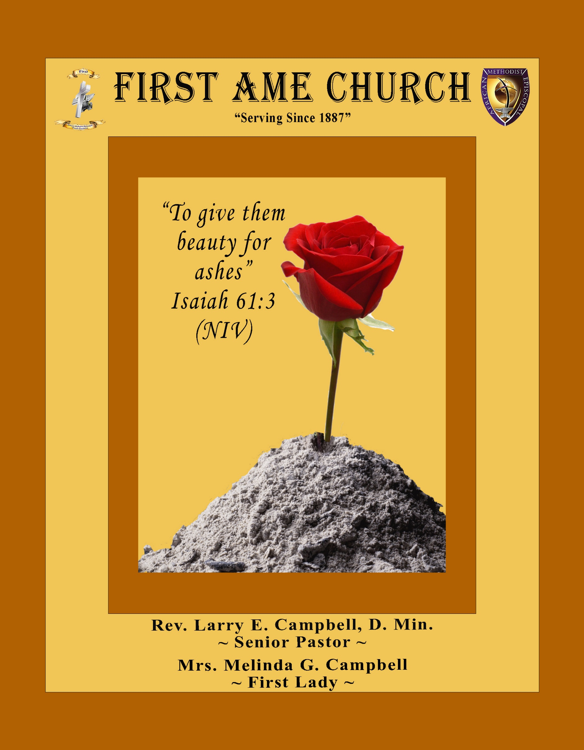
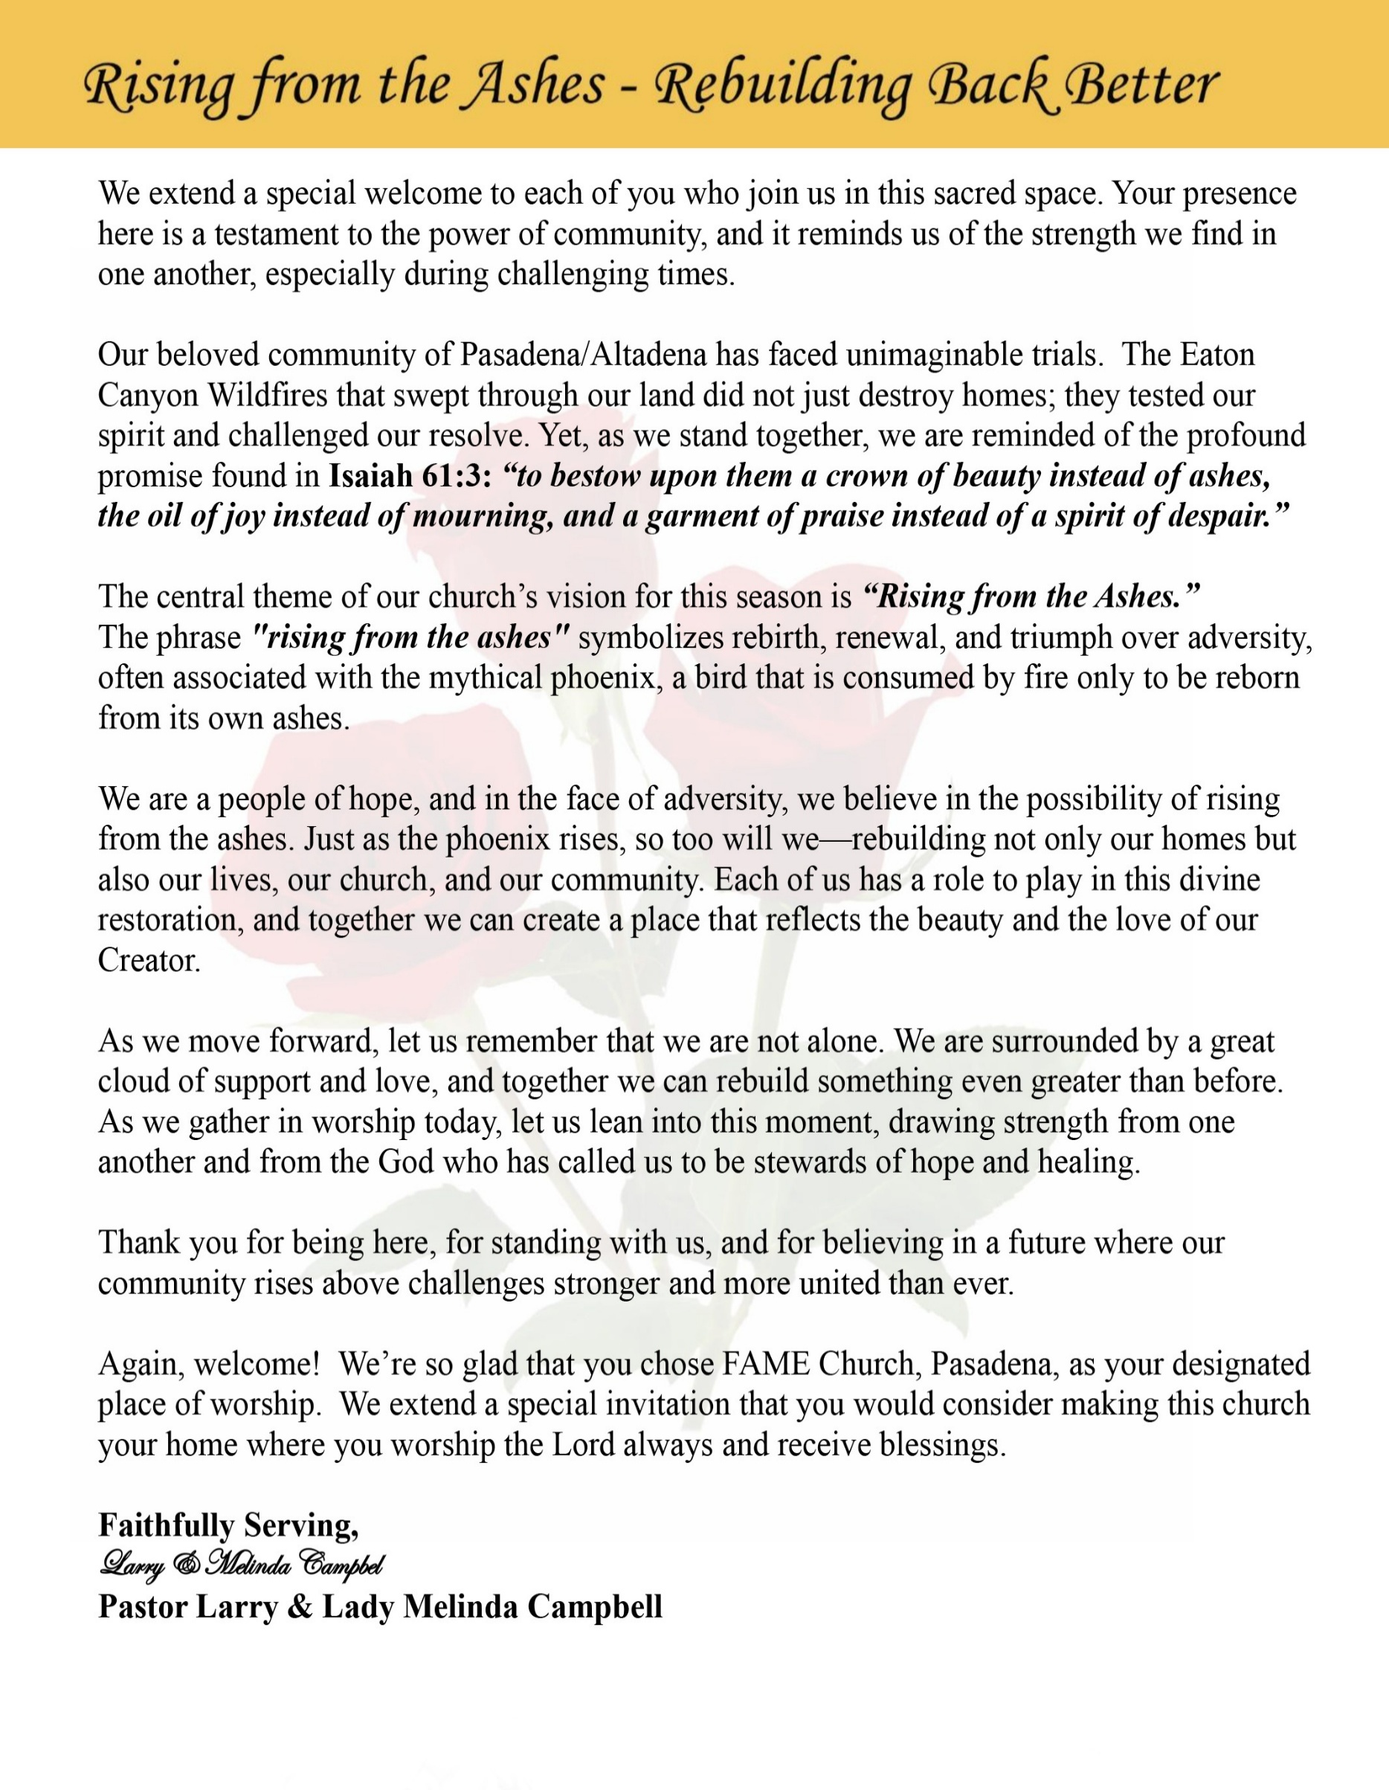

Sunday, May 3 , 2026 | 9:30 a.m.

Rt. Rev. Francine A. Brookins, Esq., Presiding Bishop
Rev. Miriam Burnett, MD, MPH, Supervisor of Missions
Rev. Roosevelt Lindsey, Jr. Presiding Elder

The Rev. Dr. Larry E. Campbell ~ Senior Pastor ~ Minister

Mobile: (951) 587-1894 ~ Email: larrycampbell@famepasadena.org

Our First Lady: Mrs. Melinda G. Campbell

The Reverend Dr. Jennifer Oliver ~ Itinerant Elder -
The Reverend Dr. Nikia Smith-Robert ~ Itinerant Elder (Affiliated)
The Reverend Lois Woodard ~ Itinerant Elder Superannuated (Retired)
The Reverend Rochelle Wright Moore ~ Itinerant Deacon
The Reverend Deborah West-Jones ~ Local Elder
The Reverend Philis J. Griffin, MDiv ~ Local Elder
Dr. Phyllis Beech ~ Evangelist
Sister Tessie Bonner ~ Deaconess

Community Resource Center Director ~ Ms. Kischchen Hazelton Venerable
Church Administrative Assistant: Ms. Letha Rhymes

Church Office Hours:
Tue - Wed 9:00 am - 5:00 pm, & Fri 9:00 am -3:00 pm.
Closed for Lunch Daily: 12:00 pm - 1:00 pm.

Music Ministry
Dr. Timothy Davis, Minister of Music
Bro. Jimmy Watlington, Percussionist ~ Bro. Carlos Caldwell, Organist
Bro. Darien Dorsey, Keyboardist
Sis. Karen Law, Women’s Chorus Director ~ Sis. Tonia Graham, Children’s Choir Director
Bro. J. Renard Washington, New Generation’s Choir

FREE WI-FI service is available on the FAME Campus by accessing FAME 1700
Password: 6267980503

-3-

~ Order of Worship Experience ~

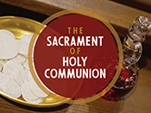

+++ The Altar Call +++
Praise & Worship

Doxology: “Praise God From Whom All Blessings Flow”

The Call to Worship Pastor Larry E. Campbell

Leader: I was glad when they said unto me, let us go into the house of the Lord, our feet shall stand within Thy gates O Jerusalem! (Psalm 122:1)

People: For a day in Thy courts is better than a thousand. I had rather be a doorkeeper in the house of my God than to dwell in the tents of wickedness. (Psalm 84:10)

Leader: Because of the house of the Lord our God, I will seek Thy good.
(Psalm 122:9)

People: Those that be planted in the house of the Lord, shall flourish in the courts of our God. (Psalm 92:13)

Leader: Blessed are they that dwell in Thy house. Lord, I have loved Thy habitation, the place where Thy honor dwelleth. (Psalm 26:8)

People: For the Lord is in His holy temple; let all the earth keep silence before Him.
(Habakkuk 2:20).

Leader: Let the words of my mouth and the meditation of my heart, be acceptable in Thy sight, O Lord my strength and my redeemer. (Psalm 19:14)

Unison: O Sing unto the Lord a new song, for He has done marvelous things. Make a
joyful noise unto the Lord, all the earth, sing His praises. (Psalm 98:1, 4)

-4-

The Hymn of Praise A.M.E. Hymnal #283
I Am Thine, O Lord

1 I am Thine, O Lord, I have heard Thy voice,
and it told Thy love to me;
but I long to rise in the arms of faith,
and be closer drawn to Thee.

Refrain:
Draw me nearer, nearer, blessed Lord,
to the cross where Thou hast died;
draw me nearer, nearer, blessed Lord,
to Thy precious, bleeding side.

2 Consecrate me now to Thy service, Lord,
by the pow'r of grace divine;
let my soul look up with a steadfast hope,
and my will be lost in Thine.

[Refrain]

3 O, the pure delight of a single hour
that before Thy throne I spend,
when I kneel in prayer, and with Thee, my God,
I commune as friend with friend!

[Refrain]

4 There are depths of love that I cannot know
till I cross the narrow sea;
there are heights of joy that I may not reach
till I rest in peace with Thee.

[Refrain]

The Invocation Rev. Rochelle Wright-Moore

Ministry of Music The Mass Choir

-5-

Scripture Lesson (Responsive Reading) Evangelist Phyllis Beech
Luke 14:1-24 (New International Version) — Jesus at a Pharisee’s House
Leader: One Sabbath, when Jesus went to eat in the house of a prominent Pharisee, he was being
carefully watched. ² There in front of him was a man suffering from abnormal swelling of
his body.

People: ³ Jesus asked the Pharisees and experts in the law, “Is it lawful to heal on the Sabbath
or not?” ⁴ But they remained silent. So taking hold of the man, he healed him and
sent him on his way.

Leader: ⁵ Then he asked them, “If one of you has a child or an ox that falls into a well on the
Sabbath day, will you not immediately pull it out?” ⁶ And they had nothing to say.

People: ⁷ When he noticed how the guests picked the places of honor at the table, he told them
this parable: ⁸ “When someone invites you to a wedding feast, do not take the place of
honor, for a person more distinguished than you may have been invited. ⁹ If so, the
host who invited both of you will come and say to you, ‘Give this person your seat.’
Then, humiliated, you will have to take the least important place.

Leader ¹⁰ But when you are invited, take the lowest place, so that when your host comes, he will
say to you, ‘Friend, move up to a better place.’ Then you will be honored in the presence
of all the other guests. ¹¹ For all those who exalt themselves will be humbled, and those
who humble themselves will be exalted.”

People: ¹² Then Jesus said to his host, “When you give a luncheon or dinner, do not invite
your friends, your brothers or sisters, your relatives, or your rich neighbors; if you
do, they may invite you back and so you will be repaid.

Leader: ¹³ But when you give a banquet, invite the poor, the crippled, the lame, the blind, ¹⁴ and
you will be blessed. Although they cannot repay you, you will be repaid at the resurrection
of the righteous.”

People: ¹⁵ When one of those at the table with him heard this, he said to Jesus, “Blessed is the
one who will eat at the feast in the kingdom of God.”

Leader: ¹⁶ Jesus replied: “A certain man was preparing a great banquet and invited many guests. ¹⁷ At the time of the banquet he sent his servant to tell those who had been invited, ‘Come, for everything is now ready.’

People: ¹⁸ “But they all alike began to make excuses. The first said, ‘I have just bought a field, and I must go and see it. Please excuse me.’ ¹⁹ “Another said, ‘I have just bought five yoke of oxen, and I’m on my way to try them out. Please excuse me.’ ²⁰ “Still another said, ‘I just got married, so I can’t come.’

Leader: ²¹ “The servant came back and reported this to his master. Then the owner of the house became angry and ordered his servant, ‘Go out quickly into the streets and alleys of the town and bring in the poor, the crippled, the blind and the lame.’ ²² “‘Sir,’ the servant said, ‘what you ordered has been done, but there is still room.’

ALL: ²³ “Then the master told his servant, ‘Go out to the roads and country lanes and compel them to come in, so that my house will be full. ²⁴ I tell you, not one of those who were invited will get a taste of my banquet.’”

-6-

The AFFIRMATION OF FAITH (The Apostle Creed)

Minister: What do you Believe?

People: I believe in God the Father Almighty, Maker of heaven and earth, and in Jesus
Christ His only son our Lord who was conceived by the Holy Spirit, born of the Virgin Mary, suffered under Pontius Pilate, was crucified, dead and buried. The third day he arose from the dead; he ascended into heaven and sitteth at the right hand of God the Father Almighty; from thence he shall come to judge the quick and the dead. I believe in the Holy Spirit, the Church Universal, the communion of saints, the forgiveness of sins, the resurrection of the body and the life
everlasting. Amen.

THE PRELUDE TO THE DECALOGUE

“From all that dwell below the skies, Let the Creator’s praise arise;
Let the Redeemer’s name be sung. Through every land, by every tongue.”

THE DECALOGUE (An Affirmation of God’s Law)

Minister: Let us express our commitment to keep God’s Law

People: God of our salvation, only You are God.
We will make no idols.
We will not invoke with malice your name, O God.
We will remember the Sabbath Day and keep it holy.
We will honor our father and our mother.
We will not commit murder.
We will not commit adultery.
We will not steal.
We will not be a false witness.
We will not covet anything that belongs to our neighbor.
Minister: Jesus said: “You shall love the Lord your God with all your heart, and with all your soul and with all your mind. This is the great and first commandment.”

ALL: Jesus also challenged us to love justly with a second commandment
which is like the first. We shall love our neighbor as ourselves! On these
commandments depend all the law and the prophets.

-7-

THE GLORIA PATRI
Glory be to the Father, and to the Son, and to the Holy Ghost.
As it was in the beginning, is now and ever shall be, world without end. Amen Amen!!

Abbreviated Announcements/ Visitor’s Welcome

Pastoral Remarks

The Offertory (Tithes~Gifts~Benevolent Offerings) Bro. Bill Matlock, Steward

In order to satisfy the steady increase of inflation, we are asking each member to consider increasing your Tithe, Offerings & Gifts.

The following Electronic GIVING Platforms are creditable methods to GIVE to FAME:

#1. GIVELIFY - Mobile Giving App available on the App Store. It’s easy to set up, just follow the guidelines.

#2. Cash App: $FirstAMEPASADENA

#3. Mail in your Tithes & Offering - If you would like to mail your tithes and offering by check or money order, please send it to: First AME Church, 1700 N. Raymond Avenue, Pasadena, CA 91103.

#4. Drop off your Tithes & Offering - During business hours in the basket outside of the office.

Choral Response: “All things come of Thee, O Lord; and of Thine own have we given Thee. Amen.”

CHILDREN’S CHURCH DISMISSAL

Sermonic Selection The Mass Choir

Proclamation of The Word: Pastor Larry E. Campbell

The Invitation (Public/Private)

-8-

The Sacrament of the Lord’s Supper or Holy Communion

THE SOLICITATION

You that do truly and earnestly repent of your sins, and are in love and charity with your neighbor, and intend to lead a new life, following the commandments of God, and walking from henceforth in His holy ways, draw near with faith and take this holy sacrament to your comfort; and make your humble confession to Almighty God.

THE GENERAL CONFESSION

Minister: Let us humbly confess our sins unto Almighty God.

Minister and People:

Almighty God, Father of our Lord Jesus Christ, Maker of all things, Judge of all men, we acknowledge and bewail our manifold sins and wickedness which we from time to time most grievously have committed by thought, word, and deed against Your divine Majesty, provoking most justly Your wrath and indignation against us. We do earnestly repent and are heartily sorry for these, our misdoings; the remembrance of them is grievous unto us. Have mercy upon us, have mercy upon us, most merciful Father for Your Son our Lord Jesus Christ’s sake; forgive us all that is past, and grant that we may ever hereafter serve and please You in newness of life, to the honor and glory of Your name through Jesus Christ our Lord.

Amen. (Choral). (You may be seated).

THE PRAYER OF PARDON

Almighty God, our Heavenly Father, who of Your great mercy has promised forgiveness of sins to all them that with hearty repentance and true faith turn unto You, have mercy upon us; pardon and deliver us from all our sins; confirm and strengthen us in all goodness; and bring us to everlasting life through Jesus Christ, our Lord.

Choral Response: Amen.

THE PRAYER OF CONSECRATION

Minister: Loving God, our Father in heaven, in Your great mercy You gave Your only Son, Jesus Christ, to die on the cross so we could be saved. Through His sacrifice — offered once and for all — He made a complete and perfect offering for the sins of the whole world. And in the gospel, He told us to keep remembering His precious death until He comes again.
So we ask You, merciful Father, hear our prayer. As we receive this bread and this cup, according to the way our Savior Jesus taught us, help us remember His suffering and death, and allow us to share in the blessing of His body and His blood.
On the night He was betrayed, Jesus took bread. After giving thanks, He broke it and gave it to His disciples, saying,
“Take and eat. This is my body, given for you. Do this to remember me.”
In the same way, after supper He took the cup. After giving thanks, He gave it to them and said,
“Drink from it, all of you. This is my blood of the new covenant, poured out for you and for many so that sins may be forgiven. Whenever you drink it, do this to remember me.” Amen!

THE LORD’S PRAYER (ALL)

THE ELEMENTS SHARED

-9-

ANNOUNCEMENTS

Men's Ministry - BIBLE STUDY
Time: Tuesday, May 5, 2026 | 6:00 p.m.
Meeting ID: 894 7536 6487 | Passcode: 465177
One tap mobile: +16699006833,,89475366487#,,,,*465177# US (San Jose)

Women's Ministry – BIBLE STUDY
Time: Tuesday– May 5, 2026 | 6:00 p.m.
Meeting ID: 857 0061 9461; Passcode: 933892
One tap mobile +16699006833,,85700619461#,,,,,,0#,,933892# US (San Jose)

Senior Ministry Luncheon
You are invited to join us to enjoy good fellowship, good food, and helpful information at the FAME Senior Ministry gathering on Tuesday, May 12, 2026 @ 11:30 a.m.
Bring a friend. All are welcome



Virtual Trustee Board Meeting
May 19, 2026 | 5:30 p.m.

Virtual Official Board Meeting
May 26, 2026 | 7:00 p.m.

-10-

ANNOUNCEMENTS (Continued)

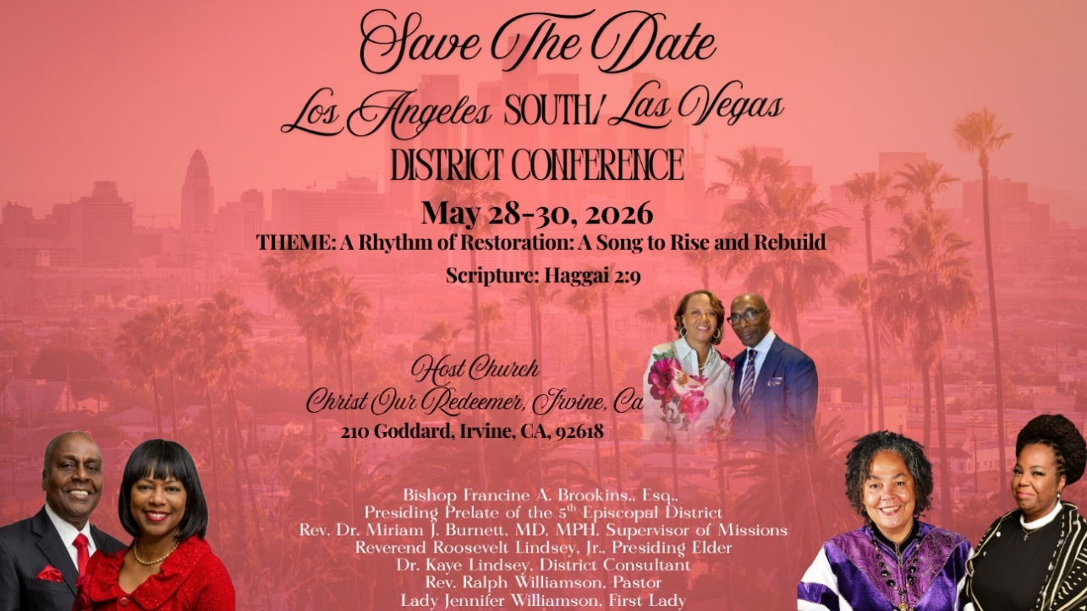

WMS Sisterhood Brunch Sells Out: Celebration of Community and Empowerment

Press Release
We are overwhelmed by the incredible response and extend our heartfelt gratitude to every woman who secured a spot for the WMS Sisterhood Brunch, taking place on May 30, 2026, at the FAME Pasadena Pavillion. The event's sold-out status is a testament to the dedication and enthusiasm of women who are eager to invest in themselves and support one another. We are committed to creating a supportive, high-energy environment that promises to be truly memorable.

Event Highlights

Keynote Speaker: AnGèle Cade. AnGèle is recognized as a thought leader, vision architect, and business strategist.

Networking Hub: Connecting women with valuable resources and a vibrant community.

-11-

Scripture of the Day
The Lord's Invitation. “If you are thirsty, come and drink water! If you don't have any money, come, eat what you want! Drink wine and milk without paying a cent. ² Why waste your money on what really isn't food? Why work hard for something that doesn't satisfy?
Listen carefully to me, and you will enjoy the very best foods.” Isaiah 55:1-2

Quote of the Day
"Jesus sets a place for us... This is God's table, and Her feast is for all."
Binary-Breaking Worship

Thought of the Week
“Come to me, all you who are weary and burdened, and I will give you rest.” — Matthew 11:28
Jesus’ invitation to the table is not reserved for the strong—it’s extended to the tired, the heavy, and the overwhelmed. In Matthew 11:28, He doesn’t say, “Fix yourself, then come.” He simply says, “Come.”
The beauty of this invitation is its simplicity. You don’t need the right words, the perfect record, or a polished life. You just need a willing heart. The table of Christ is a place where burdens are exchanged for rest, striving is replaced with grace, and emptiness is filled with His presence.
Too often, we carry what God has already offered to lift. We sit at tables of worry, regret, and pressure—but Jesus is calling us to a different table. A table where you don’t have to perform, pretend, or prove anything. Just come and receive.
Real-life reflection:
What are you carrying today that feels too heavy? Stress, disappointment, guilt, unanswered questions? That weight is your invitation. It’s the very reason Jesus is calling you closer. The table is not for those who have it all together—it’s for those who know they need Him.

Humor of the Week
A Catholic priest, a Muslim imam, and a Jewish rabbi are discussing when life begins.
The priest says, when a man and a woman decide to have a child, then life begins.
The imam replies, nonsense. Life begins when the egg is fertilized.
The rabbi shakes his head and says, you both have no idea. Life begins when the children have left home.

HOME DAILY BIBLE READINGS
May 4, 2026 – May 10, 2026 (Week 33, John)
Monday Day 225 Matthew 13:1-13:52, Psalm 90:7-12
Tuesday Day 226 Matthew 13:53-14:36, Psalm 90:13-17
Wednesday Day 227 Matthew 15:1-16:4, Psalm 91
Thursday Day 228 Matthew 16:5-17:23, Psalm 92:1-8
Friday Day 229 Matthew 17:24-18:35, Psalm 92:9-15
Saturday Day 230 Matthew 19:1-20:16, Psalm 93
Sunday Day 231 Matthew 20:17-21:27, Psalm 94:1-7

-12-

Prayer Request(s)
Please notify the Church Office of Sick & Shut-in additions, deletions, or status/address changes.

Bishop Francine A. Brookins, Esq. Supervisor Miriam Burnett, MD
Presiding Elder Roosevelt & Dr. Kaye Lindsey Rev. Dr. Larry & Melinda Campbell
Richard Craig Hazel Clark Erica Woodard Jason Shirley Joshua Shirley Julian Shirley Ayanna Terry Cheryl Jamerson Gwendolyn Flowers Andrea Anderson Ocilda Files Danielle Clark Donita Towler Rev. Charles Brooks Doris Bailey Kimberly Woods Cynithia Grace Zechariah Robinson Diane Jordan Christopher McCarthy Wilma Haynes Calle Burns Noel Johnson Brittney Petty Taylor Family Deborah Burton Nettie McChristen Jacquelyn Walker The Caple Family
Rev. Rochelle Moore Lorene Butler Stella Pulliam Collette Blizzard
The Eaton Canyon Fire Victims Selene Cox Mel Beech

College Students

Let’s continue to support and pray for our beloved College Students

Isaiah Crowell Alecia Davis Chase Johnson Grant Blizzard

Tyler Johnson Richard Jones Tyrikk Lawson Makia Rose Talbert Isaiah Ringo Journey Rogers Elyse Sharp Kylee Sharp Zion Otano Elise Tervalon Grace Jones Jordan Patterson Kimberly Robinson Donovan Williams Jasmine Collins Brandon Bates Gabriel Blizzard

Sick and Shut-Ins
Andrew Oliver 1405 N. Roosevelt Avenue. Pasadena, CA 91104
Barbara Buchanan 616 Rio Grande St. Pasadena, CA 91104
Bettina Ayers Pasadena Meadows Nursing Home, 150 Bellefontaine St., Pas., CA 91105
Bobby Thomas 1052 E. Morada Place, Altadena, CA 91001
Doris Curd 11619 Woodcock Avenue, San Fernando, CA 91340
Edmund Riddle Active Care Mission Bay, 2440 Grand Avenue, San Diego, CA 92109
Eleanor Towler 975 E. Union Street, Unit #417, Pasadena, CA 91106
Elois Blizzard P. O. Box 3646, So. Pasadena, CA 91031
Emily Cormier-Ross 2549 La Fiesta Avenue, Altadena, CA 91001
Ernestine English 26 W. Fair Oaks Drive, Pasadena, CA 91103
Fred Caple 51 North 15th Street Haledon, NJ 07508
Gloria Cubit Clay 11745 Pierce St., Lake View Terrace, CA 91342
Hugh Hamberry 19225 Chole Rd., Apple Valley, CA 92307
Jeff Thomas 603 Tocino Dr. Duarte, CA 91010 | Mountain View Terrace
Jessie Smith 3925 S Jones BL, Apt 2118 Las Vegas, NV 89103| Spring Valley Community
Josephine Brown 15607 Saddleback Rd, Riverside, CA 92506
Linnie G. Nollie 2250 E. New York Drive, Altadena, CA 91001
Malika G. Hendry P. O. Box 94082, Pasadena, CA 91109
Mildred Lewis C/O Hazel Rohr, 884 W. Jane Court, Upland, CA 91786
Norma Burnett 618 Fairview Avenue, Unit #228, Arcadia, CA 91007
Opal Hampton 1030 Chevron Court, Pasadena, CA 91103
Paul Ratliff P.O. Box 40407 Pasadena, CA 91114
Ruthie Hopkins 1155 Via Verde , San Dimas, CA 91773
Virlyn Grant 15122 Orange Ave., Paramount, CA 90723
Wanda Nelson 3618 N. Fair Oaks Avenue, Altadena, CA 91001
William Hilliard 7504 Wynstone Pl., Fontana, CA 92336
Zell L. Hill 375 Barthe Drive, Pasadena, CA 91103

-13-

Sermon Notations

Scripture: _____________________________________________________________

Subject: _______________________________________________________________

Points of the Message: ___________________________________________________
_______________________________________________________________________
_______________________________________________________________________
_______________________________________________________________________
_______________________________________________________________________
_______________________________________________________________________
_______________________________________________________________________

Main Ideas of the Sermon: ________________________________________________
_______________________________________________________________________
_______________________________________________________________________
_______________________________________________________________________
_______________________________________________________________________
_______________________________________________________________________

Illustrations I want to remember: _________________________________________
_______________________________________________________________________
_______________________________________________________________________
_______________________________________________________________________
_______________________________________________________________________
_______________________________________________________________________
_______________________________________________________________________

What should I do as a result of this Sermon? ________________________________

_____________________________________________________
_____________________________________________________
_____________________________________________________
_____________________________________________________

-14-

