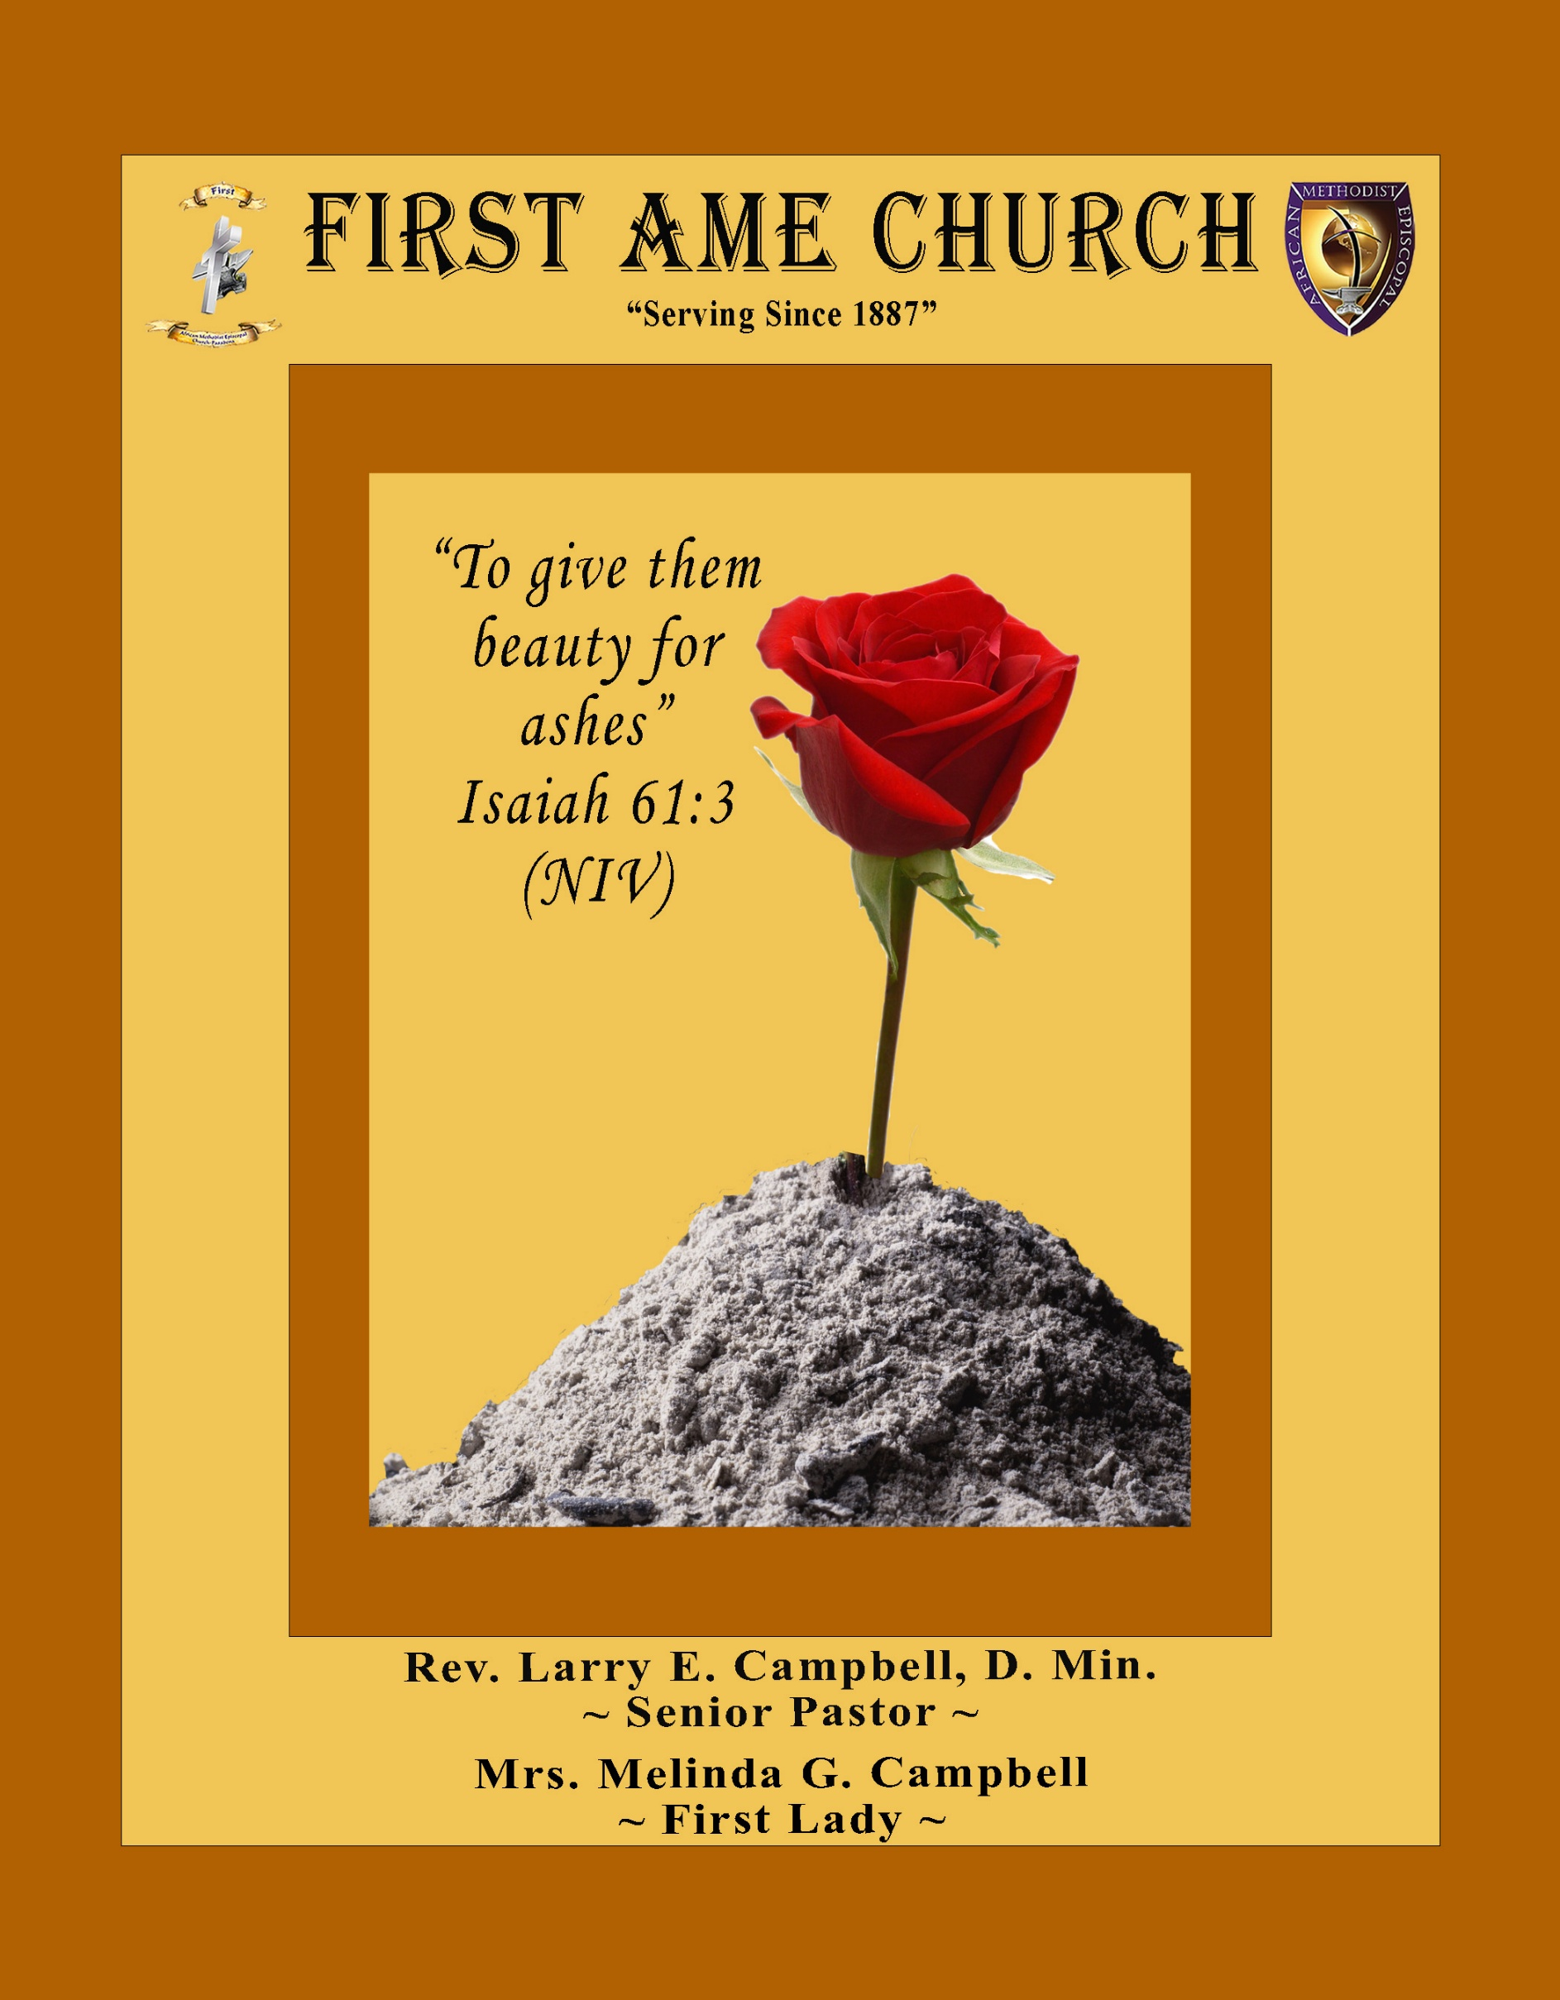
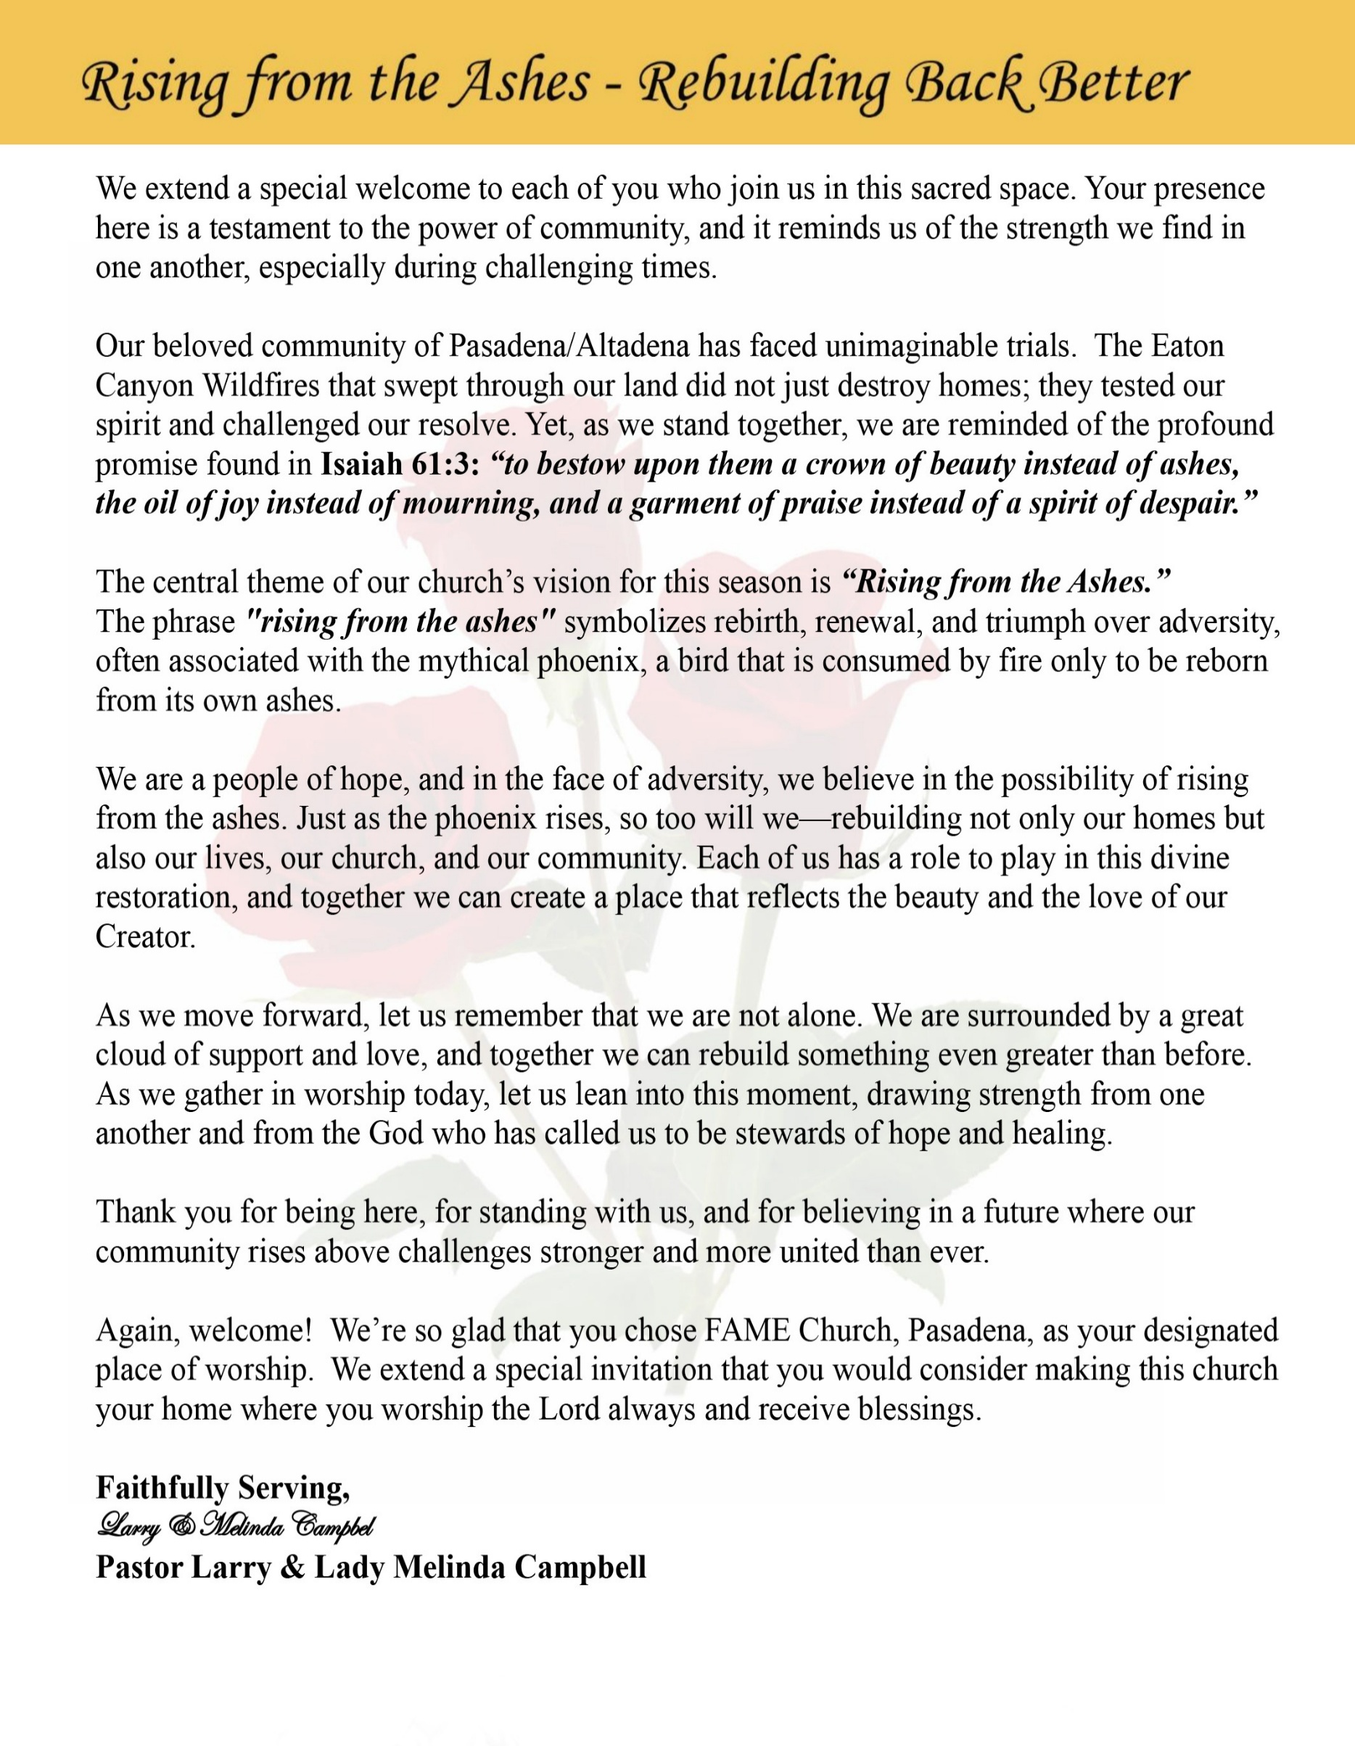

Sunday, May 17 , 2026 | 9:30 a.m.

Rt. Rev. Francine A. Brookins, Esq., Presiding Bishop
Rev. Miriam Burnett, MD, MPH, Supervisor of Missions
Rev. Roosevelt Lindsey, Jr. Presiding Elder

The Rev. Dr. Larry E. Campbell ~ Senior Pastor ~ Minister

Mobile: (951) 587-1894 ~ Email: larrycampbell@famepasadena.org

Our First Lady: Mrs. Melinda G. Campbell

The Reverend Dr. Jennifer Oliver ~ Itinerant Elder -
The Reverend Dr. Nikia Smith-Robert ~ Itinerant Elder (Affiliated)
The Reverend Lois Woodard ~ Itinerant Elder Superannuated (Retired)
The Reverend Rochelle Wright Moore ~ Itinerant Deacon
The Reverend Deborah West-Jones ~ Local Elder
The Reverend Philis J. Griffin, MDiv ~ Local Elder
Dr. Phyllis Beech ~ Evangelist
Sister Tessie Bonner ~ Deaconess

Community Resource Center Director ~ Ms. Kischchen Hazelton Venerable
Church Administrative Assistant: Ms. Letha Rhymes

Church Office Hours:
Tue - Wed 9:00 am - 5:00 pm, & Fri 9:00 am -3:00 pm.
Closed for Lunch Daily: 12:00 pm - 1:00 pm.

Music Ministry
Dr. Timothy Davis, Minister of Music
Bro. Jimmy Watlington, Percussionist ~ Bro. Carlos Caldwell, Organist
Bro. Darien Dorsey, Keyboardist
Sis. Karen Law, Women’s Chorus Director ~ Sis. Tonia Graham, Children’s Choir Director
Bro. J. Renard Washington, New Generation’s Choir

FREE WI-FI service is available on the FAME Campus by accessing FAME 1700
Password: 6267980503

-3-

~ Order of Worship Experience ~

Warning: This order of worship is subject to change without warning or prior notice --- everything is governed by the Sovereignty of the Holy Spirit.



Praise & Worship

Doxology: “Praise God From Whom All Blessings Flow”

The Call to Worship

Leader: I was glad when they said unto me, let us go into the house of the Lord, our feet shall stand within Thy gates O Jerusalem! (Psalm 122:1)

People: For a day in Thy courts is better than a thousand. I had rather be a doorkeeper in the house of my God than to dwell in the tents of wickedness. (Psalm 84:10)

Leader: Because of the house of the Lord our God, I will seek Thy good.
(Psalm 122:9)

People: Those that be planted in the house of the Lord, shall flourish in the courts of our God. (Psalm 92:13)

Leader: Blessed are they that dwell in Thy house. Lord, I have loved Thy habitation, the place where Thy honor dwelleth. (Psalm 26:8)

People: For the Lord is in His holy temple; let all the earth keep silence before Him.
(Habakkuk 2:20)

Leader: Let the words of my mouth and the meditation of my heart, be acceptable in Thy sight, O Lord my strength and my redeemer. (Psalm 19:14)

Unison: O Sing unto the Lord a new song, for He has done marvelous things. Make a
joyful noise unto the Lord, all the earth, sing His praises. (Psalm 98:1, 4)

-4-

The Song of Praise You Are Good
You Are Good
(Song and Lyrics by Israel Houghton)

Verse 1
Lord You are good and Your mercy endureth forever
Lord You are good and Your mercy endureth forever
People from every nation and tongue; From generation to generation

Chorus 1
We worship You Hallelujah Hallelujah
We worship You for who You are We worship You Hallelujah Hallelujah
We worship You for who You are For You are good

Bridge
You are good all the time, All the time You are good
You are good all the time, All the time are good

Chorus 2
We worship You Hallelujah Hallelujah
We worship You for who You are
We worship You Hallelujah Hallelujah
We worship You for who You are

We worship You Hallelujah hallelujah
We worship You for who You are We worship You Hallelujah hallelujah
We worship You For who You are; For who You are; For who You are
For You are good

The Invocation

Ministry of Music The Praise Team

-5-

Scripture Lesson
(Please Stand for the Reading of God’s Words)

Old Testament

Psalm 37:1-9 (New International Version) — Guard Your Spirit
Do not fret because of evildoers, nor be envious of the workers of iniquity.
² For they shall soon be cut down like the grass, and wither as the green herb.
³ Trust in the Lord, and do good; dwell in the land, and feed on His faithfulness.
⁴ Delight yourself also in the Lord, and He shall give you the desires of your heart.
⁵ Commit your way to the Lord, trust also in Him, and He shall bring it to pass.
⁶ He shall bring forth your righteousness as the light, and your justice as the noonday.
⁷ Rest in the Lord, and wait patiently for Him; Do not fret because of him who prospers in his way, because of the man who brings wicked schemes to pass.
⁸ Cease from anger, and forsake wrath; Do not fret—it only causes harm.
⁹ For evildoers shall be cut off; but those who wait on the Lord, they shall inherit the earth.

New Testament
1 John 4 (English Standard Version) — Test the Spirits
4 Beloved, do not believe every spirit, but test the spirits to see whether they are from God, for many false prophets have gone out into the world. ² By this you know the Spirit of God: every spirit that confesses that Jesus Christ has come in the flesh is from God, ³ and every spirit that does not confess Jesus is not from God. This is the spirit of the antichrist, which you heard was coming and now is in the world already. ⁴ Little children, you are from God and have overcome them, for he who is in you is greater than he who is in the world. ⁵ They are from the world; therefore they speak from the world, and the world listens to them. ⁶ We are from God. Whoever knows God listens to us; whoever is not from God does not listen to us. By this we know the Spirit of truth and the spirit of error.

-6-

The Summary of the Decalogue
LEADER: From all that dwell below the skies…
SUNG: From all that dwell below the skies, Let the Creator’s praise arise; Let the
Redeemer’s Name be sung, through every land, by every tongue.
LEADER: Hear what Christ our Savior saith, Thou shalt love the Lord thy God with all thy
heart, with all thy soul, and with all thy mind. This is the first and great
commandment. And the second is like unto it: Thou shalt love thy neighbor
as thyself. On these two commandments hang all the law and the prophets.
SUNG: Glory be to the Father, and to the Son, and to the Holy Ghost; as it was in
the beginning, is now, and ever shall be, world without end. A~Men

Abbreviated Announcements/Visitor’s Welcome

K-FAME Radio



New Members’ Induction

Special Congregational Hymn (Sing along)
#215 “Look and Live”

Tithes, Gifts, and Offering Litany (Centered around Malachi 3:6-12)

Leader: For I am the Lord, I do not change; therefore, we are not consumed.

People: Because God is faithful, we can trust Him with all we have.

Leader: “Return to Me, and I will return to you,” says the Lord of hosts.

People: We return to God now through our giving, with grateful and obedient hearts.

Leader: Will a people rob God? Yet you have robbed Me in tithes and offerings.

People: Today we choose faithfulness over fear, generosity over withholding.
[Continued on page 8]

-7-

Tithes, Gifts, and Offering Litany [Continued]

Leader: Bring the whole tithe into the storehouse, that there may be food in My house.

People: We bring our best, knowing God is our source and our sustainer.

Leader: “Test Me in this,” says the Lord, “and see if I will not open the windows of heaven.”

People: We give in faith, believing God will pour out blessings we cannot contain.

Leader: I will rebuke the devourer and protect what you have sown.

People: We trust God to cover, keep, and multiply what we release.

Leader: All nations will call you blessed, for you will be a delightful land. As we give, we
declare we are blessed to be a blessing!

All Together: Lord, receive our tithes and offerings. We give with joy, expectation, and trust
in Your unchanging promise. Amen!

The following Electronic GIVING Platforms are creditable methods to GIVE to FAME:

#1. GIVELIFY - Mobile Giving App available on the App Store. It’s easy to set up, just follow the guidelines.

#2. Cash App: $FirstAMEPASADENA

#3. Mail in your Tithes & Offering - If you would like to mail your tithes and offering by check or money order, please send it to: First AME Church, 1700 N. Raymond Avenue, Pasadena, CA 91103.

#4. Drop off your Tithes & Offering - During business hours in the basket outside of the office.

Choral Response: “All things come of Thee, O Lord; and of Thine own have we given Thee. Amen.”

Children’s Church Dismissal

Sermonic Selection The Praise Team

The Preached Word Pastor Larry E. Campbell

The Doxology

The Benediction

-8-

Scripture of the Day
Guard Your Spirit. “Do not be misled: “Bad company corrupts good character.”
1 Corinthians 5:33

Quote of the Day
"If you don’t guard your heart, someone else will shape it for you.”— Craig Groeschel

Thought of the Week
“Do not be misled: ‘Bad company corrupts good character.” 1 Corinthians 15:33
Our hearts are shaped by what we repeatedly allow around us — conversations, relationships, environments, influences, and attitudes. Paul warns the church not to be deceived into believing that negative influences have no effect on spiritual character. Over time, unhealthy company can slowly weaken convictions, cloud judgment, and drain spiritual passion.
Guarding your heart is not about isolating yourself from people; it is about protecting your spirit from influences that pull you away from God’s purpose. Some relationships strengthen faith, wisdom, and peace, while others feed negativity, compromise, gossip, bitterness, or temptation.
Jesus spent time with broken people, but He never allowed brokenness to shape His identity or mission. As believers, we are called to love everyone while remaining rooted in godly wisdom and discernment.
Ask yourself:
- Who is influencing my heart?
- What conversations are feeding my spirit?
- Are the people around me pushing me closer to God or farther away?
A guarded heart chooses wisdom over popularity, peace over chaos, and godly influence over toxic connection.

Humor of the Week
David Was lying in a Hospital Bed, seriously ill. He was surrounded by his wife, his two sons, his daughter, and a nurse.
​He Called His Eldest Son and Said: "To You, Peter, I Leave the Houses Near the Airport."
Turning To His Daughter, He Said: "My Dear Daughter, I leave You the Apartment Blocks in the City."
​Then He Looked at His Youngest Son: "Charlie, With Your Bright Future, I Leave You the Office Buildings in The City Centre."
Finally, He Said to His Wife: "And to You, My Dear Wife, I Leave the Three Residential Towers Downtown."
​The Nurse, Clearly Impressed, Whispered to the Wife: "Madam. Your Husband Must Be Very Rich. You're All So Lucky!"
​The Wife Replied Calmly "Rich? Lucky? We All Work for a Cleaning Company. Those Are Just His Work Schedules."
HOME DAILY BIBLE READINGS
May 18, 2026 – May 24, 2026 (Week 35, Romans)
Monday Day 239 Mark 2:13-3:19, Psalm 97:8-12
Tuesday Day 240 Mark 3:20-4:34, Psalm 98
Wednesday Day 241 Mark 4:35-5:43, Psalm 99
Thursday Day 242 Mark 6:1-6:44, Psalm 100
Friday Day 243 Mark 6:45-7:37, Psalm 101:1-5
Saturday Day 244 Mark 8:1-9:6, Psalm 101:6-8
Sunday Day 245 Mark 9:7-50, Psalm 102:1-11

-9-

ANNOUNCEMENTS

WELCOME! WELCOME! WELCOME!
It is with great pleasure and joy that we officially welcome Sondra Ware and Kimalica Guynes to the FAME Family kinship. We are truly blessed and very grateful for their presence and valued membership in our church family.



-10-

ANNOUNCEMENTS (Continued)

Homegoing Service Announcement
The Homegoing Service for Sister Ruthie Hopkins will be held on Saturday, May 23, 2026, at 11:00 a.m. at First A.M.E. Church, Pasadena. We ask that you continue to keep the Hopkins family lifted in prayer during this season of bereavement. May God’s love, comfort, and peace surround them now and in the days ahead.

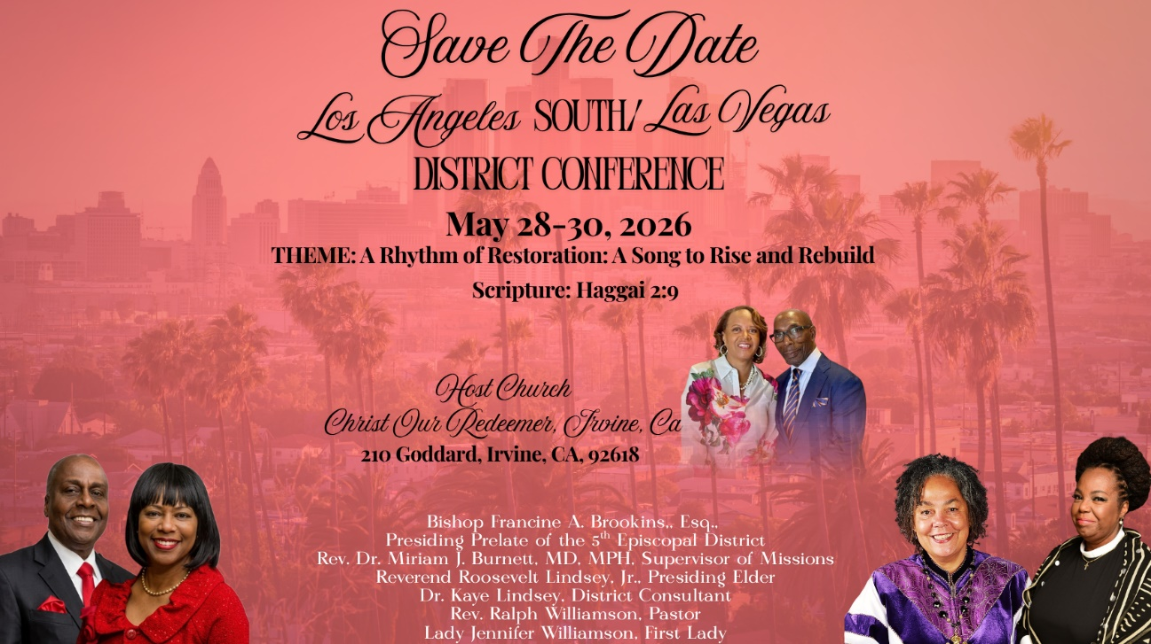

-11-

ANNOUNCEMENTS (Continued)

Background Check Reminder
This is a reminder that all adults aged 18 and older who work with children and youth in our church are required to complete the necessary background screening in compliance with the 5th Episcopal District requirements. Assistance is available to help ensure all volunteers and workers remain in compliance. Please contact the church office or Sis. Gina Tervalon for additional information and next steps.

Virtual Official Board Meeting
May 26, 2026 | 7:00 p.m.

Men's Ministry - BIBLE STUDY
Time: Tuesday, June 2, 2026 | 6:00 p.m.
Meeting ID: 894 7536 6487 | Passcode: 465177
One tap mobile: +16699006833,,89475366487#,,,,*465177# US (San Jose)

Women's Ministry – BIBLE STUDY
Time: Tuesday, June 2, 2026 | 6:00 p.m.
Meeting ID: 857 0061 9461; Passcode: 933892
One tap mobile +16699006833,,85700619461#,,,,,,0#,,933892# US (San Jose)

Annual Graduation/Special Achievement Sunday
Sunday, June 14, 2026 | 9:30 a.m.
Special Academic Achievement of our Children. Followed by a special time of food & fellowship in our Fellowship Hall. We will celebrate the Special Achievements of our students and recognize our high school and college graduates.

-12-

Prayer Request(s)
Please notify the Church Office of Sick & Shut-in additions, deletions, or status/address changes.

Bishop Francine A. Brookins, Esq. Supervisor Miriam Burnett, MD
Presiding Elder Roosevelt & Dr. Kaye Lindsey Rev. Dr. Larry & Melinda Campbell
Richard Craig Hazel Clark Erica Woodard Jason Shirley Joshua Shirley Julian Shirley Ayanna Terry Cheryl Jamerson Gwendolyn Flowers Andrea Anderson Ocilda Files Danielle Clark Donita Towler Rev. Charles Brooks Doris Bailey Kimberly Woods Cynithia Grace Zechariah Robinson Diane Jordan Christopher McCarthy Wilma Haynes Calle Burns Noel Johnson Brittney Petty Taylor Family Deborah Burton Nettie McChristen Jacquelyn Walker Donita Towler
Rev. Rochelle Moore Lorene Butler Stella Pulliam Collette Blizzard Konata Doxey
The Eaton Canyon Fire Victims Selene Cox Mel Beech

College Students

Let’s continue to support and pray for our beloved College Students

Isaiah Crowell Alecia Davis Chase Johnson Grant Blizzard

Tyler Johnson Richard Jones Tyrikk Lawson Makia Rose Talbert Isaiah Ringo Journey Rogers Elyse Sharp Kylee Sharp Zion Otano Elise Tervalon Grace Jones Jordan Patterson Kimberly Robinson Donovan Williams Jasmine Collins Brandon Bates Gabriel Blizzard

Sick and Shut-Ins
Andrew Oliver 1405 N. Roosevelt Avenue. Pasadena, CA 91104
Barbara Buchanan 616 Rio Grande St. Pasadena, CA 91104
Bettina Ayers Pasadena Meadows Nursing Home, 150 Bellefontaine St., Pas., CA 91105
Bobby Thomas 1052 E. Morada Place, Altadena, CA 91001
Doris Curd 11619 Woodcock Avenue, San Fernando, CA 91340
Edmund Riddle Active Care Mission Bay, 2440 Grand Avenue, San Diego, CA 92109
Eleanor Towler 975 E. Union Street, Unit #417, Pasadena, CA 91106
Elois Blizzard P. O. Box 3646, So. Pasadena, CA 91031
Emily Cormier-Ross 2549 La Fiesta Avenue, Altadena, CA 91001
Ernestine English 26 W. Fair Oaks Drive, Pasadena, CA 91103
Fred Caple 51 North 15th Street Haledon, NJ 07508
Gloria Cubit Clay 11745 Pierce St., Lake View Terrace, CA 91342
Hugh Hamberry 19225 Chole Rd., Apple Valley, CA 92307
Jeff Thomas 603 Tocino Dr. Duarte, CA 91010 | Mountain View Terrace
Jessie Smith 3925 S Jones BL, Apt 2118 Las Vegas, NV 89103| Spring Valley Community
Josephine Brown 15607 Saddleback Rd, Riverside, CA 92506
Linnie G. Nollie 2250 E. New York Drive, Altadena, CA 91001
Malika G. Hendry P. O. Box 94082, Pasadena, CA 91109
Mildred Lewis C/O Hazel Rohr, 884 W. Jane Court, Upland, CA 91786
Norma Burnett 618 Fairview Avenue, Unit #228, Arcadia, CA 91007
Opal Hampton 1030 Chevron Court, Pasadena, CA 91103
Paul Ratliff P.O. Box 40407 Pasadena, CA 91114
Virlyn Grant 15122 Orange Ave., Paramount, CA 90723
Wanda Nelson 3618 N. Fair Oaks Avenue, Altadena, CA 91001
William Hilliard 7504 Wynstone Pl., Fontana, CA 92336
Zell L. Hill 375 Barthe Drive, Pasadena, CA 91103

-13-

Sermon Notations

Scripture: _____________________________________________________________

Subject: _______________________________________________________________

Points of the Message: ___________________________________________________
_______________________________________________________________________
_______________________________________________________________________
_______________________________________________________________________
_______________________________________________________________________
_______________________________________________________________________
_______________________________________________________________________

Main Ideas of the Sermon: ________________________________________________
_______________________________________________________________________
_______________________________________________________________________
_______________________________________________________________________
_______________________________________________________________________
_______________________________________________________________________

Illustrations I want to remember: _________________________________________
_______________________________________________________________________
_______________________________________________________________________
_______________________________________________________________________
_______________________________________________________________________
_______________________________________________________________________
_______________________________________________________________________

What should I do as a result of this Sermon? ________________________________

_____________________________________________________
_____________________________________________________
_____________________________________________________
_____________________________________________________

-14-

