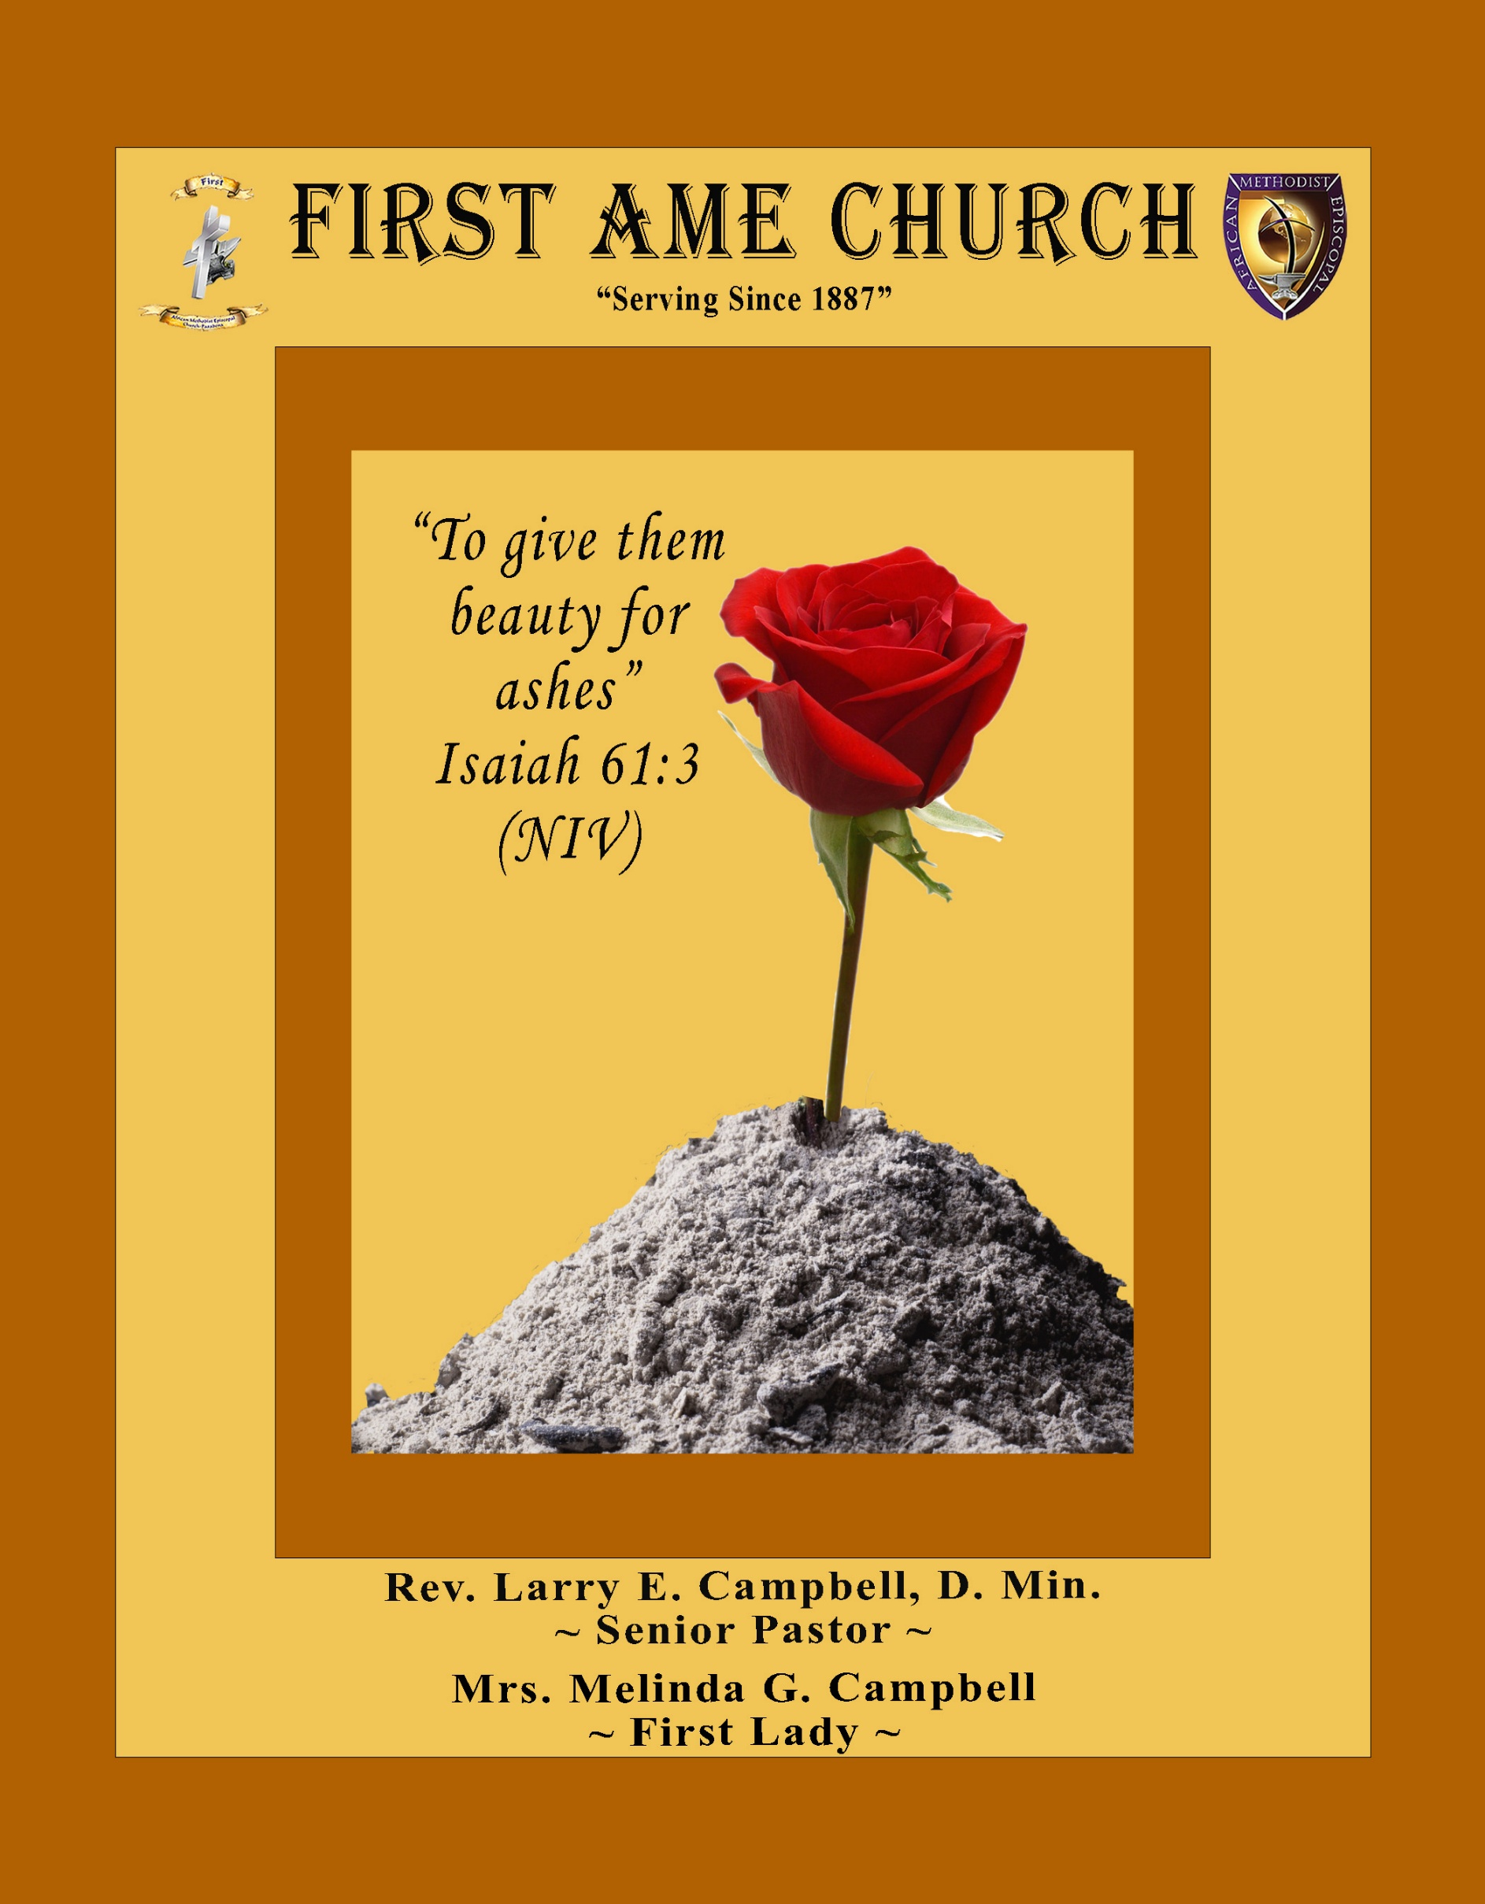
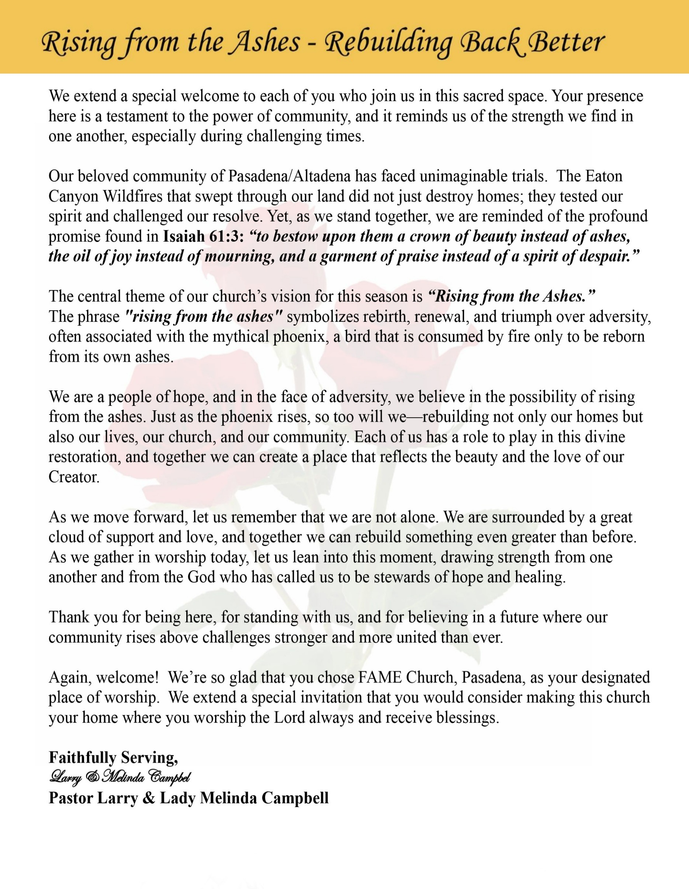

Sunday, May 24 , 2026 | 9:30 a.m.

Rt. Rev. Francine A. Brookins, Esq., Presiding Bishop
Rev. Miriam Burnett, MD, MPH, Supervisor of Missions
Rev. Roosevelt Lindsey, Jr. Presiding Elder

The Rev. Dr. Larry E. Campbell ~ Senior Pastor ~ Minister

Mobile: (951) 587-1894 ~ Email: larrycampbell@famepasadena.org

Our First Lady: Mrs. Melinda G. Campbell

The Reverend Dr. Jennifer Oliver ~ Itinerant Elder -
The Reverend Dr. Nikia Smith-Robert ~ Itinerant Elder (Affiliated)
The Reverend Lois Woodard ~ Itinerant Elder Superannuated (Retired)
The Reverend Rochelle Wright Moore ~ Itinerant Deacon
The Reverend Deborah West-Jones ~ Local Elder
The Reverend Philis J. Griffin, MDiv ~ Local Elder
Dr. Phyllis Beech ~ Evangelist
Sister Tessie Bonner ~ Deaconess

Community Resource Center Director ~ Ms. Kischchen Hazelton Venerable
Church Administrative Assistant: Ms. Letha Rhymes

Church Office Hours:
Tue - Wed 9:00 am - 5:00 pm, & Fri 9:00 am -3:00 pm.
Closed for Lunch Daily: 12:00 pm - 1:00 pm.

Music Ministry
Dr. Timothy Davis, Minister of Music
Bro. Jimmy Watlington, Percussionist ~ Bro. Carlos Caldwell, Organist
Bro. Darien Dorsey, Keyboardist
Sis. Karen Law, Women’s Chorus Director ~ Sis. Tonia Graham, Children’s Choir Director
Bro. J. Renard Washington, New Generation’s Choir

FREE WI-FI service is available on the FAME Campus by accessing FAME 1700
Password: 6267980503

-3-

~ Order of Worship Experience ~

Warning: This order of worship is subject to change without warning or prior notice --- everything is governed by the Sovereignty of the Holy Spirit.



Praise & Worship

Doxology: “Praise God From Whom All Blessings Flow”

The Call to Worship Bro. Lamont Coleman

Leader: I was glad when they said unto me, let us go into the house of the Lord, our feet shall stand within Thy gates O Jerusalem! (Psalm 122:1)

People: For a day in Thy courts is better than a thousand. I had rather be a doorkeeper in the house of my God than to dwell in the tents of wickedness. (Psalm 84:10)

Leader: Because of the house of the Lord our God, I will seek Thy good.
(Psalm 122:9)

People: Those that be planted in the house of the Lord, shall flourish in the courts of our God. (Psalm 92:13)

Leader: Blessed are they that dwell in Thy house. Lord, I have loved Thy habitation, the place where Thy honor dwelleth. (Psalm 26:8)

People: For the Lord is in His holy temple; let all the earth keep silence before Him.
(Habakkuk 2:20)

Leader: Let the words of my mouth and the meditation of my heart, be acceptable in Thy sight, O Lord my strength and my redeemer. (Psalm 19:14)

Unison: O Sing unto the Lord a new song, for He has done marvelous things. Make a
joyful noise unto the Lord, all the earth, sing His praises. (Psalm 98:1, 4)

-4-

The Hymn of Praise A.M.E. Hymnal #572

Mine Eyes Have Seen the Glory
(Battle Hymn of the Republic)

Words: Julia Ward Howe, 1819-1910

Mine eyes have seen the glory of the coming of the Lord;
He is trampling out the vintage where the grapes of wrath are stored;
He hath loosed the fateful lightning of His terrible swift sword;
His truth is marching on.

Refrain
Glo-ry! Glo-ry! Hal-le-lu-jah!
Glo-ry! Glo-ry! Hal-le-lu-jah!
Glo-ry! Glo-ry! Hal-le-lu-jah!
His truth is marching on.

I have seen Him in the watch-fires of a hundred circling camps;
They have builded Him an altar in the evening dews and damps;]
I can read His righteous sentence by the dim and flaring lamps;
His day is marching on.

Refrain

He has sounded forth the trumpet that shall never call retreat;
He is sifting out the hearts of men before His judgment seat;
O be swift, my soul, to answer Him; be jubilant, my feet!
Our God is marching on.

Refrain

In the beauty of the lilies Christ was born across the sea,
With a glory in His bosom that transfigures you and me;
As He died to make men holy, let us die to make men free!
While God is marching on.

Refrain

The Invocation Bro. Kenneth Caudle

Ministry of Music The Male Chorus

-5-

Scripture Lesson Bro. Stephen Babalola
(Please Stand for the Reading of God’s Words)

Acts 2:1-4 (New International Version) — The Holy Spirit Comes at Pentecost
2 When the day of Pentecost came, they were all together in one place. ² Suddenly a sound like the blowing of a violent wind came from heaven and filled the whole house where they were sitting. ³ They saw what seemed to be tongues of fire that separated and came to rest on each of them. ⁴ All of them were filled with the Holy Spirit and began to speak in other tongues as the Spirit enabled them.

Memorial Day Litany — “Honoring the Legacy of Sacrifice” Bro. Paul Gibson
Leader: This weekend we gather in sacred remembrance on Memorial Day to honor the brave men
and women who gave their lives in service to others.

People: We remember their courage. We honor their sacrifice. We cherish their legacy.

Leader: We remember the military veterans who stood in the face of danger to defend freedom and
protect the liberties we enjoy today.

People: For every soldier, sailor, airman, marine, guardian, and veteran — we thank God for
Their service and sacrifice.

Leader: We honor the policemen and policewomen who daily place themselves in harm’s way to
protect our communities and preserve peace.

People: Grant them wisdom, protection, courage, and compassion as they serve.

Leader: We remember firefighters who run toward danger while others run away— risking their
lives to save homes, families, and strangers alike.

People: Lord, strengthen those who stand in the heat of crisis to rescue and restore.

Leader: We lift up first responders, paramedics, dispatchers, medical workers, and emergency
personnel who answer calls in moments of fear, tragedy, and uncertainty.

People: Bless the hands that heal, the voices that comfort, and the hearts that refuse to give
up.

Leader: Today we also celebrate the heroes and sheroes in our communities, families, and
churches—those whose names may never appear in history books, but whose sacrifices
changed lives.

People: We thank God for praying mothers, faithful fathers, wise grandparents, caring
neighbors, devoted pastors, teachers, mentors, and servants of compassion.
(Continued on page 7)

-6-

Memorial Day Litany (Continued) Bro. Bishop Cohen
Leader: Some sacrificed publicly. Others sacrificed quietly. Some wore uniforms. Others wore
aprons, work boots, choir robes, nurse uniforms, or the garments of humble service.

People: Yet all reflected the spirit of selfless love.

Leader: Your Word declares in John 15:13:
“Greater love hath no man than this, that a man lay down his life for his friends.”

People: Teach us to live lives worthy of such sacrifice.

Leader: Help us not merely to remember with words, but to honor with action—by serving others,
pursuing justice, loving mercy, and walking humbly with You.

People: May their sacrifice inspire our service. May their legacy strengthen our faith. May
their memory deepen our gratitude.

Leader: Comfort every grieving family, every Gold Star family, every wounded warrior, every
lonely veteran, every first responder carrying visible and invisible scars.

People: Be their refuge and strength, a very present help in times of trouble.

Leader: And when our days on earth are complete, may we also leave behind a legacy of faith,
courage, compassion, and love.

People: Lord, help us to serve faithfully, love deeply, and live honorably.

Unison: We remember. We honor. We give thanks. And we commit ourselves to building a
world worthy of their sacrifice. In the name of God, who is our refuge, strength, and
eternal hope—Amen.

Abbreviated Announcements/Visitor’s Welcome Dr. Brian K. Venerable



Special Congregational Hymn (Sing along)
#215 “Look and Live”

-7-

The Offertory (Tithes ~ Gifts ~ Benevolent Offerings) Bro. Bill Matlock

The following Electronic GIVING Platforms are creditable methods to GIVE to FAME:

#1. GIVELIFY - Mobile Giving App available on the App Store. It’s easy to set up, just follow the guidelines.

#2. Cash App: $FirstAMEPASADENA

#3. Mail in your Tithes & Offering - If you would like to mail your tithes and offering by check or money order, please send it to: First AME Church, 1700 N. Raymond Avenue, Pasadena, CA 91103.

#4. Drop off your Tithes & Offering - During business hours in the basket outside of the office.

Choral Response: “All things come of Thee, O Lord; and of Thine own have we given Thee. Amen.”

Children’s Church Dismissal

Sermonic Selection The Male Chorus

The Preached Word Pastor Larry E. Campbell

The Invitation (Public/Private)

How to Join First A.M.E. Church of Pasadena
PROFESSION OF FAITH. If you have never been a member of any church, you may join by professing Jesus Christ as your personal Lord and Savior.

RENEWAL OF VOWS. If you have been a member of a church at one time, but have been in active, you may join by renewing your faith in Jesus Christ as Lord and Savior.

TRANSFER. If you are a member of another African Methodist Episcopal Church and you are in good standing, you may join by requesting that your membership be transferred to the First African Methodist Episcopal Church of Pasadena.

AFFILIATE MEMBER. Sometimes an individual has reasons for keeping /his/her membership in another church but would like to be an active member of First African Methodist Episcopal Church, too. This is possible as an affiliate member. __________________________________________________________________________________________

The Doxology

The Benediction

-8-

Scripture of the Day
A Time to Remember. In the future, when your children ask you, ‘What do these stones mean?’ ⁷ tell them that the flow of the Jordan was cut off before the ark of the covenant of the Lord. When it crossed the Jordan, the waters of the Jordan were cut off. Joshua 4:6-7

Quote of the Day
“A hero is someone who has given his or her life to something bigger than oneself.” — Joseph Campbell.

Thought of the Week
“Remembering the Sacrifice”. “Greater love hath no man than this, that a man lay down his life for his friends.” — John 15:13
On this Memorial Day, we pause to honor and remember the brave men and women who made the ultimate sacrifice in service to others. We thank God for military veterans, first responders, police officers, firefighters, healthcare workers, and everyday heroes whose courage, commitment, and selflessness have touched our lives and strengthened our communities.
Memorial Day reminds us that freedom, peace, and safety often come at a great cost. As believers, we are called not only to remember their sacrifice, but also to live lives marked by gratitude, compassion, service, and love. May we never take for granted the blessings we enjoy today because someone was willing to stand, serve, protect, and sacrifice.

Humor of the Week
An elderly lady was at the store and accidentally locked her keys in the car. She had a coat hanger and was trying and trying, but she couldn't get it unlocked. She finally prayed and asked God to help her.
About that time, this real rough looking guy pulled up on a motorcycle. He was dressed in leather, tattoos, and wearing a skull cap. In 15 seconds, he had the car unlocked.
She gave him a hug and said "Lord, thank you for sending me this nice man." He said "Lady, I'm not a nice man. I just got out of prison for auto theft." She hugged him again and said "Lord, thank you. You even sent me a professional."

HOME DAILY BIBLE READINGS
May 25, 2026 – May 31, 2026 (Week 36, 1 Corinthians)
Monday Day 246 Mark 10:1-40, Psalm 102:12-22
Tuesday Day 247 Mark 10:41-11:33, Psalm 102:23-28 Wednesday Day 248 Mark 12:1-44, Psalm 103:1-6
Thursday Day 249 Mark 13:1-37, Psalm 103:7-18
Friday Day 250 Mark 14:1-42, Psalm 103:19-22
Saturday Day 251 Mark 14:43-72, Psalm 104:1-9
Sunday Day 252 Mark 15:1-47, Psalm 104:10-18

-9-

ANNOUNCEMENTS

Everyone is encouraged to join our weekly Christian Education Sessions

VIRTUAL ADULT CHURCH SCHOOL
Sunday Mornings at 8:00 a.m.
http://us02web.zoom.us/j/844840183?pwd-sm0w1yvmvhOvC13175urZ2vr7M3EtU.1

HYBRID PASTOR’S WEEKLY BIBLE STUDY
Wednesdays at 11:00 a.m.
https://us02web.zoom.us/j/84484840183?pwd=sm0w1yvmvhOvC13l75urZ2vr7M3EtU.1
Meeting ID: 844 8484 0183 | Passcode: 357260

WEEKLY TELECONFERENCE PRAYERS SESSIONS
Wednesdays at 5:30 a.m. and 6:00 p.m.
Conference Call Number: (530_ 881-1212
Access Code: 234575160#

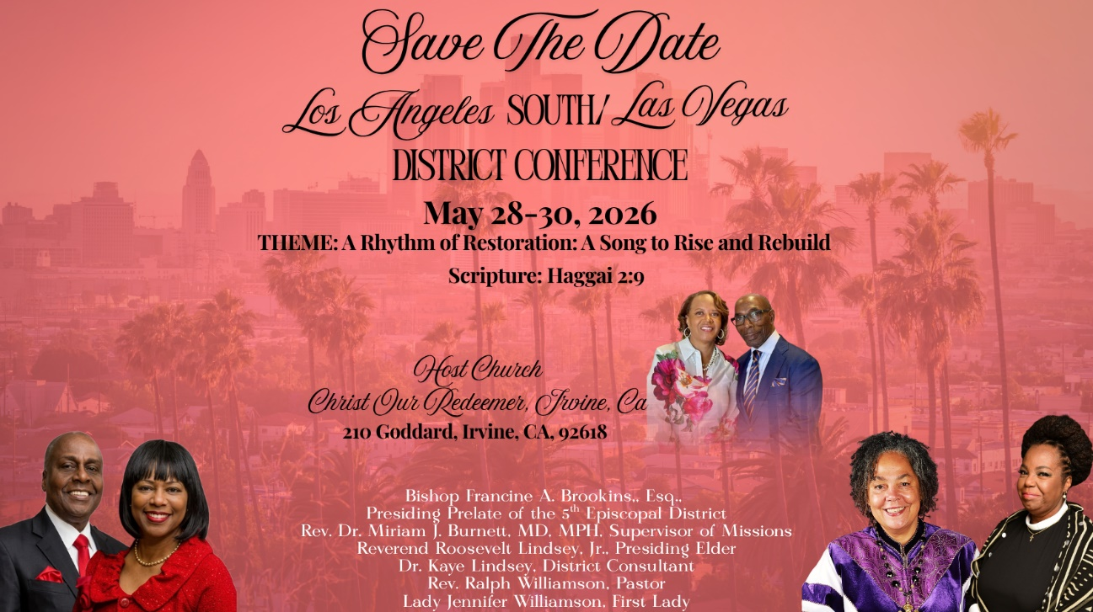

-10-

ANNOUNCEMENTS (Continued)
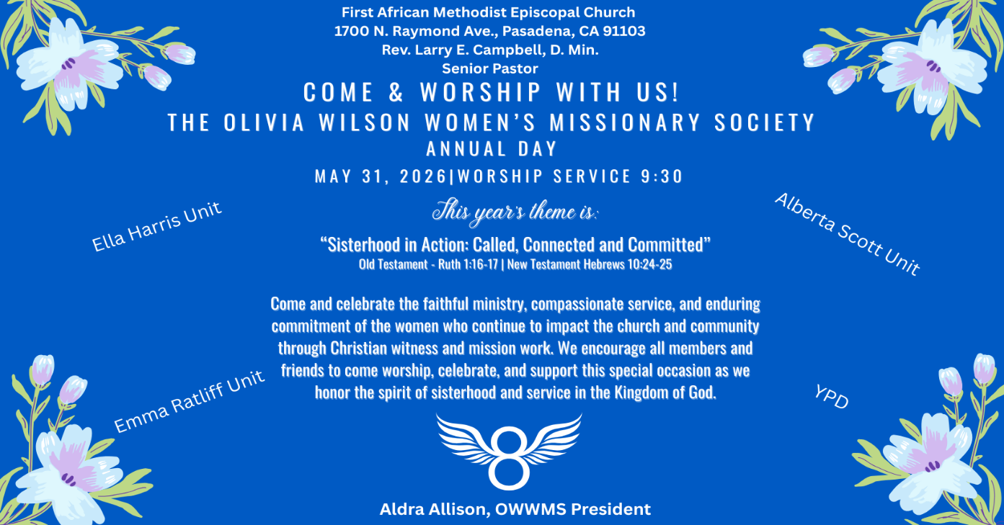
Midterm Election Day – June 2, 2026
Midterm Election Day will take place on Tuesday, June 2, 2026. As citizens and people of faith, we are encouraged to prayerfully exercise our right and responsibility to vote. Voting is one of the most powerful ways we can help shape our communities, support justice, and ensure that every voice is heard.
Let us remember that civic engagement is not only a privilege but also an opportunity to serve the common good and demonstrate responsible stewardship of the freedoms we have been given.
“Seek the peace and prosperity of the city to which I have carried you… Pray to the Lord for it, because if it prospers, you too will prosper.” — Jeremiah 29:7
“The vote is precious. It is the most powerful nonviolent tool we have in a democratic society.” — Anonymous. Please make plans to vote and encourage others to do the same.

Men's Ministry - BIBLE STUDY
Time: Wednesday, June 3, 2026 | 6:00 p.m.
Meeting ID: 894 7536 6487 | Passcode: 465177
One tap mobile: +16699006833,,89475366487#,,,,*465177# US (San Jose)

Women's Ministry – BIBLE STUDY
Time: Wednesday, June 3, 2026 | 6:00 p.m.
Meeting ID: 857 0061 9461; Passcode: 933892
One tap mobile +16699006833,,85700619461#,,,,,,0#,,933892# US (San Jose)

-11-

ANNOUNCEMENTS (Continued)

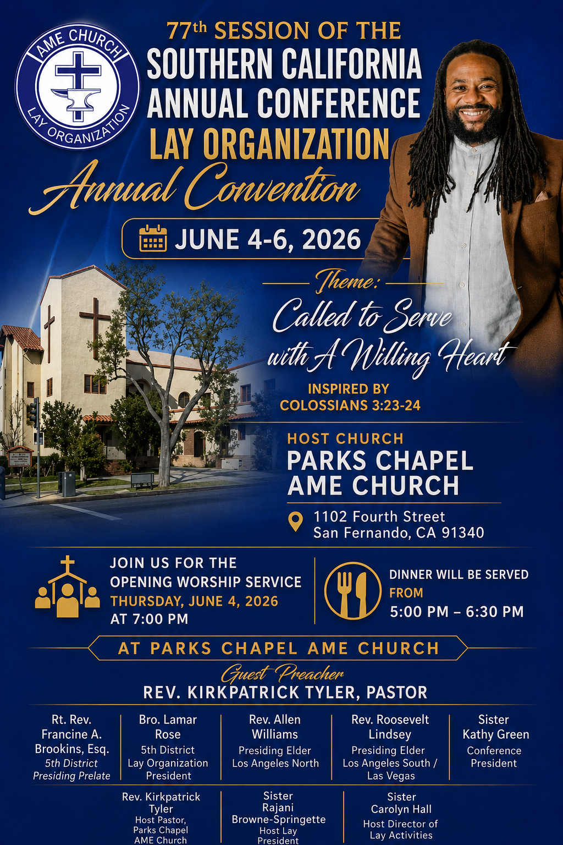

Background Check Reminder
This is a reminder that all adults aged 18 and older who work with children and youth in our church are required to complete the necessary background screening in compliance with the 5th Episcopal District requirements. Assistance is available to help ensure all volunteers and workers remain in compliance. Please contact the church office or Sis. Gina Tervalon for additional information and next steps.

Annual Graduation/Special Achievement Sunday
Sunday, June 14, 2026 | 9:30 a.m.
Special Academic Achievement of our Children. Followed by a special time of food & fellowship in our Fellowship Hall. We will celebrate the Special Achievements of our students and recognize our high school and college graduates.

-12-

Prayer Request(s)
Please notify the Church Office of Sick & Shut-in additions, deletions, or status/address changes.

Bishop Francine A. Brookins, Esq. Supervisor Miriam Burnett, MD
Presiding Elder Roosevelt & Dr. Kaye Lindsey Rev. Dr. Larry & Melinda Campbell
Richard Craig Hazel Clark Erica Woodard Jason Shirley Joshua Shirley Julian Shirley Ayanna Terry Cheryl Jamerson Gwendolyn Flowers Andrea Anderson Ocilda Files Danielle Clark Donita Towler Rev. Charles Brooks Doris Bailey Kimberly Woods Cynithia Grace Zechariah Robinson Diane Jordan Christopher McCarthy Wilma Haynes Calle Burns Noel Johnson Brittney Petty Taylor Family Deborah Burton Nettie McChristen Jacquelyn Walker Donita Towler
Rev. Rochelle Moore Lorene Butler Stella Pulliam Collette Blizzard Konata Doxey
The Eaton Canyon Fire Victims Selene Cox Mel Beech

College Students

Let’s continue to support and pray for our beloved College Students

Isaiah Crowell Alecia Davis Chase Johnson Grant Blizzard

Tyler Johnson Richard Jones Tyrikk Lawson Makia Rose Talbert Isaiah Ringo Journey Rogers Elyse Sharp Kylee Sharp Zion Otano Elise Tervalon Grace Jones Jordan Patterson Kimberly Robinson Donovan Williams Jasmine Collins Brandon Bates Gabriel Blizzard

Sick and Shut-Ins
Andrew Oliver 1405 N. Roosevelt Avenue, Pasadena, CA 91104
Barbara Buchanan 616 Rio Grande St. Pasadena, CA 91104
Bettina Ayers Pasadena Meadows Nursing Home, 150 Bellefontaine St., Pas., CA 91105
Betty Betts Turner USC Keck Rehabilitation, 300 W Huntington Dr., Arcadia, CA 91007
Bobby Thomas 1052 E. Morada Place, Altadena, CA 91001
Doris Curd 11619 Woodcock Avenue, San Fernando, CA 91340
Edmund Riddle Active Care Mission Bay, 2440 Grand Avenue, San Diego, CA 92109
Eleanor Towler 975 E. Union Street, Unit #417, Pasadena, CA 91106
Elois Blizzard P. O. Box 3646, So. Pasadena, CA 91031
Emily Cormier-Ross 2549 La Fiesta Avenue, Altadena, CA 91001
Ernestine English 26 W. Fair Oaks Drive, Pasadena, CA 91103
Fred Caple 51 North 15th Street Haledon, NJ 07508
Gloria Cubit Clay 11745 Pierce St., Lake View Terrace, CA 91342
Hugh Hamberry 19225 Chole Rd., Apple Valley, CA 92307
Jeff Thomas 603 Tocino Dr. Duarte, CA 91010 | Mountain View Terrace
Jessie Smith 3925 S Jones BL, Apt 2118 Las Vegas, NV 89103| Spring Valley Community
Josephine Brown 15607 Saddleback Rd, Riverside, CA 92506
Konata Doxey Monte Vista Healthcare Center, Duarte, CA 91010
Linnie G. Nollie 2250 E. New York Drive, Altadena, CA 91001
Malika G. Hendry P. O. Box 94082, Pasadena, CA 91109
Mildred Lewis C/O Hazel Rohr, 884 W. Jane Court, Upland, CA 91786
Norma Burnett 618 Fairview Avenue, Unit #228, Arcadia, CA 91007
Opal Hampton 1030 Chevron Court, Pasadena, CA 91103
Paul Ratliff P.O. Box 40407 Pasadena, CA 91114
Virlyn Grant 15122 Orange Ave., Paramount, CA 90723
Wanda Nelson 3618 N. Fair Oaks Avenue, Altadena, CA 91001
William Hilliard 7504 Wynstone Pl., Fontana, CA 92336
Zell L. Hill 375 Barthe Drive, Pasadena, CA 91103

-13-

Sermon Notations

Scripture: _____________________________________________________________

Subject: _______________________________________________________________

Points of the Message: ___________________________________________________
_______________________________________________________________________
_______________________________________________________________________
_______________________________________________________________________
_______________________________________________________________________
_______________________________________________________________________
_______________________________________________________________________

Main Ideas of the Sermon: ________________________________________________
_______________________________________________________________________
_______________________________________________________________________
_______________________________________________________________________
_______________________________________________________________________
_______________________________________________________________________

Illustrations I want to remember: _________________________________________
_______________________________________________________________________
_______________________________________________________________________
_______________________________________________________________________
_______________________________________________________________________
_______________________________________________________________________
_______________________________________________________________________

What should I do as a result of this Sermon? ________________________________

_____________________________________________________
_____________________________________________________
_____________________________________________________
_____________________________________________________

-14-

