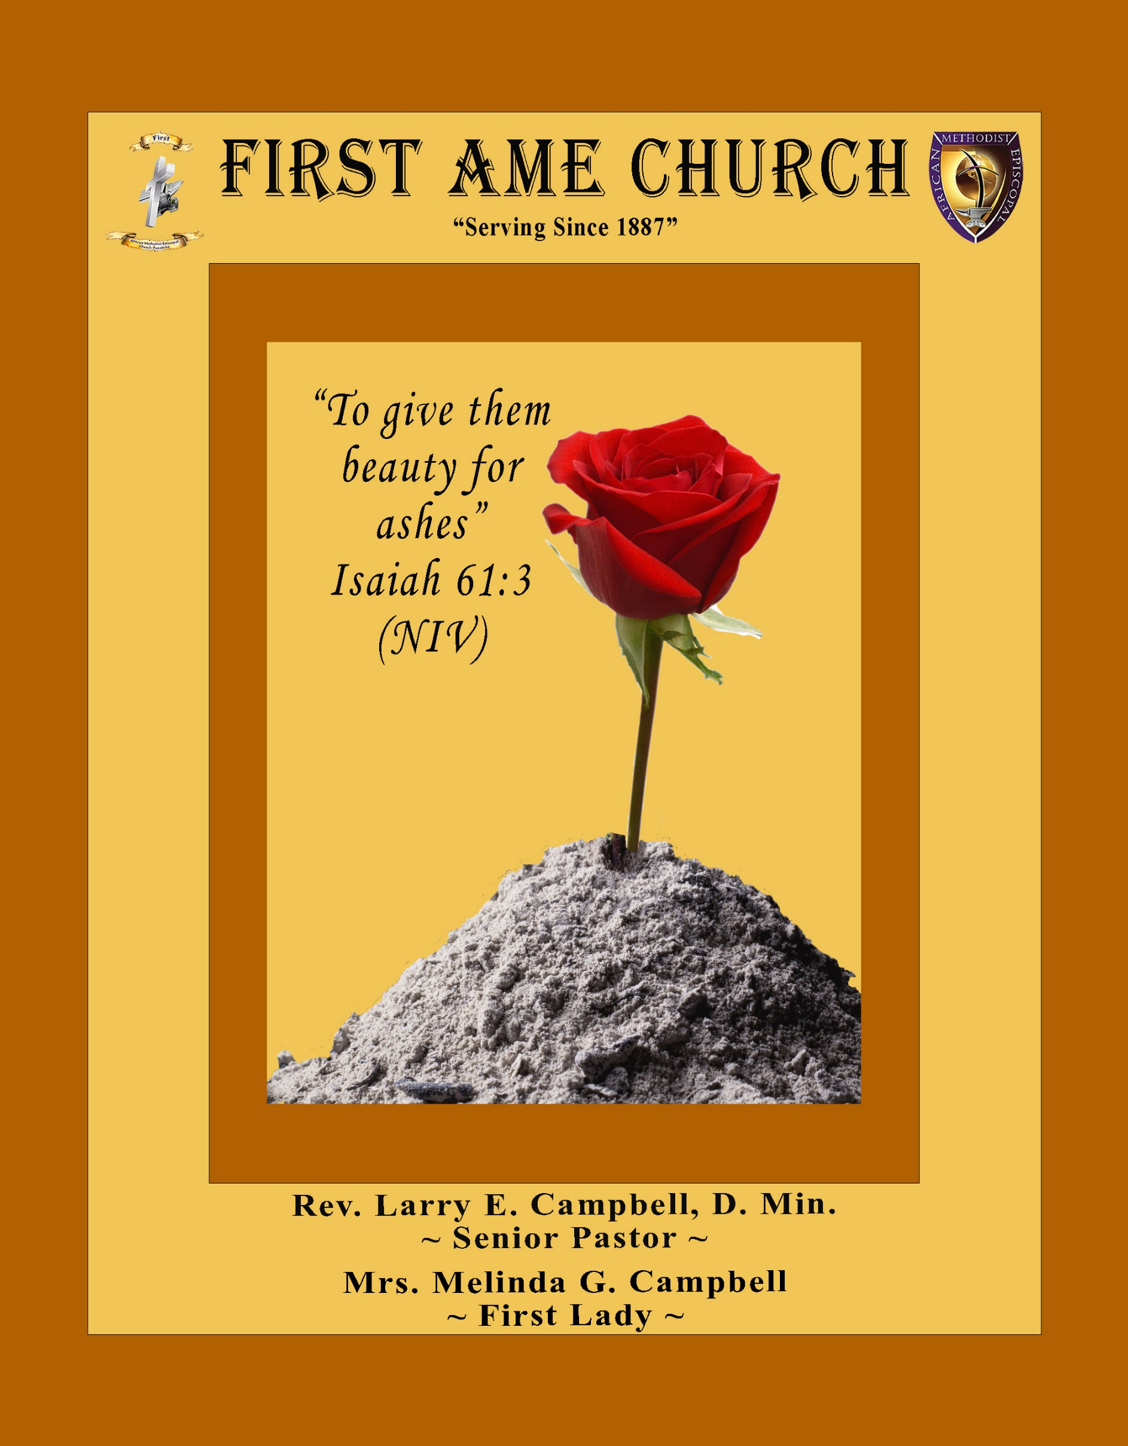
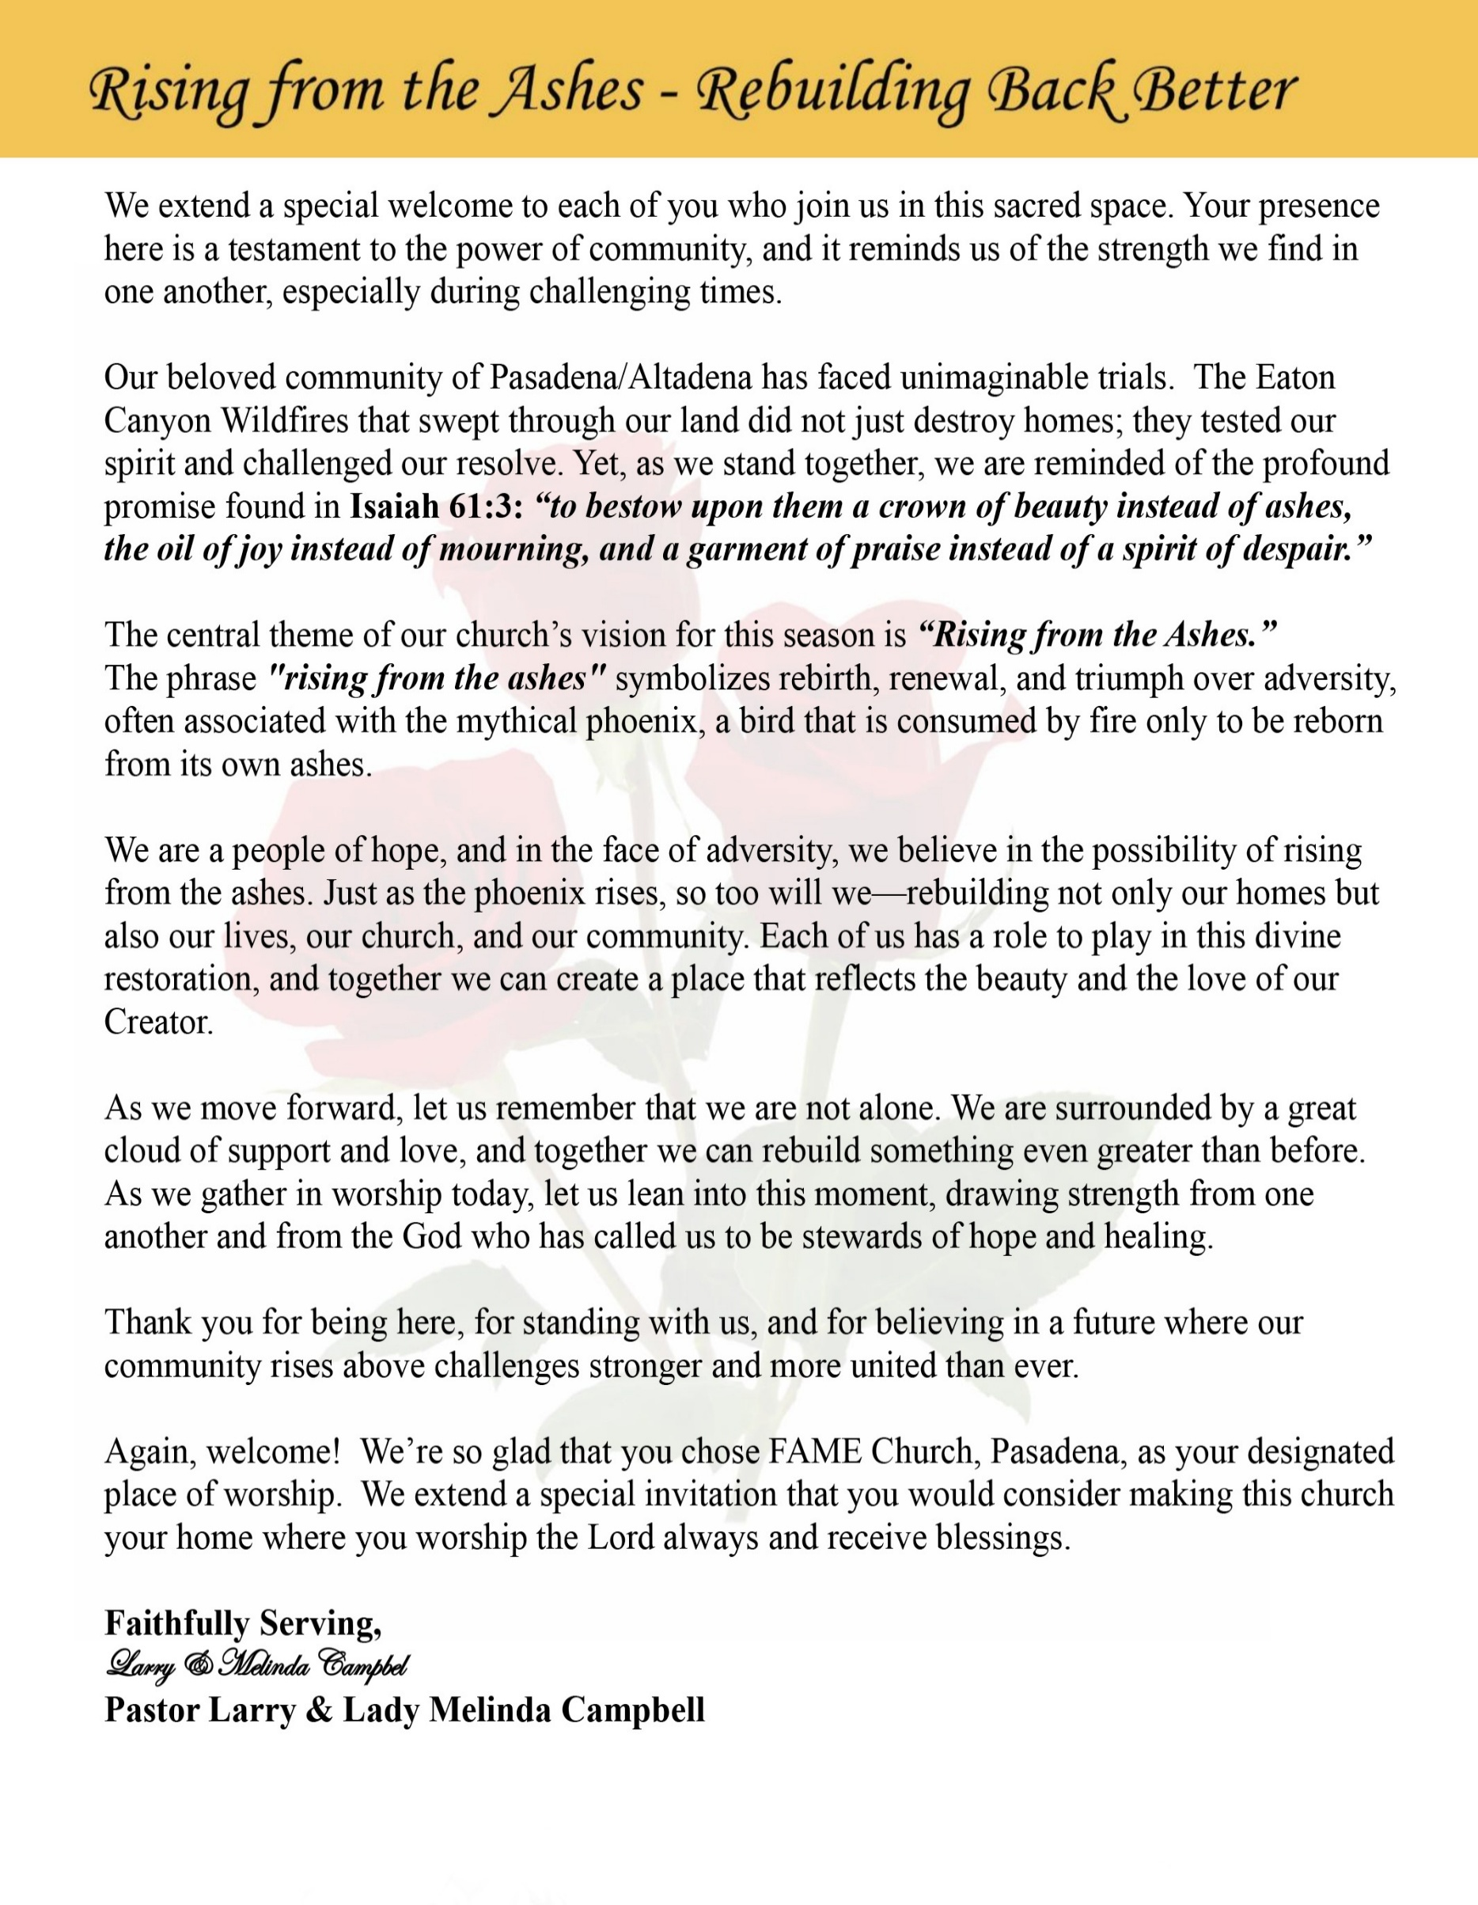

Sunday, May 31 , 2026 | 9:30 a.m.

Rt. Rev. Francine A. Brookins, Esq., Presiding Bishop
Rev. Miriam Burnett, MD, MPH, Supervisor of Missions
Rev. Roosevelt Lindsey, Jr. Presiding Elder

The Rev. Dr. Larry E. Campbell ~ Senior Pastor ~ Minister

Mobile: (951) 587-1894 ~ Email: larrycampbell@famepasadena.org

Our First Lady: Mrs. Melinda G. Campbell

The Reverend Dr. Jennifer Oliver ~ Itinerant Elder -
The Reverend Dr. Nikia Smith-Robert ~ Itinerant Elder (Affiliated)
The Reverend Lois Woodard ~ Itinerant Elder Superannuated (Retired)
The Reverend Rochelle Wright Moore ~ Itinerant Deacon
The Reverend Deborah West-Jones ~ Local Elder
The Reverend Philis J. Griffin, MDiv ~ Local Elder
Dr. Phyllis Beech ~ Evangelist
Sister Tessie Bonner ~ Deaconess

Community Resource Center Director ~ Ms. Kischchen Hazelton Venerable
Church Administrative Assistant: Ms. Letha Rhymes

Church Office Hours:
Tue - Wed 9:00 am - 5:00 pm, & Fri 9:00 am -3:00 pm.
Closed for Lunch Daily: 12:00 pm - 1:00 pm.

Music Ministry
Dr. Timothy Davis, Minister of Music
Bro. Jimmy Watlington, Percussionist ~ Bro. Carlos Caldwell, Organist
Bro. Darien Dorsey, Keyboardist
Sis. Karen Law, Women’s Chorus Director ~ Sis. Tonia Graham, Children’s Choir Director
Bro. J. Renard Washington, New Generation’s Choir

FREE WI-FI service is available on the FAME Campus by accessing FAME 1700
Password: 6267980503

-3-

~ Order of Worship Experience ~

Warning: This order of worship is subject to change without warning or prior notice --- everything is governed by the Sovereignty of the Holy Spirit.

Olivia Wilson Women’s Missionary Society
Annual Day

Sisterhood in Action
Called, Connected and Committed

Praise & Worship

Doxology: “Praise God From Whom All Blessings Flow”

The Call to Worship Sis. Brenda Harvey-Williams

Leader: I was glad when they said unto me, let us go into the house of the Lord, our feet shall stand within Thy gates O Jerusalem! (Psalm 122:1)

People: For a day in Thy courts is better than a thousand. I had rather be a doorkeeper in the house of my God than to dwell in the tents of wickedness. (Psalm 84:10)

Leader: Because of the house of the Lord our God, I will seek Thy good.
(Psalm 122:9)

People: Those that be planted in the house of the Lord, shall flourish in the courts of our God. (Psalm 92:13)

Leader: Blessed are they that dwell in Thy house. Lord, I have loved Thy habitation, the place where Thy honor dwelleth. (Psalm 26:8)

People: For the Lord is in His holy temple; let all the earth keep silence before Him.
(Habakkuk 2:20)

Leader: Let the words of my mouth and the meditation of my heart, be acceptable in Thy sight, O Lord my strength and my redeemer. (Psalm 19:14)

Unison: O Sing unto the Lord a new song, for He has done marvelous things. Make a
joyful noise unto the Lord, all the earth, sing His praises. (Psalm 98:1, 4)

-4-

The Hymn of Praise A.M.E. Hymnal #272
Pass Me Not, O Gentle Savior

Words: Fanny J. Crosby, 1820-1915
Tune: William H. Doane, 1832-1915

1 Pass me not, O gentle Savior,
hear my humble cry;
While on others Thou art calling,
do not pass me by.

Refrain
Savior, Savior, hear my humble cry;
while on others Thou art calling,
do not pass me by.

2 Let me at a throne of mercy
find a sweet relief,
kneeling there in deep contrition;
help my unbelief.

[Refrain]

3 Trusting only in Thy merit,
Would I seek Thy face;
heal my wounded, broken spirit,
save me by Thy grace.

[Refrain]

4 Thou, the Spring of all my comfort,
more than life to me;
Whom have I on earth beside Thee?
Whom in heav'n but Thee?

[Refrain]

The Invocation Sis. Catherine Graham

Ministry of Music The Women Chorus

-5-

Scripture Lesson
(Please Stand for the Reading of God’s Words)

Old Testament Sis. Mable Davis

Ruth 1:8-17 (NIV)) — Sisterhood in Action: Called, Connected and Committed
⁸ Then Naomi said to her two daughters-in-law, “Go back, each of you, to your mother’s home. May the Lord show you kindness, as you have shown kindness to your dead husbands and to me. ⁹ May the Lord grant that each of you will find rest in the home of another husband.” Then she kissed them goodbye and they wept aloud ¹⁰ and said to her, “We will go back with you to your people.”
¹¹ But Naomi said, “Return home, my daughters. Why would you come with me? Am I going to have any more sons, who could become your husbands? ¹² Return home, my daughters; I am too old to have another husband. Even if I thought there was still hope for me—even if I had a husband tonight and then gave birth to sons— ¹³ would you wait until they grew up? Would you remain unmarried for them? No, my daughters. It is more bitter for me than for you, because the Lord’s hand has turned against me!”
¹⁴ At this they wept aloud again. Then Orpah kissed her mother-in-law goodbye, but Ruth clung to her.
¹⁵ “Look,” said Naomi, “your sister-in-law is going back to her people and her gods. Go back with her.”
¹⁶ But Ruth replied, “Don’t urge me to leave you or to turn back from you. Where you go I will go, and where you stay I will stay. Your people will be my people and your God my God. ¹⁷ Where you die I will die, and there I will be buried. May the Lord deal with me, be it ever so severely, if even death separates you and me.”

New Testament Sis. Gina Tervalon, YPD President

Hebrews 10:19-25 (NIV) — Sisterhood in Action: Called, Connected and Committed
¹⁹ Therefore, brothers and sisters, since we have confidence to enter the Most Holy Place by the blood of Jesus, ²⁰ by a new and living way opened for us through the curtain, that is, his body, ²¹ and since we have a great priest over the house of God, ²² let us draw near to God with a sincere heart and with the full assurance that faith brings, having our hearts sprinkled to cleanse us from a guilty conscience and having our bodies washed with pure water. ²³ Let us hold unswervingly to the hope we profess, for he who promised is faithful. ²⁴ And let us consider how we may spur one another on toward love and good deeds, ²⁵ not giving up meeting together, as some are in the habit of doing, but encouraging one another—and all the more as you see the Day approaching.

Abbreviated Announcements/Visitor’s Welcome Sis. Aldra Allison, OWWMS President

-6-

Pastoral Remarks

Special Congregational Hymn (Sing along)
#450 “Blessed Assurance”

The Offertory (Tithes ~ Gifts ~ Benevolent Offerings) Sis. Pamela J. Hughes

The following Electronic GIVING Platforms are creditable methods to GIVE to FAME:

#1. GIVELIFY - Mobile Giving App available on the App Store. It’s easy to set up, just follow the guidelines.

#2. Cash App: $FirstAMEPASADENA

#3. Mail in your Tithes & Offering - If you would like to mail your tithes and offering by check or money order, please send it to: First AME Church, 1700 N. Raymond Avenue, Pasadena, CA 91103.

#4. Drop off your Tithes & Offering - During business hours in the basket outside of the office.

Choral Response: “All things come of Thee, O Lord; and of Thine own have we given Thee. Amen.”

Children’s Church Dismissal

First A.M.E. Church Women’s Missionary Society Litany Sis. Shirley Dauchan
Leader: Today, the First African Methodist Episcopal Church family rises in gratitude to celebrate
the faithful service and unwavering dedication of the Olivia Wilson Women’s Missionary
Society.

People: We honor these women of faith whose hands have served, whose prayers have
sustained, and whose love has strengthened our beloved church and community.

Leader: When families were hurting, they showed compassion. When communities faced hardship,
they answered the call. When hope seemed distant, they carried the light of Christ into
Pasadena and Altadena.

People: Their ministry has been more than words — it has been faith in action.

Leader: Jesus declared, “Inasmuch as ye have done it unto one of the least of these my brethren, ye
have done it unto me.” — Matthew 25:40

People: Through feeding the hungry, caring for the sick, comforting the grieving, and
uplifting the forgotten, they have served Christ faithfully.

Leader: For every prayer lifted…

People: We give thanks.

[Litany Continued on page 8]

-7-

First A.M.E. Church Women’s Missionary Society Litany [Continued]
Leader: For every sacrifice made…

People: We give thanks.

Leader” For every act of kindness extended throughout the church and community…

People: We give thanks.

Leader: The Olivia Wilson Women’s Missionary Society reminds us that true discipleship is found
not only in worship, but also in service.

People: Their legacy is written in lives touched, hearts encouraged, and communities
transformed.

Leader: Church family, shall we continue this work of love, justice, mercy, and compassion?

ALL: Yes! Together, we will serve “the least of these,” uplift our community, and continue
the mission of Jesus Christ with faith, courage, and love. Amen.

Introduction of Guest Speaker Lady Melinda G. Campbell

Sermonic Selection The Women Chorus

The Message Sister Deborah Jarrett Rabb
Historiographer/Statistician – Fifth Episcopal District Women’s Missionary Society

The Invitation (Public/Private)

How to Join First A.M.E. Church of Pasadena
PROFESSION OF FAITH. If you have never been a member of any church, you may join by professing Jesus Christ as your personal Lord and Savior.

RENEWAL OF VOWS. If you have been a member of a church at one time, but have been in active, you may join by renewing your faith in Jesus Christ as Lord and Savior.

TRANSFER. If you are a member of another African Methodist Episcopal Church and you are in good standing, you may join by requesting that your membership be transferred to the First African Methodist Episcopal Church of Pasadena.

AFFILIATE MEMBER. Sometimes an individual has reasons for keeping /his/her membership in another church but would like to be an active member of First African Methodist Episcopal Church, too. This is possible as an affiliate member. __________________________________________________________________________________________

The Doxology

The Benediction

-8-

Scripture of the Day
Called, Connected and Committed. "Whatever you do, work at it with all your heart, as working for the Lord, not for human masters..." Colossians 3:23
Quote of the Day
"There is a difference between interest and commitment. When you're interested in doing something, you do it only when circumstance permits. When you're committed to something, you accept no excuses; only results." — Renea Blanchard

Thought of the Week
Called, Connected, and Committed.
“Ye have not chosen me, but I have chosen you, and ordained you, that ye should go and bring forth fruit…” — John 15:16
As believers, we are reminded that our walk with God is never accidental. We are called by God with purpose and intention to serve, love, and reflect the light of Christ in the world. God equips each of us with gifts and opportunities to make a difference in the lives of others.
We are also connected through the bond of Christian fellowship. The church is more than a building; it is a family united in faith, prayer, encouragement, and service. Through our connection to Christ and to one another, we find strength for the journey and hope for every season.
Finally, we are committed to the work of the Kingdom. Commitment means remaining faithful even when the work is challenging. It means serving with compassion, giving with generosity, and loving without condition. Our commitment becomes a living testimony that Christ is alive and working through His people. May we continue to walk together as disciples who are Called, Connected, and Committed to advancing God’s Kingdom through faith and service.

Humor of the Week
So, Adam was talking to God and mentioned that he was becoming lonely.
God says to Adam, “I was thinking about how to remedy that situation, Adam. I think that you will like my solution. I have decided to create Woman.”
“Woman?”, “What is Woman?”, Adam asks.
God says, “Well, Adam, Woman is the perfect companion. Woman will fulfill all of your needs and desires, without question. Woman will serve your every want and need. She will obey your every command. Her only reason for being will be to bring you happiness.”
“Wow, Lord, Woman sounds perfect for me. What do I have to do?”
“Well, Adam, I require, from you, one eye, your right leg, and your left hand!”
Adam thinks for a minute, then asks, “What will you give me for a rib?”.

HOME DAILY BIBLE READINGS
June 1, 2026 – June 7, 2026 (Week 37, 2 Corinthians)
Monday Day 253 Mark 16:1-20, Psalm 104:19-26
Tuesday Day 254 Luke 1-2, Psalm 104:27-30
Wednesday Day 255 Luke 3-4, Psalm 104:31-35
Thursday Day 256 Luke 5-7, Psalm 105:1-11
Friday Day 257 Luke 8-10, Psalm 105:12-22
Saturday Day 258 Luke 11-12, Psalm 105:23-38
Sunday Day 259 Luke 12:13-59, Psalm 105:39-45

-9-

ANNOUNCEMENTS

Everyone is encouraged to join our weekly Christian Education Sessions

VIRTUAL ADULT CHURCH SCHOOL
Sunday Mornings at 8:00 a.m.
http://us02web.zoom.us/j/844840183?pwd-sm0w1yvmvhOvC13175urZ2vr7M3EtU.1

HYBRID PASTOR’S WEEKLY BIBLE STUDY
Wednesdays at 11:00 a.m.
https://us02web.zoom.us/j/84484840183?pwd=sm0w1yvmvhOvC13l75urZ2vr7M3EtU.1
Meeting ID: 844 8484 0183 | Passcode: 357260

WEEKLY TELECONFERENCE PRAYERS SESSIONS
Wednesdays at 5:30 a.m. and 6:00 p.m.
Conference Call Number: (530_ 881-1212
Access Code: 234575160#

Midterm Election Day – June 2, 2026
Midterm Election Day will take place on Tuesday, June 2, 2026. As citizens and people of faith, we are encouraged to prayerfully exercise our right and responsibility to vote. Voting is one of the most powerful ways we can help shape our communities, support justice, and ensure that every voice is heard.
Let us remember that civic engagement is not only a privilege but also an opportunity to serve the common good and demonstrate responsible stewardship of the freedoms we have been given.
“Seek the peace and prosperity of the city to which I have carried you… Pray to the Lord for it, because if it prospers, you too will prosper.” — Jeremiah 29:7
“The vote is precious. It is the most powerful nonviolent tool we have in a democratic society.” — Anonymous. Please make plans to vote and encourage others to do the same.

Men's Ministry - BIBLE STUDY
Time: Wednesday, June 3, 2026 | 6:00 p.m.
Meeting ID: 894 7536 6487 | Passcode: 465177
One tap mobile: +16699006833,,89475366487#,,,,*465177# US (San Jose)

Women's Ministry – BIBLE STUDY
Time: Wednesday, June 3, 2026 | 6:00 p.m.
Meeting ID: 857 0061 9461; Passcode: 933892
One tap mobile +16699006833,,85700619461#,,,,,,0#,,933892# US (San Jose)

-10-

ANNOUNCEMENTS (Continued)

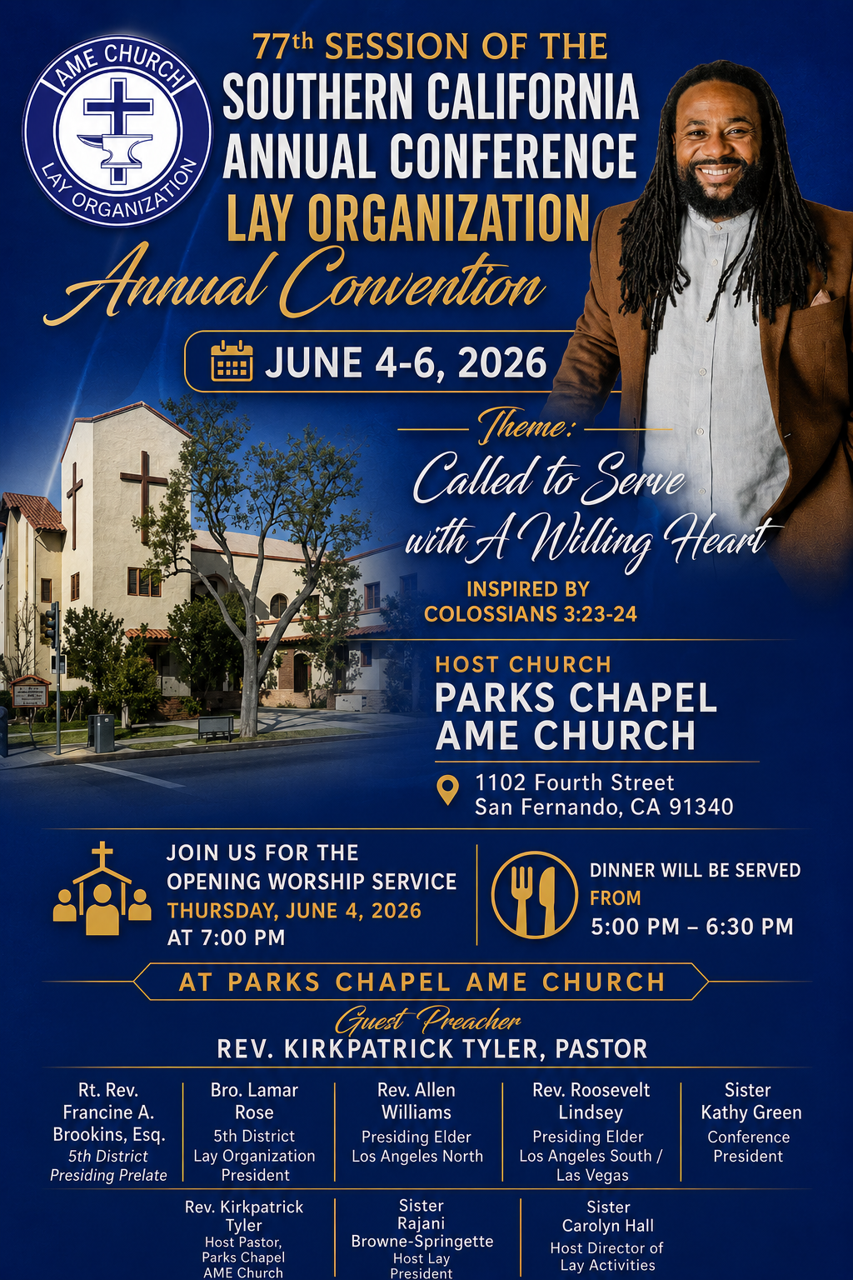

Senior Ministry Luncheon
You are invited to join us to enjoy good fellowship, good food, and helpful information at the FAME Senior Ministry gathering on Tuesday, June 9, 2026 @ 11:30 a.m. Bring a friend. All are welcome.

Steward Board Meeting
June 10, 2026 | 6:00 p.m.

Annual Graduation/Special Achievement Sunday
Sunday, June 14, 2026 | 9:30 a.m.
Special Academic Achievement of our Children. Followed by a special time of food & fellowship in our Fellowship Hall. We will celebrate the Special Achievements of our students and recognize our high school and college graduates.

Virtual Trustee Board Meeting
June 16, 2026 | 5:30 pm.

Sunday, June 21, 2026 | 9:30 a.m.
Celebrating God’s Gift of FATHERHOOD

-11-

ANNOUNCEMENTS (Continued)

New Members’ Orientation
The presence of all new members is warmly requested at our upcoming New Members’ Orientation Classes. These sessions are designed to help you grow in faith, fellowship, and understanding of the ministry and mission of the church. We look forward to journeying together as disciples of Christ and members of the household of faith.
Orientation Schedule
First Session: Wednesday, June 11 | 6:00 p.m.
Second Session: Wednesday, June 18 | 6:00 p.m.
Third Session: Wednesday, June 25 | 6:00 p.m.
Fourth Session: Wednesday, July 1 | 6:00 p.m.
Fifth Session: Wednesday, July 8 | 6:00 p.m.
Sixth Session: Wednesday, July 15 | 6:00 p.m.
We encourage every new member to attend faithfully as we grow together in grace, service, and spiritual maturity.

Background Check Reminder
This is a reminder that all adults aged 18 and older who work with children and youth in our church are required to complete the necessary background screening in compliance with the 5th Episcopal District requirements. Assistance is available to help ensure all volunteers and workers remain in compliance. Please contact the church office or Sis. Gina Tervalon for additional information and next steps.

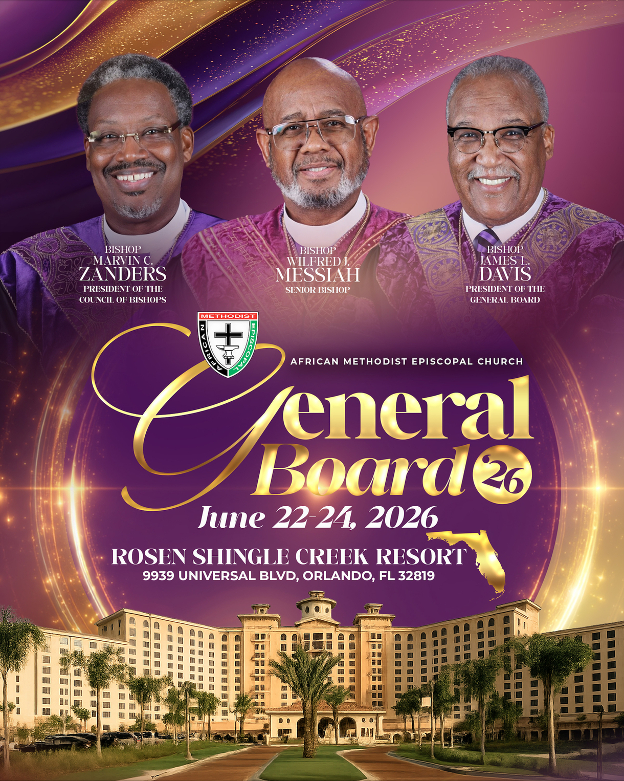

-12-

Prayer Request(s)
Please notify the Church Office of Sick & Shut-in additions, deletions, or status/address changes.

Bishop Francine A. Brookins, Esq. Supervisor Miriam Burnett, MD
Presiding Elder Roosevelt & Dr. Kaye Lindsey Rev. Dr. Larry & Melinda Campbell
Richard Craig Hazel Clark Erica Woodard Jason Shirley Joshua Shirley Julian Shirley Ayanna Terry Cheryl Jamerson Gwendolyn Flowers Andrea Anderson Ocilda Files Danielle Clark Donita Towler Rev. Charles Brooks Doris Bailey Kimberly Woods Cynithia Grace Zechariah Robinson Diane Jordan Christopher McCarthy Wilma Haynes Calle Burns Noel Johnson Brittney Petty Taylor Family Deborah Burton Nettie McChristen Jacquelyn Walker Donita Towler
Rev. Rochelle Moore Lorene Butler Stella Pulliam Collette Blizzard Konata Doxey
The Eaton Canyon Fire Victims Selene Cox Mel Beech

College Students

Let’s continue to support and pray for our beloved College Students

Isaiah Crowell Alecia Davis Chase Johnson Grant Blizzard

Tyler Johnson Richard Jones Tyrikk Lawson Makia Rose Talbert Isaiah Ringo Journey Rogers Elyse Sharp Kylee Sharp Zion Otano Elise Tervalon Grace Jones Jordan Patterson Kimberly Robinson Donovan Williams Jasmine Collins Brandon Bates Gabriel Blizzard

Sick and Shut-Ins
Andrew Oliver 1405 N. Roosevelt Avenue, Pasadena, CA 91104
Barbara Buchanan 616 Rio Grande St. Pasadena, CA 91104
Bettina Ayers Pasadena Meadows Nursing Home, 150 Bellefontaine St., Pas., CA 91105
Betty Betts Turner USC Keck Rehabilitation, 300 W Huntington Dr., Arcadia, CA 91007
Bobby Thomas 1052 E. Morada Place, Altadena, CA 91001
Doris Curd 11619 Woodcock Avenue, San Fernando, CA 91340
Edmund Riddle Active Care Mission Bay, 2440 Grand Avenue, San Diego, CA 92109
Eleanor Towler 975 E. Union Street, Unit #417, Pasadena, CA 91106
Elois Blizzard P. O. Box 3646, So. Pasadena, CA 91031
Emily Cormier-Ross 2549 La Fiesta Avenue, Altadena, CA 91001
Ernestine English 26 W. Fair Oaks Drive, Pasadena, CA 91103
Fred Caple 51 North 15th Street Haledon, NJ 07508
Gloria Cubit Clay 11745 Pierce St., Lake View Terrace, CA 91342
Hugh Hamberry 19225 Chole Rd., Apple Valley, CA 92307
Jeff Thomas 603 Tocino Dr. Duarte, CA 91010 | Mountain View Terrace
Jessie Smith 3925 S Jones BL, Apt 2118 Las Vegas, NV 89103| Spring Valley Community
Josephine Brown 15607 Saddleback Rd, Riverside, CA 92506
Konata Doxey Monte Vista Healthcare Center, Duarte, CA 91010
Linnie G. Nollie 2250 E. New York Drive, Altadena, CA 91001
Malika G. Hendry P. O. Box 94082, Pasadena, CA 91109
Mildred Lewis C/O Hazel Rohr, 884 W. Jane Court, Upland, CA 91786
Norma Burnett 618 Fairview Avenue, Unit #228, Arcadia, CA 91007
Opal Hampton 1030 Chevron Court, Pasadena, CA 91103
Paul Ratliff P.O. Box 40407 Pasadena, CA 91114
Virlyn Grant 15122 Orange Ave., Paramount, CA 90723
Wanda Nelson 3618 N. Fair Oaks Avenue, Altadena, CA 91001
William Hilliard 7504 Wynstone Pl., Fontana, CA 92336
Zell L. Hill 375 Barthe Drive, Pasadena, CA 91103

-13-

Sermon Notations

Scripture: _____________________________________________________________

Subject: _______________________________________________________________

Points of the Message: ___________________________________________________
_______________________________________________________________________
_______________________________________________________________________
_______________________________________________________________________
_______________________________________________________________________
_______________________________________________________________________
_______________________________________________________________________

Main Ideas of the Sermon: ________________________________________________
_______________________________________________________________________
_______________________________________________________________________
_______________________________________________________________________
_______________________________________________________________________
_______________________________________________________________________

Illustrations I want to remember: _________________________________________
_______________________________________________________________________
_______________________________________________________________________
_______________________________________________________________________
_______________________________________________________________________
_______________________________________________________________________
_______________________________________________________________________

What should I do as a result of this Sermon? ________________________________

_____________________________________________________
_____________________________________________________
_____________________________________________________
_____________________________________________________

-14-

