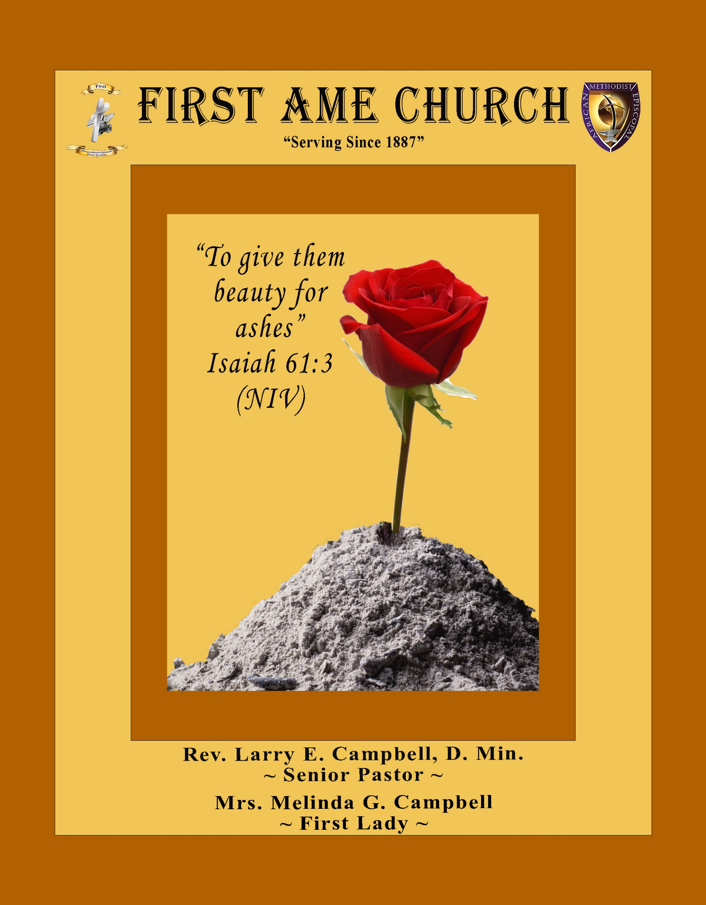
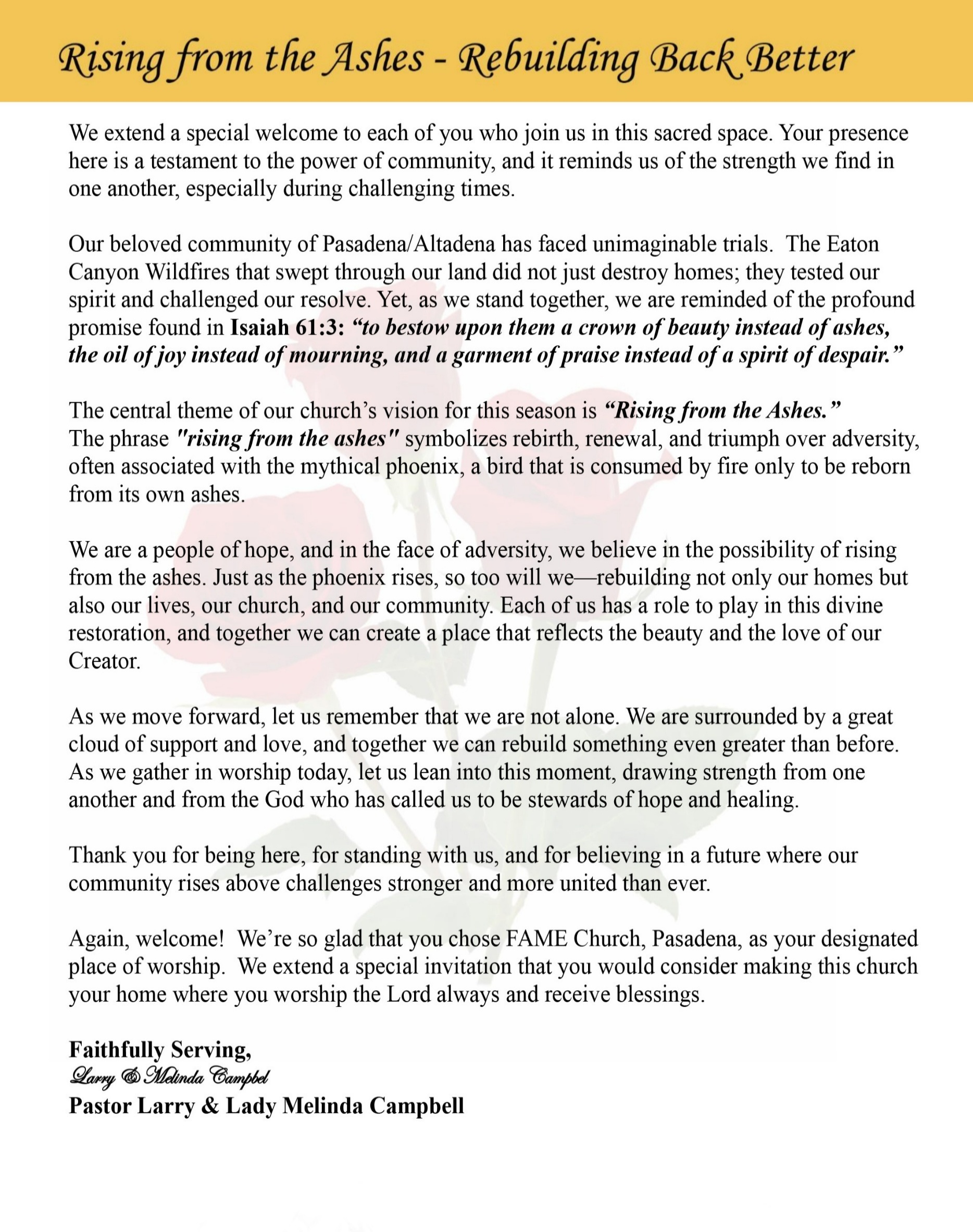

Sunday, November 1, 2026 | 9:30 a.m.

Rt. Rev. Francine A. Brookins, Esq., Presiding Bishop
Rev. Miriam Burnett, MD, MPH, Supervisor of Missions
Rev. Steven Shepard, Sr., Presiding Elder

The Rev. Dr. Larry E. Campbell ~ Pastor ~ Minister

Mobile: (951) 587-1894 ~ Email: larrycampbell@famepasadena.org

Our First Lady: Mrs. Melinda G. Campbell

The Reverend Dr. Jennifer Oliver ~ Itinerant Elder
The Reverend Dr. Nikia Smith Robert ~ Itinerant Elder (Affiliated)
The Reverend Lois Woodard ~ Itinerant Elder Superannuated (Retired)
The Reverend Rochelle Wright Moore ~ Itinerant Deacon
The Reverend Deborah West-Jones ~ Local Elder
Dr. Phyllis Beech ~ Evangelist
Sister Tessie Bonner ~ Deaconess
Community Resource Center Director ~ Mrs. Kischchen Hazelton Venerable
Church Administrative Assistant: Ms. Letha Rhymes

Church Office Hours:
Tue - Fri 9:00 am - 5:00 pm
Closed for Lunch Daily: 12:00 pm - 1:00 pm

Music Ministry
Dr. Timothy Davis, Minister of Music
Bro. Jimmy Watlington, Percussionist ~ Bro. Carlos Caldwell, Organist
Bro. Darien Dorsey, Keyboardist
Sis. Karen Law, Women’s Chorus Director ~ Sis. Tonia Graham, Children’s Choir Director
Bro. J. Renard Washington, New Generation’s Choir

FREE WI-FI service is available on the FAME Campus by accessing FAME 1700
Password: 6267980503

-3-

~ Order of Worship Experience ~

Warning: This order of worship is subject to change without warning or prior notice --- everything is governed by the Sovereignty of the Holy Spirit



+++ The Altar Call +++
Praise & Worship

Doxology: “Praise God From Whom All Blessings Flow”

The Call to Worship Pastor Larry E. Campbell

Leader: I was glad when they said unto me, let us go into the house of the Lord, our feet shall stand within Thy gates O Jerusalem! (Psalm 122:1)

People: For a day in Thy courts is better than a thousand. I had rather be a doorkeeper in the house of my God than to dwell in the tents of wickedness. (Psalm 84:10)

Leader: Because of the house of the Lord our God, I will seek Thy good.
(Psalm 122:9)

People: Those that be planted in the house of the Lord, shall flourish in the courts of our God. (Psalm 92:13)

Leader: Blessed are they that dwell in Thy house. Lord, I have loved Thy habitation, the place where Thy honor dwelleth. (Psalm 26:8)

People: For the Lord is in His holy temple; let all the earth keep silence before Him.
(Habakkuk 2:20).

Leader: Let the words of my mouth and the meditation of my heart, be acceptable in Thy sight, O Lord my strength and my redeemer. (Psalm 19:14)

Unison: O Sing unto the Lord a new song, for He has done marvelous things. Make a
joyful noise unto the Lord, all the earth, sing His praises. (Psalm 98:1, 4)

-4-

The Hymn of Praise A.M.E. Hymnal of #256
There Is a Fountain Filled with Blood
(Words: William Cowper, 1731-1800)

There is a fountain filled with blood,
Drawn from Immanuel’s veins,
And sinners plunged beneath that flood
Lose all their guilty stains: Lose all their guilty stains, Lose all their guilty stains;
And sinners plunged beneath that flood
Lose all their guilty stains.

The dying thief rejoiced to see
That fountain in His day;
And there have I, though vile as he,
Washed all my sins away: Washed all my sins away, Washed all my sins away;
And there have I, though vile as he,
Washed all my sins away.

Dear dying Lamb, Thy precious blood
Shall never lose its pow’r,
Till all the ransomed church of God
Are safe, to sin no more: Are safe, to sin no more, Are safe, to sin no more;
Till all the ransomed church of God
Are safe, to sin no more.

E’er since by faith I saw the stream
Thy flowing wounds supply,
Redeeming love has been my theme,
And shall be till I die: And shall be till I die, And shall be till I die;
Redeeming love has been my theme,
And shall be till I die.

When this poor, lisping, stamm’ring tongue
Lies silent in the grave,
Then in a nobler, sweeter song,
I’ll sing Thy pow’r to save: I’ll sing Thy pow’r to save, I’ll sing Thy pow’r to save;
Then in a nobler, sweeter song,
I’ll sing Thy pow’r to save.

The Invocation Rev. Dr. Nikia Smith Robert

Ministry of Music The Mass Choir

-5-

Responsive Scripture Lesson Rev. Rochelle Wright-Moore
(Please Stand for the Reading of God’s Words)
2 Chronicles 20:1-22 (New International Version) — Defying the Odds
Leader: After this, the Moabites and Ammonites with some of the Meunites came to wage war
against Jehoshaphat. 2 Some people came and told Jehoshaphat, “A vast army is coming
against you from Edom, from the other side of the Dead Sea. It is already in Hazezon
Tamar” (that is, En Gedi). 3 Alarmed, Jehoshaphat resolved to inquire of the Lord, and he
proclaimed a fast for all Judah. 4 The people of Judah came together to seek help from the
Lord; indeed, they came from every town in Judah to seek him.
People: 5 Then Jehoshaphat stood up in the assembly of Judah and Jerusalem at the temple of
the Lord in the front of the new courtyard 6 and said: “Lord, the God of our
ancestors, are you not the God who is in heaven? You rule over all the kingdoms of
the nations. Power and might are in your hand, and no one can withstand you. 7 Our
God, did you not drive out the inhabitants of this land before your people Israel and
give it forever to the descendants of Abraham your friend?

Leader: 8 They have lived in it and have built in it a sanctuary for your Name, saying, 9 ‘If
calamity comes upon us, whether the sword of judgment, or plague or famine, we will
stand in your presence before this temple that bears your Name and will cry out to you in
our distress, and you will hear us and save us.’

People: 10 “But now here are men from Ammon, Moab and Mount Seir, whose territory you
would not allow Israel to invade when they came from Egypt; so they turned away
from them and did not destroy them. 11 See how they are repaying us by coming to
drive us out of the possession you gave us as an inheritance. 12 Our God, will you not
judge them? For we have no power to face this vast army that is attacking us. We do
not know what to do, but our eyes are on you.”

Leader: 13 All the men of Judah, with their wives and children and little ones, stood there before the
Lord.

People: 14 Then the Spirit of the Lord came on Jahaziel son of Zechariah, the son of Benaiah,
the son of Jeiel, the son of Mattaniah, a Levite and descendant of Asaph, as he stood in
the assembly.

Leader: 15 He said: “Listen, King Jehoshaphat and all who live in Judah and Jerusalem! This is what
the Lord says to you: ‘Do not be afraid or discouraged because of this vast army. For the
battle is not yours, but God’s. 16 Tomorrow march down against them. They will be
climbing up by the Pass of Ziz, and you will find them at the end of the gorge in the Desert
of Jeruel. 17 You will not have to fight this battle. Take up your positions; stand firm and
see the deliverance the Lord will give you, Judah and Jerusalem. Do not be afraid; do not
be discouraged. Go out to face them tomorrow, and the Lord will be with you.’”

People: 18 Jehoshaphat bowed down with his face to the ground, and all the people of Judah
and Jerusalem fell down in worship before the Lord. 19 Then some Levites from the
Kohathites and Korahites stood up and praised the Lord, the God of Israel, with a
very loud voice.
[Continued on page 7]

-6-

Responsive Scriptural reading [Continued]
Leader: 20 Early in the morning they left for the Desert of Tekoa. As they set out, Jehoshaphat
stood and said, “Listen to me, Judah and people of Jerusalem! Have faith in the Lord your
God and you will be upheld; have faith in his prophets and you will be successful.”

People: 21 After consulting the people, Jehoshaphat appointed men to sing to the Lord and to
praise him for the splendor of his holiness as they went out at the head of the army,
saying: “Give thanks to the Lord, for his love endures forever.”

Unison: 22 As they began to sing and praise, the Lord set ambushes against the men of Ammon and Moab and Mount Seir who were invading Judah, and they were defeated.

THE AFFIRMATION OF FAITH (The Apostle Creed)

Minister: What do you Believe?

People: I believe in God the Father Almighty, Maker of heaven and earth, and in Jesus
Christ His only son our Lord who was conceived by the Holy Spirit, born of the Virgin Mary, suffered under Pontius Pilate, was crucified, dead and buried. The third day he arose from the dead; he ascended into heaven and sitteth at the right hand of God the Father Almighty; from thence he shall come to judge the quick and the dead. I believe in the Holy Spirit, the Church Universal, the communion of saints, the forgiveness of sins, the resurrection of the body and the life everlasting. Amen.

THE PRELUDE TO THE DECALOGUE

“From all that dwell below the skies, Let the Creator’s praise arise;
Let the Redeemer’s name be sung. Through every land, by every tongue.”

THE DECALOGUE (An Affirmation of God’s Law)

Minister: Let us express our commitment to keep God’s Law

People: God of our salvation, only You are God.
We will make no idols.
We will not invoke with malice your name, O God.
We will remember the Sabbath Day and keep it holy.
We will honor our father and our mother.
We will not commit murder.
We will not commit adultery.
We will not steal.
We will not be a false witness.
We will not covet anything that belongs to our neighbor.

Minister: Jesus said: “You shall love the Lord your God with all your heart, and with all your soul and with all your mind. This is the great and first commandment.”

ALL: Jesus also challenged us to love justly with a second commandment
which is like the first. We shall love our neighbor as ourselves! On these
commandments depend all the law and the prophets.

-7-

THE GLORIA PATRI
Glory be to the Father, and to the Son, and to the Holy Ghost.
As it was in the beginning, is now and ever shall be, world without end. Amen Amen!!

THE 2026-2027 PASTORAL APPOINTMENT Steward Board Pro-Tem

Abbreviated Announcements/ Visitor’s Welcome

Pastoral Remarks

The Offertory (Tithes ~ Gifts ~ Benevolent Offerings) Sis. Linda P. Wright

In order to satisfy the steady increase of inflation, we are asking each member to consider increasing your Tithe, Offerings & Gifts.

The following Electronic GIVING Platforms are creditable methods to GIVE to FAME:

#1. GIVELIFY - Mobile Giving App available on the App Store. It’s easy to set up, just follow the guidelines.

#2. Cash App: $FirstAMEPASADENA

#3. Mail in your Tithes & Offering - If you would like to mail your tithes and offering by check or money order, please send it to: First AME Church, 1700 N. Raymond Avenue, Pasadena, CA 91103.

#4. Drop off your Tithes & Offering - During business hours in the basket outside of the office.

Choral Response: “All things come of Thee, O Lord; and of Thine own have we given Thee. Amen.”

Children’s Church School Dismissal

Sermonic Selection The Mass Choir

Proclamation of The Word: Pastor Larry E. Campbell

The Invitation (Public/Private)

.

-8-

The Sacrament of the Lord’s Supper or Holy Communion

THE SOLICITATION

You that do truly and earnestly repent of your sins, and are in love and charity with your neighbor, and intend to lead a new life, following the commandments of God, and walking from henceforth in His holy ways, draw near with faith and take this holy sacrament to your comfort; and make your humble confession to Almighty God.

THE GENERAL CONFESSION

Minister: Let us humbly confess our sins unto Almighty God.

Minister and People:

Almighty God, Father of our Lord Jesus Christ, Maker of all things, Judge of all men, we acknowledge and bewail our manifold sins and wickedness which we from time to time most grievously have committed by thought, word, and deed against Your divine Majesty, provoking most justly Your wrath and indignation against us. We do earnestly repent and are heartily sorry for these, our misdoings; the remembrance of them is grievous unto us. Have mercy upon us, have mercy upon us, most merciful Father for Your Son our Lord Jesus Christ’s sake; forgive us all that is past, and grant that we may ever hereafter serve and please You in newness of life, to the honor and glory of Your name through Jesus Christ our Lord.

Amen. (Choral). (You may be seated).

THE PRAYER OF PARDON

Almighty God, our Heavenly Father, who of Your great mercy has promised forgiveness of sins to all them that with hearty repentance and true faith turn unto You, have mercy upon us; pardon and deliver us from all our sins; confirm and strengthen us in all goodness; and bring us to everlasting life through Jesus Christ, our Lord.

Choral Response: Amen.

THE PRAYER OF CONSECRATION

Minister: Loving God, our Father in heaven, in Your great mercy You gave Your only Son, Jesus Christ, to die on the cross so we could be saved. Through His sacrifice — offered once and for all — He made a complete and perfect offering for the sins of the whole world. And in the gospel, He told us to keep remembering His precious death until He comes again.
So we ask You, merciful Father, hear our prayer. As we receive this bread and this cup, according to the way our Savior Jesus taught us, help us remember His suffering and death, and allow us to share in the blessing of His body and His blood.
On the night He was betrayed, Jesus took bread. After giving thanks, He broke it and gave it to His disciples, saying, “Take and eat. This is my body, given for you. Do this to remember me.”
In the same way, after supper He took the cup. After giving thanks, He gave it to them and said,
“Drink from it, all of you. This is my blood of the new covenant, poured out for you and for many so that sins may be forgiven. Whenever you drink it, do this to remember me.” Amen!

THE LORD’S PRAYER (ALL)
THE ELEMENTS SHARED
THE BENEDICTION

-9-

ANNOUNCEMENTS

Welcome Back to our beloved
First Family
Pastor Larry & Lady Melinda Campbell

A HEARTFELT THANK YOU TO OUR FAME PASADENA CHURCH FAMILY!
To God Be the Glory for the Great Things He Has Done!
A heartfelt THANK YOU to our entire FAME Pasadena Church Family for the outstanding job you did in hosting the 102nd Session of the Southern California Annual Conference!
Your spirit of excellence, hospitality, dedication, and love made this conference a tremendous success! Special appreciation to everyone who generously shared their gifts, talents, time, and resources. Whether you served behind the scenes or on the front lines, your contributions made a difference. You demonstrated what can be accomplished when God's people work together in unity and love. I am extremely proud and grateful to serve as your Pastor! May God richly bless each of you for your faithful service. With Love and Appreciation,
Rev. Dr. Larry E. Campbell

2026 MIDTERM ELECTION — YOUR VOTE MATTERS!
Tuesday, November 3, 2026
Voting is more than a privilege—it is a precious right and a sacred responsibility! The struggle for voting rights, particularly within the African American community, was marked by tremendous sacrifice, courage, and determination. Many marched, suffered, and even gave their lives so that future generations could have a voice at the ballot box.
We honor their sacrifices by exercising the rights they fought to secure. The decisions made in this election will affect our schools, healthcare, housing, economic opportunities, and the future of our communities.
BE INFORMED! BE PREPARED! MAKE YOUR VOICE HEARD!
Research the candidates, review the ballot measures, and know your voting options. Remember: Your vote is your voice. Your voice matters. And our democracy is stronger when we participate!

Congratulations to the following FAME Church Family Members
Sis. Elizabeth Anne Lyles Pinned as a new member of the Women’s Missionary Society
Sis. Alisha Jeffries Pinned as a new member of the Women’s Missionary Society

BEREAVEMENT NOTIFICATION
It is with deep sorrow and heartfelt sympathy that we announce the passing of Brother Michael Dotson. Michael was a faithful member of First A.M.E. Church, Pasadena. While our hearts are saddened by his passing, we find comfort in the promise of God and the blessed assurance that to be absent from the body is to be present with the Lord. We ask the entire FAME Church family to keep the entire Dotson family lifted in prayer during this season of bereavement. May the God of all comfort strengthen them, surround them with His love, and grant them peace in the days ahead. Homegoing/Memorial Service arrangements will be shared as they become available.

BEREAVEMENT UPDATE
Memorial Services honoring the life and legacy of our beloved Sis. Barbara J. Walker will be held here at her home church on Saturday, November 21, 2026.at 11:00 am; a luncheon will immediately follow the service.

-10-

ANNOUNCEMENTS (Continued)

Southern California Conference Pastoral Changes
Transitioned to other areas:
The Rev. Godfrey Patterson: Transferring to the Missouri Annual Conference
The Rev. Dr. Michael W. Eagle: Supernumerary Status
The Rev. Denise Jackson: Supernumerary Status
The Rev. Andross Milteer: Supernumerary Status
The Rev. William Shephard: Superannuated (Retired)
The Rev. Michael Carr: Superannuated (Retired)

Congratulations to The Rev. Steven Shepard, Sr. appointment as the Presiding Elder of the Los Angeles South /Las Vegas District

Congratulations to the following pastors on their new pastoral assignment:
The Rev. Everett Bell – Grant AM.E. Church, Long Beach
The Rev. Dr. Jennifer Oliver – Holy Trinity A.M.E. Church, Long Beach
The Rev. Jameka Redmon Matthews– Brown Memorial A.M.E. Church, Pasadena
The Rev. John Cager – St. Paul A.M.E. Church, San Bernardino
The Rev. Dr. Felicia Bagneris – A.K. Quinn A.M.E. Church, Moreno Valley
The Rev. John Freeman – Bethel A.M.E. Church, Fontana
The Rev. Dr. Johnnie Simmons-Robbs – Bethel A.M.E. Church, Monrovia
The Rev. Van E. White – First A.M.E. Church, Indio
The Rev. De Jeanne Taylor – Allen A.M.E. Church, Riverside
The Rev. Curtis Johnson – Rose of Sharon A.M.E. Church, Norwalk

SEXUAL HARASSMENT AWARENESS
First AME Church Pasadena is committed to a church environment where every person is treated with dignity and respect. Sexual harassment—including unwelcome sexual advances, inappropriate sexual comments, requests for sexual favors, and unwanted touching—is unacceptable.
All clergy, officers, members, employees, volunteers, and visitors are expected to respect personal boundaries. Anyone experiencing or witnessing inappropriate conduct is encouraged to report concerns promptly to the Pastor or, if the concern involves the Pastor, to the Presiding Elder. Concerns should be handled with care, discretion, and appropriate accountability. Respect every person. Honor every boundary. Help keep our church safe.

Men's Ministry - BIBLE STUDY | Time: Tuesday, November 10, 2026 | 6:00 p.m.
Meeting ID: 894 7536 6487 | Passcode: 465177
One tap mobile: +16699006833,,89475366487#,,,,*465177# US (San Jose)

Women's Ministry – BIBLE STUDY | Time: Tuesday, November 10, 2026 | 6:00 p.m.
Meeting ID: 857 0061 9461; Passcode: 933892
One tap mobile +16699006833,,85700619461#,,,,,,0#,,933892# US (San Jose)

Senior Ministry In-Person Gathering| Tuesday, November 10, 2026 | 11:30 a.m.
Church Fellowship Hall

-11-

Scripture of the Day
Defying the Odds. “Be strong and of a good courage, fear not, nor be afraid of them: for the LORD thy God, he it is that doth go with thee; he will not fail thee, nor forsake thee.”
– Deuteronomy 31:6

Quote of the Day
“Never be afraid to trust an unknown future to a known God.” — Corrie ten Boom.

Thought of the Week
DEFYING THE ODDS!
“ For everyone who has been born of God overcomes the world. And this is the victory that has overcome the world—our faith.” 1 John 5:4
Life has a way of placing us in situations where the odds seem stacked against us. Sometimes the challenges are greater than our resources, the obstacles are bigger than our strength, and the circumstances suggest that defeat is inevitable.
But faith refuses to accept that the odds have the final word!
As believers, we are not defined by what stands against us, but by WHO stands with us! John reminds us that our victory is not determined by our circumstances, but by our faith in God.
We may face setbacks, but we are not defeated. We may experience disappointment, but we are not without hope. We may be knocked down, but by God's grace, we can rise again!
Defying the odds does not mean the journey will be easy. It means trusting that God is greater than whatever we face.
So whatever challenges lie ahead, keep believing, keep trusting, and keep moving forward.
Remember: The odds may be against you, but GOD IS FOR YOU!
“If God be for us, who can be against us?” — Romans 8:31

Humor of the Week
When a late husband’s will was read, a widow learned he had left the bulk of his fortune to another woman. Enraged, she rushed to change the inscription on her spouse’s tombstone.
“Sorry, lady,” said the stonecutter. “I inscribed ‘Rest in Peace” on your orders. I can’t change it now.” “Very well,” she said grimly. “Just add ‘Until We Meet Again.’”

HOME DAILY BIBLE READINGS
November 2, 2026 – November 8, 2026 (Week 10, 2 Kings)
Monday Day 64 Deuteronomy 28-29, Psalm 40:9-17
Tuesday Day 65 Deuteronomy 30-31, Psalm 41
Wednesday Day 66 Deuteronomy 32-34, Psalm 42
Thursday Day 67 Joshua 1-4, Psalm 43
Friday Day 68 Joshua 5-8, Psalm 44:1-13
Saturday Day 69 Joshua 9-11, Psalm 44:14-26
Sunday Day 70 Joshua 12-15, Psalm 45:1-9

-12-

Prayer Request(s)
Please notify the Church Office of Sick & Shut-in additions, deletions, or status/address changes.

Bishop Francine A. Brookins, Esq. Supervisor Miriam Burnett, MD Presiding Elder Roosevelt & Dr. Kaye Lindsey Rev. Dr. Larry & Melinda Campbell Richard Craig Hazel Clark Erica Woodard Jason Shirley Joshua Shirley Julian Shirley Ayanna Terry Cheryl Jamerson Gwendolyn Flowers Andrea Anderson Ocilda Files Danielle Clark Rev. Charles Brooks Kimberly Woods Cynithia Grace Calle Burns Noel Johnson The Taylor Family
Zechariah Robinson Christopher McCarthy Wilma Haynes Jacquelyn Walker Brittney Petty Selene Cox Deborah Burton Nettie McChristen The Caple Family Mel Beech
Rev. Rochelle Moore Lorene Butler Stella Pulliam Collette Blizzard The Eaton Canyon Fire Victims

College Students

Let’s continue to support and pray for our beloved College Students

Isaiah Crowell Alecia Davis Chase Johnson Grant Blizzard Gabriel Blizzard

Tyler Johnson Richard Jones Tyrikk Lawson Makia Rose Talbert Isaiah Ringo Journey Rogers Elyse Sharp Kylee Sharp Zion Otano Elise Tervalon Grace Jones Jordan Patterson Kimberly Robinson Donovan Williams Jasmine Collins Brandon Bates

Sick and Shut-Ins
Andrew Oliver 1405 N. Roosevelt Avenue, Pasadena, CA 91104
Barbara Buchanan 616 Rio Grande St. Pasadena, CA 91104
Bettina Ayers Pasadena Meadows Nursing Home, 150 Bellefontaine St., Pas., CA 91105
Betty Betts Turner 1625 S. Magnolia Ave., Unit 4125, Monrovia, CA 91016
Bobby Thomas 1052 E. Morada Place, Altadena, CA 91001
Diane Jordan 1719 Fremont Ave., #302, S. Pasadena, CA 91030
Donita Towler 14148 Francisquito Ave., Baldwin Park, CA 91706
Doris Curd 11619 Woodcock Avenue, San Fernando, CA 91340
Edmund Riddle Active Care Mission Bay, 2440 Grand Avenue, San Diego, CA 92109
Eleanor Towler 975 E. Union Street, Unit #417, Pasadena, CA 91106
Elois Blizzard P. O. Box 3646, So. Pasadena, CA 91031
Emily Cormier-Ross 2549 La Fiesta Avenue, Altadena, CA 91001
Ernestine English 26 W. Fair Oaks Drive, Pasadena, CA 91103
Fred Caple 51 North 15th Street, Haledon, NJ 07508
Hugh Hamberry 19225 Chole Rd., Apple Valley, CA 92307
Jessie Smith 3925 S. Jones Blvd., Apt. 2118, Las Vegas, NV 89103| Spring Valley Community
Jimmy Williams 215 W. Pearl Street, Pomona, CA 91768
Lenora Moore 2445 E. Del Mar Blvd., #338, Pasadena, CA 91107
Linnie G. Nollie 2250 E. New York Drive, Altadena, CA 91001
Malika G. Hendry P. O. Box 94082, Pasadena, CA 91109
Mildred Lewis C/O Hazel Rohr, 884 W. Jane Court, Upland, CA 91786
Norma Burnett 618 Fairview Avenue, Unit #228, Arcadia, CA 91007
Opal Hampton 1030 Chevron Court, Pasadena, CA 91103
Paul Ratliff P.O. Box 40407, Pasadena, CA 91114
Virlyn Grant 15122 Orange Ave., Paramount, CA 90723
Wanda Nelson 3618 N. Fair Oaks Avenue, Altadena, CA 91001
William Hilliard 7504 Wynstone Pl., Fontana, CA 92336
Zell L. Hill 375 Barthe Drive, Pasadena, CA 91103

-13-

Sermon Notations

Scripture: _____________________________________________________________

Subject: _______________________________________________________________

Points of the Message: ___________________________________________________
_______________________________________________________________________
_______________________________________________________________________
_______________________________________________________________________
_______________________________________________________________________
_______________________________________________________________________
_______________________________________________________________________

Main Ideas of the Sermon: ________________________________________________
_______________________________________________________________________
_______________________________________________________________________
_______________________________________________________________________
_______________________________________________________________________
_______________________________________________________________________

Illustrations I want to remember: _________________________________________
_______________________________________________________________________
_______________________________________________________________________
_______________________________________________________________________
_______________________________________________________________________
_______________________________________________________________________
_______________________________________________________________________

What should I do as a result of this Sermon? ________________________________

_____________________________________________________
_____________________________________________________
_____________________________________________________
_____________________________________________________

-14-

