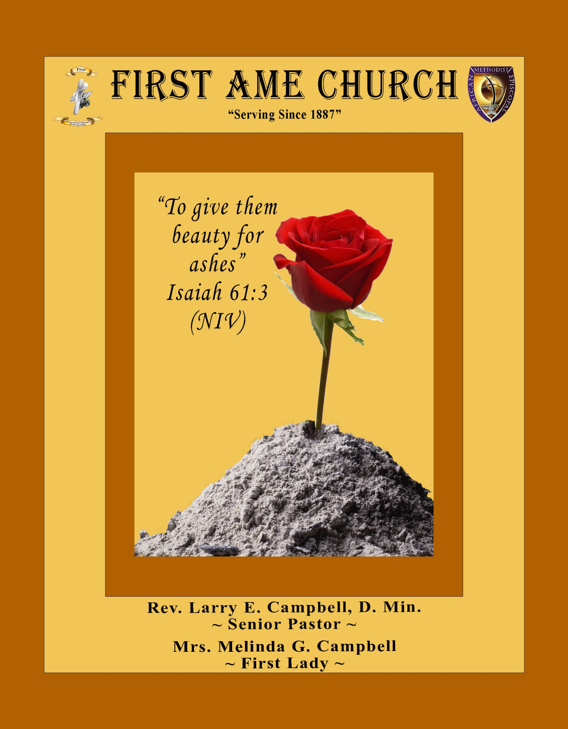
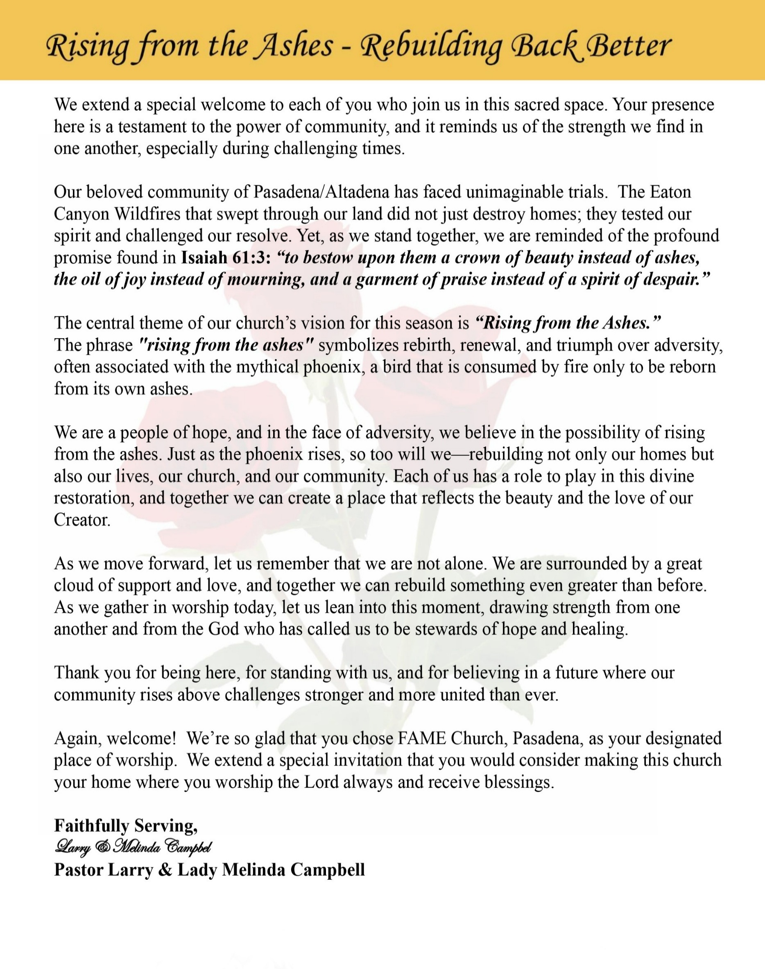

Sunday, October 11, 2026 | 9:30 a.m.

Rt. Rev. Francine A. Brookins, Esq., Presiding Bishop
Rev. Miriam Burnett, MD, MPH, Supervisor of Missions
Rev. Roosevelt Lindsey, Jr. Presiding Elder

The Rev. Dr. Larry E. Campbell ~ Senior Pastor ~ Minister

Mobile: (951) 587-1894 ~ Email: larrycampbell@famepasadena.org

Our First Lady: Mrs. Melinda G. Campbell

The Reverend Dr. Jennifer Oliver ~ Itinerant Elder -
The Reverend Dr. Nikia Smith Robert ~ Itinerant Elder (Affiliated)
The Reverend Lois Woodard ~ Itinerant Elder Superannuated (Retired)
The Reverend Rochelle Wright Moore ~ Itinerant Deacon
The Reverend Deborah West-Jones ~ Local Elder
The Reverend Philis J. Griffin, MDiv ~ Local Elder
Dr. Phyllis Beech ~ Evangelist
Sister Tessie Bonner ~ Deaconess

Community Resource Center Director ~ Ms. Kischchen Hazelton Venerable
Church Administrative Assistant: Ms. Letha Rhymes

Church Office Hours:
Tue – Fri 9:00 am - 5:00 pm
Closed for Lunch Daily: 12:00 pm - 1:00 pm.

Music Ministry
Dr. Timothy Davis, Jr., Minister of Music
Bro. Jimmy Watlington, Percussionist ~ Bro. Carlos Caldwell, Organist
Bro. Darien Dorsey, Keyboardist
Sis. Karen Law, Women’s Chorus Director ~ Sis. Tonia Graham, Children’s Choir Director
Bro. J. Renard Washington, New Generation’s Choir

FREE WI-FI service is available on the FAME Campus by accessing FAME 1700
Password: 6267980503

-3-

~ Order of Worship Experience ~

Warning: This order of worship is subject to change without warning or prior notice --- everything is governed by the Sovereignty of the Holy Spirit.

+ + + The Altar Call +++

Praise & Worship

Doxology: “Praise God From Whom All Blessings Flow”

The Call to Worship Sis. Sharon Sharp

Leader: I was glad when they said unto me, let us go into the house of the Lord, our feet shall stand within Thy gates O Jerusalem! (Psalm 122:1)

People: For a day in Thy courts is better than a thousand. I had rather be a doorkeeper in the house of my God than to dwell in the tents of wickedness. (Psalm 84:10)

Leader: Because of the house of the Lord our God, I will seek Thy good.
(Psalm 122:9)

People: Those that be planted in the house of the Lord, shall flourish in the courts of our God. (Psalm 92:13)

Leader: Blessed are they that dwell in Thy house. Lord, I have loved Thy habitation, the place where Thy honor dwelleth. (Psalm 26:8)

People: For the Lord is in His holy temple; let all the earth keep silence before Him.
(Habakkuk 2:20)

Leader: Let the words of my mouth and the meditation of my heart, be acceptable in Thy sight, O Lord my strength and my redeemer. (Psalm 19:14)

Unison: O Sing unto the Lord a new song, for He has done marvelous things. Make a
joyful noise unto the Lord, all the earth, sing His praises. (Psalm 98:1, 4)

-4-

The Hymn of Praise A.M.E. Hymnal #394
We Are Often Tossed and Driven
(We’ll Understand It Better By and By)

Words and Tune: Charles Albert Tindley, 1851-1933

1. We are often tossed and driv'n on the restless sea of time;
Somber skies and howling tempests oft succeed a bright sunshine;
In that land of perfect day, when the mists have rolled away,
We will understand it better by and by.

Refrain:
By and by, when the morning comes,
All the saints of God are gathered home,
We will tell the story how we've overcome;
We will understand it better by and by.

2. We are often destitute of the things that life demands;
Want of food and want of shelter, thirsty hills and barren lands;
We are trusting in the Lord, and according to his Word,
We will understand it better by and by.

Refrain

3. Trials dark on ev'ry hand and we cannot understand
All the ways that God would lead us to that blessèd Promised Land,
But he guides us with his eye, and we'll follow till we die,
For we'll understand it better by and by.

Refrain

4. Temptations, hidden snares often take us unaware,
And our hearts are made to bleed for a tho'tless word or deed,
And we wonder why the test when we try to do our best,
But we'll understand it better by and by.

Refrain

The Invocation Bro. Paul Gibson

Ministry of Music The Praise Team

-5-

Scripture Lesson
(Please Stand for the Reading of God’s Words)

Old Testament Sis. Cheryl Moody
Isaiah 40:27-31 (New King James Version) — Handling Stress and Pressure
²⁷ Why do you say, O Jacob, and speak, O Israel: “My way is hidden from the Lord, and my just claim is passed over by my God”? ²⁸ Have you not known? Have you not heard?
The everlasting God, the Lord, the Creator of the ends of the earth, neither faints nor is weary. His understanding is unsearchable.
²⁹ He gives power to the weak, and to those who have no might He increases strength.
³⁰ Even the youths shall faint and be weary, and the young men shall utterly fall, ³¹ But those who wait on the Lord shall renew their strength;
They shall mount up with wings like eagles,
They shall run and not be weary,
They shall walk and not faint.

New Testament Sis. Marva Sampson
2 Corinthians 4:7-18 (New King James Version) — Cast Down but Unconquered
⁷ But we have this treasure in earthen vessels, that the excellence of the power may be of God and not of us. ⁸ We are hard-pressed on every side, yet not crushed; we are perplexed, but not in despair; ⁹ persecuted, but not forsaken; struck down, but not destroyed— ¹⁰ always carrying about in the body the dying of the Lord Jesus, that the life of Jesus also may be manifested in our body. ¹¹ For we who live are always delivered to death for Jesus’ sake, that the life of Jesus also may be manifested in our mortal flesh. ¹² So then death is working in us, but life in you.

The Summary of the Decalogue Bro. Stephen Babalola
LEADER: From all that dwell below the skies…
SUNG: From all that dwell below the skies, Let the Creator’s praise arise; Let the
Redeemer’s Name be sung, through every land, by every tongue.
LEADER: Hear what Christ our Savior saith, Thou shalt love the Lord thy God with all
Thy heart, with all thy soul, and with all thy mind. This is the first and great
commandment. And the second is like unto it: Thou shalt love thy neighbor
as thyself. On these two commandments hang all the law and the prophets.
SUNG: Glory be to the Father, and to the Son, and to the Holy Ghost; as it was in
the beginning, is now, and ever shall be, world without end. A~Men

-6-

Abbreviated Updated Announcements/Visitor’s Welcome



Wedding


Birthdays Recognized for the Month

“The best Birthday wish that you can get for the day is that you may live each moment of your life to the very fullest, without any regrets.” Anonymous

Special Congregational Hymn (Sing along)
#361 Yes, God Is Real

Tithing and Offering Litany
Leader: Lord, we bring these gifts before You.

People: Receive them and use them for Your glory.

Leader: Bless every giver and every gift.

People: Multiply what we give for the work of Your Kingdom.

Leader: May our giving reflect our faith.

People: May our giving reflect our love.

Leader: May our giving be a blessing to others.

People: And may God receive all the glory!

Leader: For everything comes from You—

People: And we give You only what You have first given us!

Leader: We give with grateful hearts.

People: We give with willing spirits.

Leader: We give in faith and We give in love.

All: And we give God the glory! Amen!

-7-

The Offertory (Tithes ~ Gifts ~ Benevolent Offerings) Sis. Mable Davis, Steward

The following Electronic GIVING Platforms are creditable methods to GIVE to FAME:
#1. GIVELIFY - Mobile Giving App available on the App Store. It’s easy to set up, just follow the guidelines.
#2. Cash App: $FirstAMEPASADENA
#3. Mail in your Tithes & Offering - If you would like to mail your tithes and offering by check or money order, please send it to: First AME Church, 1700 N. Raymond Avenue, Pasadena, CA 91103.
#4. Drop off your Tithes & Offering - During business hours in the basket outside of the office.

Choral Response: “All things come of Thee, O Lord; and of Thine own have we given Thee. Amen.”

Induction of New Members

Sermonic Selection The Praise Team

Proclamation of The Word Pastor Larry E. Campbell

The Invitation (Public/Private)

How to Join First A.M.E. Church of Pasadena
PROFESSION OF FAITH. If you have never been a member of any church, you may join by professing Jesus Christ as your personal Lord and Savior.

RENEWAL OF VOWS. If you have been a member of a church at one time, but have been in active, you may join by renewing your faith in Jesus Christ as Lord and Savior.

TRANSFER. If you are a member of another African Methodist Episcopal Church and you are in good standing, you may join by requesting that your membership be transferred to the First African Methodist Episcopal Church of Pasadena.

AFFILIATE MEMBER. Sometimes an individual has reasons for keeping /his/her membership in another church but would like to be an active member of First African Methodist Episcopal Church, too. This is possible as an affiliate member. ___________________________________________________________________________
The Doxology

The Benediction

-8-

Scripture of the Day
Handling Stress and Pressure. “Hear my cry, O God; attend unto my prayer.
² From the end of the earth will I cry unto thee, when my heart is overwhelmed: lead me to the rock that is higher than I. — Psalm 61:1-2

Quote of the Day
“Everything negative – pressure, challenges – is all an opportunity for me to rise.”.
Kobe Bryant

Thought of the Week
YOU PUSHED ME—BUT GOD HELPED ME
You pushed me violently, that I might fall, but the Lord helped me. ¹⁴ The Lord is my strength and song, and He has become my salvation.— Psalm 118:13–14
Life has a way of pushing us. Pressure from our families, finances, health, work, relationships, and the uncertainty of our world can leave us feeling as though we are living on the edge.
The psalmist does not pretend that the pressure wasn't real. He declares, “Thou hast thrust sore at me that I might fall.” In other words, I was pushed hard enough to lose my footing.
But the LORD helped me!
That small word “but” changes everything. The pressure was real, but so was God's presence. The attack was strong, but God was stronger. I may have been pushed, but I was not abandoned.
Like Jesus in Luke 4:29–30, sometimes life can take us right to the edge. Yet being at the edge does not mean we have to go over the edge.
When pressure pushes you, remember where your help comes from.
You may be pushed—but God will help you stand.

Humor of the Week
A pastor decided to skip church one Sunday morning and go play golf. He told his assistant he wasn't feeling well. He drove to a golf course in another city, so nobody would know him.
He teed off on the first hole. A huge gust of wind caught his ball, carried it an extra hundred yards and dropped it right in the hole, for a 450-yard hole in one. An angel looked at God and said, "What'd you do that for?" God smiled and said, "Who's he going to tell?"

HOME DAILY BIBLE READINGS
October 12, 2026 – October 18, 2026 (Week 7, Ruth)
Monday Day 43 Numbers 5-7, Psalm 29
Tuesday Day 44 Numbers 8-10, Psalm 30:1-7
Wednesday Day 45 Numbers 11-13, Psalm 30:8-12
Thursday Day 46 Numbers 14-15, Psalm 31:1-13
Friday Day 47 Numbers 16-17, Psalm 31:14-24
Saturday Day 48 Numbers 18-20, Psalm 32
Sunday Day 49 Numbers 21-22, Psalm 33:1-11

-9-

ANNOUNCEMENTS

BEREAVEMENT ANNOUNCEMENT
It is with deep sorrow and heartfelt sympathy that we announce the passing of Dr. Melvin Beech, beloved husband of Evangelist Dr. Phyllis Beech and a dear and cherished member of the First A.M.E. Church, Pasadena family. Dr. Beech lived a distinguished life of faith, service, education, leadership and commitment to his community and country. A proud United States Army veteran, Dr. Beech served his country during the Korean Conflict, answering the call to military service with courage and honor. A Special Memorial Service is tentatively scheduled for Friday, October 16, 2026 at 11:00. a.m. Place: FAME Pasadena. We extend our love, prayers, and deepest condolences to Evangelist Dr. Phyllis Beech, the entire Beech family, and all who mourn his passing. May we surround the family with our prayers and Christian love during this season of bereavement.

90+ Ministry Holiday Bazaar Fundraiser
The annual 90+ Ministry Holiday Catalog Bazaar is here! Let us make your Christmas shopping easy this year with Afrocentric cards and gifts by Shades of Color and African American Expressions.
Orders may be placed by contacting one of the following team members October 11, 2026 through October 25, 2026: Robin Ford, Ann Hall-Jones, Karyn Hawthorne, Beverly Price, or Brenda Sharp. We will have a sales table set up outside after church service on October 11, October 18, and October 25. Catalogs and order forms are also available in the church office.
Proceeds from this fundraiser will help ensure our ability to continue bringing smiles and encouragement to our cherished 90+ FAME members. Thank you in advance for your support.
The 90+ Ministry Team

Women's Ministry – BIBLE STUDY | Time: Tuesday, October 13, 2026 | 6:00 p.m.
Meeting ID: 857 0061 9461; Passcode: 933892
One tap mobile +16699006833,,85700619461#,,,,,,0#,,933892# US (San Jose)
Senior Ministry In-Person Gathering| Tuesday, October 13, 2026 | 11:30 a.m.
Church Fellowship Hall

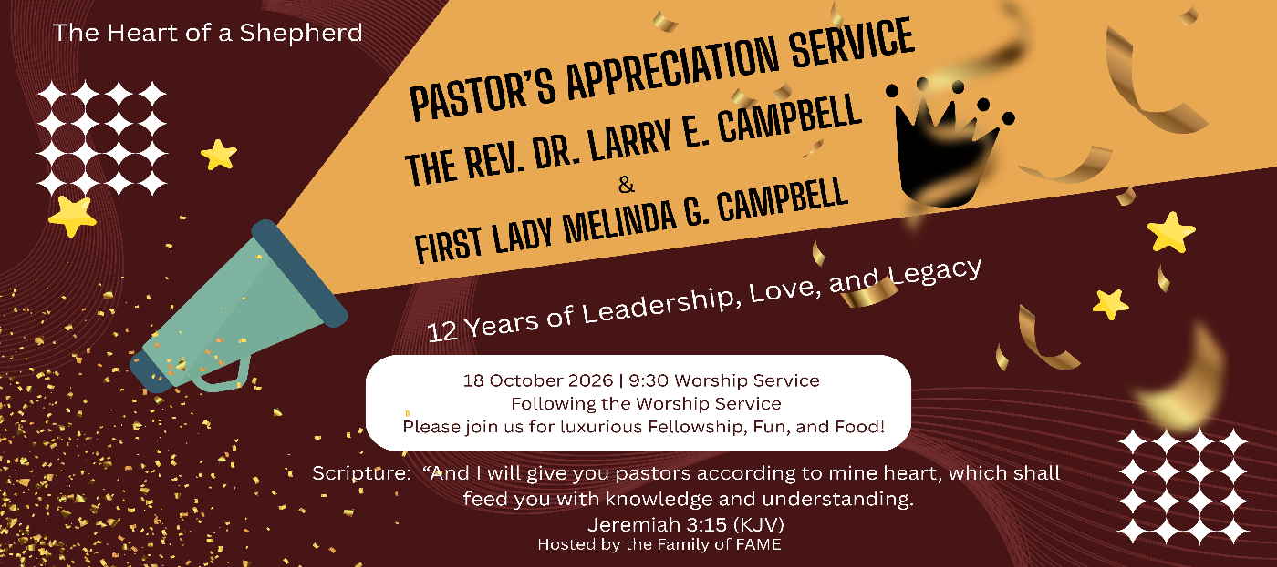

-10-

ANNOUNCEMENTS (Continued)

CHURCH CONFERENCE: Annual State of the Church
Pastor Campbell will present the FAME Church Family with an official “State of the Church” Address at 7:00 p.m. on Wednesday, October 14, 2026. The presence of the entire church membership is requested to be in attendance. Join Zoom Meeting https://us02web.zoom.us/j/89877657218?pwd=2dWYtHOJyyg9pAatJtFhC5BZ2aynZ9.1
Meeting ID: 898 7765 7218 | Passcode: 622008
*** Each Ministry President or designated representative will present the Top FIVE Significant Accomplishments of this Annual Conference Year. ***






-11-

102nd SESSION SOUTHERN CALIFORNIA ANNUAL CONFERENCE SCHEDULE

TUESDAY, OCTOBER 20, 2026
2:00 pm Registration, Credentialing, and Mission Project

WEDNESDAY, OCTOBER 21, 2026
7:00 am WMS Convention begins
7:30 am Breakfast & Fellowship
10:30 am Bishop meets with Presiding Elder(s); Finance Committee; Board of Examiners
12:00 Noon WIM Convention
12:00 Noon WMS Luncheon
2:00 pm WMS Convention
3:00 pm Bishop’s prescheduled meetings with Pastors/Congregations
6:00 pm WMS Worship Service (Night in White)
9:00 pm Committee and Component Meetings

THURSDAY, OCTOBER 22, 2026
8:30 am Devotion – Board of Examiners
9:00 am Conference Institute – AME Freedom Summer
10:00 am Business Session I – Roll Call, Organization & Pastors’ Reports
12:00 Noon WIM Hour of Power: Preacher: Rev. Gabrielle NS Kennedy
1:00 pm – 2:30 pm Lunch Break
2:30 pm Business Session II – Pastors’ Reports
5:30 pm – 6:45 pm Dinner Break
7:00 pm Opening Worship Service: Rev. Dr. Timothy O. Coston, Jr.

FRIDAY, OCTOBER 23, 2026
8:30 am Devotion – Mindful Movements (WMS & WIM)
9:00 am Conference Institute – AME Freedom Summer
10:00 am Business Session III – Reports Cont’d.
12:00 Noon Hour of Power
1:00 – 2:30 pm Lunch Break
2:30 pm Business Session IV – Reports Cont’d
5:00 pm Dinner Break
6:00 pm Lay Witness Night

SATURDAY, OCTOBER 24, 2026
8:00 am Church School/Bible Study
9:00 am Closing Business: Component Reports, Summary of the Minutes, Disciplinary Questions, Memorial Ritual, Retirement Ritual

SATURDAY, OCTOBER 24, 2026 (CONT’D)
10:00 am The Service of Ordination & Sacrament
Preacher: The Rev. M. Jo David Sales, Pastor, Brookins AME Church, Oakland, CA

SUNDAY, OCTOBER 25, 2026
3:00 PM Closing and Commissioning Services
Preacher: The Rev. Roosevelt Lindsey, Jr., Presiding Elder

-12-

Prayer Request(s)
Please notify the Church Office of Sick & Shut-in additions, deletions, or status/address changes.

Bishop Francine A. Brookins, Esq. Supervisor Miriam Burnett, MD Presiding Elder Roosevelt & Dr. Kaye Lindsey Rev. Dr. Larry & Melinda Campbell Richard Craig Hazel Clark Erica Woodard Jason Shirley Joshua Shirley Julian Shirley Ayanna Terry Cheryl Jamerson Gwendolyn Flowers Andrea Anderson Ocilda Files Danielle Clark Rev. Charles Brooks Kimberly Woods Cynithia Grace Calle Burns Noel Johnson The Taylor Family
Zechariah Robinson Christopher McCarthy Wilma Haynes Jacquelyn Walker Brittney Petty Selene Cox Deborah Burton Nettie McChristen The Caple Family Mel Beech Michael Dotson
Rev. Rochelle Moore Lorene Butler Stella Pulliam Collette Blizzard The Eaton Canyon Fire Victims

College Students

Let’s continue to support and pray for our beloved College Students

Isaiah Crowell Alecia Davis Chase Johnson Grant Blizzard Gabriel Blizzard

Tyler Johnson Richard Jones Tyrikk Lawson Makia Rose Talbert Isaiah Ringo Journey Rogers Elyse Sharp Kylee Sharp Zion Otano Elise Tervalon Grace Jones Jordan Patterson Kimberly Robinson Donovan Williams Jasmine Collins Brandon Bates

Sick and Shut-Ins
Andrew Oliver 1405 N. Roosevelt Avenue, Pasadena, CA 91104
Barbara Buchanan 616 Rio Grande St. Pasadena, CA 91104
Bettina Ayers Pasadena Meadows Nursing Home, 150 Bellefontaine St., Pas., CA 91105
Betty Betts Turner 1625 S. Magnolia Ave., Unit 4125, Monrovia, CA 91016
Bobby Thomas 1052 E. Morada Place, Altadena, CA 91001
Diane Jordan 1719 Fremont Ave., #302, S. Pasadena, CA 91030
Donita Towler 14148 Francisquito Ave., Baldwin Park, CA 91706
Doris Curd 11619 Woodcock Avenue, San Fernando, CA 91340
Edmund Riddle Active Care Mission Bay, 2440 Grand Avenue, San Diego, CA 92109
Eleanor Towler 975 E. Union Street, Unit #417, Pasadena, CA 91106
Elois Blizzard P. O. Box 3646, So. Pasadena, CA 91031
Emily Cormier-Ross 2549 La Fiesta Avenue, Altadena, CA 91001
Ernestine English 26 W. Fair Oaks Drive, Pasadena, CA 91103
Fred Caple 51 North 15th Street, Haledon, NJ 07508
Hugh Hamberry 19225 Chole Rd., Apple Valley, CA 92307
Jessie Smith 3925 S. Jones Blvd., Apt. 2118, Las Vegas, NV 89103| Spring Valley Community
Jimmy Williams 215 W. Pearl Street, Pomona, CA 91768
Lenora Moore 2445 E. Del Mar Blvd., #338, Pasadena, CA 91107
Linnie G. Nollie 2250 E. New York Drive, Altadena, CA 91001
Malika G. Hendry P. O. Box 94082, Pasadena, CA 91109
Mildred Lewis C/O Hazel Rohr, 884 W. Jane Court, Upland, CA 91786
Norma Burnett 618 Fairview Avenue, Unit #228, Arcadia, CA 91007
Opal Hampton 1030 Chevron Court, Pasadena, CA 91103
Paul Ratliff P.O. Box 40407, Pasadena, CA 91114
Virlyn Grant 15122 Orange Ave., Paramount, CA 90723
Wanda Nelson 3618 N. Fair Oaks Avenue, Altadena, CA 91001
William Hilliard 7504 Wynstone Pl., Fontana, CA 92336
Zell L. Hill 375 Barthe Drive, Pasadena, CA 91103

-13-

Sermon Notations

Scripture: _____________________________________________________________

Subject: _______________________________________________________________

Points of the Message: ___________________________________________________
_______________________________________________________________________
_______________________________________________________________________
_______________________________________________________________________
_______________________________________________________________________
_______________________________________________________________________
_______________________________________________________________________

Main Ideas of the Sermon: ________________________________________________
_______________________________________________________________________
_______________________________________________________________________
_______________________________________________________________________
_______________________________________________________________________
_______________________________________________________________________

Illustrations I want to remember: _________________________________________
_______________________________________________________________________
_______________________________________________________________________
_______________________________________________________________________
_______________________________________________________________________
_______________________________________________________________________
_______________________________________________________________________

What should I do as a result of this Sermon? ________________________________

_____________________________________________________
_____________________________________________________
_____________________________________________________
_____________________________________________________

-14-

