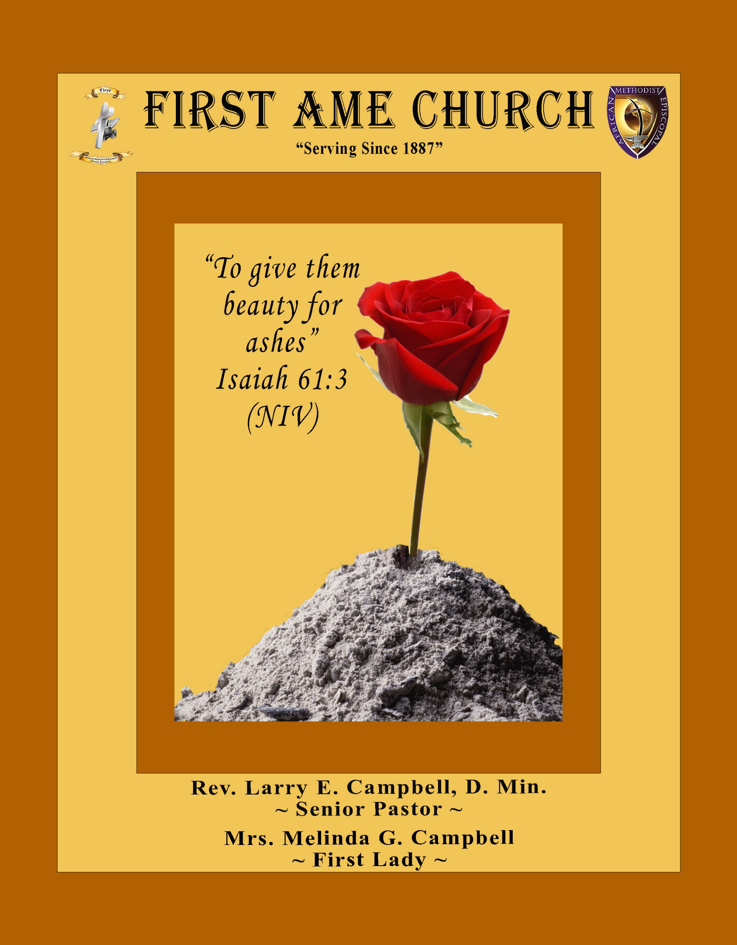
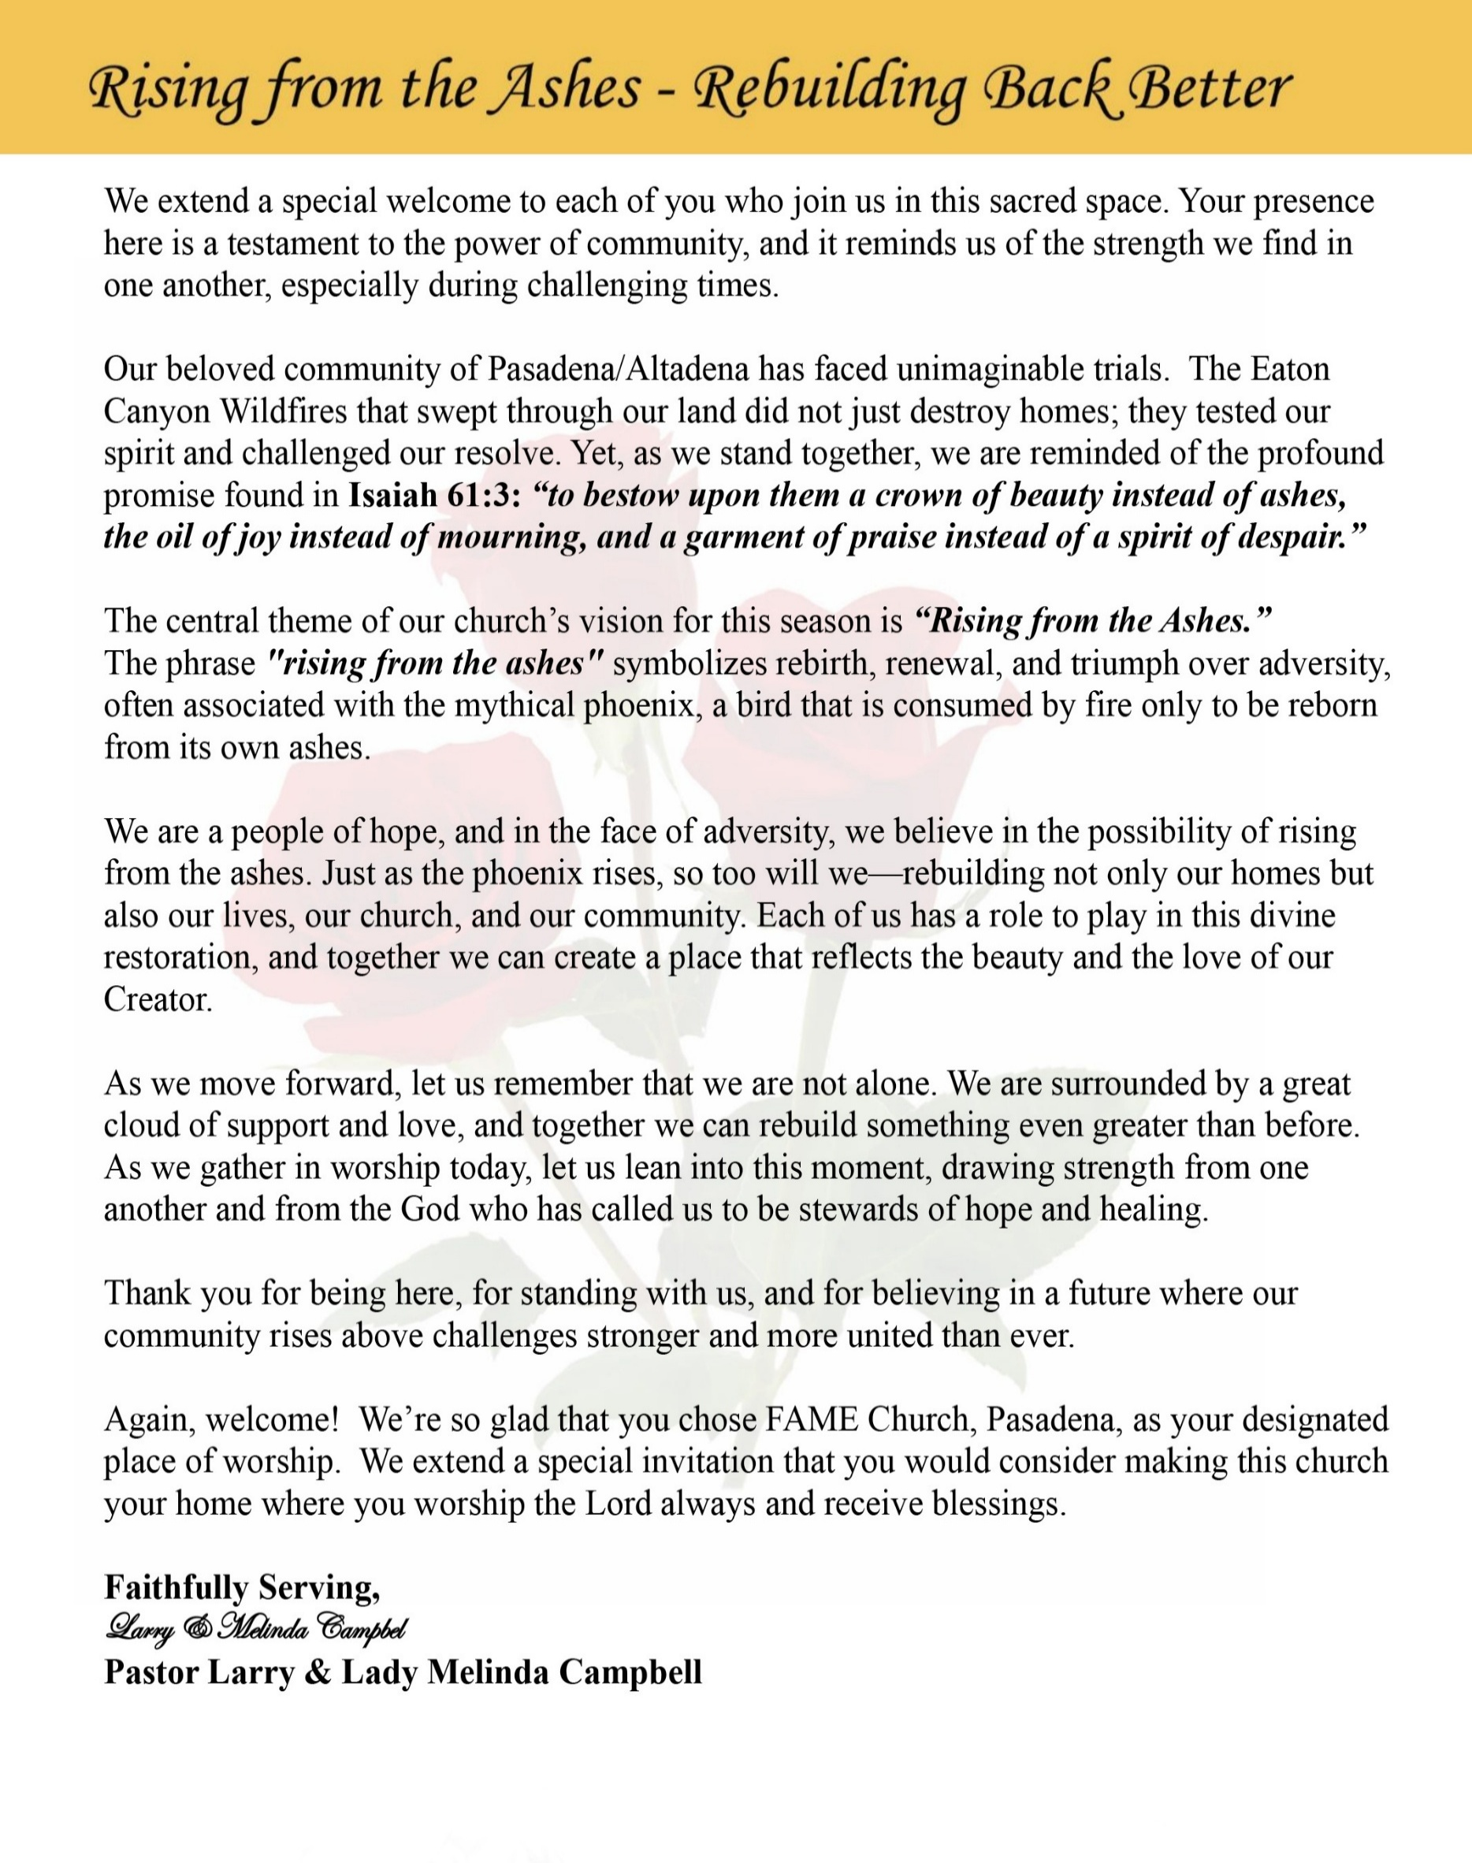

Sunday, October 18, 2026 | 9:30 a.m.

Rt. Rev. Francine A. Brookins, Esq., Presiding Bishop
Rev. Miriam Burnett, MD, MPH, Supervisor of Missions
Rev. Roosevelt Lindsey, Jr. Presiding Elder

The Rev. Dr. Larry E. Campbell ~ Senior Pastor ~ Minister

Mobile: (951) 587-1894 ~ Email: larrycampbell@famepasadena.org

Our First Lady: Mrs. Melinda G. Campbell

The Reverend Dr. Jennifer Oliver ~ Itinerant Elder -
The Reverend Dr. Nikia Smith Robert ~ Itinerant Elder (Affiliated)
The Reverend Lois Woodard ~ Itinerant Elder Superannuated (Retired)
The Reverend Rochelle Wright Moore ~ Itinerant Deacon
The Reverend Deborah West-Jones ~ Local Elder
The Reverend Philis J. Griffin, MDiv ~ Local Elder
Dr. Phyllis Beech ~ Evangelist
Sister Tessie Bonner ~ Deaconess

Community Resource Center Director ~ Ms. Kischchen Hazelton Venerable
Church Administrative Assistant: Ms. Letha Rhymes

Church Office Hours:
Tue – Fri 9:00 am - 5:00 pm
Closed for Lunch Daily: 12:00 pm - 1:00 pm.

Music Ministry
Dr. Timothy Davis, Jr., Minister of Music
Bro. Jimmy Watlington, Percussionist ~ Bro. Carlos Caldwell, Organist
Bro. Darien Dorsey, Keyboardist
Sis. Karen Law, Women’s Chorus Director ~ Sis. Tonia Graham, Children’s Choir Director
Bro. J. Renard Washington, New Generation’s Choir

FREE WI-FI service is available on the FAME Campus by accessing FAME 1700
Password: 6267980503

-3-

~ Order of Worship Experience ~

Warning: This order of worship is subject to change without warning or prior notice --- everything is governed by the Sovereignty of the Holy Spirit

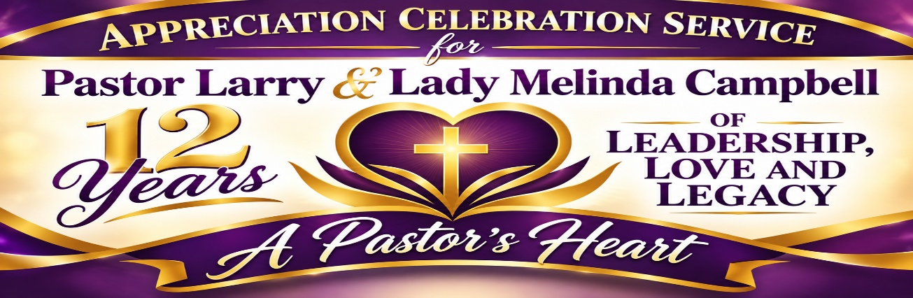

+The Altar Call +
Praise & Worship

Doxology: “Praise God From Whom All Blessings Flow”

The Call to Worship Sis. Natalya Romo Jones-Steward

Leader: I was glad when they said unto me, let us go into the house of the Lord, our feet shall stand within Thy gates O Jerusalem! (Psalm 122:1)

People: For a day in Thy courts is better than a thousand. I had rather be a doorkeeper in the house of my God than to dwell in the tents of wickedness. (Psalm 84:10)

Leader: Because of the house of the Lord our God, I will seek Thy good.
(Psalm 122:9)

People: Those that be planted in the house of the Lord, shall flourish in the courts of our God. (Psalm 92:13)

Leader: Blessed are they that dwell in Thy house. Lord, I have loved Thy habitation, the place where Thy honor dwelleth. (Psalm 26:8)

People: For the Lord is in His holy temple; let all the earth keep silence before Him.
(Habakkuk 2:20).

Leader: Let the words of my mouth and the meditation of my heart, be acceptable in Thy sight, O Lord my strength and my redeemer. (Psalm 19:14)

Unison: O Sing unto the Lord a new song, for He has done marvelous things. Make a
joyful noise unto the Lord, all the earth, sing His praises. (Psalm 98:1, 4)

-4-

The Hymn of Praise A.M.E. Hymnal #513
Time Is Filled with Swift Transition
(Hold to God’s Unchanging Hands)

Words: Jennie Wilson
Tune: F.L. Eiland

1 Time is filled with swift transition,
naught of earth unmoved can stand;
Build your hopes on things eternal,
hold to God’s unchanging hand!

Refrain:
Hold to God’s unchanging hand!
Hold to God’s unchanging hand!
Build your hopes on things eternal,
hold to God’s unchanging hand!

2 Trust in Him who will not leave you,
whatsoever years may bring;
If by earthly friends forsaken,
still more closely to Him cling.
[Refrain]

3 Covet not this world’s vain riches
that so rapidly decay;
Seek to gain the heav’nly treasures,
they will never pass away!
[Refrain]

4 When your journey is completed,
if to God you have been true,
fair and bright the home in glory,
your enraptured soul will view!
[Refrain]

The Invocation Bro. Bill Matlock-Steward

Ministry of Music The Praise Team

-5-

Scripture Lesson Miss Brooklyn Cole
(Please Stand for the Reading of God’s Words)
Jeremiah 3:14-18 (New International Version) —A Pastor’s Heart
¹⁴ “Return, faithless people,” declares the Lord, “for I am your husband. I will choose you—one from a town and two from a clan—and bring you to Zion. ¹⁵ Then I will give you shepherds after my own heart, who will lead you with knowledge and understanding. ¹⁶ In those days, when your numbers have increased greatly in the land,” declares the Lord, “people will no longer say, ‘The ark of the covenant of the Lord.’ It will never enter their minds or be remembered; it will not be missed, nor will another one be made. ¹⁷ At that time they will call Jerusalem The Throne of the Lord, and all nations will gather in Jerusalem to honor the name of the Lord. No longer will they follow the stubbornness of their evil hearts. ¹⁸ In those days the people of Judah will join the people of Israel, and together they will come from a northern land to the land I gave your ancestors as an inheritance.

Pastoral Appreciation Litany & Presentations
A Legacy of Faith, A Heart of Love, A Life of Leadership
Leader: Today, we gather with grateful hearts to honor a shepherd, a servant, and a spiritual leader whom
God has placed among us. We celebrate the ministry, dedication, and unwavering faithfulness of
our beloved pastor, Rev. Dr. Larry E. Campbell.

People: We thank God for our pastor! His legacy inspires us, his love strengthens us, and his
leadership guides us.

A LEGACY THAT WILL LAST – Dr. Paul and Sis. Sherrie Price

Leader: A legacy is not measured merely by the years one serves, but by the lives one touches, the seeds
one plants, and the difference one makes. Through preaching, teaching, prayer, and faithful
service, our pastor continues to build upon the foundation of those who came before him.

People: We celebrate a legacy of faith, a legacy of service, and a legacy that will bless generations yet
to come!

Leader: Through seasons of celebration and moments of uncertainty, he has remained committed to the
mission of the Church, encouraging us to stand firm in faith and move forward with purpose.

People: Because of his faithfulness, we are stronger. Because of his vision, we are growing.
Because of his example, we are inspired to serve!

A LOVE THAT REACHES BEYOND THE PULPIT – Bro. Melvin & Sis. Ruth Sharpe

Leader: We honor a pastor whose love is demonstrated not only through the words he preaches, but
through the compassion he extends, the prayers he offers, and the burdens he helps others carry.

People: We thank God for a pastor who loves God's people with compassion, humility, and a
servant's heart!

Leader: He has celebrated our victories, comforted us in sorrow, encouraged us through adversity, and
reminded us that God's love never fails.

People: His love reminds us that the Church is more than a building. We are a family, united in faith
and strengthened by love!

Leader: When our community faced the devastation of the Eaton Fire, his commitment to ministry
reminded us that even in the ashes of adversity, faith, hope, and love could rise again.
Continued on Page 7

-6-

Pastoral Appreciation Litany & Presentations (Continued)
People: We thank God for a shepherd who stands with his flock, serves his community, and leads
with love!

A LEADERSHIP ROOTED IN PURPOSE – Bro. LaWayne & Sis. Ashley Williams

Leader: True leadership is not simply holding a position; it is answering God's call with courage, wisdom,
humility, and conviction.

People: We honor a leader who walks by faith, leads by example, and serves with purpose!

Leader: Through his vision, ministries have expanded, lives have been enriched, and doors of
opportunity have opened for our congregation and the surrounding community.

People: We celebrate leadership that empowers, leadership that encourages, and leadership
that makes room for others to grow!

Leader: He challenges us to reach beyond the sanctuary walls, to serve those in need, to
strengthen our families, and to be the hands and feet of Christ in our community.

People: We will continue the work, embrace the vision, and carry forward the mission God
has entrusted to our church!

OUR GRATITUDE AND COMMITMENT- Masters Vann & Koah Rahman

Leader: Pastor Campbell, today we honor not only what you have accomplished, but who you are:
a man of faith, a servant of God, a compassionate shepherd, and a leader whose influence
extends far beyond the pulpit.

People: We appreciate you! We celebrate you! We thank God for you!

Leader: May God renew your strength when you grow weary, grant you wisdom for every
decision, surround you with His peace, and bless the work of your hands.

People: May your legacy continue to grow, your heart remain filled with love, and your
leadership continue to inspire generations!

Leader: As we celebrate our pastor, let us also renew our commitment to pray for him, support the
ministry, walk together in unity, and serve God with gladness.

People: We stand together in faith, united in love, and committed to the vision!

A DECLARATION OF APPRECIATION - Bro. Todd Skinner, Steward

ALL: Rev. Dr. Larry E. Campbell, today we honor your LEGACY, because the seeds you have
planted will continue to bear fruit.

We celebrate your LOVE, because your compassion has touched our hearts and
strengthened our church family.

We appreciate your LEADERSHIP, because your faith, vision, and dedication continue
to guide us toward God's greater purpose.

Your legacy is lasting. Your love is evident. Your leadership is a blessing.
And as you continue to lead, we promise to continue praying, serving, growing, and
walking together in faith.

We are FAME! We are Family! And we thank God for our Pastor!
To God be the glory for the great things He has done! AMEN!

-7-

Announcements/Visitor’s Welcome

K-FAME - Radio
Announcements
Sharing the Updated, Progress and Successes of our Children & Youth

Musical Selection The Children Choir

The Offertory (Tithes ~ Gifts ~ Benevolent Offerings) Sister Darlene Anderson, Steward

The following Electronic GIVING Platforms are creditable methods to GIVE to FAME:
#1. GIVELIFY - Mobile Giving App available on the App Store. It’s easy to set up, just follow the guidelines.
#2. Cash App: $FirstAMEPASADENA
#3. Mail in your Tithes & Offering - If you would like to mail your tithes and offering by check or money order, please send it to: First AME Church, 1700 N. Raymond Avenue, Pasadena, CA 91103.
#4. Drop off your Tithes & Offering - During business hours in the basket outside of the office.

Choral Response: “All things come of Thee, O Lord; and of Thine own have we given Thee. Amen.”

Introduction of the Speaker Sis. Kischchen A. Hazelton Venerable, Steward Protem

Sermonic Selection The Praise Team

Proclamation of The Word Pastor G. LaKeith Kennebrew
Hillside Tabernacle of Faith Church - Altadena

The Invitation (Public/Private)

Pastor & FirstLady Remarks

The Doxology

The Benediction

-8-

Scripture of the Day
A Pastor’s Heart. “God was pleased to trust us with his message. We didn't speak to please people, but to please God who knows our hearts. ⁵ You also know we didn't try to flatter anyone. God himself knows what we did wasn't a cover-up for greed. ⁶ We were not trying to get you or anyone else to praise us.” 2 Thessalonians 2:4-6

Quote of the Day
"It's your heart, not the dictionary, that gives meaning to your words." Eugene Petersen

Thought of the Week
A Pastor’s Heart
Jeremiah 3:15 “And I will give you pastors according to mine heart, which shall feed you with knowledge and understanding.”
A pastor’s heart is a heart shaped by God, guided by His wisdom, and committed to caring for His people. In Jeremiah 3:15, God promises to provide shepherds who will lead His people with knowledge and understanding. This reminds us that pastoral ministry is not merely a profession; it is a divine calling and a sacred responsibility.
A pastor’s heart beats with compassion for the hurting, patience for the struggling, and a commitment to nurturing spiritual growth. It is a heart that teaches God’s Word, offers encouragement in difficult seasons, and faithfully guides the congregation toward a closer relationship with Christ.
Pastoral ministry is not always easy. There are moments of celebration and seasons of sorrow, times of encouragement and moments of exhaustion. Yet, a pastor who serves according to God’s heart remains steadfast, trusting that the One who called them will provide the wisdom, strength, and grace needed for the journey.
The true measure of a pastor’s heart is not simply how well they preach, but how faithfully they love, lead, feed, and care for God’s people.

Humor of the Week
A man went to his doctor one day to do something about his bad hearing. He said, "Everyone in my family is complaining about my hearing!" The doctor said he could help and treated him with a small hearing aid. The doctor said, "See how this works and come back to let me know." The man said, "Okay."
The man came back to his doctor and said, "Everything is working great!" The doctor replied, "I bet your family is happy about that!" The man said, " I have not told them yet. I just sit there and listen. So far, I have changed my Will 3 times!!!"

HOME DAILY BIBLE READINGS
October 19, 2026 – October 25, 2026 (Week 8, 1 Samuel)
Monday Day 50 Numbers 23-25, Psalm 33:12-22
Tuesday Day 51 Numbers 26-27, Psalm 34:1-10
Wednesday Day 52 Numbers 28-30, Psalm 34:11-22
Thursday Day 53 Numbers 31-32, Psalm 35:1-16
Friday Day 54 Numbers 33-34, Psalm 35:17-28
Saturday Day 55 Numbers 35-36, Psalm 36
Sunday Day 56 Deuteronomy 1-4, Psalm 37:1-13

-9-

ANNOUNCEMENTS

SEXUAL HARASSMENT AWARENESS
First AME Church Pasadena is committed to a church environment where every person is treated with dignity and respect. Sexual harassment—including unwelcome sexual advances, inappropriate sexual comments, requests for sexual favors, and unwanted touching—is unacceptable.
All clergy, officers, members, employees, volunteers, and visitors are expected to respect personal boundaries. Anyone experiencing or witnessing inappropriate conduct is encouraged to report concerns promptly to the Pastor or, if the concern involves the Pastor, to the Presiding Elder. Concerns should be handled with care, discretion, and appropriate accountability. Respect every person. Honor every boundary. Help keep our church safe.

90+ Ministry Holiday Bazaar Fundraiser
The annual 90+ Ministry Holiday Catalog Bazaar is here! Let us make your Christmas shopping easy this year with Afrocentric cards and gifts by Shades of Color and African American Expressions.
Orders may be placed by contacting one of the following team members October 11, 2026 through October 25, 2026: Robin Ford, Ann Hall-Jones, Karyn Hawthorne, Beverly Price, or Brenda Sharp. We will have a sales table set up outside after church service on October 11, October 18, and October 25. Catalogs and order forms are also available in the church office.
Proceeds from this fundraiser will help ensure our ability to continue bringing smiles and encouragement to our cherished 90+ FAME members. Thank you in advance for your support.
The 90+ Ministry Team

BIBLE STUDY & PRAYER MEETING NOTICE
All Bible studies and prayer meeting sessions will not be held this week due to the 102nd Session of the Southern California Annual Conference. Please keep our Bishop, conference leadership, clergy, delegates, and host church in your prayers.

Updating FAME-Pasadena Membership Directory
FAME is updating each household/member’s contact information. We are asking all households to complete a Google Form. Completing the form ensures your contact information is current.
Starting in October, volunteers will be available in the Fellowship Hall on first Sundays to assist families in completing form.


You have four options to complete the Google form:
Complete Google Form on-line. Use the QR code.
Request an internet link to access the form.
Complete a paper form, and then drop it off to the office.
Schedule an Interview to get assistance in completing the form.

If you experience any issues with completing this form, please text or email Sharon Sharp, 626-840-7374, sharon_s91104@yahoo.com. Thank you for supporting this project.

-10-

ANNOUNCEMENTS (Continued)




Men's Ministry - BIBLE STUDY | Time: Tuesday, November 10, 2026 | 6:00 p.m.
Meeting ID: 894 7536 6487 | Passcode: 465177
One tap mobile: +16699006833,,89475366487#,,,,*465177# US (San Jose)

Women's Ministry – BIBLE STUDY | Time: Tuesday, November 10, 2026 | 6:00 p.m.
Meeting ID: 857 0061 9461; Passcode: 933892
One tap mobile +16699006833,,85700619461#,,,,,,0#,,933892# US (San Jose)

Senior Ministry In-Person Gathering| Tuesday, November 10, 2026 | 11:30 a.m.
Church Fellowship Hall

2026 MIDTERM ELECTION — BE INFORMED, BE PREPARED
The African American struggle for voting rights is an important part of our nation’s history. The upcoming Tuesday, November 3, 2026, midterm election provides an opportunity for all eligible voters to participate in decisions affecting our communities. Review the candidates and ballot measures, check your registration, and know your voting options. California’s online voter registration deadline is October 19. Visit RegisterToVote.ca.gov for information. An informed congregation helps build an informed community
URGENT REQUEST – FAME CHURCH FAMILY!
Let’s Stand Together at the 102nd Southern California Annual Conference! On Thursday, October 22, 2026, bus transportation will be provided for our FAME members to attend the Annual Conference as we stand together in unity and support during the reading of our church report. We anticipate that our report will be presented in the morning; however, there is a possibility that Bishop Brookins may begin the reports after lunch. Important Details: Transportation: round-trip bus transportation from FAME Pasadena (Departure 8:00 a.m.) to the Annual Conference; Lunch: A boxed lunch will be provided; Return Time: If our report is presented in the morning, the bus will depart the conference at 1:30 PM. If the report is presented after lunch, the bus will depart at 3:00 PM. We need to know who is interested in riding the bus! Please text Kischchen Hazelton at 626-616-0626 as soon as possible to reserve your interest.

-11-

102nd SESSION SOUTHERN CALIFORNIA ANNUAL CONFERENCE SCHEDULE

TUESDAY, OCTOBER 20, 2026
2:00 pm Registration, Credentialing, and Mission Project

WEDNESDAY, OCTOBER 21, 2026
7:00 am WMS Convention begins
7:30 am Breakfast & Fellowship
10:30 am Bishop meets with Presiding Elder(s); Finance Committee; Board of Examiners
12:00 Noon WIM Convention
12:00 Noon WMS Luncheon
2:00 pm WMS Convention
3:00 pm Bishop’s prescheduled meetings with Pastors/Congregations
6:00 pm WMS Worship Service (Night in White)
9:00 pm Committee and Component Meetings

THURSDAY, OCTOBER 22, 2026
8:30 am Devotion – Board of Examiners
9:00 am Conference Institute – AME Freedom Summer
10:00 am Business Session I – Roll Call, Organization & Pastors’ Reports
12:00 Noon WIM Hour of Power: Preacher: Rev. Gabrielle NS Kennedy
1:00 pm – 2:30 pm Lunch Break
2:30 pm Business Session II – Pastors’ Reports
5:30 pm – 6:45 pm Dinner Break
7:00 pm Opening Worship Service: Rev. Dr. Timothy O. Coston, Jr.

FRIDAY, OCTOBER 23, 2026
8:30 am Devotion – Mindful Movements (WMS & WIM)
9:00 am Conference Institute – AME Freedom Summer
10:00 am Business Session III – Reports Cont’d.
12:00 Noon Hour of Power
1:00 – 2:30 pm Lunch Break
2:30 pm Business Session IV – Reports Cont’d
5:00 pm Dinner Break
6:00 pm Lay Witness Night

SATURDAY, OCTOBER 24, 2026
8:00 am Church School/Bible Study
9:00 am Closing Business: Component Reports, Summary of the Minutes, Disciplinary Questions, Memorial Ritual, Retirement Ritual

SATURDAY, OCTOBER 24, 2026 (CONT’D)
10:00 am The Service of Ordination & Sacrament
Preacher: The Rev. M. Jo David Sales, Pastor, Brookins AME Church, Oakland, CA

SUNDAY, OCTOBER 25, 2026
3:00 PM Closing and Commissioning Services
Preacher: The Rev. Roosevelt Lindsey, Jr., Presiding Elder

-12-

Prayer Request(s)
Please notify the Church Office of Sick & Shut-in additions, deletions, or status/address changes.

Bishop Francine A. Brookins, Esq. Supervisor Miriam Burnett, MD Presiding Elder Roosevelt & Dr. Kaye Lindsey Rev. Dr. Larry & Melinda Campbell Richard Craig Hazel Clark Erica Woodard Jason Shirley Joshua Shirley Julian Shirley Ayanna Terry Cheryl Jamerson Gwendolyn Flowers Andrea Anderson Ocilda Files Danielle Clark Rev. Charles Brooks Kimberly Woods Cynithia Grace Calle Burns Noel Johnson The Taylor Family
Zechariah Robinson Christopher McCarthy Wilma Haynes Jacquelyn Walker Brittney Petty Selene Cox Deborah Burton Nettie McChristen The Caple Family Mel Beech Michael Dotson
Rev. Rochelle Moore Lorene Butler Stella Pulliam Collette Blizzard The Eaton Canyon Fire Victims

College Students

Let’s continue to support and pray for our beloved College Students

Isaiah Crowell Alecia Davis Chase Johnson Grant Blizzard Gabriel Blizzard

Tyler Johnson Richard Jones Tyrikk Lawson Makia Rose Talbert Isaiah Ringo Journey Rogers Elyse Sharp Kylee Sharp Zion Otano Elise Tervalon Grace Jones Jordan Patterson Kimberly Robinson Donovan Williams Jasmine Collins Brandon Bates

Sick and Shut-Ins
Andrew Oliver 1405 N. Roosevelt Avenue, Pasadena, CA 91104
Barbara Buchanan 616 Rio Grande St. Pasadena, CA 91104
Bettina Ayers Pasadena Meadows Nursing Home, 150 Bellefontaine St., Pas., CA 91105
Betty Betts Turner 1625 S. Magnolia Ave., Unit 4125, Monrovia, CA 91016
Bobby Thomas 1052 E. Morada Place, Altadena, CA 91001
Diane Jordan 1719 Fremont Ave., #302, S. Pasadena, CA 91030
Donita Towler 14148 Francisquito Ave., Baldwin Park, CA 91706
Doris Curd 11619 Woodcock Avenue, San Fernando, CA 91340
Edmund Riddle Active Care Mission Bay, 2440 Grand Avenue, San Diego, CA 92109
Eleanor Towler 975 E. Union Street, Unit #417, Pasadena, CA 91106
Elois Blizzard P. O. Box 3646, So. Pasadena, CA 91031
Emily Cormier-Ross 2549 La Fiesta Avenue, Altadena, CA 91001
Ernestine English 26 W. Fair Oaks Drive, Pasadena, CA 91103
Fred Caple 51 North 15th Street, Haledon, NJ 07508
Hugh Hamberry 19225 Chole Rd., Apple Valley, CA 92307
Jessie Smith 3925 S. Jones Blvd., Apt. 2118, Las Vegas, NV 89103| Spring Valley Community
Jimmy Williams 215 W. Pearl Street, Pomona, CA 91768
Lenora Moore 2445 E. Del Mar Blvd., #338, Pasadena, CA 91107
Linnie G. Nollie 2250 E. New York Drive, Altadena, CA 91001
Malika G. Hendry P. O. Box 94082, Pasadena, CA 91109
Mildred Lewis C/O Hazel Rohr, 884 W. Jane Court, Upland, CA 91786
Norma Burnett 618 Fairview Avenue, Unit #228, Arcadia, CA 91007
Opal Hampton 1030 Chevron Court, Pasadena, CA 91103
Paul Ratliff P.O. Box 40407, Pasadena, CA 91114
Virlyn Grant 15122 Orange Ave., Paramount, CA 90723
Wanda Nelson 3618 N. Fair Oaks Avenue, Altadena, CA 91001
William Hilliard 7504 Wynstone Pl., Fontana, CA 92336
Zell L. Hill 375 Barthe Drive, Pasadena, CA 91103

-13-

Sermon Notations

Scripture: _____________________________________________________________

Subject: _______________________________________________________________

Points of the Message: ___________________________________________________
_______________________________________________________________________
_______________________________________________________________________
_______________________________________________________________________
_______________________________________________________________________
_______________________________________________________________________
_______________________________________________________________________

Main Ideas of the Sermon: ________________________________________________
_______________________________________________________________________
_______________________________________________________________________
_______________________________________________________________________
_______________________________________________________________________
_______________________________________________________________________

Illustrations I want to remember: _________________________________________
_______________________________________________________________________
_______________________________________________________________________
_______________________________________________________________________
_______________________________________________________________________
_______________________________________________________________________
_______________________________________________________________________

What should I do as a result of this Sermon? ________________________________

_____________________________________________________
_____________________________________________________
_____________________________________________________
_____________________________________________________

-14-

