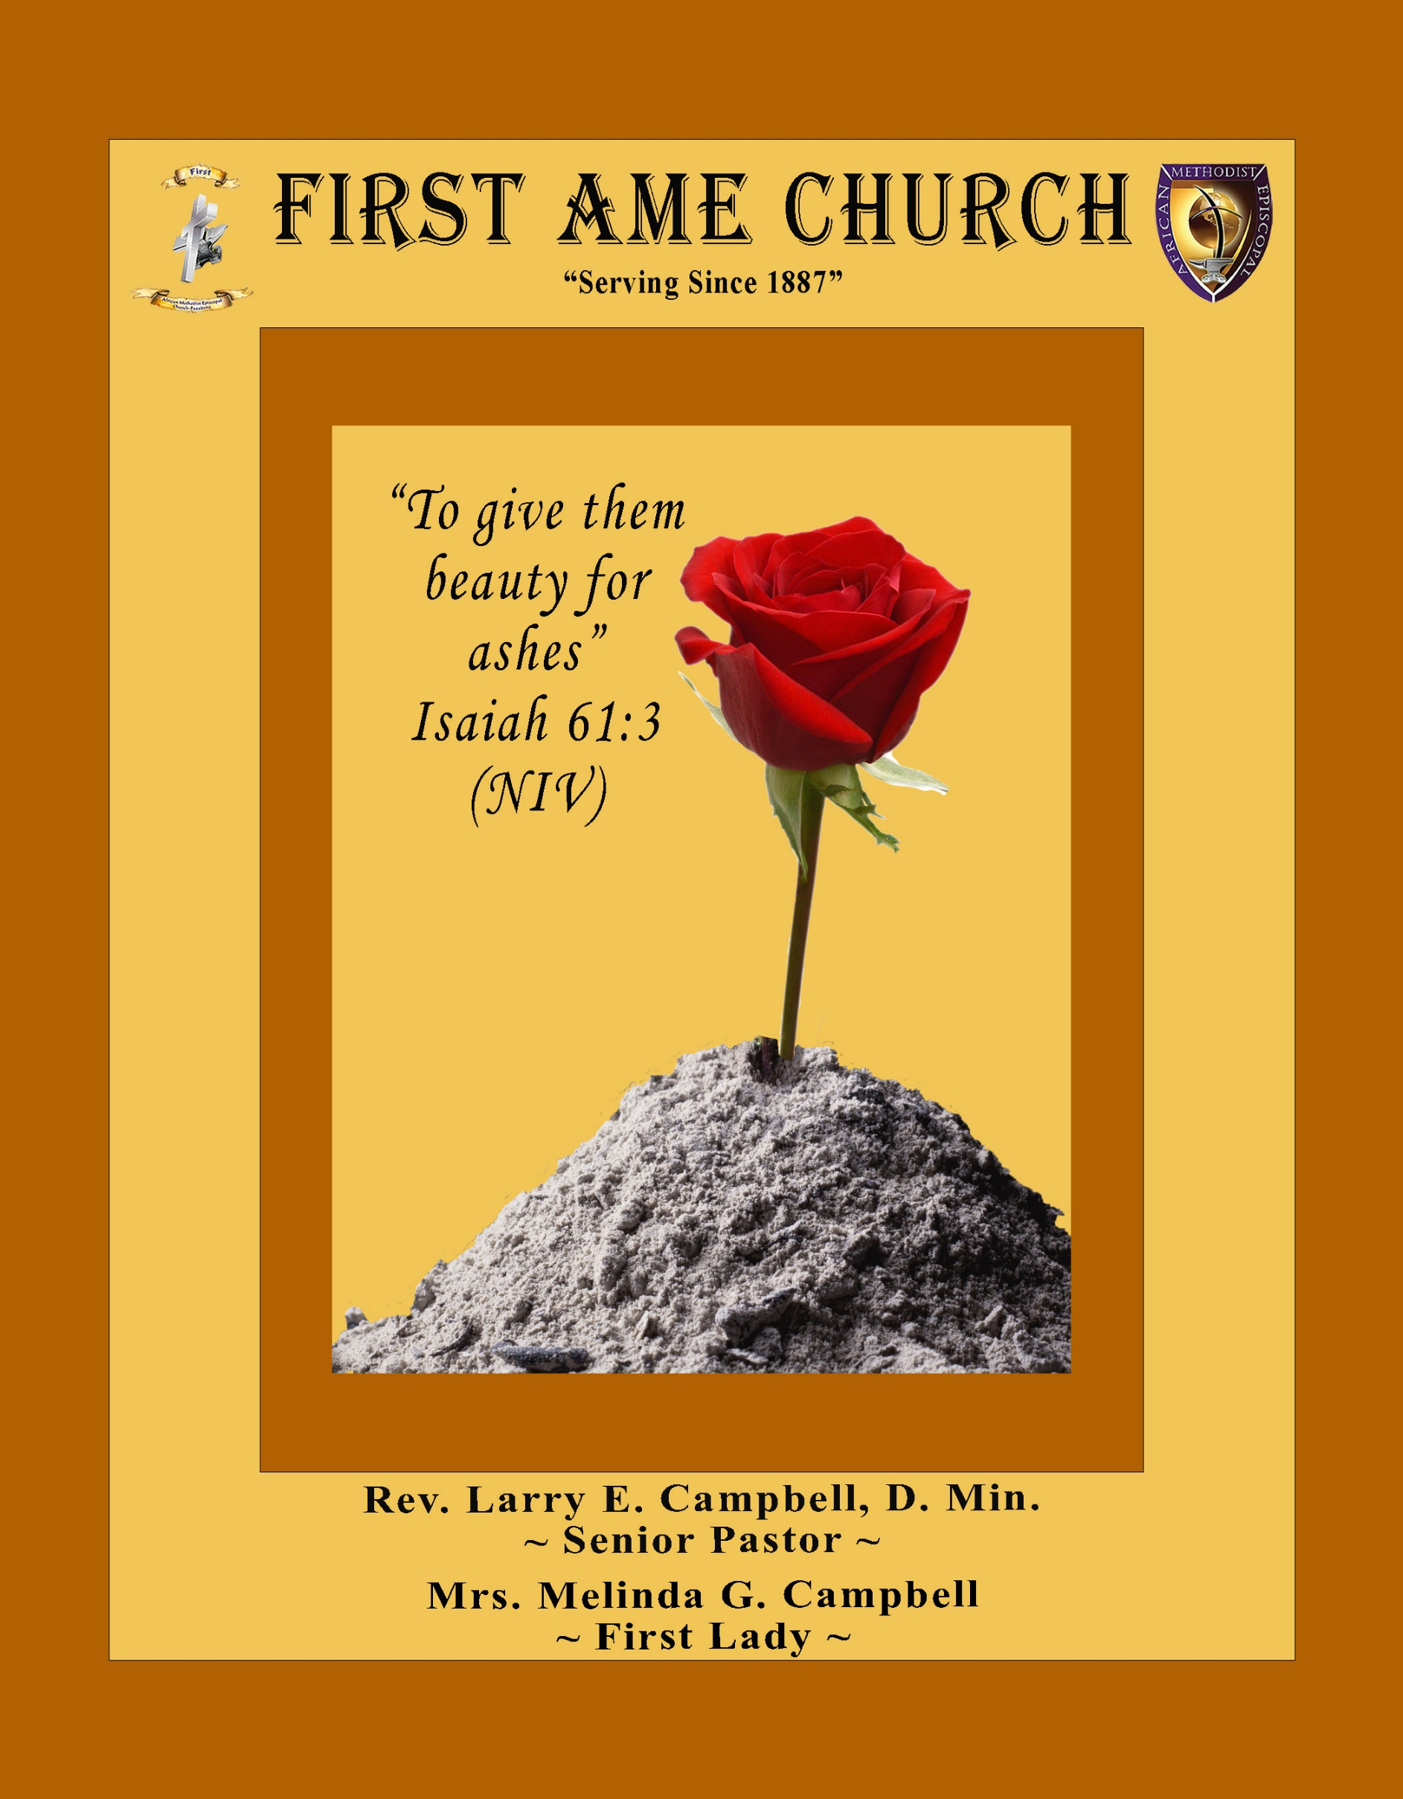
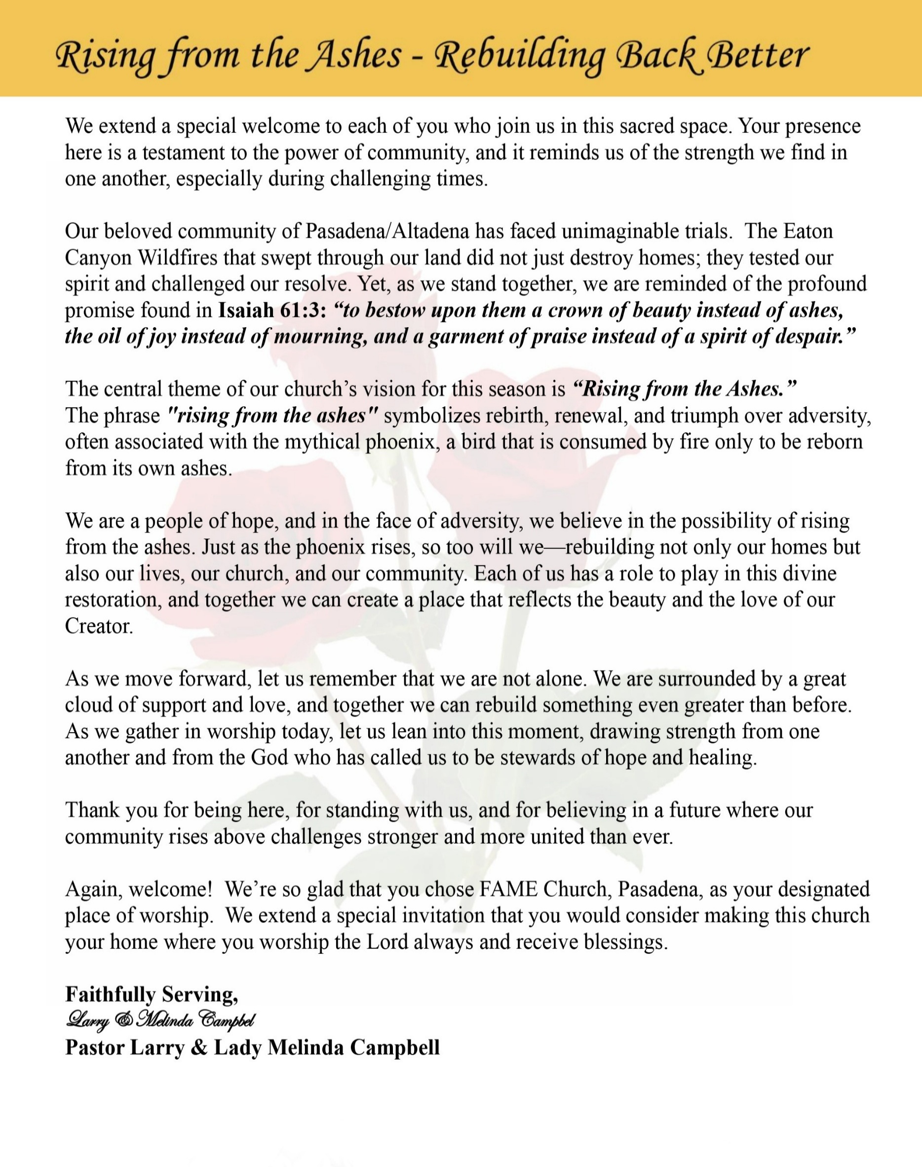

Sunday, October 4, 2026 | 9:30 a.m.

Rt. Rev. Francine A. Brookins, Esq., Presiding Bishop
Rev. Miriam Burnett, MD, MPH, Supervisor of Missions
Rev. Roosevelt Lindsey, Jr. Presiding Elder

The Rev. Dr. Larry E. Campbell ~ Senior Pastor ~ Minister

Mobile: (951) 587-1894 ~ Email: larrycampbell@famepasadena.org

Our First Lady: Mrs. Melinda G. Campbell

The Reverend Dr. Jennifer Oliver ~ Itinerant Elder -
The Reverend Dr. Nikia Smith-Robert ~ Itinerant Elder (Affiliated)
The Reverend Lois Woodard ~ Itinerant Elder Superannuated (Retired)
The Reverend Rochelle Wright Moore ~ Itinerant Deacon
The Reverend Deborah West-Jones ~ Local Elder
The Reverend Philis J. Griffin, MDiv ~ Local Elder
Dr. Phyllis Beech ~ Evangelist
Sister Tessie Bonner ~ Deaconess

Community Resource Center Director ~ Ms. Kischchen Hazelton Venerable
Church Administrative Assistant: Ms. Letha Rhymes

Church Office Hours:
Tue - Wed 9:00 am - 5:00 pm, & Fri 9:00 am -3:00 pm.
Closed for Lunch Daily: 12:00 pm - 1:00 pm.

Music Ministry
Dr. Timothy Davis, Minister of Music
Bro. Jimmy Watlington, Percussionist ~ Bro. Carlos Caldwell, Organist
Bro. Darien Dorsey, Keyboardist
Sis. Karen Law, Women’s Chorus Director ~ Sis. Tonia Graham, Children’s Choir Director
Bro. J. Renard Washington, New Generation’s Choir

FREE WI-FI service is available on the FAME Campus by accessing FAME 1700
Password: 6267980503

-3-

~ Order of Worship Experience ~

Warning: This order of worship is subject to change without warning or prior notice --- everything is governed by the Sovereignty of the Holy Spirit



+++ The Altar Call +++
Praise & Worship

Doxology: “Praise God From Whom All Blessings Flow”

The Call to Worship Pastor Larry E. Campbell

Leader: I was glad when they said unto me, let us go into the house of the Lord, our feet shall stand within Thy gates O Jerusalem! (Psalm 122:1)

People: For a day in Thy courts is better than a thousand. I had rather be a doorkeeper in the house of my God than to dwell in the tents of wickedness. (Psalm 84:10)

Leader: Because of the house of the Lord our God, I will seek Thy good.
(Psalm 122:9)

People: Those that be planted in the house of the Lord, shall flourish in the courts of our God. (Psalm 92:13)

Leader: Blessed are they that dwell in Thy house. Lord, I have loved Thy habitation, the place where Thy honor dwelleth. (Psalm 26:8)

People: For the Lord is in His holy temple; let all the earth keep silence before Him.
(Habakkuk 2:20).

Leader: Let the words of my mouth and the meditation of my heart, be acceptable in Thy sight, O Lord my strength and my redeemer. (Psalm 19:14)

Unison: O Sing unto the Lord a new song, for He has done marvelous things. Make a
joyful noise unto the Lord, all the earth, sing His praises. (Psalm 98:1, 4)

-4-

The Hymn of Praise A.M.E. Hymnal of #139

Alas! And Did My Savior Bleed
(At the Cross)

(Words: Isaac Watts, 1674-1748)

Alas! And did my Savior bleed, And did my Sovereign die?
Would He devote that sacred head
For sinners such as I?

(Refrain)
At the cross, at the cross where I first saw the light,
And the burden of my heart rolled away,
It was there by faith I received my sight,
And now I am happy all the day.

Was if for crimes that I had done He groaned upon the tree?
Amazing pity! Grace unknown!
And love beyond degree!

Refrain

Well might the sun in darkness hide, And shut his glories in,
When Christ the mighty Maker died
For man, the creature’s sin.

Refrain

But drops of grief an ne’er repay The debt of love I owe;
Here, Lord, I give my self away;
‘Tis all that I can do.

Refrain

The Invocation Rev. Deborah West-Jones

Ministry of Music The Mass Choir

-5-

Responsive Scripture Lesson Rev. Rochelle Wright-Moore
(Please Stand for the Reading of God’s Words)

Matthew 26:17-25; 47-50 (New International Version) — The Betrayal of Jesus

Leader: ¹⁷ On the first day of the Festival of Unleavened Bread, the disciples came to Jesus
and asked, “Where do you want us to make preparations for you to eat the
Passover?”

People: ¹⁸ He replied, “Go into the city to a certain man and tell him, ‘The Teacher
says: My appointed time is near. I am going to celebrate the Passover with my
disciples at your house.’” ¹⁹ So the disciples did as Jesus had directed them and
prepared the Passover.

Leader: ²⁰ When evening came, Jesus was reclining at the table with the Twelve. ²¹ And
while they were eating, he said, “Truly I tell you, one of you will betray me.”

People: ²² And they were exceedingly sorrowful, and each of them began to say to Him,
“Lord, is it I?”

Leader: ²³ Jesus replied, “The one who has dipped his hand into the bowl with me will
betray me. ²⁴ The Son of Man will go just as it is written about him. But woe to that
man who betrays the Son of Man! It would be better for him if he had not been
born.”

People: ²⁵ Then Judas, the one who would betray him, said, “Surely you don’t mean
me, Rabbi?” Jesus answered, “You have said so.”

Leader: ⁴⁷ While he was still speaking, Judas, one of the Twelve, arrived. With him was a
large crowd armed with swords and clubs, sent from the chief priests and the elders
of the people.

People: ⁴⁸ Now the betrayer had arranged a signal with them: “The one I kiss is the
man; arrest him.”

Leader: ⁴⁹ Going at once to Jesus, Judas said, “Greetings, Rabbi!” and kissed him.

ALL: ⁵⁰ Jesus replied, “Do what you came for, friend.” Then the men stepped
forward, Seized Jesus and arrested him.

-6-

THE AFFIRMATION OF FAITH (The Apostle Creed) Rev. Rochelle Wright-Moore

Minister: What do you Believe?

People: I believe in God the Father Almighty, Maker of heaven and earth, and in Jesus
Christ His only son our Lord who was conceived by the Holy Spirit, born of the Virgin Mary, suffered under Pontius Pilate, was crucified, dead and buried. The third day he arose from the dead; he ascended into heaven and sitteth at the right hand of God the Father Almighty; from thence he shall come to judge the quick and the dead. I believe in the Holy Spirit, the Church Universal, the communion of saints, the forgiveness of sins, the resurrection of the body and the life everlasting. Amen.
THE PRELUDE TO THE DECALOGUE Pastor

“From all that dwell below the skies, Let the Creator’s praise arise;
Let the Redeemer’s name be sung. Through every land, by every tongue.”

THE DECALOGUE (An Affirmation of God’s Law)

Minister: Let us express our commitment to keep God’s Law

People: God of our salvation, only You are God.
We will make no idols.
We will not invoke with malice your name, O God.
We will remember the Sabbath Day and keep it holy.
We will honor our father and our mother.
We will not commit murder.
We will not commit adultery.
We will not steal.
We will not be a false witness.
We will not covet anything that belongs to our neighbor.
Minister: Jesus said: “You shall love the Lord your God with all your heart, and with all your soul and with all your mind. This is the great and first commandment.”

ALL: Jesus also challenged us to love justly with a second commandment
which is like the first. We shall love our neighbor as ourselves! On these
commandments depend all the law and the prophets.

-7-

THE GLORIA PATRI
Glory be to the Father, and to the Son, and to the Holy Ghost.
As it was in the beginning, is now and ever shall be, world without end. Amen Amen!!

Abbreviated Announcements/ Visitor’s Welcome

Pastoral Remarks

The Offertory (Tithes ~ Gifts ~ Benevolent Offerings) Sis. Juanita West-Tillman, Steward

In order to satisfy the steady increase of inflation, we are asking each member to consider increasing your Tithe, Offerings & Gifts.

The following Electronic GIVING Platforms are creditable methods to GIVE to FAME:

#1. GIVELIFY - Mobile Giving App available on the App Store. It’s easy to set up, just follow the guidelines.

#2. Cash App: $FirstAMEPASADENA

#3. Mail in your Tithes & Offering - If you would like to mail your tithes and offering by check or money order, please send it to: First AME Church, 1700 N. Raymond Avenue, Pasadena, CA 91103.

#4. Drop off your Tithes & Offering - During business hours in the basket outside of the office.

Choral Response: “All things come of Thee, O Lord; and of Thine own have we given Thee. Amen.”

CHILDREN’S CHURCH DISMISSAL

Sermonic Selection The Mass Choir

Proclamation of The Word: Pastor Larry E. Campbell

The Invitation (Public/Private)

-8-

The Sacrament of the Lord’s Supper or Holy Communion

THE SOLICITATION

You that do truly and earnestly repent of your sins, and are in love and charity with your neighbor, and intend to lead a new life, following the commandments of God, and walking from henceforth in His holy ways, draw near with faith and take this holy sacrament to your comfort; and make your humble confession to Almighty God.

THE GENERAL CONFESSION

Minister: Let us humbly confess our sins unto Almighty God.

Minister and People:

Almighty God, Father of our Lord Jesus Christ, Maker of all things, Judge of all men, we acknowledge and bewail our manifold sins and wickedness which we from time to time most grievously have committed by thought, word, and deed against Your divine Majesty, provoking most justly Your wrath and indignation against us. We do earnestly repent and are heartily sorry for these, our misdoings; the remembrance of them is grievous unto us. Have mercy upon us, have mercy upon us, most merciful Father for Your Son our Lord Jesus Christ’s sake; forgive us all that is past, and grant that we may ever hereafter serve and please You in newness of life, to the honor and glory of Your name through Jesus Christ our Lord.

Amen. (Choral). (You may be seated).

THE PRAYER OF PARDON

Almighty God, our Heavenly Father, who of Your great mercy has promised forgiveness of sins to all them that with hearty repentance and true faith turn unto You, have mercy upon us; pardon and deliver us from all our sins; confirm and strengthen us in all goodness; and bring us to everlasting life through Jesus Christ, our Lord.

Choral Response: Amen.

THE PRAYER OF CONSECRATION

Minister: Loving God, our Father in heaven, in Your great mercy You gave Your only Son, Jesus Christ, to die on the cross so we could be saved. Through His sacrifice — offered once and for all — He made a complete and perfect offering for the sins of the whole world. And in the gospel, He told us to keep remembering His precious death until He comes again.
So we ask You, merciful Father, hear our prayer. As we receive this bread and this cup, according to the way our Savior Jesus taught us, help us remember His suffering and death, and allow us to share in the blessing of His body and His blood.
On the night He was betrayed, Jesus took bread. After giving thanks, He broke it and gave it to His disciples, saying,
“Take and eat. This is my body, given for you. Do this to remember me.”
In the same way, after supper He took the cup. After giving thanks, He gave it to them and said,
“Drink from it, all of you. This is my blood of the new covenant, poured out for you and for many so that sins may be forgiven. Whenever you drink it, do this to remember me.” Amen!

THE LORD’S PRAYER (ALL)
THE ELEMENTS SHARED
THE BENEDICTION

-9-

ANNOUNCEMENTS
\
BEREAVEMENT ANNOUNCEMENT
It is with deep sorrow and heartfelt sympathy that we announce the passing of Dr. Melvin Beech, beloved husband of Evangelist Dr. Phyllis Beech and a dear and cherished member of the First A.M.E. Church, Pasadena family. Dr. Beech lived a distinguished life of faith, service, education, leadership and commitment to his community and country. A proud United States Army veteran, Dr. Beech served his country during the Korean Conflict, answering the call to military service with courage and honor. A Special Memorial Service is tentatively scheduled for Friday, October 16, 2026 at 11:00. a.m. Place: FAME Pasadena. We extend our love, prayers, and deepest condolences to Evangelist Dr. Phyllis Beech, the entire Beech family, and all who mourn his passing. May we surround the family with our prayers and Christian love during this season of bereavement.

Updating FAME-Pasadena Membership Directory
FAME is updating each household/member’s contact information. We are asking all households to complete a Google Form. Completing the form ensures your contact information is current.
Starting in October, volunteers will be available in the Fellowship Hall on first Sundays to assist families in completing form. You have four options to complete the Google form:

Complete Google Form on-line. Use the QR code.
Request an internet link to access the form.
Complete a paper form, and then drop it off to the office.
Schedule an Interview to get assistance in completing the form.

If you experience any issues with completing this form, please text or email
Sharon Sharp, 626-840-7374, sharon_s91104@yahoo.com. Thank you for supporting this project.

Men's Ministry - BIBLE STUDY | Time: Tuesday, October 6, 2026 | 6:00 p.m.
Meeting ID: 894 7536 6487 ; Passcode: 465177 One tap mobile: +16699006833,,89475366487#,,,,*465177# US (San Jose)

CHRISTIAN EDUCATION SEMINAR — Church School Volunteer Training
“STUDY IT. LIVE IT. TEACH IT.”
Saturday, October 10, 2026 (9:00 a.m. – 12:00 Noon)
All Church School teachers, assistants, substitutes, and volunteers are encouraged to attend this important Christian Education training session designed to strengthen and equip us for the ministry of teaching God’s Word.
Theme Scripture — Ezra 7:10 (God’s Word Translation)
“Ezra was determined to study the Lord’s Teachings, live by them, and teach their rules and regulations in Israel.” OUR TRAINING FOCUS
STUDY IT — Preparation (A teacher cannot effectively teach what they have not studied.)
LIVE IT — Demonstration (The teacher’s life should reinforce the lesson being taught.)
TEACH IT — Communication (We teach so that others may know, live, and share God’s Word.)
Before we teach the lesson with our lips, we must learn the Word with our minds and live the Word with our lives. Whether you are a veteran teacher or a new volunteer, your presence is important as we prepare ourselves to provide meaningful, relevant, and biblically grounded Christian Education for children, youth, and adults. Come ready to learn. Come ready to grow. Come ready to teach!

Women's Ministry – BIBLE STUDY | Time: Tuesday, October 13, 2026 | 6:00 p.m.
Meeting ID: 857 0061 9461; Passcode: 933892 One tap mobile +16699006833,,85700619461#,,,,,,0#,,933892# US (San Jose)

Senior Ministry In-Person Gathering| Tuesday, October 13, 2026| 11:30 a.m. Church Fellowship Hall

-10-

ANNOUNCEMENTS (Continued)

CHURCH CONFERENCE: Annual State of the Church
Pastor Campbell will present the FAME Church Family with an official “State of the Church” Address at 7:00 p.m. on Tuesday, October 13, 2026. The presence of the entire church membership is requested to attend. Join Zoom Meeting
https://us02web.zoom.us/j/89877657218?pwd=2dWYtHOJyyg9pAatJtFhC5BZ2aynZ9.1
Meeting ID: 898 7765 7218 | Passcode: 622008
*** Each Ministry President or designated representative will present the Top FIVE Significant Accomplishments of this Annual Conference Year. ***

FAME CHURCH FAMILY — LET US PRAY!
Dear FAME Church Family,
As we prepare to host the 102nd Session of the Southern California Annual Conference, I am asking our entire FAME Church Family to join me for two special Congregational Prayer Sessions.

This will be a time for us to come together in prayer and seek God’s blessings, success, protection, and favor upon this important spiritual convocation. We will specifically pray for:

🙏🏾 Our Bishop and Supervisor 🙏🏾 Our Presiding Elders 🙏🏾 Pastors and Delegates 🙏🏾 The Success of the Annual Conference 🙏🏾 The Salvation of Souls and Transformation of Lives

As the host church, let us cover this conference in prayer before we gather in person. Let us believe God for a powerful, Spirit-filled, and successful Annual Conference.
CONGREGATIONAL PRAYER SESSIONS
Wednesday, October 7, 2026 — 6:00 PM & Wednesday, October 14, 2026 — 6:00 PM
Join Zoom Meeting: https://us02web.zoom.us/j/86093500638?pwd=UbkJuCck0aK3EIHy365mbkX57Qs81p.1
Meeting ID: 860 9350 0638 | Passcode: 695057
One Tap Mobile: +16694449171,,86093500638#,,,,*695057# US
+16699006833,,86093500638#,,,,*695057# US (San Jose)
I look forward to seeing you on both prayer calls.
With prayer and expectation, Rev. Dr. Larry E. Campbell

SAVE THE DATE
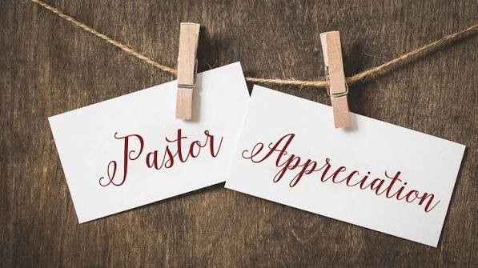
Sunday, October 18, 2026 | 9:30 am | Fellowship Celebration in the luxurious Fellowship Hall

Pastor Larry E. & Lady Melinda G. Campbell's 12th Pastoral Appreciation

“The Heart of a Shepherd: 12 Years of Leadership, Love, and Legacy”

Scripture: “And I will give you pastors according to mine heart, which shall feed you with knowledge and understanding.” — Jeremiah 3:15 (KJV)



-11-

Hands of Betrayal. Even my close friend, someone I trusted, one who shared my bread, has turned against me.” Psalm 41:9

Quote of the Day
"The saddest thing about betrayal is that it never comes from your enemies." — William Shakespear

Thought of the Week
I WASN'T EXPECTING IT FROM YOU
“For it was not an enemy that reproached me; then I could have borne it… But it was thou, a man mine equal, my guide, and mine acquaintance.” Psalms 55:12-14
Some wounds hurt more because of who caused them. David declares that if the attack had come from an enemy, he could have prepared himself. But this wound came from someone he trusted, walked with, worshiped with, and considered a friend.
Betrayal hurts because it comes from a place where we expected loyalty. It reminds us that proximity does not always mean faithfulness, and familiarity does not always mean friendship.
Yet David teaches us something even greater: when people disappoint us, God remains dependable. Later he declares, “Cast thy burden upon the LORD, and he shall sustain thee” (Psalm 55:22). You may not have expected it from them, but you can still expect God to sustain you through it.
Betrayal may reveal who they are, but don't let it change who God has called you to be.

Humor of the Week
A man died and went to heaven. He is met at the Pearly Gates by St. Peter, who led him down the golden streets. They walk by mansions after beautiful estates until they came to the end of the road where they stopped in front of a little shack. The man asked St. Peter why he got a simple hut when there were so many mansions where he would be more comfortable. St. Peter replied, “I did the best with the money you sent us.”

HOME DAILY BIBLE READINGS
October 5, 2026 – October 11, 2026 (Week 6, Judges)
Monday Day 36 Leviticus 14-15, Psalm 24
Tuesday Day 37 Leviticus 16-18, Psalm 25:1-10
Wednesday Day 38 Leviticus 19-21, Psalm 25:11-22
Thursday Day 39 Leviticus 22-23, Psalm 26
Friday Day 40 Leviticus 24-25, Psalm 27:1-6
Saturday Day 41 Leviticus 26-27, Psalm 27:7-14
Sunday Day 42 Numbers 1-4, Psalm 28

-12-

Prayer Request(s)
Please notify the Church Office of Sick & Shut-in additions, deletions, or status/address changes.

Bishop Francine A. Brookins, Esq. Supervisor Miriam Burnett, MD Presiding Elder Roosevelt & Dr. Kaye Lindsey Rev. Dr. Larry & Melinda Campbell Richard Craig Hazel Clark Erica Woodard Jason Shirley Joshua Shirley Julian Shirley Ayanna Terry Cheryl Jamerson Gwendolyn Flowers Andrea Anderson Ocilda Files Danielle Clark Rev. Charles Brooks Kimberly Woods Cynithia Grace Calle Burns Noel Johnson The Taylor Family
Zechariah Robinson Christopher McCarthy Wilma Haynes Jacquelyn Walker Brittney Petty Selene Cox Deborah Burton Nettie McChristen The Caple Family Mel Beech Michael Dotson
Rev. Rochelle Moore Lorene Butler Stella Pulliam Collette Blizzard The Eaton Canyon Fire Victims

College Students

Let’s continue to support and pray for our beloved College Students

Isaiah Crowell Alecia Davis Chase Johnson Grant Blizzard Gabriel Blizzard

Tyler Johnson Richard Jones Tyrikk Lawson Makia Rose Talbert Isaiah Ringo Journey Rogers Elyse Sharp Kylee Sharp Zion Otano Elise Tervalon Grace Jones Jordan Patterson Kimberly Robinson Donovan Williams Jasmine Collins Brandon Bates

Sick and Shut-Ins
Andrew Oliver 1405 N. Roosevelt Avenue, Pasadena, CA 91104
Barbara Buchanan 616 Rio Grande St. Pasadena, CA 91104
Bettina Ayers Pasadena Meadows Nursing Home, 150 Bellefontaine St., Pas., CA 91105
Betty Betts Turner 1625 S. Magnolia Ave., Unit 4125, Monrovia, CA 91016
Bobby Thomas 1052 E. Morada Place, Altadena, CA 91001
Diane Jordan 1719 Fremont Ave., #302, S. Pasadena, CA 91030
Donita Towler 14148 Francisquito Ave., Baldwin Park, CA 91706
Doris Curd 11619 Woodcock Avenue, San Fernando, CA 91340
Edmund Riddle Active Care Mission Bay, 2440 Grand Avenue, San Diego, CA 92109
Eleanor Towler 975 E. Union Street, Unit #417, Pasadena, CA 91106
Elois Blizzard P. O. Box 3646, So. Pasadena, CA 91031
Emily Cormier-Ross 2549 La Fiesta Avenue, Altadena, CA 91001
Ernestine English 26 W. Fair Oaks Drive, Pasadena, CA 91103
Fred Caple 51 North 15th Street, Haledon, NJ 07508
Hugh Hamberry 19225 Chole Rd., Apple Valley, CA 92307
Jessie Smith 3925 S. Jones Blvd., Apt. 2118, Las Vegas, NV 89103| Spring Valley Community
Jimmy Williams 215 W. Pearl Street, Pomona, CA 91768
Lenora Moore 2445 E. Del Mar Blvd., #338, Pasadena, CA 91107
Linnie G. Nollie 2250 E. New York Drive, Altadena, CA 91001
Malika G. Hendry P. O. Box 94082, Pasadena, CA 91109
Mildred Lewis C/O Hazel Rohr, 884 W. Jane Court, Upland, CA 91786
Norma Burnett 618 Fairview Avenue, Unit #228, Arcadia, CA 91007
Opal Hampton 1030 Chevron Court, Pasadena, CA 91103
Paul Ratliff P.O. Box 40407, Pasadena, CA 91114
Virlyn Grant 15122 Orange Ave., Paramount, CA 90723
Wanda Nelson 3618 N. Fair Oaks Avenue, Altadena, CA 91001
William Hilliard 7504 Wynstone Pl., Fontana, CA 92336
Zell L. Hill 375 Barthe Drive, Pasadena, CA 91103

-13-

Sermon Notations

Scripture: _____________________________________________________________

Subject: _______________________________________________________________

Points of the Message: ___________________________________________________
_______________________________________________________________________
_______________________________________________________________________
_______________________________________________________________________
_______________________________________________________________________
_______________________________________________________________________
_______________________________________________________________________

Main Ideas of the Sermon: ________________________________________________
_______________________________________________________________________
_______________________________________________________________________
_______________________________________________________________________
_______________________________________________________________________
_______________________________________________________________________

Illustrations I want to remember: _________________________________________
_______________________________________________________________________
_______________________________________________________________________
_______________________________________________________________________
_______________________________________________________________________
_______________________________________________________________________
_______________________________________________________________________

What should I do as a result of this Sermon? ________________________________

_____________________________________________________
_____________________________________________________
_____________________________________________________
_____________________________________________________

-14-

