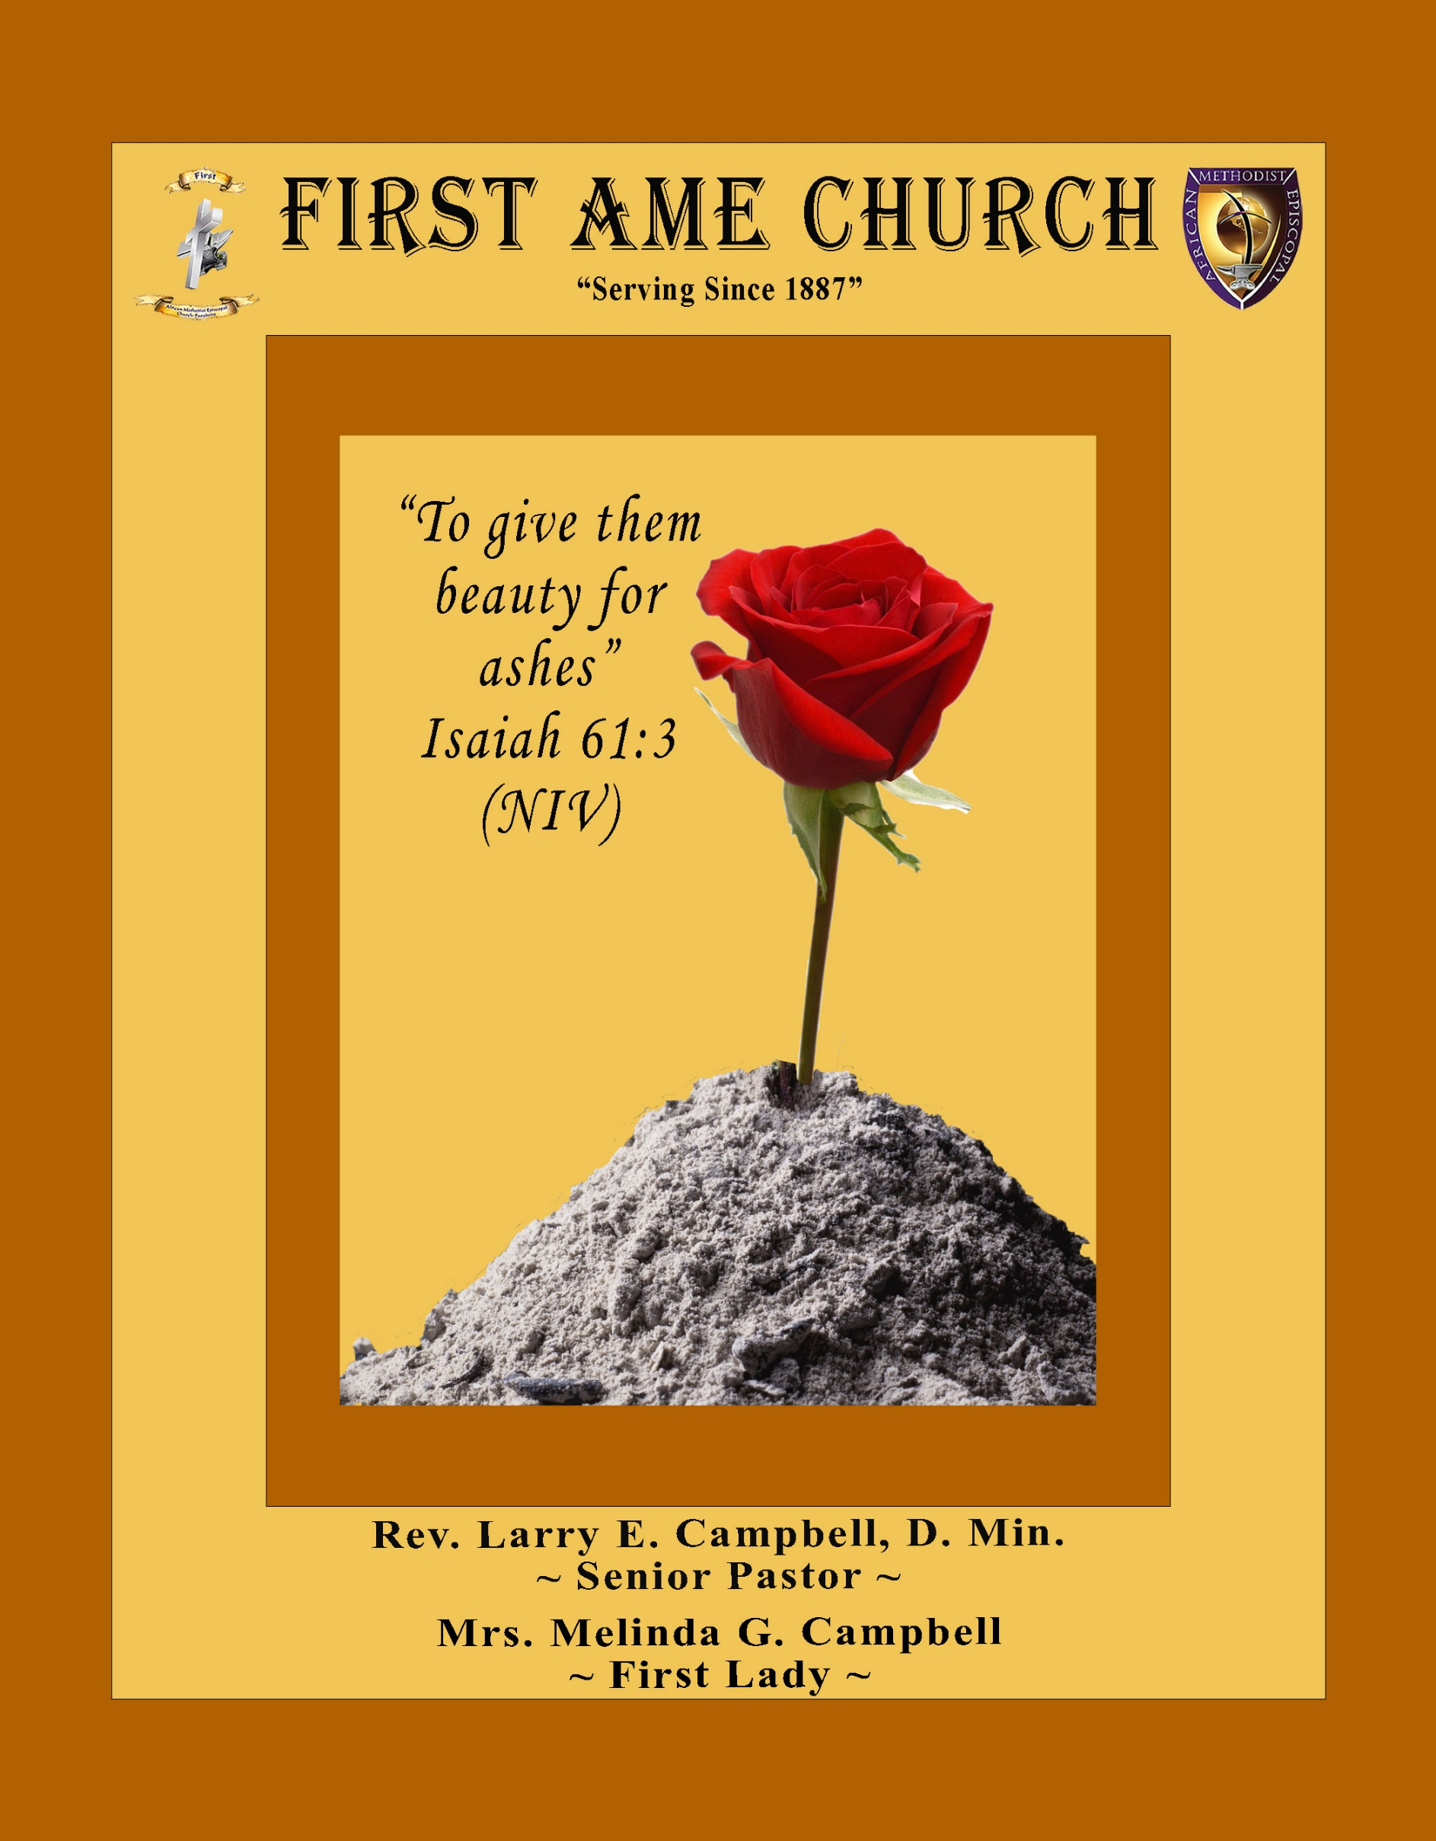
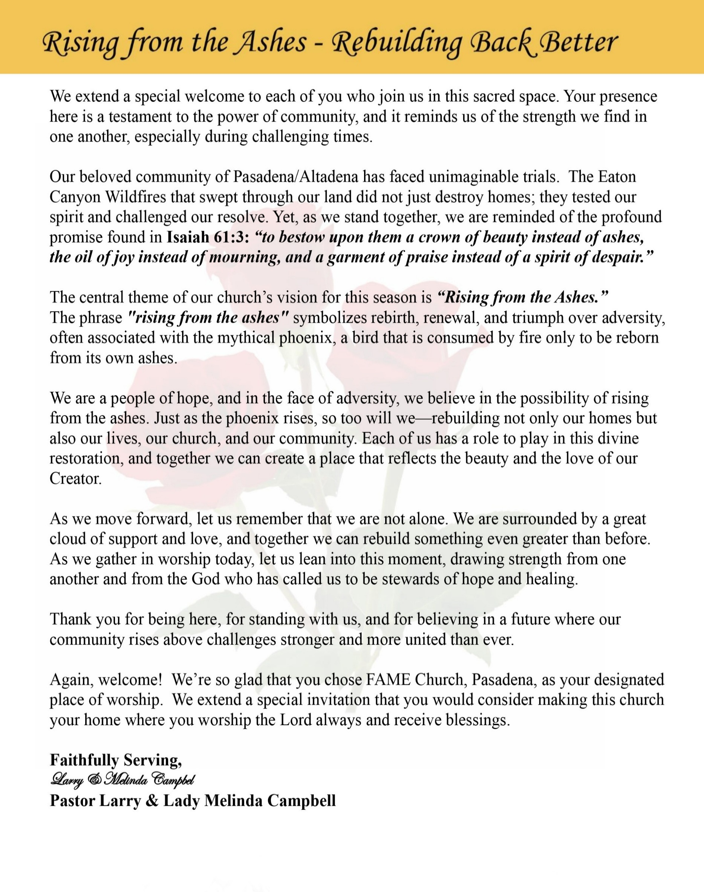

Sunday, September 13, 2026 | 9:30 a.m.

Rt. Rev. Francine A. Brookins, Esq., Presiding Bishop
Rev. Miriam Burnett, MD, MPH, Supervisor of Missions
Rev. Roosevelt Lindsey, Jr. Presiding Elder

The Rev. Dr. Larry E. Campbell ~ Senior Pastor ~ Minister

Mobile: (951) 587-1894 ~ Email: larrycampbell@famepasadena.org

Our First Lady: Mrs. Melinda G. Campbell

The Reverend Dr. Jennifer Oliver ~ Itinerant Elder -
The Reverend Dr. Nikia Smith-Robert ~ Itinerant Elder (Affiliated)
The Reverend Lois Woodard ~ Itinerant Elder Superannuated (Retired)
The Reverend Rochelle Wright Moore ~ Itinerant Deacon
The Reverend Deborah West-Jones ~ Local Elder
The Reverend Philis J. Griffin, MDiv ~ Local Elder
Dr. Phyllis Beech ~ Evangelist
Sister Tessie Bonner ~ Deaconess

Community Resource Center Director ~ Ms. Kischchen Hazelton Venerable
Church Administrative Assistant: Ms. Letha Rhymes

Church Office Hours:
Tue - Wed 9:00 am - 5:00 pm, & Fri 9:00 am -3:00 pm.
Closed for Lunch Daily: 12:00 pm - 1:00 pm.

Music Ministry
Dr. Timothy Davis, Minister of Music
Bro. Jimmy Watlington, Percussionist ~ Bro. Carlos Caldwell, Organist
Bro. Darien Dorsey, Keyboardist
Sis. Karen Law, Women’s Chorus Director ~ Sis. Tonia Graham, Children’s Choir Director
Bro. J. Renard Washington, New Generation’s Choir

FREE WI-FI service is available on the FAME Campus by accessing FAME 1700
Password: 6267980503

-3-

~ Order of Worship Experience ~

Warning: This order of worship is subject to change without warning or prior notice --- everything is governed by the Sovereignty of the Holy Spirit.



Praise & Worship

Doxology: “Praise God From Whom All Blessings Flow”

The Call to Worship The Newman Family

Leader: I was glad when they said unto me, let us go into the house of the Lord, our feet shall stand within Thy gates O Jerusalem! (Psalm 122:1)

People: For a day in Thy courts is better than a thousand. I had rather be a doorkeeper in the house of my God than to dwell in the tents of wickedness. (Psalm 84:10)

Leader: Because of the house of the Lord our God, I will seek Thy good.
(Psalm 122:9)

People: Those that be planted in the house of the Lord, shall flourish in the courts of our God. (Psalm 92:13)

Leader: Blessed are they that dwell in Thy house. Lord, I have loved Thy habitation, the place where Thy honor dwelleth. (Psalm 26:8)

People: For the Lord is in His holy temple; let all the earth keep silence before Him.
(Habakkuk 2:20)

Leader: Let the words of my mouth and the meditation of my heart, be acceptable in Thy sight, O Lord my strength and my redeemer. (Psalm 19:14)

Unison: O Sing unto the Lord a new song, for He has done marvelous things. Make a
joyful noise unto the Lord, all the earth, sing His praises. (Psalm 98:1, 4)

-4-

The Hymn of Praise A.M.E. Hymnal #61
O God, Our Help in Ages Past

Words: Isaac Watts, 1674-1748

O God, our help in ages past, Our hope for years to com,
Our shelter from the stormy blast, And our eternal home!

Under the shadow of Thy throne Still may we dwell secure;
Sufficient is Thine arm alone, And our defense is sure.

Before the hills in order stood, Or earth received her frame,
From everlasting Thou art God, To endless years the same.

A thousand ages in Thy sight, Are like an evening gone;
Short as the watch that ends the night, Before the rising sun.

Time, like an ever rolling stream, Bears all its sons away;
They fly forgotten, as a dream Dies at the opening day.

O God, our help in ages past. Our hope for years to come;
Be thou our guide while life shall last, And our eternal home!

The Invocation Sis. Allene Washington

Ministry of Music The Mass Choir

Scripture Lesson
(Please Stand for the Reading of God’s Words)
Old Testament Sis. Sharon Sharp
Jeremiah 29:10-14 (New King James Version) — Honoring Our Past; Embracing Our Future
¹⁰ For thus says the Lord: After seventy years are completed at Babylon, I will visit you and perform My good word toward you and cause you to return to this place. ¹¹ For I know the thoughts that I think toward you, says the Lord, thoughts of peace and not of evil, to give you a future and a hope. ¹² Then you will call upon Me and go and pray to Me, and I will listen to you. ¹³ And you will seek Me and find Me, when you search for Me with all your heart. ¹⁴ I will be found by you, says the Lord, and I will bring you back from your captivity; I will gather you from all the nations and from all the places where I have driven you, says the Lord, and I will bring you to the place from which I cause you to be carried away captive.

-5-

New Testament (Responsive Reading) Bro. Charles Ludd, Jr., Esq.
New Testament (Colossians 2:1-15) — New Revised Standard Version Updated Edition
Leader: For I want you to know how greatly I strive for you and for those in Laodicea and for all
who have not seen me face to face.

People: ² I want their hearts to be encouraged and united in love, so that they may have all the
riches of assured understanding and have the knowledge of God’s mystery, that is,
Christ, ³ in whom are hidden all the treasures of wisdom and knowledge.

Leader: ⁴ I am saying this so that no one may deceive you with plausible arguments. ⁵ For though I am
absent in body, yet I am with you in spirit, and I rejoice to see your orderly conduct and the
firmness of your faith in Christ.

People: ⁶ As you therefore have received Christ Jesus the Lord, continue to walk in him, ⁷ rooted
and built up in him and established in the faith, just as you were taught, abounding in
thanksgiving.

Leader: ⁸ Watch out that no one takes you captive through philosophy and empty deceit, according to
human tradition, according to the elemental principles of the world, and not according to
Christ.

People: ⁹ For in him the whole fullness of deity dwells bodily, ¹⁰ and you have come to fullness
in him, who is the head of every ruler and authority.

Leader: ¹¹ In him also you were circumcised with a spiritual circumcision, by the removal of the
body of the flesh in the circumcision of Christ; ¹² when you were buried with him in
baptism, you were also raised with him through faith in the power of God, who raised him
from the dead.

People: ¹³ And when you were dead in trespasses and the uncircumcision of your flesh, God made
you alive together with him, when he forgave us all our trespasses, ¹⁴ erasing the record
that stood against us with its legal demands.

ALL: He set this aside, nailing it to the cross. ¹⁵ He disarmed the rulers and authorities and
made a public example of them, triumphing over them in it.

The Summary of the Decalogue Sis. Anna Lou Parker
LEADER: From all that dwell below the skies…
SUNG: From all that dwell below the skies, Let the Creator’s praise arise; Let the
Redeemer’s Name be sung, through every land, by every tongue.
LEADER: Hear what Christ our Savior saith, Thou shalt love the Lord thy God with all thy
heart, with all thy soul, and with all thy mind. This is the first and great
commandment. And the second is like unto it: Thou shalt love thy neighbor
as thyself. On these two commandments hang all the law and the prophets.
SUNG: Glory be to the Father, and to the Son, and to the Holy Ghost; as it was in
the beginning, is now, and ever shall be, world without end. A~Men

-6-

Historical Perspective Sis. Lorna Dee Washington
Abbreviated Announcements/Visitor’s Welcome



Wedding


90 Plus Birthday Celebrations

Birthdays Recognized for the Month


“The best Birthday wish that you can get for the day is that you may live each moment of your life to the very fullest, without any regrets.” Anonymous

__________________________________________________________________________________________

The Offertory (Tithes ~ Gifts ~ Benevolent Offerings) Sis. Juanita West-Tillman

The following Electronic GIVING Platforms are creditable methods to GIVE to FAME:
#1. GIVELIFY - Mobile Giving App available on the App Store. It’s easy to set up, just follow the guidelines.
#2. Cash App: $FirstAMEPASADENA
#3. Mail in your Tithes & Offering - If you would like to mail your tithes and offering by check or money order, please send it to: First AME Church, 1700 N. Raymond Avenue, Pasadena, CA 91103.
#4. Drop off your Tithes & Offering - During business hours in the basket outside of the office.

Choral Response: “All things come of Thee, O Lord; and of Thine own have we given Thee. Amen.”

-7-

139th CHURCH ANNIVERSARY LITANY Sis. Alison Moses
LEADER: For 139 years, God has been our refuge, our strength, and our guide. We give
thanks for those whose faith, sacrifice, and service laid the foundation upon
which we stand.

People: We honor our past and thank God for every generation that has carried the faith
forward.

Leader: Through seasons of joy and sorrow, struggle and triumph, God has remained faithful to
His Church.

People: “For I know the plans I have for you,” declares the Lord—plans to give us hope
and a future.

Leader: As we celebrate where God has brought us from, we will not be afraid of where God is
leading us next.

People: We embrace our future with faith, courage, and expectation.

Leader: May we preserve the legacy entrusted to us while preparing the way for generations yet
to come.

People: We will build upon the faith of our ancestors and leave a strong foundation for our
children and our children’s children.

Leader: With gratitude for yesterday, commitment for today, and hope for tomorrow, let us
move forward together.

ALL: We honor our past. We embrace our future. And we trust the God who has kept
us for 139 years to lead us into the years ahead. To God be the glory! Amen.

Introduction of Guest Preacher Pastor Larry E. Campbell

Sermonic Selection The Mass Choir

Proclamation of The Word Rev. Kenny Baker
Pastor — St. Mark A.M.E. Church, Los Angeles

The Invitation (Public/Private)

The Doxology

The Benediction

-8-

Scripture of the Day
Honoring our Past; Embracing our Future. " God says, “Look back and thank Me for everything I’ve done for you. Look ahead and trust Me because I am not done blessing You.” — Haggai 2:19

Quote of the Day
"We remember with gratitude, celebrate with joy, and move forward with faith."
Author Unknown

Thought of the Week
HONORING OUR PAST; EMBRACING OUR FUTURE
“One generation shall praise thy works to another, and shall declare thy mighty acts.” Psalm 145:4
A church anniversary is more than a celebration of how many years we have existed; it is a testimony of how long God has been faithful.
For 139 years, generations before us prayed, worshiped, sacrificed, served, and trusted God. We stand today on the foundation their faith helped to build. Their testimony reminds us that we did not get here by ourselves—God brought us.
But Psalm 145:4 also reminds us that every generation has a responsibility to the next. We must not only honor the faith of those who came before us; we must pass that faith to those coming behind us.
So, as we celebrate 139 years, we look back with gratitude, serve today with faithfulness, and look forward with hope. We honor our past, but we are not finished. The same God who brought us this far is already preparing the way for our future.
To God be the glory for 139 years—and for the years yet to come!

Humor of the Week
Two brooms were hanging in the closet and after a while they got to know each other so well, they decided to get married.
One broom was, of course, the bride broom, the other the groom broom.
The bride broom looked very beautiful in her white dress.
The groom broom was handsome and suave in his tuxedo.
The wedding was lovely.
After the wedding, at the wedding dinner, the bride-broom leaned over and said to the groom-broom, 'I think I am going to have a little broom!'
'IMPOSSIBLE!' said the groom broom. ???
Are you ready for this? Brace yourself; this is going to hurt!!!!!!
'WE HAVEN'T EVEN SWEPT TOGETHER!'
HOME DAILY BIBLE READINGS
September 14, 2026 – September 20, 2026 (Week 52, Jude)
Monday Day 358 2 Peter 1-3, Ecclesiastes 5
Tuesday Day 359 1 John 1-5, Ecclesiastes 6
Wednesday Day 360 2 John, 3 John, Jude, Ecclesiastes 7
Thursday Day 361 Revelation 1-5, Ecclesiastes 8
Friday Day 362 Revelation 6-8, Ecclesiastes 9
Saturday Day 363 Revelation 9-14, Ecclesiastes 10
Sunday Day 364 Revelation 15-18, Ecclesiastes 11
Day 365 Revelation 19-22, Ecclesiastes 12

-9-

ANNOUNCEMENTS

A MESSAGE FROM THE PASTOR & FIRST LADY

Dear FAME Church Family and Friends,

What a tremendous blessing it is to celebrate the 139th Anniversary of First African Methodist Episcopal Church, Pasadena!

Since 1887, FAME Pasadena has been more than a place of worship. It has been a spiritual home where souls have been saved, families strengthened, children nurtured, leaders developed, communities served, and the Gospel of Jesus Christ proclaimed.

Throughout these 139 years, our congregation has experienced changing times, unexpected challenges, and new opportunities for ministry. Yet through every season, the hand of God has remained upon this church.

Our anniversary theme, “Honoring Our Past; Embracing Our Future,” calls us to cherish the sacred heritage entrusted to us while remaining open to the new possibilities God is placing before this ministry. Jeremiah 29:11 assures us that God’s intentions toward His people are filled with hope and purpose.

As Pastor and First Lady, we are deeply grateful for every member, ministry, family, friend, and community partner who continues to strengthen the witness of FAME Pasadena. Your prayers, generosity, service, and commitment enable this church to remain a beacon of faith and hope throughout Pasadena, Altadena, and beyond.

As we enter another chapter, may we continue to love boldly, serve faithfully, welcome graciously, and follow wherever God leads.
Happy 139th Anniversary, FAME Pasadena!
May the Lord continue to bless this great church and use us for His glory.

With Love and Gratitude,
Rev. Dr. Larry E. & Lady Melinda G. Campbell

Los Angeles South/ Las Vegas District Cluster
Presiding Elder Roosevelt Lindsey will hold the Fourth Quarterly Cluster on Saturday, September 19, 2026, at 10:00 a.m. The event will take place at Bryant Temple AME Church. The participating churches include Christ Our Redeemer, Bethel LA, Bethel Barstow, Brookins-Kirkland, First Pasadena, Greater Harvest, Bethel Oxnard, Brown Memorial, Walker Temple, Rose of Sharon, Johnson Chapel Santa Ana, Holy Trinity Long Beach, Bryant Temple, and Grant Long Beach. All ministers, officers, and church members are invited to attend.

-10-

ANNOUNCEMENTS (Continued)

Virtual Official Board Meeting
Tuesday, September 29, 2026 | 6:00 P.M.

Digital Souvenir Journal
The 102nd Session of the Southern California Annual Conference is preparing a special Digital Souvenir Journal, and FAME Pasadena members, families, businesses, and community partners are invited to participate!
Help make this commemorative journal a success by purchasing an ad or encouraging a local business, store, restaurant, vendor, organization, or community partner to place an AD.
This is a wonderful opportunity to highlight your business or organization, promote a ministry or special event, or extend congratulations and greetings to the Southern California Conference.
Two advertising options are available:
Single-Page Digital Ad or 30-Second Video Message
FAME Family, we need your help! Consider purchasing an ad personally, sponsoring an ad through your ministry, or asking a business you regularly support to advertise in the journal. Let’s support those who support our community!
For advertising information, please contact:
Rev. Van Edward White: (540) 842-1738
Dr. Paul-Jahi Price: (626) 823-5004
Email: scc2026ads@gmail.com
Thank you for helping us celebrate and support the 102nd Session of the Southern California Annual Conference!

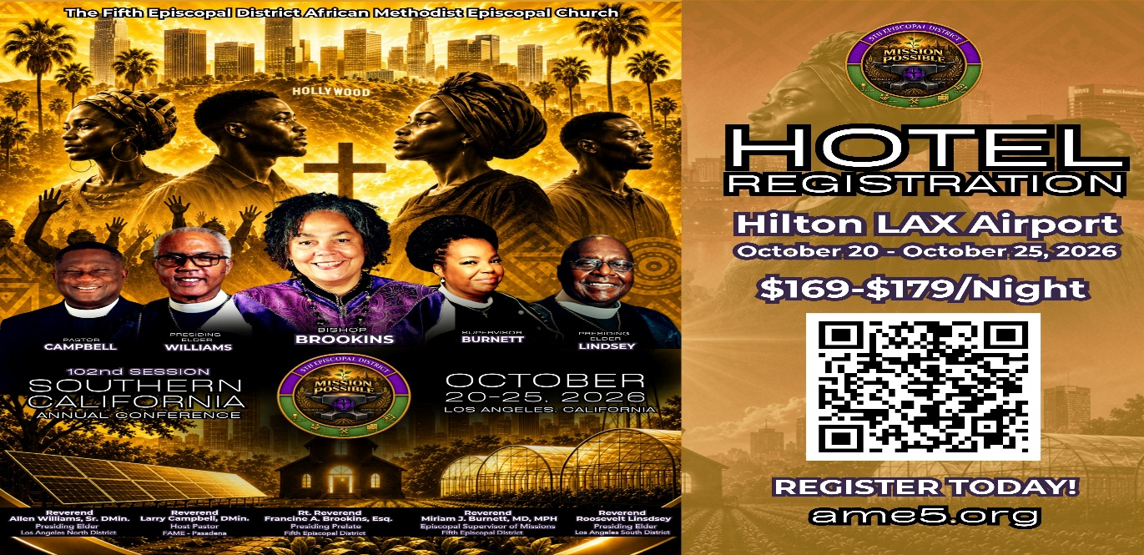

-11-

ANNOUNCEMENTS (Continued)

CALLING ALL VENDORS!
Showcase Your Business to 1,500+ Conference Attendees
First A.M.E. Church, Pasadena is honored to host the 102nd Session of the Southern California Annual Conference, October 21–27, 2026, at the Hilton Los Angeles Airport Hotel, 5711 West Century Boulevard, Los Angeles, CA 90045.
We are inviting business owners, entrepreneurs, vendors, and community partners to showcase and market their products and services to more than 1,500 conference attendees!

VENDOR BOOTH RATES
$500 for the entire week
$150 per day
Each pre-assigned booth includes one six-foot table with linen and two chairs. Vendors may purchase additional booth spaces if needed.
Setup: Tuesday, October 20, beginning at 7:00 a.m.
Vendor Hours: 8:00 a.m. through approximately 10:00 p.m. daily
Application & Payment Deadline: October 9, 2026
Space is limited and will be assigned on a first-come, first-served basis. All rental fees are non-refundable. Vendors are responsible for securing their merchandise. First A.M.E. Church, Pasadena, the Southern California Annual Conference, and the Hilton Los Angeles Airport Hotel are not responsible for lost, stolen, or damaged merchandise. Vendors are also invited to advertise in the Electronic Conference Program by providing a postcard or business card.

RESERVE YOUR SPACE TODAY!
For applications or additional information, contact:
Joann Forté-Wormley, Vendor Chairperson: (818) 434-4140
FAME Family: If you know a business owner, entrepreneur, artist, author, retailer, or community vendor who would benefit from this opportunity, please share this announcement and encourage them to participate!

THE STATE OF THE BLACK COMMUNITY: PASADENA & ALTADENA
The Black Clergy & Civic Alliance (BCCA) invites the community to the inaugural State of the Black Community: Pasadena & Altadena on Saturday, September 26, 2026, from 9:00 a.m.–3:00 p.m. at First AME Church, Pasadena, 1700 N. Raymond Avenue.

The Main Program will be held from 10:00 a.m.–12:30 p.m. and will feature Congresswoman Maxine Waters as Keynote Speaker, with Dr. Yolanda Gorman serving as Master of Ceremonies. Community leaders will engage important issues affecting the Black community, including wealth, faith, housing, health equity, education, public policy, and Eaton Fire recovery.

The day will also feature Black art, community exhibits, nonprofits, civic organizations, and businesses. RSVP is requested for the Main Program.
Come be in the room. Be part of the conversation. Be part of the solution.

-12-

Prayer Request(s)
Please notify the Church Office of Sick & Shut-in additions, deletions, or status/address changes.

Bishop Francine A. Brookins, Esq. Supervisor Miriam Burnett, MD Presiding Elder Roosevelt & Dr. Kaye Lindsey Rev. Dr. Larry & Melinda Campbell Richard Craig Hazel Clark Erica Woodard Jason Shirley Joshua Shirley Julian Shirley Ayanna Terry Cheryl Jamerson Gwendolyn Flowers Andrea Anderson Ocilda Files Danielle Clark Rev. Charles Brooks Kimberly Woods Cynithia Grace Calle Burns Noel Johnson The Taylor Family
Zechariah Robinson Christopher McCarthy Wilma Haynes Jacquelyn Walker Brittney Petty Selene Cox Deborah Burton Nettie McChristen The Caple Family Mel Beech Michael Dotson
Rev. Rochelle Moore Lorene Butler Stella Pulliam Collette Blizzard The Eaton Canyon Fire Victims

College Students

Let’s continue to support and pray for our beloved College Students

Isaiah Crowell Alecia Davis Chase Johnson Grant Blizzard Gabriel Blizzard

Tyler Johnson Richard Jones Tyrikk Lawson Makia Rose Talbert Isaiah Ringo Journey Rogers Elyse Sharp Kylee Sharp Zion Otano Elise Tervalon Grace Jones Jordan Patterson Kimberly Robinson Donovan Williams Jasmine Collins Brandon Bates

Sick and Shut-Ins
Andrew Oliver 1405 N. Roosevelt Avenue, Pasadena, CA 91104
Barbara Buchanan 616 Rio Grande St. Pasadena, CA 91104
Bettina Ayers Pasadena Meadows Nursing Home, 150 Bellefontaine St., Pas., CA 91105
Betty Betts Turner 1625 S. Magnolia Ave., Unit 4125, Monrovia, CA 91016
Bobby Thomas 1052 E. Morada Place, Altadena, CA 91001
Diane Jordan 1719 Fremont Ave., #302, S. Pasadena, CA 91030
Donita Towler 14148 Francisquito Ave., Baldwin Park, CA 91706
Doris Curd 11619 Woodcock Avenue, San Fernando, CA 91340
Edmund Riddle Active Care Mission Bay, 2440 Grand Avenue, San Diego, CA 92109
Eleanor Towler 975 E. Union Street, Unit #417, Pasadena, CA 91106
Elois Blizzard P. O. Box 3646, So. Pasadena, CA 91031
Emily Cormier-Ross 2549 La Fiesta Avenue, Altadena, CA 91001
Ernestine English 26 W. Fair Oaks Drive, Pasadena, CA 91103
Fred Caple 51 North 15th Street, Haledon, NJ 07508
Hugh Hamberry 19225 Chole Rd., Apple Valley, CA 92307
Jessie Smith 3925 S. Jones Blvd., Apt. 2118, Las Vegas, NV 89103| Spring Valley Community
Josephine Brown 15607 Saddleback Rd., Riverside, CA 92506
Lenora Moore 2445 E. Del Mar Blvd., #338, Pasadena, CA 91107
Linnie G. Nollie 2250 E. New York Drive, Altadena, CA 91001
Malika G. Hendry P. O. Box 94082, Pasadena, CA 91109
Mildred Lewis C/O Hazel Rohr, 884 W. Jane Court, Upland, CA 91786
Norma Burnett 618 Fairview Avenue, Unit #228, Arcadia, CA 91007
Opal Hampton 1030 Chevron Court, Pasadena, CA 91103
Paul Ratliff P.O. Box 40407, Pasadena, CA 91114
Virlyn Grant 15122 Orange Ave., Paramount, CA 90723
Wanda Nelson 3618 N. Fair Oaks Avenue, Altadena, CA 91001
William Hilliard 7504 Wynstone Pl., Fontana, CA 92336
Zell L. Hill 375 Barthe Drive, Pasadena, CA 91103

-13-

Sermon Notations

Scripture: _____________________________________________________________

Subject: _______________________________________________________________

Points of the Message: ___________________________________________________
_______________________________________________________________________
_______________________________________________________________________
_______________________________________________________________________
_______________________________________________________________________
_______________________________________________________________________
_______________________________________________________________________

Main Ideas of the Sermon: ________________________________________________
_______________________________________________________________________
_______________________________________________________________________
_______________________________________________________________________
_______________________________________________________________________
_______________________________________________________________________

Illustrations I want to remember: _________________________________________
_______________________________________________________________________
_______________________________________________________________________
_______________________________________________________________________
_______________________________________________________________________
_______________________________________________________________________
_______________________________________________________________________

What should I do as a result of this Sermon? ________________________________

_____________________________________________________
_____________________________________________________
_____________________________________________________
_____________________________________________________

-14-

