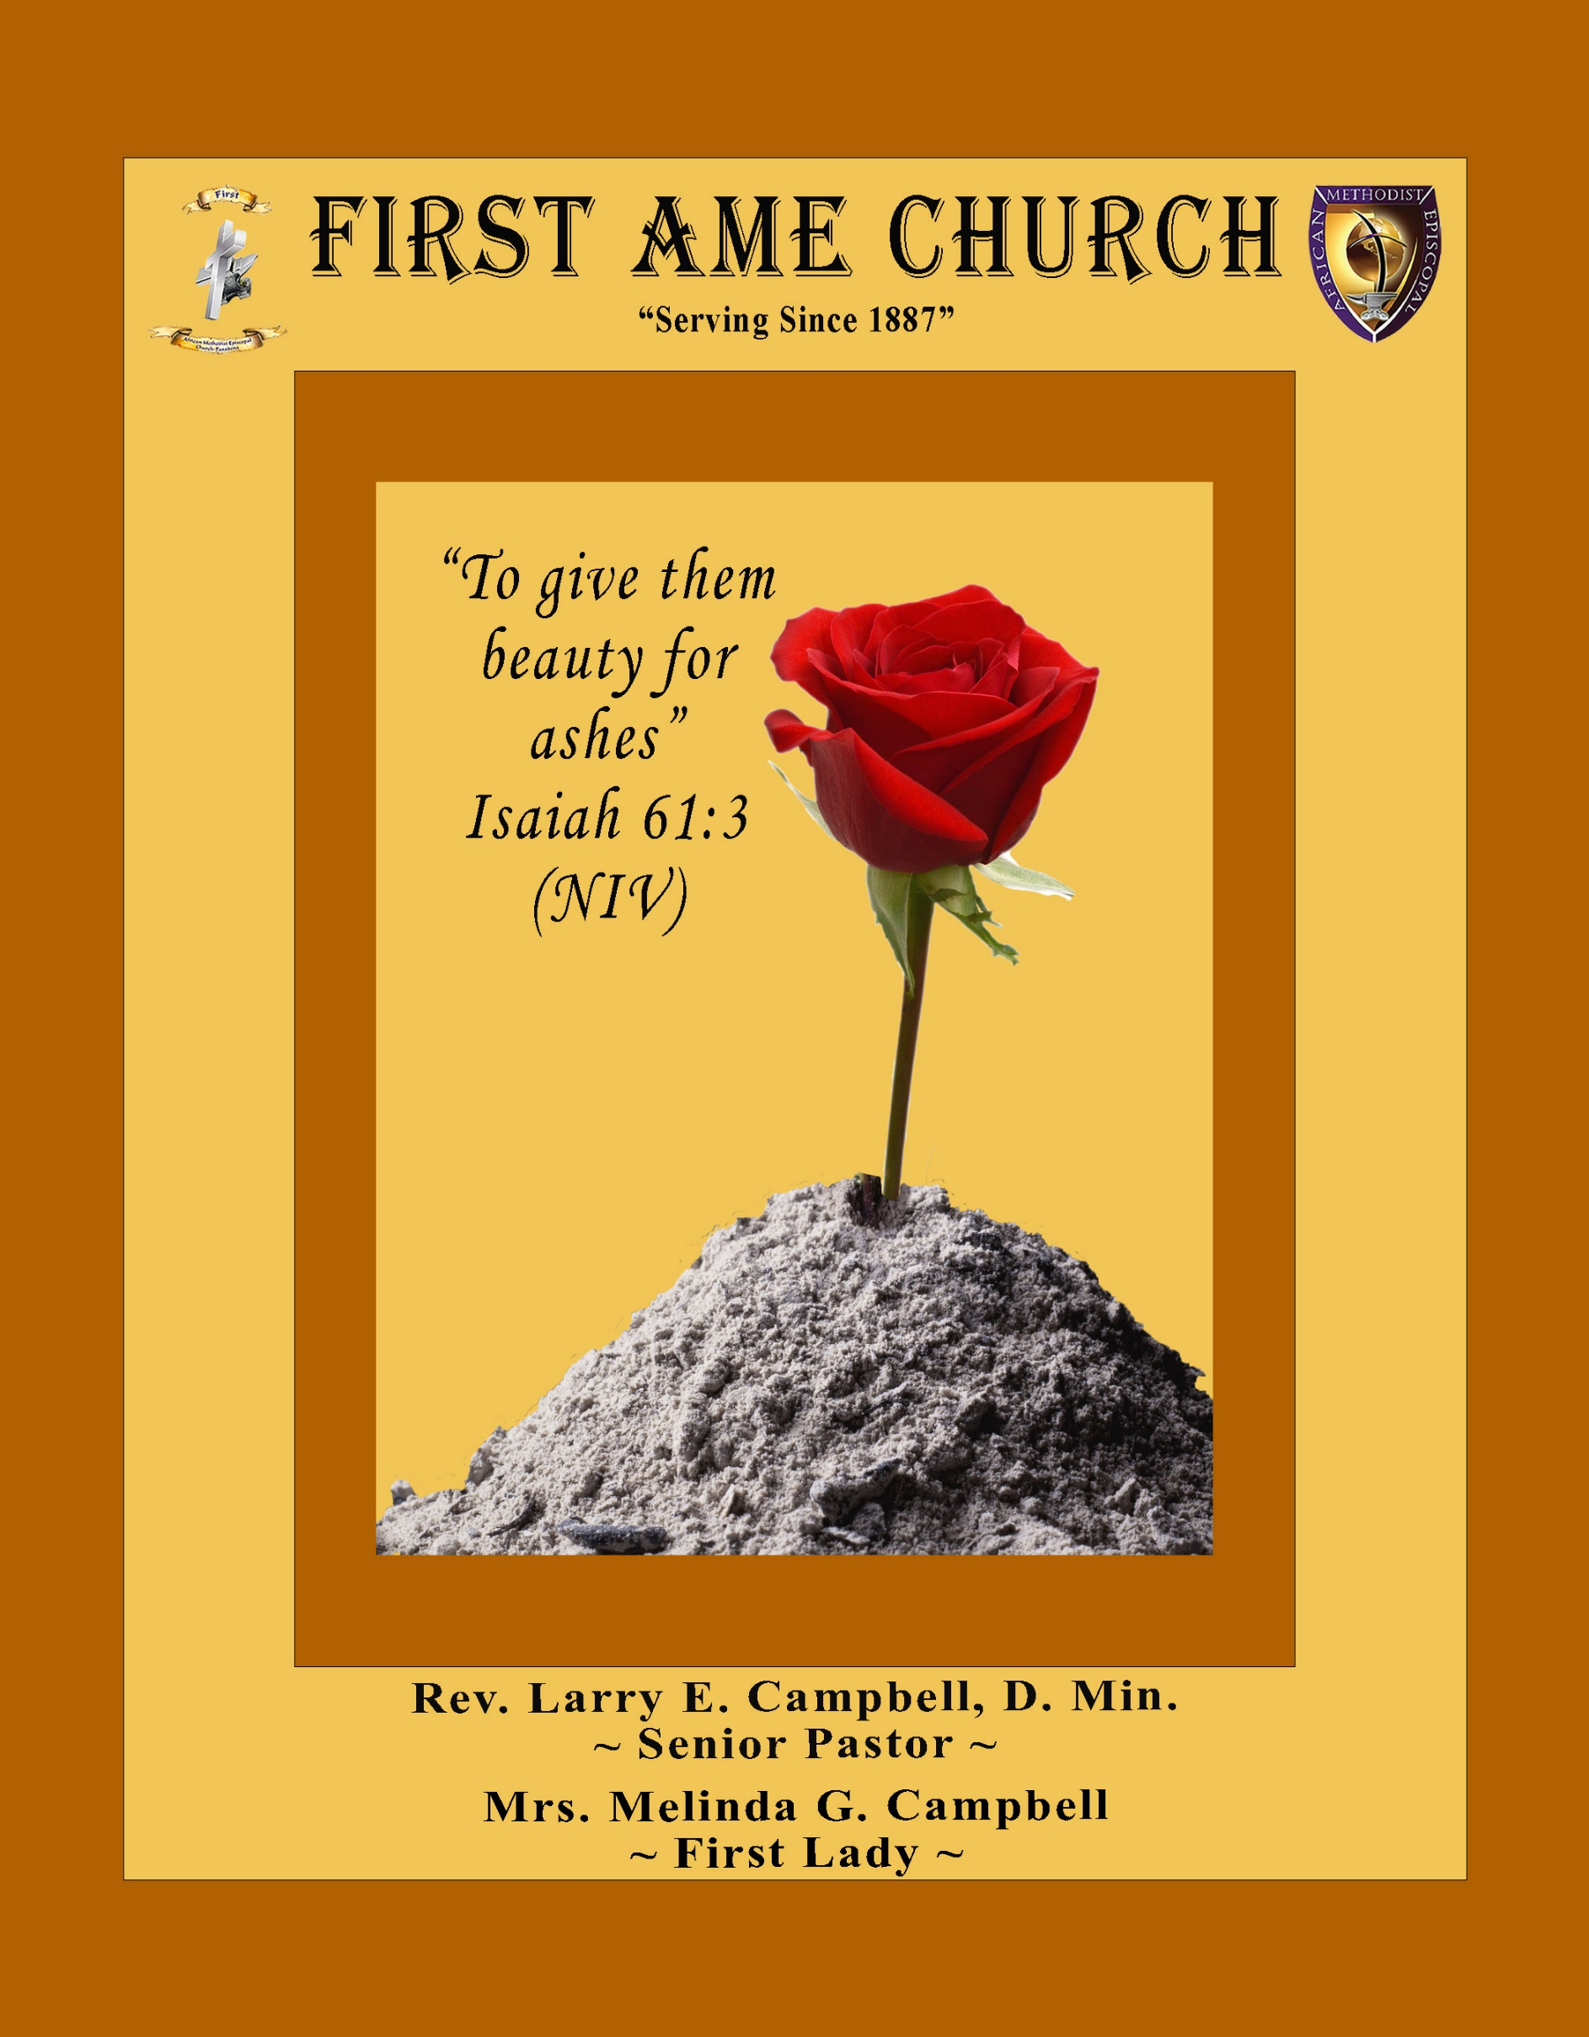
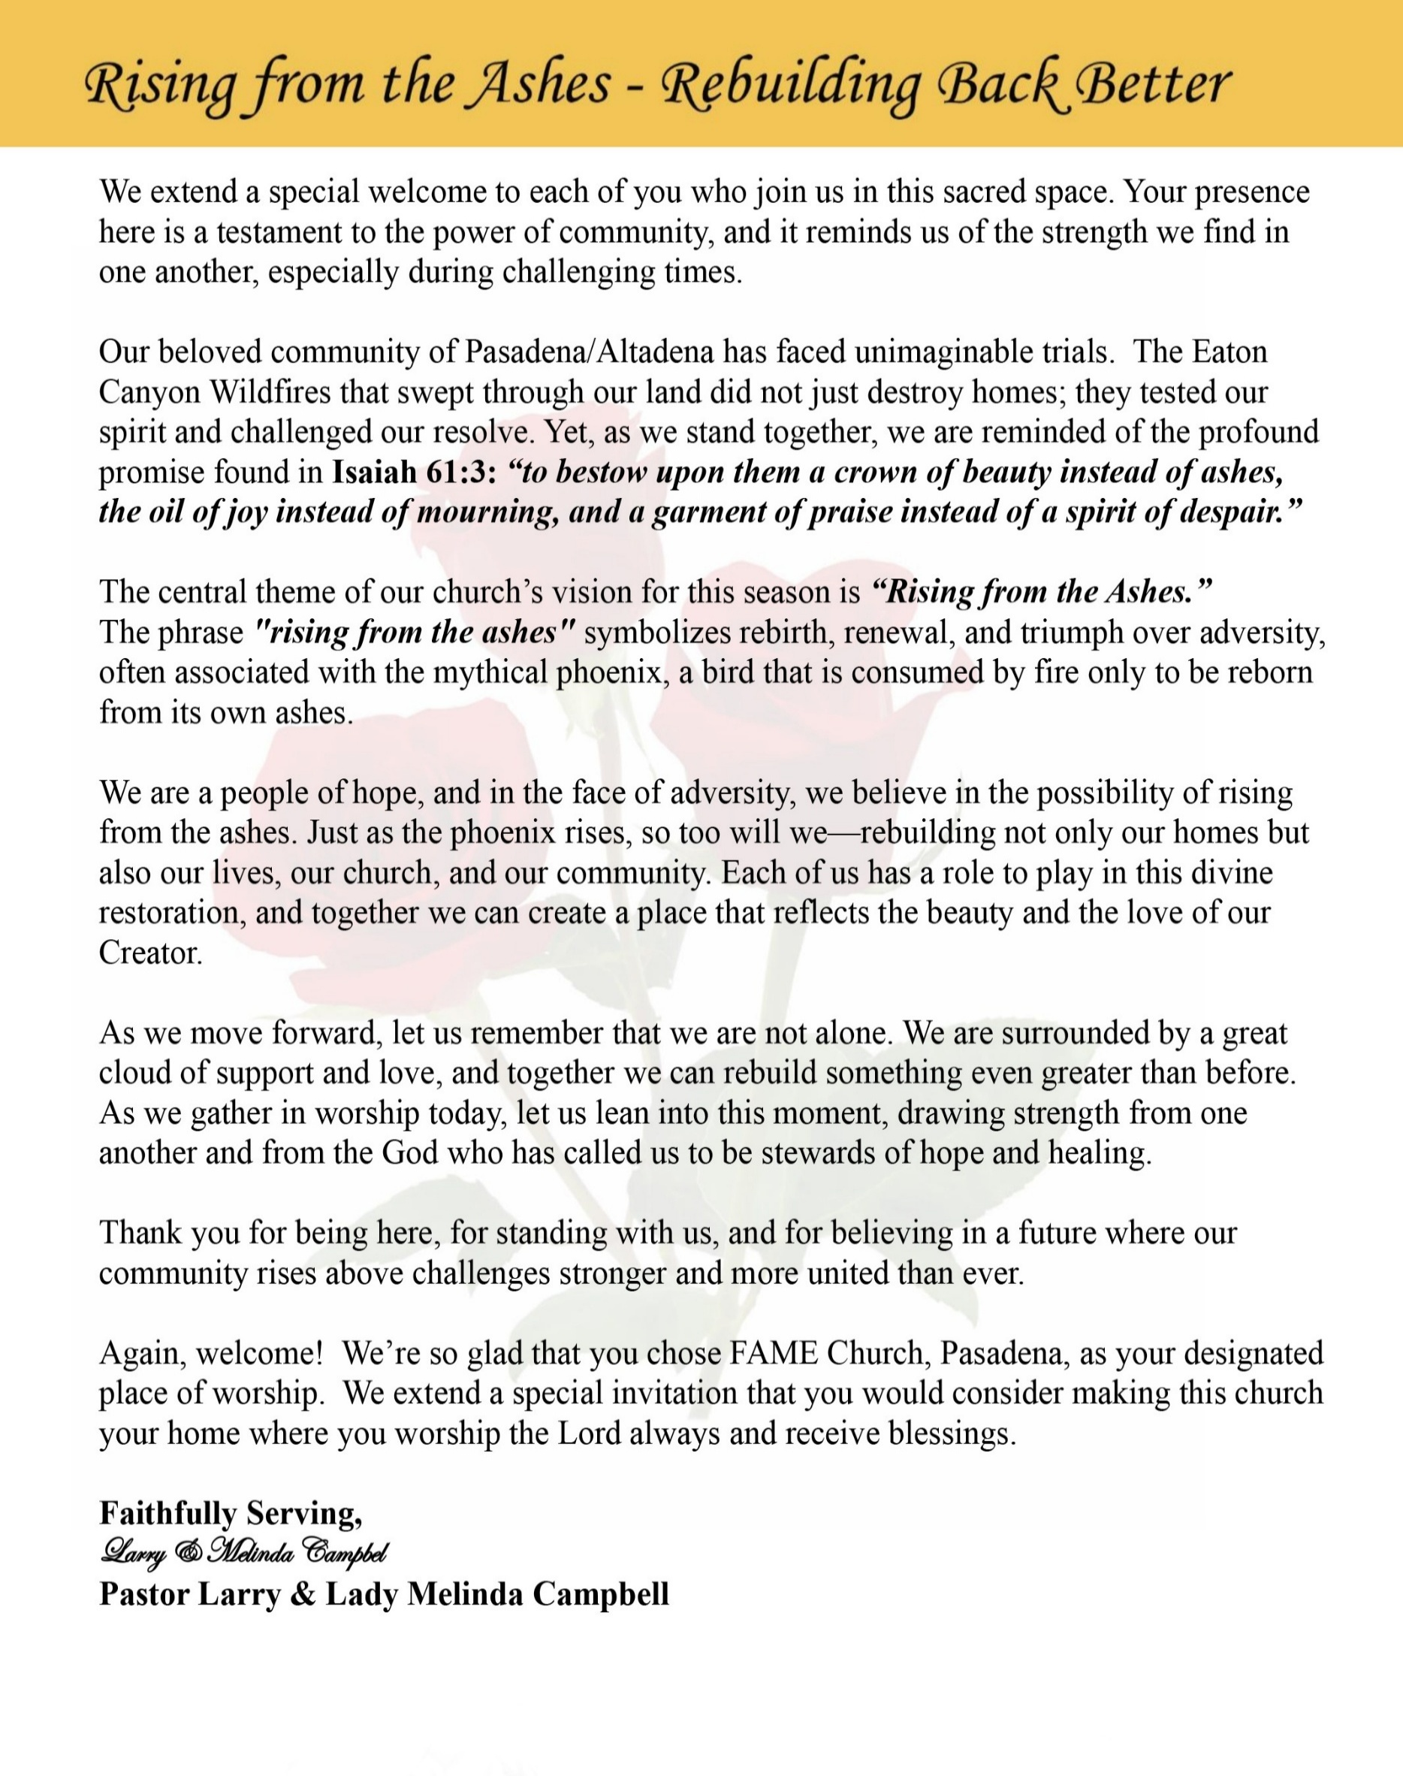

Sunday, September 20, 2026 | 9:30 a.m.

Rt. Rev. Francine A. Brookins, Esq., Presiding Bishop
Rev. Miriam Burnett, MD, MPH, Supervisor of Missions
Rev. Roosevelt Lindsey, Jr. Presiding Elder

The Rev. Dr. Larry E. Campbell ~ Senior Pastor ~ Minister

Mobile: (951) 587-1894 ~ Email: larrycampbell@famepasadena.org

Our First Lady: Mrs. Melinda G. Campbell

The Reverend Dr. Jennifer Oliver ~ Itinerant Elder -
The Reverend Dr. Nikia Smith-Robert ~ Itinerant Elder (Affiliated)
The Reverend Lois Woodard ~ Itinerant Elder Superannuated (Retired)
The Reverend Rochelle Wright Moore ~ Itinerant Deacon
The Reverend Deborah West-Jones ~ Local Elder
The Reverend Philis J. Griffin, MDiv ~ Local Elder
Dr. Phyllis Beech ~ Evangelist
Sister Tessie Bonner ~ Deaconess

Community Resource Center Director ~ Ms. Kischchen Hazelton Venerable
Church Administrative Assistant: Ms. Letha Rhymes

Church Office Hours:
Tue - Wed 9:00 am - 5:00 pm, & Fri 9:00 am -3:00 pm.
Closed for Lunch Daily: 12:00 pm - 1:00 pm.

Music Ministry
Dr. Timothy Davis, Minister of Music
Bro. Jimmy Watlington, Percussionist ~ Bro. Carlos Caldwell, Organist
Bro. Darien Dorsey, Keyboardist
Sis. Karen Law, Women’s Chorus Director ~ Sis. Tonia Graham, Children’s Choir Director
Bro. J. Renard Washington, New Generation’s Choir

FREE WI-FI service is available on the FAME Campus by accessing FAME 1700
Password: 6267980503

-3-

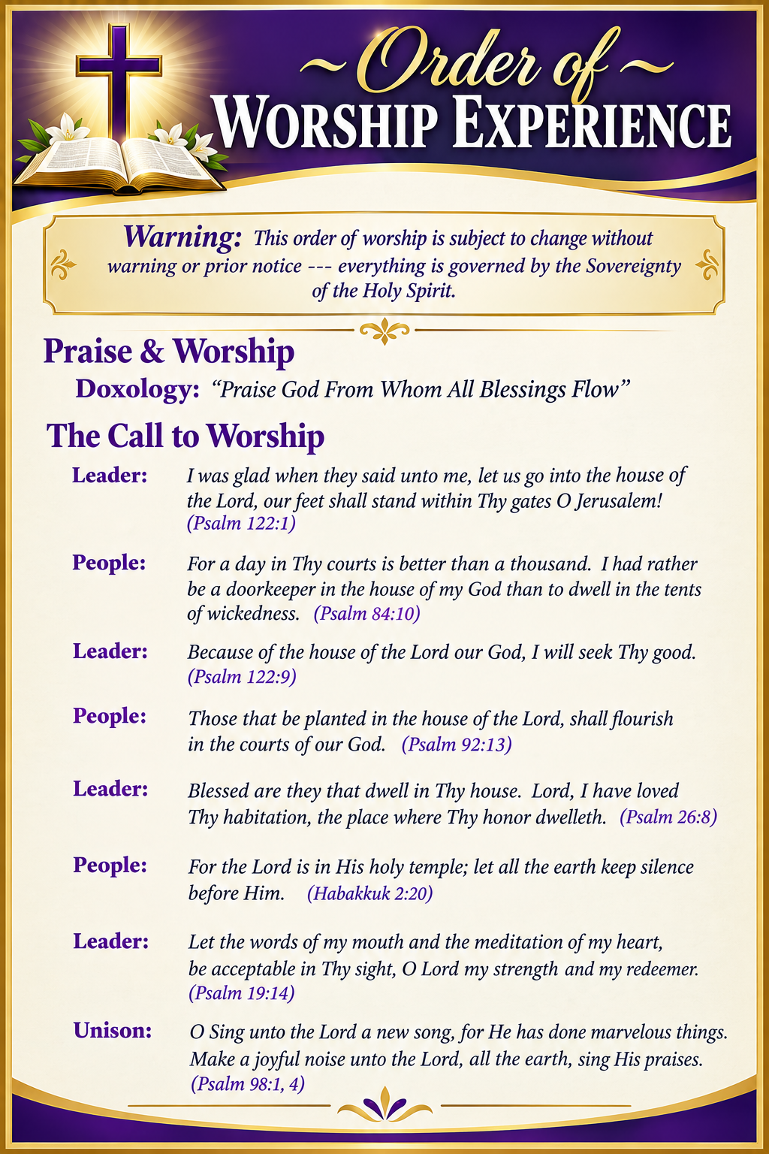
Princess Selah Robert

-4-

The Worship Song of Praise Every Praise
(Repeat Verse 3 times)
Every praise is to our God.
Every word of worship with one accord
Every praise every praise is to our God.
Sing hallelujah to our God
Glory hallelujah is due our God
Every praise every praise is to our God.

(Repeat Chorus 3 times)
God my Savior
God my Healer
God my Deliverer
Yes He is, yes He is

Yes He is, yes He is, yes He is, yes He is
Yes He is, yes He is, yes He is, yes He is

(Repeat Verse 2 times)
Every praise is to our God.
Every word of worship with one accord
Every praise, every praise, every praise, every praise
Every praise, every praise, every praise, every praise
Every praise, every praise, every praise, every praise
All of my worship, every praise,
Every praise, every praise
When you see me dancing, every praise
Every praise, every praise
When you see me shoutin', every praise
Every praise, every praise, every praise, every praise
Every praise, every praise, to our god
Is to our God

Every praise, every praise, I got to praise you, every praise
Every praise, every praise, I got to thank him, every praise
Every praise, every praise, He's been so good, every praise
Every praise, every praise, He's been so kind, every praise
Every praise, every praise, every praise, every praise
Is to our God

The Invocation Master Lester Robert Jr.

Ministry of Music The Praise Team

-5-

Responsive Scripture Lesson — Standing Firm in Faith Miss Nia Robert
(Please Stand for the Reading of God’s Words)

Leader: “But Daniel purposed in his heart that he would not defile himself...” — Daniel 1:8

People: Lord, settle our hearts and strengthen us to remain faithful when our convictions are
tested.

Leader: “Buy the truth, and sell it not; also wisdom, and instruction, and understanding.”
— Proverbs 23:23

People: Teach us to treasure truth, seek wisdom, and walk with integrity.

Leader: “We ought to obey God rather than men.” — Acts 5:29

People: Give us courage to obey Your Word, even when obedience is difficult.

Leader: “Be not conformed to this world: but be ye transformed by the renewing of your mind...”
— Romans 12:2

People: Renew our minds and keep us from being shaped by values contrary to Your Word.

Leader: “Choose you this day whom ye will serve...but as for me and my house, we will serve the
LORD.” — Joshua 24:15

People: We choose to serve the Lord. Let our choices and our lives reflect our commitment to
You.

Leader: “For what is a man profited, if he shall gain the whole world, and lose his own soul?”
— Matthew 16:26

People: Give us wisdom to value what is eternal above what is temporary.

Leader: “Watch ye, stand fast in the faith...be strong.” — 1 Corinthians 16:13

People: Strengthen us to stand firm, remain faithful, and demonstrate courage when our
convictions are challenged.

Leader: “To him that knoweth to do good, and doeth it not, to him it is sin.” — James 4:17

People: Give us courage not only to know what is right, but to do what is right.

Leader: People of God, what shall guide our lives?

People: THE WORD OF GOD AND THE LEADING OF THE HOLY SPIRIT!

Leader: How shall we respond when our faith is challenged?

People: WE WILL STAND FAST IN THE FAITH AND BE STRONG IN THE LORD!

Leader: How shall we live before God and one another?

People: WE WILL SEEK JUSTICE, LOVE MERCY, WALK HUMBLY, SPEAK TRUTH,
AND LIVE WITH INTEGRITY!

Leader: May God give us wisdom to discern, courage to stand, and faith to remain steadfast.

ALL: LORD, ORDER OUR STEPS, GUARD OUR HEARTS, RENEW OUR MINDS, AND
LET OUR LIVES HONOR YOU. AMEN.

-6-

The Summary of the Decalogue Princess Scholar Jeffery
LEADER: From all that dwell below the skies…
SUNG: From all that dwell below the skies, Let the Creator’s praise arise; Let the
Redeemer’s Name be sung, through every land, by every tongue.
LEADER: Hear what Christ our Savior saith, Thou shalt love the Lord thy God with all thy
heart, with all thy soul, and with all thy mind. This is the first and great
commandment. And the second is like unto it: Thou shalt love thy neighbor
as thyself. On these two commandments hang all the law and the prophets.
SUNG: Glory be to the Father, and to the Son, and to the Holy Ghost; as it was in
the beginning, is now, and ever shall be, world without end. A~Men

Abbreviated Announcements/Visitor’s Welcome

K-FAME - Radio
Announcements
Sharing the Updated, Progress and Successes of our Children & Youth



Special Congregational Hymn (Sing along)
Hymn #347— I’m Pressing on the Upward Way

-7-

The Offertory (Tithes ~ Gifts ~ Benevolent Offerings) Bro. Bill Matlock

The following Electronic GIVING Platforms are creditable methods to GIVE to FAME:

#1. GIVELIFY - Mobile Giving App available on the App Store. It’s easy to set up, just follow the guidelines.

#2. Cash App: $FirstAMEPASADENA

#3. Mail in your Tithes & Offering - If you would like to mail your tithes and offering by check or money order, please send it to: First AME Church, 1700 N. Raymond Avenue, Pasadena, CA 91103.

#4. Drop off your Tithes & Offering - During business hours in the basket outside of the office.

Choral Response: “All things come of Thee, O Lord; and of Thine own have we given Thee. Amen.”

Sermonic Selection The Praise Team

Proclamation of The Word Pastor Larry E. Campbell

The Invitation (Public/Private)

How to Join First A.M.E. Church of Pasadena
PROFESSION OF FAITH. If you have never been a member of any church, you may join by professing Jesus Christ as your personal Lord and Savior.

RENEWAL OF VOWS. If you have been a member of a church at one time, but have been in active, you may join by renewing your faith in Jesus Christ as Lord and Savior.

TRANSFER. If you are a member of another African Methodist Episcopal Church and you are in good standing, you may join by requesting that your membership be transferred to the First African Methodist Episcopal Church of Pasadena.

AFFILIATE MEMBER. Sometimes an individual has reasons for keeping /his/her membership in another church but would like to be an active member of First African Methodist Episcopal Church, too. This is possible as an affiliate member. ______________________________________________________________________________________________________________

The Doxology

The Benediction

-8-

Scripture of the Day
Moral Convictions. "Buy the truth and do not sell it — wisdom, instruction and insight as well.” — Proverbs 23:23
Quote of the Day
“I would unite with anybody to do right and with nobody to do wrong.”
— Frederick Douglass."
Thought of the Week
“But Daniel purposed in his heart that he would not defile himself...” — Daniel 1:8 (KJV)
Daniel teaches us an important lesson about moral conviction: Decide what you will stand for before the pressure comes.
Daniel was living in Babylon, surrounded by a culture that challenged his faith and pressured him to compromise. Yet Scripture says Daniel had already “purposed in his heart.” His conviction was settled before his faith was tested.
That is the power of conviction. If we wait until temptation comes, pressure rises, or an attractive offer is placed before us to decide what we believe, compromise becomes easier.
There are some things we should settle in our hearts beforehand: I will tell the truth. I will maintain my integrity. I will treat people justly. I will remain faithful to God. I will do what is right—even when doing right costs me something.
Conviction is not merely knowing what is right; it is deciding beforehand that pressure will not change what you know is right.
Something to Think About
What have you already “purposed in your heart” that you will not compromise?
Humor of the Week
A son took his father to a restaurant to enjoy a delicious dinner. His father was quite old and therefore a little weak too. While eating, food occasionally fell on his shirt and pants. The other guests watched the old man with their faces contorted in disgust, but his son remained calm.
After they both finished eating, the son, quietly helped his father and took him to the toilet. Cleaned food scraps from his crumpled face and attempted to wash food stains from his clothes; graciously combed his gray hair and finally put on his glasses.
As he left the bathroom, a deep silence reigned in the restaurant. The son was ready to foot the bill, but before leaving, a man, also old, got up and asked the old man's son: 'Don't you think you left something here? '
The young man replied: 'No, I did not leave anything.' Then the stranger said to him: 'You left a lesson here for every son, and a hope for every father!” The whole restaurant was so quiet, you could hear a pin drop.
One of the greatest honors that exist is being able to take care of those who have taken care of us too. Our parents and all those elders who sacrificed their lives, with all their time, money and effort for us, deserve our utmost respect.””
HOME DAILY BIBLE READINGS
September 21, 2026 – September 27, 2026 (Week 53, Revelation)
Monday Bonus Day 1 Psalm 119:1-24
Tuesday Bonus Day 2 Psalm 119:25-48
Wednesday Bonus Day 3 Psalm 119:49-72
Thursday Bonus Day 4 Psalm 119:73-96
Friday Bonus Day 5 Psalm 119:97-120
Saturday Bonus Day 6 Psalm 119:121-144
Sunday Bonus Day 7 Psalm 119:145-176

-9-

ANNOUNCEMENTS

Updating FAME-Pasadena Membership Directory

FAME is updating each household/member’s contact information. We are asking all households to complete a Google Form. Completing the form ensures your contact information is current.
Starting in October, volunteers will be available in the Fellowship Hall on first Sundays to assist families in completing form.


You have four options to complete the Google form:
Complete Google Form on-line. Use the QR code.
Request an internet link to access the form.
Complete a paper form, and then drop it off to the office.
Schedule an Interview to get assistance in completing the form,

If you experience any issues with completing this form, please text or email Sharon Sharp, 626-840-7374, sharon_s91104@yahoo.com. Thank you for supporting this project.

THE STATE OF THE BLACK COMMUNITY: PASADENA & ALTADENA
The Black Clergy & Civic Alliance (BCCA) invites the community to the inaugural State of the Black Community: Pasadena & Altadena on Saturday, September 26, 2026, from 9:00 a.m.–3:00 p.m. at First AME Church, Pasadena, 1700 N. Raymond Avenue.
The Main Program will be held from 10:00 a.m.–12:30 p.m. and will feature Congresswoman Maxine Waters as Keynote Speaker, with Dr. Yolanda Gorman serving as Master of Ceremonies. Community leaders will engage important issues affecting the Black community, including wealth, faith, housing, health equity, education, public policy, and Eaton Fire recovery.
The day will also feature Black art, community exhibits, nonprofits, civic organizations, and businesses. RSVP is requested for the Main Program.
Come be in the room. Be part of the conversation. Be part of the solution

Virtual Official Board Meeting
Tuesday, September 29, 2026 | 6:00 P.M.

Everyone is encouraged to join our weekly Christian Education Sessions

VIRTUAL ADULT CHURCH SCHOOL
Sunday Mornings at 8:00 a.m.
http://us02web.zoom.us/j/844840183?pwd-sm0w1yvmvhOvC13175urZ2vr7M3EtU.1

HYBRID PASTOR’S WEEKLY BIBLE STUDY
Wednesdays at 11:00 a.m.
https://us02web.zoom.us/j/84484840183?pwd=sm0w1yvmvhOvC13l75urZ2vr7M3EtU.1
Meeting ID: 844 8484 0183 | Passcode: 357260
WEEKLY TELECONFERENCE PRAYERS SESSIONS
Wednesdays at 5:30 a.m. and 6:00 p.m.
Conference Call Number: (530_ 881-1212
Access Code: 234575160#

-10-

ANNOUNCEMENTS (Continued)

Digital Souvenir Journal
The 102nd Session of the Southern California Annual Conference is preparing a special Digital Souvenir Journal, and FAME Pasadena members, families, businesses, and community partners are invited to participate!
Help make this commemorative journal a success by purchasing an ad or encouraging a local business, store, restaurant, vendor, organization, or community partner to place an AD.
This is a wonderful opportunity to highlight your business or organization, promote a ministry or special event, or extend congratulations and greetings to the Southern California Conference.
Two advertising options are available:
Single-Page Digital Ad or 30-Second Video Message
FAME Family, we need your help! Consider purchasing an ad personally, sponsoring an ad through your ministry, or asking a business you regularly support to advertise in the journal. Let’s support those who support our community!
For advertising information, please contact:
Rev. Van Edward White: (540) 842-1738
Dr. Paul-Jahi Price: (626) 823-5004
Email: scc2026ads@gmail.com
Thank you for helping us celebrate and support the 102nd Session of the Southern California Annual Conference!

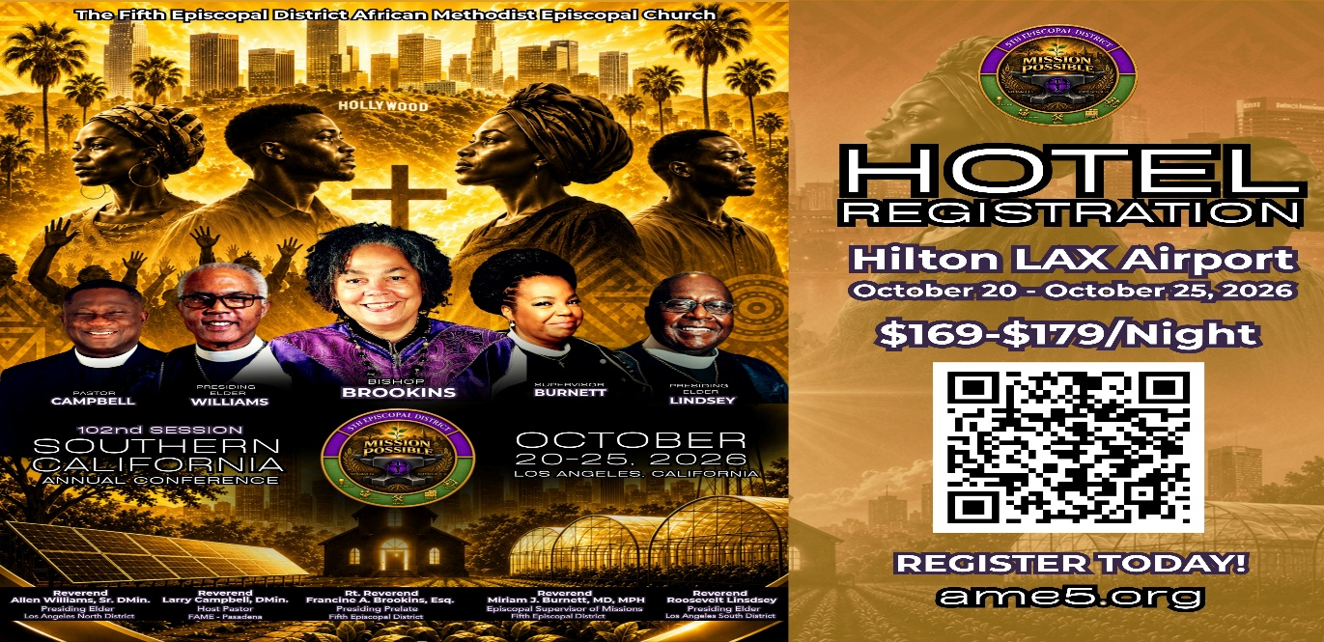

-11-

ANNOUNCEMENTS (Continued)

CALLING ALL VENDORS!
Showcase Your Business to 1,500+ Conference Attendees
First A.M.E. Church, Pasadena is honored to host the 102nd Session of the Southern California Annual Conference, October 21–27, 2026, at the Hilton Los Angeles Airport Hotel, 5711 West Century Boulevard, Los Angeles, CA 90045.
We are inviting business owners, entrepreneurs, vendors, and community partners to showcase and market their products and services to more than 1,500 conference attendees!

VENDOR BOOTH RATES
$500 for the entire week
$150 per day
Each pre-assigned booth includes one six-foot table with linen and two chairs. Vendors may purchase additional booth spaces if needed.
Setup: Tuesday, October 20, beginning at 7:00 a.m.
Vendor Hours: 8:00 a.m. through approximately 10:00 p.m. daily
Application & Payment Deadline: October 9, 2026
Space is limited and will be assigned on a first-come, first-served basis. All rental fees are non-refundable. Vendors are responsible for securing their merchandise. First A.M.E. Church, Pasadena, the Southern California Annual Conference, and the Hilton Los Angeles Airport Hotel are not responsible for lost, stolen, or damaged merchandise. Vendors are also invited to advertise in the Electronic Conference Program by providing a postcard or business card.

RESERVE YOUR SPACE TODAY!
For applications or additional information, contact:
Joann Forté-Wormley, Vendor Chairperson: (818) 434-4140
FAME Family: If you know a business owner, entrepreneur, artist, author, retailer, or community vendor who would benefit from this opportunity, please share this announcement and encourage them to participate!

Women's Ministry – BIBLE STUDY
Time: Tuesday, October 13, 2026 | 6:00 p.m.
Meeting ID: 857 0061 9461; Passcode: 933892
One tap mobile +16699006833,,85700619461#,,,,,,0#,,933892# US (San Jose)

Men's Ministry - BIBLE STUDY
Time: Tuesday, October 13, 2026 | 6:00 p.m.
Meeting ID: 894 7536 6487 | Passcode: 465177
One tap mobile: +16699006833,,89475366487#,,,,*465177# US (San Jose)

-12-

Prayer Request(s)
Please notify the Church Office of Sick & Shut-in additions, deletions, or status/address changes.

Bishop Francine A. Brookins, Esq. Supervisor Miriam Burnett, MD Presiding Elder Roosevelt & Dr. Kaye Lindsey Rev. Dr. Larry & Melinda Campbell Richard Craig Hazel Clark Erica Woodard Jason Shirley Joshua Shirley Julian Shirley Ayanna Terry Cheryl Jamerson Gwendolyn Flowers Andrea Anderson Ocilda Files Danielle Clark Rev. Charles Brooks Kimberly Woods Cynithia Grace Calle Burns Noel Johnson The Taylor Family
Zechariah Robinson Christopher McCarthy Wilma Haynes Jacquelyn Walker Brittney Petty Selene Cox Deborah Burton Nettie McChristen The Caple Family Mel Beech Michael Dotson
Rev. Rochelle Moore Lorene Butler Stella Pulliam Collette Blizzard The Eaton Canyon Fire Victims

College Students

Let’s continue to support and pray for our beloved College Students

Isaiah Crowell Alecia Davis Chase Johnson Grant Blizzard Gabriel Blizzard

Tyler Johnson Richard Jones Tyrikk Lawson Makia Rose Talbert Isaiah Ringo Journey Rogers Elyse Sharp Kylee Sharp Zion Otano Elise Tervalon Grace Jones Jordan Patterson Kimberly Robinson Donovan Williams Jasmine Collins Brandon Bates

Sick and Shut-Ins
Andrew Oliver 1405 N. Roosevelt Avenue, Pasadena, CA 91104
Barbara Buchanan 616 Rio Grande St. Pasadena, CA 91104
Bettina Ayers Pasadena Meadows Nursing Home, 150 Bellefontaine St., Pas., CA 91105
Betty Betts Turner 1625 S. Magnolia Ave., Unit 4125, Monrovia, CA 91016
Bobby Thomas 1052 E. Morada Place, Altadena, CA 91001
Diane Jordan 1719 Fremont Ave., #302, S. Pasadena, CA 91030
Donita Towler 14148 Francisquito Ave., Baldwin Park, CA 91706
Doris Curd 11619 Woodcock Avenue, San Fernando, CA 91340
Edmund Riddle Active Care Mission Bay, 2440 Grand Avenue, San Diego, CA 92109
Eleanor Towler 975 E. Union Street, Unit #417, Pasadena, CA 91106
Elois Blizzard P. O. Box 3646, So. Pasadena, CA 91031
Emily Cormier-Ross 2549 La Fiesta Avenue, Altadena, CA 91001
Ernestine English 26 W. Fair Oaks Drive, Pasadena, CA 91103
Fred Caple 51 North 15th Street, Haledon, NJ 07508
Hugh Hamberry 19225 Chole Rd., Apple Valley, CA 92307
Jessie Smith 3925 S. Jones Blvd., Apt. 2118, Las Vegas, NV 89103| Spring Valley Community
Josephine Brown 15607 Saddleback Rd., Riverside, CA 92506
Lenora Moore 2445 E. Del Mar Blvd., #338, Pasadena, CA 91107
Linnie G. Nollie 2250 E. New York Drive, Altadena, CA 91001
Malika G. Hendry P. O. Box 94082, Pasadena, CA 91109
Mildred Lewis C/O Hazel Rohr, 884 W. Jane Court, Upland, CA 91786
Norma Burnett 618 Fairview Avenue, Unit #228, Arcadia, CA 91007
Opal Hampton 1030 Chevron Court, Pasadena, CA 91103
Paul Ratliff P.O. Box 40407, Pasadena, CA 91114
Virlyn Grant 15122 Orange Ave., Paramount, CA 90723
Wanda Nelson 3618 N. Fair Oaks Avenue, Altadena, CA 91001
William Hilliard 7504 Wynstone Pl., Fontana, CA 92336
Zell L. Hill 375 Barthe Drive, Pasadena, CA 91103

-13-

Sermon Notations

Scripture: _____________________________________________________________

Subject: _______________________________________________________________

Points of the Message: ___________________________________________________
_______________________________________________________________________
_______________________________________________________________________
_______________________________________________________________________
_______________________________________________________________________
_______________________________________________________________________
_______________________________________________________________________

Main Ideas of the Sermon: ________________________________________________
_______________________________________________________________________
_______________________________________________________________________
_______________________________________________________________________
_______________________________________________________________________
_______________________________________________________________________

Illustrations I want to remember: _________________________________________
_______________________________________________________________________
_______________________________________________________________________
_______________________________________________________________________
_______________________________________________________________________
_______________________________________________________________________
_______________________________________________________________________

What should I do as a result of this Sermon? ________________________________

_____________________________________________________
_____________________________________________________
_____________________________________________________
_____________________________________________________

-14-

