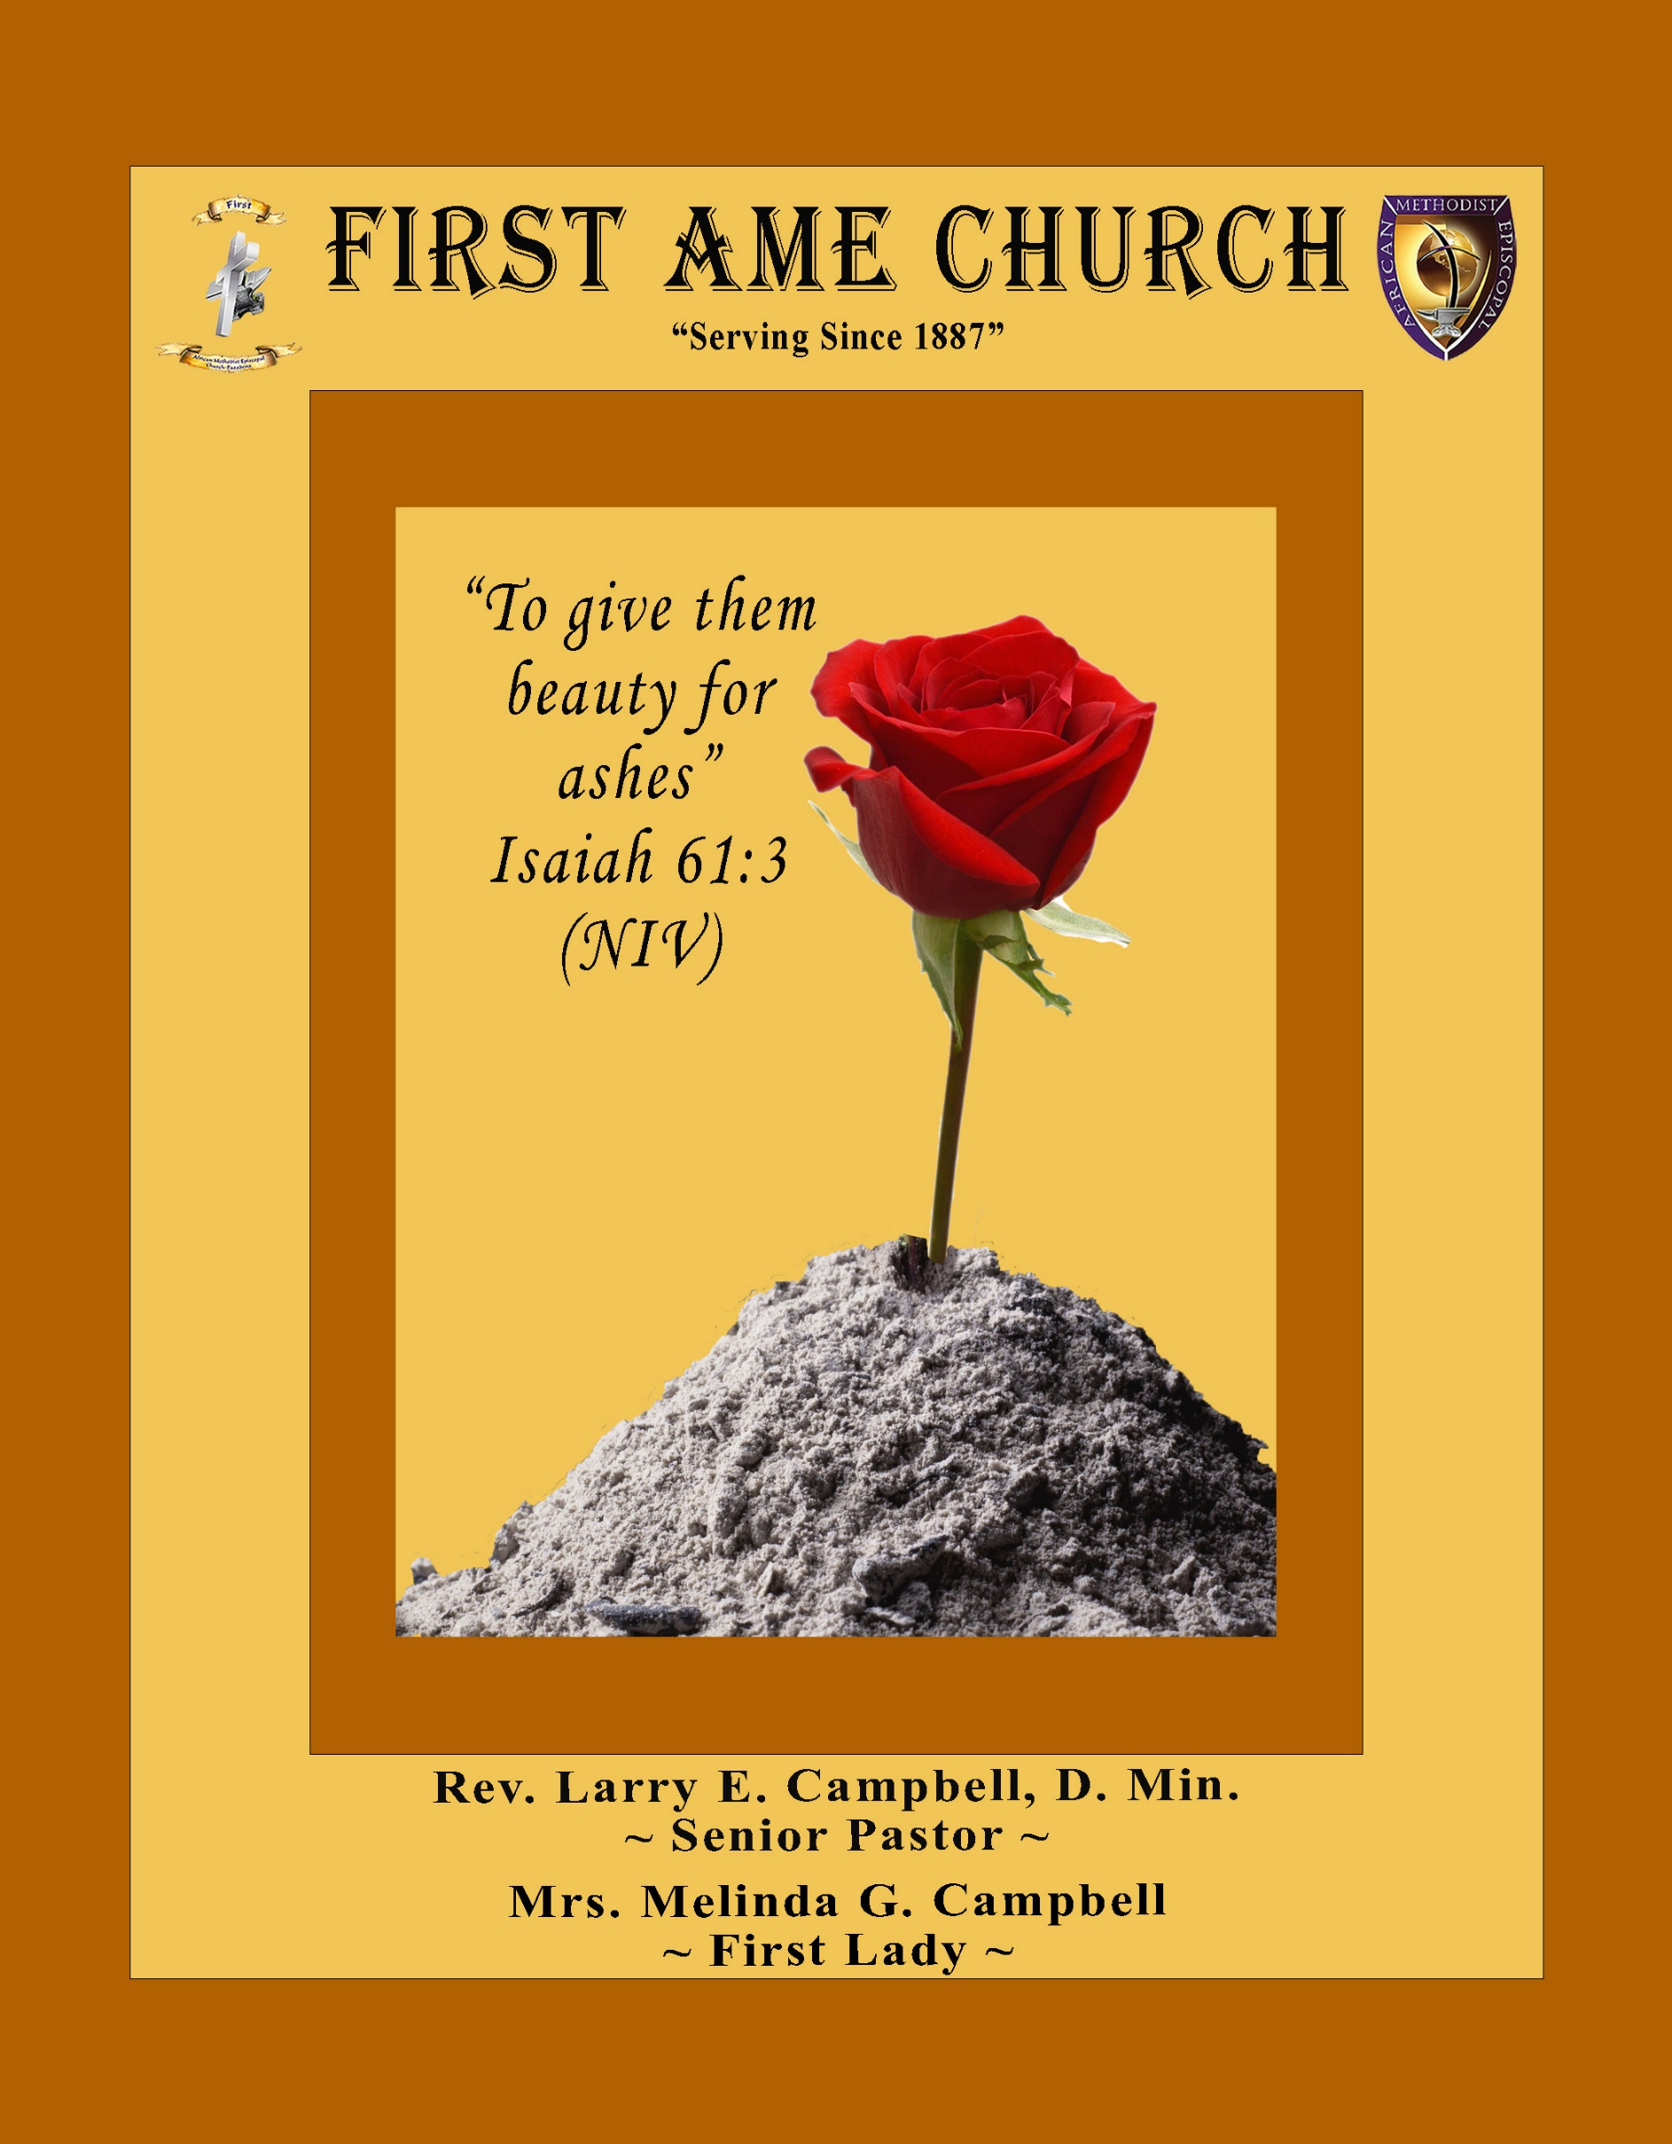
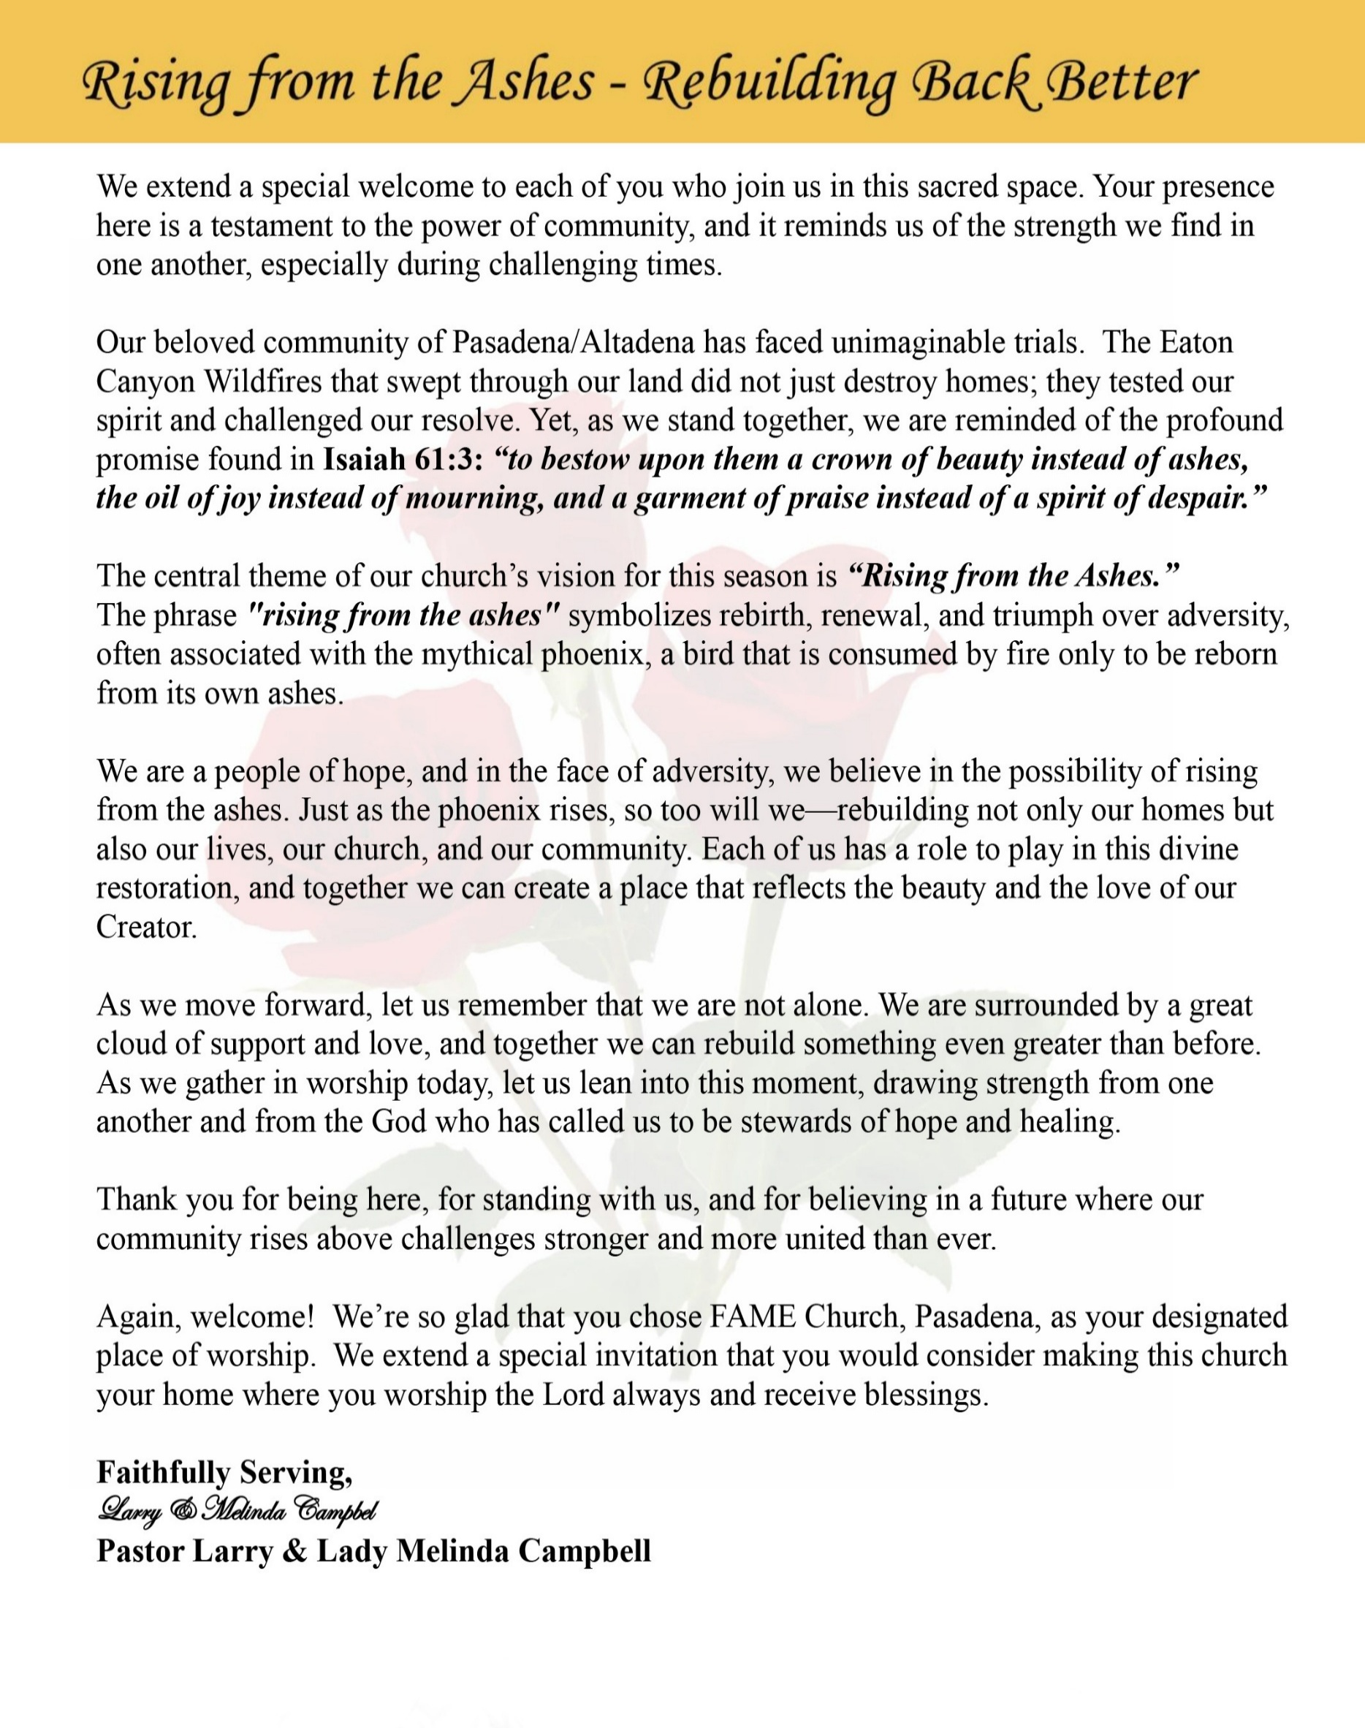

Sunday, September 27, 2026 | 9:30 a.m.

Rt. Rev. Francine A. Brookins, Esq., Presiding Bishop
Rev. Miriam Burnett, MD, MPH, Supervisor of Missions
Rev. Roosevelt Lindsey, Jr. Presiding Elder

The Rev. Dr. Larry E. Campbell ~ Senior Pastor ~ Minister

Mobile: (951) 587-1894 ~ Email: larrycampbell@famepasadena.org

Our First Lady: Mrs. Melinda G. Campbell

The Reverend Dr. Jennifer Oliver ~ Itinerant Elder -
The Reverend Dr. Nikia Smith-Robert ~ Itinerant Elder (Affiliated)
The Reverend Lois Woodard ~ Itinerant Elder Superannuated (Retired)
The Reverend Rochelle Wright Moore ~ Itinerant Deacon
The Reverend Deborah West-Jones ~ Local Elder
The Reverend Philis J. Griffin, MDiv ~ Local Elder
Dr. Phyllis Beech ~ Evangelist
Sister Tessie Bonner ~ Deaconess

Community Resource Center Director ~ Ms. Kischchen Hazelton Venerable
Church Administrative Assistant: Ms. Letha Rhymes

Church Office Hours:
Tue - Wed 9:00 am - 5:00 pm, & Fri 9:00 am -3:00 pm.
Closed for Lunch Daily: 12:00 pm - 1:00 pm.

Music Ministry
Dr. Timothy Davis, Minister of Music
Bro. Jimmy Watlington, Percussionist ~ Bro. Carlos Caldwell, Organist
Bro. Darien Dorsey, Keyboardist
Sis. Karen Law, Women’s Chorus Director ~ Sis. Tonia Graham, Children’s Choir Director
Bro. J. Renard Washington, New Generation’s Choir

FREE WI-FI service is available on the FAME Campus by accessing FAME 1700
Password: 6267980503

-3-

~ Order of Worship Experience ~

Warning: This order of worship is subject to change without warning or prior notice --- everything is governed by the Sovereignty of the Holy Spirit

~ Altar Call ~

Praise & Worship

Doxology: “Praise God From Whom All Blessings Flow”

The Call to Worship Bro. Hasan Doxey

Leader: I was glad when they said unto me, let us go into the house of the Lord, our feet shall stand within Thy gates O Jerusalem! (Psalm 122:1)

People: For a day in Thy courts is better than a thousand. I had rather be a doorkeeper in the house of my God than to dwell in the tents of wickedness. (Psalm 84:10)

Leader: Because of the house of the Lord our God, I will seek Thy good. (Psalm 122:9)

People: Those that be planted in the house of the Lord, shall flourish in the courts of our God. (Psalm 92:13)

Leader: Blessed are they that dwell in Thy house. Lord, I have loved Thy habitation, the place where Thy honor dwelleth. (Psalm 26:8)

People: For the Lord is in His holy temple; let all the earth keep silence before Him.
(Habakkuk 2:20)

Leader: Let the words of my mouth and the meditation of my heart, be acceptable in Thy sight, O Lord my strength and my redeemer. (Psalm 19:14)

Unison: O Sing unto the Lord a new song, for He has done marvelous things. Make a
joyful noise unto the Lord, all the earth, sing His praises. (Psalm 98:1, 4)

-4-

The Hymn of Praise A.M.E. Hymnal #321

Jesus, Keep Me Near the Cross

Words: Fanny J. Crosby, 1820-1915
Tune: William Doane, 1832-1915

1 Jesus, keep me near the cross,
There a precious fountain;
Free to all, a healing stream,
Flows from Calv'ry's mountain.

Refrain:
In the cross, in the cross
Be my glory ever,
Till my ransomed soul shall find
Rest beyond the river.

2 Near the cross, a trembling soul,
Love and mercy found me;
There the Bright and Morning Star
Shed His beams around me.

[Refrain]

3 Near the cross! O lamb of God,
Bring its scenes before me;
Help me walk from day to day
With its shadow o'er me.

[Refrain]

4 Near the cross! I'll watch and wait,
Hoping, trusting ever;
Till I reach the golden strand,
Just beyond the river.

[Refrain]

The Invocation Bro. Versie Gaddis

Ministry of Music The Male Chorus

-5-

Responsive Scripture Lesson Bro. Jorge Otano
(Please Stand for the Reading of God’s Words)

1 Samuel 1:1-18 New King James Version — When Appearances Get It Wrong
Leader: Now there was a certain man of Ramathaim Zophim, of the mountains of Ephraim, and his
name was Elkanah the son of Jeroham, the son of Elihu, the son of Tohu, the son of Zuph,
an Ephraimite.

People: ² And he had two wives: the name of one was Hannah, and the name of the other
Peninnah. Peninnah had children, but Hannah had no children.

Leader: ³ This man went up from his city yearly to worship and sacrifice to the Lord of hosts in
Shiloh. Also the two sons of Eli, Hophni and Phinehas, the priests of the Lord, were there.

People: ⁴ And whenever the time came for Elkanah to make an offering, he would give portions
to Peninnah his wife and to all her sons and daughters.

Leader: ⁵ But to Hannah he would give a double portion, for he loved Hannah, although the Lord had
closed her womb. ⁶ And her rival also provoked her severely, to make her miserable,
because the Lord had closed her womb.

People: ⁷ So it was, year by year, when she went up to the house of the Lord, that she provoked
her; therefore she wept and did not eat.

Leader: ⁸ Then Elkanah her husband said to her, “Hannah, why do you weep? Why do you not eat?
And why is your heart grieved? Am I not better to you than ten sons?”

People: ⁹ So Hannah arose after they had finished eating and drinking in Shiloh. Now Eli the
priest was sitting on the seat by the doorpost of the tabernacle of the Lord. ¹⁰ And she
was in bitterness of soul, and prayed to the Lord and wept in anguish.

Leader: ¹¹ Then she made a vow and said, “O Lord of hosts, if You will indeed look on the affliction
of Your maidservant and remember me, and not forget Your maidservant, but will give Your
maidservant a male child, then I will give him to the Lord all the days of his life, and no
razor shall come upon his head.”

People: ¹² And it happened, as she continued praying before the Lord, that Eli watched her
mouth.

Leader: ¹³ Now Hannah spoke in her heart; only her lips moved, but her voice was not heard.
Therefore Eli thought she was drunk. ¹⁴ So Eli said to her, “How long will you be drunk?
Put your wine away from you!”

People: ¹⁵ But Hannah answered and said, “No, my lord, I am a woman of sorrowful spirit. I
have drunk neither wine nor intoxicating drink, but have poured out my soul before
the Lord. ¹⁶ Do not consider your maidservant a wicked woman, for out of the
abundance of my complaint and grief I have spoken until now.”

Leader: ¹⁷ Then Eli answered and said, “Go in peace, and the God of Israel grant your petition which
you have asked of Him.”

Unison: ¹⁸ And she said, “Let your maidservant find favor in your sight.” So the woman went
her way and ate, and her face was no longer sad.

-6-

The Summary of the Decalogue Bro. Lamont Coleman
LEADER: From all that dwell below the skies…
SUNG: From all that dwell below the skies, Let the Creator’s praise arise; Let the
Redeemer’s Name be sung, through every land, by every tongue.
LEADER: Hear what Christ our Savior saith, Thou shalt love the Lord thy God with all thy
heart, with all thy soul, and with all thy mind. This is the first and great
commandment. And the second is like unto it: Thou shalt love thy neighbor
as thyself. On these two commandments hang all the law and the prophets.
SUNG: Glory be to the Father, and to the Son, and to the Holy Ghost; as it was in
the beginning, is now, and ever shall be, world without end. A~MEN

Abbreviated Announcements/ Welcome Bro. Dr. Brian K. Venerable



Special Congregational Hymn (Sing along)
Hymn #97— We Praise Thee, O God

LITANY FOR TITHES, GIFTS, AND OFFERINGS Bro. Zack De Johnette, Steward

Leader: People of God, everything we have is a gift of God’s grace. Every blessing, every
resource, and every opportunity comes from His gracious hand.

People: “Every good gift and every perfect gift is from above.” (James 1:17)

Leader: Because God has given so freely to us, we give—not out of fear or obligation, but
with gratitude, joy, and faith.

People: “Freely ye have received, freely give.” (Matthew 10:8)

Leader: As we bring our tithes, gifts, and offerings, may our giving become an expression
of worship and a testimony of God’s grace.

People: “God loveth a cheerful giver.” (2 Corinthians 9:7)

Leader: May God receive what we give and use it to bless His Church, strengthen our
community, and advance His Kingdom.

ALL: By God’s grace we have received; by God’s grace we gladly give. Lord, receive our
gifts and use them for Your glory. Amen.

-7-

The Offertory (Tithes ~ Gifts ~ Benevolent Offerings) Bro. Zack De Johnette, Steward

The following Electronic GIVING Platforms are creditable methods to GIVE to FAME:

#1. GIVELIFY - Mobile Giving App available on the App Store. It’s easy to set up just follow the guidelines.

#2. Cash App: $FirstAMEPASADENA

#3. Mail in your Tithes & Offering - If you would like to mail your tithes and offering by check or money order, please send it to: First AME Church, 1700 N. Raymond Avenue, Pasadena, CA 91103.

#4. Drop off your Tithes & Offering - During business hours in the basket outside of the office.

Choral Response: “All things come of Thee, O Lord; and of Thine own have we given Thee. Amen.”

Children’s Church Dismissal

Sermonic Selection The Male Chorus

Proclamation of The Word Pastor Larry E. Campbell

The Invitation (Public/Private)

How to Join First A.M.E. Church of Pasadena
PROFESSION OF FAITH. If you have never been a member of any church, you may join by professing Jesus Christ as your personal Lord and Savior.

RENEWAL OF VOWS. If you have been a member of a church at one time, but have been in active, you may join by renewing your faith in Jesus Christ as Lord and Savior.

TRANSFER. If you are a member of another African Methodist Episcopal Church and you are in good standing, you may join by requesting that your membership be transferred to the First African Methodist Episcopal Church of Pasadena.

AFFILIATE MEMBER. Sometimes an individual has reasons for keeping /his/her membership in another church but would like to be an active member of First African Methodist Episcopal Church, too. This is possible as an affiliate member. ______________________________________________________________________________________________________________

The Doxology

The Benediction

-8-

Scripture of the Day
God Sees Everything. "The eyes of the LORD are in every place, observing the evil and the good." Proverbs 15:3

Quote of the Day
"God is able to see every detail of your life. Nothing is hidden from God's sight, and to Him your road ahead is clearly [known]." — Christian Proverb

Thought of the Week
GOD SEES WHAT OTHERS CANNOT SEE
Hebrews 4:13: “And no creature is hidden from his sight, but all are naked and exposed to the eyes of him to whom we must give account.”
People often judge us by what they can see—our facial expressions, our reactions, our silence, our tears, or our circumstances. But what people see does not always reveal what is happening inside.
Hebrews reminds us that God sees beyond appearances. He sees the heart behind the behavior, the pain behind the smile, the struggle behind the silence, and the burden behind the tears. Nothing about us is hidden from Him.
This truth is both comforting and convicting. It comforts us because when others misunderstand us, God knows our whole story. It convicts us because God also sees beyond the image we present to others and knows the true condition of our hearts.
So today, take comfort in knowing that God sees you, God knows you, and God understands you. You may be misunderstood by people, but you are never misunderstood by God.
Remember: People may only see a moment of your life, but God knows your entire story.

Humor of the Week
A Catholic, a Christian and a charismatic Evangelist are at the pearly gates as they have passed away while on Earth. Peter checks their names in the Book of Life, however they must wait a while because their rooms are not quite ready. Peter calls down to a defeated Lucifer for a holding area while their rooms are prepared. They are brought down. A short while later Peter's phone rings and Lucifer tells him he's gotta get the three out of there. Peter asks why and Lucifer tells him, "The Christian is saving everyone, the Catholic is forgiving everyone ,... and the charismatic Evangelist has raised enough money to buy air conditioning!"

HOME DAILY BIBLE READINGS
September 28, 2026 – October 4, 2026 (Week 5, Deuteronomy)
Monday Day 29 Exodus 32-34, Psalm 20
Tuesday Day 30 Exodus 35-37, Psalm 21:1-7 Wednesday Day 31 Exodus 38-40, Psalm 21:8-13
Thursday Day 32 Leviticus 1-4, Psalm 22:1-10 Friday Day 33 Leviticus 5-7, Psalm 22:11-21
Saturday Day 34 Leviticus 8-10, Psalm 22:22-31
Sunday Day 35 Leviticus 11-13, Psalm 23

-9-

ANNOUNCEMENTS

BEREAVEMENT ANNOUNCEMENT
“For we know that if our earthly house of this tabernacle were dissolved, we have a building of God, a house not made with hands, eternal in the heavens.” – 2 Corinthians 5:1 (KJV)

It is with deep sorrow and heartfelt sympathy that we announce the passing of Dr. Melvin Beech, beloved husband of Evangelist Dr. Phyllis Beech and a dear and cherished member of the First A.M.E. Church, Pasadena family. Dr. Beech lived a distinguished life of faith, service, education, leadership and commitment to his community and country. A proud United States Army veteran, Dr. Beech served his country during the Korean Conflict, answering the call to military service with courage and honor.

Following his military service, Dr. Beech dedicated much of his life to educating and empowering others. His distinguished career in education included serving as a beloved sixth-grade teacher at Altadena Elementary School, where he left an enduring impression upon generations of students. He later served as an elementary school principal and rose to the position of Deputy Superintendent in Inglewood.

His commitment to service extended well beyond the classroom. Dr. Beech also provided leadership to Foothill Area Community Services, demonstrating throughout his life a deep concern for the well-being and advancement of others. Whether serving his country, his students, his community, or his church, Dr. Beech leaves behind a rich and lasting legacy of service, leadership, and lives touched.

We extend our love, prayers, and deepest condolences to Evangelist Dr. Phyllis Beech, the entire Beech family, and all who mourn his passing. May we surround the family with our prayers and Christian love during this season of bereavement, trusting in the promise of our Lord: “Blessed are they that mourn: for they shall be comforted.” - Matthew 5:4. Service arrangements will be announced as they become available.
Rev. Larry E. Campbell, D. Min., Pastor, First AME Church, Pasadena

Updating FAME-Pasadena Membership Directory
FAME is updating each household/member’s contact information. We are asking all households to complete a Google Form. Completing the form ensures your contact information is current.
Starting in October, volunteers will be available in the Fellowship Hall on first Sundays to assist families in completing form. You have four options to complete the Google form:

Complete Google Form on-line. Use the QR code.
Request an internet link to access the form.
Complete a paper form, and then drop it off to the office.
Schedule an Interview to get assistance in completing the form.

If you experience any issues with completing this form, please text or email
Sharon Sharp, 626-840-7374, sharon_s91104@yahoo.com. Thank you for supporting this project.

Women's Ministry – BIBLE STUDY | Time: Tuesday, October 13, 2026 | 6:00 p.m.
Meeting ID: 857 0061 9461; Passcode: 933892
One tap mobile +16699006833,,85700619461#,,,,,,0#,,933892# US (San Jose)

-10-

ANNOUNCEMENTS (Continued)

Men's Ministry - BIBLE STUDY | Time: Tuesday, October 13, 2026 | 6:00 p.m.
Meeting ID: 894 7536 6487 | Passcode: 465177
One tap mobile: +16699006833,,89475366487#,,,,*465177# US (San Jose)

Senior Ministry In-Person Gathering| Tuesday, October 13, 2026| 11:30 a.m. Church Fellowship Hall

CHURCH CONFERENCE : Annual State of the Church
Pastor Campbell will present the FAME Church Family with an official “State of the Church” Address at 7:00 p.m. on Wednesday, October 14, 2026. The presence of the entire church membership is requested to be in attendance. Join Zoom Meeting https://us02web.zoom.us/j/89877657218?pwd=2dWYtHOJyyg9pAatJtFhC5BZ2aynZ9.1
Meeting ID: 898 7765 7218 | Passcode: 622008
*** Each Ministry President or designated representative will present the Top FIVE Significant Accomplishments of this Annual Conference Year. ***

Digital Souvenir Journal
The 102nd Session of the Southern California Annual Conference is preparing a special Digital Souvenir Journal, and FAME Pasadena members, families, businesses, and community partners are invited to participate! Help make this commemorative journal a success by purchasing an ad or encouraging a local business, store, restaurant, vendor, organization, or community partner to place an AD.
This is a wonderful opportunity to highlight your business or organization, promote a ministry or special event, or extend congratulations and greetings to the Southern California Conference.
Two advertising options are available: Single-Page Digital Ad or 30-Second Video Message
FAME Family, we need your help! Consider purchasing an ad personally, sponsoring an ad through your ministry, or asking a business you regularly support to advertise in the journal. Let’s support those who support our community! For advertising information, please contact:
Rev. Van Edward White: (540) 842-1738 or
Dr. Paul-Jahi Price: (626) 823-5004 Email: scc2026ads@gmail.com
Thank you for helping us celebrate and support the 102nd Session of the Southern California Annual Conference!

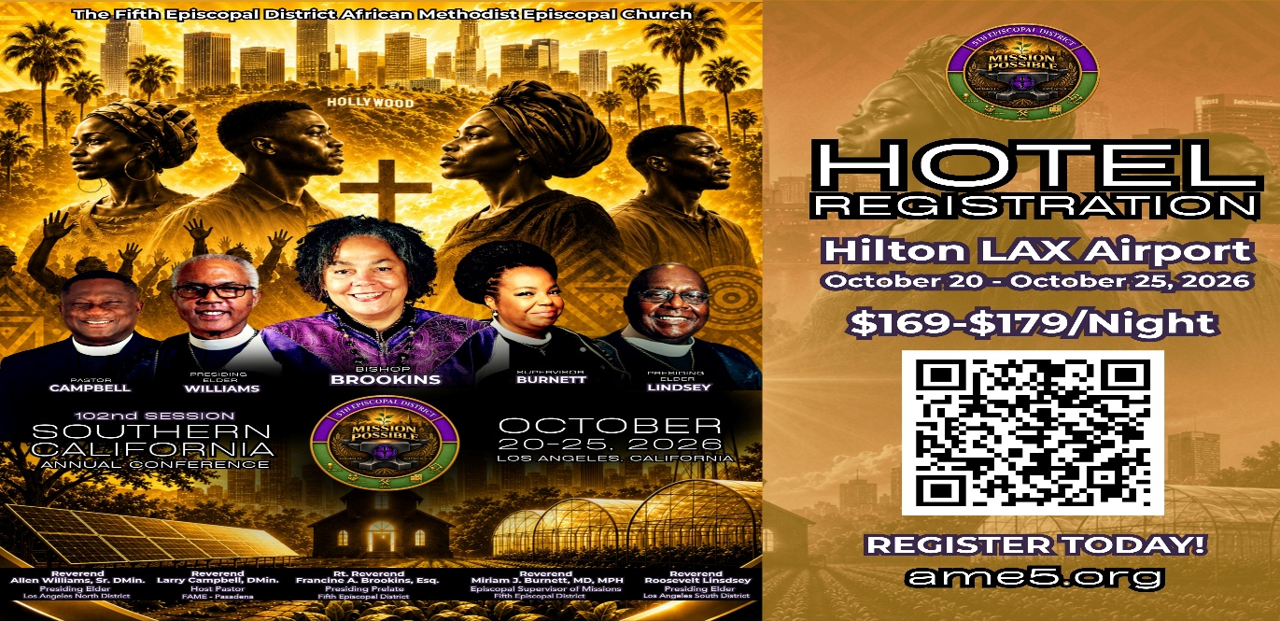

-11-

ANNOUNCEMENTS (Continued)

CALLING ALL VENDORS!
Showcase Your Business to 1,500+ Conference Attendees
First A.M.E. Church, Pasadena is honored to host the 102nd Session of the Southern California Annual Conference, October 21–27, 2026, at the Hilton Los Angeles Airport Hotel, 5711 West Century Boulevard, Los Angeles, CA 90045.
We are inviting business owners, entrepreneurs, vendors, and community partners to showcase and market their products and services to more than 1,500 conference attendees!
VENDOR BOOTH RATES
$500 for the entire week
$150 per day
Each pre-assigned booth includes one six-foot table with linen and two chairs. Vendors may purchase additional booth spaces if needed.
Setup: Tuesday, October 20, beginning at 7:00 a.m.
Vendor Hours: 8:00 a.m. through approximately 10:00 p.m. daily
Application & Payment Deadline: October 9, 2026
Space is limited and will be assigned on a first-come, first-served basis. All rental fees are non-refundable. Vendors are responsible for securing their merchandise. First A.M.E. Church, Pasadena, the Southern California Annual Conference, and the Hilton Los Angeles Airport Hotel are not responsible for lost, stolen, or damaged merchandise. Vendors are also invited to advertise in the Electronic Conference Program by providing a postcard or business card.
RESERVE YOUR SPACE TODAY!
For applications or additional information, contact:
Joann Forté-Wormley, Vendor Chairperson: (818) 434-4140
FAME Family: If you know a business owner, entrepreneur, artist, author, retailer, or community vendor who would benefit from this opportunity, please share this announcement and encourage them to participate!



-12-

Prayer Request(s)
Please notify the Church Office of Sick & Shut-in additions, deletions, or status/address changes.

Bishop Francine A. Brookins, Esq. Supervisor Miriam Burnett, MD Presiding Elder Roosevelt & Dr. Kaye Lindsey Rev. Dr. Larry & Melinda Campbell Richard Craig Hazel Clark Erica Woodard Jason Shirley Joshua Shirley Julian Shirley Ayanna Terry Cheryl Jamerson Gwendolyn Flowers Andrea Anderson Ocilda Files Danielle Clark Rev. Charles Brooks Kimberly Woods Cynithia Grace Calle Burns Noel Johnson The Taylor Family
Zechariah Robinson Christopher McCarthy Wilma Haynes Jacquelyn Walker Brittney Petty Selene Cox Deborah Burton Nettie McChristen The Caple Family Mel Beech Michael Dotson
Rev. Rochelle Moore Lorene Butler Stella Pulliam Collette Blizzard The Eaton Canyon Fire Victims

College Students

Let’s continue to support and pray for our beloved College Students

Isaiah Crowell Alecia Davis Chase Johnson Grant Blizzard Gabriel Blizzard

Tyler Johnson Richard Jones Tyrikk Lawson Makia Rose Talbert Isaiah Ringo Journey Rogers Elyse Sharp Kylee Sharp Zion Otano Elise Tervalon Grace Jones Jordan Patterson Kimberly Robinson Donovan Williams Jasmine Collins Brandon Bates

Sick and Shut-Ins
Andrew Oliver 1405 N. Roosevelt Avenue, Pasadena, CA 91104
Barbara Buchanan 616 Rio Grande St. Pasadena, CA 91104
Bettina Ayers Pasadena Meadows Nursing Home, 150 Bellefontaine St., Pas., CA 91105
Betty Betts Turner 1625 S. Magnolia Ave., Unit 4125, Monrovia, CA 91016
Bobby Thomas 1052 E. Morada Place, Altadena, CA 91001
Diane Jordan 1719 Fremont Ave., #302, S. Pasadena, CA 91030
Donita Towler 14148 Francisquito Ave., Baldwin Park, CA 91706
Doris Curd 11619 Woodcock Avenue, San Fernando, CA 91340
Edmund Riddle Active Care Mission Bay, 2440 Grand Avenue, San Diego, CA 92109
Eleanor Towler 975 E. Union Street, Unit #417, Pasadena, CA 91106
Elois Blizzard P. O. Box 3646, So. Pasadena, CA 91031
Emily Cormier-Ross 2549 La Fiesta Avenue, Altadena, CA 91001
Ernestine English 26 W. Fair Oaks Drive, Pasadena, CA 91103
Fred Caple 51 North 15th Street, Haledon, NJ 07508
Hugh Hamberry 19225 Chole Rd., Apple Valley, CA 92307
Jessie Smith 3925 S. Jones Blvd., Apt. 2118, Las Vegas, NV 89103| Spring Valley Community
Josephine Brown 15607 Saddleback Rd., Riverside, CA 92506
Lenora Moore 2445 E. Del Mar Blvd., #338, Pasadena, CA 91107
Linnie G. Nollie 2250 E. New York Drive, Altadena, CA 91001
Malika G. Hendry P. O. Box 94082, Pasadena, CA 91109
Mildred Lewis C/O Hazel Rohr, 884 W. Jane Court, Upland, CA 91786
Norma Burnett 618 Fairview Avenue, Unit #228, Arcadia, CA 91007
Opal Hampton 1030 Chevron Court, Pasadena, CA 91103
Paul Ratliff P.O. Box 40407, Pasadena, CA 91114
Virlyn Grant 15122 Orange Ave., Paramount, CA 90723
Wanda Nelson 3618 N. Fair Oaks Avenue, Altadena, CA 91001
William Hilliard 7504 Wynstone Pl., Fontana, CA 92336
Zell L. Hill 375 Barthe Drive, Pasadena, CA 91103

-13-

Sermon Notations

Scripture: _____________________________________________________________

Subject: _______________________________________________________________

Points of the Message: ___________________________________________________
_______________________________________________________________________
_______________________________________________________________________
_______________________________________________________________________
_______________________________________________________________________
_______________________________________________________________________
_______________________________________________________________________

Main Ideas of the Sermon: ________________________________________________
_______________________________________________________________________
_______________________________________________________________________
_______________________________________________________________________
_______________________________________________________________________
_______________________________________________________________________

Illustrations I want to remember: _________________________________________
_______________________________________________________________________
_______________________________________________________________________
_______________________________________________________________________
_______________________________________________________________________
_______________________________________________________________________
_______________________________________________________________________

What should I do as a result of this Sermon? ________________________________

_____________________________________________________
_____________________________________________________
_____________________________________________________
_____________________________________________________

-14-

